Question-2: Design a html page that describes about you and your team with a button for each that facilitates user to access your resumes.

**Output:**

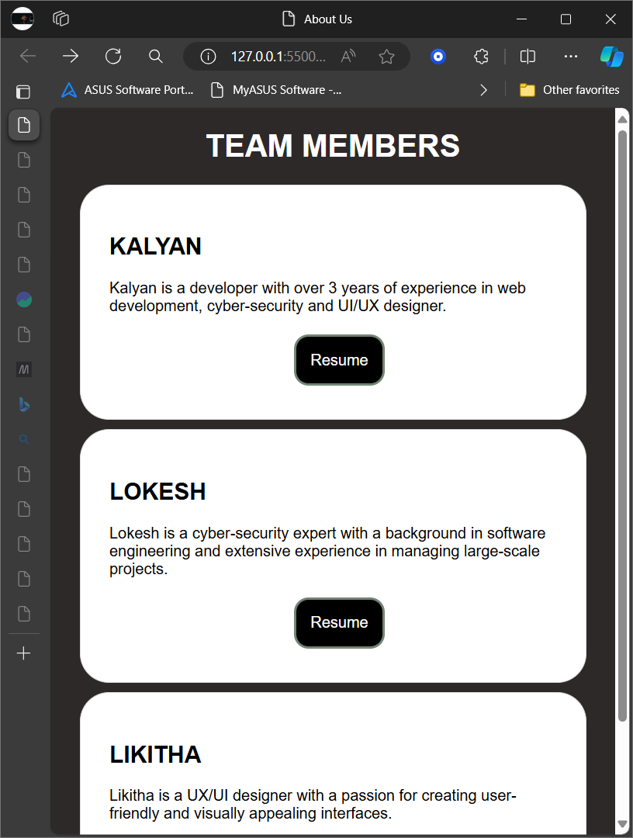

**Source code:**

<!DOCTYPE html>

<html lang="en">

<head>

    <meta charset="UTF-8">

    <meta name="viewport" content="width=device-width, initial-scale=1.0">

    <title>About Us</title>

    <style>

        body {

            font-family: Arial, sans-serif;

            margin: 20px;

            background-color: #2e2929;

        }

        .team {

            background-color: #fff;

            border: 1px solid #ddd;

            padding: 30px;

            margin: 10px;

            border-radius: 30px;

        }

        .resume-button {

            background-color: #000000;

            color: rgb(255, 255, 255);

            border: solid 3px rgb(114, 132, 116);

            padding: 15px 15px;

            text-align: center;

            text-decoration: none;

            display: inline-block;

            font-size: 16px;

            margin: 4px 190px;

            cursor: pointer;

            border-radius: 15px;

        }

        h1{

            color: #fff;

            text-align: center;

        }

    </style>

</head>

<body>

    <h1>TEAM MEMBERS</h1>

    <div class="team">

        <h2>KALYAN</h2>

        <p>Kalyan is a developer with over 3 years of experience in web development, cyber-security and UI/UX designer.</p>

        <a href="kalyan.pdf" class="resume-button">Resume</a>

    </div>

    <div class="team">

        <h2>LOKESH</h2>

        <p>Lokesh is a cyber-security expert with a background in software engineering and extensive experience in managing large-scale projects.</p>

        <a href="lokesh.pdf" class="resume-button">Resume</a>

    </div>

    <div class="team">

        <h2>LIKITHA</h2>

        <p>Likitha is a UX/UI designer with a passion for creating user-friendly and visually appealing interfaces.</p>

        <a href="likitha.pdf" class="resume-button">Resume</a>

    </div>

</body>

</html>