Question: Design a html page that consists of 5 hyperlinks that redirects to various products in an e-commerce application.

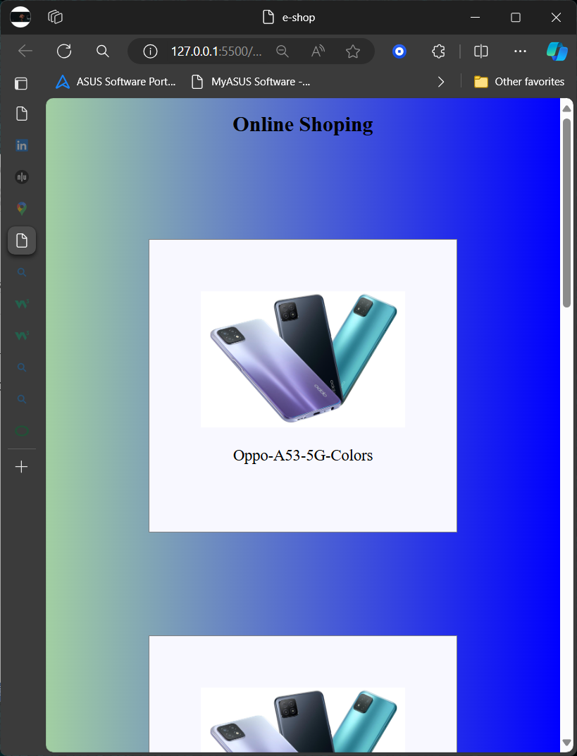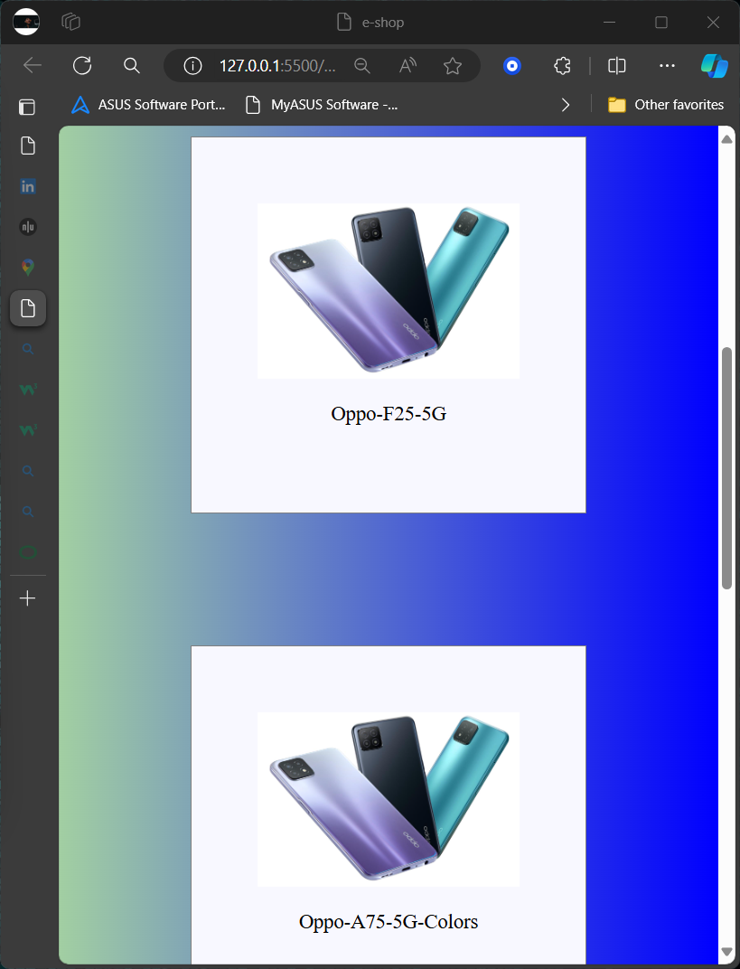

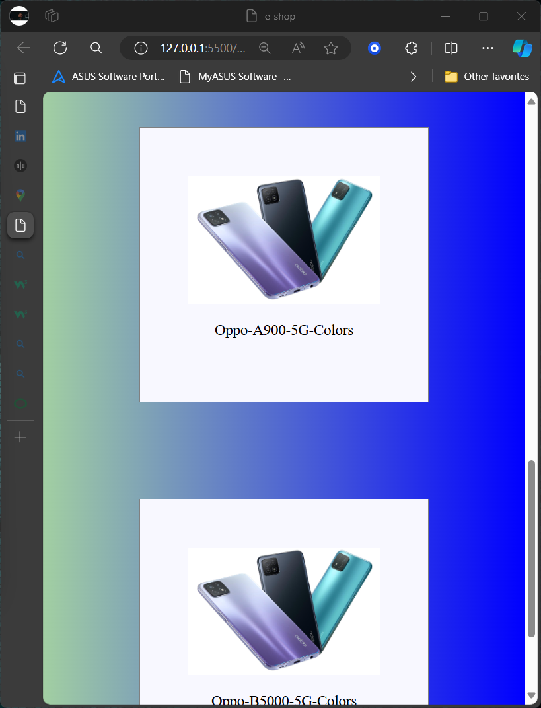

Source Code:

<!DOCTYPE html>

<html lang="en">

<head>

    <meta charset="UTF-8">

    <meta name="viewport" content="width=device-width, initial-scale=1.0">

    <title>e-shop</title>

    <style>

        body{

            margin: 0;

            padding: 0;

            color: aliceblue;

            background: linear-gradient(to right,rgb(162, 207, 162),blue);

        }

        h1{

            color: black;

            text-align: center;

        }

        .mob{

            background: ghostwhite;

            border: solid 2px grey;

            margin: 20%;

            padding: 10%;

        }

        img{

            width: 100%;

        }

        p{

            color: black;

            text-align: center;

            font-size: x-large;

        }

    </style>

</head>

<body>

    <h1>Online Shoping</h1>

    <div class="mob">

        <a href="https://www.oppo.com/in/smartphones/series-reno/reno12-pro/">        <img src="https://www.chooseyourmobile.com/wp-content/uploads/2020/12/Oppo-A53-5G-Colors.jpg" alt=""></a>

        <p>Oppo-A53-5G-Colors</p>

    </div>

    <div class="mob">

        <a href="https://th.bing.com/th?id=ODL.06105ab140efc23f098c2317dab49c35&w=146&h=146&c=7&rs=1&qlt=80&o=6&dpr=1.3&pid=RichNav">        <img src="https://www.chooseyourmobile.com/wp-content/uploads/2020/12/Oppo-A53-5G-Colors.jpg" alt=""></a>

        <p>Oppo-F25-5G</p>

    </div>

    <div class="mob">

        <a href="https://www.oppo.com/in/smartphones/series-reno/reno12-pro/">        <img src="https://www.chooseyourmobile.com/wp-content/uploads/2020/12/Oppo-A53-5G-Colors.jpg" alt=""></a>

        <p>Oppo-A75-5G-Colors</p>

    </div>

    <div class="mob">

        <a href="https://www.oppo.com/in/smartphones/series-reno/reno12-pro/">        <img src="https://www.chooseyourmobile.com/wp-content/uploads/2020/12/Oppo-A53-5G-Colors.jpg" alt=""></a>

        <p>Oppo-A900-5G-Colors</p>

    </div>

    <div class="mob">

        <a href="https://www.oppo.com/in/smartphones/series-reno/reno12-pro/">        <img src="https://www.chooseyourmobile.com/wp-content/uploads/2020/12/Oppo-A53-5G-Colors.jpg" alt=""></a>

        <p>Oppo-B5000-5G-Colors</p>

    </div>

</body>

</html>