Question: Design a html page that consists of five different mobiles images and the updated cost.

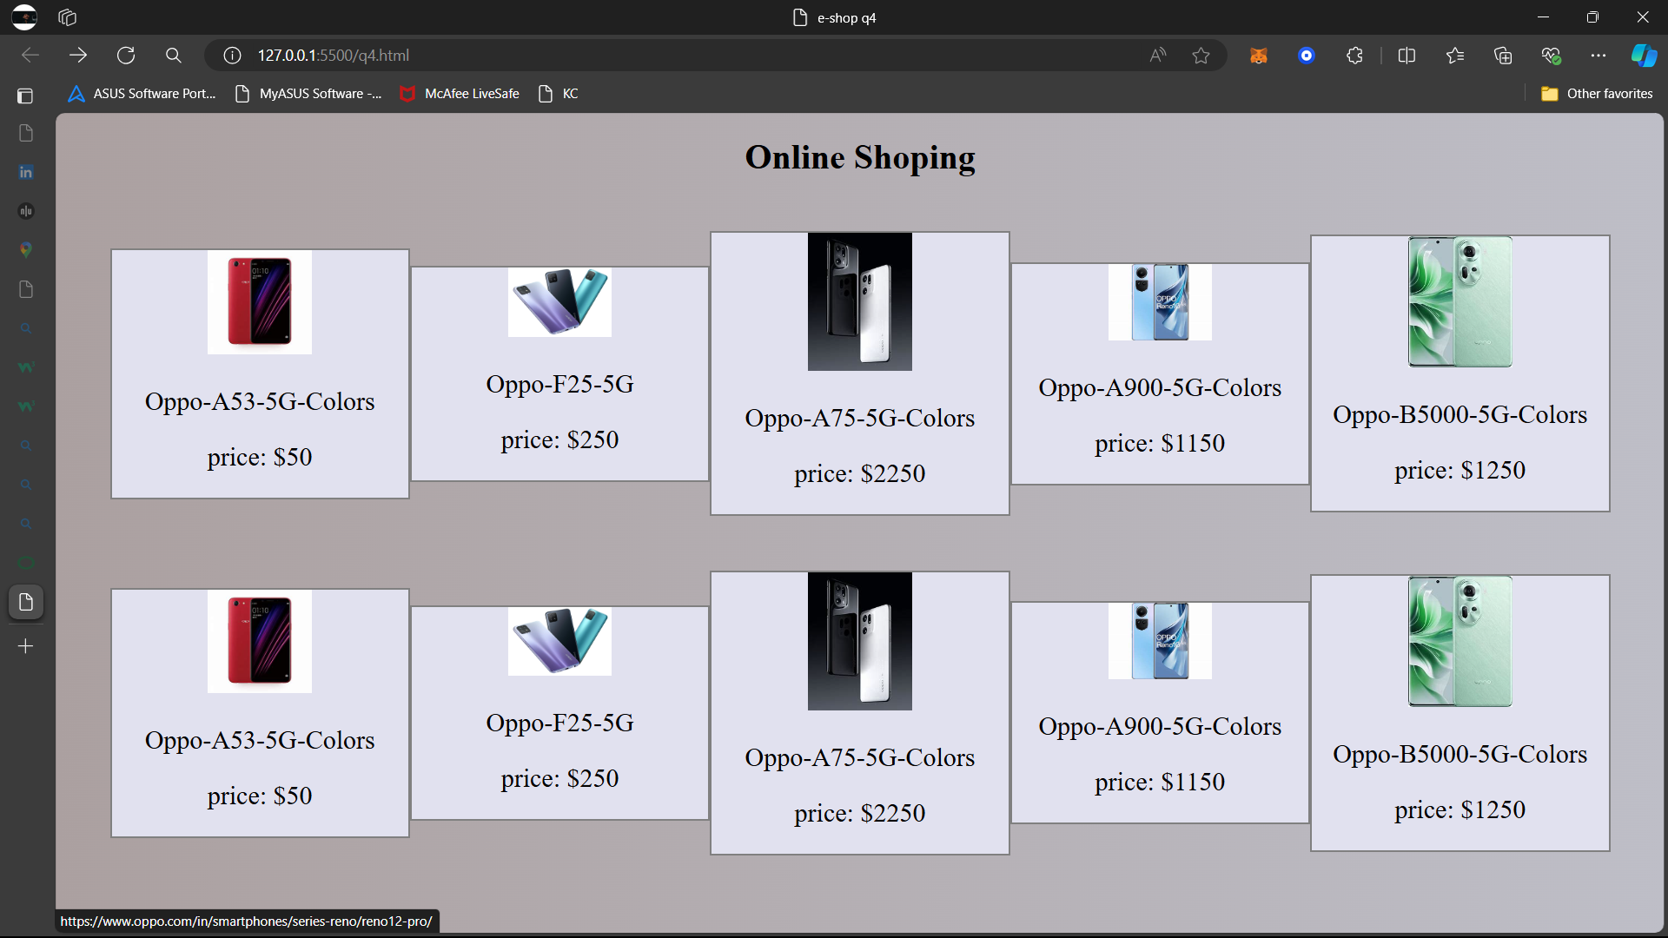

Source Code:

<!DOCTYPE html>

<html lang="en">

<head>

    <meta charset="UTF-8">

    <meta name="viewport" content="width=device-width, initial-scale=1.0">

    <title>e-shop q4</title>

    <style>

        body{

            margin: 0;

            padding: 0;

            color: aliceblue;

            background: linear-gradient(to right,rgb(171, 160, 160),rgb(190, 190, 199));

        }

        h1{

            color: black;

            text-align: center;

        }

        .con,mob{

            display: flex;

            margin: 50px;

            align-items: center;

        }

        .mob{

            background: rgb(225, 225, 239);

            border: solid 2px grey;

        }

        .mob,img{

            width: 35%;

        }

        .mob,p{

            color: black;

            text-align: center;

            font-size: x-large;

        }

    </style>

</head>

<body>

    <h1>Online Shoping</h1>

    <div class="con">

    <div class="mob">

        <a href="https://www.oppo.com/in/smartphones/series-reno/reno12-pro/">        <img src="https://th.bing.com/th/id/OIP.oHi8TNo5zBiocaHgEGPl1gHaHa?w=213&h=213&c=7&r=0&o=5&dpr=1.3&pid=1.7" alt=""></a>

        <p>Oppo-A53-5G-Colors</p>

        <p> price: $50</p>

    </div>

    <div class="mob">

        <a href="https://th.bing.com/th?id=ODL.06105ab140efc23f098c2317dab49c35&w=146&h=146&c=7&rs=1&qlt=80&o=6&dpr=1.3&pid=RichNav">        <img src="https://www.chooseyourmobile.com/wp-content/uploads/2020/12/Oppo-A53-5G-Colors.jpg" alt=""></a>

        <p>Oppo-F25-5G</p>

        <p> price: $250</p>

    </div>

    <div class="mob">

        <a href="https://www.oppo.com/in/smartphones/series-reno/reno12-pro/">        <img src="https://th.bing.com/th/id/OIP.vYhUgN1hY3loqVjYGaaqYgHaJ4?w=144&h=192&c=7&r=0&o=5&dpr=1.3&pid=1.7" alt=""></a>

        <p>Oppo-A75-5G-Colors</p>

        <p> price: $2250</p>

    </div>

    <div class="mob">

        <a href="https://www.oppo.com/in/smartphones/series-reno/reno12-pro/">        <img src="https://th.bing.com/th/id/OIP.oLt8S6W5clJ8AeMsBuzHEgHaFh?w=254&h=187&c=7&r=0&o=5&dpr=1.3&pid=1.7" alt=""></a>

        <p>Oppo-A900-5G-Colors</p>

        <p> price: $1150</p>

    </div>

    <div class="mob">

        <a href="https://www.oppo.com/in/smartphones/series-reno/reno12-pro/">        <img src="https://th.bing.com/th/id/OIP.Ta7P9TN-suRMwivs25P-CAHaJT?w=153&h=193&c=7&r=0&o=5&dpr=1.3&pid=1.7" alt=""></a>

        <p>Oppo-B5000-5G-Colors</p>

        <p> price: $1250</p>

    </div>

</div>

<div class="con">

    <div class="mob">

        <a href="https://www.oppo.com/in/smartphones/series-reno/reno12-pro/">        <img src="https://th.bing.com/th/id/OIP.oHi8TNo5zBiocaHgEGPl1gHaHa?w=213&h=213&c=7&r=0&o=5&dpr=1.3&pid=1.7" alt=""></a>

        <p>Oppo-A53-5G-Colors</p>

        <p> price: $50</p>

    </div>

    <div class="mob">

        <a href="https://th.bing.com/th?id=ODL.06105ab140efc23f098c2317dab49c35&w=146&h=146&c=7&rs=1&qlt=80&o=6&dpr=1.3&pid=RichNav">        <img src="https://www.chooseyourmobile.com/wp-content/uploads/2020/12/Oppo-A53-5G-Colors.jpg" alt=""></a>

        <p>Oppo-F25-5G</p>

        <p> price: $250</p>

    </div>

    <div class="mob">

        <a href="https://www.oppo.com/in/smartphones/series-reno/reno12-pro/">        <img src="https://th.bing.com/th/id/OIP.vYhUgN1hY3loqVjYGaaqYgHaJ4?w=144&h=192&c=7&r=0&o=5&dpr=1.3&pid=1.7" alt=""></a>

        <p>Oppo-A75-5G-Colors</p>

        <p> price: $2250</p>

    </div>

    <div class="mob">

        <a href="https://www.oppo.com/in/smartphones/series-reno/reno12-pro/">        <img src="https://th.bing.com/th/id/OIP.oLt8S6W5clJ8AeMsBuzHEgHaFh?w=254&h=187&c=7&r=0&o=5&dpr=1.3&pid=1.7" alt=""></a>

        <p>Oppo-A900-5G-Colors</p>

        <p> price: $1150</p>

    </div>

    <div class="mob">

        <a href="https://www.oppo.com/in/smartphones/series-reno/reno12-pro/">        <img src="https://th.bing.com/th/id/OIP.Ta7P9TN-suRMwivs25P-CAHaJT?w=153&h=193&c=7&r=0&o=5&dpr=1.3&pid=1.7" alt=""></a>

        <p>Oppo-B5000-5G-Colors</p>

        <p> price: $1250</p>

    </div>

</div>

</body>

</html>