V2

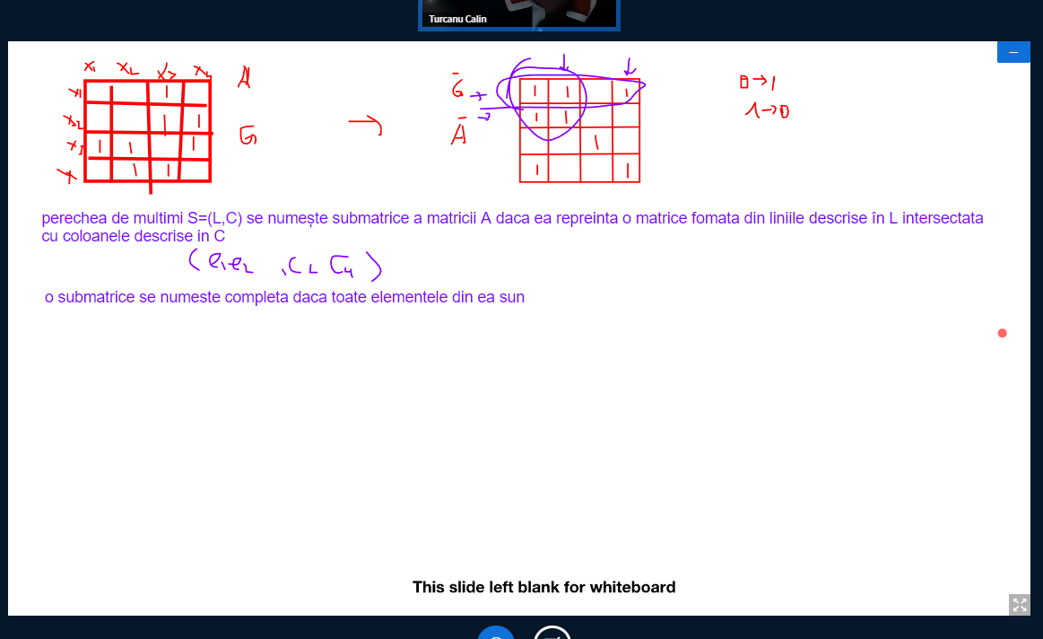

V1

