mbeDshield: YET ANOTHER MBED
Kazuki Yamamoto(@_K4ZUKI_)
26/Dec/2013 rev1.0
30/Dec/2014 rev2.0

THE mbeDshield is YET ANOTHER MBED, which looks like arduino, will make you use ANY arduino "shields" from MBEDs 1768/11U24/11U35. This document is for current PCB design version 0.5.0 and future design 0.6.0

Contents:
1. Version history
2. Components
3. Soldering of the Kit
4. Software
5. Schematics of v0.5.0
6. Revision history

1. Version history
1.1: v0.0.1 = hand-wired prototype
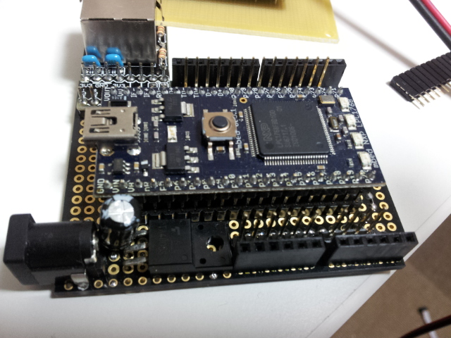
- Sunhayato's universal shield UB-ARD01
- Switch Science(SSCI)'s SSCI-MBED-ETHER-KIT
- mbed 1768

1.2: v0.1.0 = first PCB design as "mbeduino"
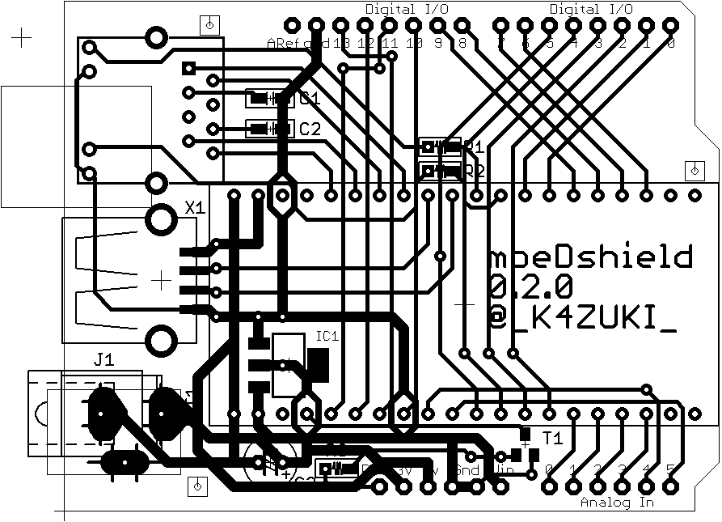

- the name already exist but didn't ask to Mr. Google
- old arduino pin-out
- no reset button
- some mistake on reset signal line
- no M3 screw mounting hole but 0.8mm guide hole instead
- USB host supported

1.3: v0.3.7 = second PCB design release
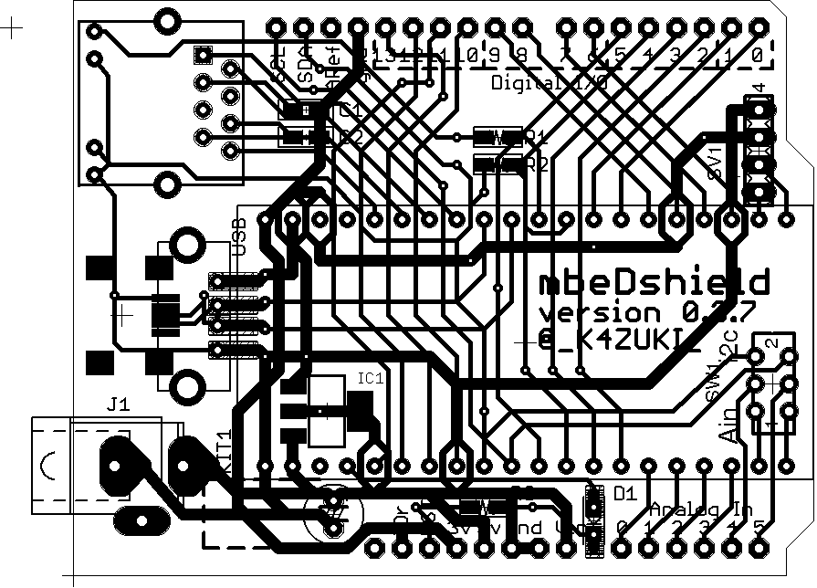
- from this version it is named "mbeDshield", D is large character
- USB host and device supported(mini-B USB on bottom side)
- later arduino pin-out
- A4/A5 pins are multiplexed of analog input or I2C-IO
- no M3 mounting screw hole(FORGOT to add XO)
- no reset switch

1.4: v0.4.0 = third PCB design release
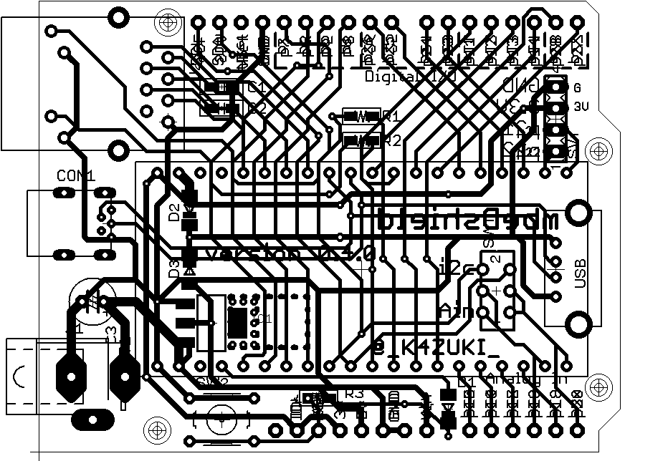
- most of components can be bought from AKIZUKI
- all components on top side
- design bug on Vin capacitor with normal-height(cheap) one (kit uses low height one!)
- M3 mounting hole implemented finally
- silkscreen on Both sides

1.5: v0.4.1 = 4th PCB design rc1
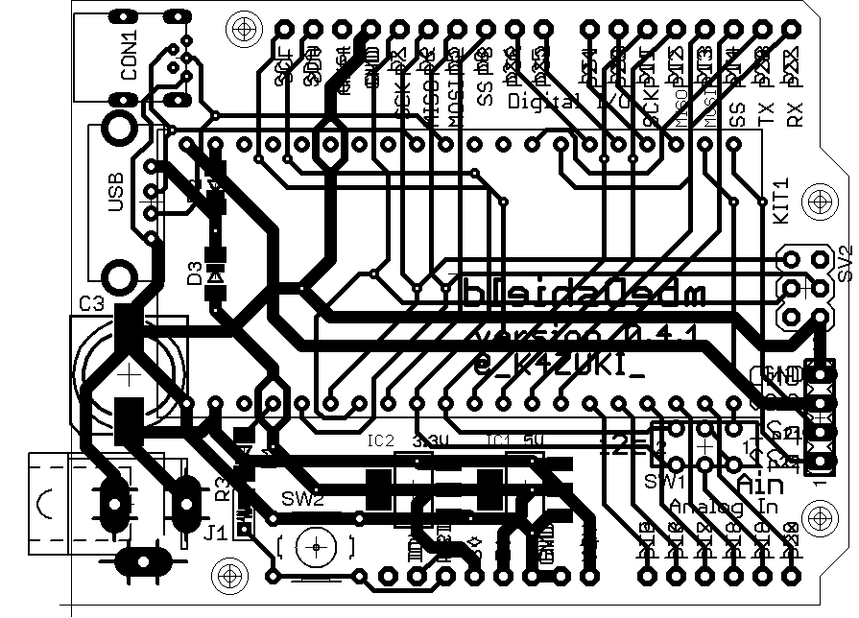
- only data exists
- no RJ45 socket
- 1mm(40mil)line ground
- tail 2x3p pin headers for SPI (p5-8 shared)
- silkscreen on Both sides
- local LDOs on 3V and 5V lines, 0.5A each
- 7-9V input is necessary

1.6: v0.4.2 = 4th PCB design rc2
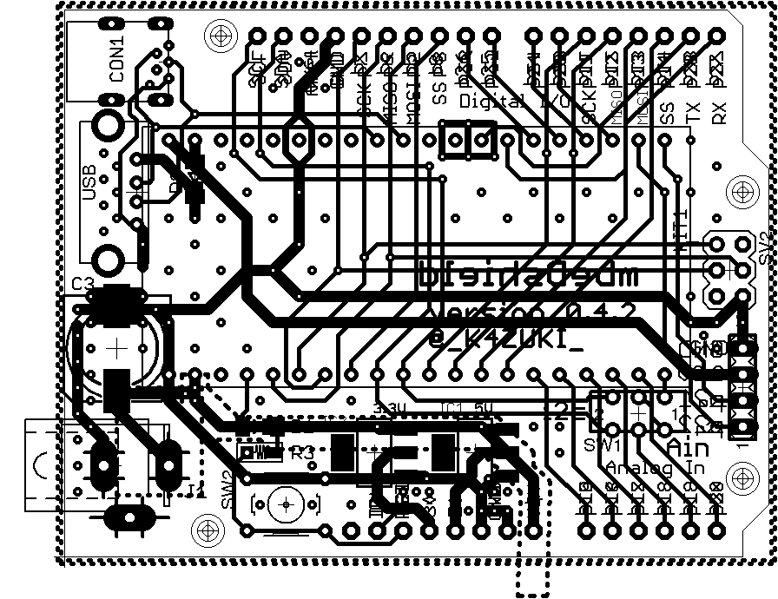
- only data exists
- split plane ground and Vin
- local LDOs on 3V and 5V lines, 0.5A each
- USB host is powered from mbed on-board LDO
- SMD Vin capacitor
- tail 2x3p high-height pin headers for SPI
- ask SSCI or AKIZUKI for selling??? - maybe after prototype

1.7: v0.5.0 = released 4th PCB design
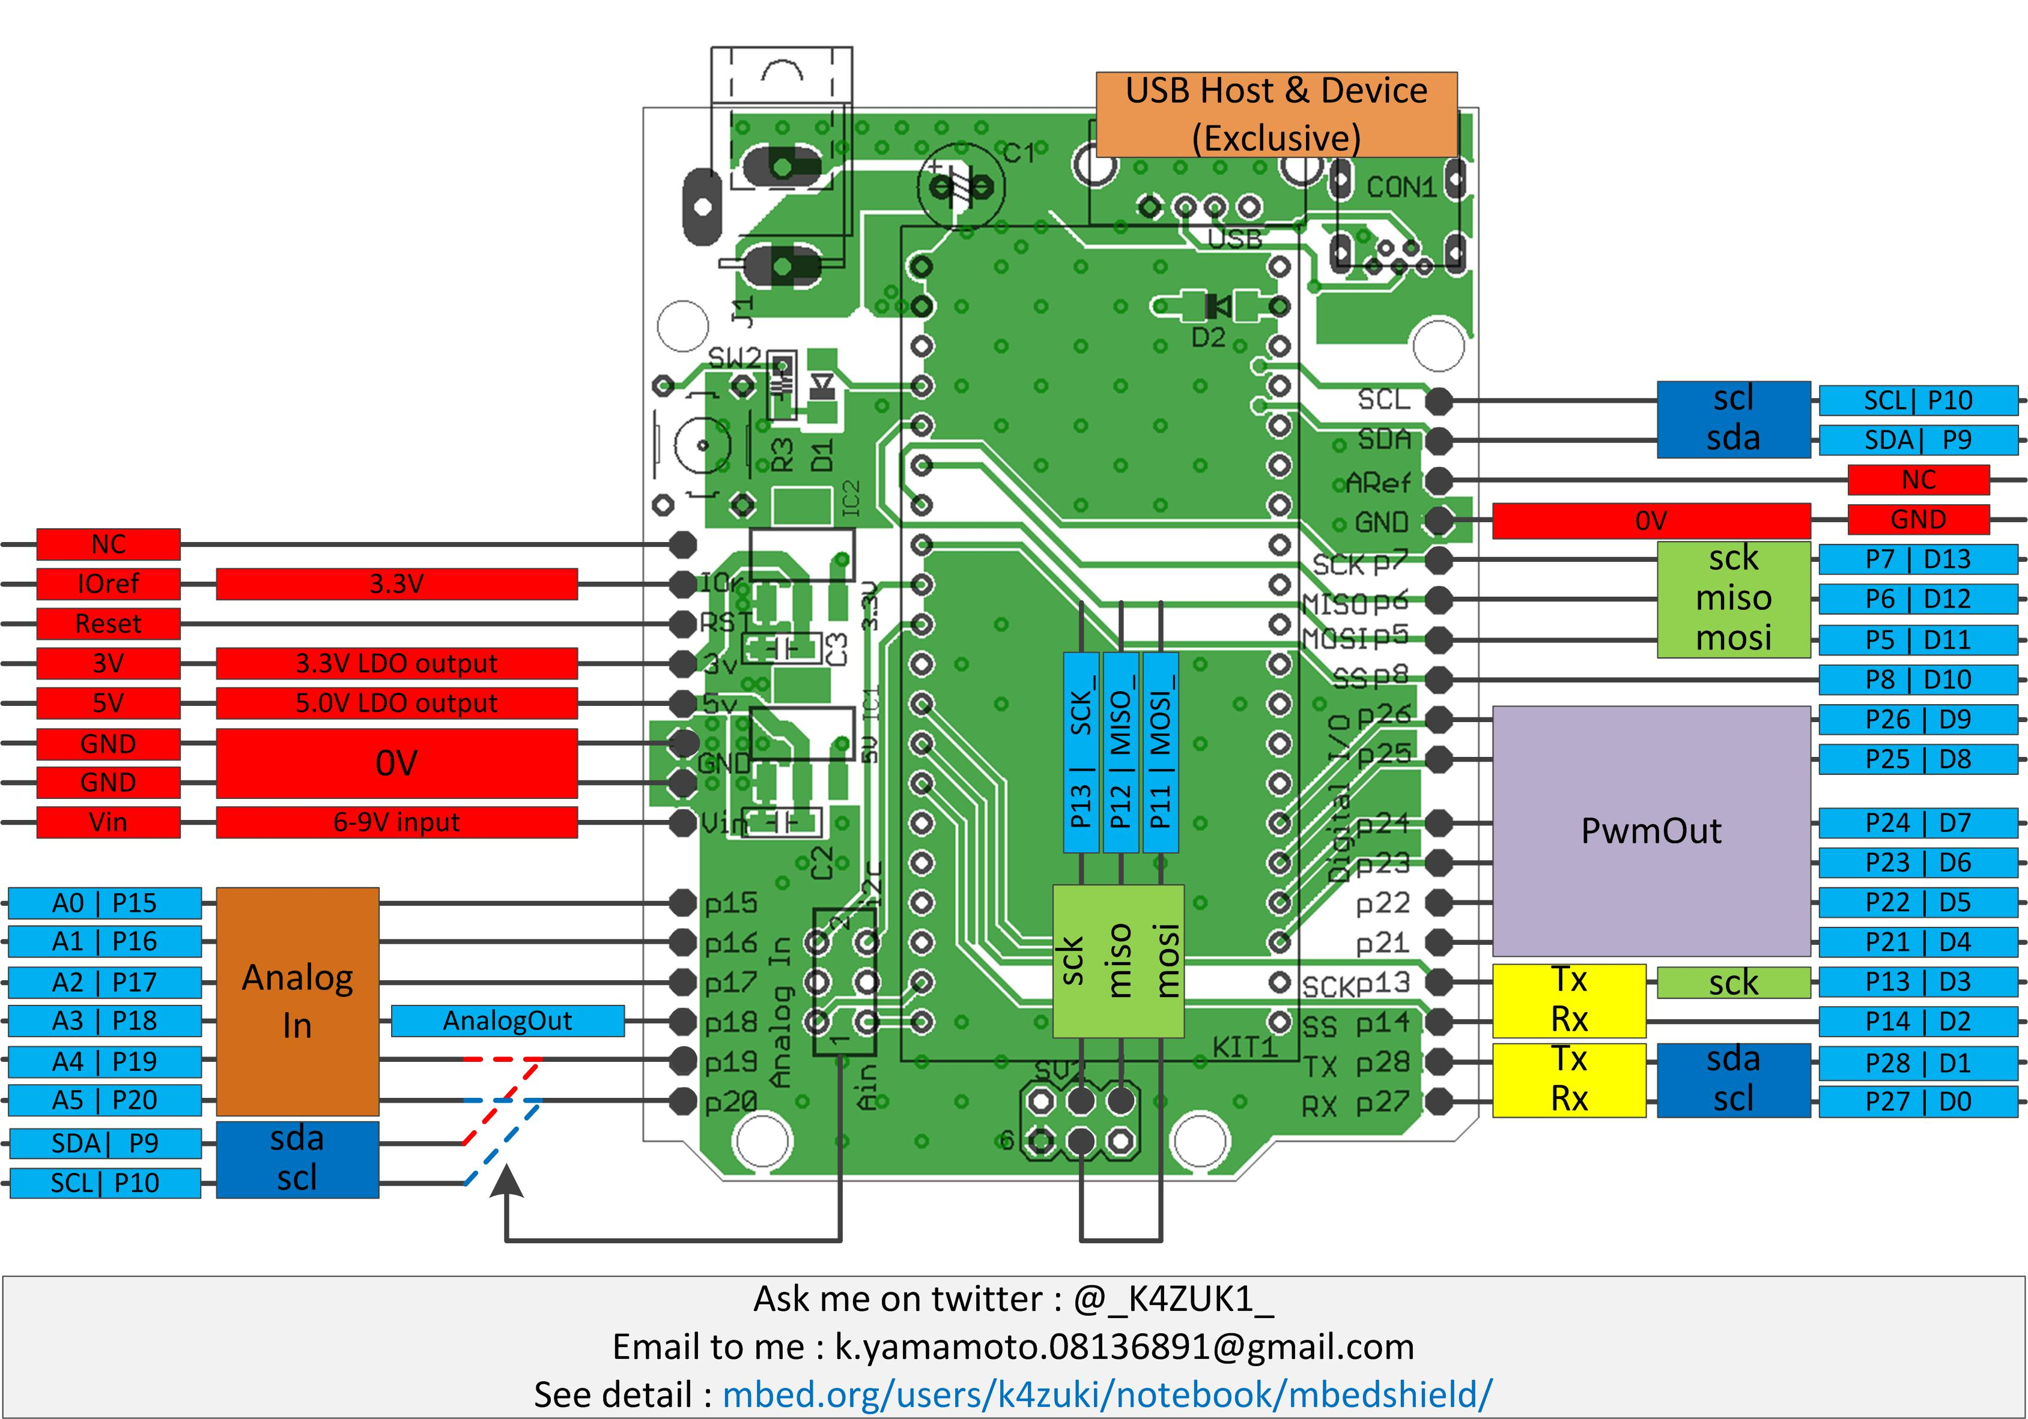
- sales available from SSCI( https://www.switch-science.com/catalog/1717/ )
- only 1 pcs left(as of 30/Dec/2014) and discontinued
- USB host is available only if main USB is connected(1768 only)
- USB device mode only uses data lines(cannot get power from host)
- I2C is only available with 1768(known bug)

1.8: v0.6.0 = planned 5th PCB design
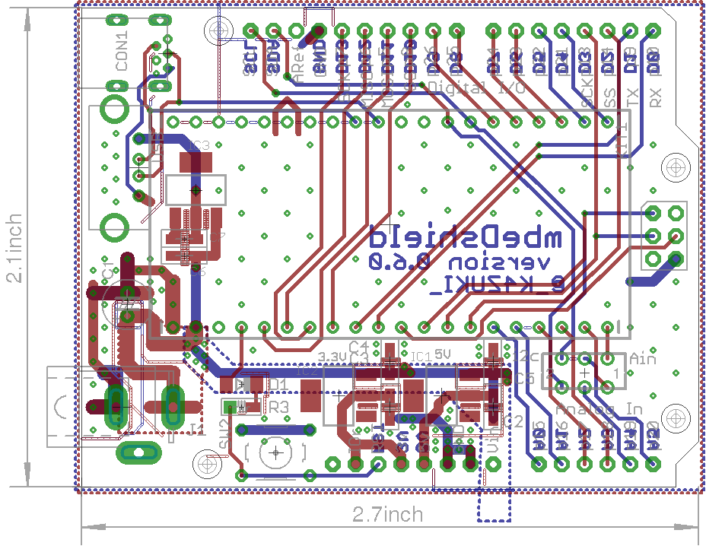
- only data exists
- local LDO for USB host
- I2C pin-out change: p27/28 → p9/10
- ask SSCI for selling?

2. Components

3. Soldering of the Kit
From lower height components:
a. SMD parts C,R,D,LDO
b. mbed socket
c. Vin capacitor
d. USB sockets A and mini-B
e. Vin capacitor
f. DC jack

g. board connectors
g1. unplug pins from one of each pair
g2. stack with other one
g3. solder stacked socket
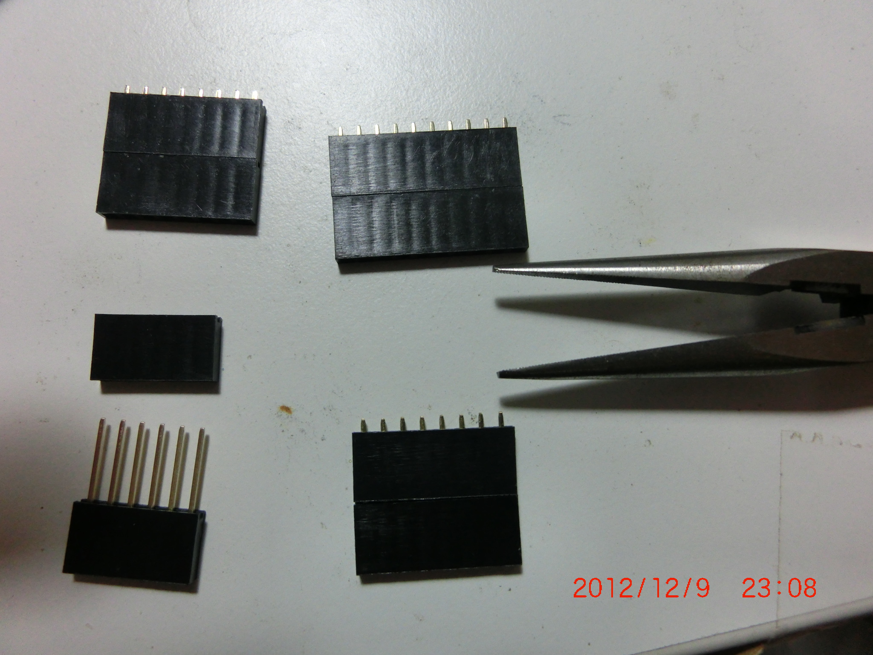

h. Ethernet RJ45 socket(not for 0.5.0)
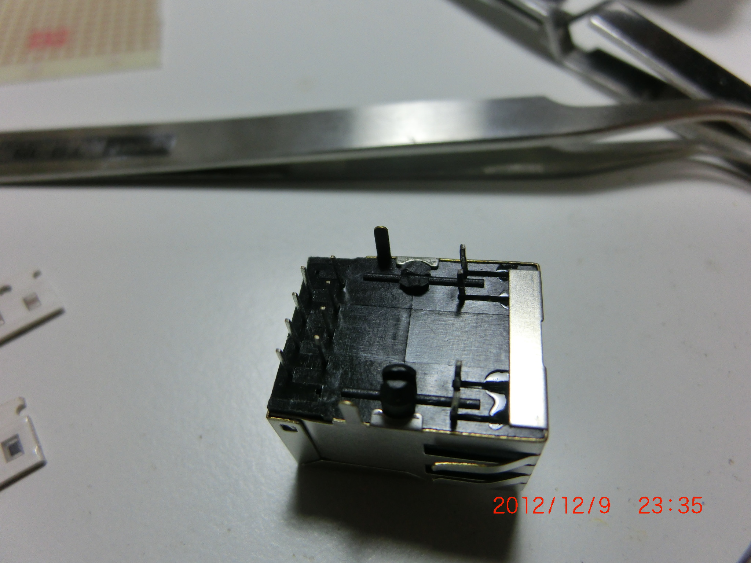

4.Software
You can use any existing softwares for mbed. From writer's experience:
- onboard Ethernet + NTP client (mbed1768 + PCB <0.4.0)
- onchip USB host + Bluetooth dongle connected to Wiimote(Wii Rimokon)
(mbed1768 + PCB <0.4.0)
- 2.8 inch touch LCD shield from Seeed Studio(0.5.0)
- VFD clock shield from SSCI/@hayasita
- Touch Shield(MPR121 used) from sparkfun
- SPI memory LCD from AKIZUKI(need to make your own shield)
-- breakout board will be available from MARUTSU(2015~)
- I2C graphic LCD from AKIZUKI(need to make your own shield)
- I2C 16x2 character LCD from AKIZUKI(need to make your own shield)
- Aquestalk Pico from AKIZUKI(need to make your own shield)
- eVY1 shield from SSCI
UNDER CONFIRMATIONS:
- Ethernet shield R3 from SSCI/Arduino team
- USB host shield from sparkfun
- Xbee shield from sparkfun
- Gameduino from SSCI

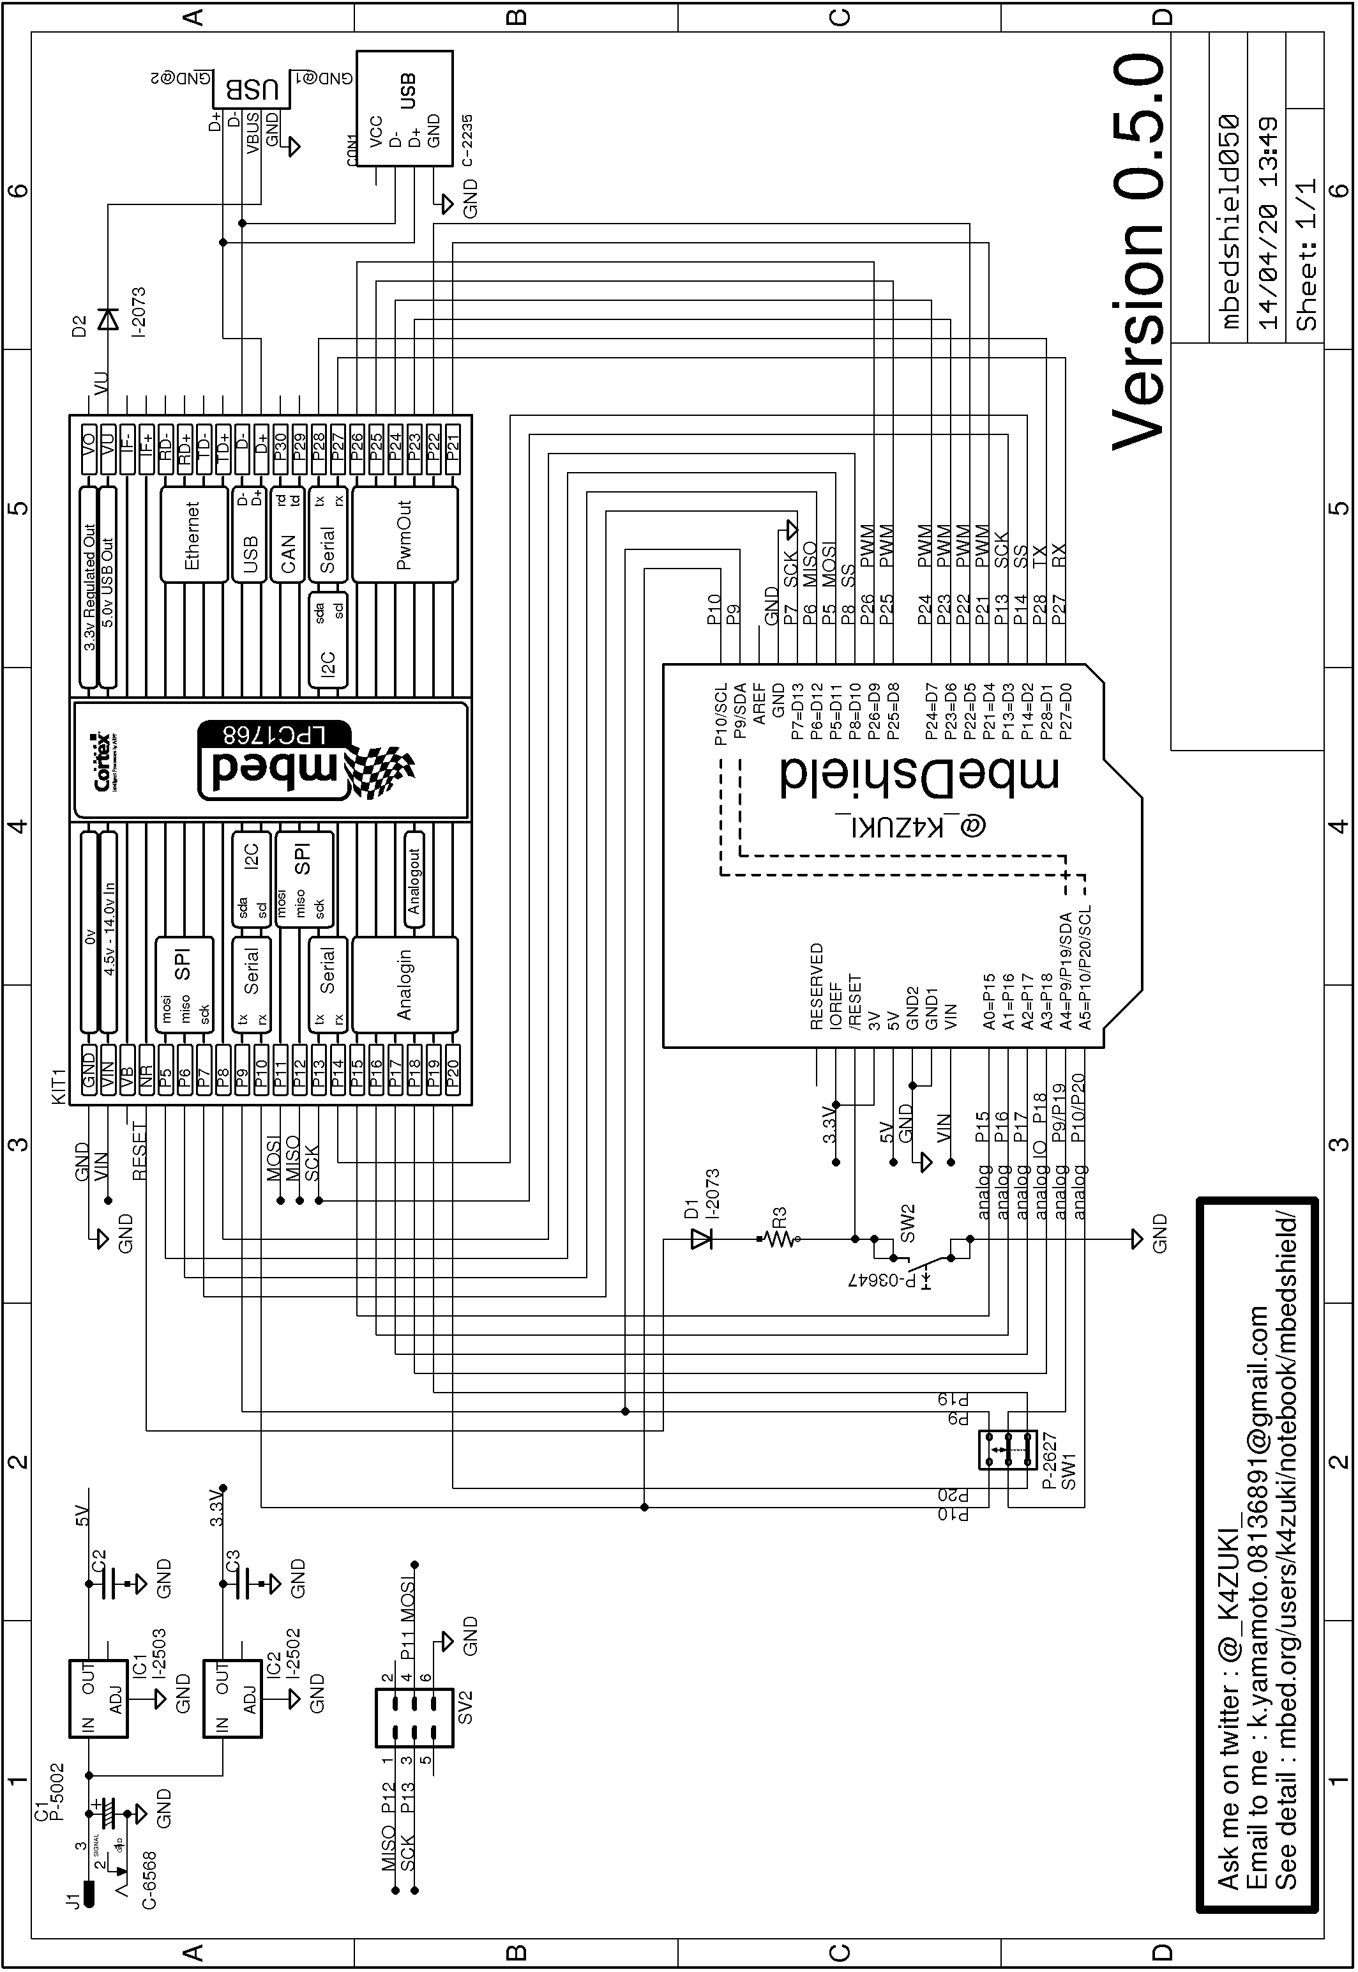
5. Schematics of v0.5.0

6. Revision history

Revision 1.0: released at C85(2013)
- documented up to 0.4.2

Revision 2.0: released at C87(2014)
- modification/correction/replace from Revision 1.0
- documented up to 0.6.0

------------------------------------
mbeDshield: YET ANOTHER MBED
Kazuki Yamamoto
@_K4ZUKI_
Revision 2.0
------------------------------------

