When in spectrum, band mode (F+6 from VFO)

Press 4 to enter the band list menu:

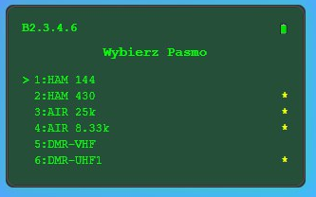

Use Up/Down to choose the line, press 4 to add or remove a band, a star is shown.

Press 5 to clear all bands and activate the one selected.

Long press 4 to go back to spectrum.