(all in English)

Title Font: Times New Roman, Size 16

Student Name (in Chinese Pinyin for Chinese ,Times New Roman, Size 16)
Or (Full-name as registered with the university)
Student No.
Major
Course Software Processes and Project Management/Software Project Management
Supervisor 孙 恒
Date(dd/mm/yyyy)

暨 南 大 学
课程毕业论文

论文题目 中文题目，小三号宋体

学 院_ 信息科学技术学院/国际学院
专 业
课 程 软件过程与项目管理/软件项目管理
姓 名
学 号
指导教师 孙恒
2017年 月 日

（Thesis Title )A Sample Thesis for Students of International School

Abstract: A concise abstract should briefly state the main purpose, methods, results, conclusion and significance of the thesis. An abstract is often presented separate from the article, so it must be able to stand alone. The abstract should be about 150 words with 3-4 key words.
Key Words: One, Two, Three (Notes: All key words must be significance of retrieval)

中文题目(宋体，四号，加粗）

摘 要: 摘要应扼要叙述本论文的主要内容、特点，文字要精炼，是一篇具有独立性和完整性的短文，应包括本论文的主要成果和结论性意见。
摘要中不宜使用公式、图表，不标注引用文献编号，避免将摘要写成目录式的内容介绍，也不要将摘要写成“前言”。（宋体，小四，1.5倍行距）
关键词: 关键词一；关键词二；关键词三 (3~4个关键词，用分号分隔)

1. Introduction
The main text should be typed with Font Times New Roman, Size 12. No indention is needed for the first paragraph. One Tab of indention is used for the rest of paragraphs. Line spacing should be 1.5 times. Also there should be no empty lines between paragraphs.
The introduction should review the theoretical background of the topic and introduce the purpose of the research.

2. Materials and methods
2.1 Materials
Materials, subjects, and equipment (chemicals, experimental animals, apparatus, etc.) used in the experiment should described in this section in which all materials must have clear sources and specification.
Table 2-1 Culture Factor for Accounting Standards
Social culture environment |  | Characteristics of accounting standards
 |  | Setting & implementation | Information  disclosure | Accounting methods
Ⅰ | -Collectivism;  -Strong response;  -Pliable culture | -Emphasize on legislation and administration; | Tend to be inexplicit. | Emphasize on uniformity & conservatism
Ⅱ | -Individualism;  -Weak response;  -Rigid culture | -Emphasize on profession-oriented  -Less government | Tend to be explicit. | Emphasize on flexibility & optimism

2.2 Methods or procedures
The procedures, analytical or test methods and data process carried out should be described in this part.
The SI unit system should be used for all scientific and laboratory data; if, in certain instances, it is necessary to quote other units, these should be added in parentheses. Temperatures should be given in degrees Celsius. The unit 'billion' (109 in America, 1012 in Europe) is ambiguous and should not be used.
Symbols or abbreviations for units should follow the suggestions of the British Standards publication BS 1991. The full stop should not be included in abbreviations, e.g. m (not m.), ppm (not p.p.m.), % and '/' should be used in preference to 'per cent' and 'per'. Where abbreviations are likely to cause ambiguity or may not be readily understood by an international readership, units should be put in full.
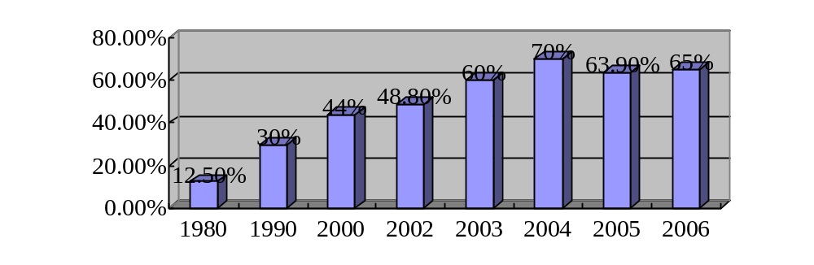
Figure 2-1 Foreign Trade Dependence Degree in China

3. Results
3.1 Result 1…….
3.2 Result 2…….
Results obtained from experimental study should be reported here following the most important to less important order. All results must be data based with the concrete support by tables and figures.
The format of three lines table is used and all tables and figures should have clear legend or captions.

4. Discussion
This section should summarize the most important findings, point out the indication of the observations, explain the possible mechanism to the results and state how results relate to expectations and to literature cited in the introduction.
In the text refer to the author's name (without initials) and year of publication. All authors are to be listed at first citation. At subsequent citations use first author et al., e.g. It has been convincingly shown that acrylamide in food is mainly formed by a reaction between asparagines and reducing sugars (Becalski, Lau, Lewis, & Seaman, 2003; Mottram, Wedzicha, & Dodson, 2002; Stadler et al., 2002; Weisshaar & Gutsche, 2002). Some data indicate that the type of oil used for deep frying can influence the formation of acrylamide (Becalski et al., 2003). For Chinese names, please list the surname/family name of the author only (e.g. Liao，2005). And in the end of text, where you list all of your references, the author’s full name should be given.

5. Conclusion
The conclusion should be a summary of the problems identified and analyzed, the solutions suggested and comments by the student.

References
In this section, all the citations within the main text of the thesis should be found here. Some examples are listed below. Please note that the references are in alphabetical order. The list of references should be arranged alphabetically by authors' names and should be as full as possible, listing all authors, the full title of articles and journals, publisher and year. The manuscript should be carefully checked to ensure that the spelling of authors' names and dates are exactly the same in the text as in the reference list. The reference format that Elsevier-SDOL (Science Direct Online) journals used is recommended to use:
Author, Initials. (Year). Title of article. Full Title of Journal, Volume number (Issue/Part number), Page numbers.
Ahmed, I. A. & Robinson, R. K. (1999). The ability of date extracts to support the production of aflatoxins. Food Chemistry, 66(3), 307-312.
Chapter author(s) surname(s) and initials. (Year of chapter). Title of chapter followed by “In”. Book editor(s)/author(s) initials. surnames, Title of book. (Chapter number or first and last page numbers followed by full-stop). Place of publication: Publisher.
Barber, S. (1972). Milled rice and changes during storage. In D. F. Houston, Rice Chemistry and Technology (pp. 215-263). St. Paul, Minnesota: American Association of Cereal Chemists.
Author, Initials. (Year). Title of topic followed by “In”. title of conference proceedings (Chapter number or first and last page numbers followed by full-stop) Place: Organizer.
Hagawara, N., Tateishi, M., Yamane, T., & Takahashi, T. (1991). Inhibition of azoxymethane-induced colon carcinogenesis in rat by tea polyphenols. In Proceedings of the International Symposium on Tea Science (pp.190-194). Shizuoka: Tea Science Society of Japan.
Hu, X. Z. (1991). The enhancing effect of green tea catechins on cell mediated immunity in mice. Chinese Journal of Microbiological Immunology, 11, 97-99. (In Chinese).

Thesis Evaluation for Undergraduate Students
Supervisor’s Comments：

Marks：_______/100 Signature：
Date (dd/mm/yyyy):

“软件过程与项目管理”课程论文指南
Thesis Instructions of Software Project Management Course

1.课程论文围绕项目整体管理展开，重点描述其概念（30分）、作用（30分）及案例（40分）等。
Theme: Project integration management is an element of Project management which coordinates all the aspects of a project. Project integration ensures smooth performance of all processes. Please describe concepts (30 marks), importance (30 marks), and cases (40 marks) of project integration management in your own words.
2.封面字体为Times New Roman，字号为16；正文字体为Times New Roman，字号为12，行距1.5倍。页码从正文开始，标注在右下方。正文页边距，左3厘米，右2厘米，上下为2.5厘米。
Font: Times New Roman, Font Size: cover 16, 12 for the rest of the paper. Line Spacing: 1.5 times for all paragraphs. Page number starts from bottom-right of the introduction. Margins: 3cm to the left，2cm to the right, 2.5cm to the top and bottom.
3.摘要不能少于150字，关键词3-4个；关键词中，每个词的首字母需要大写，且逗号隔开。
Abstract requires no less than 150 words. Key words (3 to 4 words) can be listed at the end of the abstract on a separate line, with the first letter capitalized and comma (,) separating each word.
4.正文中，标题加粗；一级标题之间空一行；每级标题下的首段齐头，从第二段开始缩进一个制表符（tab）。
Text titles print in bold letters. No indention is needed for the first paragraph under each title. One TAB of indention is used for the rest of paragraphs. No empty lines between paragraphs in the same parts.
5.正文中的图和表分别编号，图的编号标注在图的下方，表的编号标注在表的上方。如有来源，一律标注在下方。
Tables are numbered on top and Figures at bottom with titles, while source for both can only be printed at bottoms.
6.正文中的引用，需标注出作者的姓及出版年份，中文姓名标注姓的拼音，机构则是机构的英文全称。直接引用需标注出页码。
About citations: English names need to be listed the surname and the year of publication (Smith, 2001), Chinese name should be listed only the surname/family name and the year of publication (Liu, 2005), and the full name to the organization (World Bank, 2004). Direct citations need numbers.
7.参考文献的标注顺序：（所有作者姓名）作者—--出版年份—--书的章节或文章名—--书名或杂志名—--出版地点—--出版机构—--页码
References must be listed in the order as: all authors (Surname, initial of Given name)---year of publication---book title or chapter---title of book or journal--- location --- edition and publisher ---page.
8.所有文献分别按照A-Z的顺序排列。作者姓在前，名的首字母在后，逗号隔开；中文作者标注姓名拼音，中文文献最后标明“（In Chinese）”。
References should be arranged in alphabetical order; Chinese reference should be marked “(In Chinese)” in the end.
9.课程论文（打印版及电子版）提交截止时间：2017年6月22/23日，逾期不再接收。
You must submit the final draft (including typed paper and digit file) within deadline (June 22-23, 2017). Please upload to ftp://up:up@202.116.3.232:8866.

