SOCIAL MEDIA DASHBOARD WEBSITE
AI23431- WEB TECHNOLOGY AND MOBILE APPLICATION

MINI-PROJECT REPORT
SUBMITTED BY KAAVYA H
(241801112)



RAJALAKSHMI ENGINEERING COLLEGE

(an Autonomous Institution Affiliated to Anna University, Chennai)

BONAFIDE CERTIFICATE
Certified that this Project Thesis titled “SOCIAL MEDIA DASHBOARD” is the bonafide work of KAAVYA H (2116241801112) who carried out the work under my supervision. Certified further that to the best of my knowledge, the work reported here does not form part of any other thesis or dissertation on the basis of which a degree or award was conferred on an earlier occasion on this or any other candidate.



INTERNAL EXAMINER EXTERNAL EXAMINER

ACKNOWLEDGEMENT

Initially we thank the Almighty for being with us through every walk of our life and showering his blessings through the endeavor to put forth this report. Our sincere thanks to our Chairman, Mr S. MEGANATHAN, B.E., F.I.E., our Vice Chairman Mr. ABHAY SHANKAR MEGANATHAN, B.E., M.S., and our respected Chairperson Dr. (Mrs.) THANGAM MEGANATHAN, Ph.D., for providing us with the requisite infrastructure and sincere endeavoring in educating us in their premier institution.

Our sincere thanks to Dr. S.N. MURUGESAN, M.E., Ph.D., our beloved Principal for his kind support and facilities provided to complete our work in time. We express our sincere thanks to Dr. J. M. GNANASEKAR, Professor and Head of the Department of Artificial Intelligence and Data Science for his guidance and encouragement throughout the project work. We convey our sincere and deepest gratitude to our internal guide, Mr. G. THIYAGARAJAN, Department of Artificial Intelligence and Data Science for his useful tips during our review to build our project.

Kaavya H - 241801112

DEPARTMENT VISION
To promote highly Ethical and Innovative Computer Professionals through excellence in teaching, training and research.

DEPARTMENT MISSION
- To produce globally competent professionals who are motivated to learn emerging technologies and demonstrate innovation in solving real-world problems.
- To promote research activities among students and faculty members that contribute meaningfully to society.
- To instill strong moral and ethical values in professional practice.

PROGRAMME EDUCATIONAL OBJECTIVES(PEO’S)

PEO 1: To equip students with an essential background in computer science, basic electronics and applied mathematics.
PEO 2: To prepare students with fundamental knowledge in programming languages, and tools and enable them to develop applications.
PEO 3: To encourage the research abilities and innovative project development in the field of AI, ML, DL, networking, security, web development, Data Science and also emerging technologies for the cause of social benefit.
PEO 4: To develop professionally ethical individuals enhanced with analytical skills, communication skills and organizing ability to meet industry.

PROGRAMME OUTCOMES (POs)

PO 1: Engineering knowledge: Apply the knowledge of Mathematics, Science, Engineering fundamentals, and an engineering specialization to the solution of complex engineering problems.

PO 2: Problem analysis: Identify, formulate, review research literature, and analyze complex engineering problems reaching substantiated conclusions using first principles of mathematics, natural sciences, and engineering sciences.

PO 3: Design/development of solutions: Design solutions for complex engineering problems and design system components or processes that meet the specified needs with appropriate consideration for the public health and safety, and the cultural, societal, and environmental considerations.

PO 4: Conduct investigations of complex problems: Use research-based knowledge and research methods including design of experiments, analysis and interpretation of data, and synthesis of the information to provide valid conclusions.

PO 5: Modern tool usage: Create, select, and apply appropriate techniques, resources, and modern engineering and IT tools including prediction and modeling to complex engineering activities with an understanding of the limitations.

PO 6: The engineer and society: Apply reasoning informed by the contextual knowledge to assess societal, health, safety, legal and cultural issues and the consequent responsibilities relevant to the professional engineering practice.
PO 7: Environment and sustainability: Understand the impact of the professional engineering solutions in societal and environmental contexts, and demonstrate the knowledge of, and need for sustainable development.
PO 8: Ethics: Apply ethical principles and commit to professional ethics and responsibilities and norms of the engineering practice.

PO 9: Individual and team work: Function effectively as an individual, and as a member or leader in diverse teams, and in multidisciplinary settings.

PO 10: Communication: Communicate effectively on complex engineering activities with the engineering community and with society at large, such as, being able to comprehend and write effective reports and design documentation, make effective presentations, and give and receive clear instructions.

PO 11: Project management and finance: Demonstrate knowledge and understanding of the engineering and management principles and apply these to one’s own work, as a member and leader in a team, to manage projects and in multidisciplinary environments.

PO 12: Life-long learning: Recognize the need for, and have the preparation and ability to engage in independent and life-long learning in the broadest context of technological change.

PROGRAM SPECIFIC OUTCOMES (PSOs)

A graduate of the Artificial Intelligence and Data Science Program will demonstrate

PSO 1: Foundation Skills: Ability to understand, analyze and develop computer programs in the areas related to algorithms, system software, web design, AI, machine learning, deep learning, data science, and networking

PSO 2: Problem-Solving Skills: Ability to apply mathematical methodologies to solve computational task, model real world problem using appropriate AI and ML algorithms. To understand the standard practices and strategies in project development, using open- ended programming environments to deliver a quality product.

PSO 3: Successful Progression: Ability to apply knowledge in various domains to identify research gaps and to provide solution to new ideas, inculcate passion towards higher studies, creating innovative career paths to be an entrepreneur and evolve as an ethically social responsible AI and ML professional.

COURSE OBJECTIVE
- To provide foundational knowledge and practical skills in creating and structuring web pages using HTML, enabling students to build accessible and well-organized websites.
- To understand and practice Embedded Dynamic Scripting on Client-side Internet Programming.
- To implement Server Side Scripting.
- To facilitate students to understand android Application Design
- To help students to gain a basic understanding of Android application development

COURSE OUTCOME
On completion of course students will be able to,

- CO 2: Upon completing the course, students will be able to design and develop basic web pages with proper structure and semantic elements, ensuring accessibility and functionality.
- CO 3: Design and implement dynamic web page with validation using javascript objects and by applying different event handling mechanism.
- CO 4: Design and implement simple webpage to learn JSP and Servlet.
- CO 5: Design and implement simple Application Design.
- CO 6: Identify various concepts of mobile programming that make it unique from programming for other
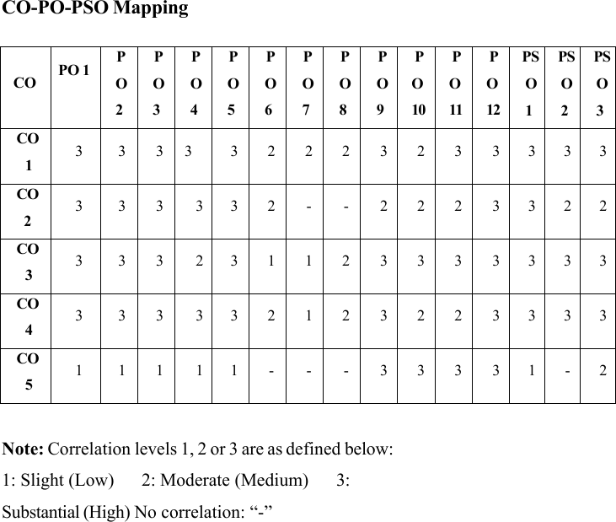
SUSTAINABLE DEVELOPMENT GOALS

SDG | GOAL | JUSTIFICATION
  SDG-4 | Quality Education | Education drives progress on other SDGs, breaks poverty cycles, and promotes peace and inequality reduction.
  SDG-8 | Decent Work and Economic Growth | Necessary for social stability, shared prosperity, and combating poverty.
  SDG-9 | Industry, Innovation, and Infrastructure | Infrastructure is vital for  economic growth and stability. It acts as a poverty reduction tool through job creation and provides technological solutions to environmental challenges.
  SDG-17 | Partnerships for the Goals | Given the interconnected nature of the SDGs, success requires collaborative action, global resource sharing, and bridging the immense financing gap faced by developing nations.

ABSTRACT

This project is a Social Media Analytics Dashboard designed to monitor and analyze multiple user profiles across different social media platforms. The system provides a centralized interface where users can view performance metrics such as followers, engagement rate, reach, and growth trends.

The dashboard allows multiple profiles (influencers or users) to be displayed in a structured format using cards, tables, and graphical representations. Users can analyze engagement data visually through charts and metric indicators, making it easier to interpret performance.

The system is developed using HTML, CSS, and JavaScript, focusing on responsive design and modern UI techniques such as glassmorphism and dynamic animations. It includes features like login interface, profile listing, analytics visualization, and user input forms.

Overall, the project demonstrates how web technologies can be used to build an interactive and user-friendly dashboard for analyzing social media reach and engagement effectively.

SI NO | TITLE | PAGE NO
 | ACKNOWLEDGEMENT | 3
 | ABSTRACT | 11
 | LIST OF ABBREVIATIONS | 14
1 | INTRODUCTION | 15
1.1 | General | 15
1.2 | Need for Online Property Listing System | 15
1.3 | Scope of the System | 16
1.4 | Organization of the Report | 16
1.5 | System architecture diagram | 17
2 | LITERATURE SURVEY | 18
2.1 | Introduction | 18
2.2 | Existing Real Estate Platforms | 18
2.3 | Related Work | 18
2.4 | Summary | 19
3 | PROBLEM FORMULATION AND OBJECTIVES | 20
3.1 | Problem Statement | 20
3.2 | Objectives of the System | 20
4 | SYSTEM DESIGN | 21
4.1 | Introduction | 21
4.2 | System Architecture | 22
4.3 | Database Design | 23
4.4 | System Requirements | 23

SI NO | TITLE | PAGE NO
4.4.2 | Software Requirements | 23
5 | SYSTEM IMPLEMENTATION | 24
5.1 | System Methodology | 24
5.2 | Module Descriptions | 24
5.2.1 | User Module | 24
5.2.2 | Property Management Module | 25
5.2.2.1 | Search Module | 25
5.2.3 | Property Details Module | 25
5.2.4 | Inquiry Module | 25
5.2.5 | Login and Authentication Module | 26
5.2.6 | Delete Property Module | 26
6 | RESULTS AND DISCUSSION | 27
6.1 | System Output Screens | 27
6.2 | Performance Evaluation | 31
6.3 | System Testing | 31
7 | CONCLUSION AND FUTURE WORK | 32
7.1 | Conclusion | 32
7.2 | Future Enhancements | 33
 | REFERENCES | 34
 | COURSE CERTIFICATES | 35
 | APPENDICES | 36
 | PSEUDOCODE | 39

LIST OF ABBREVIATIONS

Abbreviation | Full Form
HTML | HyperText Markup Language
CSS | Cascading Style Sheets
JSP | Java Server Pages
JDBC | Java Database Connectivity
SQL | Structured Query Language
DBMS | Database Management System
UI | User Interface
UX | User Experience
HTTP | HyperText Transfer Protocol

CHAPTER 1

INTRODUCTION

1.1 General

In today’s digital world, social media platforms play a significant role in communication, marketing, and branding. Individuals, influencers, and businesses rely heavily on platforms such as Instagram, YouTube, and Twitter to reach their audience. However, analyzing social media performance manually is difficult due to the large amount of data generated, making it hard for users to track their growth effectively.
This project introduces a Social Media Analytics Dashboard that provides a centralized system to track and analyze multiple profiles in a single interface. Developed using HTML, CSS, and JavaScript, the system focuses on responsive design and modern UI techniques such as glassmorphism. The dashboard displays key performance metrics such as followers, engagement rate, and reach, helping users understand their performance trends efficiently through cards, tables, and graphical representations.

1.2 Need for System

Managing multiple social media profiles individually is a time-consuming and inefficient process. Users often face significant challenges because there is no centralized data view, making it difficult to track consistent growth or compare performance across different platforms like Instagram, YouTube, and Twitter. Without a consolidated tool, it is hard to interpret the large amount of data generated, leading to a lack of clear insight into overall reach and engagement.
The Social Media Analytics Dashboard addresses these problems by providing a single platform where all profiles can be viewed in one place. The system allows users to see critical performance metrics and analyze their digital footprint through a structured interface. By utilizing this dashboard, users can save time and gain a better understanding of their audience interaction and performance trends without having to manually compile data from separate sources.

1.3 Scope of the System

The system is designed to provide a comprehensive and interactive platform for monitoring social media performance. It features a profile listing for various influencers and users, displaying essential performance metrics such as followers, reach, and engagement. To enhance user experience, the dashboard utilizes data visualization through charts and graphs, organized within a responsive interface that incorporates modern UI components like cards and tables. Additionally, the system includes user input forms to demonstrate form handling and user interaction.
While the current implementation focuses on a robust frontend experience, it establishes a foundation for significant future growth. The intended future scope includes the integration of real-time APIs to fetch live data directly from social media platforms. Furthermore, there are plans to implement real-time analytics and AI-based predictions to provide users with deeper insights and automated performance forecasting.

1.4 Organization of the Report
This report is organized into several chapters that describe the development and implementation of the Social Media Analytics Dashboard.
Chapter 1 provides an introduction to the project, including the general overview, need for the system, and scope.
Chapter 2 presents the literature survey and discusses existing systems and related work.
Chapter 3 explains the problem formulation and objectives of the proposed system.
Chapter 4 describes the system design, including architecture and requirements.
Chapter 5 discusses the implementation and the system's modules.
Chapter 6 presents the results and system performance.
Chapter 7 concludes the project and suggests future enhancements.

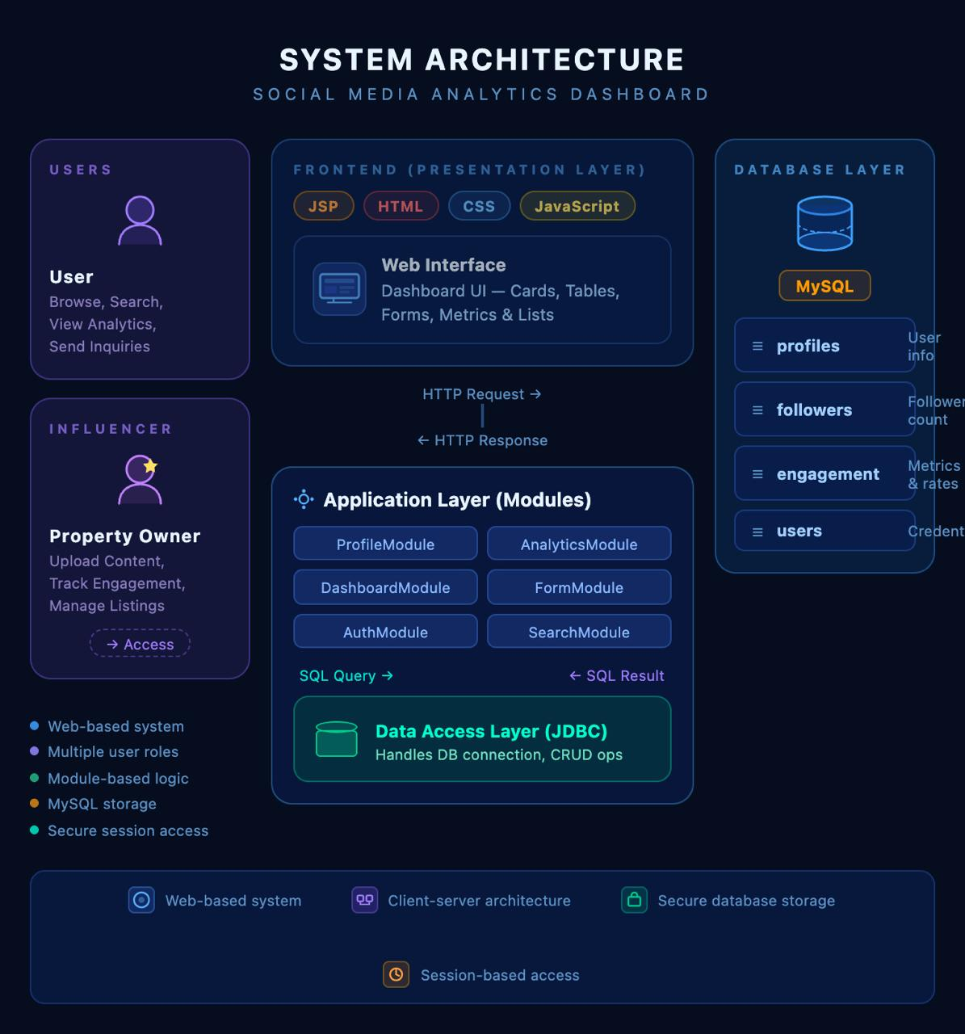
System architecture diagram

CHAPTER 2
LITERATURE SURVEY

2.1 Introduction
The literature survey explores existing systems and approaches used in social media analytics and dashboard applications. With the rapid growth of social media platforms, analyzing user engagement and performance has become essential for individuals and organizations. This section examines how current systems function, the technologies they use, and the challenges they face. Understanding these aspects helps in designing a system that is efficient, simple, and user-friendly.

2.2 Existing Social Media Analytics Systems
Modern social media platforms provide built-in analytics tools that allow users to monitor performance metrics such as followers, likes, shares, and engagement rates. These systems are widely used by influencers and businesses to track audience interaction and growth.
Most existing systems offer features such as performance tracking, graphical representation of data, and user engagement analysis. However, these tools are usually platform-specific, meaning users must access separate dashboards for each platform.
Some limitations of existing systems include complexity in user interface, lack of integration across platforms, and difficulty in comparing multiple profiles. In addition, advanced tools often require subscriptions or technical knowledge, making them less accessible to beginners.

2.3 Related Work
Previous studies and projects in the field of web-based dashboards have focused on improving data visualization and user experience. Researchers have explored techniques such as interactive charts, responsive design, and real-time data updates to enhance usability.
Many systems use modern frontend technologies to create dynamic and visually appealing interfaces. Data visualization techniques such as graphs, charts, and tables are commonly used to represent information clearly.
Security and data management are also important aspects in related work. Some systems include authentication mechanisms and database integration to ensure secure access and efficient data handling. However, these features can increase system complexity.

2.4 Summary
The study of existing systems highlights the importance of creating a balance between functionality and simplicity. While advanced analytics platforms provide powerful features, there is a need for a system that is easy to use and focuses on essential functionalities.
The proposed Social Media Analytics Dashboard aims to provide a centralized platform where users can view and analyze multiple profiles in a simple and structured manner. The focus is on delivering a clean user interface, effective data visualization, and ease of use without unnecessary complexity.

CHAPTER 3
PROBLEM FORMULATION AND OBJECTIVES

3.1 Problem Statement
In the current digital environment, social media platforms generate a large amount of data related to user engagement, followers, and content performance. However, this data is often scattered across different platforms, making it difficult for users to analyze and compare performance effectively.
Users typically rely on individual platform analytics, which limits their ability to view consolidated information. This leads to inefficient tracking, lack of proper comparison, and difficulty in understanding overall performance trends. Existing systems are often complex and include advanced features that may not be necessary for all users. They may also require technical knowledge or subscriptions, making them less accessible.
Therefore, there is a need for a simple, centralized, and user-friendly system that allows users to monitor and analyze multiple social media profiles in one place.

3.2 Objectives of the System
The main objective of the system is to develop a web-based Social Media Analytics Dashboard that simplifies the process of tracking and analyzing user profiles.
The specific objectives are as follows:
- To design and develop a user-friendly dashboard interface
- To display multiple social media profiles in a structured format
- To show key performance metrics such as followers, engagement, and reach
- To provide visual representation of data using charts and UI components
- To enable easy comparison of different profiles
- To create a responsive and interactive system using modern web technologies
- To organize data efficiently using tables, lists, and card

CHAPTER 4
SYSTEM DESIGN

4.1 Introduction
System design is an important phase in software development where the overall structure and components of the system are planned. It defines how different modules interact and how data flows within the system. A well-designed system improves efficiency, usability, and maintainability.
The Social Media Analytics Dashboard is designed as a web-based application that focuses on presenting data in a clear and organized manner. The design emphasizes simplicity, responsiveness, and visual clarity to enhance user experience.

4.2 System Architecture
The system follows a simple frontend-based architecture. It consists of a presentation layer that handles user interaction and displays data through a structured interface.
Presentation Layer
The system follows a modular three-layer architecture to ensure a clear separation between the user interface, business logic, and data management. The Presentation Layer serves as the front-end interface, utilizing HTML, CSS, and JavaScript to display the social media dashboard, analytics charts, and profile metrics in a responsive and interactive format. This layer is responsible for collecting user inputs and rendering visual data through modern UI components such as cards and tables.
Application Layer
The Application Layer acts as the core processing hub, implemented using Java Servlets to handle the system's business logic. These servlets manage user authentication, session state, and the coordination of data between the front-end and back-end storage. By delegating specific tasks such as profile management, search functions, and analytics processing to dedicated servlets, the system maintains a structured and maintainable framework.
The backend logic of the dashboard is implemented using Java Servlets, where each servlet is responsible for a specific functionality within the system:
- DashboardServlet → Displays the main overview and high-level performance metrics.
- AnalyticsServlet → Processes data for graphical representation and trend analysis.
- ProfileServlet → Manages the listing and display of multiple social media user profiles.
- TableServlet → Organizes and renders profile data in a structured tabular format.
- FormServlet → Handles user interactions and data submission through input forms.
- LoginServlet & RegisterServlet → Manage user authentication and secure session access.
- ProfileDetailServlet → Shows comprehensive metrics and detailed information for a selected profile.
These layer ensures proper execution of all operations and maintains system functionality

Data Layer

This layer is responsible for the persistent storage and management of all application data, ensuring that social media profile metrics and user information are accurately maintained. The system utilizes a MySQL database connected through JDBC (Java Database Connectivity) to handle essential data operations such as retrieval and storage.
The database is structured into three main tables to organize information effectively:
- Users → Stores authorized user credentials, including names, email addresses, and passwords for secure access.
- Profiles → Stores social media profile details such as the platform name, handle, and specific metrics like followers, reach, and engagement rates.
- Analytics → Stores historical performance data and trends, enabling the system to generate graphical representations and comparative charts.
The relationships between these tables ensure data integrity, allowing each social media profile to be linked to a specific user and its corresponding performance metrics.

4.3 Database Design
The system uses a basic data structure to represent user profiles and their associated metrics. Although the current implementation uses static data, it can be extended to include a database for dynamic data storage.
The main entities in the system include:
- Users
Stores user information such as name and email
- Profiles
Stores social media profile details
- Metrics
Stores data such as followers, engagement, and reach
- These entities can be managed using a database management system in future enhancements to support real-time data processing.

4.4 System Requirements

4.4.1 Hardware Requirements
- Computer or Laptop
- Minimum 4 GB RAM
- Basic input and output devices

4.4.2 Software Requirements
- Web browser such as Chrome, Firefox, or Edge
- HTML, CSS, and JavaScript
- Code editor such as Visual Studio Code

CHAPTER 5
SYSTEM IMPLEMENTATION

5.1 System Methodology
The system is developed using a structured approach based on the Model-View-Controller (MVC) architecture. This methodology helps in separating the user interface, business logic, and data handling, making the system easier to develop and maintain.
- Model: Represents the data and business logic using Java classes such as Profile, User, and Analytics.
- View: Consists of JSP pages that display analytics data to users and collect input through forms.
- Controller: Implemented using Java Servlets, which handle user requests, process metric data, and control the flow between the view and model.
The development process involves designing the database, creating model classes for social media metrics, implementing servlets for different dashboard functionalities, and developing JSP pages for user interaction. JDBC is used to connect the application with the MySQL database.

5.2 Module Descriptions
The system is divided into several modules, each responsible for a specific functionality.

5.2.1 Login Module
This module ensures secure access to the analytics system.
- It validates user credentials during the login process.
- Uses session management to maintain user state and prevent unauthorized access to restricted features.
- Handles both login and logout operations to maintain security integrity.

5.2.2 Dashboard Module
The dashboard module is the main component of the system.
- It displays key metrics such as followers, engagement rate, and reach using card-based UI elements.
- The information is presented in a clear and visually structured format to enhance interpretability.
- It serves as a centralized interface for viewing performance trends across multiple profiles.

5.2.3 Analytics Module
This module provides graphical representation of data using charts and visual indicators.
- It helps users understand performance trends and compare different profiles effectively.
- Visualizations allow for the easy interpretation of engagement data through modern UI techniques.
- The module integrates dynamic animations to make the data analysis interactive.

5.2.4 Profile Module
The profile module displays multiple user profiles in a structured format.
- Each profile includes specific details such as name, platform, followers, and engagement metrics.
- This structure allows for easy comparison between different users or social media handles.
- Profiles are rendered using a combination of cards and detailed lists for better visibility.

5.2.5 Table Module
The table module organizes data in tabular form to improve readability.
- It includes details such as user name, platform, followers, and engagement rate.
- The grid view allows users to quickly analyze and scan information across all tracked profiles.
- This module ensures a structured presentation of quantitative metrics.

5.2.6 Form Module
The form module allows users to input and submit specific details to the system.
- Users can enter information such as name, email, branch, gender, and bio.
- It demonstrates form handling and interactive user communication within the dashboard.
- Data entered here is validated before being stored in the database.

5.2.7 User Module
This module handles broader user registration and session management.
- New users can register by providing details such as name, email, and password.
- Session management is implemented using HTTP Session to track authorized access.
- User data is stored securely in the MySQL database for persistence.

CHAPTER 6
RESULTS AND DISCUSSION

6.1 Results
The Social Media Dashboard was successfully implemented, featuring a modern, dark-themed user interface with glass morphism effects. The application provides dynamic real-time analytics and creator intelligence. The following sections describe the key output screens:

6.1.1 Landing Page (Social Media Dashboard Analyzer)
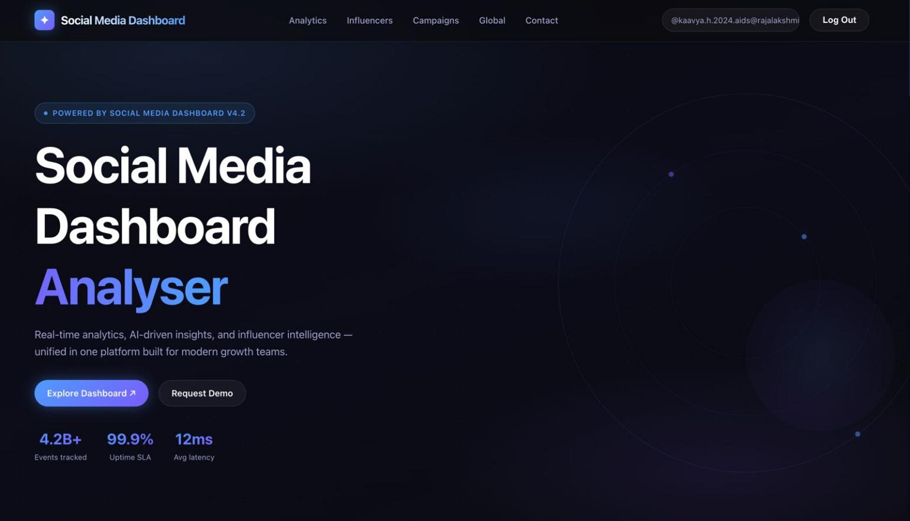
The landing page serves as the entry point for users, offering a high-level overview of the platform's capabilities, such as AI-driven insights and influencer intelligence.

- Key Metrics: Displays system-wide performance stats, including 4.2B+ events tracked, 99.9% uptime SLA, and an average latency of 12ms.
- Navigation: Provides quick access to explore the dashboard or request a demo.

6.1.2 Platform Overview (Main Dashboard)
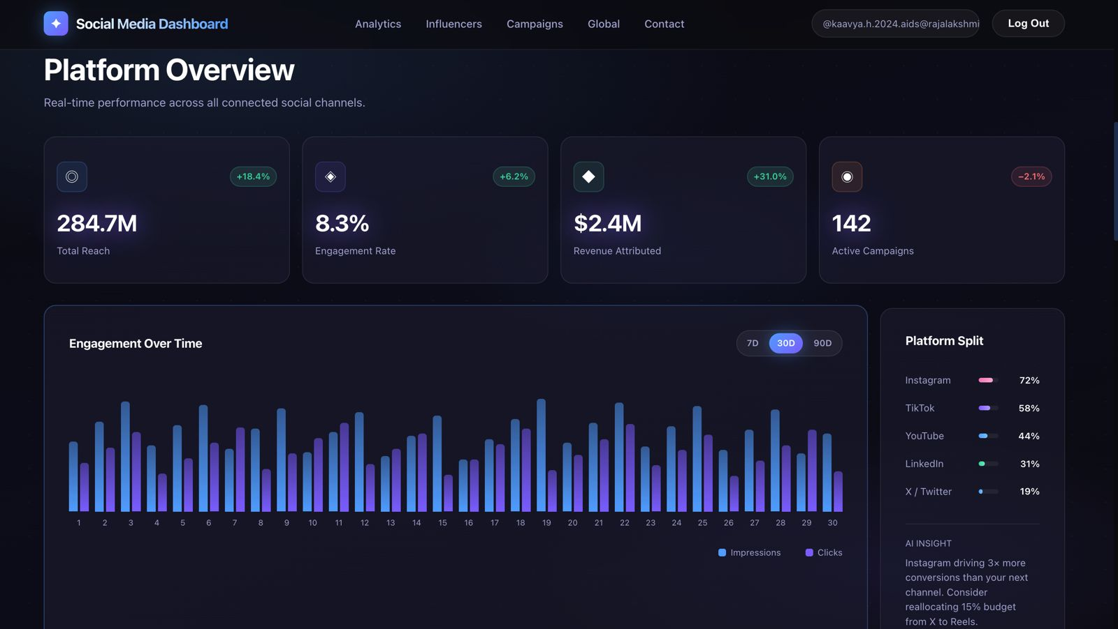This screen provides a centralized view of real-time performance across all connected social channels.

- Performance Cards: Tracks critical KPIs including Total Reach (284.7M), Engagement Rate (8.3%), Revenue Attributed ($2.4M), and Active Campaigns (142).
- Engagement Over Time: A dynamic bar chart visualizing Impressions and Clicks over a 30-day period.
- Platform Split: A breakdown of audience distribution, showing Instagram (72%), TikTok (58%), and YouTube (44%) as leading channels.
- AI Insight: A dedicated panel providing actionable advice, such as reallocating budget from X to Instagram Reels based on conversion data.

6.1.3 Creator Intelligence (Influencer Module)
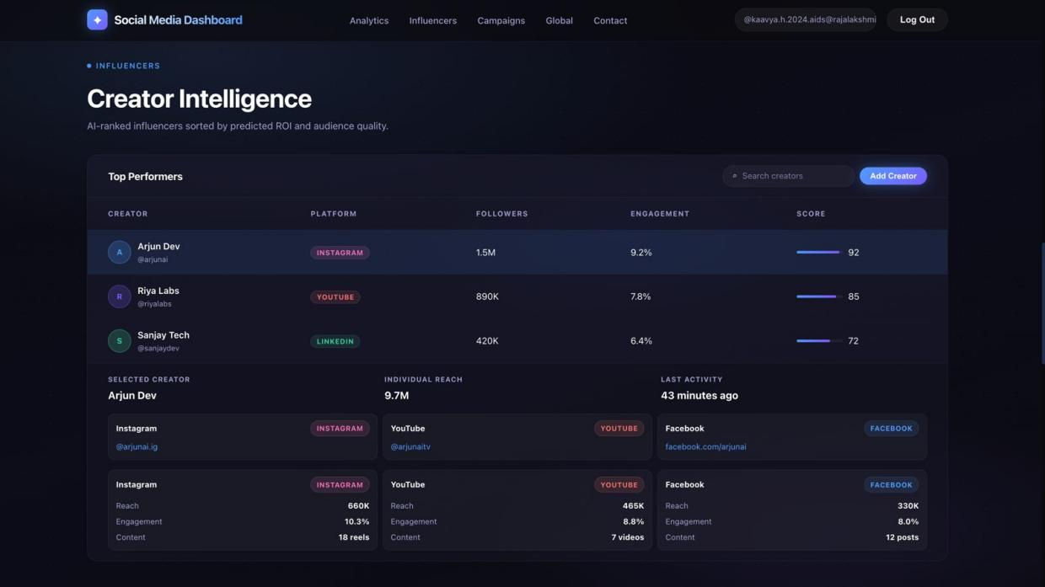
This module lists top-performing influencers and creators sorted by predicted ROI and audience quality.

- Top Performers Table: Lists creators like Arjun Dev and Riya Labs with their primary platform, follower count, and engagement score.
- Deep Dive Analytics: Selecting a creator reveals granular data across multiple platforms (Instagram, YouTube, Facebook), detailing specific reach, engagement percentages, and content volume (e.g., "18 reels").

6.1.4 Global Reach (Interactive Map)

The Global Reach screen allows users to visualize their audience distribution geographically.
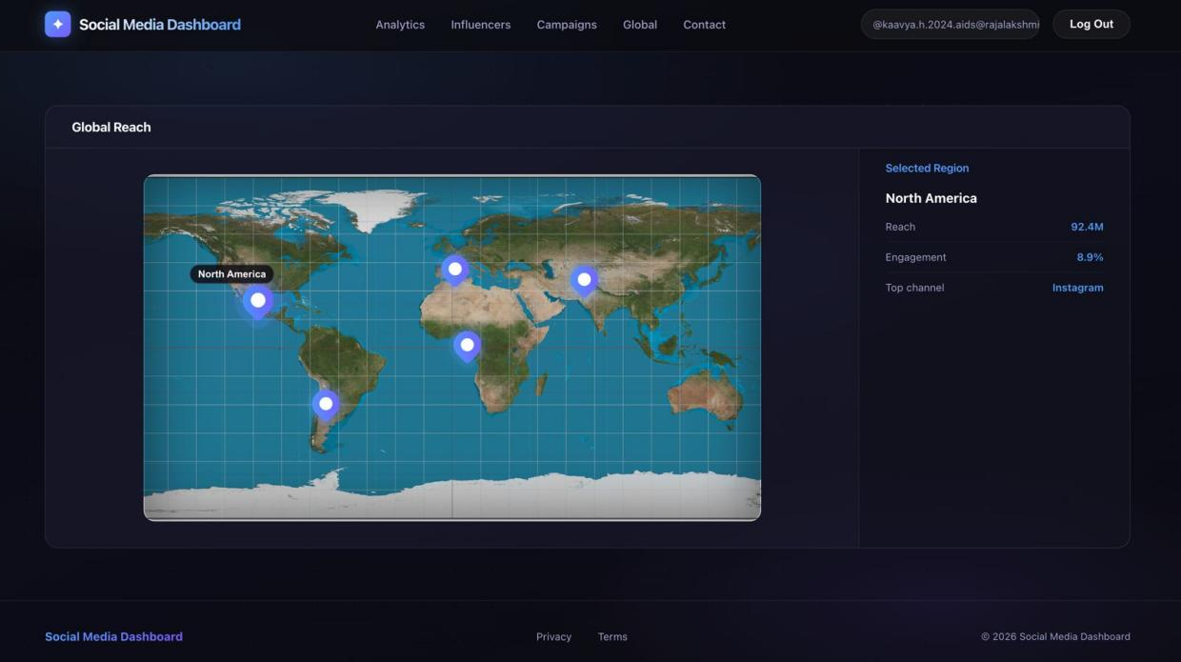
- Geospatial Visualization: An interactive world map with pins indicating major audience hubs.
- Regional Statistics: Selecting a region like "North America" displays specific data, such as a reach of 92.4M, an 8.9% engagement rate, and Instagram as the top-performing channel in that area.

6.1.5 User Interaction (Form Module)

The "Get in Touch" screen provides a functional interface for user communication and data entry.

- Input Fields: Includes fields for Name, Email, and a multi-line Bio.
- Selection Tools: Features radio buttons for gender selection (Male/Female).
- Action Button: A prominent "Submit" button to process the user data through the application layer.

6.1.6 Login and Authentication Interface

The login page provides a secure entry point for authorised users to access the analytics dashboard.
- User Credentials: The form requires several fields for authentication, including Name, Username, Gmail, and Phone Number.
- Validation: The system is designed to validate these inputs, such as checking for a valid 10-digit phone number and a properly formatted email address, before granting access.
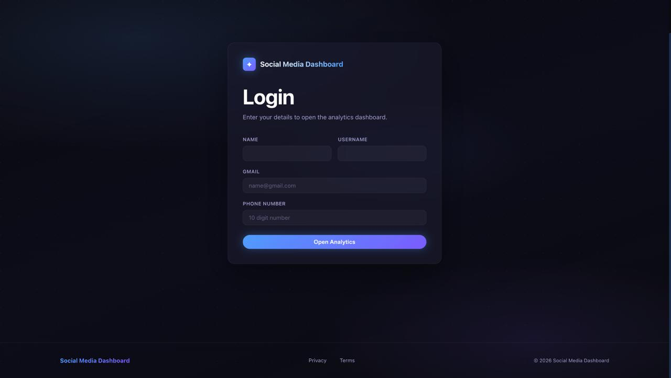
- Security: Upon entering the correct details, the "Open Analytics" button initiates the user session, redirecting the user to the central dashboard while maintaining secure state management.

6.2 Performance Evaluation
The Social Media Dashboard was evaluated based on responsiveness, accuracy, and usability to ensure a high-quality user experience.
- Response Time: The system maintains an average latency of 12ms, allowing it to respond quickly to user requests such as loading real-time analytics, filtering influencers, and rendering global maps.
- Data Accuracy: All metric data retrieved from the database—including reach, engagement rates, and revenue—is displayed correctly without inconsistencies.
- Usability: The user interface utilizes a modern dark theme and glassmorphism, making it simple and easy to navigate for growth teams and influencers.
- Efficiency: The use of JDBC and optimized SQL queries ensures efficient data handling and retrieval, even when processing large datasets like the 4.2B+ events tracked.

6.3 System Testing
The system underwent rigorous testing across different scenarios to ensure reliability and correctness.
- Functional Testing: All core features, such as the Explore Dashboard navigation, influencer search, and form submissions, were tested and found to be working as expected.
- Validation Testing: Input fields in the Get in Touch form were tested for correct validation, ensuring that invalid or empty data—such as an incorrect email format—is not accepted.
- Authentication Testing: Login and session management were tested to ensure secure access to restricted analytics and to confirm the "Log Out" functionality terminates sessions properly.
- Database Testing: Data insertion (adding creators), retrieval (fetching platform splits), and deletion operations were verified to ensure proper interaction with the MySQL database.
- Error Handling: The system handles errors gracefully, such as displaying appropriate messages when data cannot be retrieved or when unauthorised access is attempted.
The testing results confirm that the dashboard is stable, reliable, and ready for deployment.

CHAPTER 7

CONCLUSION AND FUTURE WORK

Conclusion
The Social Media Analytics Dashboard was successfully designed and developed using web technologies such as HTML, CSS, and JavaScript. The system provides a centralized platform for displaying and analyzing multiple social media profiles in a clear and structured manner.
The dashboard enables users to view important metrics such as followers, engagement rate, and reach through an interactive and user-friendly interface. The use of modern UI components like cards, tables, and forms improves readability and enhances the overall user experience.
The project demonstrates how a simple and effective dashboard can be built to analyse social media performance without the need for complex systems. It fulfils the objective of providing an easy-to-use platform for monitoring and comparing multiple profiles.
Overall, the system is efficient, responsive, and visually appealing, making it suitable for basic analytics and educational purposes.
7.2 Future Enhancements
The current system can be further improved by adding advanced features and functionalities. Some possible enhancements include:
Integration of real-time data using APIs from social media platforms
Implementation of a backend system and database for dynamic data storage
Addition of advanced analytics such as graphs, charts, and predictive insights
User authentication with secure login and session management
Development of a mobile-friendly or standalone application version
Incorporation of AI-based recommendations for improving engagement and reach
These enhancements would make the system more powerful, scalable, and suitable for real-world applications.

REFERENCES

- Oracle Corporation, Java Servlet Technology Documentation. Available: https://docs.oracle.com/javaee/
- Oracle Corporation, JSP (Java Server Pages) Documentation. Available: https://docs.oracle.com/javaee/
- Oracle Corporation, JDBC API Documentation. Available: https://docs.oracle.com/javase/
- Apache Software Foundation, Apache Tomcat Documentation. Available: https://tomcat.apache.org/
- MongoDB, Inc. “What is MongoDB?” Available at: https://www.mongodb.com/what-is-mongodb
- MDN Web Docs, HTML, CSS, and Web Development Guides. Available: https://developer.mozilla.org/
- W3Schools. “MongoDB Tutorial.” Available at: https://www.w3schools.com/mongodb/
- GeeksforGeeks. “MongoDB Tutorial.” Available at: https://www.geeksforgeeks.org/mongodb/
- K. Sierra and B. Bates, Head First Servlets and JSP, O’Reilly Media, 2nd Edition, 2008.
- E. Balagurusamy, Programming with Java, McGraw Hill Education, 6th Edition.
COURSE COMPLETION CERTIFICATES



APPENDICES

Appendix-1: Sample Database Tables

Users Table

Field Name | Data Type | Description
user_id | INT (PK) | Unique user ID
name | VARCHAR | User name
email | VARCHAR | User email
password | VARCHAR | User password

Properties Table

Field Name | Data Type | Description
property_id | INT (PK) | Unique property ID
title | VARCHAR | Property title
price | DOUBLE | Property price
location | VARCHAR | Property location
description | TEXT | Property description
image | VARCHAR | Image path
user_id | INT (FK) | Reference to user

Inquiries Table

Field Name | Data Type | Description
inquiry_id | INT (PK) | Unique inquiry ID
property_id | INT (FK) | Related property
name | VARCHAR | Sender name
message | TEXT | Inquiry message

Appendix-2: Sample SQL Queries
-- Insert User
INSERT INTO users (name, email, password) VALUES ('John Doe', 'john@example.com', '123456');
-- Insert Property
INSERT INTO properties (title, price, location, description, image, user_id) VALUES ('2BHK Apartment', 5000000, 'Chennai', 'Spacious flat', 'img1.jpg', 1);
-- Search Property
SELECT * FROM properties WHERE location LIKE '%Chennai%';
-- Delete Property DELETE FROM properties WHERE property_id = 1;

Appendix-4: Key Servlet Example
@WebServlet("/index")
public class PropertyServlet extends HttpServlet {
protected void doGet(HttpServletRequest request, HttpServletResponse response)
throws ServletException, IOException {
List<Property> list = new ArrayList<>(); Connection con = DBConnection.getConnection();
try {
Statement stmt = con.createStatement(); ResultSet rs = stmt.executeQuery(
"SELECT * FROM properties");
while (rs.next()) {
Property p = new Property(); p.setTitle(rs.getString("title")); p.setPrice(rs.getDouble("price")); list.add(p);
}
} catch (Exception e) { e.printStackTrace();
}
request.setAttribute("propertyList", list); request.getRequestDispatcher("index.jsp")
.forward(request, response);
}
}

PSEUDOCODE

The following pseudocode represents the core functionalities of the online property listing system.

User Registration
BEGIN
INPUT name, email, password CONNECT to database
CHECK if email already exists IF exists THEN
DISPLAY "Email already registered" ELSE
INSERT user details into users table DISPLAY "Registration successful"
ENDIF

CLOSE database connection END

User Login
BEGIN
INPUT email, password CONNECT to database
FETCH user where email and password match
IF user exists THEN CREATE session
STORE user details in session REDIRECT to homepage
ELSE
DISPLAY "Invalid credentials" ENDIF
CLOSE database connection END

Add Property

BEGIN
CHECK if user is logged in

INPUT title, price, location, description, image CONNECT to database
INSERT property details into properties table with user_id from session
DISPLAY "Property added successfully" CLOSE database connection
END

View Properties
BEGIN
CONNECT to database
FETCH all properties ordered by latest STORE results in list
SEND list to JSP page DISPLAY properties to user
CLOSE database connection END

Search Property
BEGIN
INPUT location keyword CONNECT to database
EXECUTE query:
SELECT * FROM properties WHERE location LIKE '%keyword%'

STORE results in list
DISPLAY search results

CLOSE database connection END

View Property Details
BEGIN
GET property_id from request CONNECT to database
FETCH property details using property_id DISPLAY complete property information
CLOSE database connection END

Send Inquiry
BEGIN
INPUT name, message, property_id CONNECT to database
INSERT inquiry into inquiries table
DISPLAY "Inquiry sent successfully" CLOSE database connection
END

Delete Property
BEGIN
GET property_id CHECK if user is owner CONNECT to database
DELETE related inquiries from inquiries table DELETE property from properties table
CLOSE database connection

