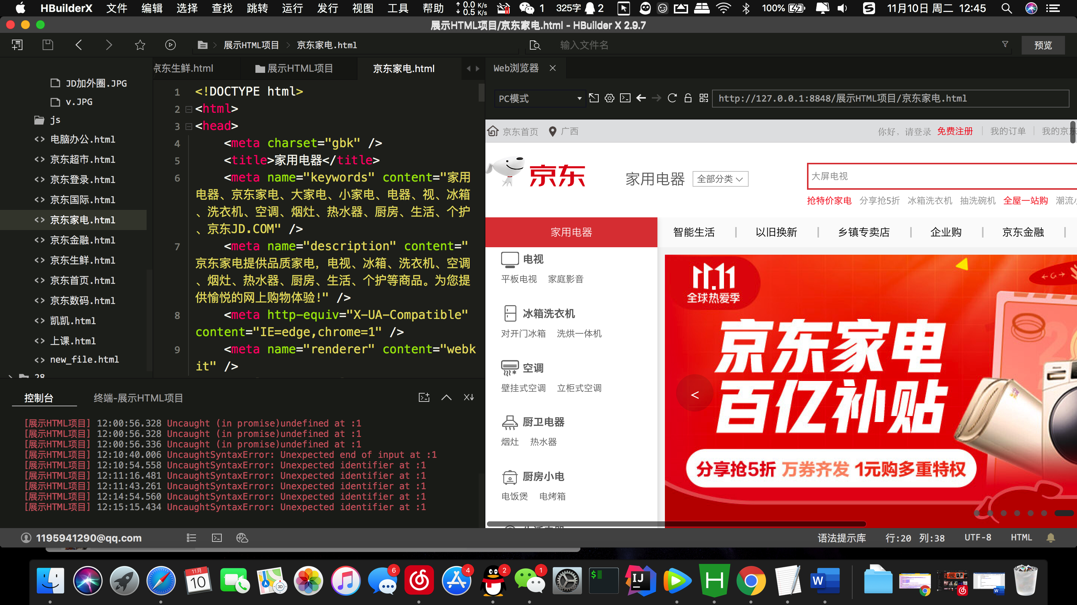

|  |  |
| --- | --- |
|  | <!DOCTYPE html> |
|  | <html> |
|  | <head> |
|  | <meta charset="gbk" /> |
|  | <title>家用电器</title> |
|  | <meta name="keywords" content="家用电器、京东家电、大家电、小家电、电器、视、冰箱、洗衣机、空调、烟灶、热水器、厨房、生活、个护、京东JD.COM" /> |
|  | <meta name="description" content="京东家电提供品质家电，电视、冰箱、洗衣机、空调、烟灶、热水器、厨房、生活、个护等商品。为您提供愉悦的网上购物体验!" /> |
|  | <meta http-equiv="X-UA-Compatible" content="IE=edge,chrome=1" /> |
|  | <meta name="renderer" content="webkit" /> |
|  | <!--[if lte IE 8]> |
|  | <script src="//misc.360buyimg.com/mtd/pc/index/home/ie6tip.min.js"></script> |
|  | <![endif]--> |
|  | <link rel="dns-prefetch" href="[//static.360buyimg.com](https://static.360buyimg.com/)"> |
|  | <link rel="dns-prefetch" href="[//misc.360buyimg.com](https://misc.360buyimg.com/)"> |
|  | <link rel="dns-prefetch" href="[//img10.360buyimg.com](https://img10.360buyimg.com/)"> |
|  | <link rel="dns-prefetch" href="[//img11.360buyimg.com](https://img11.360buyimg.com/)"> |
|  | <link rel="dns-prefetch" href="[//img12.360buyimg.com](https://img12.360buyimg.com/)"> |
|  | <link rel="dns-prefetch" href="[//img13.360buyimg.com](https://img13.360buyimg.com/)"> |
|  | <link rel="dns-prefetch" href="[//img14.360buyimg.com](https://img14.360buyimg.com/)"> |
|  | <link rel="dns-prefetch" href="[//img20.360buyimg.com](https://img20.360buyimg.com/)"> |
|  | <link rel="dns-prefetch" href="[//img30.360buyimg.com](https://img30.360buyimg.com/)"> |
|  | <link rel="dns-prefetch" href="[//ai.jd.com](https://ai.jd.com/)"> |
|  | <link rel="icon" href="[//www.jd.com/favicon.ico](https://www.jd.com/favicon.ico)" mce\_href="//www.jd.com/favicon.ico" type="image/x-icon"> |
|  | <script> |
|  | !function (n) { |
|  | function o(n) { |
|  | for (var o = n + "=", t = document.cookie.split(";"), e = 0; e < t.length; e++) { for (var i = t[e]; " " == i.charAt(0);)i = i.substring(1, i.length); if (0 == i.indexOf(o)) return i.substring(o.length, i.length) } return null |
|  | } |
|  | var t = o("pcm"),e = n.navigator.userAgent.toLocaleLowerCase(), i = "https://pro.m.jd.com/mall/active/48v7Xzb3FfKt6mKgMaS9EoHrvieE/index.html", r = /iphone|iPod|android|symbianos|windows\sphone/g; return i && r.test(e) && "1" != t ? (n.location.href = i, !1) : void 0 |
|  | }(window); |
|  | </script> |
|  | <link type="text/css" rel="stylesheet" href="[//misc.360buyimg.com/??jdf/1.0.0/unit/ui-base/5.0.0/ui-base.css,jdf/1.0.0/unit/shortcut/5.0.0/shortcut.css,jdf/1.0.0/unit/global-header/5.0.0/global-header.css,jdf/1.0.0/unit/myjd/5.0.0/myjd.css,jdf/1.0.0/unit/nav/5.0.0/nav.css,jdf/1.0.0/unit/shoppingcart/5.0.0/shoppingcart.css](https://misc.360buyimg.com/??jdf/1.0.0/unit/ui-base/5.0.0/ui-base.css,jdf/1.0.0/unit/shortcut/5.0.0/shortcut.css,jdf/1.0.0/unit/global-header/5.0.0/global-header.css,jdf/1.0.0/unit/myjd/5.0.0/myjd.css,jdf/1.0.0/unit/nav/5.0.0/nav.css,jdf/1.0.0/unit/shoppingcart/5.0.0/shoppingcart.css)"> |
|  | <link type="text/css" rel="stylesheet" href="[//storage.360buyimg.com/portalstatic/common.min.css](https://storage.360buyimg.com/portalstatic/common.min.css)"> |
|  | <script type="text/javascript">window.pageConfig = {compatible: true}</script> |
|  | <script type="text/javascript" src="[//misc.360buyimg.com/jdf/??/1.0.0/unit/base/5.0.0/base.js,/lib/jquery-1.6.4.js](https://misc.360buyimg.com/jdf/??/1.0.0/unit/base/5.0.0/base.js,/lib/jquery-1.6.4.js)"></script> |
|  | <script type="text/javascript">pageConfig.wideVersion = true; </script> |
|  | <script type="text/javascript" src="[//static.360buyimg.com/mtd/pc/cms/js/o2\_ua.min.js](https://static.360buyimg.com/mtd/pc/cms/js/o2_ua.min.js)"></script> |
|  | <link href="[//storage.360buyimg.com/portalstatic/static/pc.styles.a21b180b7858e52fc5fb.css](https://storage.360buyimg.com/portalstatic/static/pc.styles.a21b180b7858e52fc5fb.css)" rel="stylesheet"></head> |
|  | <body> |
|  | <!--shortcut start--> |
|  | <div id="shortcut-2014"> |
|  | <div class="w"> |
|  | <ul class="fl"> |
|  | <li id="ttbar-home"><i class="iconfont">&#xe608;</i><a href="[//www.jd.com/](https://www.jd.com/)" target="\_blank">京东首页</a></li> |
|  | <li class="dorpdown" id="ttbar-mycity"></li> |
|  | </ul> |
|  | <ul class="fr"> |
|  | <li class="fore1" id="ttbar-login"> |
|  | <a href="[javascript:login();](about:blank" \t "_blank)" class="link-login">你好，请登录</a>&nbsp;&nbsp;<a href="[javascript:regist();](about:blank" \t "_blank)" class="link-regist style-red">免费注册</a> |
|  | </li> |
|  | <li class="spacer"></li> |
|  | <li class="fore2"> |
|  | <div class="dt"> |
|  | <a target="\_blank" href="[//order.jd.com/center/list.action](https://order.jd.com/center/list.action)">我的订单</a> |
|  | </div> |
|  | </li> |
|  | <li class="spacer"></li> |
|  | <li class="fore3 dorpdown" id="ttbar-myjd"> |
|  | <div class="dt cw-icon"> |
|  | <a target="\_blank" href="[//home.jd.com/](https://home.jd.com/)">我的京东</a><i class="iconfont">&#xe605;</i> |
|  | </div> |
|  | <div class="dd dorpdown-layer"></div> |
|  | </li> |
|  | <li class="spacer"></li> |
|  | <li class="fore4"> |
|  | <div class="dt"> |
|  | <a target="\_blank" href="[//vip.jd.com/](https://vip.jd.com/)">京东会员</a> |
|  | </div> |
|  | </li> |
|  | <li class="spacer"></li> |
|  | <li class="fore5"> |
|  | <div class="dt"> |
|  | <a target="\_blank" href="[//b.jd.com/](https://b.jd.com/)">企业采购</a> |
|  | </div> |
|  | </li> |
|  | <li class="spacer"></li> |
|  | <li class="fore6 dorpdown" id="ttbar-serv"> |
|  | <div class="dt cw-icon"> |
|  | 客户服务<i class="iconfont">&#xe605;</i> |
|  | </div> |
|  | <div class="dd dorpdown-layer"></div> |
|  | </li> |
|  | <li class="spacer"></li> |
|  | <li class="fore7 dorpdown" id="ttbar-navs"> |
|  | <div class="dt cw-icon"> |
|  | 网站导航<i class="iconfont">&#xe605;</i> |
|  | </div> |
|  | <div class="dd dorpdown-layer"></div> |
|  | </li> |
|  | <li class="spacer"></li> |
|  | <li class="fore8 dorpdown" id="ttbar-apps"> |
|  | <div class="dt cw-icon"> |
|  | <a target="\_blank" href="[//app.jd.com/](https://app.jd.com/)">手机京东</a> |
|  | </div> |
|  | </li> |
|  | </ul> |
|  | <span class="clr"></span> |
|  | </div> |
|  | </div> |
|  | <div id="o-header-2013"><div id="header-2013" style="display:none;"></div></div> |
|  | <!--shortcut end--> |
|  | <!-- S 主体内容 --> |
|  | <div class="mod\_conatiner"> |
|  | <script> |
|  | (function(window){ |
|  | window.data = window.data || {}; |
|  | window.data['cms\_header'] = { |
|  | setting: [{"NAME":"家用电器","URL":"//","ANCHOR":"","property":"1662","CUSTOM1":"#dd4545","CUSTOM2":"","CUSTOM3":""}] |
|  | }; |
|  | })(window); |
|  | </script> |
|  | <div class="o2data-lazyload cms\_header" style="min-height:100px" id="cms\_header" data-id="cms\_header" data-tpl="//static.360buyimg.com/mtd/pc/cms/floors/cms\_header\_tpl.min.js"></div> |
|  | <div id="app" data-type="atom" class="o2cms"></div> |
|  | </div> |
|  | <!-- E 主体内容 --> |
|  | <div class="o2data-lazyload" id="cmsfooter" data-tpl="//static.360buyimg.com/mtd/pc/cms/js/cmsfooter\_tpl.min.js" data-script="seajs.use('//misc.360buyimg.com/??jdf/1.0.0/unit/global-footer/1.0.0/global-footer.css,jdf/1.0.0/unit/service/1.0.0/service.css')"></div> |
|  | <script type="text/javascript"> |
|  | if (!!window.ActiveXObject || "ActiveXObject" in window) { |
|  | document.write('<script src="//storage.360buyimg.com/o2cms/lib/polyfill.1.0.0.js"><\/script>') |
|  | } |
|  | </script> |
|  | <script type="text/javascript" src="[//static.360buyimg.com/mtd/pc/base/1.0.0/base.js](https://static.360buyimg.com/mtd/pc/base/1.0.0/base.js)" charset="UTF-8"></script> |
|  | <script type="text/javascript"> |
|  | window.pageConfig = window.pageConfig || {}; |
|  | window.pageConfig.o2JSConfig = { |
|  | useTplInJs: true, |
|  | pathRule: function (path) { |
|  | return '//static.360buyimg.com/mtd/pc/cms' + '/floors/' + path + '.min.js'; |
|  | } |
|  | }; |
|  | seajs.use(['//static.360buyimg.com/mtd/pc/base/1.0.1/channel.js']); |
|  | seajs.use(['//wl.jd.com/wl.js']); |
|  | </script> |
|  | <script> |
|  | /\* window.o2PageConfig = { |
|  | pageid: '42114', |
|  | data: |
|  | } \*/ |
|  | </script> |
|  | <script type="text/javascript" src="[//storage.360buyimg.com/portalstatic/static/pc.config.ea85c019.js](https://storage.360buyimg.com/portalstatic/static/pc.config.ea85c019.js)" charset="UTF-8"></script> |
|  | <script type="text/javascript" src="[//storage.360buyimg.com/portalstatic/static/vendor.dll.04633498.js](https://storage.360buyimg.com/portalstatic/static/vendor.dll.04633498.js)" charset="UTF-8"></script> |
|  | <script type="text/javascript" src="[//static.360buyimg.com/webstatic/getprice/1.0.0/js/price.min.js](https://static.360buyimg.com/webstatic/getprice/1.0.0/js/price.min.js)"></script> |
|  | <script type="text/javascript" src="[//storage.360buyimg.com/portalstatic/static/pc.main.30f6c863.js](https://storage.360buyimg.com/portalstatic/static/pc.main.30f6c863.js)" charset="UTF-8"></script></body> |
|  | </html> |
|  |  |