About the document
This documentation is intended to explain a developer how to add a device to the pushdemo sdk.

Prerequisites
Before proceeding with this installer build up procedure, you should have below mentioned files and steps covered.
- Install the pushdemoAtt installer.
- An att Device.
- Device Setting Tool

3. The first request from device to server

- After the software is installed open the url http://localhost:6060/ . This will open a page like below.
- If there is no device the list will be blank.

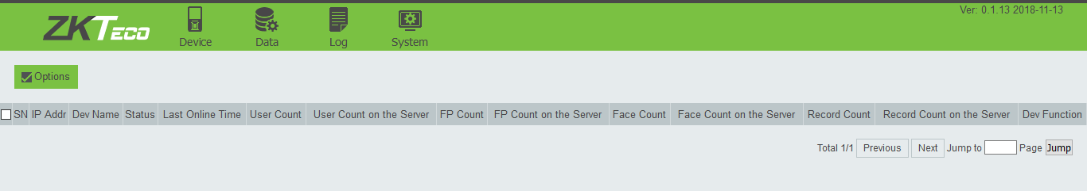

- Now run the deviceSettingTool given with installer.
- Once its open click on search, it will list all the device connected to the network.
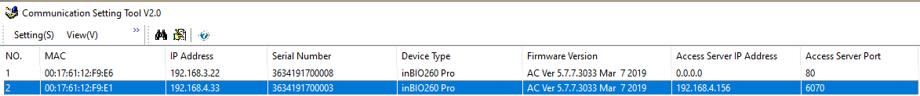

- Next choose the device and click on the modify option to edit the device details.

- This will open another window to modify the details and click ok. The device will reboot automatically.

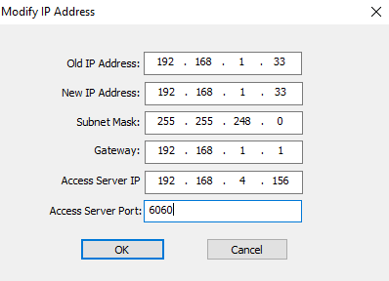
The ip on which push sdk is running.
If new ip is needed enter desired ip or enter the same as old one
The port on which push sdk is running.

- The device will be listed, and it can be controlled manually from the browser.
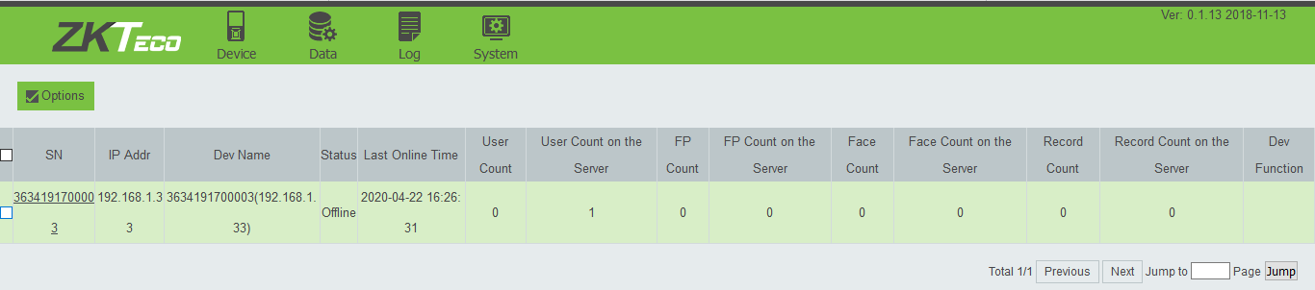

- Now the commands for the device can be send from the web page.
The example for some commands and the results are given below.

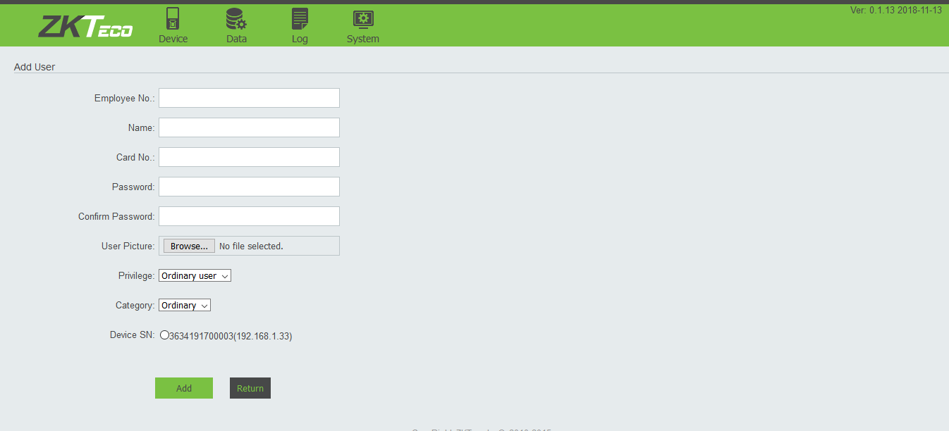
To add a person

