Data Distributions and Visualization

Student’s Name

Course Number- Name of Course

Instructor’s Name

Date

**PART I:**

**Distribution table:**

|  |  |  |  |  |
| --- | --- | --- | --- | --- |
| Interval | Frequency | Cumulative Frequency | Percentage distribution | Cumulative percentage distribution |
| 10-12 | 2 | 2 | 13.33 | 13.33 |
| 12.1-14 | 5 | 7 | 33.33 | 46.66 |
| 14.1-16 | 8 | 15 | 53.33 | 99.99 |
| 16.1-18 | 0 | 15 | 0 | 99.99 |
| >18.1 | 0 | 15 | 0 | 99.99 |

Majority of the countries, eight, fall in the 14.1-16 category. Five countries fall in the 12.1-14 category and two countries in the 10-12 bin. The remaining categories have zero entries. This means the data does not follow a normal distribution since most of the countries are concentrated at the highest peak.

This data could be better visualized in a histogram.

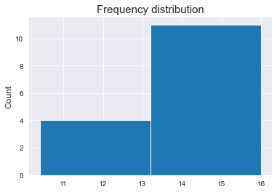

**Frequency distribution with revised interval:**

|  |  |  |  |  |
| --- | --- | --- | --- | --- |
| Interval | Frequency | Cumulative Frequency | Percentage Frequency | Cumulative percentage |
| <12 | 2 | 2 | 13.33 | 13.33 |
| 12-12.9 | 1 | 3 | 6.67 | 20 |
| 13-13.9 | 4 | 7 | 26.67 | 46.67 |
| 14-14.9 | 4 | 11 | 26.67 | 73.34 |
| 15-15.9 | 3 | 14 | 20 | 93.34 |
| 16-16.9 | 1 | 15 | 6.67 | 100.01 |
| 17-17.9 | 0 | 15 | 0 | 100.01 |
| >18 | 0 | 15 | 0 | 100.01 |

Eight countries have between 14% and 18% of their population above age 65. The number of countries with 14% - 18% of their population above 65 years remain the same even after revising the interval.

The percentage of countries that have between 14-18 percent of their population above age 65 is 53.33%.

**PART II**

Q1. Time series chart for divorce rate in Netherlands

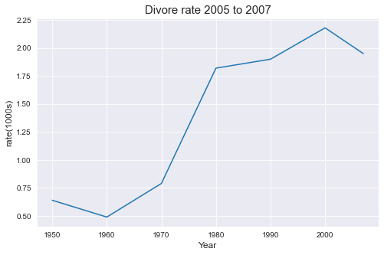

Q2. Describe divorce rate in Netherlands before and after 1970.

There is a decline in divorce rate between 1950 and 1960. There is a moderate rise in divorce rate between 1960 and 1970, the rate steadily rises between 1970 and 1980 and thereafter exhibits a slight decline between 1980 and 1990. The rate shifts to a declining trend after the year 2000. The decline does not indicate negative number of divorces, this could be attributed to increased population size and fewer number of divorce cases filed.

Q3. A bar graph would best display the divorce rate for each year, hence easy comparison.

Q4. Bar graph

The highest number of divorce cases were recorded in the year 2000, while the least number was observed in 1960.

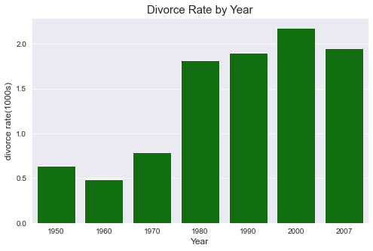

Set 2: Show how different elements contributed to population change in 2018

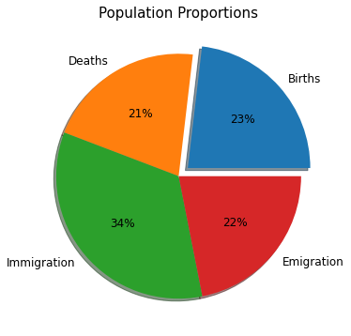

Immigration contributed 34 percent of the change in population; births, Emigration, and deaths contributed almost equal change in population.

Q2. Elements of population growth

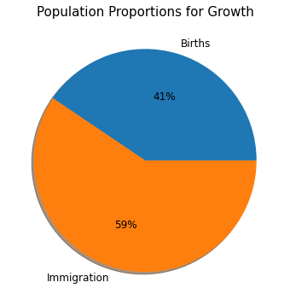

Immigration contributed the largest change in population growth compared to birth.

Q3. A time series to show changes in male and female population

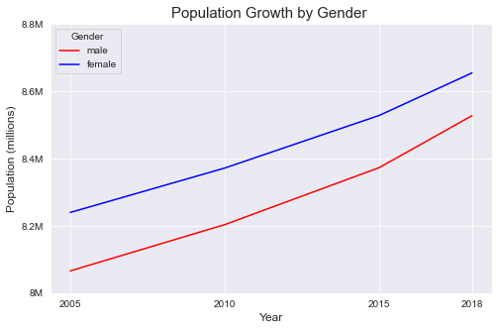

Both populations show an increasing trend over the 4 years. We could also conclude there are more females than males in the country’s population.