**Background**

Eliza, the first Chabot was introduced into the technology world in the 1960 by Professor Joseph Weizenbaun. The bot was designed to mimic human conversation. In the second half of the 20th century many other bots were developed. In 2009, China developed a more advanced Chabot called Wechat which is a highly favored platform by businesses and individual users. Wechat has made it easy for developers who want to create simple bots. Additionally, Wechat has grown to become one of the most effective ways for marketing experts to interact with online clients (Sumit, 2018).

Currently, Alexa, a personal assistant Chabot built by Amazon, is the leading in the industry. Developers can implement conversational agents by leveraging the Natural Language Understanding (NLU) and Speech Recognition features of Alexa.

**Objective**

The main goal of my project to provide smooth interconnection between users and Alexa system by leveraging natural language understanding and speech recognition features on Alexa. Besides, I will add an option to choose different languages for example German, French, Spanish etc. This will ensure a great user experience for clients who are not familiar with English. Also, my project adopts an easy and simple design of the Chabot as this approach will improve the conversation between customers and the bot’s customer support. This approach could increase the number of customers using the conversational agents built on Alexa.

Data security and integrity is a primary focus of this project. This will ensure sensitive customer information is safe.

**Methodology**

The project adopts machine learning and artificial intelligence to build contextual chatbot. Unlike Keyword recognition chatbots, contextual bot tracks progress of conversation, improve domain and customer knowledge over time. In this project I will use neural networks and graphs to improve the bot’s performance. In the beginning of the program we introduce a self-learning feature of the natural language toolkit (NLTK). The bot is supplied with intents and patterns. The patterns supplied in a json file are mapped to one of the intents (query category). The patterns supplied undergo through a preprocessing stage where each pattern is tokenized by the NLTK engine before matching it to a specific tag in the intents list.

**Conversation Flow**

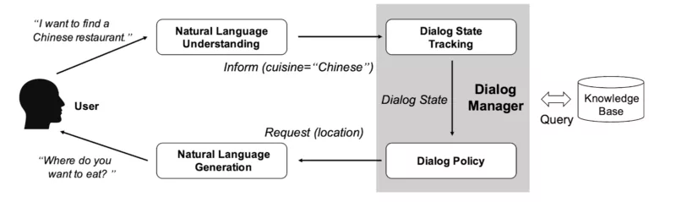

**Track Performance**

The project observes all aspects of system development by ensuring the chatbots performance is tracked and measured over time. This includes three key steps to ensure the predicted performance is accurate. The data is assessed in the Alexa system to ensure there are no quality or tidiness issues in it. Once the data is assessed, it is cleaned and stored in the Alexa engine. This approach come in handy in organizing the data in one place to ensure quick retrieval of accurate response. Besides, data cleaning ensures effective measures to prevent data trafficking, data duplication, and save space to accommodate more details on the client’s situation.

**Conclusion**

Adopting the inbuilt neural network in the NLTK and NLU tool help in accurately mapping clients’ query or statement with the appropriate context. This therefore ensure accurate response is generated from the learned patterns. Unlike retrieval based chatbots which are more of hard-coded, the contextual bot implemented in this project ensures the bot can handle more diverse conversation without breaking since it keeps generating responses from the learned patterns. The implemented chatbot will ensure quality conversation between humans and digital conversation agent.

References

Sumit Raj (2018). Building Chatbots with Python: Using Natural Language Processing and Machine Learning