**MRK455 – Applied Marketing Research**

**Question 1:**

*Solution*

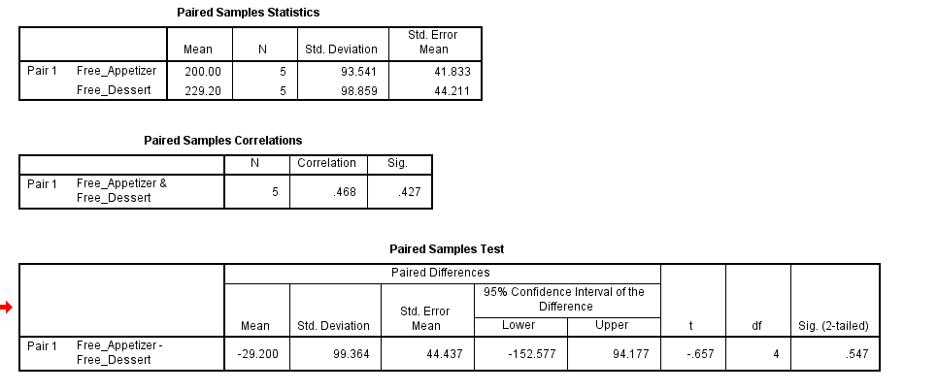

The mean of the free appetizer is 200, and the mean of the free dessert is 229.20, which means the free dessert promotion attracted more customers than the free appetizer promotion. The correlation between the number of customers advertising the two promotions is weak and positive (r = 0.468) and is not statistically significant (p > 0.05). The mean difference between pairs: -29.20 t-test of equal means with the independent random sample: $t = -0.657, df = 4, p-value = 0.547$. Hence, *Isabelle’s Diner should adopt strategy (iii) flexibility to offer either promotion*.

**Question 2**

*Solution*

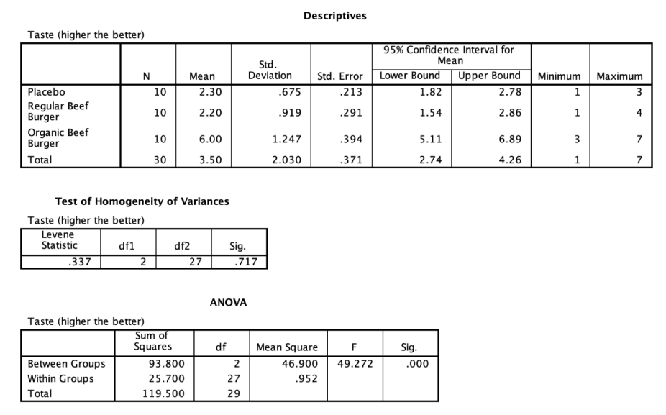

1. Do the customers believe that the organic beef burger tastes significantly better than others, at a 95% confidence interval?

***Solution***

The assumption of equal variances is not violated since p = 0.717, more significant than 0.05. The ANOVA results have an F-value = 49.272 and p = 0.000, which is less than 0.05, demonstrating significant differences in customer taste ratings. To determine if the organic beef burger taster is significantly better than others, you would have needed to perform post hoc tests like Tukey’s HSD. However, it is rated significantly better than both the Placebo (2.30) and the Regular Beef Burger (2.20), so the high mean for the Organic Beef Burger (6.00) is troubling.

1. Should Daniel continue to keep the organic beef burger on the menu?

***Solution***

Yes, the organic beef burger should remain on the menu, as customers think it tastes a lot better and therefore, it could improve customer satisfaction and even increase sales, given the very high mean taste rating of 6.00 for the organic beef burger, quite clearly higher than those for the other two options. The significant results of the ANOVA suggest that customers finally feel that they are getting a better taste of the organic beef burger.

**Question 3**

***Solution***

1. Correlational analysis

***Solution***

None of the variables have a strong correlation with each other — no. All the Pearson correlation coefficients ( $r$) for PRICE, EMAILS, and RECENTDISCOUNTS are close to zero ($r = 0.039, 0.061, 0.083$), which means weak or no relationships between PRICE, EMAILs, and RECENTDISCOUNTs.

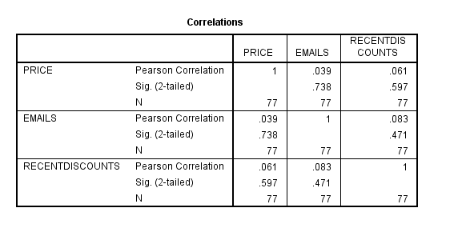

1. Multiple linear regression

***Solution***

The regression analysis studies the relationship between SALES (dependent variable) and PRICE, EMAILS, and RECENTDISCOUNTS (predictors). The model is highly significant $(ANOVA F=185.893,p<0.001)$ with an $R2$ of 0.884 (explaining 88.4% variance in SALES), and predictors explain 88.4% of the variance in SALES. PRICE has a strong negative effect on SALES $(B = -25.266, p<0.001B = -25.266, p<0.001)$: the higher price correlates with less sales. In addition, however, SALES $(B=-31.416,p<0.001B=-31.416,p<0.001)$ is negatively impacted by EMAILS, although at a smaller magnitude than PRICE. Yet, there is no effect of RECENTDISCOUNTS on SALES $(B=10.668, p=0.244 B=10.668, p=0.244)$.

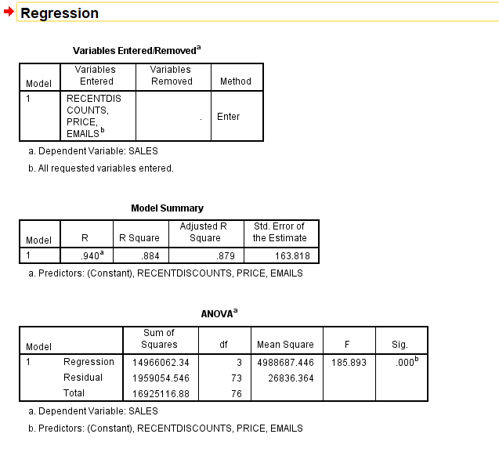

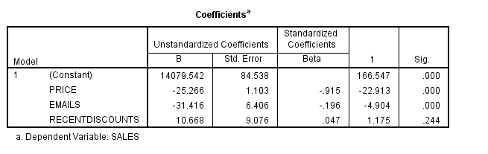

1. Regression equation

***Solution***

$$SALES = 14079.542-25.266\left(PRICE\right)-31.416\left(EMAILS\right)+10.668\left(RECENTDISCOUNTS\right)$$

1. Solves

***Solution***

$PRICE = 50$

$EMAILS = 5$

$RECENTDISCOUNTS = 6$

$$SALES = 14079.542-25.266\left(PRICE\right)-31.416\left(EMAILS\right)+10.668\left(RECENTDISCOUNTS\right)$$

$$SALES=14079.542-25.266(50)-31.416(5)+10.668(6)$$

$$SALES=14079.542-1263.3-157.08+64.008$$

$$Sales =12,723.17$$