**Smart PC Instruction**

CONTENTS

1 Introduction 2

2 Connect 2

2.1 Connect 2

2.2 Change Modbus ID 2

2.3 About 3

3 Measurement 4

3.1 Measurement 4

3.1.1 DO Measurement 4

3.1.2 Turbidity Measurement 4

3.1.3 SS Measurement 5

3.1.4 Conductivity Measurement 5

3.1.5 Salinity Measurement 5

3.1.6 pH Measurement 5

3.1.7 Chlorophyll Measurement 6

3.1.8 BGA Measurement 6

3.1.9 OIW Measurement 6

3.1.10 COD Measurement 7

3.1.11 NH4_N Measurement 8

3.2 Data Log 8

3.3 Wiper 9

4 Calibration 9

4.1 Manual Calibration 9

4.2 Auto Calibration 10

4.2.1 DO calibration 10

4.2.2 Turbidity Calibration 11

4.2.3 Conductivity Calibration 11

4.2.4 Salinity Calibration 11

4.2.5 pH Calibration 12

4.2.6 Chlorophyll Calibration 12

4.2.7 BGA Calibration 13

4.2.8 OIW Calibration 13

4.2.9 COD Calibration 13

4.2.10 SS Calibration 14

4.2.11 NH4_N Calibration 14

4.2.12 Low-Turbidity calibration 15

4.3 Debug 15

# 1 Introduction

The smart PC tool is a platform integrating measurement, recording and calibration, which basically covers most of Sensors, making it more convenient, efficient and reliable.

Please follow the instructions and procedures stated in this manual.

# 2 Connect

## 2.1 Connect

At first, chose Port and click “Connect”. If success, it will show probe type as shown in figure 2. Here take DO as an example. The Modbus ID is 01.

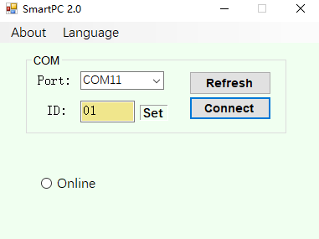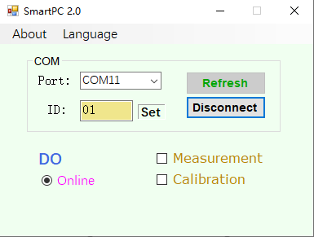

Figure 1 Figure 2

## 2.2 Change Modbus ID

If you want to change Modbus ID, click “Set “as shown in figure 3. It will show a dialog box. Input needed address and click “OK” to confirm. Back to main interface, the ID is changed.

Note: If multiple probes are connected in parallel, such as DO (address is 1) and pH (address is 4). To connect pH, you must first enter address 4 and then click “Connect” as shown in Figure 4. Otherwise the PC tool may not find the pH probe when asking for the address.

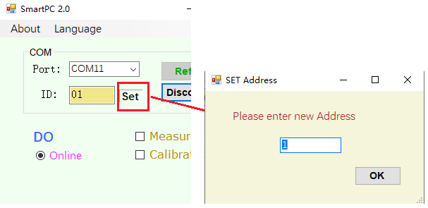

Figure 3

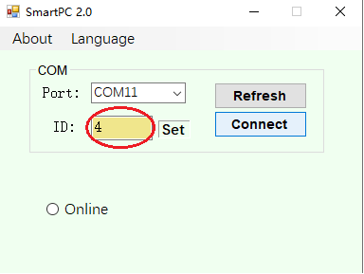

Figure 4

## 2.3 About

Click “About “in title block will show a drop-down menu including “Probe” and “Help”. “Probe” contains some information, including probe IDSN, software version and hardware version as shown in figure 5. “Help” dialog box means press F1 can pop up this document.

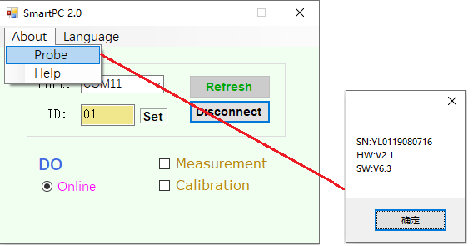

Figure 5

# 3 Measurement

## 3.1 Measurement

Check “Measurement” in Figure 2 can allow access to measurement interface. Click "start" to get current measurement values.

## 3.1.1 DO Measurement

As shown in figure 6. Measurements including DO(mg/L), DO (%) and Temperature. The temperature can be selected in unit ℃ or Kelvin. Pressure and salinity are closely related to DO (mg / L). Input currently air pressure and salinity can get more accurate DO (mg / L). The salinity is 0 ppt and the air pressure is standard atmospheric pressure by default. Note that measurement must be stopped when “Set” or “Get”.

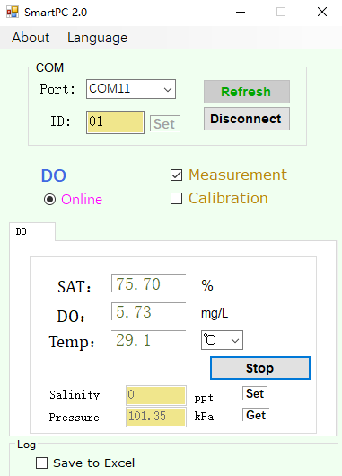 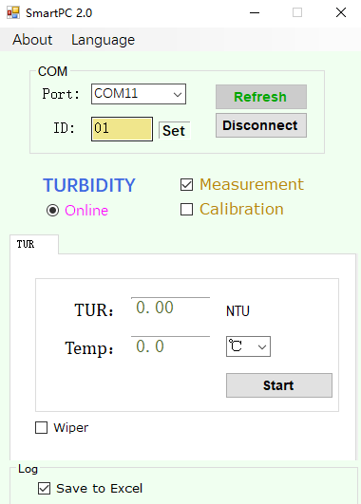

Figure 6 Figure 7

## 3.1.2 Turbidity Measurement

As shown in figure 7. Measurements including Turbidity(NTU) and Temperature. The temperature can be selected in unit ℃ or Kelvin.

## 3.1.3 SS Measurement

As shown in figure 8. Measurements including SS(mg/L) and Temperature. The temperature can be selected in unit ℃ or Kelvin.

## 3.1.4 Conductivity Measurement

As shown in figure 9. Measurements including Conductivity(mS/cm), TDS(mg/L) and Temperature. The temperature can be selected in unit ℃ or Kelvin.

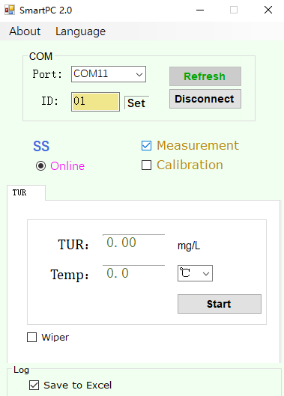 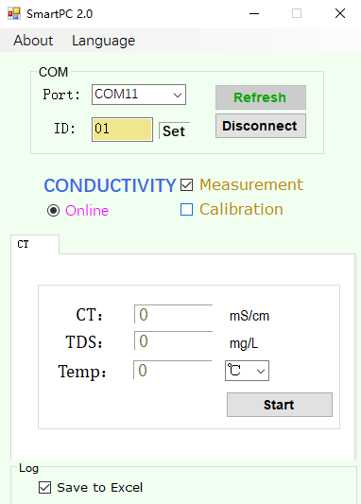

Figure8 Figure 9

## 3.1.5 Salinity Measurement

Measurements including Salinity(ppt) and Temperature. The temperature can be selected in unit ℃ or Kelvin.

## 3.1.6 pH Measurement

As shown in figure 10. Measurements including pH, Potential value (mV) and Temperature. The temperature can be selected in unit ℃ or Kelvin.

When the ORP probe is connected, the Measurements are pH (negligible), ORP value (mV), and temperature.

## 3.1.7 Chlorophyll Measurement

As shown in figure 11. Measurements including Chlorophyll(ug/L) and Temperature. The temperature can be selected in unit ℃ or Kelvin.

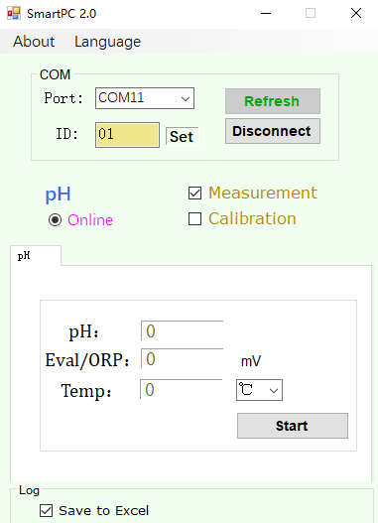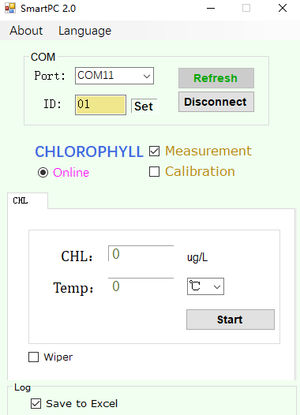

Figure10 Figure 11

## 3.1.8 BGA Measurement

As shown in figure 12. Measurements including BGA(cells/mL) and Temperature. The temperature can be selected in unit ℃ or Kelvin.

## 3.1.9 OIW Measurement

As shown in figure 13. Measurements including OIW(ppm) and Temperature. The temperature can be selected in unit ℃ or Kelvin.

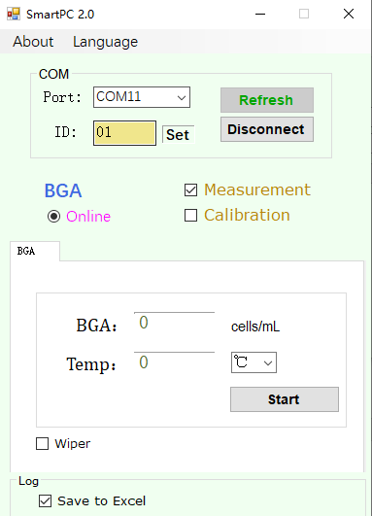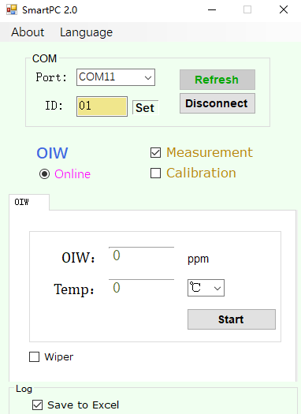

Figure12 Figure 13

## 3.1.10 COD Measurement

As shown in figure 14. Measurements including COD(mg/L), Turbidity(NTU) and Temperature. The temperature can be selected in unit ℃ or Kelvin.

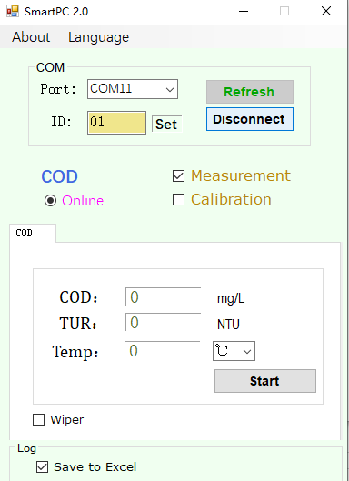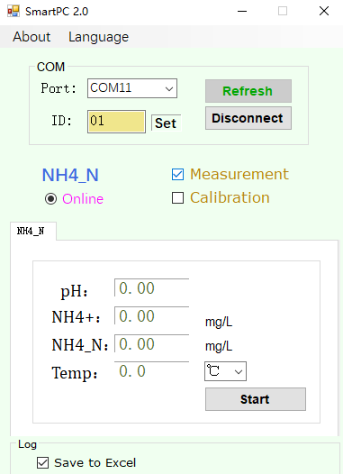

Figure14 Figure 15

## 3.1.11 NH4_N Measurement

As shown in figure 15. Measurements including pH, NH4+(mg/L), NH4_N(mg/L) and Temperature. The temperature can be selected in unit ℃ or Kelvin.

## 3.2 Data Log

Check "Save to Excel" in Figure 6 can allow access to data record interface as shown in Figure 16. At first, enter recording time interval. Click “start” and then a dialog box will pop up. Select the excel path and create the name, such as “do”. After that, the data will be saved to excel. Click "stop" if you want to stop recording and open excel to view data, as shown in Figure 17. Note: **please do not open excel during data recording, otherwise data recording will be interrupted.**

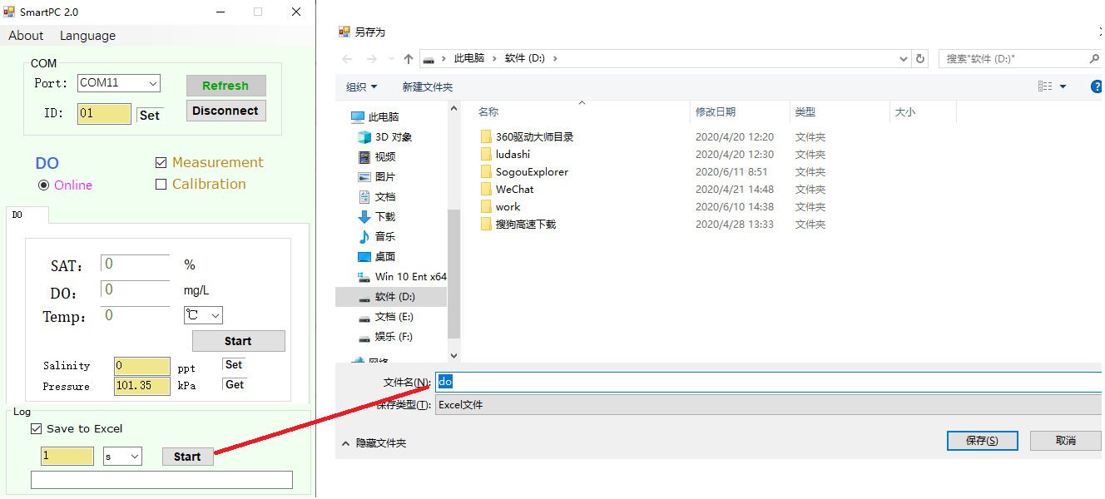

Figure 16

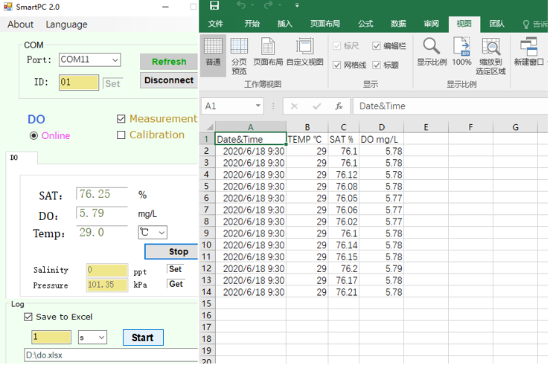

Figure 17

## 3.3 Wiper

If connected probe has a brush, check "wiper" in Figure 7 and the brush control interface will be displayed, as shown in Figure 18.

"Rotate Wiper" to make the wiper turn immediately;"Time" can change the wiper working frequency, the default time is 30 min.

The pull-down box "NON-AutoRun" indicates that the brush will not rotate when powered on unless receive " Rotate Wiper " command. " AutoRun " means the brush will rotate automatically when powered on . The user can select the mode according to the actual situation. (This function is only suitable for turbidity and sludge)

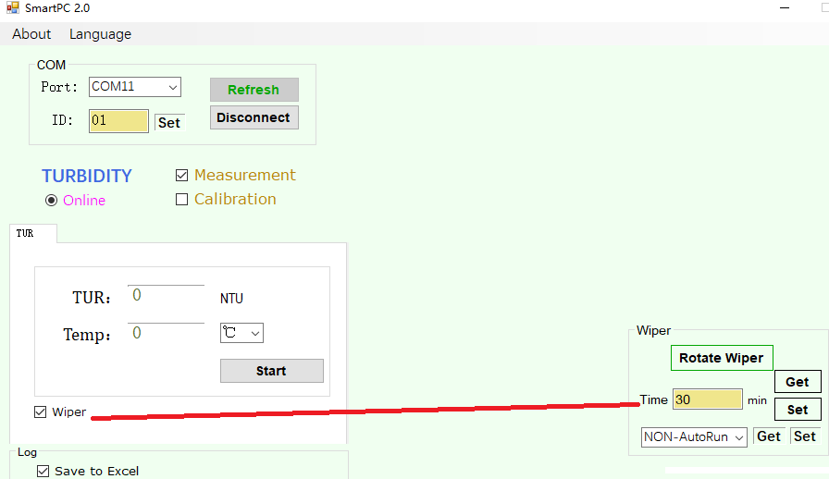

Figure 18

# 4 Calibration

## 4.1 Manual Calibration

Check “Calibration” in Figure 2 can allow access to calibration interface. There are manual calibration and auto calibration two mode. Manual calibration means user do calibration step by step and calculate parameters K and B and write back to probe by self.

Note: **Before do calibration, please stop measurement.**

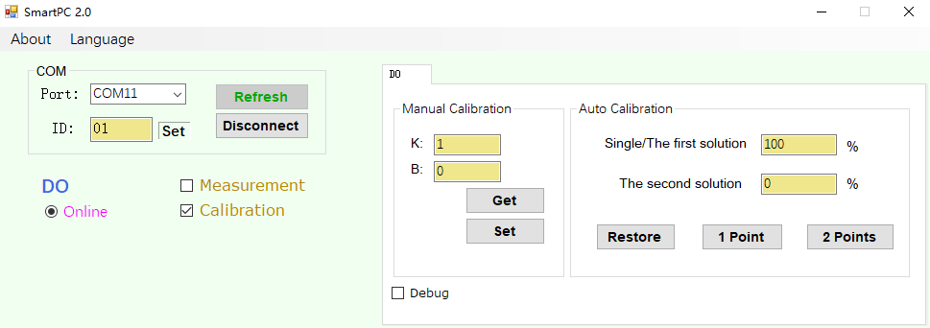

Figure 19

## 4.2 Auto Calibration

Auto calibration means user do calibration step by step according to the screen instructions and PC tool will automatically calculate parameters K and B and write back to probe.

## 4.2.1 DO calibration

One-point calibration: Enter the values of standard solutions under label “Single/ the first solutions”. **Normally 100%SAT DO is chosen for single-point calibration**. Choose “1 point” will pop up a sub interface as shown in Figure 20. Follow the screen instructions and wait for few minutes to stabilize the data and then click “OK” to finish process. Click “ESC” to abort calibration.

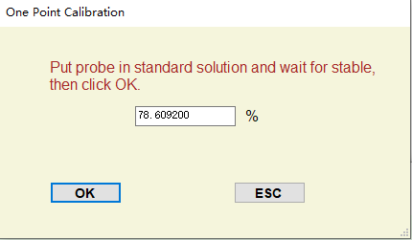

Figure 20

Two-points calibration：Enter the values of standard solutions first. We recommend to use 100%SAT DO as first standard value and 0%SAT DO as second standard value.

Choose “2 point” and follow the instructions to perform calibration. Remember the order of two input values. The order is the same as that of actual calibrate solutions.

Restore: Click “Restore” to restore factory setup K=1.B=0.

Note: **The two calibration values cannot be the same**.

## 4.2.2 Turbidity Calibration

Zero Calibration: Follow the instructions to put sensor into 0 NTU standard solution. Wait for few minutes to stabilize the data then click “OK”.

One-point calibration: Same as DO, see 4.2.1.

Two-points calibration：Same as DO, see 4.2.1.

Restore: Same as DO, see 4.2.1.

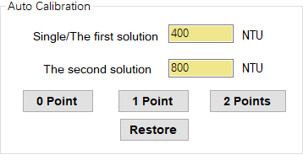

Figure 21

## 4.2.3 Conductivity Calibration

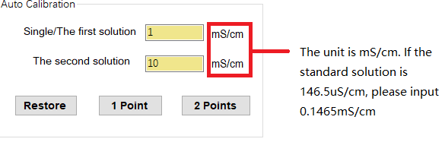

Figure 22

One-point calibration: Same as DO, see 4.2.1.

Two-points calibration：Same as DO, see 4.2.1.

Restore: Same as DO, see 4.2.1.

The normal standard solutions are 146.5us/cm, 1408.3us/cm, 12.852 MS / cm, 111.31ms/cm, etc.

## 4.2.4 Salinity Calibration

One-point calibration: Same as DO, see 4.2.1.

Two-points calibration：Same as DO, see 4.2.1.

Restore: Same as DO, see 4.2.1.

## 4.2.5 pH Calibration

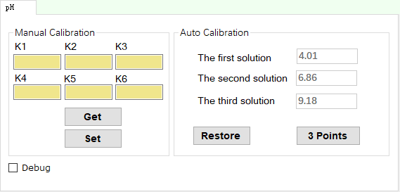

Figure 23

Three-points Calibration: Standard three-point calibration at pH4.01, pH6.86, and pH9.18 is required for pH sensor. Choose “3 point” will pop up a sub interface as shown in Figure 23. Follow the screen instructions to perform calibration.

Restore: Click “Restore” to restore factory setup values.

Note: The calculation of pH calibration is complex and manual calibration is not recommended.

## 4.2.6 Chlorophyll Calibration

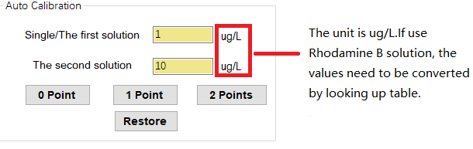

Figure 24

Zero calibration: Same as Turbidity, see 4.2.2.

One-point calibration: Same as DO, see 4.2.1.

Two-points calibration：Same as DO, see 4.2.1.

Restore: Same as DO, see 4.2.1.

Approximate algal chlorophyll equivalent of 0.5 mg/L Rhodamine B as a function of temperature.

|  |  |
| --- | --- |
| Temperature℃ | Coefficients |
| 30 | 290.4 |
| 28 | 296.4 |
| 26 | 302.4 |
| 24 | 308 |
| 22 | 317.6 |
| 20 | 328 |
| 18 | 345.6 |
| 16 | 363.2 |
| 14 | 372.8 |
| 12 | 380.4 |
| 10 | 392 |
| 8 | 400 |

For example: 0.2mg/L Rhodamine B at 28 ℃ corresponds to chlorophyll 296.4 * (0.2 / 0.5) = 118.56ug/l

## 4.2.7 BGA Calibration

Two-points calibration：Same as DO, see 4.2.1.

Restore: Same as DO, see 4.2.1.

## 4.2.8 OIW Calibration

Zero calibration: Same as Turbidity, see 4.2.2.

One-point calibration: Same as DO, see 4.2.1.

Two-points calibration：Same as DO, see 4.2.1.

Restore: Same as DO, see 4.2.1.

## 4.2.9 COD Calibration

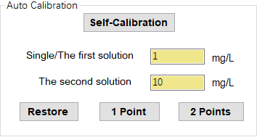

Figure 25

Self-Calibration：This is first step of calibration. Before do one-point calibration or two-points calibration, self-Calibration must be performed first. Follow the instructions to put sensor into DI water. Wait for few minutes to stabilize the mV then click “OK”.

One-point calibration: Same as DO, see 4.2.1.

Two-points calibration：Same as DO, see 4.2.1.

Restore: Same as DO, see 4.2.1.

Note: Check “Info”will display mV value continuously. Generally, do not need to check “Info”.

## 4.2.10 SS Calibration

One-point calibration: Same as DO, see 4.2.1.

Two-points calibration：Same as DO, see 4.2.1.

Restore: Same as DO, see 4.2.1.

## 4.2.11 NH4_N Calibration

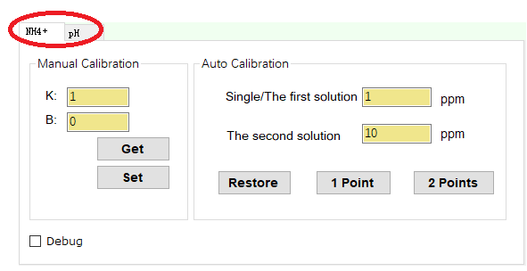

Figure 26

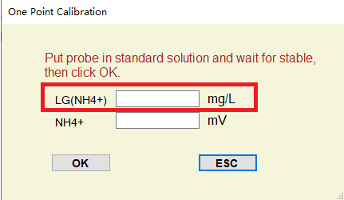

Figure 27

NH4_N calibration has two part: NH4+ calibration and pH calibration as shown in figure 26.

pH calibration: see 4.2.4 in detail.

NH4+ calibration:

One-point calibration: Same as DO, see 4.2.1.

Two-points calibration：Same as DO, see 4.2.1.

Restore: Same as DO, see 4.2.1.

Note: If LG(NH4+)>3mg/L, a prompt “Calibration failed!” will appear. At this time, please contact our customer service department.

## 4.2.12 Low-Turbidity calibration

One-point calibration: Enter the values of standard solutions under label “Single solutions”. Choose “1 point” will pop up a sub interface. Follow the screen instructions and wait for few minutes to stabilize the data and then click “OK” to finish process. Then the offset value B is changed. Click “ESC” to abort calibration.

Note : B values range from -0.5 to 0.5, otherwise an error prompt will be generated

## 4.3 Debug

Check "Debug" in Calibration or "Debug" in Measurement can allow access to frame command box, and check "Show Frame" can see the frame flow of instructions. “Clear” will clear all frames.

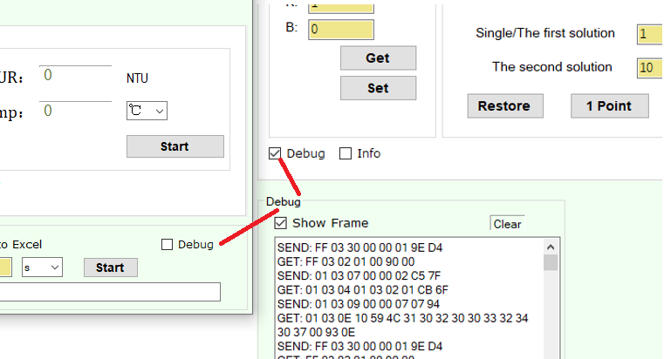

Figure 28