MPI Implementation
- Implementation Overview
  - The r1.cpp program is the MPI implementation. It computes C = A x B for an N x N matrix using ranks for processes. I implemented a checksum that calculates the first two rows and compares that calculation to the static first two rows calculation for the correctness check. Rank 0 allocates and fills A and B with random doubles that range from 1 – 10000 and sends the correct counts / offsets to each rank. All ranks will perform their multiplication of their ranks they were sent. I broadcast B to all ranks because all ranks use the entirety of B. I used scatter to send the rows to each rank because that allows me to send different numbers of data to each rank. I did this because we may not always know if the amount of work will be evenly divided among the ranks. I used gatherv to have all ranks send their C_local back to the rank 0 so it can gather all of C back up. Then for correctness check I implemented a sequential checksum for the first two rows and a parallel sum of the first two rows using an MPI_Reduce. These correctness checks are outside of the MPI_Wtime to ensure they do not mess with the execution times.
- Data Decomposition
  - I choose the row-wise decomposition of matrix A. Each rank will get its own. local_rows which is just N/p with the added ternary operator that handles the potential uneven number of rows that may occur. The offsets of each rank are calculated by rank 0 and distributed via the scatterv and gatherv. Every rank will need all of B so I broadcast that to each rank. Each rank then will work on its own rows of A and all of B. This might be risky as there is a potential problem of some processes getting a significantly harder set of data and become a bottleneck to the rest of the processes. This could be a future improvement of the program.
- Mapping Strategy
  - MPI_Bcast of B to give every rank the entirety of B.
  - MPI_Scatterv of each ranks A to send each rank its correct amount of A rows.
  - MPI_Gatherv of each ranks C to send back their product of A rows and B Columns.
  - MPI_barrier at the beginning and end to start each process on their work at the same time
- Design Choices
  - total_rows_per_rank contains N / p. remainder_of_rows contains the N % p. local_rows then contains each ranks total rows and the optional +1 depending on if there was an even distribution of rows per rank. Then the row_offset contains the offset of where each rank should start their A product with B.
  - The triple loop for the matrix multiplication is for the following purpose:
    - i is to iterate the rows of A_local or the row_offset
    - k is for the value at A [row_offset + i][k] and the beginning of row k of B
    - j contains the C[row_offset + i][j] += A[row_offset + i][k] * B[k][j]
  - I for the correct number of rows the rank is supposed to work on, k and j is for the iteration of the matrix multiplication.
  - I then used rand which allows for “random numbers” to generate. This will ensure that each time this is run in all iterations they are going over the same numbers so each run with different number of processes and size has the same deterministic numbers.
- Execution Times
  - Table
N | P | Time | Row Count | Speedup | Efficiency
2048 | 1 | 8.95 | 2048 | 1.0 | 1.0
2048 | 4 | 4.07 | 512 | 2.2 | 0.55
2048 | 8 | 2.58 | 256 | 3.5 | 0.43
2048 | 16 | 2.59 | 128 | 3.5 | 0.21

  - Plots
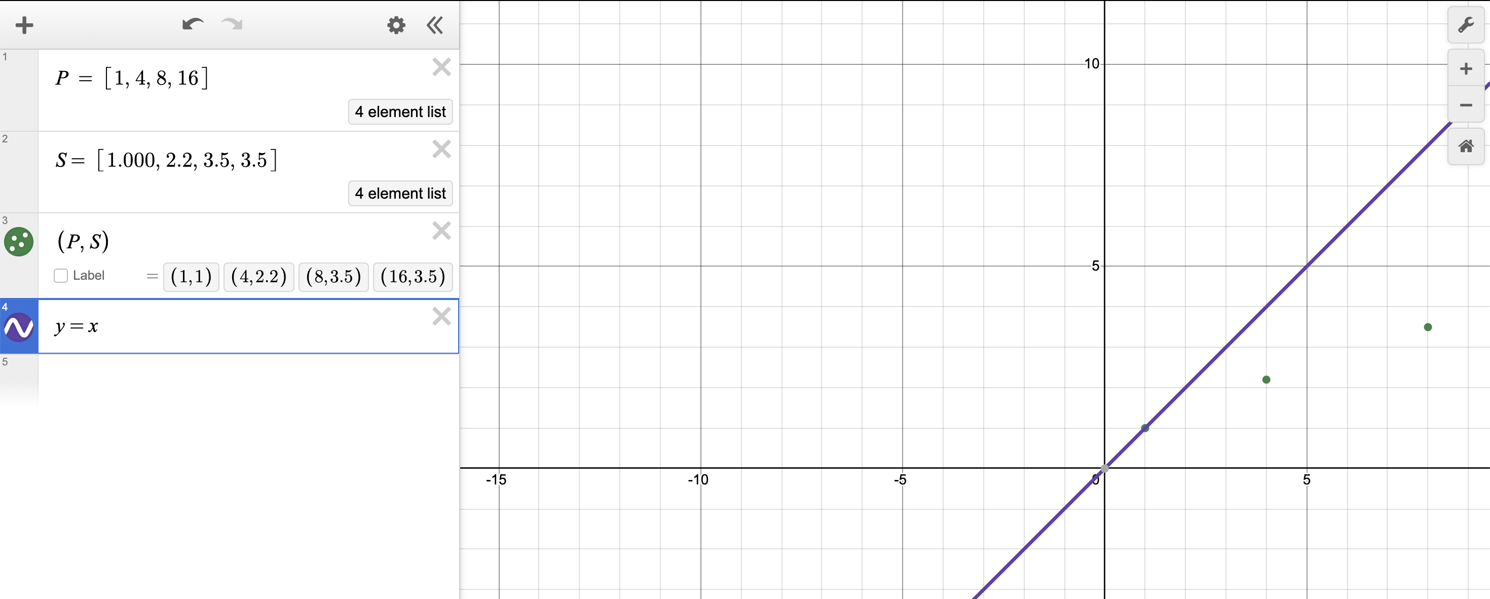
- Screenshots
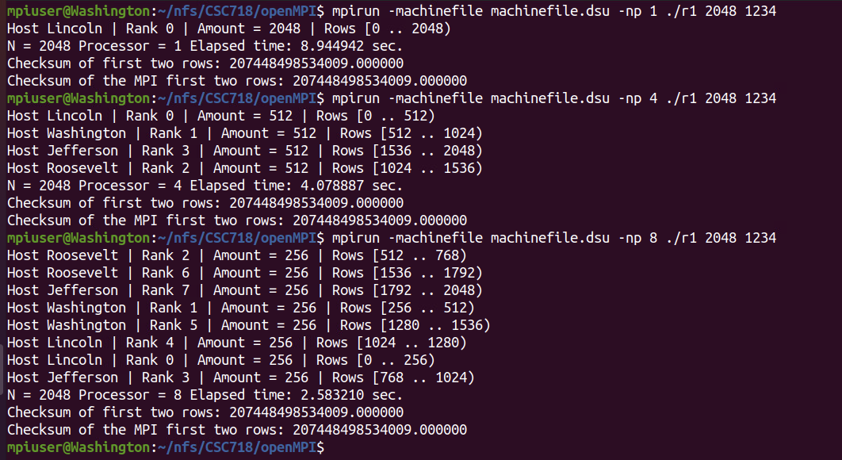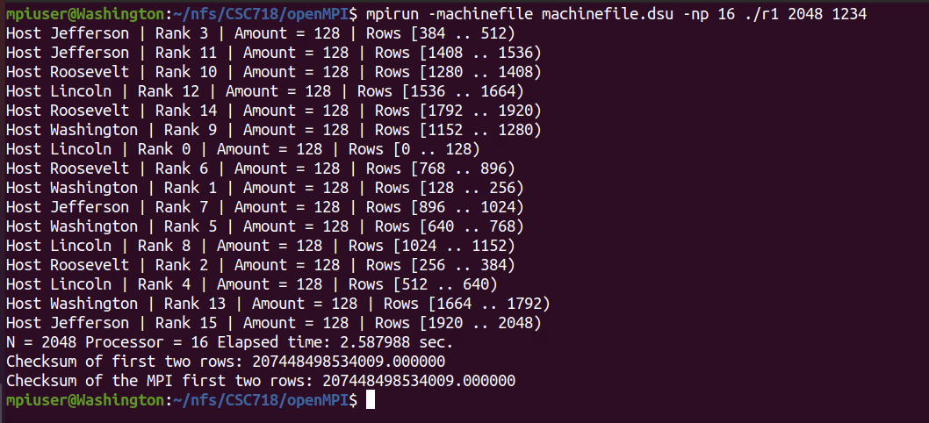

OpenMP
- Implementation Overview
  - For the openMP implementation the goal is the same. Compute C = A * B for an N * N matrix. I measure the parallel portion with omp_get_wtime() and perform the same correctness check with a parallel reduction for the first two rows and a non-parallel checksum of the first two rows of the matrix. I used the same fill function for the MPI implementation, so the numbers are the same. I used the same seed to ensure that the numbers are the same. For the parallel checksum I used a reduction with the add operation to calculate the first_two_rows_sum.
- Data Decomposition
  - I used the same row-wise decomposition method as the MPI program. I paralyze the outer of the three loops, which means that i will be the “row_offset” of the MPI version. Then multiply the a_ik and B_row and store those values into the C_row array
- Mapping Strategy
  - for the checksum, I used openMP’s reduction(+:first_two_rows_sum) so that when the first two rows are calculated the total values are added back to the first_two_rows_sum and not lost. We talked about this idea and why it’s important in class as seen on slides 42 – 44. I had an aha moment I remember this!
  - The pragma that does the full matrix multiplication shares the A, B, C arrays and N. I set j and k to private because those as described in slide 20 of openMP have different addresses in execution context of every thread. They are an independent copy from any other thread. No other thread needs access to the j and k of each thread for the multiplication of the matrix.
- Design Choices
  - To test out all the scheduling options i setup an omp_sched_t enum that switches the scheduling type based on the user input stored in schedule. That was switching between the different types is easy as shown in the screenshots.
  - Determinism of the “random” numbers. Since all matrixes have the same numbers inside of them and the same size, the comparison of time for each is correct for each. Since the numbers are the same, the math is the same, and if the math is the same the only outlying factor is the different implementations.

- Execution Times (Table)
  - Table
N | Threads | Schedule | Chunk | Time | Speedup | Efficiency
2048 | 1 | Static | 2048 | 8.88 | 1.0 | 1.0
2048 | 2 | Static | 1024 | 4.62 | 1.92 | 0.96
2048 | 4 | Static | 512 | 2.52 | 3.52 | 0.88
2048 | 8 | Static | 256 | 1.83 | 4.85 | 0.61
2048 | 16 | Static | 128 | 1.63 | 5.45 | 0.34
2048 | 1 | Dynamic | 32 | 8.91 | 1.0 | 1.0
2048 | 2 | Dynamic | 32 | 4.66 | 1.91 | 0.96
2048 | 4 | Dynamic | 32 | 2.55 | 3.49 | 0.87
2048 | 8 | Dynamic | 32 | 1.84 | 4.84 | 0.61
2048 | 16 | Dynamic | 32 | 1.70 | 5.24 | 0.33
2048 | 1 | Dynamic | 64 | 8.96 | 1.0 | 1.0
2048 | 2 | Dynamic | 64 | 4.64 | 1.93 | 0.97
2048 | 4 | Dynamic | 64 | 2.55 | 3.51 | 0.88
2048 | 8 | Dynamic | 64 | 1.84 | 4.87 | 0.61
2048 | 16 | Dynamic | 64 | 1.66 | 5.40 | 0.34
2048 | 1 | Guided | 16 | 8.94 | 1.0 | 1.0
2048 | 2 | Guided | 16 | 4.60 | 1.94 | 0.97
2048 | 4 | Guided | 16 | 2.58 | 3.47 | 0.87
2048 | 8 | Guided | 16 | 1.83 | 4.89 | 0.61
2048 | 16 | Guided | 16 | 1.61 | 5.55 | 0.35

  - Plots
STATIC
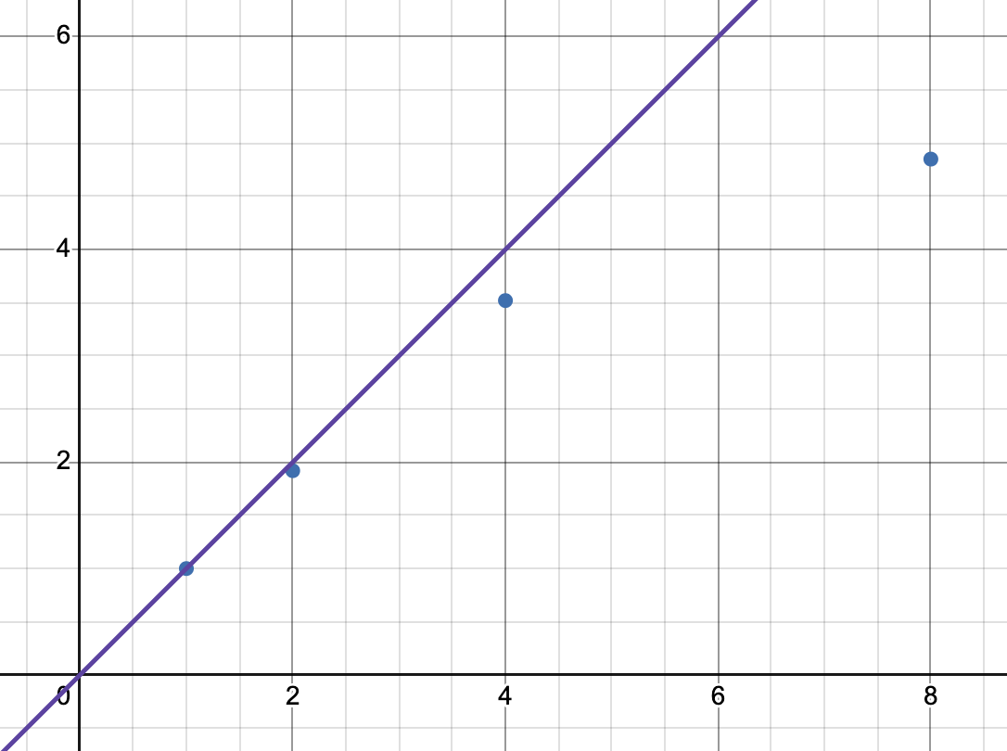
DYNAMIC – 32 CHUNK
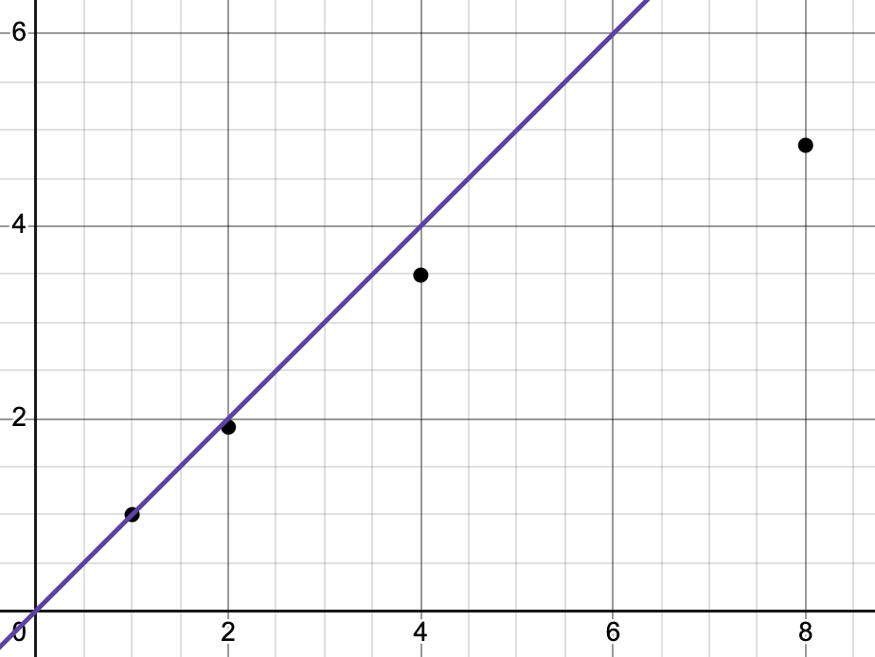

DYNAMIC – 64 CHUNK
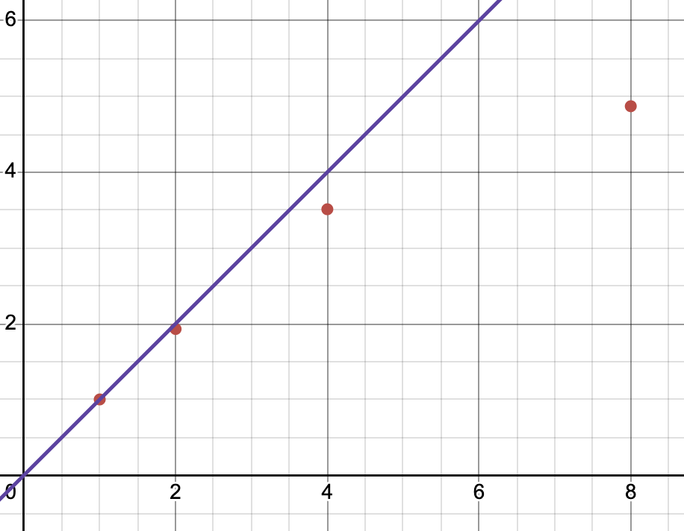
GUIDED
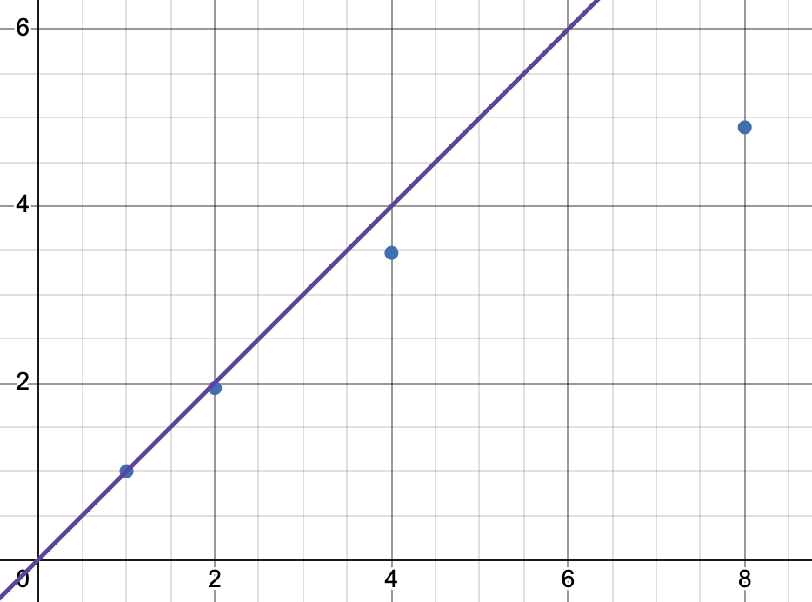
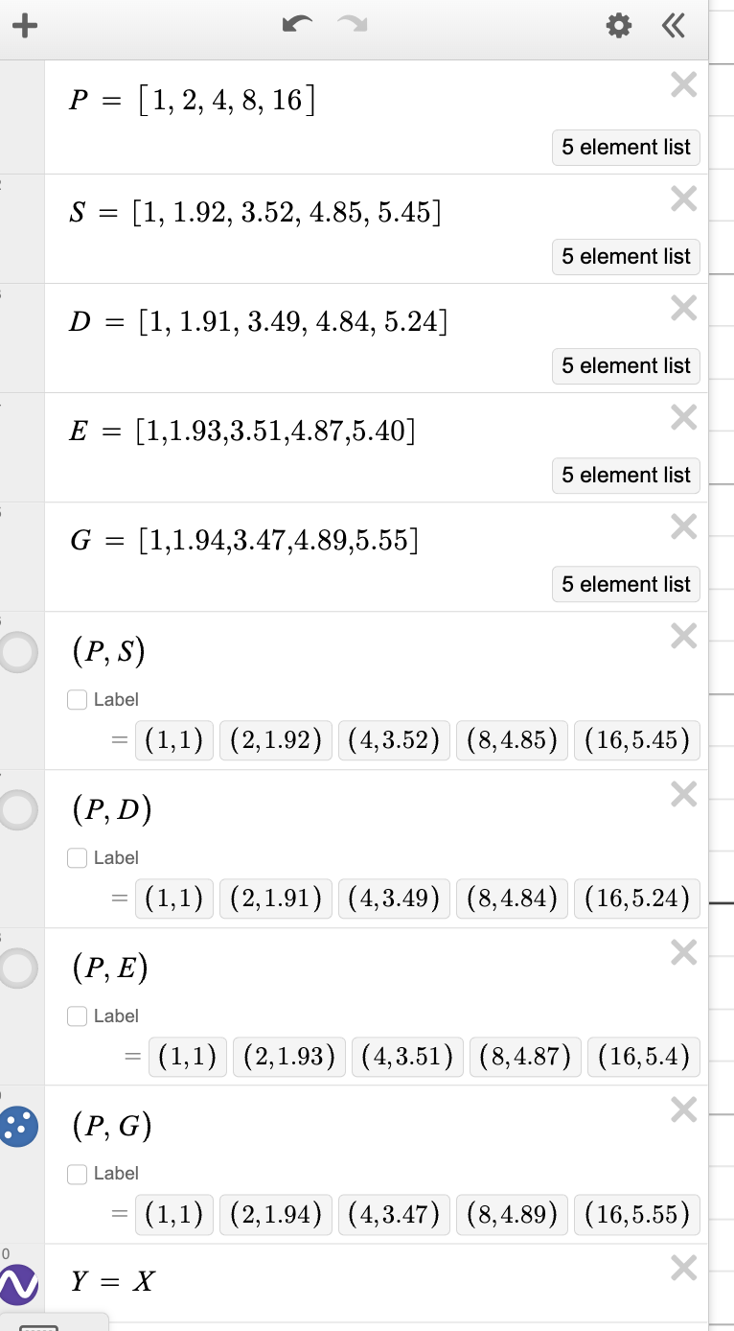
- Screenshots
STATIC
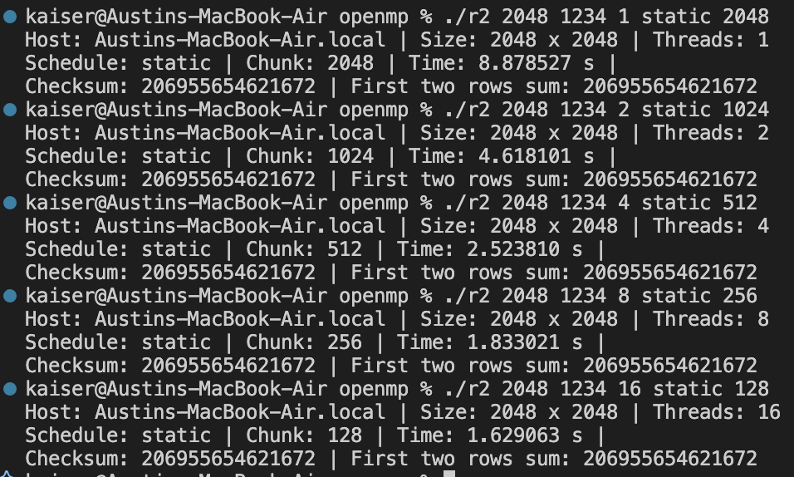

DYNAMIC
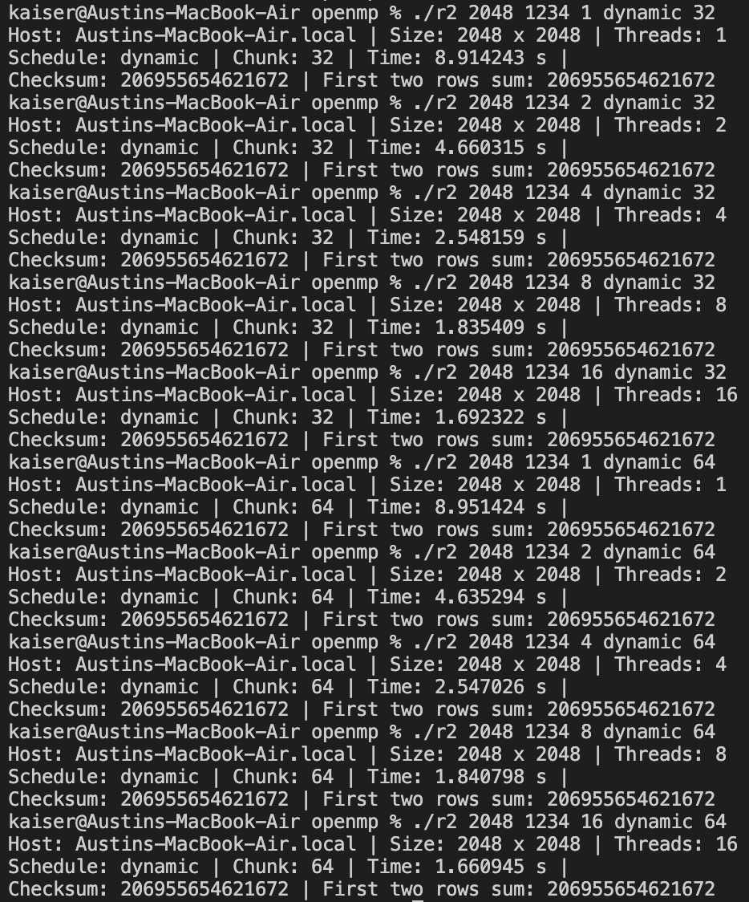

GUIDED
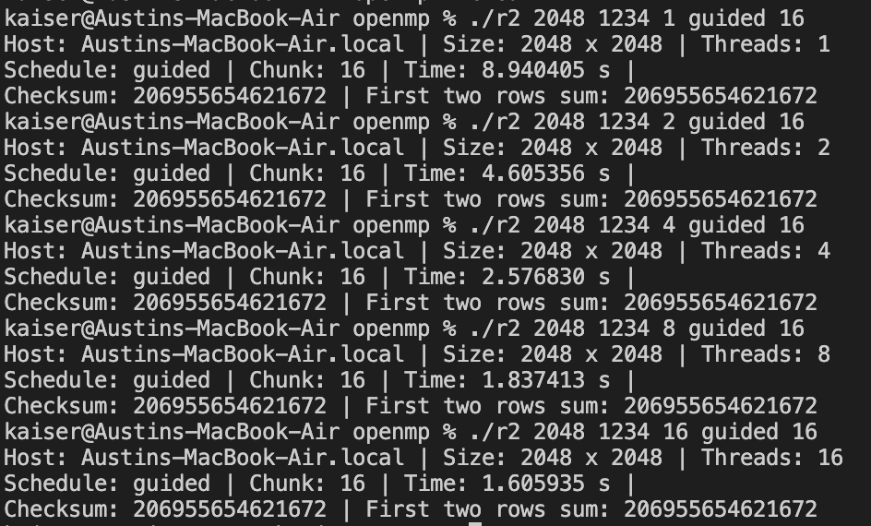

Comparative Discussion
- Performance Differences
- Communication Overhead
- Synchronization
- Data Locality
- OpenMP Scheduling and Chunk Size Performance
- Scale Thresholds
Conclusion
- Summary
  - openMP works well for single node runs due to minimal overhead and shared-cache benefits. Also, it is way easier to program compared to MPI! I am glad that I got them working and set up. I think it was good experience.
- Architectural Trade-Offs
  - openMP is used for simple shared memory systems. It has a much smaller learning curve compared to MPI. MPI is great for both single system machines as well as clusters that utilize multiple systems that are interconnected. It uses explicit data movements that are completely in the programmer’s control. It scales well with the implementation of as many machines as you can throw into a cluster and interconnect.
- Observed Scalability Limits
  - openMP stops working to well when you introduce 16 threads or more because your CPU can only work on so many at a time. MPI’s becomes less efficient when the communication overhead is larger than the dataset requires. For instance, if you have a small matrix to multiply it does not make sense to spread the load onto multiple machines if you are only multiplying a 5x5 matrix. Paralyzing will only slow the process down.
- Ease of Development
  - openMP to me clicked fast and made a lot of sense. I found that it was way easier to implement especially after having already done most of the matrix multiplication logic and a few helper functions from the MPI program. MPI is really complicated and hard to understand. I understand it, but I really don’t like setting it up and using it.

