DATE 9 june 2026
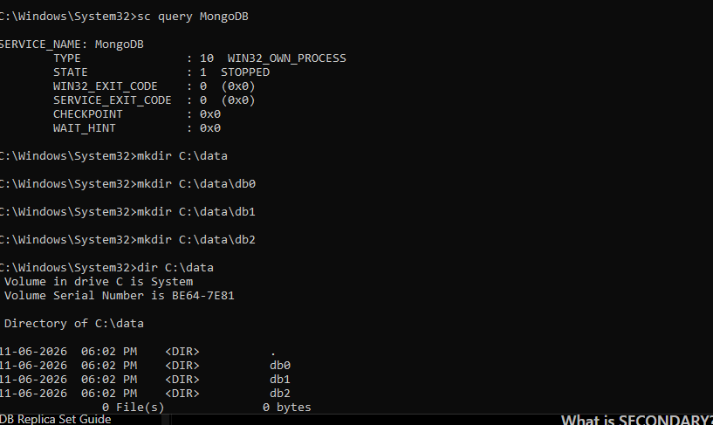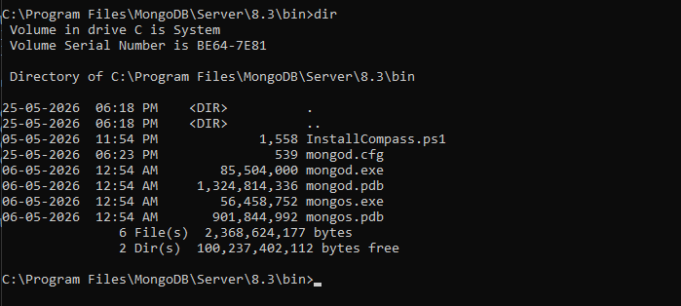
WINDOW 1
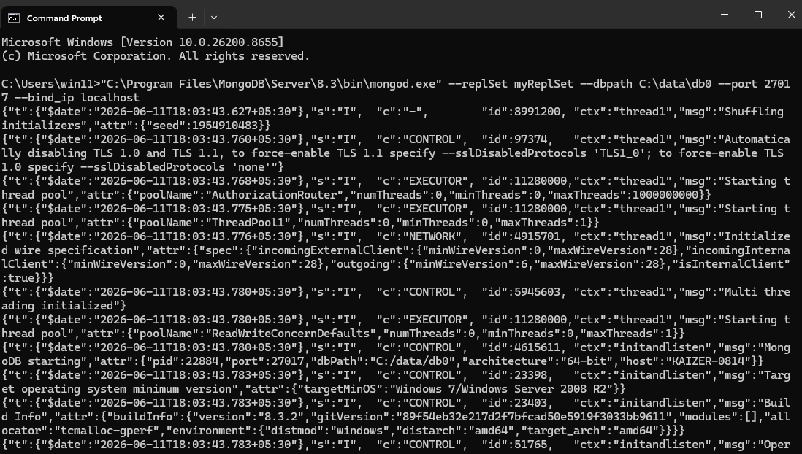
Primary
Window 2
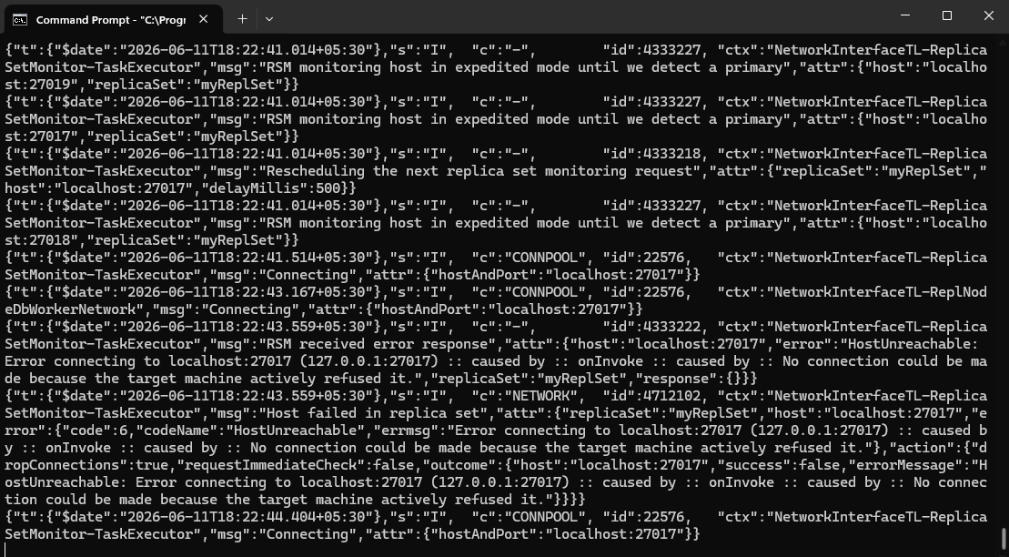
WINDOW 3
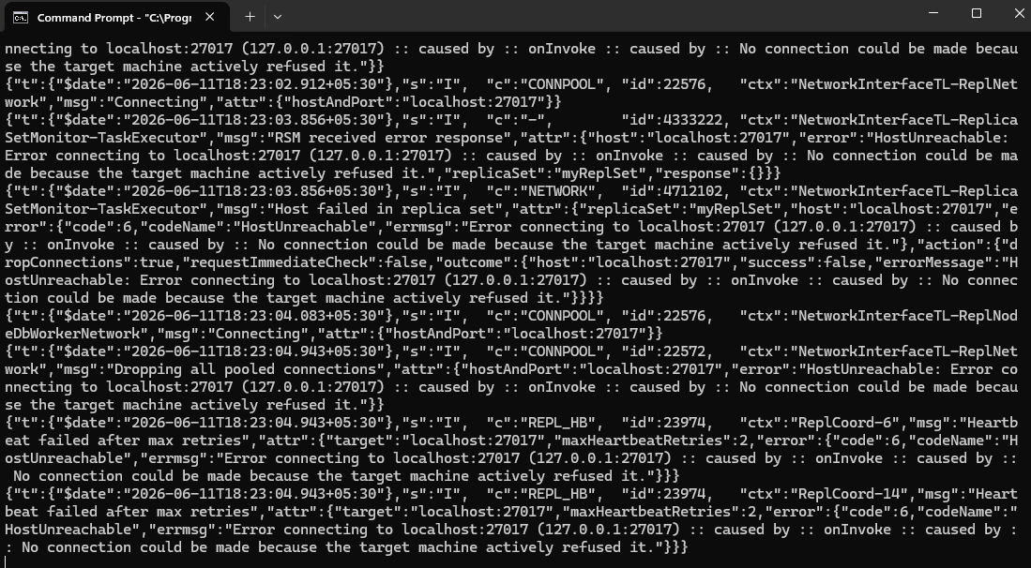
MONGO COMPASS PART
PRIMARY WINDOW
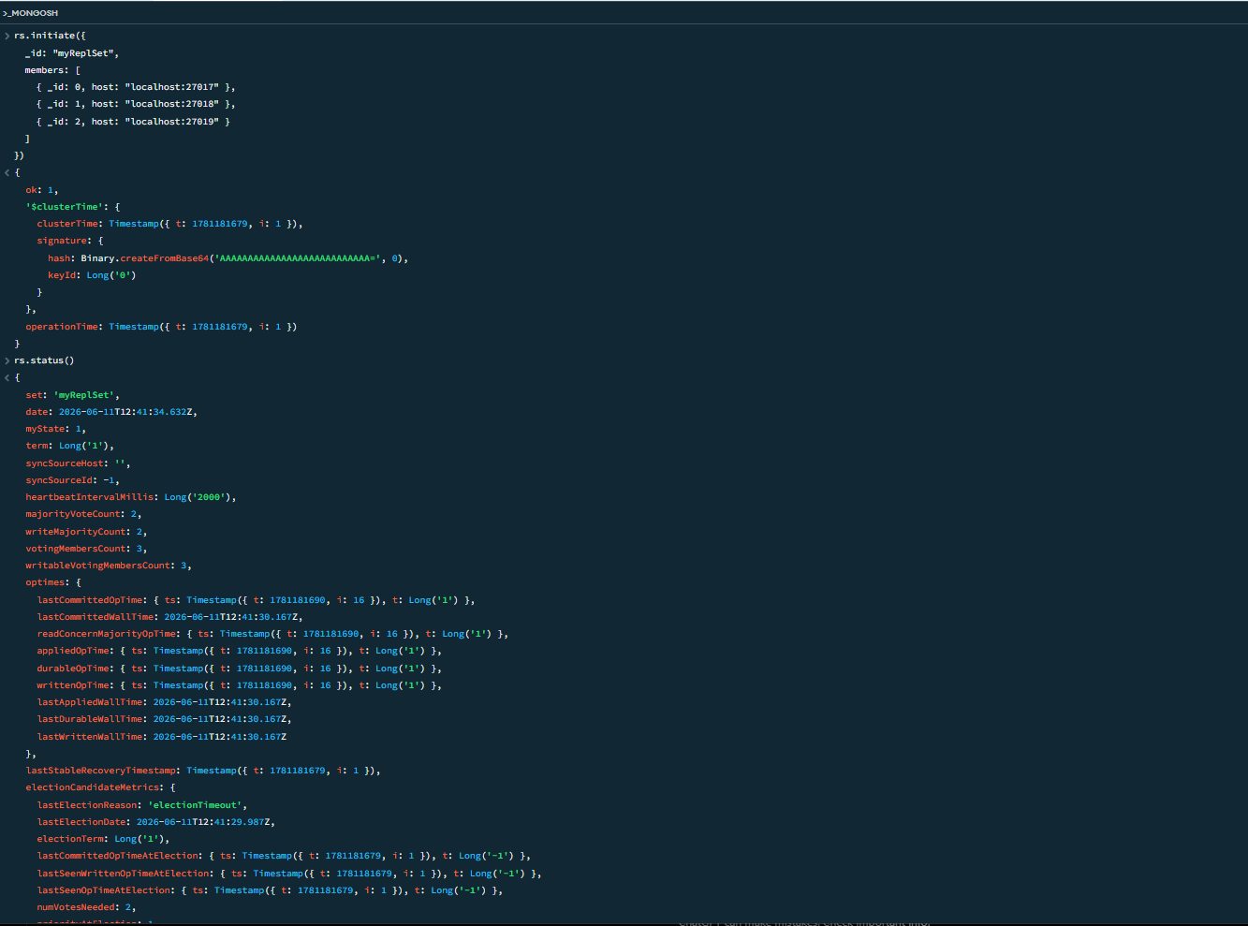
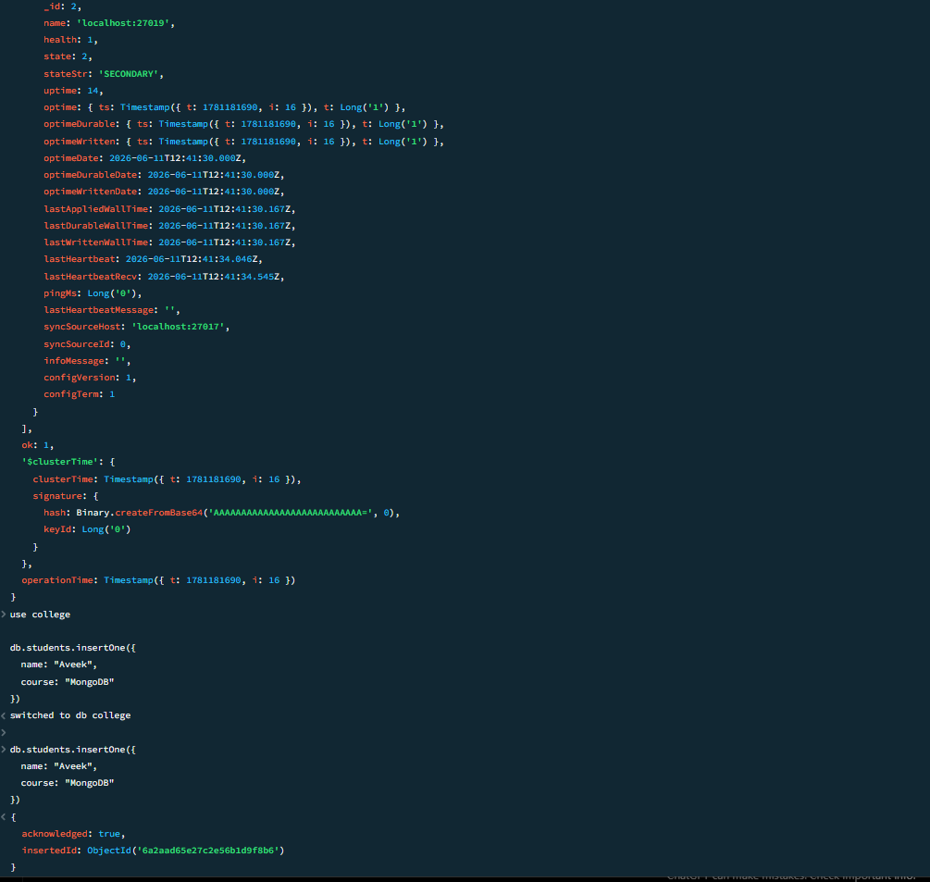
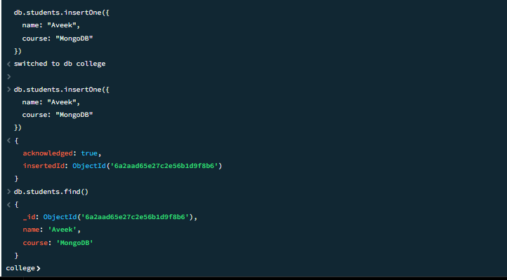
NOW WE MOVE TO THE SECONDARY SET
WHERE WE C AN SEE THE DATA REGISTERED IN WINDOW 1 got copied to window 2 aswell
All the windows got closed
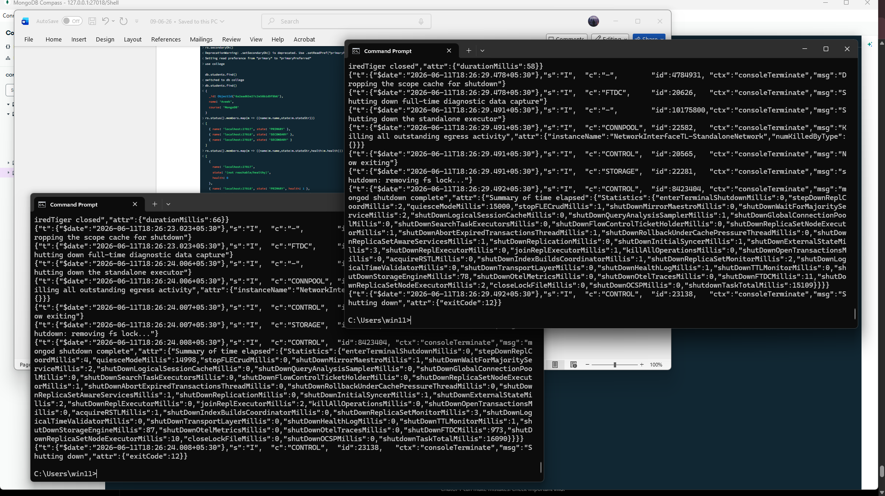
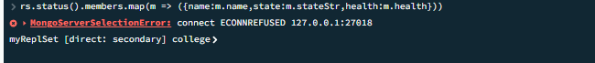
since no active ones exist and secondary also closed so it throws error

