Assignment 2
MAHENDRA ENGINEERING COLLEGES FOR WOMEN
NAME:S.PONMALAR
CLASS:4 YEAR IT
SUBJECT:IBM
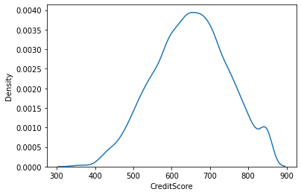
REGISTER NUMBER:611419205021
#Bi - Variate Analysis
plt.bar(df.CustomerId, df.CreditScore)
plt.title('CreditScore')
plt.xlabel('CustomerId')
plt.ylabel('CreditScore')
Text(0, 0.5, 'CreditScore')
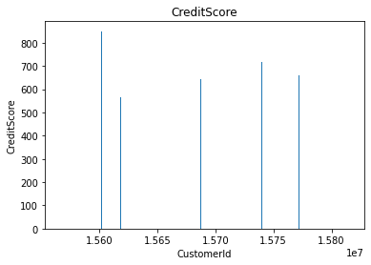
sns.lmplot(x='Tenure', y='Balance', data=df ,hue='Exited',size=8)
/usr/local/lib/python3.7/dist-packages/seaborn/regression.py:581:
UserWarning: The `size` parameter has been renamed to `height`; please
update your code.
warnings.warn(msg, UserWarning)
<seaborn.axisgrid.FacetGrid at 0x7fc4a149e2d0>
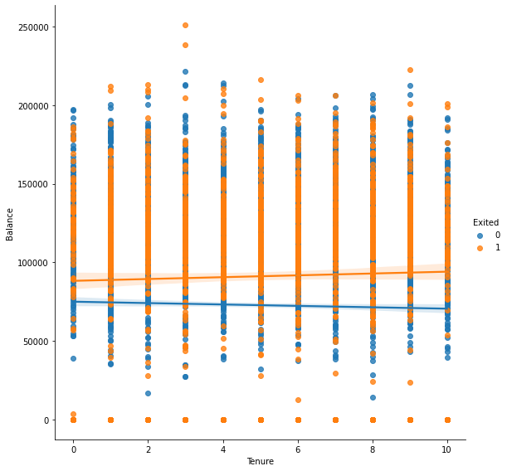
#Multi - Variate Analysis
ax =
df[["CreditScore","Age","Tenure","Balance"]].plot(figsize=(80,40))
ax.legend(loc='center left', bbox_to_anchor=(1, 0.5));
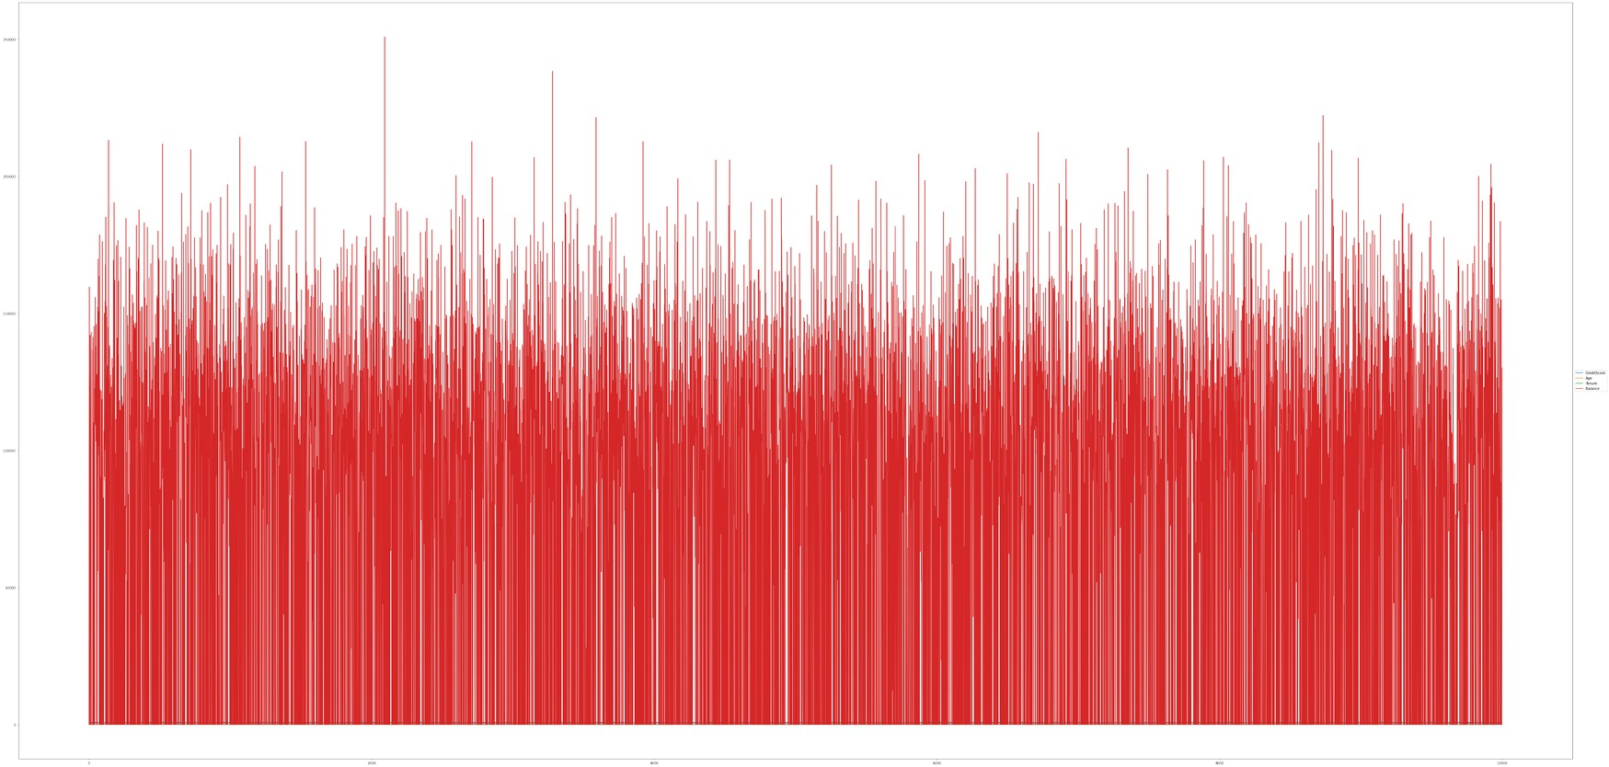
df.isnull().sum()
RowNumber 0
CustomerId 0
Surname 0
CreditScore 0
Geography 0
Gender 0
Age 0
Tenure 0
Balance 0
NumOfProducts 0
HasCrCard 0
IsActiveMember 0
EstimatedSalary 0
Exited 0
dtype: int64
plt.figure(figsize=(15,13))
sns.heatmap(df.corr(),annot=True,cmap='BuPu')
plt.show()
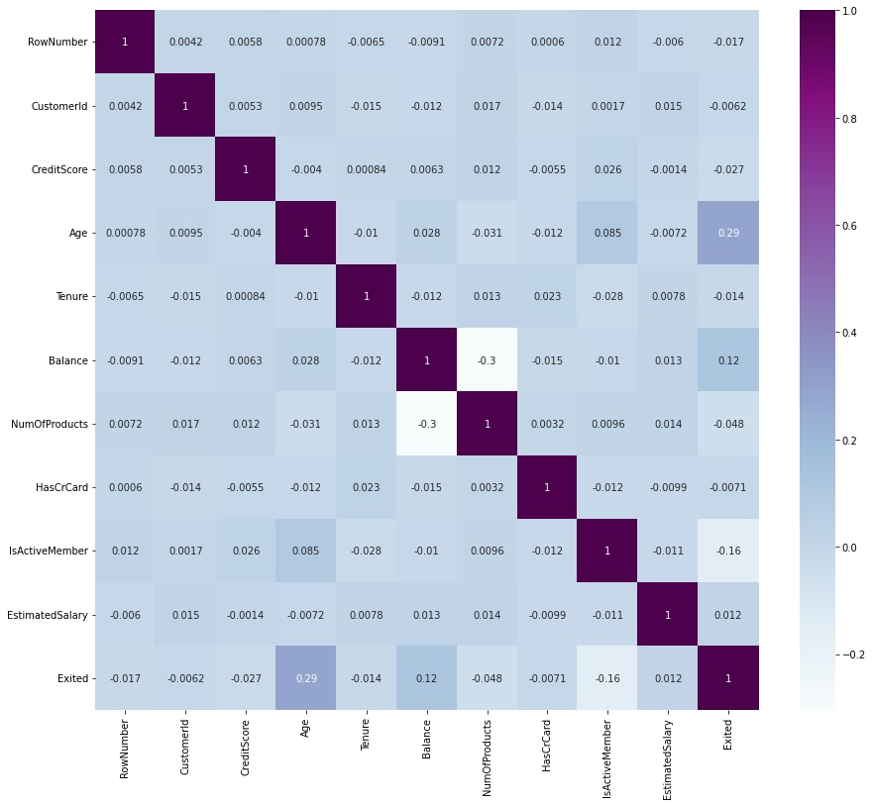
df.drop(['RowNumber', 'CustomerId','Surname'],axis=1,inplace=True)
df.head()
CreditScore Geography Gender Age Tenure Balance
NumOfProducts \
0 619 France Female 42 2 0.00
1
1 608 Spain Female 41 1 83807.86
1
2 502 France Female 42 8 159660.80
3
3 699 France Female 39 1 0.00
2
4 850 Spain Female 43 2 125510.82
1
HasCrCard IsActiveMember EstimatedSalary Exited
0 1 1 101348.88 1
1 0 1 112542.58 0
2 1 0 113931.57 1
3 0 0 93826.63 0
4 1 1 79084.10 0
df.info()
<class 'pandas.core.frame.DataFrame'>
RangeIndex: 10000 entries, 0 to 9999
Data columns (total 11 columns):
# Column Non-Null Count Dtype
--- ------ -------------- -----
0 CreditScore 10000 non-null int64
1 Geography 10000 non-null object
2 Gender 10000 non-null object
3 Age 10000 non-null int64
4 Tenure 10000 non-null int64
5 Balance 10000 non-null float64
6 NumOfProducts 10000 non-null int64
7 HasCrCard 10000 non-null int64
8 IsActiveMember 10000 non-null int64
9 EstimatedSalary 10000 non-null float64
10 Exited 10000 non-null int64
dtypes: float64(2), int64(7), object(2)
memory usage: 859.5+ KB
df["Geography"].unique()
array(['France', 'Spain', 'Germany'], dtype=object)
df["Gender"].unique()
array(['Female', 'Male'], dtype=object)
geo=pd.get_dummies(df["Geography"],drop_first=False)
geo.head()
France Germany Spain
0 1 0 0
1 0 0 1
2 1 0 0
3 1 0 0
4 0 0 1
gen=pd.get_dummies(df["Gender"],drop_first=False)
df=pd.concat([df, geo,gen], axis=1)
df
CreditScore Geography Gender Age Tenure Balance
NumOfProducts \
0 619 France Female 42 2 0.00
1
1 608 Spain Female 41 1 83807.86
1
2 502 France Female 42 8 159660.80
3
3 699 France Female 39 1 0.00
2
4 850 Spain Female 43 2 125510.82
1
... ... ... ... ... ... ...
...
9995 771 France Male 39 5 0.00
2
9996 516 France Male 35 10 57369.61
1
9997 709 France Female 36 7 0.00
1
9998 772 Germany Male 42 3 75075.31
2
9999 792 France Female 28 4 130142.79
1
HasCrCard IsActiveMember EstimatedSalary Exited France
Germany \
0 1 1 101348.88 1 1
0
1 0 1 112542.58 0 0
0
2 1 0 113931.57 1 1
0
3 0 0 93826.63 0 1
0
4 1 1 79084.10 0 0
0
... ... ... ... ... ...
...
9995 1 0 96270.64 0 1
0
9996 1 1 101699.77 0 1
0
9997 0 1 42085.58 1 1
0
9998 1 0 92888.52 1 0
1
9999 1 0 38190.78 0 1
0
Spain Female Male
0 0 1 0
1 1 1 0
2 0 1 0
3 0 1 0
4 1 1 0
... ... ... ...
9995 0 0 1
9996 0 0 1
9997 0 1 0
9998 0 0 1
9999 0 1 0
[10000 rows x 16 columns]
df.drop(["Geography","Gender"], axis=1, inplace=True)
df.head()
CreditScore Age Tenure Balance NumOfProducts HasCrCard \
0 619 42 2 0.00 1 1
1 608 41 1 83807.86 1 0
2 502 42 8 159660.80 3 1
3 699 39 1 0.00 2 0
4 850 43 2 125510.82 1 1
IsActiveMember EstimatedSalary Exited France Germany Spain
Female \
0 1 101348.88 1 1 0 0
1
1 1 112542.58 0 0 0 1
1
2 0 113931.57 1 1 0 0
1
3 0 93826.63 0 1 0 0
1
4 1 79084.10 0 0 0 1
1
Male
0 0
1 0
2 0
3 0
4 0
x=df.drop('Exited',axis=1)
x
CreditScore Age Tenure Balance NumOfProducts HasCrCard \
0 619 42 2 0.00 1 1
1 608 41 1 83807.86 1 0
2 502 42 8 159660.80 3 1
3 699 39 1 0.00 2 0
4 850 43 2 125510.82 1 1
... ... ... ... ... ... ...
9995 771 39 5 0.00 2 1
9996 516 35 10 57369.61 1 1
9997 709 36 7 0.00 1 0
9998 772 42 3 75075.31 2 1
9999 792 28 4 130142.79 1 1
IsActiveMember EstimatedSalary France Germany Spain Female
Male
0 1 101348.88 1 0 0 1
0
1 1 112542.58 0 0 1 1
0
2 0 113931.57 1 0 0 1
0
3 0 93826.63 1 0 0 1
0
4 1 79084.10 0 0 1 1
0
... ... ... ... ... ... ...
...
9995 0 96270.64 1 0 0 0
1
9996 1 101699.77 1 0 0 0
1
9997 1 42085.58 1 0 0 1
0
9998 0 92888.52 0 1 0 0
1
9999 0 38190.78 1 0 0 1
0
[10000 rows x 13 columns]
y=df['Exited']
y
0 1
1 0
2 1
3 0
4 0
..
9995 0
9996 0
9997 1
9998 1
9999 0
Name: Exited, Length: 10000, dtype: int64
df.shape
(10000, 14)
x.shape
(10000, 13)
y.shape
(10000,)
from sklearn.model_selection import train_test_split
x_train,x_test, y_train,y_test = train_test_split(x,y,
test_size=0.2,random_state=0)
x_train.shape
(8000, 13)
x_test.shape
(2000, 13)
y_test.shape
(2000,)
from sklearn.preprocessing import StandardScaler
sc = StandardScaler()
x_train = sc.fit_transform(x_train)
x_train
array([[ 0.16958176, -0.46460796, 0.00666099, ..., 1.74309049,
1.09168714, -1.09168714],
[-2.30455945, 0.30102557, -1.37744033, ..., -0.57369368,
-0.91601335, 0.91601335],
[-1.19119591, -0.94312892, -1.031415 , ..., -0.57369368,
1.09168714, -1.09168714],
...,
[ 0.9015152 , -0.36890377, 0.00666099, ..., -0.57369368,
-0.91601335, 0.91601335],
[-0.62420521, -0.08179119, 1.39076231, ..., 1.74309049,
1.09168714, -1.09168714],
[-0.28401079, 0.87525072, -1.37744033, ..., -0.57369368,
1.09168714, -1.09168714]])
x_test = sc.transform(x_test)
x_test
array([[-0.55204276, -0.36890377, 1.04473698, ..., -0.57369368,
1.09168714, -1.09168714],
[-1.31490297, 0.10961719, -1.031415 , ..., -0.57369368,
1.09168714, -1.09168714],
[ 0.57162971, 0.30102557, 1.04473698, ..., 1.74309049,
1.09168714, -1.09168714],
...,
[-0.74791227, -0.27319958, -1.37744033, ..., 1.74309049,
-0.91601335, 0.91601335],
[-0.00566991, -0.46460796, -0.33936434, ..., -0.57369368,
-0.91601335, 0.91601335],
[-0.79945688, -0.84742473, 1.04473698, ..., -0.57369368,
-0.91601335, 0.91601335]])

