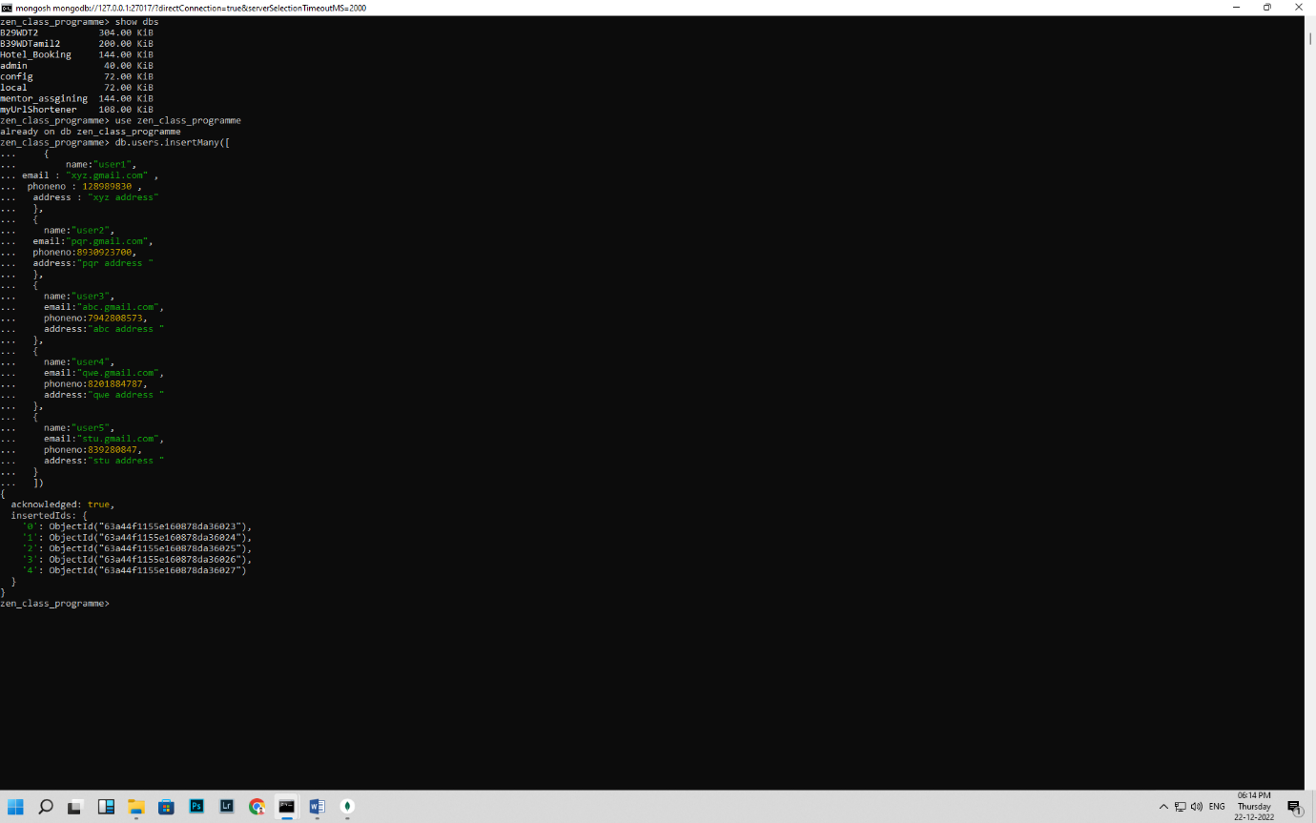**Create users:**

zen_class_programme> db.users.insertMany([

... {

... name:"user1",

... email : "xyz.gmail.com" ,

... phoneno : 128989830 ,

... address : "xyz address"

... },

... {

... name:"user2",

... email:"pqr.gmail.com",

... phoneno:8930923700,

... address:"pqr address "

... },

... {

... name:"user3",

... email:"abc.gmail.com",

... phoneno:7942808573,

... address:"abc address "

... },

... {

... name:"user4",

... email:"qwe.gmail.com",

... phoneno:8201884787,

... address:"qwe address "

... },

... {

... name:"user5",

... email:"stu.gmail.com",

... phoneno:839280847,

... address:"stu address "

... }

... ])

{

acknowledged: true,

insertedIds: {

'0': ObjectId("63a44f1155e160878da36023"),

'1': ObjectId("63a44f1155e160878da36024"),

'2': ObjectId("63a44f1155e160878da36025"),

'3': ObjectId("63a44f1155e160878da36026"),

'4': ObjectId("63a44f1155e160878da36027")

}

}

**Create codekata:**

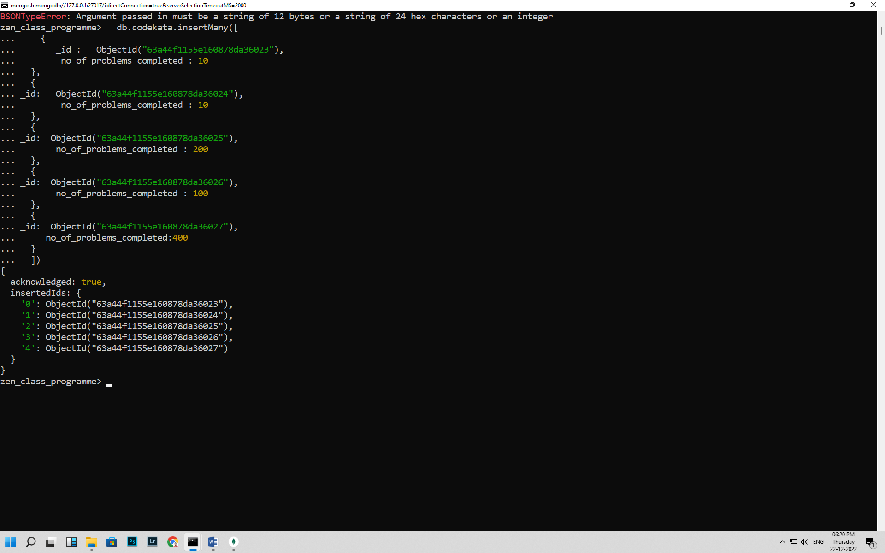

db.codekata.insertMany([

{

user_id : ObjectId("63a44f1155e160878da36023"),

no_of_problems_completed : 10

},

{

user_id: ObjectId("63a44f1155e160878da36024"),

no_of_problems_completed : 10

},

{

user_id: ObjectId("63a44f1155e160878da36025"),

no_of_problems_completed : 200

},

{

user_id: ObjectId("63a44f1155e160878da36026"),

no_of_problems_completed : 100

},

{

user_id: ObjectId("63a44f1155e160878da36027"),

no_of_problems_completed:400

}

])

**Create attendance:**

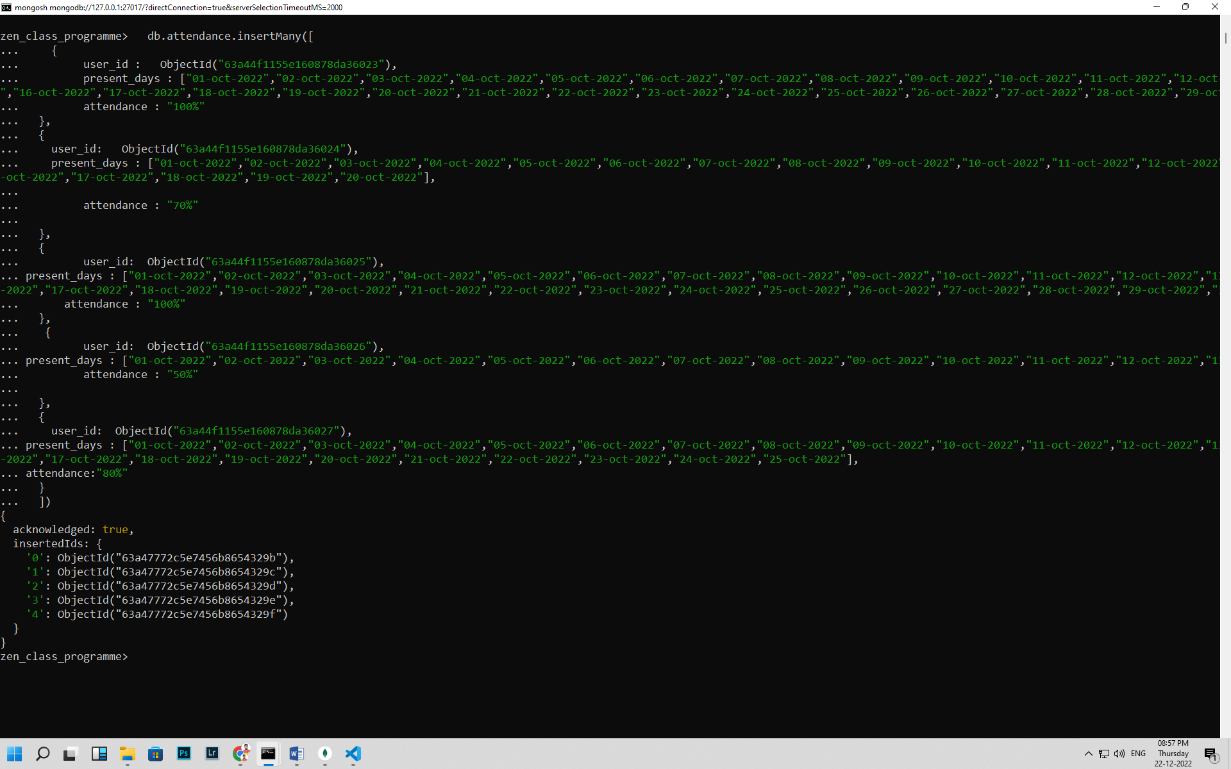 db.attendance.insertMany([

{

user_id : ObjectId("63a44f1155e160878da36023"),

present_days : ["01-oct-2022","02-oct-2022","03-oct-2022","04-oct-2022","05-oct-2022","06-oct-2022","07-oct-2022","08-oct-2022","09-oct-2022","10-oct-2022","11-oct-2022","12-oct-2022","13-oct-2022","14-oct-2022","15-oct-2022","16-oct-2022","17-oct-2022","18-oct-2022","19-oct-2022","20-oct-2022","21-oct-2022","22-oct-2022","23-oct-2022","24-oct-2022","25-oct-2022","26-oct-2022","27-oct-2022","28-oct-2022","29-oct-2022","30-oct-2022","31-oct-2022"],

attendance : "100%"

},

{

user_id: ObjectId("63a44f1155e160878da36024"),

present_days : ["01-oct-2022","02-oct-2022","03-oct-2022","04-oct-2022","05-oct-2022","06-oct-2022","07-oct-2022","08-oct-2022","09-oct-2022","10-oct-2022","11-oct-2022","12-oct-2022","13-oct-2022","14-oct-2022","15-oct-2022","16-oct-2022","17-oct-2022","18-oct-2022","19-oct-2022","20-oct-2022"],

attendance : "70%"

},

{

user_id: ObjectId("63a44f1155e160878da36025"),

present_days : ["01-oct-2022","02-oct-2022","03-oct-2022","04-oct-2022","05-oct-2022","06-oct-2022","07-oct-2022","08-oct-2022","09-oct-2022","10-oct-2022","11-oct-2022","12-oct-2022","13-oct-2022","14-oct-2022","15-oct-2022","16-oct-2022","17-oct-2022","18-oct-2022","19-oct-2022","20-oct-2022","21-oct-2022","22-oct-2022","23-oct-2022","24-oct-2022","25-oct-2022","26-oct-2022","27-oct-2022","28-oct-2022","29-oct-2022","30-oct-2022","31-oct-2022"],

attendance : "100%"

},

{

user_id: ObjectId("63a44f1155e160878da36026"),

present_days : ["01-oct-2022","02-oct-2022","03-oct-2022","04-oct-2022","05-oct-2022","06-oct-2022","07-oct-2022","08-oct-2022","09-oct-2022","10-oct-2022","11-oct-2022","12-oct-2022","13-oct-2022","14-oct-2022","15-oct-2022"],

attendance : "50%"

},

{

user_id: ObjectId("63a44f1155e160878da36027"),

present_days : ["01-oct-2022","02-oct-2022","03-oct-2022","04-oct-2022","05-oct-2022","06-oct-2022","07-oct-2022","08-oct-2022","09-oct-2022","10-oct-2022","11-oct-2022","12-oct-2022","13-oct-2022","14-oct-2022","15-oct-2022","16-oct-2022","17-oct-2022","18-oct-2022","19-oct-2022","20-oct-2022","21-oct-2022","22-oct-2022","23-oct-2022","24-oct-2022","25-oct-2022"],

attendance:"80%"

}

])

**Create topics:**

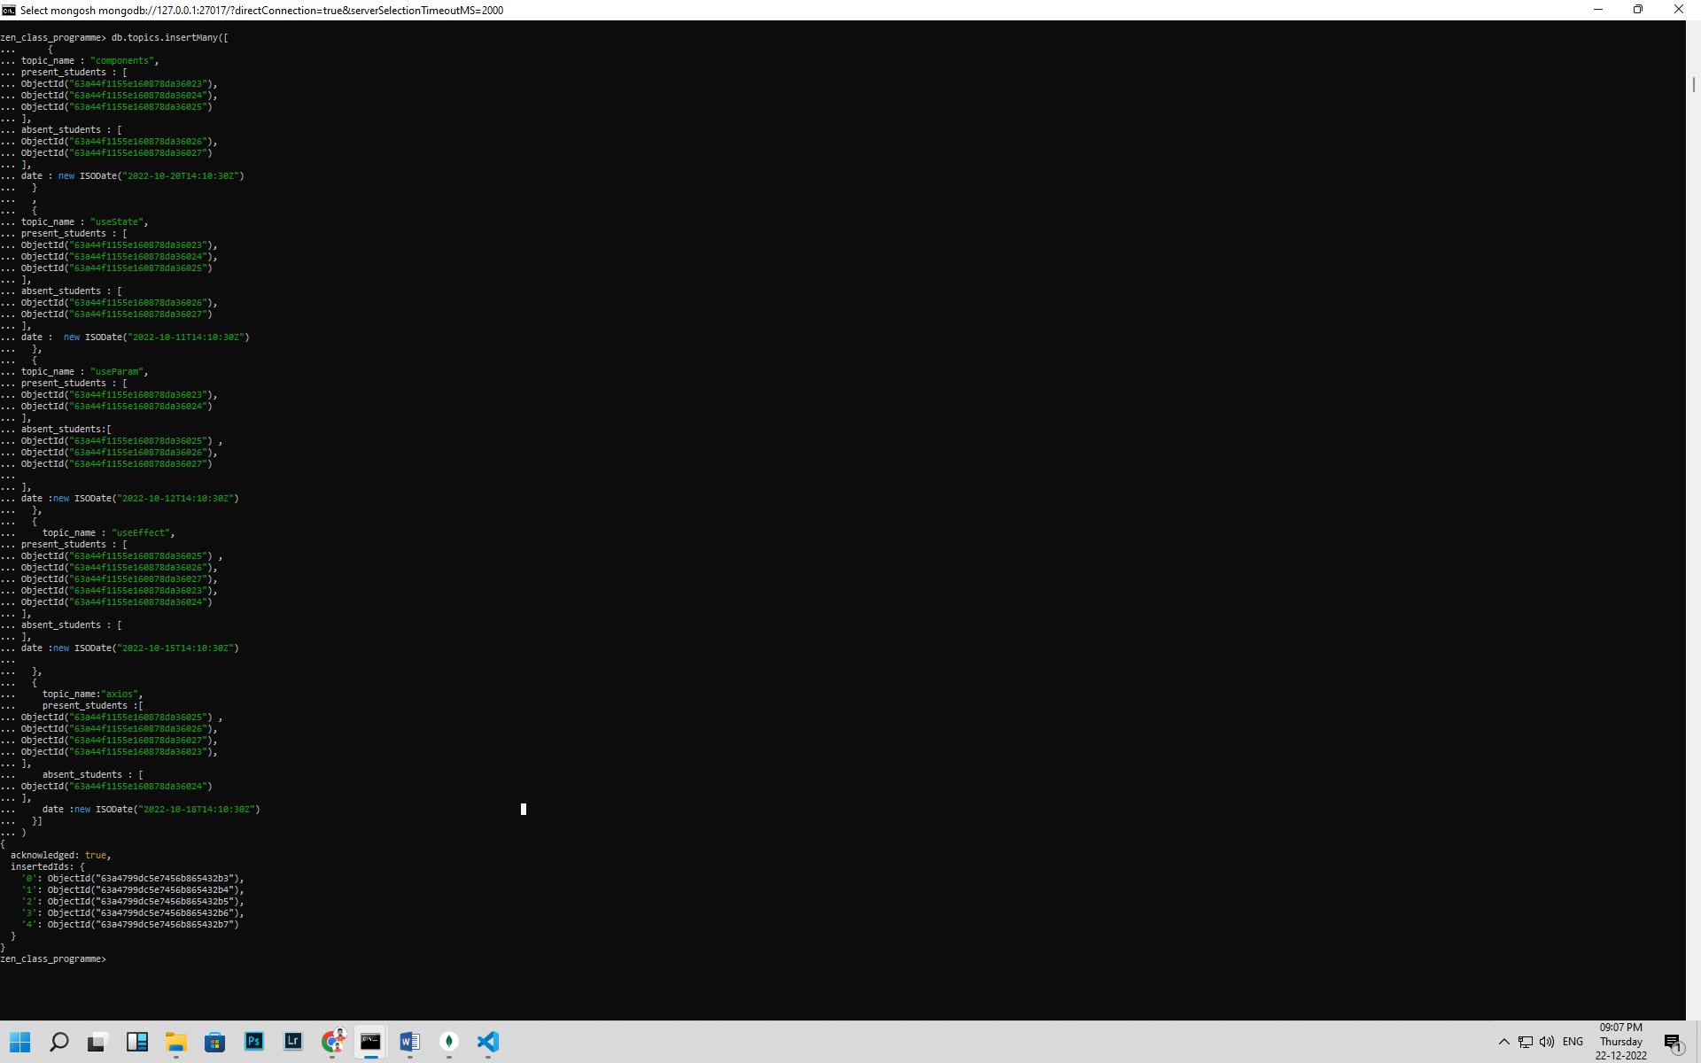

db.topics.insertMany([

{

topic_name : "components",

present_students : [

ObjectId("63a44f1155e160878da36023"),

ObjectId("63a44f1155e160878da36024"),

ObjectId("63a44f1155e160878da36025")

],

absent_students : [

ObjectId("63a44f1155e160878da36026"),

ObjectId("63a44f1155e160878da36027")

],

date : new ISODate("2022-10-20T14:10:30Z")

}

,

{

topic_name : "useState",

present_students : [

ObjectId("63a44f1155e160878da36023"),

ObjectId("63a44f1155e160878da36024"),

ObjectId("63a44f1155e160878da36025")

],

absent_students : [

ObjectId("63a44f1155e160878da36026"),

ObjectId("63a44f1155e160878da36027")

],

date : new ISODate("2022-10-11T14:10:30Z")

},

{

topic_name : "useParam",

present_students : [

ObjectId("63a44f1155e160878da36023"),

ObjectId("63a44f1155e160878da36024")

],

absent_students:[

ObjectId("63a44f1155e160878da36025") ,

ObjectId("63a44f1155e160878da36026"),

ObjectId("63a44f1155e160878da36027")

],

date :new ISODate("2022-10-12T14:10:30Z")

},

{

topic_name : "useEffect",

present_students : [

ObjectId("63a44f1155e160878da36025") ,

ObjectId("63a44f1155e160878da36026"),

ObjectId("63a44f1155e160878da36027"),

ObjectId("63a44f1155e160878da36023"),

ObjectId("63a44f1155e160878da36024")

],

absent_students : [

],

date :new ISODate("2022-10-15T14:10:30Z")

},

{

topic_name:"axios",

present_students :[

ObjectId("63a44f1155e160878da36025") ,

ObjectId("63a44f1155e160878da36026"),

ObjectId("63a44f1155e160878da36027"),

ObjectId("63a44f1155e160878da36023"),

],

absent_students : [

ObjectId("63a44f1155e160878da36024")

],

date :new ISODate("2022-10-18T14:10:30Z")

}]

)

**Create tasks:**

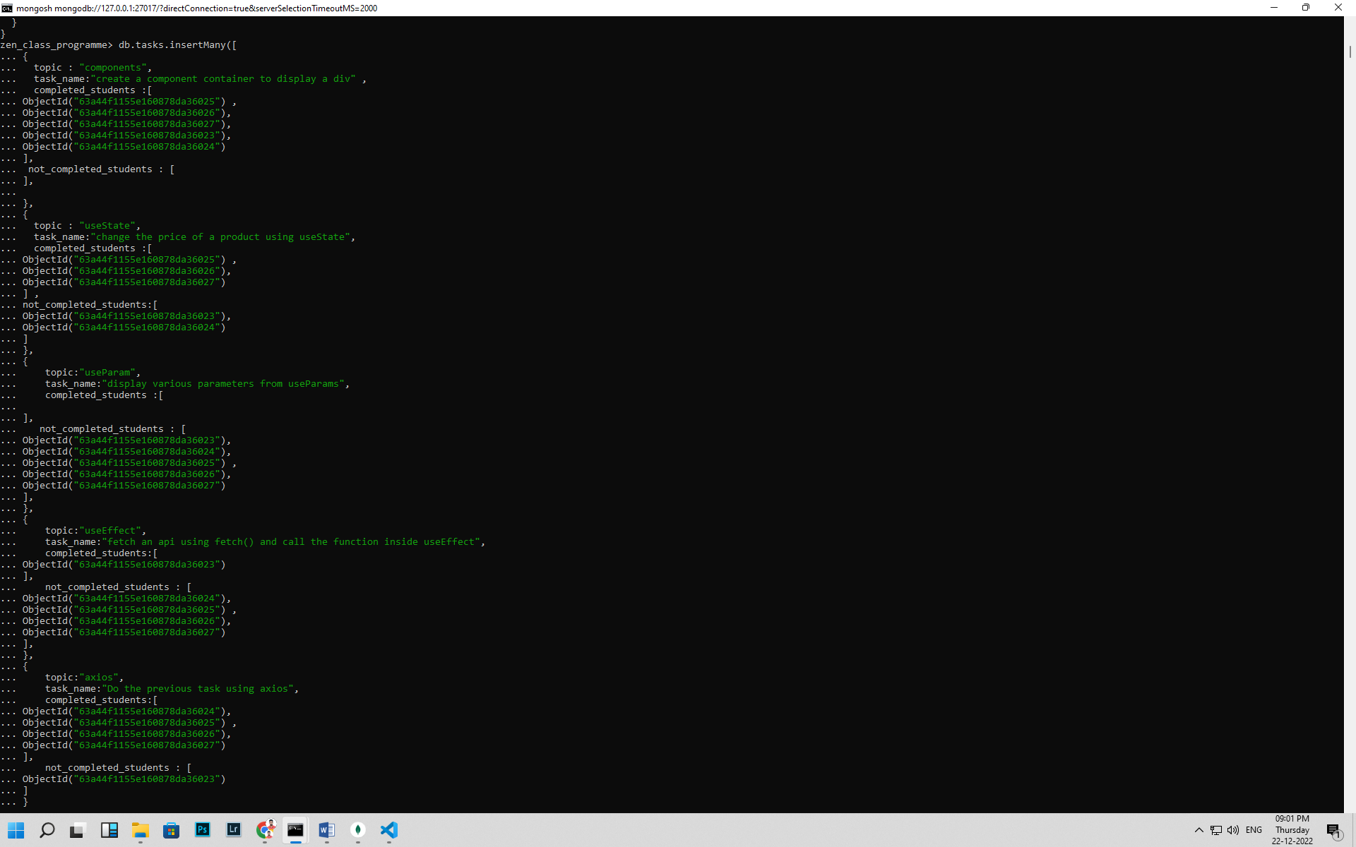

db.tasks.insertMany([

{

topic : "components",

task_name:"create a component container to display a div" ,

completed_students :[

ObjectId("63a44f1155e160878da36025") ,

ObjectId("63a44f1155e160878da36026"),

ObjectId("63a44f1155e160878da36027"),

ObjectId("63a44f1155e160878da36023"),

ObjectId("63a44f1155e160878da36024")

],

not_completed_students : [

],

},

{

topic : "useState",

task_name:"change the price of a product using useState",

completed_students :[

ObjectId("63a44f1155e160878da36025") ,

ObjectId("63a44f1155e160878da36026"),

ObjectId("63a44f1155e160878da36027")

] ,

not_completed_students:[

ObjectId("63a44f1155e160878da36023"),

ObjectId("63a44f1155e160878da36024")

]

},

{

topic:"useParam",

task_name:"display various parameters from useParams",

completed_students :[

],

not_completed_students : [

ObjectId("63a44f1155e160878da36023"),

ObjectId("63a44f1155e160878da36024"),

ObjectId("63a44f1155e160878da36025") ,

ObjectId("63a44f1155e160878da36026"),

ObjectId("63a44f1155e160878da36027")

],

},

{

topic:"useEffect",

task_name:"fetch an api using fetch() and call the function inside useEffect",

completed_students:[

ObjectId("63a44f1155e160878da36023")

],

not_completed_students : [

ObjectId("63a44f1155e160878da36024"),

ObjectId("63a44f1155e160878da36025") ,

ObjectId("63a44f1155e160878da36026"),

ObjectId("63a44f1155e160878da36027")

],

},

{

topic:"axios",

task_name:"Do the previous task using axios",

completed_students:[

ObjectId("63a44f1155e160878da36024"),

ObjectId("63a44f1155e160878da36025") ,

ObjectId("63a44f1155e160878da36026"),

ObjectId("63a44f1155e160878da36027")

],

not_completed_students : [

ObjectId("63a44f1155e160878da36023")

]

}

])

**Create company_drives:** 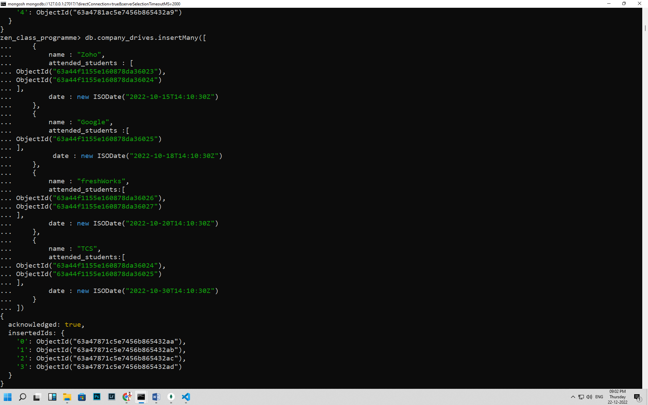

db.company_drives.insertMany([

{

name : "Zoho",

attended_students : [

ObjectId("63a44f1155e160878da36023"),

ObjectId("63a44f1155e160878da36024")

],

date : new ISODate("2022-10-15T14:10:30Z")

},

{

name : "Google",

attended_students :[

ObjectId("63a44f1155e160878da36025")

],

date : new ISODate("2022-10-18T14:10:30Z")

},

{

name : "freshWorks",

attended_students:[

ObjectId("63a44f1155e160878da36026"),

ObjectId("63a44f1155e160878da36027")

],

date : new ISODate("2022-10-20T14:10:30Z")

},

{

name : "TCS",

attended_students:[

ObjectId("63a44f1155e160878da36024"),

ObjectId("63a44f1155e160878da36025")

],

date : new ISODate("2022-10-30T14:10:30Z")

}

])

**Create mentors:** 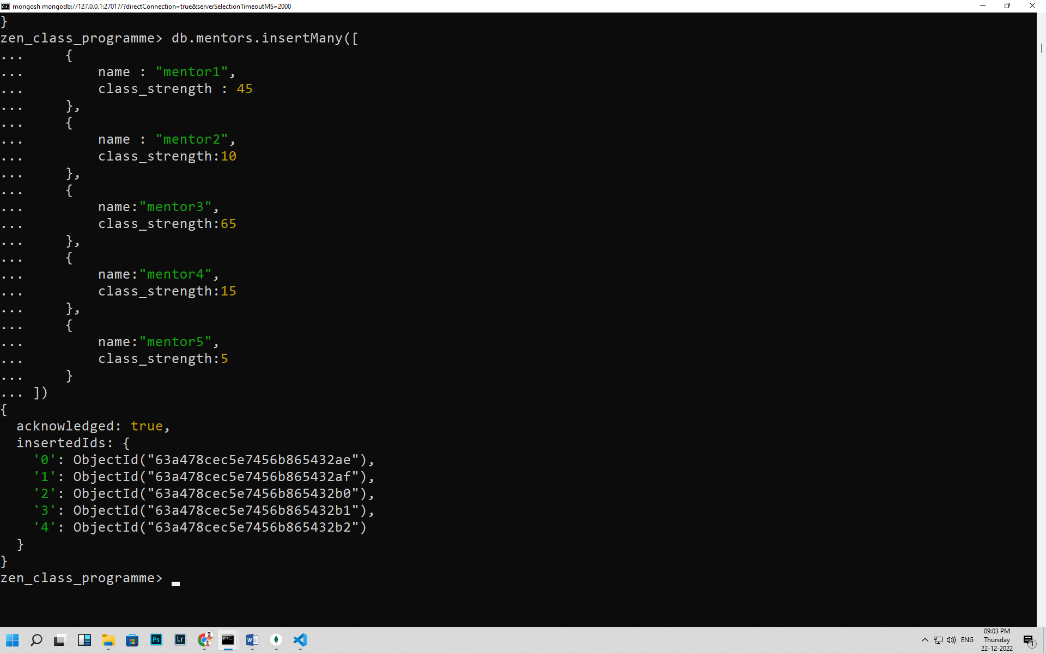

db.mentors.insertMany([

{

name : "mentor1",

class_strength : 45

},

{

name : "mentor2",

class_strength:10

},

{

name:"mentor3",

class_strength:65

},

{

name:"mentor4",

class_strength:15

},

{

name:"mentor5",

class_strength:5

}

])

**1)Find all the topics and tasks which are thought in the month of October:**

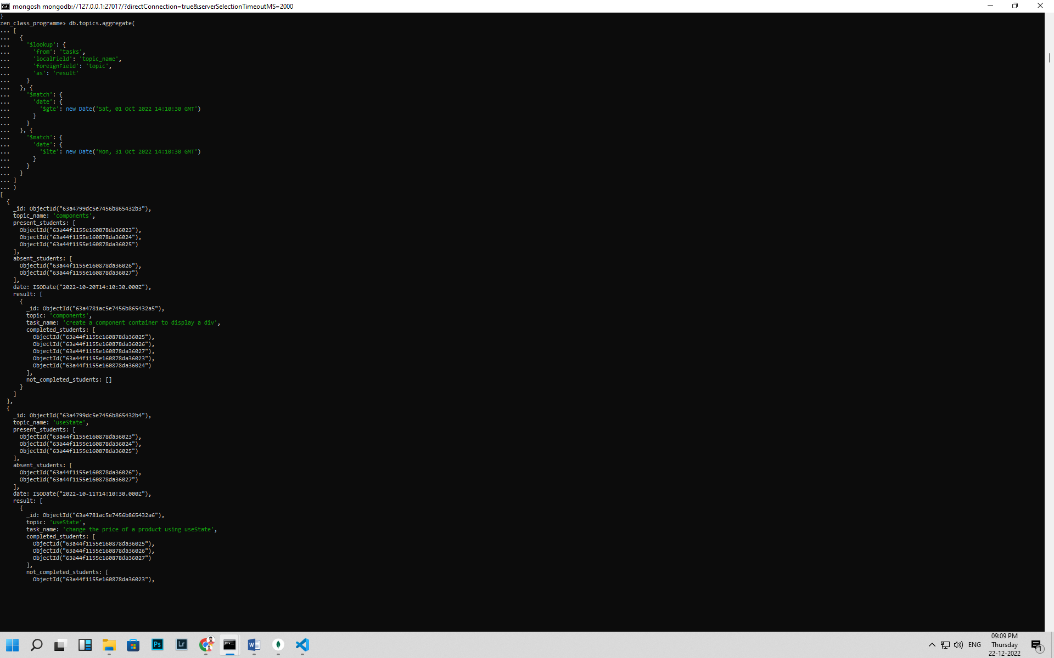 db.topics.aggregate(

[

{

'$lookup': {

'from': 'tasks',

'localField': 'topic_name',

'foreignField': 'topic',

'as': 'result'

}

}, {

'$match': {

'date': {

'$gte': new Date('Sat, 01 Oct 2022 14:10:30 GMT')

}

}

}, {

'$match': {

'date': {

'$lte': new Date('Mon, 31 Oct 2022 14:10:30 GMT')

}

}

}

]

)

**2) Find all the company drives which appeared between 15 oct-2020 and 31-oct-2020**

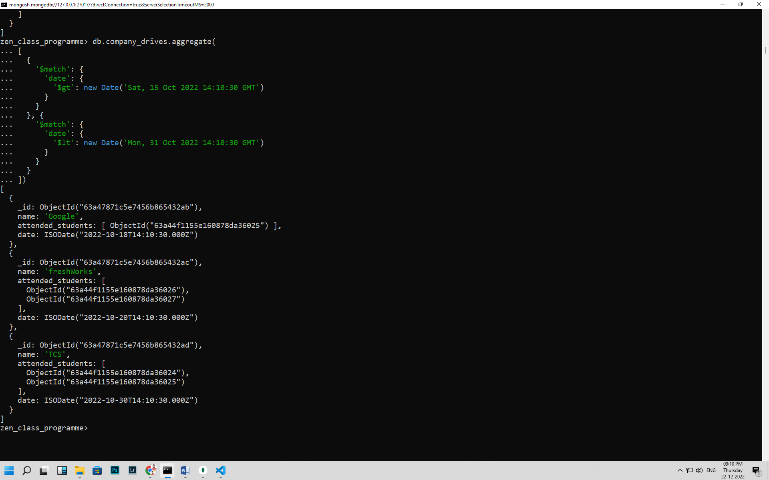

db.company_drives.aggregate(

[

{

'$match': {

'date': {

'$gt': new Date('Sat, 15 Oct 2022 14:10:30 GMT')

}

}

}, {

'$match': {

'date': {

'$lt': new Date('Mon, 31 Oct 2022 14:10:30 GMT')

}

}

}

])

**3)Find all the company drives and students who are appeared for the placement.**

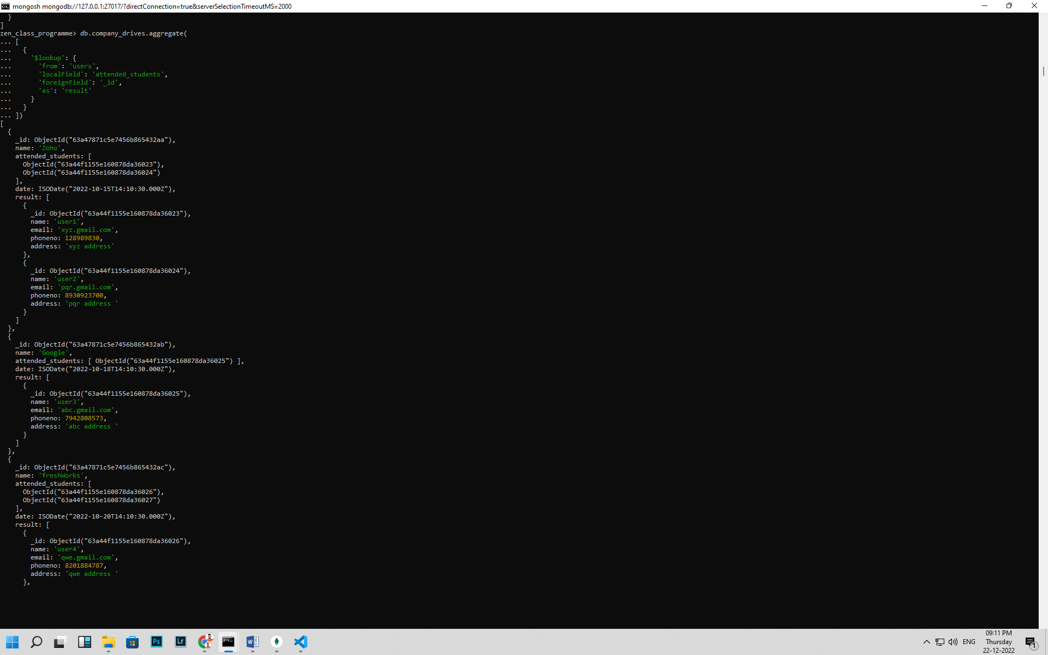

db.company_drives.aggregate(

[

{

'$lookup': {

'from': 'users',

'localField': 'attended_students',

'foreignField': '_id',

'as': 'result'

}

}

])

**4)Find the number of problems solved by the user in codekata:**

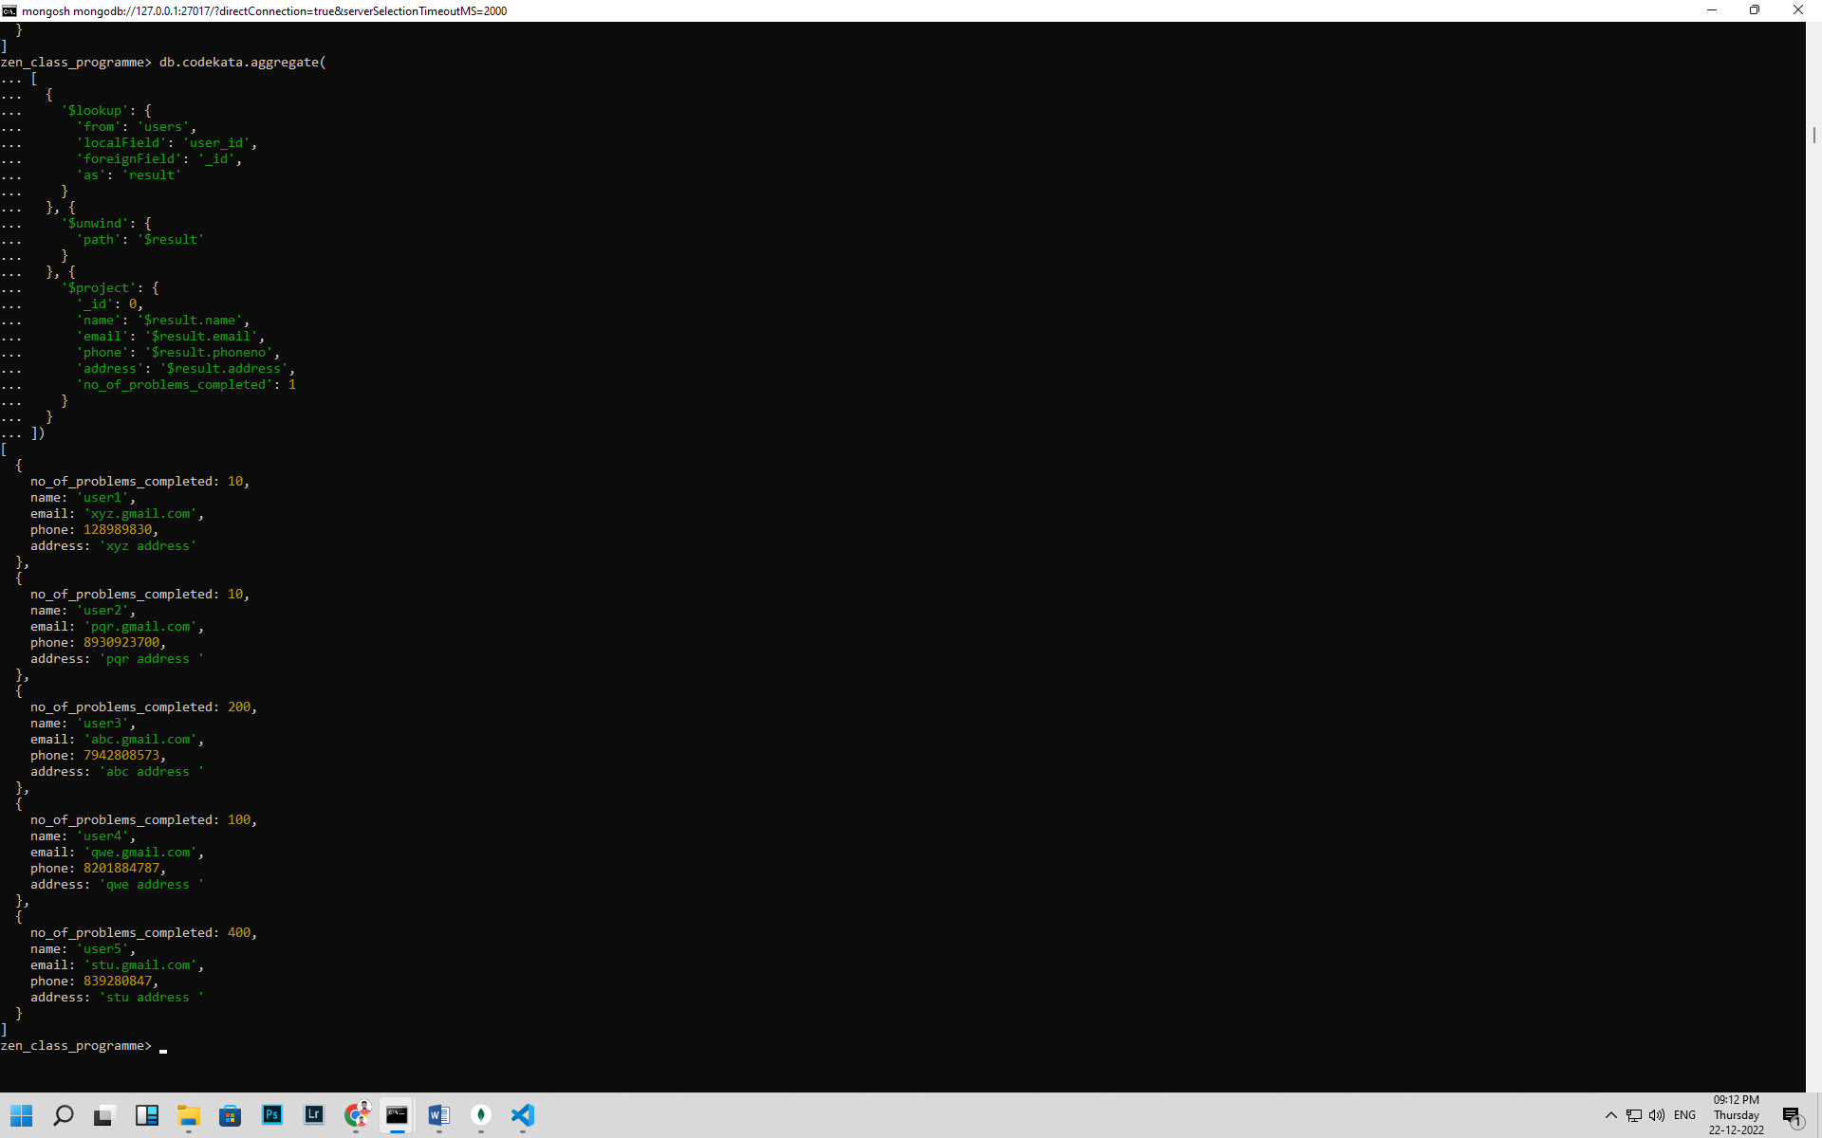 db.codekata.aggregate(

[

{

'$lookup': {

'from': 'users',

'localField': 'user_id',

'foreignField': '_id',

'as': 'result'

}

}, {

'$unwind': {

'path': '$result'

}

}, {

'$project': {

'_id': 0,

'name': '$result.name',

'email': '$result.email',

'phone': '$result.phoneno',

'address': '$result.address',

'no_of_problems_completed': 1

}

}

])

**5) Find all the mentors with who has the mentee's count more than 15:**

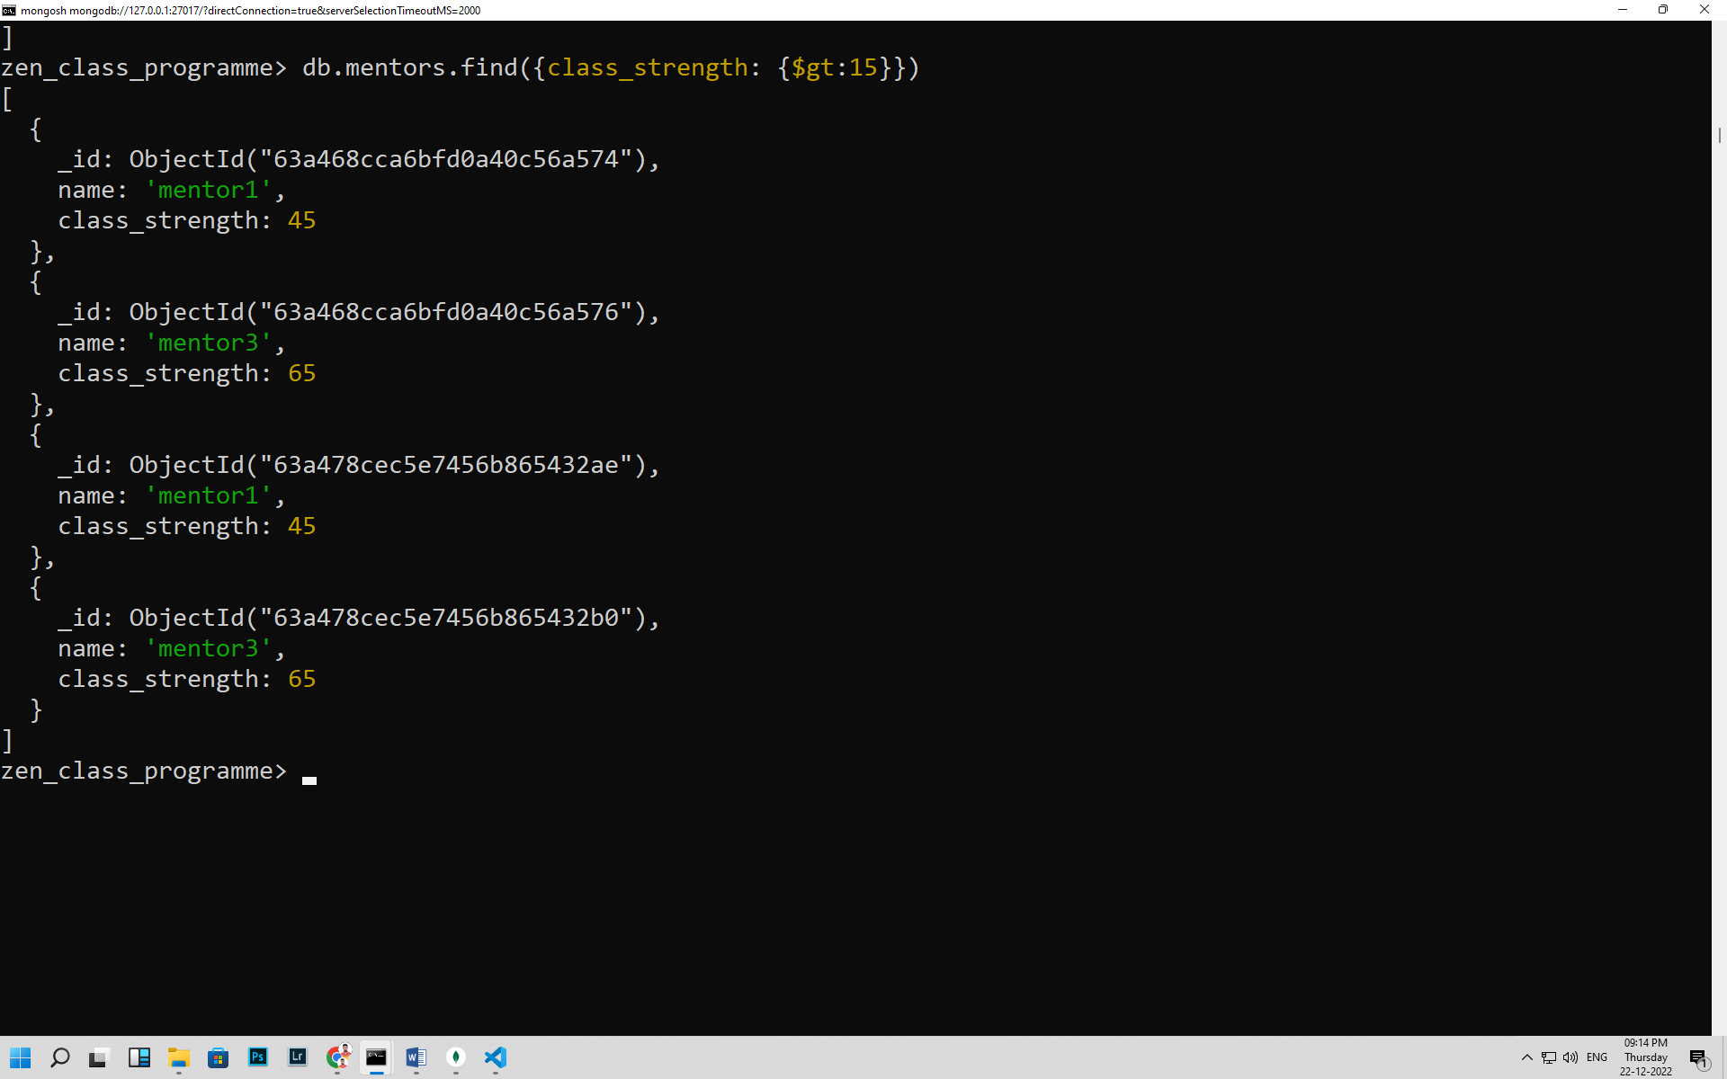

db.mentors.find({class_strength: {$gt:15}})

**6)Find the number of users who are absent and task is not submitted between 15 oct-2020 and 31-oct-2020:**

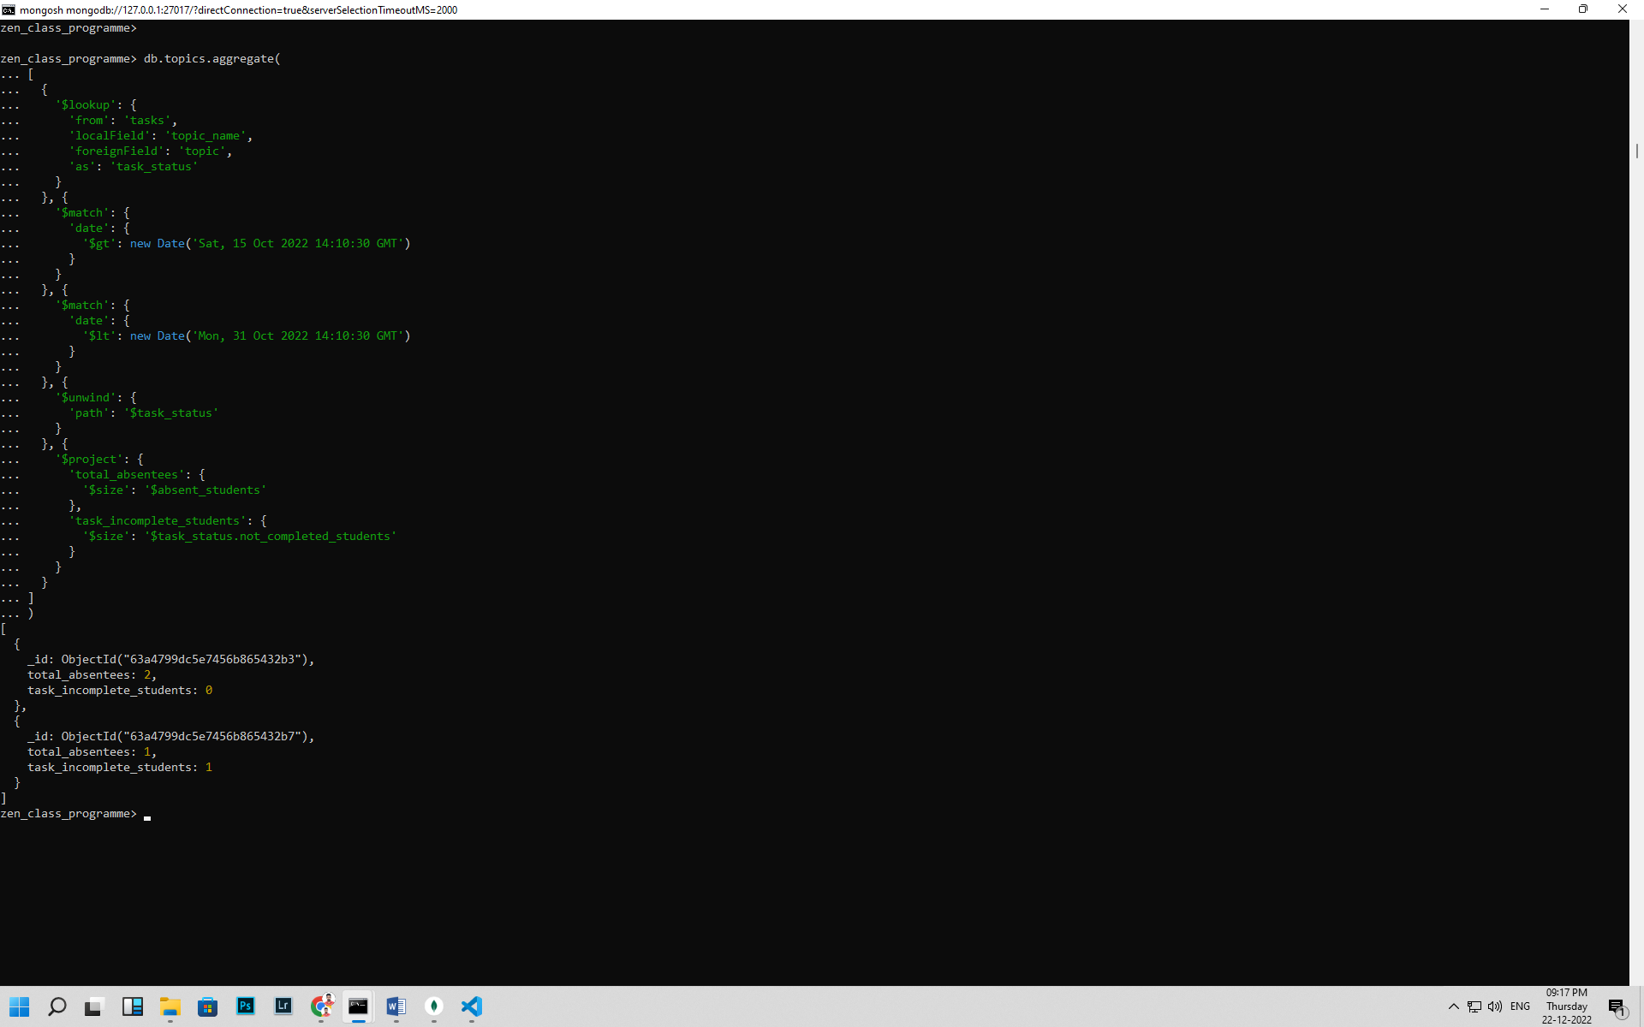 db.topics.aggregate(

[

{

'$lookup': {

'from': 'tasks',

'localField': 'topic_name',

'foreignField': 'topic',

'as': 'task_status'

}

}, {

'$match': {

'date': {

'$gt': new Date('Sat, 15 Oct 2022 14:10:30 GMT')

}

}

}, {

'$match': {

'date': {

'$lt': new Date('Mon, 31 Oct 2022 14:10:30 GMT')

}

}

}, {

'$unwind': {

'path': '$task_status'

}

}, {

'$project': {

'total_absentees': {

'$size': '$absent_students'

},

'task_incomplete_students': {

'$size': '$task_status.not_completed_students'

}

}

}

]

)