PATH PARAMETERS
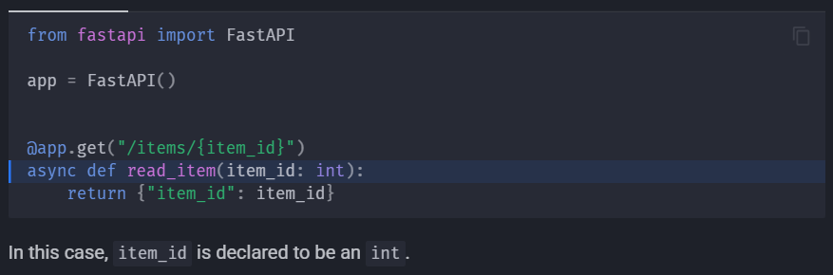
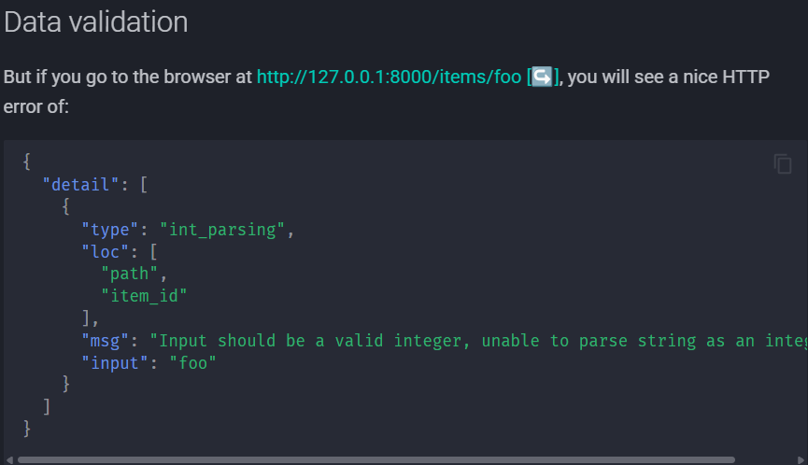

ORDER OF PATH OPERATIONS:
Because path operations are evaluated in order, you need to make sure that the path for /users/me is declared before the one for /users/{user_id}:
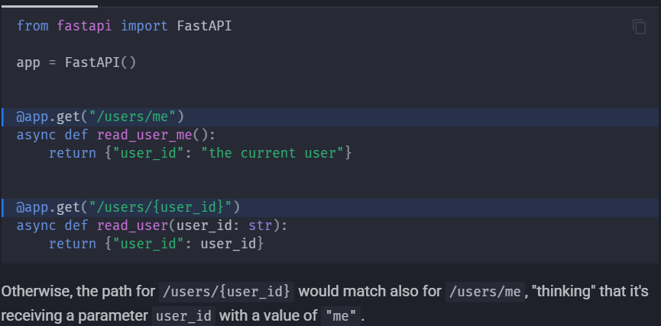

CAN WE REDEFINE A PATH OPERATION?
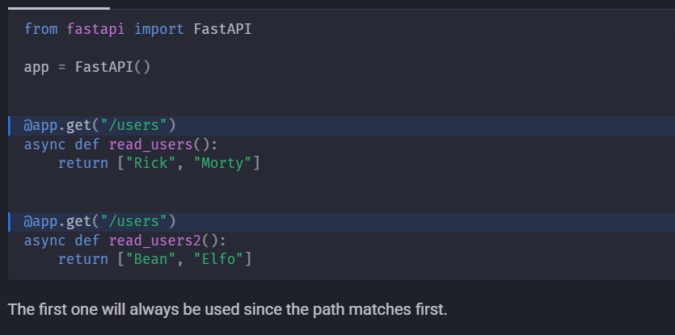

USING ENUM CLASS
This we can use while we want to predefine possible valid path parameter values
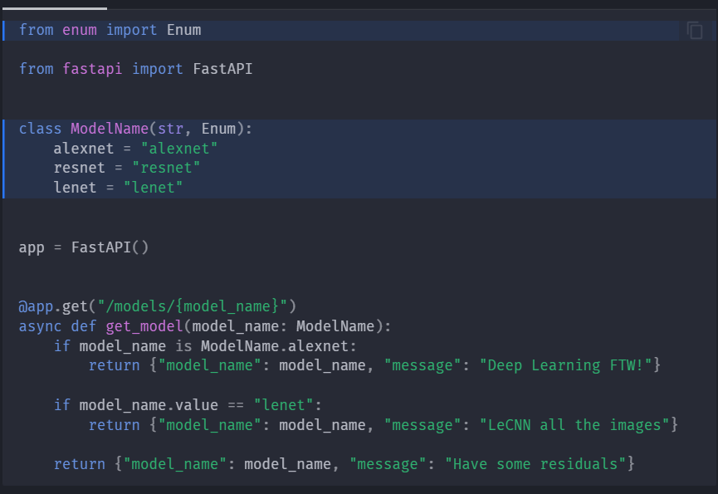

ADDING PATH IN PATH PARAMETERS:
Suppose we wish to add path of file in the path parameters then,
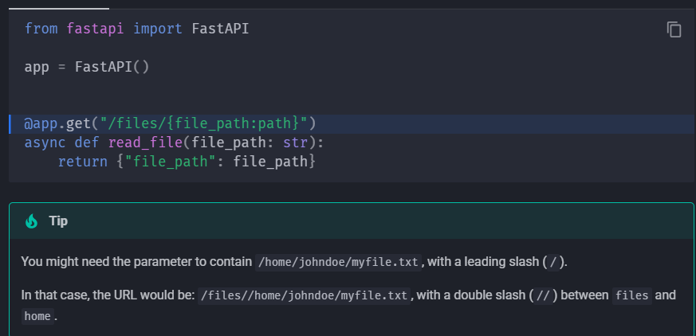

QUERY PARAMETERS

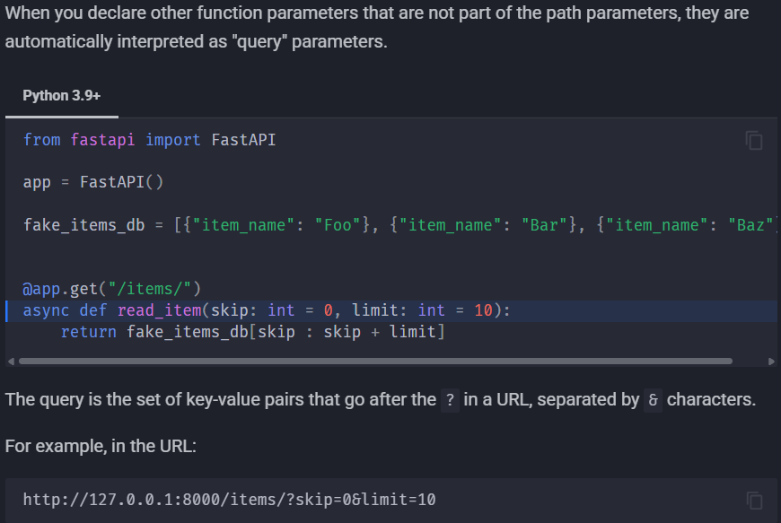
Skip and limit are query parameters and since we pass them in URL, they are initially passed as strings but fastapi will convert them into the python types they were defined
Here default values for skip is zero and for limit it is 10. If no value is provided in the URL, these are considered, we can even keep them as optional by using None
Multiple query and path params
You can declare multiple path parameters and query parameters at the same time, FastAPI knows which is which.
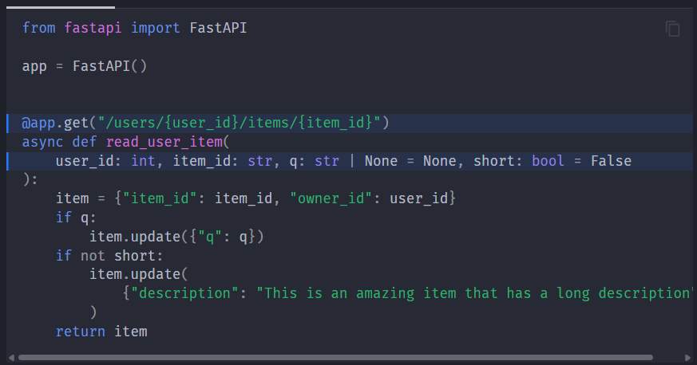
User_id and item_id are path parameters and short is the query parameter

REQUEST BODY
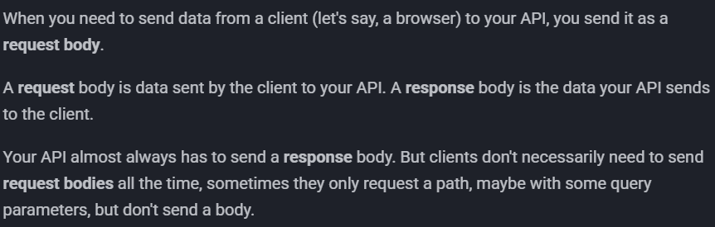
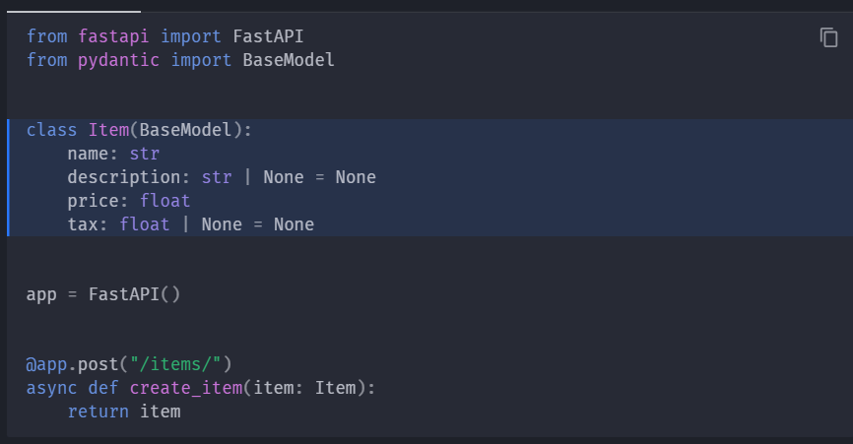

BODY+PATH PARAMETERS:
In the below example, item_id is path parameter and item is the body parameter
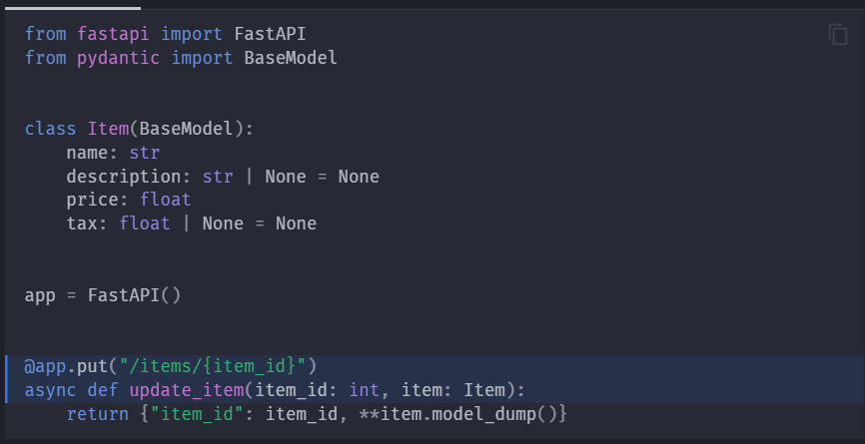
BODY+PATH+QUERY PARAMETERS:
in the below example q is the query parameter.
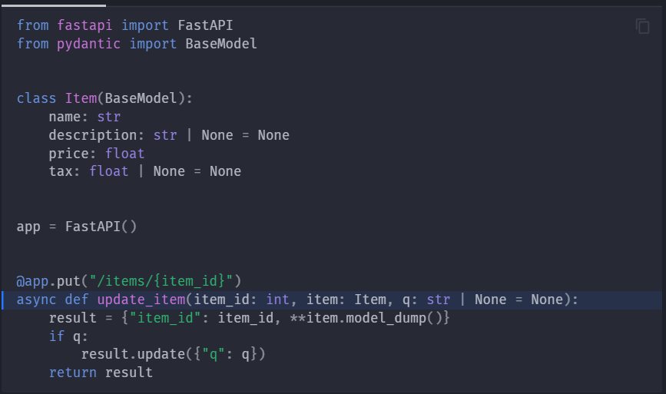
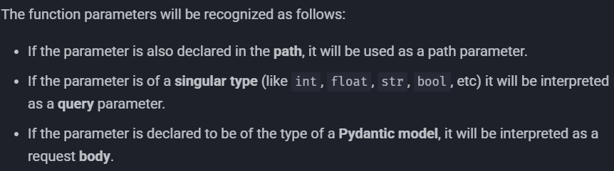
QUERY PARAMETERS AND STRING VALIDATIONS
The query param q here is optional by default but if provided it can’t exceed 50 characters
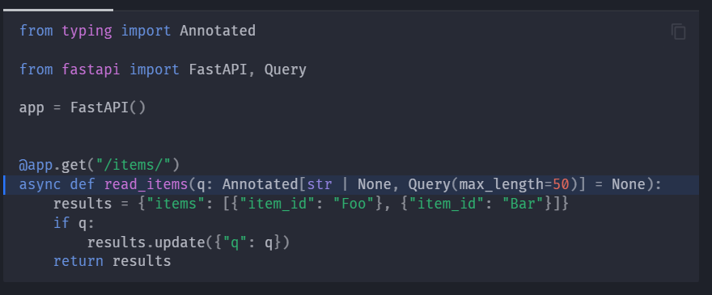
Some more validations like min_length, some regex, default value
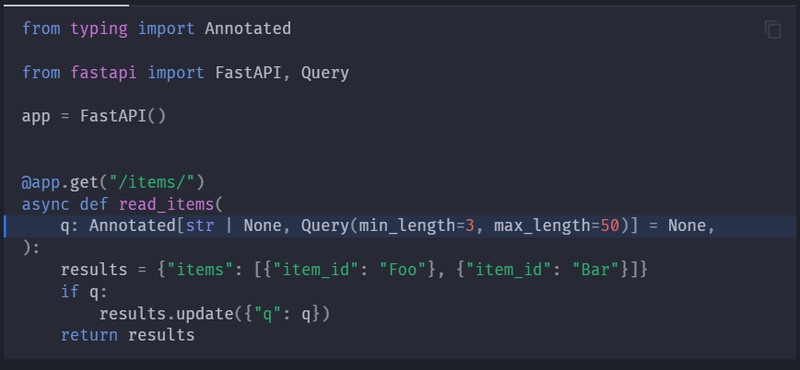
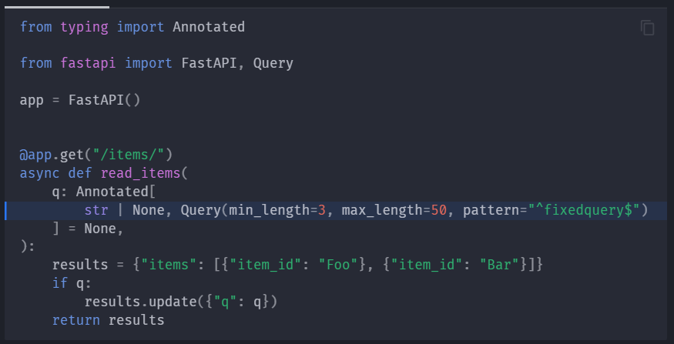
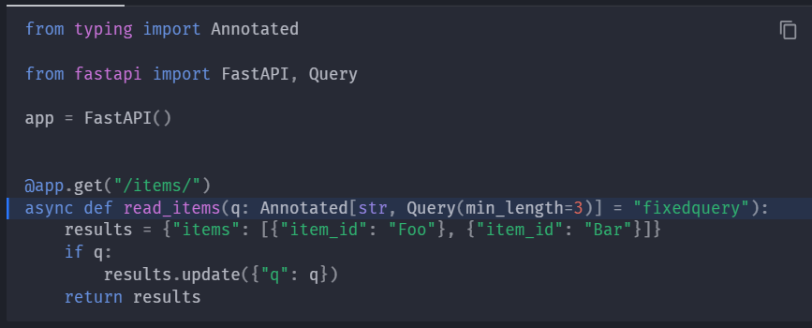
Query parameter list/multiple values
We can pass list of query parameters in the URL, for that we have use python list in the definition and can pass it like http://localhost:8000/items/?q=foo&q=bar

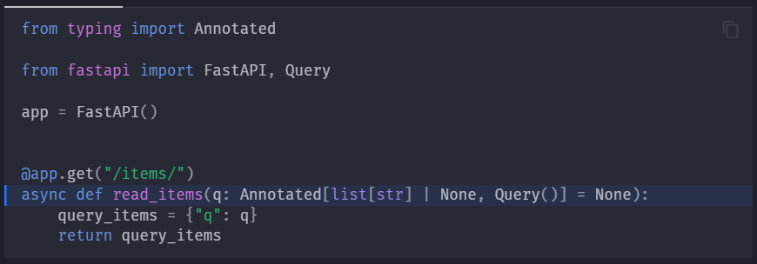
We can also give some default values like the following. Foo and bar are the default query parameters
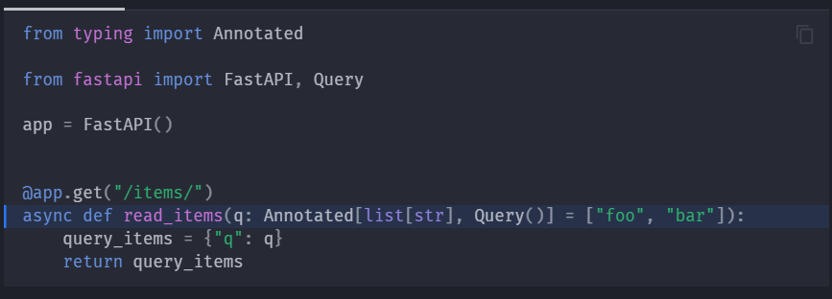
Declaring more metadata:
Adding a title
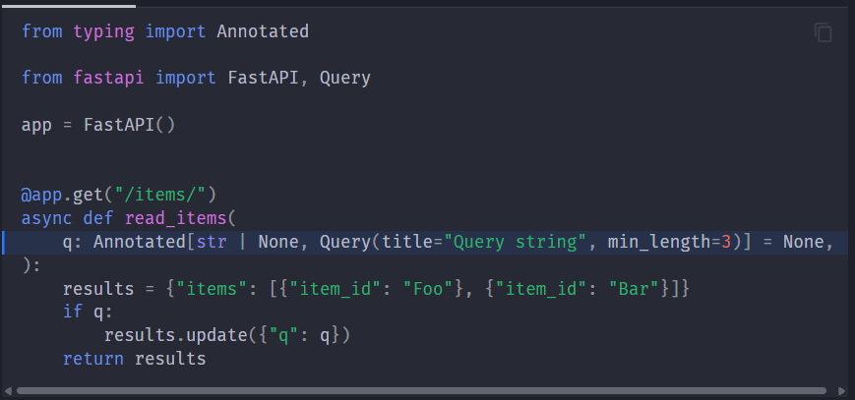
Adding some description
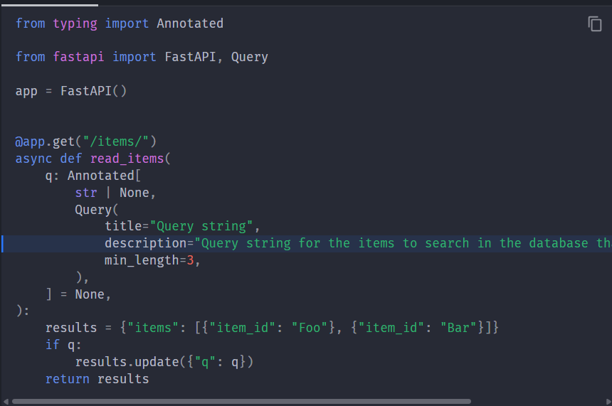
Alias parameters:
Suppose we want to declare item-query which is not valid(item_query is valid) but still we want to define it, in that case, we can use alias
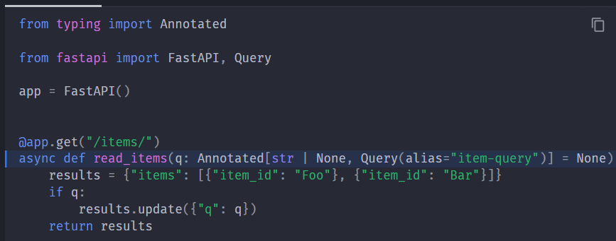
Deprecated parameters
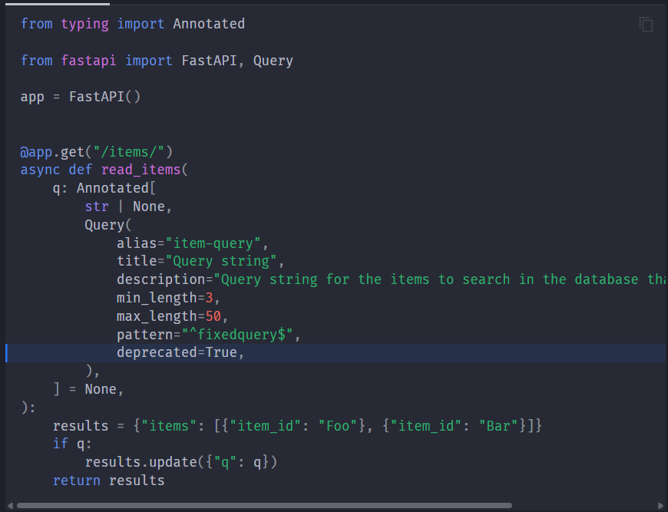
Excluding a query parameter
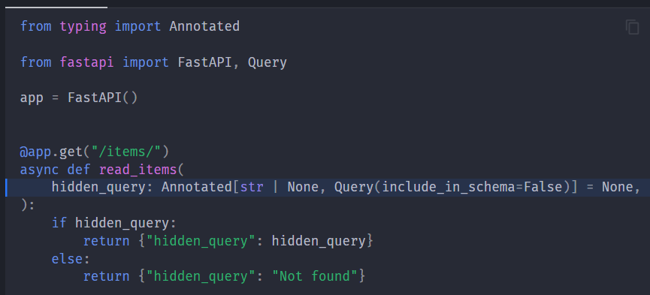

PATH PARAMETERS AND NUMERIC VALIDATIONS
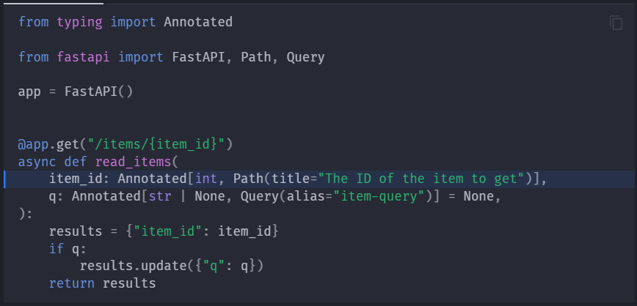
QUERY PARAMETER MODELS
Whenever we have a group of parameters that are related, we can use pydantic model to define so we can define once and can re-use wherever required.
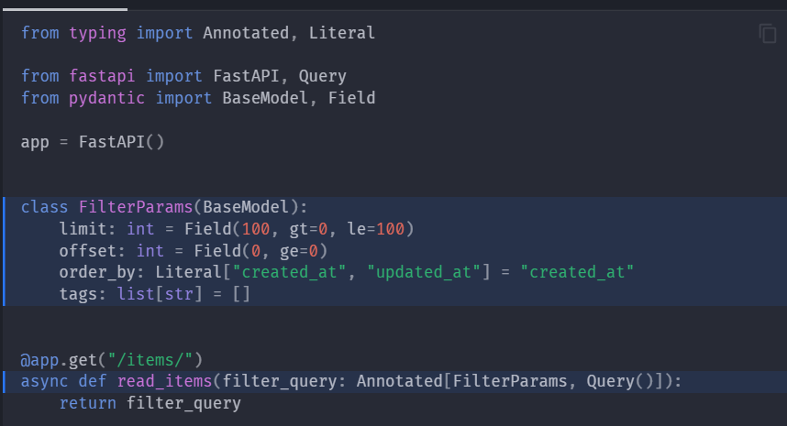
Whenever we want to avoid passing of extra query parameters that mentioned in the definition, and when the user tries to send extra, we can send a throwback.
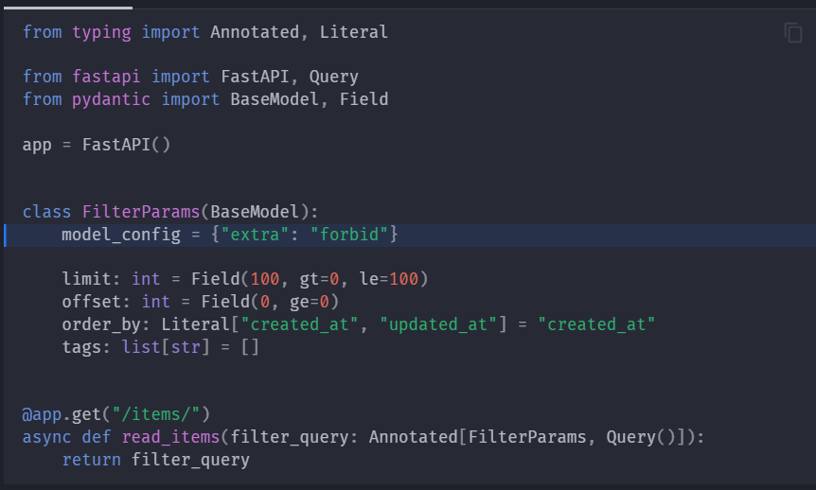
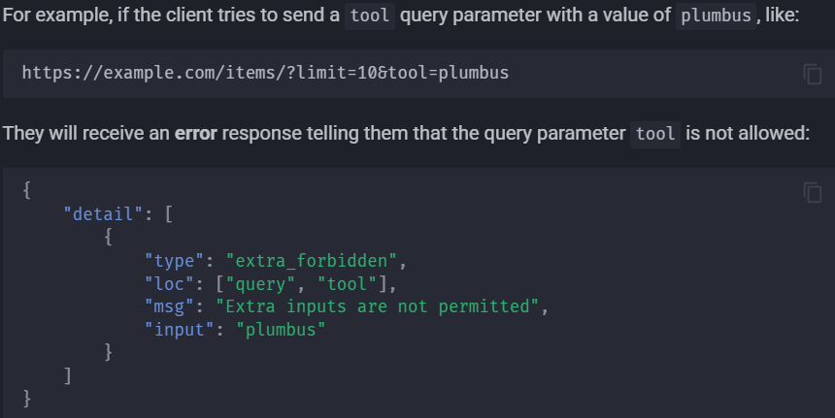

BODY – MULTIPLE PARAMETERS
Mixing body, query and path parameters
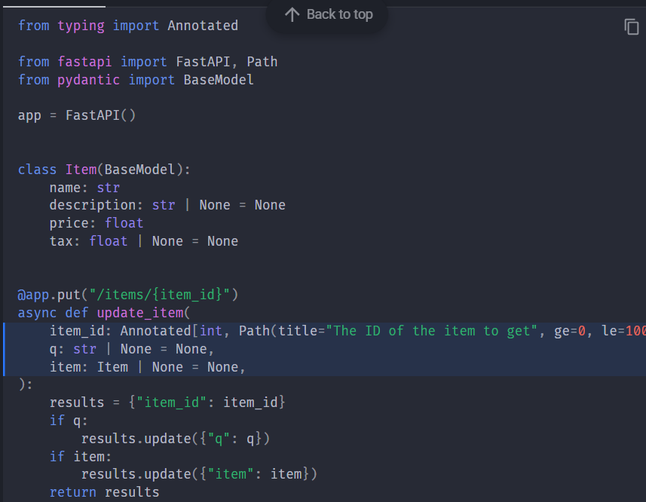

Declaring multiple body parameters:
Here, fastapi knows there are two body parameters since two pydantic models are defined
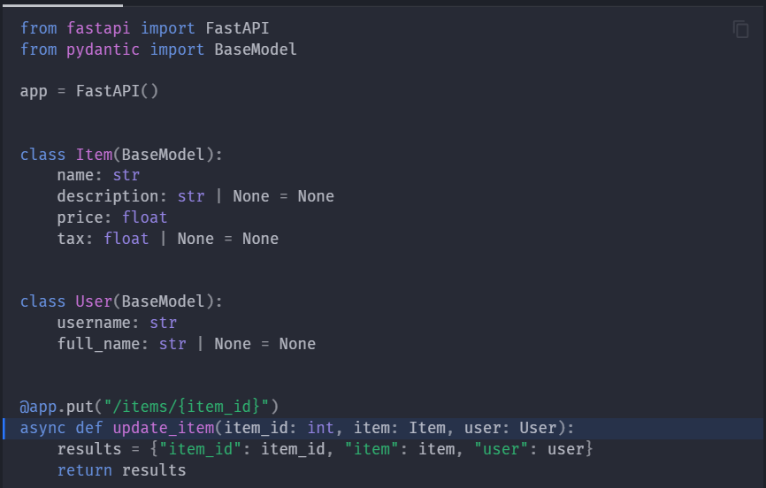
Suppose we want to pass a singular body parameters and if we pass it simply, fastapi assumes it as query parameter. In that case, we can pass it using Body()
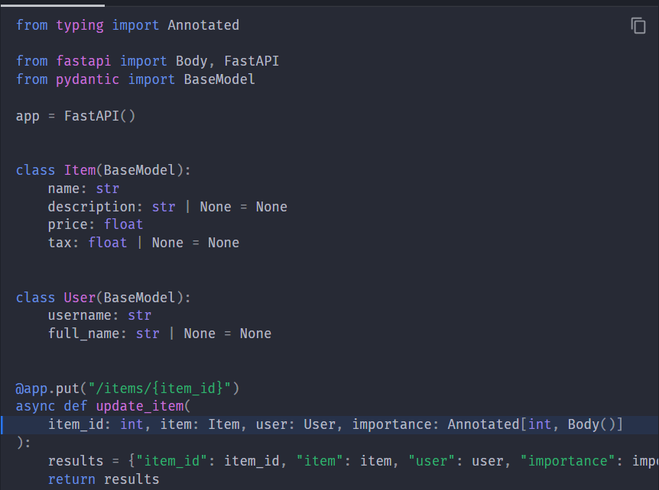

Passing path, query and multiple body parameters:
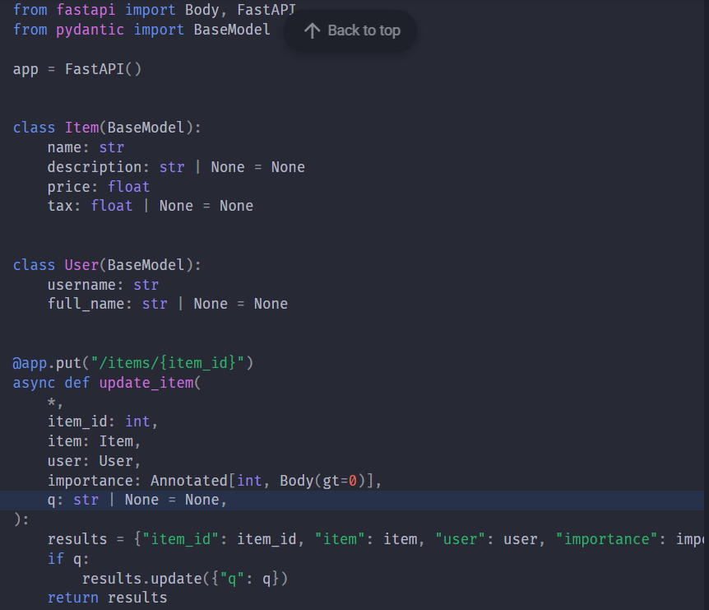

Embedding a single body parameter
This is the case where we want to pass JSON with key and model content. See the example
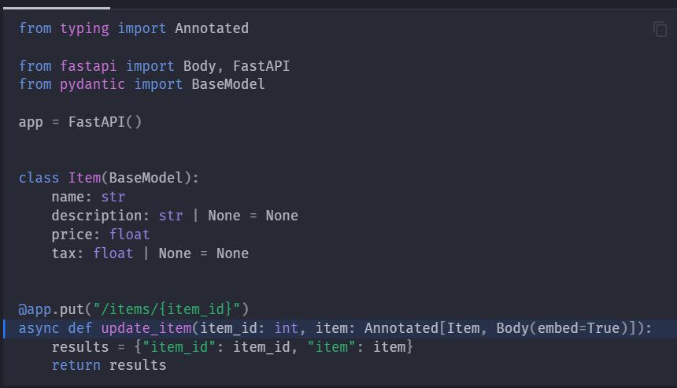
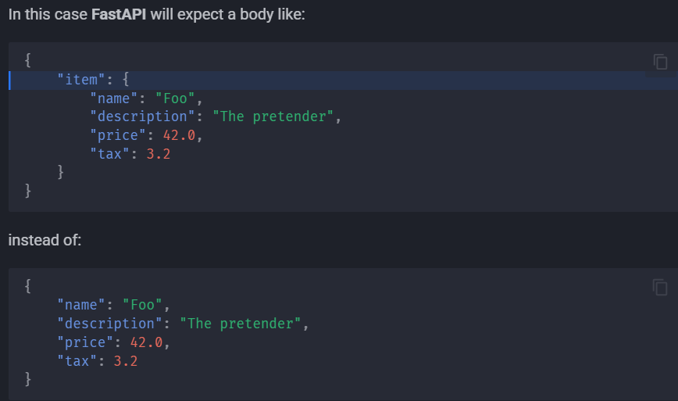

BODY – FIELDS
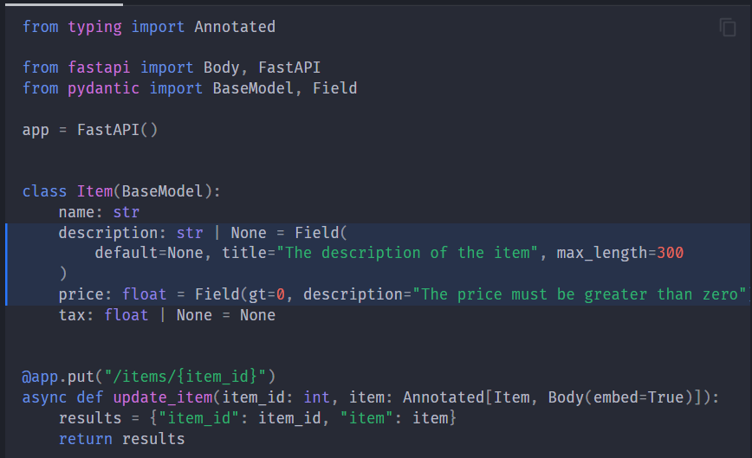
COOKIE PARAMETERS
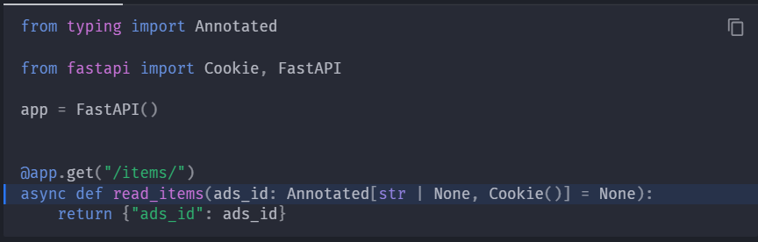
HEADER PARAMETERS
We can define using Header class from fastapi and it will deal with case-insensitiveness and also converting underscore to hyphen
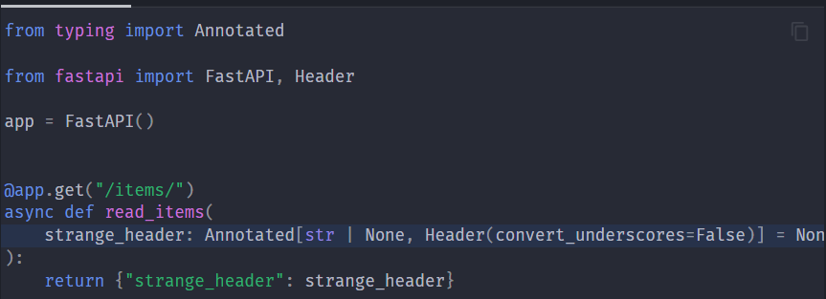
We can pass duplicate headers using list
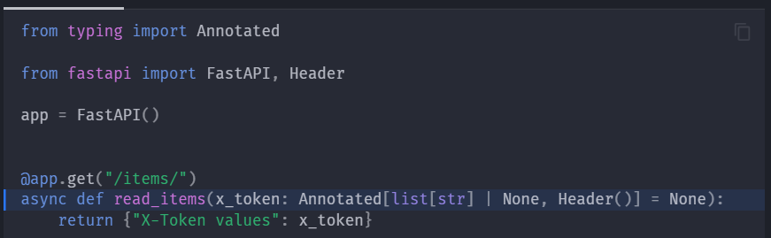
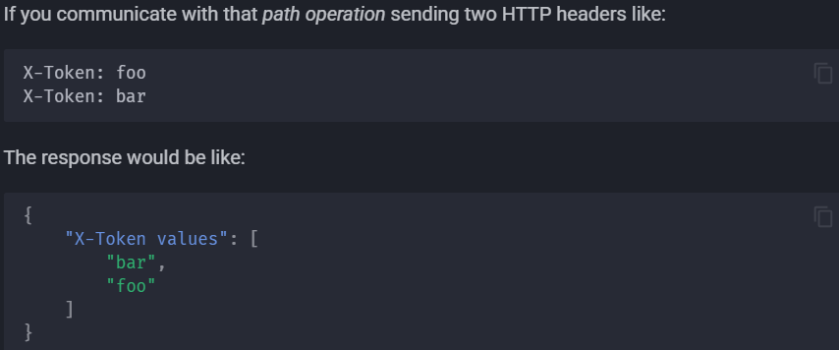
COOKIE PARAMETER MODELS
We can use pydantic model to declare them
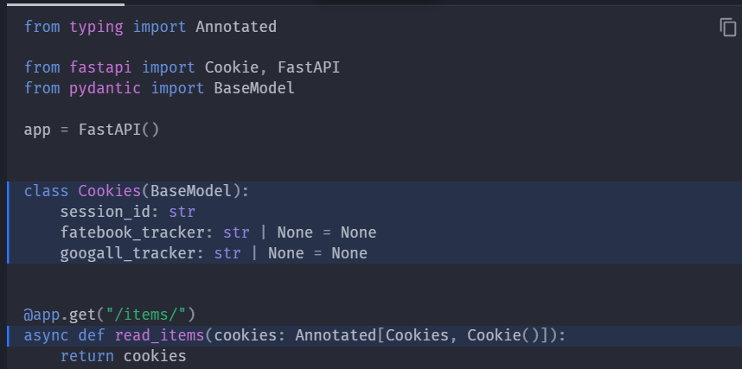
We can forbid extra cookies as well
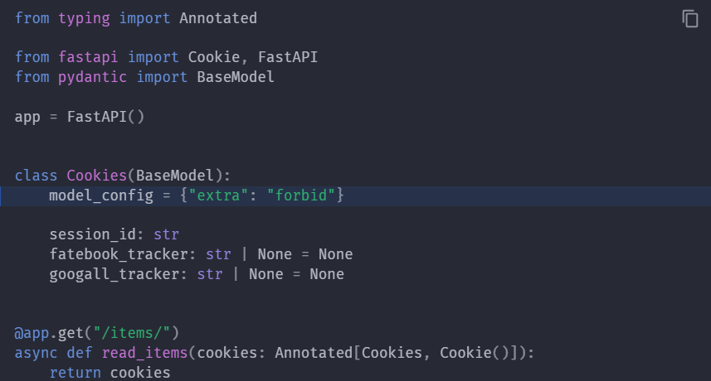

HEADER PARAMETERS MODELS
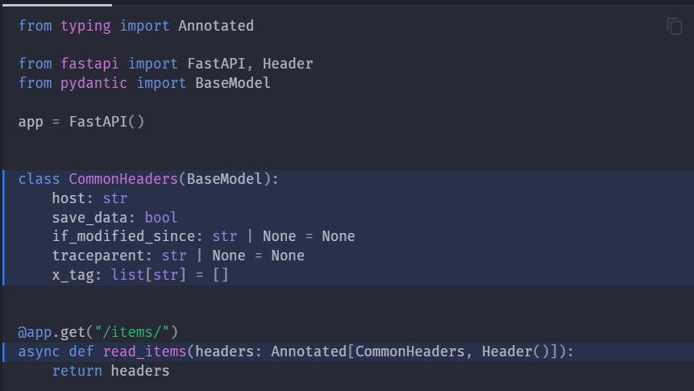
Forbid extra headers
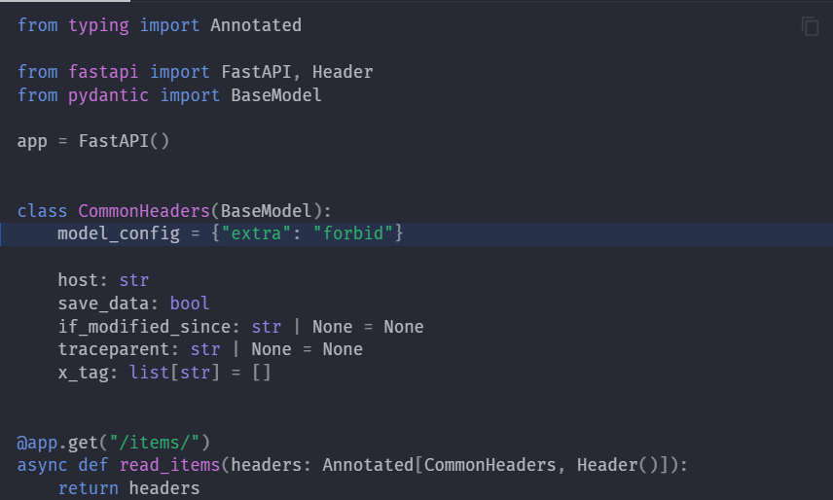
Disabling underscore conversion
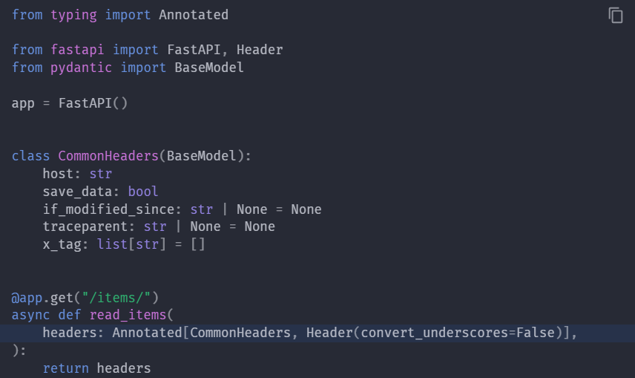

RESPONSE MODEL - RETURN TYPE
we can use python type annotation in the path function for the return type and Fastapi uses this return type to validate the returned data. If the data is invalid, it will return the server error instead of returning the incorrect data. So , client and server should understand the error in data shape
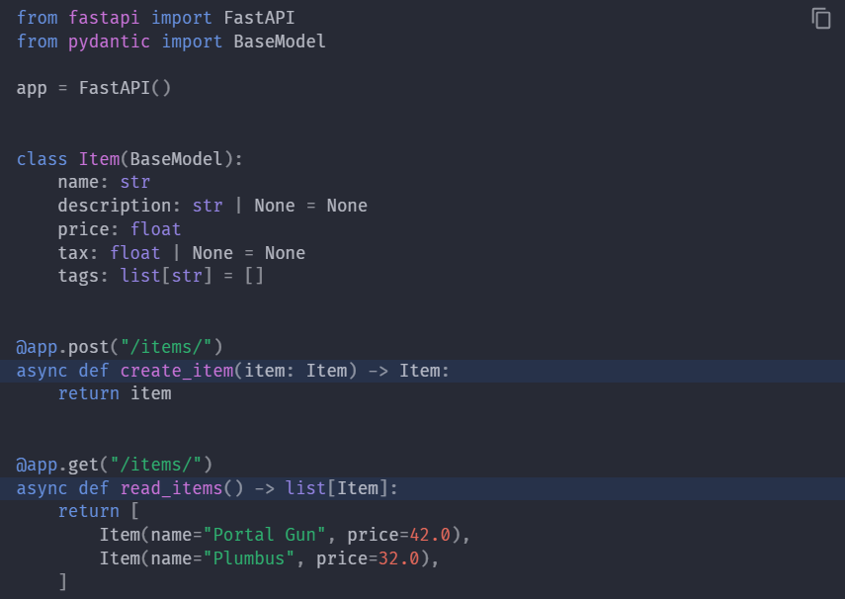

In few cases we want to return something different from what the path function declares. For example, we want to return a dictionary or a database-object but declared as pydantic model
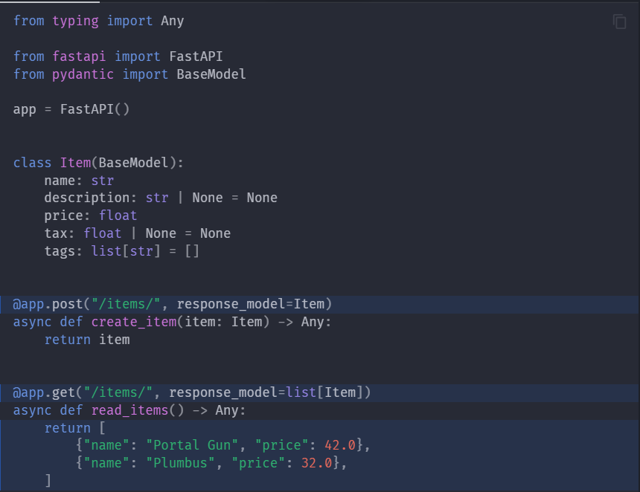
If you declare both a return type and a response_model, the response_model will take priority and be used by FastAPI

RESPONSE STATUS CODE
We can declare the HTTP status code used for response in any path operation.
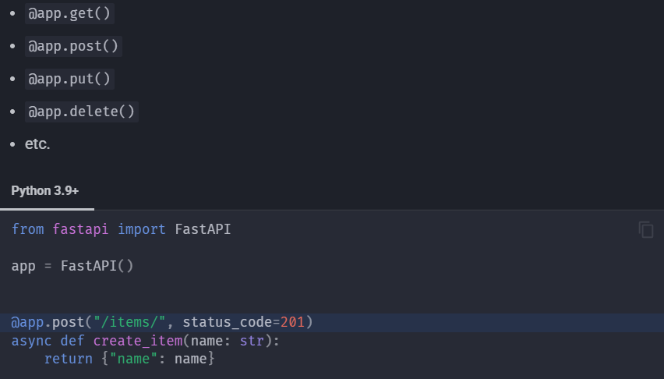
HTTP status codes
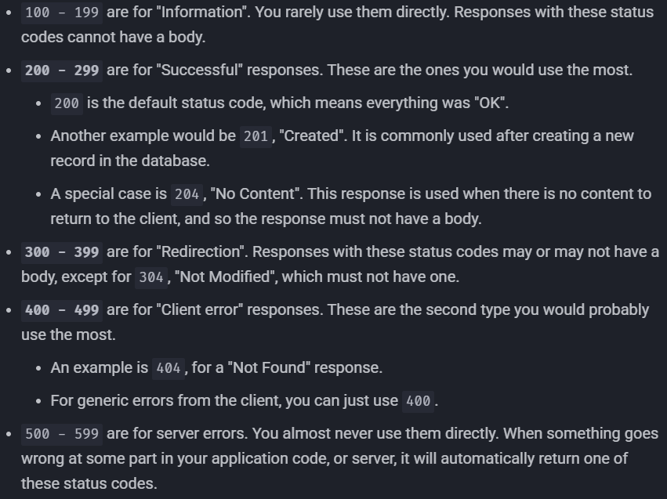
We don’t have to remember the above, we can use fastapi.status so for every number their purpose is also mentioned
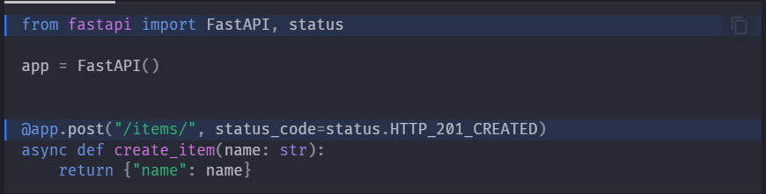

FORM FIELDS
Whenever a form data is expected as the input instead of JSON, we can use Form.
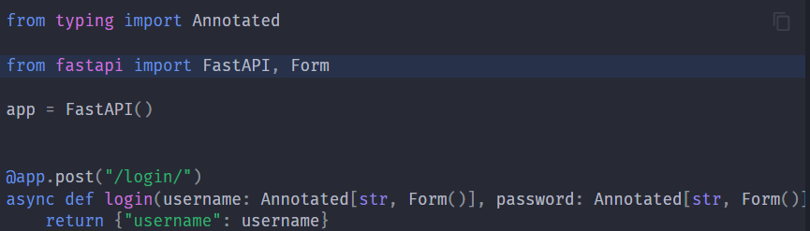
With Form also we can declare same kind of validations like alias which were used in cases of Query, Path, Cookies etc.
FORM MODELS
We can use pydantic models to declare form fields and also forbid if we require.
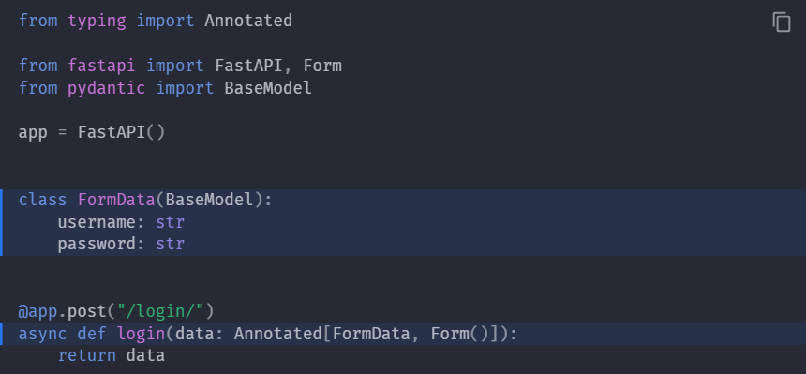
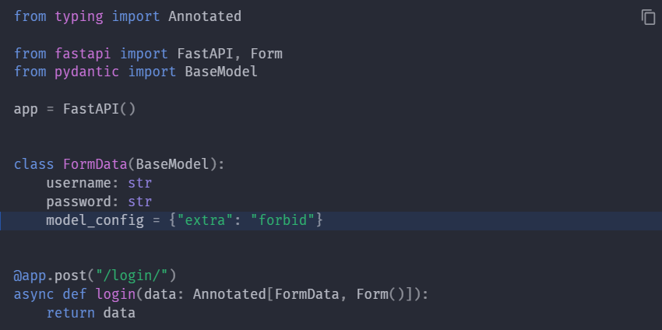
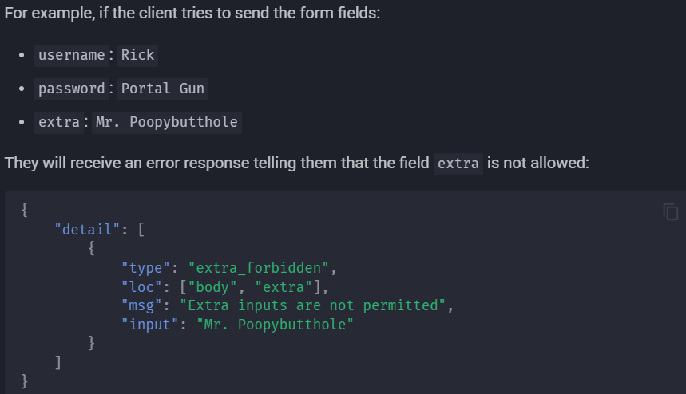

REQUEST FILES
We can create file same like body or form

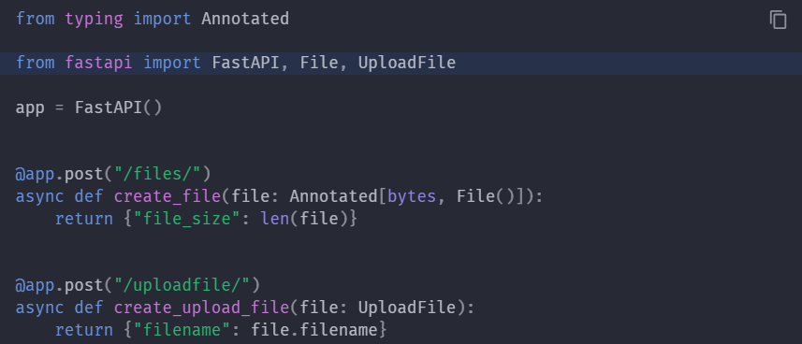

Upload file has several advantages over File(), since the file will be stored in the memory till some limit, then after that it is stored in disk means it works well for large files without consuming much memory.
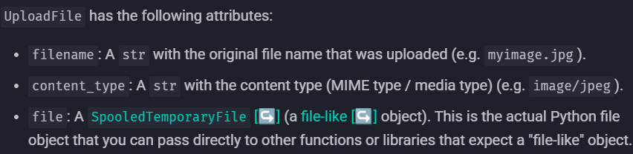
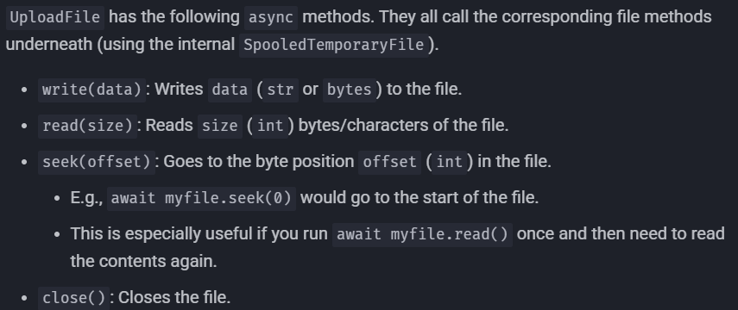

Optional file upload:
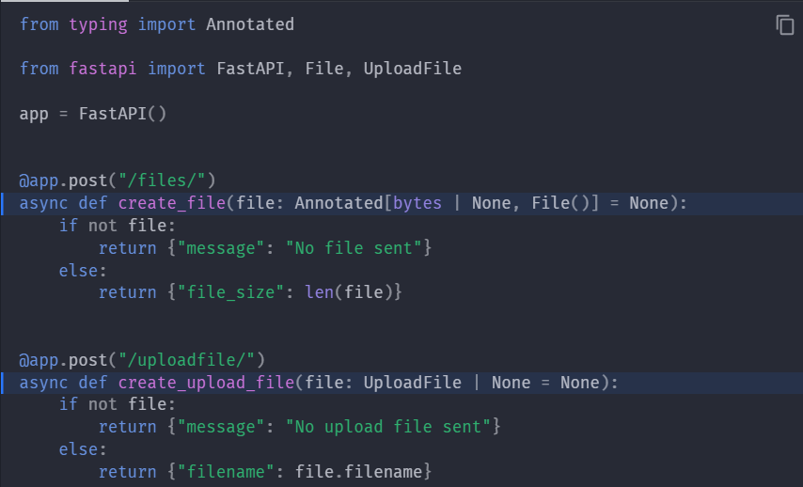
Upload file with additional metadata:
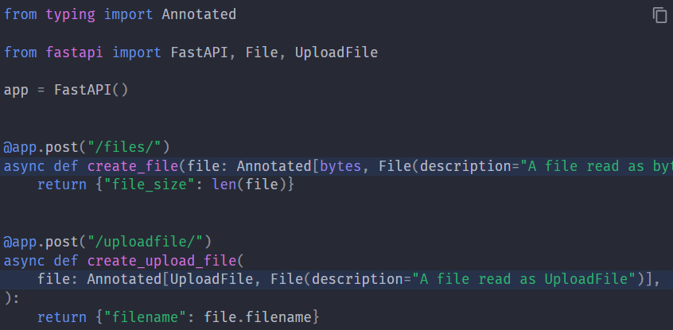
Multiple file uploads:
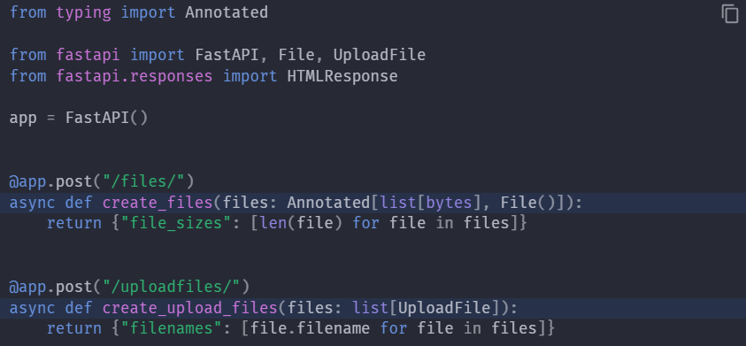

REQUEST FORMS AND FILES
We can define files and form fields at the same time using File and Form.
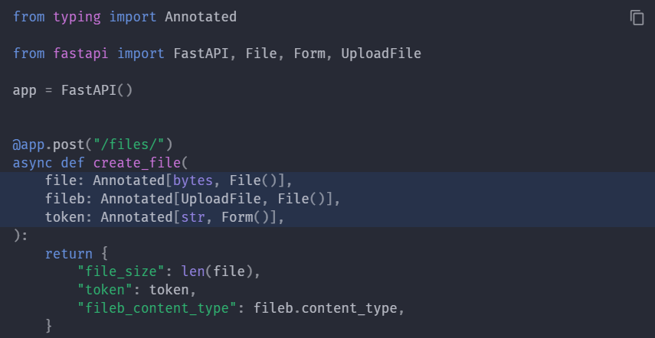
HANDLING ERRORS
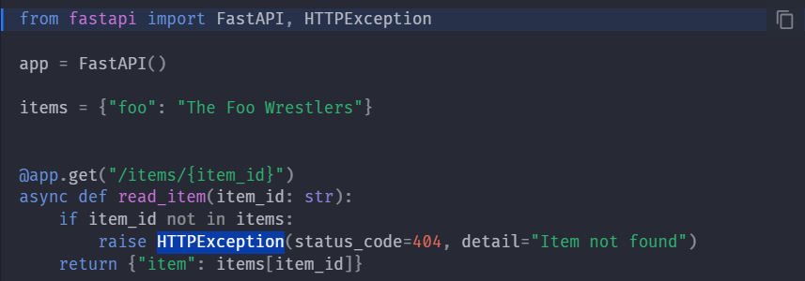

GENERATOR USE CASES IN FASTAPI
