SBA CODE:
DATABASE CONNECTION : FOR MOVIE MANAGEMENT SYSTEM:

JAVA CODE:

package com.mindtree.milestone;
import java.sql.*;
import java.util.*;
import java.io.*;
public class Moviee {

public static void main(String[] args) throws SQLException {
// TODO Auto-generated method stub
Scanner sc=new Scanner(System.in);
System.out.println("welcome to movie management system");
System.out.println("Select the required option");
while(true)
{
System.out.println("1.Insert movie details");
System.out.println("2.Show all movie details");
System.out.println("3.update movie details");
System.out.println("4.Display particular movie details");
System.out.println("5.Delete movie details");
System.out.println("6.Exit");
int option=sc.nextInt();
switch(option)
{
case 1:
insert();
break;
case 2:
show();
break;
case 3:
update();
break;
case 4:
particular();
break;
case 5:
delete();
break;
case 6:return;
}
}
}
public static void insert() throws SQLException
{
Scanner sc=new Scanner(System.in);
Connection con=DriverManager.getConnection("jdbc:mysql://localhost:3306/movie", "root","root");
System.out.println("enter the movie details:");
System.out.println("enter the movie id:");
int id=sc.nextInt();
System.out.println("enter the movie name:");
String name=sc.next();
System.out.println("enter the movie budget:");
int budget=sc.nextInt();
System.out.println("enter the movie leadactor male:");
String male=sc.next();
System.out.println("enter the movie leadactor female:");
String female=sc.next();
String query="insert into movieprofile values(?,?,?,?,?)";
PreparedStatement stmt1=con.prepareStatement(query);
stmt1.setInt(1, id);
stmt1.setString(2,name);
stmt1.setInt(3, budget);
stmt1.setString(4, male);
stmt1.setString(5, female);
int result=stmt1.executeUpdate();
System.out.println("record added successfully");

}

public static void show() throws SQLException
{
Scanner sc=new Scanner(System.in);
Connection con=DriverManager.getConnection("jdbc:mysql://localhost:3306/movie", "root","root");
Statement stmt=con.createStatement();
ResultSet rs=stmt.executeQuery("Select * from movieprofile");
while(rs.next())
{
System.out.print(rs.getInt("movieid"));
System.out.print(" "+rs.getString("moviename"));
System.out.print(" "+rs.getInt("budget"));
System.out.print(" "+rs.getString("leadactormale"));
System.out.print(" "+rs.getString("leadactorfemale"));
System.out.println("");
}

}

public static void particular() throws SQLException
{
Scanner sc=new Scanner(System.in);
Connection con=DriverManager.getConnection("jdbc:mysql://localhost:3306/movie", "root","root");
System.out.println("enter the movie id that to be displayed");
int id=sc.nextInt();
Statement stmt=con.createStatement();
String query="Select * from movieprofile where movieid="+id;
ResultSet rs=stmt.executeQuery(query);
while(rs.next())
{
System.out.print(rs.getInt("movieid"));
System.out.print(" "+rs.getString("moviename"));
System.out.print(" "+rs.getInt("budget"));
System.out.print(" "+rs.getString("leadactormale"));
System.out.print(" "+rs.getString("leadactorfemale"));
System.out.println("");
}

}

public static void update() throws SQLException
{
Scanner sc=new Scanner(System.in);
Connection con=DriverManager.getConnection("jdbc:mysql://localhost:3306/movie", "root","root");
System.out.println("enter the movie details to be updated:");
System.out.println("enter the movie id that to be updated");
int id=sc.nextInt();
System.out.println("enter what to update");
System.out.println("1.movie name 2.budget 3.leadactormael 4.leadactorfemale");
int option=sc.nextInt();

if(option==2)
{
System.out.println("enter budget to be update");
int b=sc.nextInt();
String query="update movieprofile set budget=? where movieid="+id;
PreparedStatement stmt1=con.prepareStatement(query);
stmt1.setInt(1, b);
int result=stmt1.executeUpdate();
System.out.println("record updated successfully");
}
else {
System.out.println("enter value to be update");
String val=sc.next();
String n="";
if(option==1)
n="moviename";
else if(option==3)
n="leadactormale";
else
n="leadactorfemale";
String query="update movieprofile set "+n+"=? where movieid="+id;
PreparedStatement stmt1=con.prepareStatement(query);
stmt1.setString(1, val);
int result=stmt1.executeUpdate();
System.out.println("record updated successfully");

}

}

public static void delete() throws SQLException
{
Scanner sc=new Scanner(System.in);
Connection con=DriverManager.getConnection("jdbc:mysql://localhost:3306/movie", "root","root");
System.out.println("enter the movie id to be deleted :");
int id=sc.nextInt();
String query="delete from movieprofile where movieid= ?";
PreparedStatement stmt1=con.prepareStatement(query);
stmt1.setInt(1, id);
int result=stmt1.executeUpdate();
System.out.println("record deleted successfully");

}

}

SCREENSHOTS:
MYSQL :
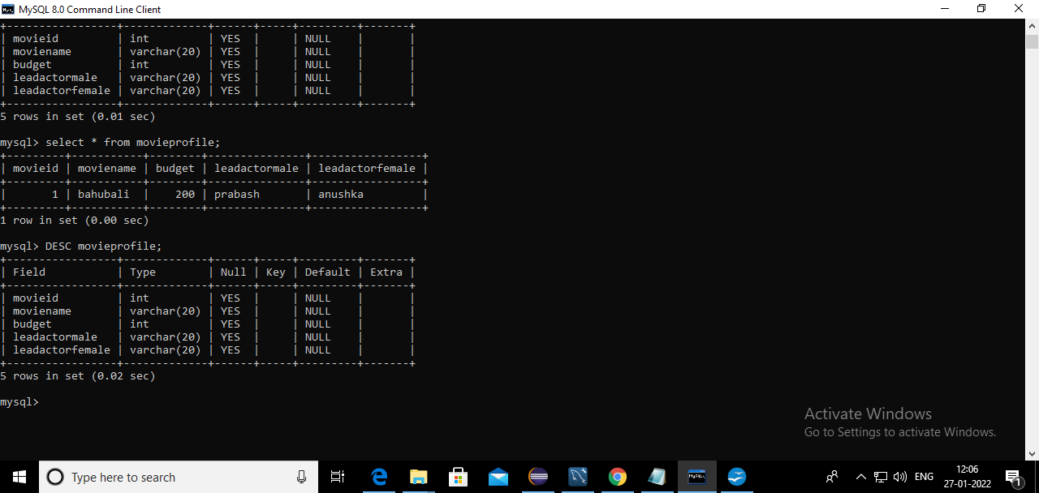

java execution :
for insertion:
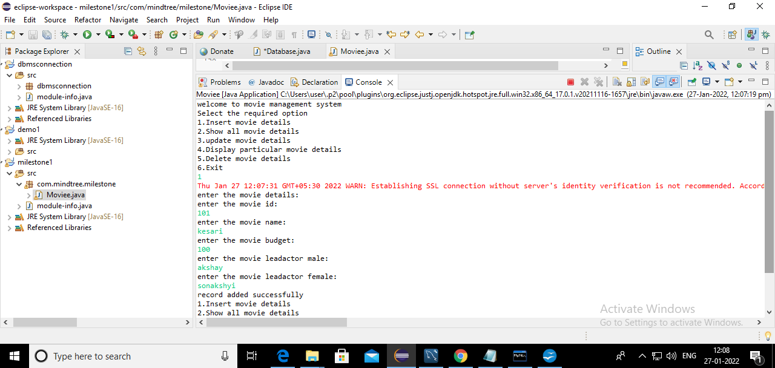
selcting all data:
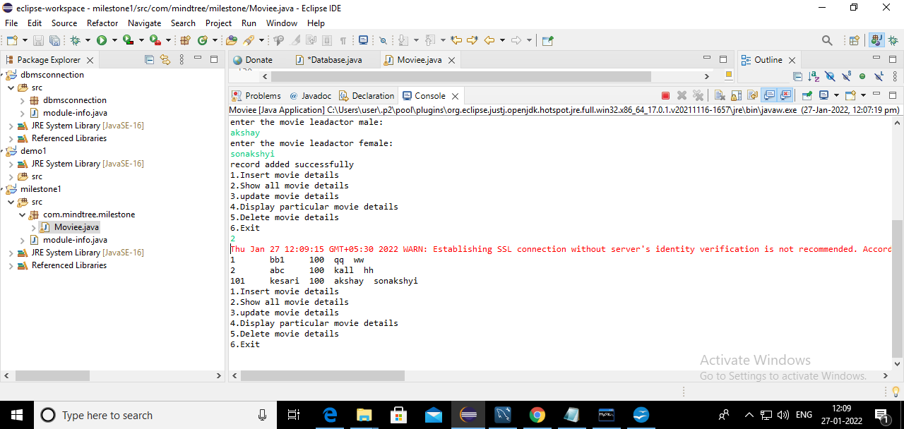

updating the data

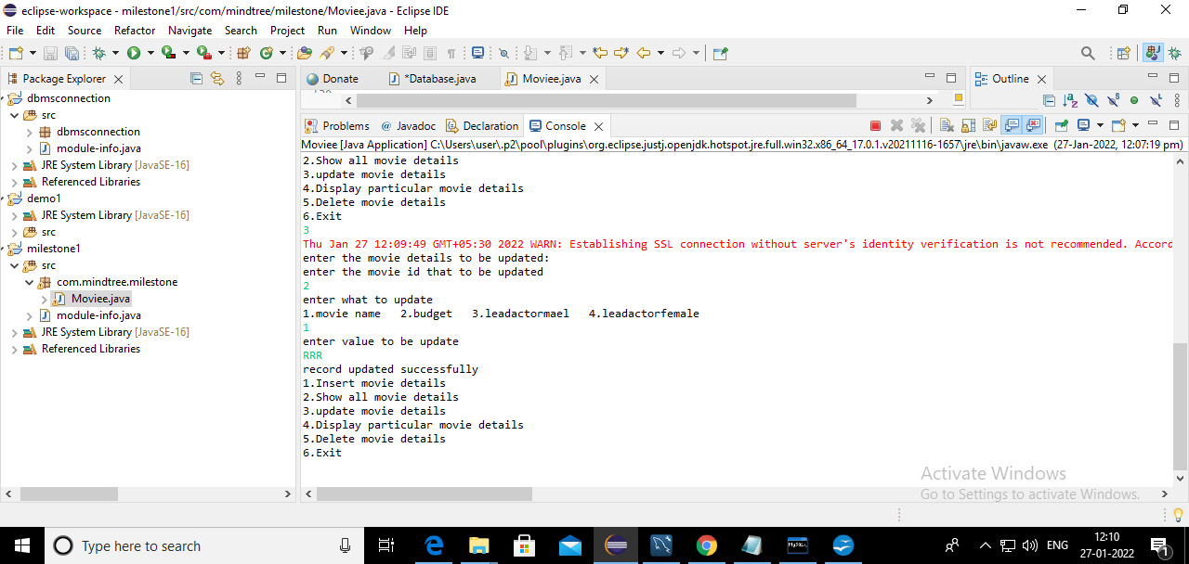
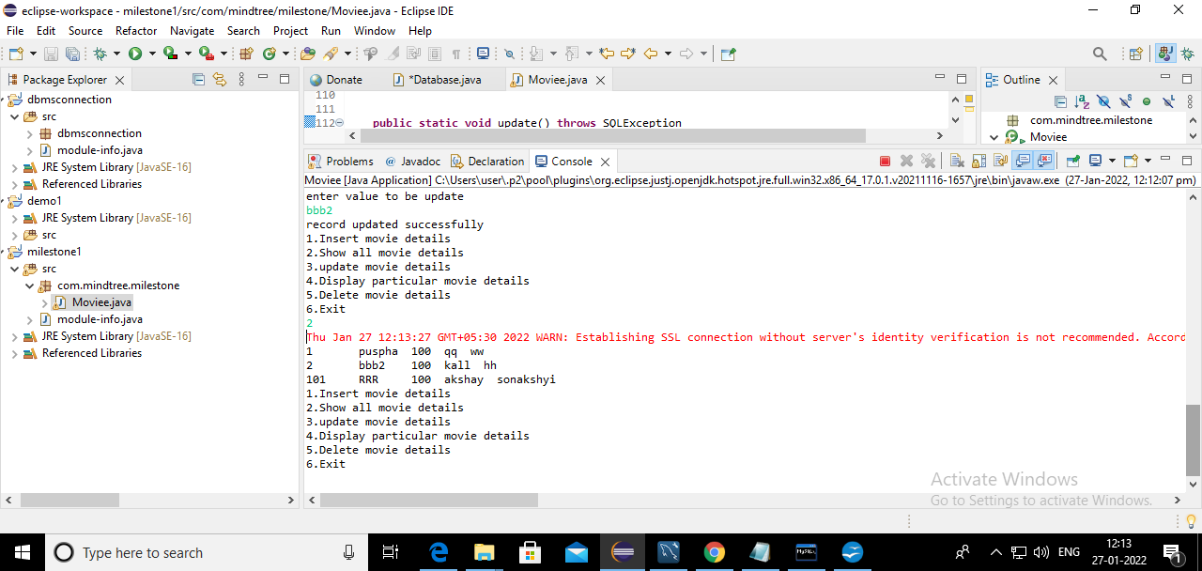

DISPLAY PARTICULAR MOVIE DETAILS:
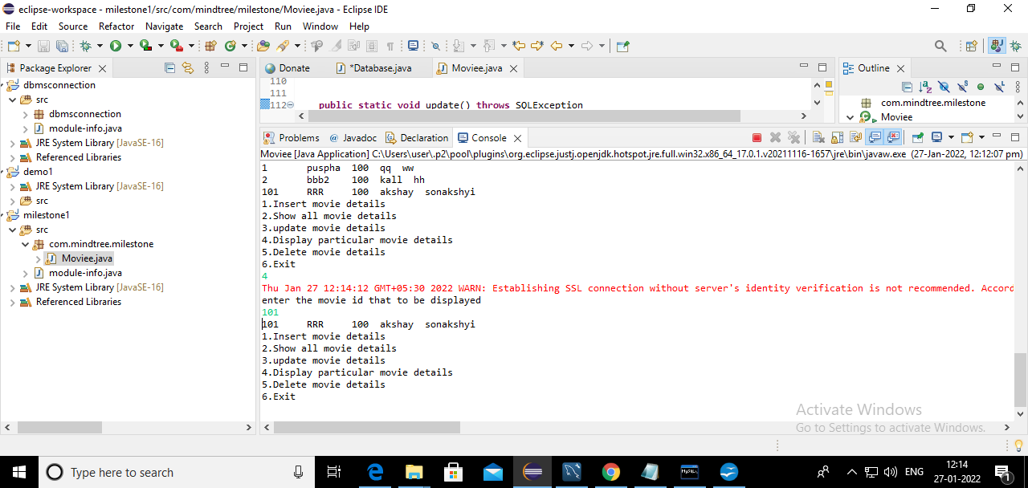
DELETING PARTICULAR COLOUMN
