ASSIGNMENT 4

Firstname Lastname

2010-02-14

# Markdown Basics

**Headings**: Use # before text to create headings. The number of # corresponds to the heading level, with one # being the largest and six # being the smallest.

**Text Emphasis**: Use * or _ to add emphasis to text. Single * or _ will italicize text, and double ** or __ will bold text.

**Lists**: Use *, -, or + to create bullet point lists, and use numbers to create numbered lists.

**Links**: To create a hyperlink, use square brackets [] to enclose the text you want to display, followed immediately by the URL in parentheses ().

**Images**: To insert an image, use an exclamation mark ! followed by square brackets [] containing alt text, and then the image URL in parentheses ().

**Code**: Use backticks ` to indicate inline code, and use triple backticks to indicate a code block

## Favorite Foods

* Sushi
* Italian
* Smoked Meat

## Images

all cases (Log Plot)

## Add a Quote

“Torture the data and it will confess to anything.” - Ronald Coase

## Add an Equation

The Pythagorean theorem is expressed as a^2 + b^2 = c^2.

$$a^{2}+b^{2}=c^{2}$$

## Add a Footnote

[1] [2]

## Add Citations

* R for Everyone (Lander 2014)
* Discovering Statistics Using R* (Field, Miles, and Field 2012)

# Inline Code

## NY Times COVID-19 Data

## Warning: package 'dplyr' was built under R version 4.2.3

##   
## Attaching package: 'dplyr'

## The following objects are masked from 'package:stats':  
##   
## filter, lag

## The following objects are masked from 'package:base':  
##   
## intersect, setdiff, setequal, union

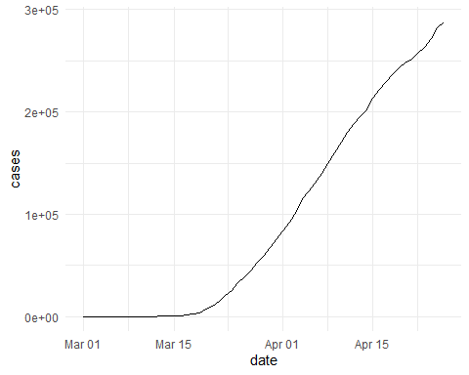

## R4DS Height vs Earnings

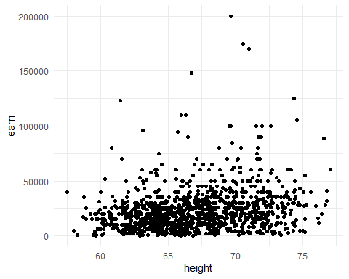

# Tables

## Knitr Table with Kable

library(knitr)

## Warning: package 'knitr' was built under R version 4.2.3

library(pander)

## Warning: package 'pander' was built under R version 4.2.3

## The dataframe of the Lord of the Rings characters  
name <- c("Aragon", "Bilbo", "Frodo", "Galadriel", "Sam", "Gandalf", "Legolas",  
 "Sauron", "Gollum")  
race <- c("Men", "Hobbit", "Hobbit", "Elf", "Hobbit", "Maia", "Elf", "Maia",  
 "Hobbit")  
in_fellowship <- c(TRUE, FALSE, TRUE, FALSE, TRUE, TRUE, TRUE, FALSE, FALSE)  
ring_bearer <- c(FALSE, TRUE, TRUE, FALSE, TRUE, TRUE, FALSE, TRUE, TRUE)  
age <- c(88, 129, 51, 7000, 36, 2019, 2931, 7052, 589)  
  
characters_df <- data.frame(name, race, in_fellowship, ring_bearer, age)  
  
## Generate the table using kable function  
kable(characters_df, caption = "One Ring to Rule Them All")

One Ring to Rule Them All

| name | race | in_fellowship | ring_bearer | age |
| --- | --- | --- | --- | --- |
| Aragon | Men | TRUE | FALSE | 88 |
| Bilbo | Hobbit | FALSE | TRUE | 129 |
| Frodo | Hobbit | TRUE | TRUE | 51 |
| Galadriel | Elf | FALSE | FALSE | 7000 |
| Sam | Hobbit | TRUE | TRUE | 36 |
| Gandalf | Maia | TRUE | TRUE | 2019 |
| Legolas | Elf | TRUE | FALSE | 2931 |
| Sauron | Maia | FALSE | TRUE | 7052 |
| Gollum | Hobbit | FALSE | TRUE | 589 |

## Pandoc Table  
pandoc.table(characters_df, style = 'grid')

##   
##   
## +-----------+--------+---------------+-------------+------+  
## | name | race | in_fellowship | ring_bearer | age |  
## +===========+========+===============+=============+======+  
## | Aragon | Men | TRUE | FALSE | 88 |  
## +-----------+--------+---------------+-------------+------+  
## | Bilbo | Hobbit | FALSE | TRUE | 129 |  
## +-----------+--------+---------------+-------------+------+  
## | Frodo | Hobbit | TRUE | TRUE | 51 |  
## +-----------+--------+---------------+-------------+------+  
## | Galadriel | Elf | FALSE | FALSE | 7000 |  
## +-----------+--------+---------------+-------------+------+  
## | Sam | Hobbit | TRUE | TRUE | 36 |  
## +-----------+--------+---------------+-------------+------+  
## | Gandalf | Maia | TRUE | TRUE | 2019 |  
## +-----------+--------+---------------+-------------+------+  
## | Legolas | Elf | TRUE | FALSE | 2931 |  
## +-----------+--------+---------------+-------------+------+  
## | Sauron | Maia | FALSE | TRUE | 7052 |  
## +-----------+--------+---------------+-------------+------+  
## | Gollum | Hobbit | FALSE | TRUE | 589 |  
## +-----------+--------+---------------+-------------+------+

# References

## References

[1]: Lander, J. P. (2014). R for everyone: advanced analytics and graphics. Addison-Wesley Professional.

[2]: Field, A., Miles, J., & Field, Z. (2012). Discovering statistics using R. Sage.

Field, A., J. Miles, and Z. Field. 2012. *Discovering Statistics Using r*. SAGE Publications. <https://books.google.com/books?id=wd2K2zC3swIC>.

Lander, J. P. 2014. *R for Everyone: Advanced Analytics and Graphics*. Addison-Wesley Data and Analytics Series. Addison-Wesley. <https://books.google.com/books?id=3eBVAgAAQBAJ>.

1. R for Everyone
2. Discovering Statistics Using R