# **Documentation for building the Karlsruhe low-cost sky imager (KALiSI) for solar irradiance forecasting**

## Introduction

This a documentation that guides you through building the Karlsruhe low-cost sky imager (KALiSI) around the RaspberryPi single board computer. This involves capturing hemispherical sky images at regular interval for storage which can be used for cloud cover analysis and solar irradiance forecasting. This a low-cost sky cost sky imager ideal for educational and research projects as well as small-scale systems and weather stations. A scientific journal article (open access) describing the design and performance of KALiSI, compared to a commercially-available sky imager.

## Materials Required

|  |  |
| --- | --- |
| Components | Link to supplier (active as of 24.10.2024) |
| Raspberry Pi 4 Model-B (8GB RAM) | <https://www.conrad.de/de/p/raspberry-pi-4-b-8-gb-4-x-1-5-ghz-raspberry-pi-2250399.html> |
| Raspberry Pi 8 MP Camera v2.1 | <https://www.conrad.de/de/p/raspberry-pi-rb-camerav2-camera-module-v2-8mp-cmos-farb-kameramodul-passend-fuer-entwicklungskits-raspberry-pi-1438999.html> |
| Raspberry Pi power supply (5V, 3A) | <https://de.rs-online.com/web/p/raspberry-pi-netzteile/1873417> |
| Entaniya Fisheye 220° lens | <https://de.rs-online.com/web/p/raspberry-pi-kameras/1675919> |
| Entaniya weatherproof dome | <https://de.rs-online.com/web/p/raspberry-pi-gehause/2011438> |
| Real-time clock module | <https://amzn.eu/d/9yDSdMk> |
| ADC module | <https://de.rs-online.com/web/p/raspberry-pi-hats-und-add-ons/1887103?gb=s> |
| 2 TB SSD external storage | <https://www.conrad.de/de/p/intenso-performance-2-tb-interne-sata-ssd-6-35-cm-2-5-zoll-sata-6-gb-s-retail-3814470-2734918.html> |
| 32 GB microSDXC memory card | <https://www.conrad.de/de/p/raspberry-pi-bookworm-betriebssystem-32-gb-passend-fuer-entwicklungskits-raspberry-pi-2992816.html> |
| SunFounder UPS | <https://www.sunfounder.com/collections/raspberry-pi-ups/products/power-pack> |
| Weatherproof ABS plastic box | <https://www.conrad.de/de/p/tru-components-tc-9065684-industrie-gehaeuse-abs-lichtgrau-ral-7035-1-st-2266421.html> |
| Miscellaneous consumables (jumper cables, silicone adhesive, screws, cable glands, LAN cable etc) | <https://www.conrad.de/de/p/joy-it-rb-cb3-025-jumper-kabel-raspberry-pi-banana-pi-arduino-20x-drahtbruecken-buchse-20x-drahtbruecken-buchse-25-0-1182193.html>  <https://www.conrad.de/de/p/spelsberg-22942501-kabelverschraubung-schlagfest-mit-zugentlastung-mit-gegenmutter-m25-kunststoff-lichtgrau-1-st-2379510.html>  <https://de.rs-online.com/web/p/ethernetkabel/0411172> |
|  |  |
| *Optional items for remote power, internet connection and solar irradiance measurement (advanced version):* | |
| 50W PV panel | <https://amzn.eu/d/9yDSdMk> |
| 30000 mAh power bank | <https://www.conrad.de/de/p/ansmann-pb212-powerbank-30000-mah-smart-ic-lipo-micro-usb-usb-c-lightning-schwarz-statusanzeige-2368770.html> |
| 50W DC-DC converter | <https://amzn.eu/d/a7L2oBC> |
| 4G modem | <https://amzn.eu/d/ePH7QE5> |
| Solar irradiance sensor | <https://imt-technology.com/en/products/pv-reference-cells/pv-reference-cell> |
|  |  |

Note that a screen, a keyboard and a mouse are also needed during the development and programming stage, but are not needed during operation after the set-up is complete.

## Hardware Setup

### KALiSI Assembly

* Fix the RaspberryPi on top of the Pipower UPS
* Fix the ADC HAT module onto the RaspberryPi GPIO pins and fix the RTC on top of the ADC HAT.
* Position the RaspberryPi into the weatherproof enclosure after making appropriate hole holes glands to receive the cables for powering and internet
* Collect all other components needed for KALiSI, e.g. external hard drive, power-bank, and solar irradiance sensor.
* Fix the fish eye lens on top of the camera and mount the camera-lens assembly in transparent dome after fixing the fish eye lens on top of the camera
* Fix the dome with the camera inside on top of the enclosure and connect the camera to the RaspberryPi.
* Connect a keyboard, a mouse and a screen to the Raspberry Pi. These are removed after the software set up.

See **Fig. 1** for how the RaspberryPi and other components are assembled inside the weather proof enclosure as well as the transparent dome on top of the enclosure.

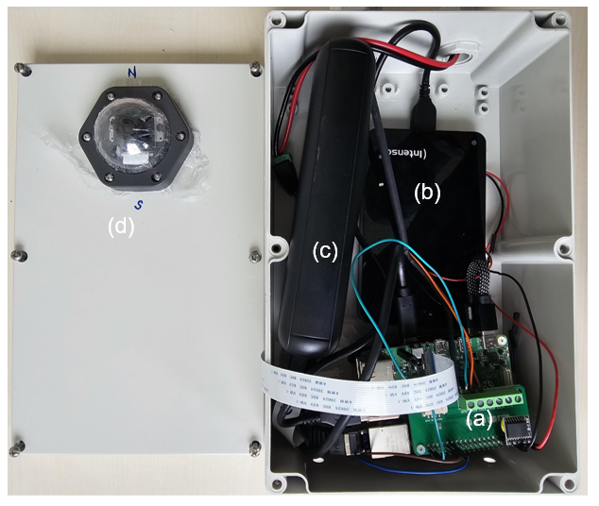

***Fig. 1.*** *Components assembled in weather proof enclosure and camera fixed on top. (a) RaspberryPi with RTC and ADC: (b) the SSD external storage; (c) power-bank as a backup battery; and (d) the camera module secured in the weatherproof dome case mounted on top of the enclosure.*

## Software Setup

### Installing Raspberry Pi OS

* Download the latest version of Raspberry Pi OS from the official Raspberry Pi website. <https://www.raspberrypi.com/software/>
* Install the OS on the MicroSD Card using tools like Raspberry Pi Imager or Balena Etcher to flash the OS image to the MicroSD card.
* A general tutorial on how to setup a Raspberry Pi and get it started can be found here: <https://www.raspberrypi.com/documentation/computers/getting-started.html>

### Camera set up and Python libraries installations

* A general tutorial on how to setup the camera and get it started can be found here: <https://projects.raspberrypi.org/en/projects/getting-started-with-picamera>
* Install required libraries including the necessary camera and imaging libraries such as Picamera2, OpenCV2 etc.

### Capturing sky images

* Configure the Python scripts for capturing and storing images e.g adding the correct path of the directory for storing images
* If needed configure the script for measuring and logging solar irradiance data e.g adding the correct path of the directory for storing solar irradiance data.
* Schedule Cron Jobs to run the script at regular intervals

After the setup, the keyboard, mouse and screen can be disconnected from the RaspberryPi. Before outdoor installation ensure the dome and enclosure are well sealed in the weatherproof. As can be seen in Fig. 2

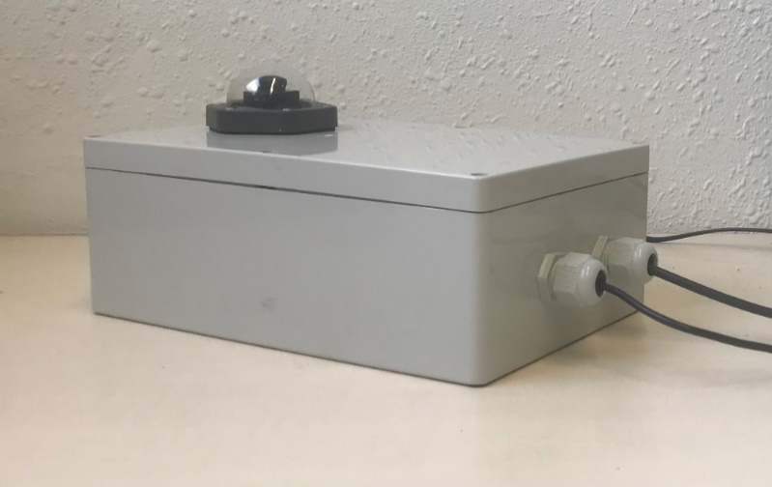

***Fig. 1.*** *The sealed enclosure with the camera-lens assembly secured in the weatherproof dome case mounted on top of the enclosure*