**Error! No bookmark name ,./given.**   
**SHOPPING MALL MANAGEMENT SYSTEM**

Document ID: ASP-CMS-SRS-02.doc

Author: Kamal B

Version: 0.1

Date: March 22,2024

1.Abstract .3

1.1 Objective of the project .3

1.2 Scope of the project. .3

2. Project End user ……………………………….................................................……………… .……3

2.1 Admin……….............................................................................................................3

2.2 Customer................................................................................................................4

**3. Project Features**............................................................... ..........................................4

3.1 Login to the system**…………………….……………………………………………….….…**..4

3.2 Add/Update/delete/view items**(Admin)……… …………… …………..……………..…**4

3.3 Add/Update/delete/view items **(customer)………………………… ……………….…**4

3.4 Place order**…………..…….…………………………………….……..……………….………5**

3.5 Manage Order............................................................................................5

**4.Diagram…………………….………………………..…………………………..……………….………………5**

4.1 Flow Diagram**………….………………………..…………………………..………………**………………..5

4.2 UseCase Diagram**………….………………………..……………………………………..………………**6

4.3 Class Diagram**………….………………………..…………………………..……………………..………**7

4.4 Sequence Diagram**………….………………………..………………………………..…..………………8**

**5.Functional and Non Functional Requirements …………………………..………………..…………8**

5.1 Functional Requirements**……………………………………………………………………….………...**8

5.2 Non Functional Requirements**……………………………………………………………………………**8

**6.High Level Design …………..………………………………..……..……………………..………………..9**

**7.Low Level Design…………..….………………………………..……………………….……………………..9**

**8.Conclusion………………..……………………………………………………………..……………….………..9**

# Abstract

The main Purpose of making this system is to provide more facilities to shop owners to see the customer and add /remove product to the customer and also payment which was made by customer can be seen by owner.On the other side the customer can view their product and added to cart and buy their desired products.

.

## Objective of project

**1.Shop Owners:** .It will helps the shop owners to add /remove the available items in the particular shop according to the availability of the particular products in the shop.

2.**Customers:**Customer can view their desired products and make it them to the cart if it is available then payment is made by payment method provided in the system.

## Scope of the project

The scope defines two roles i.e the owner of the mall and the customers. The administrator is the manager of the mall. The Mall Management System aims at assisting the customers and shop owners/admins at performing managerial tasks, and easy tracking of sales & ongoing transactions.

# Project End User

The end users of Projects or Shop Owner/Admin and Customers

## Admin:

* Create a simple interface for admins to add ,edit ,delete the products.
* It can manage the order placed by the customer.

## Customer:

* Customer can add ,edit ,delete the products in the cart and continue with the payment.
* Customer can place the order .

# Project Features

## Login to the System

The administrator login system provides authorized access to administrative functionalities within the Shopping mall management system. Administrators can securely log in using unique credentials to perform tasks such as add or edit or delete the items available in the shop and also the payment made by the customer for various items at the mall by customer.This ensures that only authorized personnel can access sensitive administrative functions, enhancing security and accountability within the system.

## Add /update /delete /view items(Admin)

**Add Items**: Admin can add the items which are available to sell in the system by login with his credential.

**Update Items**:Admin can also update that product details like increasing price,increasing quantity.

**Delete Items**:Admin can delete the particular item if it is not available .

## Add /update /delete /view items(Customer)

1. **Add Items**: Custmers can add the items which are available to them in the system by login with his credential to the cart .
2. **Update Items**:Customer can also update that product details by reducing quantity or buy more quantity according to the need in the cart .
3. **Delete Items**:Customer can delete the particular item if it is not needed to them .

## 3.4 Place order:

* + Customer can place their order after adding to the cart by appropriate payment method available.

## Manage Order

* + Admin can manage the order made by the customer

# 4. Diagrams

## Flow Diagram

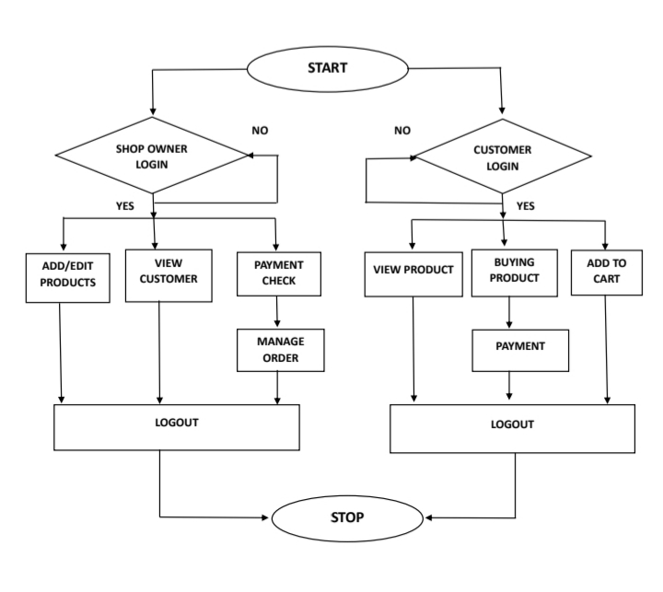

## UseCase Diagram

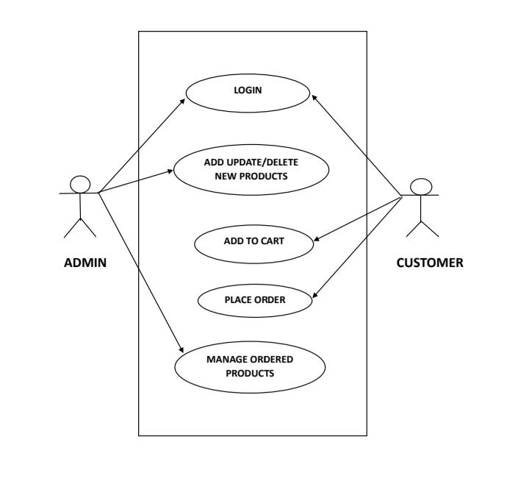

## Class Diagram and Sequence Diagram

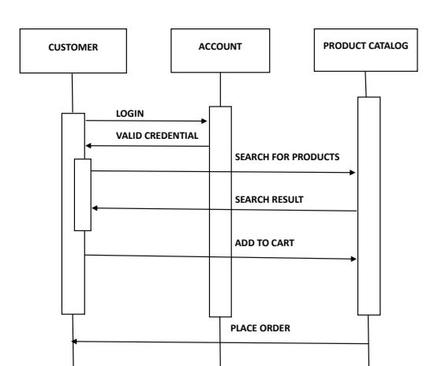

# 5. Functional and Non –Functional Requirements

## Functional Requirements

**Login:Customer can login to the system by using their credential.**

**Add Product:Admin can add the product to the system.**

**Update Product:Admin can edit the product details .**

**Delete Product:Admin can delete the unavailable product .**

**View product :Both Admin and Customer can view the product.**

**Add to cart:Customer can add the product to the cart.**

**Place order:Customer can place the order for their products.**

## Non-Functional Requirements

* + This Requirement is not directly Concerned with Specific function.This may need good internet connection to avoid latency,response time
  + The Software will Support Multiple User at a time .

# High Level Design

* + High level design explains the architecture that would develop a system.In this System frontend can be done by HTML ,CSS and Javascript.
  + It can be the main component that would be developed for the product and their interfaces.

# Low Level Design

* + Low level Design is a component level design process that follows a step by step process.This Process can be used for designing data structures,required software architecture source code and ultimately performed algorithms.Overall data organization maybe defined during data design wotk.LLD describes a class diagram with the methods and relation between the classes and program specs.

# Conclusion

* Shopping mall Management System provide effective service for shop owners and customers to buy the product and sell product .Hence this system is useful for the day to day life.