**MERGE SORT – TDD APPROACH**

**Visual Link –General**

<https://www.youtube.com/watch?v=dxuIwsPKRts>

**Visual Link Using Cards**

<https://www.youtube.com/watch?v=nLDwSngBV5I>

**Visual Link With Numbers**

<https://www.youtube.com/watch?v=JSceec-wEyw>

**Prerequisits**

* pop()
* append()
* List slicing
* Recursion

**Step 0**

* Create an unsorted list
  + Ex: numls=[8,7,6,9,4,5,3,2,1]
* Print the middle element of the list
  + Ex: numls=[8,7,6,9,4,5,3,2,1]

mid=int(len(numls)/2)

print(numls[mid])

**Step 1**

Using slicing print the

* Right half of the list
  + Ex: numls=[8,7,6,9,4,5,3,2,1]

mid=int(len(numls)/2)

print(numls[mid:])

* Left half of the list
  + Ex: numls=[8,7,6,9,4,5,3,2,1]

mid=int(len(numls)/2)

print(numls[:mid])

**Step 2 (divide phase)**

* Using recursion repeatedly divide the left list until length of the list is 1

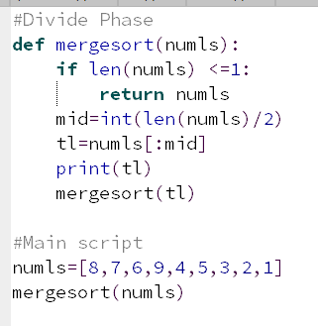

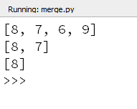

* Using recursion repeatedly divide the entire list until length of the list is 1

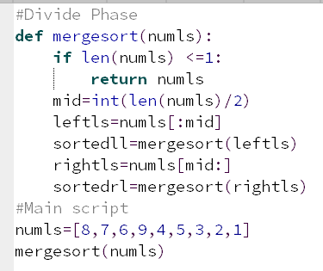

**Step 3 (conquer phase)**Sort and combine the lists split in divide phase

