PA MUTE Enable

To enable TRM power amplifier / provide 50V to the Drain of the Power amplifier, PA-MUTE IO should be drive HIGH.
PA-MUTE IO state should depends on VSWR-STATUS IO, 50V-Status and Software control.
State | Description
0 | TRM Power amplifier is in OFF state
1 | TRM Power amplifier is in ON state (ON state not only depends on PA-MUTE IO, also depends on TRM local hardware logic, PA-ON status is described detailed in PA-OK-STATUS section.)

Software Control | 50V-Status | VSWR-STATUS | PA-MUTE drive State
0 | X | X | 0
X | 0 | X | 0
X | X | 0 | 0
1 | 1 | 1 | 1

PA-OK-STATUS
“PA-OK-STATUS” IO shows the result of Power Amplifier ON/OFF state.
PA-OK-STATUS is a input signal which tells the system and TRM hardware that PA was Turned ON and ready to operate if the State is HIGH.
PA-OK-STATUS depends TRM local Hardware AND logic of 50V status, TRM temperature status, -5V volt status and VSWR status.
If TRM temperature status, -5V status and VSWR status were good(HIGH State) , then PA-OK-STATUS will be raised from LOW to HIGH within 30 to 300 Mili Second from the raising edge and HIGH state of PA-MUTE enable IO.
State | Description
0 | TRM Power amplifier not ready to operate, TRM HEALTH STATUS fail
1 | TRM Power amplifier ready to operate, TRM HEALTH STATUS pass

Latch the PA-OK-STATUS IO falling edge or LOW state. Which should software accessible.
And also the Latched state can be cleared only by software.

VSWR-HANDLING

VSWR-STATUS
“VSWR-STATUS” is input IO which shows the result VSWR status of TRM module (at ANT port).
State | Description
0 | VSWR error occurred, RF power was reflected back more than threshold limit.
1 | VSWR error not occurred, safe to operate.

If VSWR error occurred, immediately the System go to Hardware safe state as mentioned in _________________

Latch the Falling edge or LOW state of the VSWR-STATUS IO, which should be accessed and cleared by only software.

The IO and Device state are described in VSWR

VSWR-RESET
“VSWR-RESET” is output IO to clear the VSWR Hardware latch. And enable the Hardware to Functional Mode.
State | Description
LOW Pulse | Clear the Hardware Latch error state. Pulse duration 10 uS
1 | Default state.

Falling of “VSWR-RESET” IO will cleared the Hardware latch, So drive the IO LOW for 10 uS, while resetting the VSWR Error.

VSWR-RESETTING is to revert back the system from Hardware safe mode to Functional Mode, After VSWR error occurred, the system should be in Hardware Safe mode until user clear the VSWR error through software (GUI).

Current State |  |  | Next State
VSWR | SW LATCH CLR | VSWR-LATCH | PA-MUTE | VSWR-RESET | TRP | DAC-TX | SW LATCH CLR | VSWR-LATCH
0 | 0 | X | 0 | 1 | 0 | 0 | 0 | 1
0 | 1 | 1 | 0 | 0 | 0 | 0 | 0 | 1
1 | 0 | 0 | X | 1 | X | X | 0 | 0

‘X’ state of OUTPUT signal denote the drive state can be HIGH or LOW based the other signal conditions.
‘0’ mentioned for VSWR-RESET is LOW pulse for 10 uS second.

State Description:

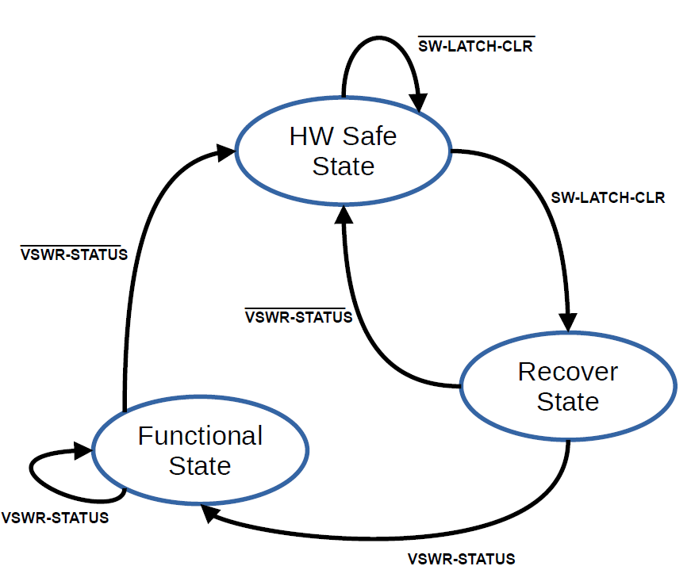

1) Functional State:
System Operates only in Functional State, The next will be Functional until the Falling or LOW state detected in VSWR-STATUS IO.

Signal State |  |  | Drive State
VSWR-STATUS | VSWR-LATCH | SW-LATCH-CLR | TRP | PA-MUTE | DAC-TX | VSWR-RESET
0 | 0 | 0 | X | X | X | 1

If LOW or Falling edge detected then the next State is Hardware Safe state.

2) Hardware Safe state:

System operation will be in Halted, PA-MUTE and DAC-TX will be disable, TRP signal will drive as LOW. The next will be Hardware Safe state until the User trigger the VSWR clear signal.

Signal State |  |  | Drive State
VSWR-STATUS | VSWR-LATCH | SW-LATCH-CLR | TRP | PA-MUTE | DAC-TX | VSWR-RESET
1 | 1 | 0 | 0 | 0 | 0 | 1

3) Recovery State:

When User trigger the VSWR clear signal (SW LATCH CLR signal) Drive LOW the VSWR-RESET IO for 10 micro seconds, after that Move next state of Functional State if VSWR-STATUS is High, else next state will be Hardware Safe state.

Signal State |  |  | Drive State
VSWR-STATUS | VSWR-LATCH | SW-LATCH-CLR | TRP | PA-MUTE | DAC-TX | VSWR-RESET
0 | 1 | 1/0 | 0 | 0 | 0 | 0/1

Harmonic Filter Path Selection

There are 6+1 Path for Harmonic filter switch (6 Filter paths + 1 RX Path).
To Path are selected based on state of the below mentioned 4 Ios.

* The IOs Can not be used for LBAND configuration only applicable for V/UHF Configuration.

Since the RX path near ANT port share the same Harmonic filter switches, Those IO should drive as mentioned in table while TRP is LOW and independent of the System Frequency.

Digital Tunable Filter
Digital Tunable required two type of data (Band data, Frequency Data),

* The IOs Can not be used for LBAND configuration only applicable for V/UHF Configuration.

Cosite Mode
Cosite mode is LOW RX Gain mode by Bypass the RF signal at first stage LNA. To reduce the signal degradation while operate two radios in near by location.
The IO Drive state should be controlled by Software.
State | Description
0 | COSITE Mode
1 | Non-COSITE Mode

* The IO Can not be used for LBAND configuration only applicable for V/UHF Configuration.

Narrow / Wide Band Selection
In TRM common path the Digital Tunable Filter can be By-Passed by drive “________” IO HIGH.
The IO Drive state should be controlled by Software, for DP-COMM-8076-600 the IO always drive LOW, but should configurable for internal debugging purpose.

State | Description
0 | Narrow Band
1 | Wide Band (Tunable Filter Bypassed mode)

* The IO Can not be used for LBAND configuration only applicable for V/UHF Configuration.

