

# Placement Empowerment Program

***Cloud Computing and DevOps Centre***

Cloud StorageCreate a storage bucket on your cloud platform and upload/download files.

Name:Kamali Anna Jayaprakash Department:IT



# Introduction

Cloud storage is a key component of modern computing, enabling secure and scalable storage solutions for individuals and organizations. Platforms like AWS, Azure, and Google Cloud provide powerful cloud storage services that allow users to store, manage, and access data from anywhere. By setting up and using a storage bucket, users can upload/download files and manage access permissions efficiently.

# Overview

This project guides you through the process of creating and managing a cloud storage bucket on a cloud platform. You’ll learn how to upload and download files, configure access permissions, and utilize advanced features like versioning and lifecycle management. With step-by-step instructions, this guide simplifies cloud storage usage, making it accessible to beginners and professionals alike.

**Key Features of Cloud Storage:**

* Scalability: Store a few gigabytes to petabytes of data effortlessly.
* Accessibility: Access data globally with high-speed performance.
* Security: Advanced encryption and role-based permissions for secure data management.
* Cost Efficiency: Pay only for the storage and data transfer you use.

# Importance

• **Data Accessibility and Mobility:** Cloud storage allows data to be accessed from anywhere, enabling seamless collaboration and mobility.

• **Scalability:** Storage solutions grow with your needs, eliminating concerns about hardware limitations.

• **Backup and Recovery:** Reliable data backup options and disaster recovery ensure business continuity.

• **Security:** Role-based access control, encryption, and compliance with data privacy standards protect sensitive information.

• **Cost Efficiency:** Avoid upfront costs of physical storage; only pay for what you use.

• **Flexibility:** Ideal for hosting static websites, storing application data, or archiving old files.

**Step-by-Step Overview** Step 1:

**: Sign in to Your Cloud Platform**

1. Log in to your cloud provider account (e.g., AWS, Azure, or GCP).
2. Navigate to the cloud storage service dashboard:
   * **AWS:** Amazon S3
   * **Azure:** Azure Blob Storage
   * **GCP:** Google Cloud Storage

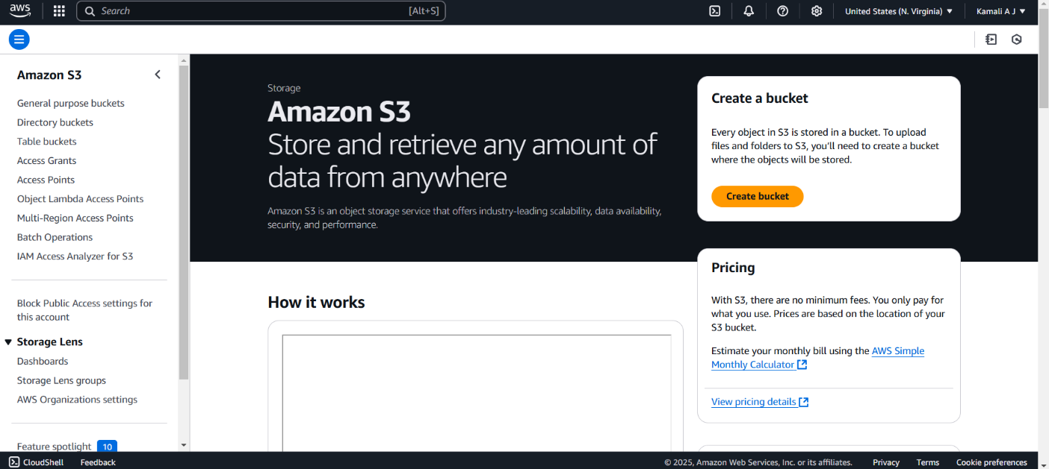

Step 2: **Create a Storage Bucket**

1. Click on the "Create Bucket" button.
2. Provide a unique name for your bucket.
3. Select the region closest to your users for better performance.
4. Choose storage settings such as:
   * **Public or Private Access:** Decide whether the bucket should be publicly accessible.
   * **Versioning:** Enable if you want to keep versions of uploaded files.
   * **Storage Class:** Select based on usage (e.g., standard, coldline, or archive).
5. Confirm and create the bucket.

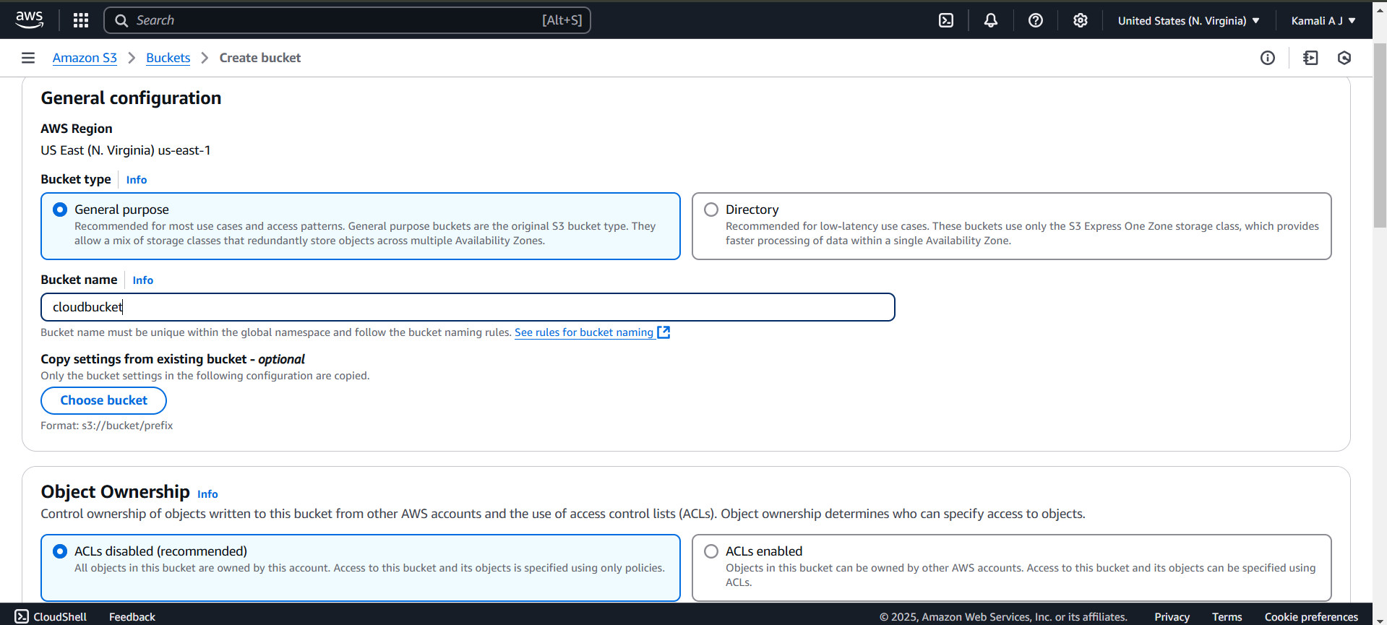

Step 3: **Upload Files**

1. Open your newly created bucket.
2. Click on the "Upload" button.
3. Drag and drop files or browse your local system to select files to upload.
4. Confirm and start the upload process.

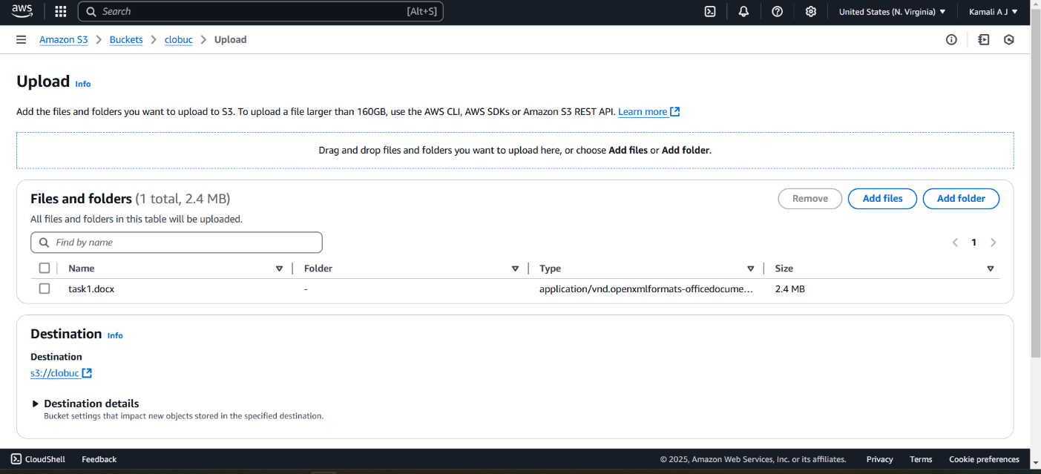

Step 4: **Download Files**

1. Navigate to the file you want to download in your bucket.
2. Click on the file name to open its details.
3. Choose the "Download" option to save the file locally. 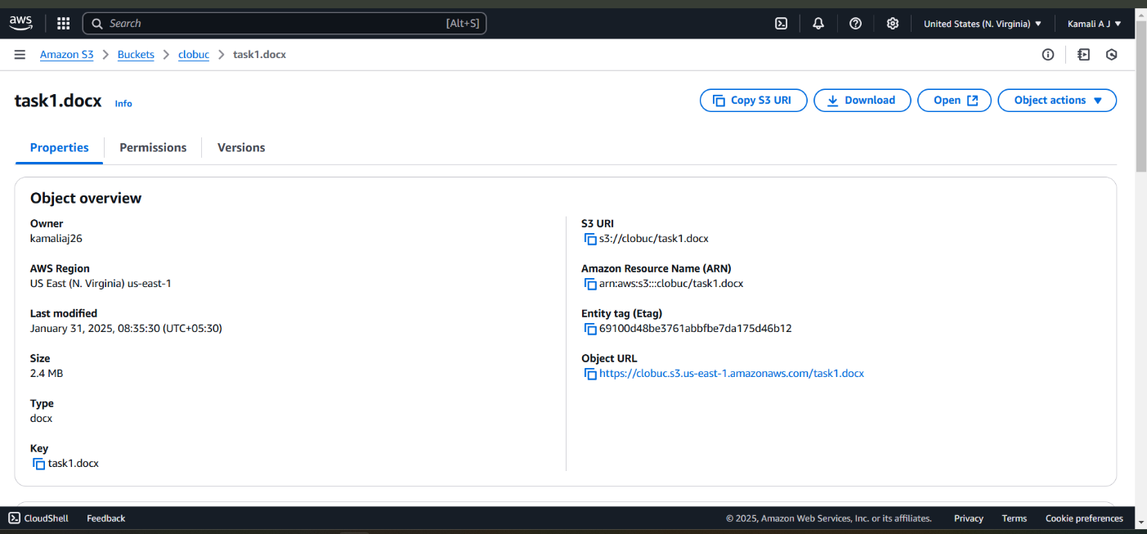

Step 5:

**Configure Access Permissions**

1. Open the bucket settings and locate the permissions section.
2. Modify access permissions:
   * **Public Access:** Set permissions for public users to view/download files.
   * **IAM Roles:** Assign roles to users for restricted access (e.g., Viewer, Editor).
   * **Access Control Lists (ACLs):** Customize file-level access permissions.
3. Save the configuration

Step 6:

1. Verify that the permissions work as intended.
   * Public files should be accessible via the provided URL.
   * Restricted files should only be accessible by authorized users.
   * **Monitor and Manage Storage**

Check the bucket for usage statistics, such as storage size and file counts.

Set lifecycle rules to automate file management (e.g., move older files to archive storage).

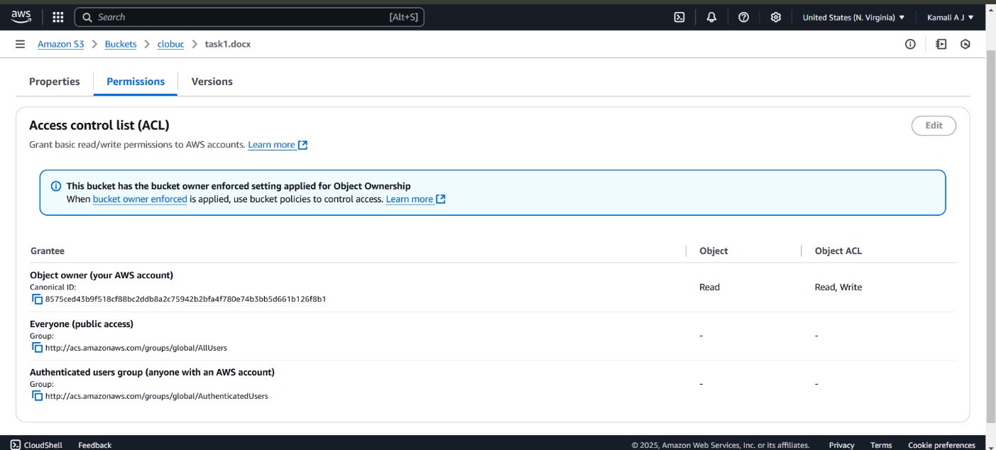

Outcome

. Secure and Scalable Storage Setup

You will have a fully functional cloud storage bucket where you can safely store your files and data.

With scalability as a core feature, you can store anything from a few files to terabytes of data without worrying about capacity constraints.

2. Hands-On Experience with File Management

You will gain practical knowledge of uploading and downloading files to and from your cloud storage bucket.

Learn to manage your files efficiently, including organizing them into folders, renaming, and deleting as needed.

3. Mastery of Access Control and Permissions

You will understand how to configure fine-grained permissions for your bucket and files:

Granting or restricting access to users based on roles or identities.

Setting public and private permissions for individual files or the entire bucket.

Implementing secure sharing with access expiration and pre-signed URLs.

This will ensure your data is both accessible to the right people and protected from unauthorized access.

4. Data Accessibility and Collaboration

The bucket will enable global accessibility, allowing you or your team to access files from any location.

Shared access permissions will facilitate real-time collaboration, especially in team-based environments.

5. Exposure to Advanced Cloud Storage Features

Versioning: You will know how to enable versioning, allowing you to track changes to files and recover older versions if necessary.

Lifecycle Policies: You will learn to automate file management by setting rules to transition files to cheaper storage tiers or delete them after a specified period.

Storage Classes: Experience using different storage tiers (e.g., standard, coldline, archive) based on access frequency and cost considerations.

6. Improved Data Security and Compliance

Gain expertise in using encryption options (at rest and in transit) to secure sensitive data.

Learn to comply with data privacy regulations by using audit logs and monitoring access activity on your storage bucket.

7. Disaster Recovery and Backup Readiness

By using cloud storage, you will set up a reliable backup system for important files.

Learn to restore files easily in case of accidental deletion or corruption.

8. Cost-Effective File Storage and Management

Understand how to monitor storage costs and optimize them by:

Deleting unnecessary files.

Using lower-cost storage classes for infrequently accessed data.

This ensures a budget-friendly yet robust storage setup.

9. Application of Real-World Use Cases

Learn how cloud storage can be applied in different scenarios:

Hosting static website content like HTML, CSS, and JavaScript files.

Storing logs, backups, or media files for applications.

Managing big data files for analysis and reporting.