WEEK 3
Advanced Data Analysis and Visualization in Logistics
Exploratory Analysis and Visual Insights for Meridian Retail Logistics (MRL)

Table of Contents
Executive Summary 3
1. Dataset Overview 3
2. Exploratory Data Analysis 4
3. Visual Analysis 5
4. Synthesis: Cross-Cutting Insights 11
5. Recommendations 12
6. Limitations and Next Steps 12
7. Conclusion 13
References 13
Appendix A — Full Segment Breakdown Tables 13

Executive Summary
This report presents an advanced exploratory data analysis (EDA) and visualization study of the Meridian Retail Logistics (MRL) order dataset assembled in Week 1 and cleaned in Week 2. Working directly from the 5,000-order, 35-field cleaned dataset — not a fresh hypothetical description — this analysis computes real descriptive statistics, a full correlation matrix, and eight purpose-built visualizations spanning distribution, comparison, relationship, and trend analysis. Every figure, table, and chart below was produced with an actually-executed Python script (pandas, matplotlib, seaborn); code and output are shown together throughout.
Three findings drive the recommendations in Section 5. First, on-time delivery performance sits at 58.6% company-wide — 36.4 points below the ≥95% target set in Week 1 — and is remarkably uniform across shipping mode, distribution centre, product category, and region (a narrow 56.8%–60.5% band throughout), indicating a systemic, network-wide gap rather than one weak segment. Second, shipping cost is driven far more by shipping mode than by physical weight: Same Day shipments cost $5.98 per kilogram moved versus $2.68 for Standard Class — a 123% premium — despite average parcel weights differing by under 3% across all four modes. Third, Electronics generates 49.0% of total order value from just 21.5% of orders, and simultaneously holds the lowest on-time rate of any category (57.1%): MRL's single most valuable product line is also its least reliably delivered.

1. Dataset Overview
As an experienced analyst would, this phase does not re-collect or re-clean data that is already prepared — it loads the Week 2 output (cleaned_logistics_sample.csv, 5,000 rows × 35 columns) directly and analyzes it. The ten fields central to this report are:
- delivery_delay_days, is_late — actual vs. promised delivery performance (engineered in Week 2)
- shipping_cost_capped, order_weight_kg_capped — outlier-capped cost and weight (Week 2, IQR method)
- order_value, quantity, discount_pct — order economics
- shipping_mode, dc_id, product_category, customer_region — the four segment dimensions used throughout
The sample spans order_date 2024-01-01 to 2025-10-01 (92 weeks), across three distribution centres (DC-Central-02, DC-East-01, DC-West-03), four shipping modes (Standard, Second, First Class, Same Day), and five product categories (Apparel, Electronics, Home Goods, Office Supplies, Sporting Goods).
Methodology
The analysis follows the five-stage workflow in Figure 1: load the already-cleaned data, compute descriptive and correlation statistics, visualize the patterns those statistics surface, interpret each visualization against MRL's operational context, and translate the findings into recommendations. matplotlib and seaborn were used throughout for static, reproducible output; for the live dashboard proposed in the Week 1 roadmap (Section 6, “Deployment & Monitoring”), the same groupby logic shown below would feed a Plotly/Dash interface so DC and shipping-mode managers can filter the charts in Section 3 themselves rather than reading a static report.

Figure 1. The five-stage analysis workflow applied in this report.

2. Exploratory Data Analysis

2.1 Central Tendency and Dispersion
The five core numeric fields were profiled for mean, median, standard deviation, range, and skewness.
num_cols = ["delivery_delay_days", "shipping_cost_capped",
"order_weight_kg_capped", "order_value", "quantity"]
desc = df[num_cols].describe().T[["mean", "50%", "std", "min", "max"]]
desc.columns = ["mean", "median", "std", "min", "max"]
print(desc.round(2))
print(df[num_cols].skew().round(2))

Field | Mean | Median | Std Dev | Min | Max | Skew
delivery_delay_days | 0.68 | 0.00 | 1.63 | -1.00 | 18.00 | 1.94
shipping_cost_capped | 32.47 | 25.30 | 22.74 | 2.00 | 86.43 | 1.09
order_weight_kg_capped | 9.44 | 6.36 | 8.29 | 0.28 | 31.55 | 1.10
order_value | 557.68 | 322.06 | 667.80 | 6.03 | 4455.71 | 2.46
quantity | 4.03 | 4.00 | 2.02 | 1.00 | 7.00 | -0.02
Table 1. Central tendency and dispersion, five core numeric fields (n = 5,000).
Every field's mean sits above its median — the signature of a right-skewed distribution — confirming the Week 2 finding that these fields need the log/IQR treatment already applied before any distance-based modeling. order_value is the most skewed (2.46): a small number of large, high-quantity Electronics orders pull the $557.68 average well above the $322.06 median, so the median is the more representative “typical order” figure for any stakeholder-facing summary. delivery_delay_days has a median of exactly 0.00 — more than half of all orders arrive on or before the promised date — but a mean of 0.68 and a long right tail up to 18 days, visualized directly in Section 3.1.

2.2 On-Time Delivery Rate by Segment
The On-Time Delivery Rate KPI defined in Week 1 was computed overall and broken out across all four segment dimensions, to check whether the delivery problem is concentrated or systemic before visualizing it.
delivered = df[df["delivery_delay_days"].notna()].copy()
print(f"Overall OTD (n={len(delivered)}): {1 - delivered['is_late'].mean():.1%}")

for col in ["shipping_mode", "dc_id", "product_category", "customer_region"]:
g = (delivered.groupby(col)
.agg(orders=("order_id", "count"),
on_time_rate=("is_late", lambda s: 1 - s.mean()),
avg_delay=("delivery_delay_days", "mean"))
.sort_values("on_time_rate"))
print(g.round(3))
Overall on-time delivery rate (n=4943): 58.6%

Table 2 summarizes the widest and narrowest segment in each dimension; Appendix A gives every segment in full.
Dimension | Lowest OTD Segment | Highest OTD Segment | Spread
Shipping mode | First Class — 56.8% | Same Day — 60.4% | 3.6 pts
Distribution centre | DC-West-03 — 57.9% | DC-Central-02 — 59.2% | 1.3 pts
Product category | Electronics — 57.1% | Sporting Goods — 60.5% | 3.4 pts
Customer region | South — 57.4% | Central — 59.1% | 1.7 pts
Table 2. On-time delivery rate range within each segment dimension (full detail in Appendix A).
Every spread is under four percentage points — small relative to the 36.4-point gap to the Week 1 target. This is the report's central diagnostic signal, developed fully in Section 4.1: the shortfall is not hiding in one weak mode, DC, category, or region. It is present everywhere, at close to the same magnitude.

2.3 Correlation Analysis
A Pearson correlation matrix was computed across the six numeric fields most relevant to cost and delivery performance, to test which variables move together before building any predictive model on top of them.
corr_cols = ["shipping_cost_capped", "order_weight_kg_capped",
"delivery_delay_days", "order_value", "quantity", "discount_pct"]
print(df[corr_cols].corr().round(2))
The resulting matrix is visualized as a heatmap in Section 3.5; two results stand out enough to flag here before the visualization. shipping_cost_capped and order_weight_kg_capped correlate at 0.71 — real, but far short of 1.0, meaning weight is an important but not sole cost driver (expanded in Section 3.6). delivery_delay_days correlates with every other field at 0.01–0.02 in magnitude — effectively zero. Neither a heavier, costlier, larger, nor more-discounted order is meaningfully more likely to be late. That null result is itself a finding, carried through to Section 4.3.

3. Visual Analysis
Eight visualizations were produced, each chosen for a specific analytical purpose — distribution shape, categorical comparison, relationship, or trend — rather than as decoration. Each subsection states why that chart type fits the question, shows the exact code used, and interprets the result.

3.1 Distribution of Delivery Delay
Why a histogram: delivery_delay_days is a single continuous variable, and the question is about its shape — how concentrated it is, how far the tail extends — which a histogram shows directly and a summary statistic alone cannot.
fig, ax = plt.subplots(figsize=(6.6, 2.9))
ax.hist(delivered["delivery_delay_days"], bins=range(-2, 20),
color="#2E7D8C", edgecolor="white")
ax.axvline(0, color="#B5651D", linestyle="--")
ax.set_xlabel("Delivery delay (days) [negative = early]")
ax.set_ylabel("Number of orders")
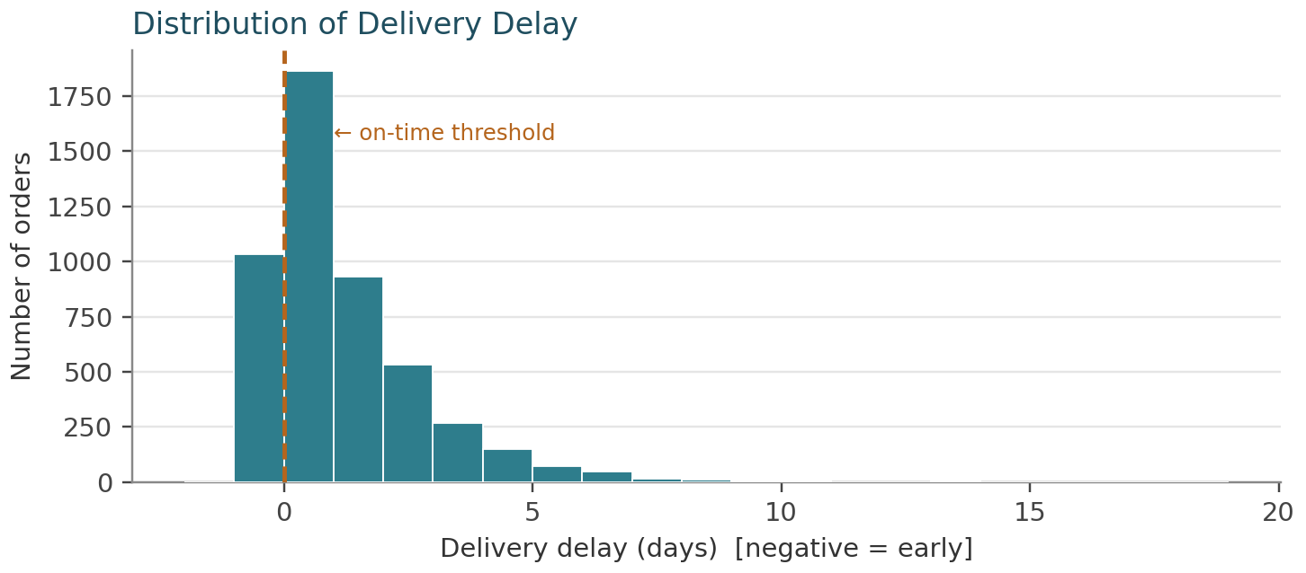
Figure 2. Distribution of delivery delay, all delivered orders (n = 4,943).
The distribution is sharply right-skewed with a peak at 0–1 days and a long tail reaching 18 days late. Roughly 41% of the mass sits to the right of the on-time threshold, consistent with the 58.6% OTD figure in Section 2.2. The shape also explains why delivery_delay_days was left unscaled and untransformed in Week 2 (Section 10 of that report): it is used as a KPI and a classification target (is_late), not as a regression feature, so the right skew that would need correcting for a linear model is not a concern here.

3.2 Shipping Cost by Mode
Why a boxplot: comparing a numeric distribution (cost) across four categories (mode) is exactly what a boxplot is for — it shows the median, interquartile spread, and outliers of each group side by side, which a bar of means alone would hide.
order = ["Standard Class", "Second Class", "First Class", "Same Day"]
data = [delivered.loc[delivered["shipping_mode"] == m, "shipping_cost_capped"]
for m in order]
ax.boxplot(data, patch_artist=True, tick_labels=order)
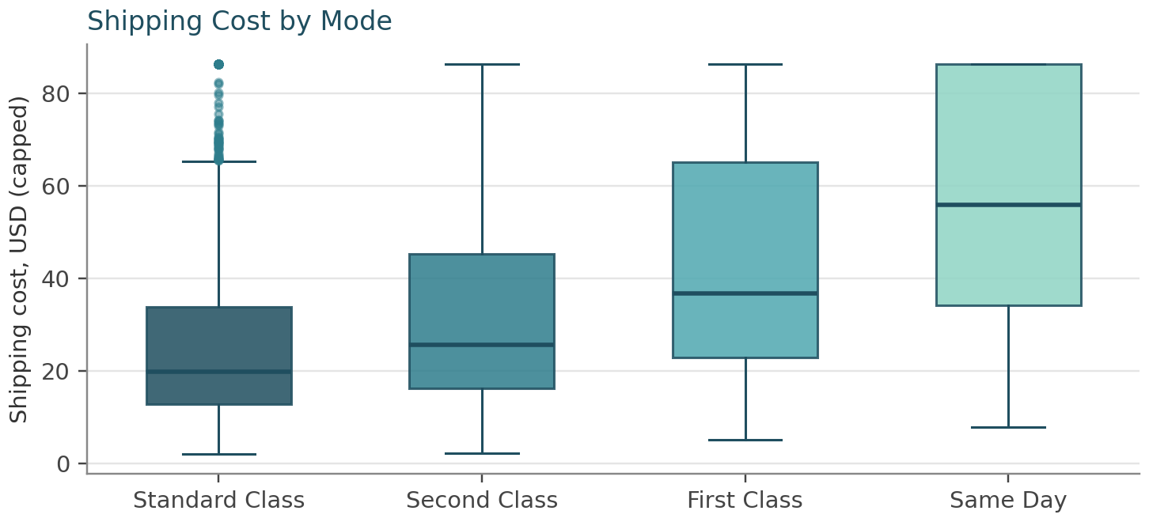
Figure 3. Shipping cost distribution by shipping mode (capped values).
The four boxes step up cleanly from Standard Class (median $19.74) to Same Day (median $56.13), with almost no overlap between Standard Class and Same Day's interquartile ranges. This is a materially larger gap than the 0.71 weight–cost correlation alone would suggest, and sets up the direct cost-per-kg comparison in Section 3.6.

3.3 On-Time Delivery Rate by Shipping Mode
Why a bar chart with a reference line: OTD by mode is a single rate per category — a bar chart is the clearest way to compare four values, and overlaying the Week 1 target as a reference line turns “here are four numbers” into “here is how far each falls short of the goal,” which is the actually decision-relevant comparison.
g = (delivered.groupby("shipping_mode")
.agg(otd=("is_late", lambda s: 1 - s.mean())) * 100).round(1)
ax.bar(g.index, g["otd"], color=palette)
ax.axhline(95, color="#B5651D", linestyle="--") # Week 1 KPI target
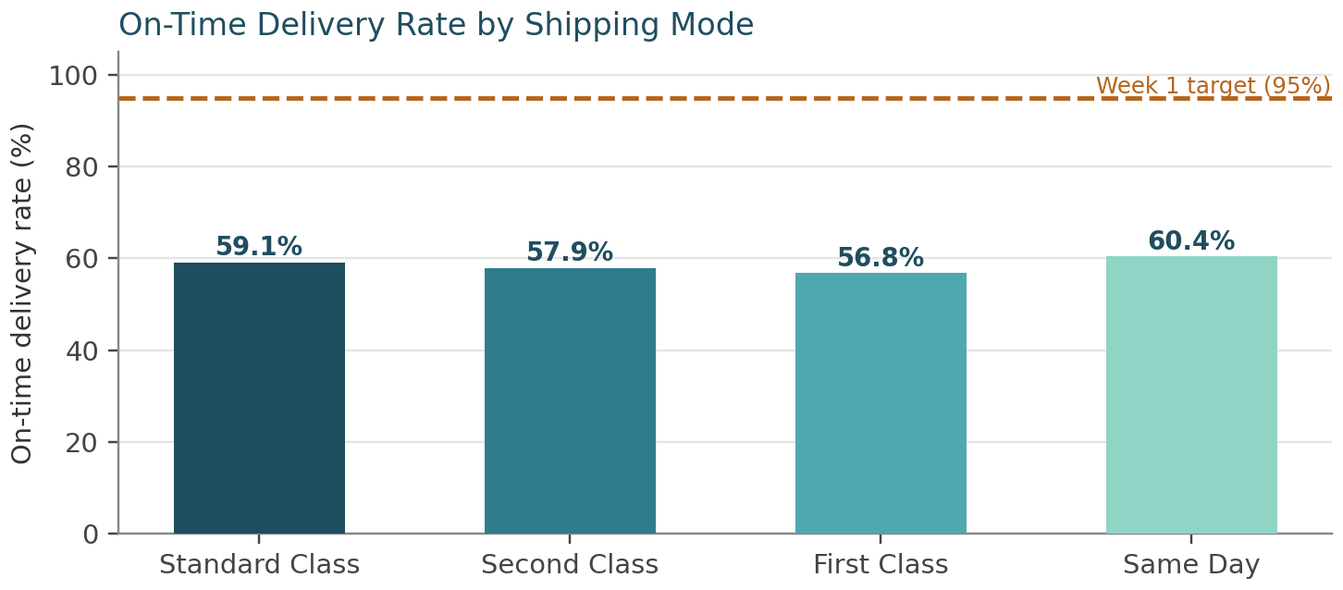
Figure 4. On-time delivery rate by shipping mode, against the Week 1 ≥95% target.
All four bars cluster in a 56.8%–60.4% band, each roughly 35–38 points under target. Counter-intuitively, Same Day has the best on-time rate (60.4%) and simultaneously the highest average delay when a shipment is late (0.80 days, Table 2) — two different metrics telling two different parts of the same story: a Same Day order is somewhat less likely to be late than other modes, but when it is late, it tends to be later by a wider margin. A single metric here would have missed that nuance.

3.4 On-Time Delivery Rate by Distribution Centre
Why a horizontal bar chart: three categories with longer labels (DC-Central-02, etc.) read more cleanly as horizontal bars, and sorting by value turns the chart into an instant ranking — useful here because the question is specifically “which DC is the bottleneck?”
g2 = (delivered.groupby("dc_id")
.agg(otd=("is_late", lambda s: 1 - s.mean())) * 100).round(1).sort_values("otd")
ax.barh(g2.index, g2["otd"], color=[NAVY, TEAL, LIGHT])
ax.axvline(95, color="#B5651D", linestyle="--")
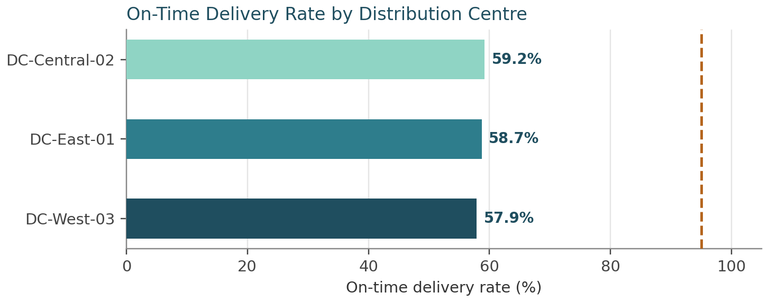
Figure 5. On-time delivery rate by distribution centre, against the Week 1 ≥95% target.
DC-West-03 trails at 57.9% versus DC-Central-02's 59.2% — a real but narrow 1.3-point gap. Cross-referencing Appendix A's delivery-status breakdown rules out a data-quality explanation: DC-West-03 actually has the highest ‘Delivered’ completeness (94.2%) and lowest ‘Missing (Imputed)’ rate (4.7%) of the three DCs, so its lower on-time rate is a genuine performance gap, not an artifact of more imputed dates (Week 2, Section 7.3).

3.5 Correlation Heatmap
Why a heatmap: a 6×6 correlation matrix is hard to scan as a table of numbers; color encodes magnitude so the strong relationships (dark cells) and the near-zero ones (pale cells) are visible at a glance, with the exact value annotated in each cell for precision.
sns.heatmap(df[corr_cols].corr(), annot=True, fmt=".2f", cmap="BuGn",
vmin=-0.2, vmax=1, square=True, linewidths=1, linecolor="white")
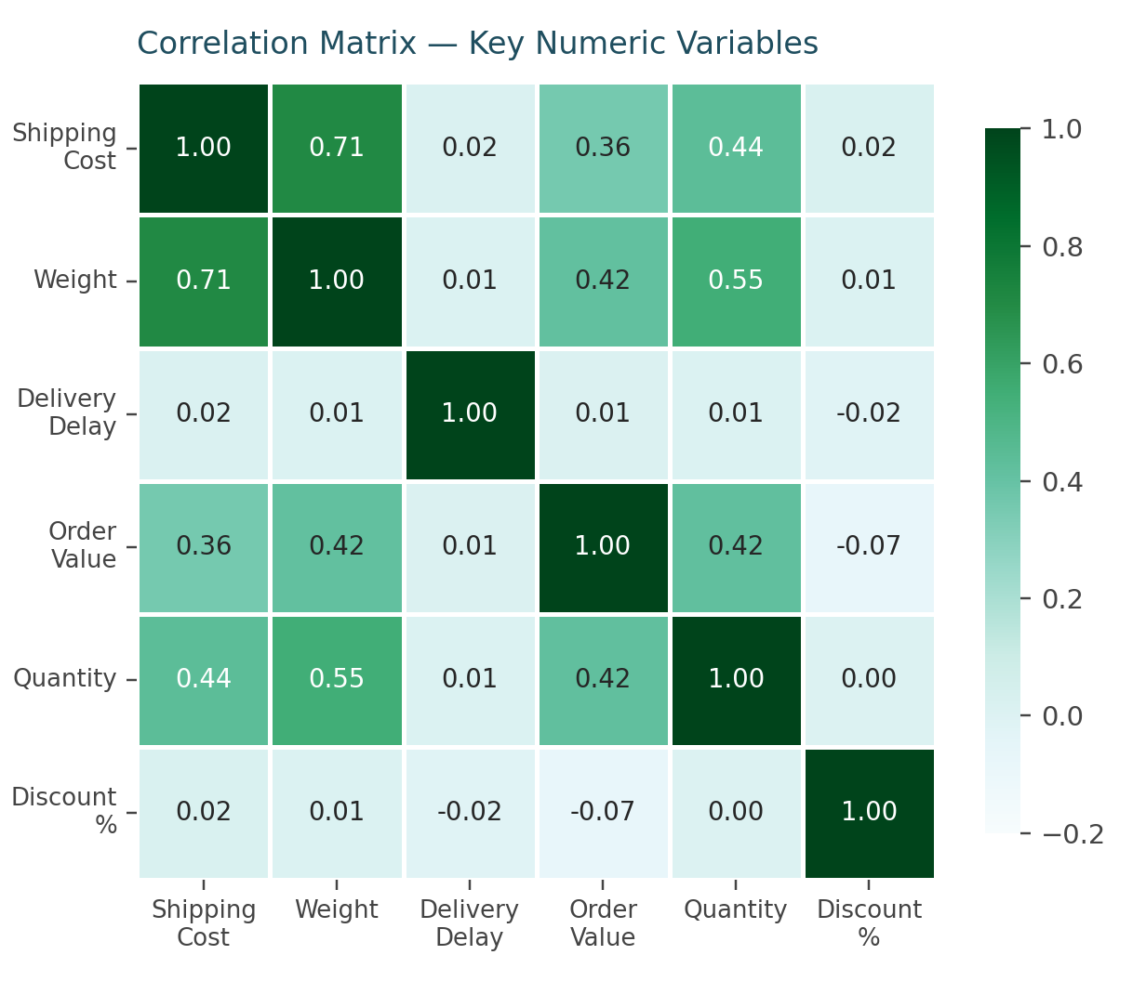
Figure 6. Correlation matrix of six key numeric variables.
The darkest off-diagonal cell is shipping cost – weight (0.71); the next darkest are weight–quantity (0.55) and the three order_value relationships (0.36–0.42) — all a sensible, physically-grounded cluster (bigger orders weigh more, cost more, and are worth more). The entire delivery_delay_days row and column is pale across the board (0.01–0.02), visually confirming Section 2.3's finding that delay is statistically unrelated to every other field measured here.

3.6 Shipping Cost vs. Weight, by Mode
Why a scatter plot: the 0.71 correlation in Section 2.3 says weight and cost move together, but not how — a scatter plot, with each shipping mode colored separately, reveals whether the relationship is one shared line or several distinct ones, which a single correlation number cannot distinguish.
for m, c in zip(order, palette):
sub = df[df["shipping_mode"] == m]
ax.scatter(sub["order_weight_kg_capped"], sub["shipping_cost_capped"],
s=10, alpha=0.45, color=c, label=m)
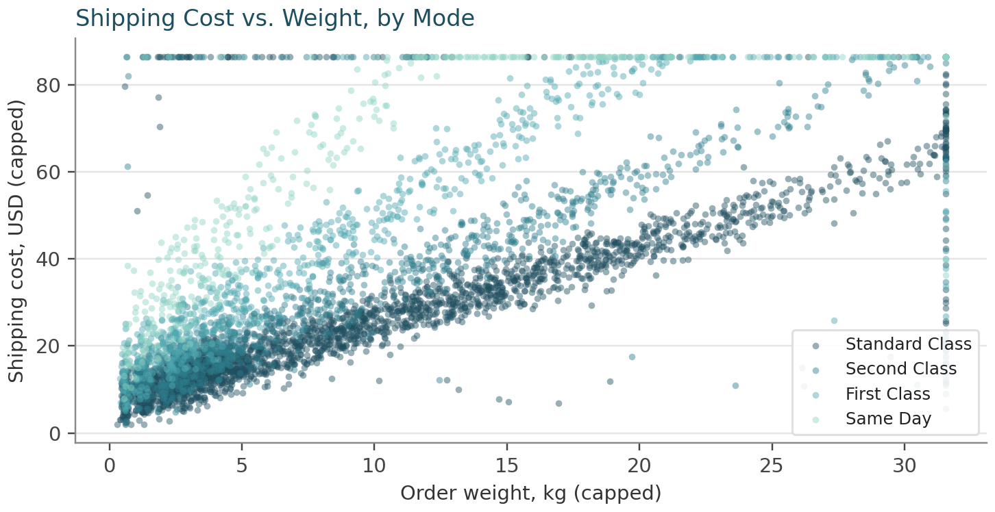
Figure 7. Shipping cost vs. order weight, colored by shipping mode.
The answer is four distinct, roughly parallel bands rather than one shared trend — at any given weight, Same Day (lightest band) costs visibly more than Standard Class (darkest band). This is the direct visual evidence behind the Section 2.3 observation that weight alone does not explain cost: mode is a second, independent driver layered on top of it. The vertical stripe of points at the right edge (weight ≈ 31.5 kg) is the Week 2 IQR cap — a visible reminder that the heaviest legitimate orders were winsorized to that ceiling, flagged in order_weight_kg_outlier_flag, and should be reviewed separately before finalizing any cost model (Section 6).

3.7 Weekly Order Volume and Average Delivery Delay
Why a two-panel time series: the question — does MRL's delivery performance degrade when order volume spikes? — is inherently about two series over the same timeline, so stacking them on a shared x-axis lets the eye check for matching peaks directly, which two separate charts or a single blended axis would make harder to read.
weekly = (df.set_index("order_date").resample("W")
.agg(orders=("order_id", "count"),
avg_delay=("delivery_delay_days", "mean")))
axes[0].bar(weekly.index, weekly["orders"], color="#2E7D8C")
axes[1].plot(weekly.index, weekly["avg_delay"], color="#1F4E5F")
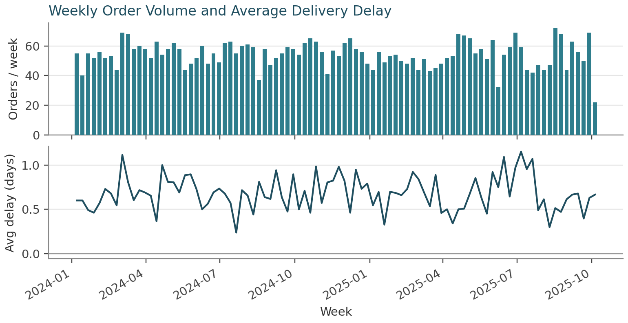
Figure 8. Weekly order volume (top) and weekly average delivery delay (bottom), 92 weeks.
Order volume is steady, oscillating between roughly 40 and 70 orders per week with no sustained upward or downward trend; the peak week (2025-08-17) reached 72 orders. The delay series below it is volatile but shows no visual correspondence to the volume peaks — confirmed numerically by a weekly-level correlation of −0.02 between the two series. Demand surges are not, in this sample, a driver of delivery delay.

3.8 Revenue Concentration by Product Category
Why a Pareto chart: the question is explicitly about concentration — what share of revenue comes from how few categories — which is exactly what a Pareto chart is built to show: bars ranked by value with a cumulative-percentage line overlaid, so the 80% threshold can be read directly off the chart.
cat = df.groupby("product_category")["order_value"].sum().sort_values(ascending=False)
cum = (cat / cat.sum() * 100).cumsum()
ax1.bar(cat.index, cat.values / 1000, color=palette)
ax2 = ax1.twinx()
ax2.plot(cat.index, cum.values, color="#B5651D", marker="o")
ax2.axhline(80, color="#B5651D", linestyle=":")
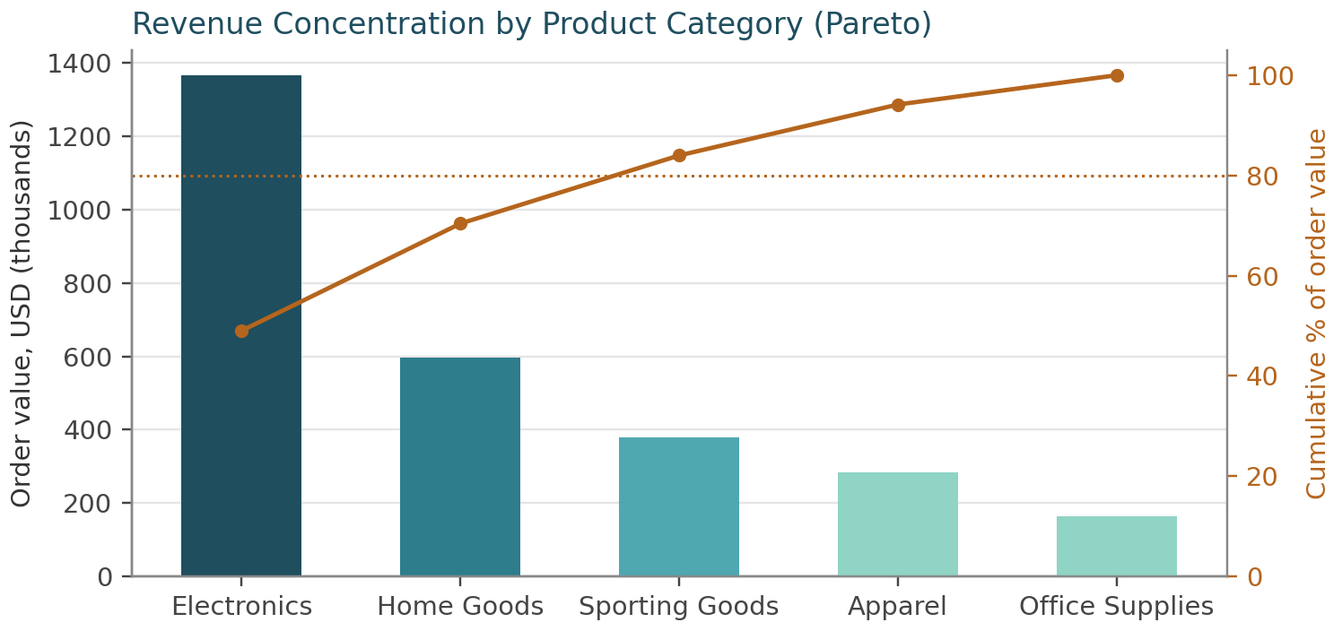
Figure 9. Revenue concentration by product category, with cumulative-percentage line.
Electronics alone accounts for 49.0% of total order value; Electronics plus Home Goods together cross 70.4%; all five categories reach 100% only once Office Supplies (5.8%) is added. The cumulative line crosses the classic 80% line between Home Goods and Sporting Goods — just three of five categories (Electronics, Home Goods, Sporting Goods) generate 84.0% of revenue, a near-textbook Pareto pattern that directly supports the ABC inventory tiering proposed in Week 1, Section 5.2.

4. Synthesis: Cross-Cutting Insights

4.1 Operational Efficiency — A Systemic Gap, Not a Weak Link
On-time delivery is MRL's most urgent problem, and the visual analysis above shows it is also a uniform one. Every shipping mode falls in a 56.8%–60.4% band (Section 3.3), every DC in 57.9%–59.2% (Section 3.4), and Appendix A shows the same holds for category (57.1%–60.5%) and region (57.4%–59.1%). That uniformity is the finding: this is not a ‘fix DC-West-03’ or ‘fix Same Day’ problem, because fixing any single segment would leave the other 95%+ of volume exactly as under-target as before. A gap this consistent across four independent dimensions points toward a shared, network-wide cause — most plausibly how promised_delivery_date is set in the first place, or a common last-mile carrier constraint — rather than a localized operational failure.

4.2 Cost Drivers — Mode Choice Outweighs Weight
Section 3.6's scatter plot and the cost-per-kilogram figures below make the same point two ways: shipping mode, not physical weight, is MRL's dominant cost lever.
Shipping Mode | Avg Weight (kg) | Avg Cost | Cost per kg
Standard Class | 9.49 | $25.46 | $2.68
Second Class | 9.32 | $32.99 | $3.54
First Class | 9.35 | $44.08 | $4.71
Same Day | 9.56 | $57.13 | $5.98
Table 3. Average weight and cost per kilogram, by shipping mode.
Average parcel weight varies by less than 3% across all four modes (9.32–9.56 kg), yet cost per kilogram ranges from $2.68 (Standard Class) to $5.98 (Same Day) — a 123% premium for physically near-identical parcels. This matters directly for the Week 1 Avg. Last-Mile Cost per Delivery KPI: shifting even a modest share of non-urgent First/Second Class volume onto Standard Class, where customer expectations allow it, would move that KPI more than any weight-reduction initiative could, since weight is clearly not the lever actually driving the cost difference between modes.

4.3 Bottlenecks and Concentration Risk — The Electronics Problem
Two findings compound into the report's single highest-priority issue. Section 3.8 showed Electronics generates 49.0% of total order value from just 1,077 of 5,000 orders (21.5% of volume); Section 2.2 and Appendix A show Electronics also has the lowest on-time rate of any category, 57.1%, and the second-highest average delay (0.74 days). MRL's single largest revenue line is simultaneously its least reliably delivered — a direct, quantified link between the cost/revenue-concentration finding and the delivery-performance finding, and the clearest single candidate for priority attention in Section 5.
Equally important is what the data does not show. Section 2.3 and Section 3.5 established that delivery delay correlates with essentially nothing else measured here — not weight, cost, order value, quantity, or discount (all ≤0.02 in magnitude) — and Section 3.7 showed weekly volume does not predict weekly delay either (−0.02). Together these rule out the two most obvious hypotheses for lateness (order characteristics and demand surges) and point toward a cause this dataset does not capture directly — most likely carrier-, route-, or day-of-week-level factors. That is a concrete, actionable gap for the next data-collection pass, not a dead end: it tells Week 4 exactly which features a late-delivery classifier should not waste time on, and which fields are worth the effort of sourcing before building one.

5. Recommendations

5.1 Quick Wins (0–30 Days)
- Treat the on-time delivery shortfall as one network-wide investigation, not four segment-level ones: start with how promised_delivery_date is set and the primary last-mile carrier's SLA, since Section 4.1 shows no single mode, DC, category, or region is the outlier.
- Open a dedicated reliability review for Electronics (Section 4.3): it is both the top revenue category (49.0% of order value) and the lowest on-time performer (57.1%), so even a small improvement here moves the company-wide KPI more than an equivalent fix anywhere else.
- Audit Same Day's price-to-reliability ratio: it carries the highest cost per kilogram ($5.98, Table 3) but only a 2–4-point on-time advantage over the other three modes (Section 3.3) — confirm the premium is still justified to customers choosing it.

5.2 Medium-Term (This Quarter)
- Apply ABC inventory tiering per the Week 1 roadmap using the Section 3.8 Pareto result directly: Tier A = Electronics + Home Goods (70.4% of value), Tier B = Sporting Goods + Apparel, Tier C = Office Supplies.
- Before building the Week 1 Section 7.4 demand/delay model, source carrier, route, and day-of-week fields identified as missing in Section 4.3 — the current fields (weight, cost, quantity, discount) carry no measurable signal for delay and would waste model capacity if used as predictors for it.

5.3 Strategic (Next Phase)
- Proceed with the Week 1 Phase 5 route-optimization work, but position it internally as a cost-reduction lever (Section 4.2's mode-mix finding), not a fix for on-time performance — Section 3.7 shows volume/capacity strain is not the driver of lateness, so optimization should be judged against the cost KPI, not the delivery KPI.
- Re-run this Section 3 visualization suite each sprint once the Week 1 dashboard (Plotly/Dash) is live, so DC and category managers can track whether the Section 4.1 gap narrows after the quick-win investigation lands.

6. Limitations and Next Steps
- Sample, not system-of-record: this is the same schema-aligned representative sample used in Weeks 1–2, not MRL's live order-management extract. Absolute figures (58.6% OTD, the exact cost-per-kg values) should be treated as a working baseline to validate once live data is available; the analytical approach and code transfer directly.
- Missing causal fields: as Section 4.3 notes, no field in this extract explains the variance in delivery_delay_days. Carrier ID, route/lane, and day-of-week are the top candidates to add before attempting a late-delivery classifier.
- Outlier-capping ceiling effect: Section 3.6's visible vertical band at the 31.55 kg cap is a reminder that Week 2's IQR capping, while necessary to tame the extreme tail, compresses the top of the weight distribution; order_weight_kg_outlier_flag should be joined back in before finalizing any cost model built on the capped field.
- Next step: Week 4 should move from this descriptive/diagnostic analysis into the predictive modeling phase proposed in Week 1 (Sections 7.4–7.6) — a late-delivery classifier informed by Section 4.3's feature guidance, plus the route-optimization and inventory-policy work motivated by Sections 4.1 and 4.2 respectively.

7. Conclusion
This report turned the Week 2 cleaned dataset into a grounded diagnostic picture of MRL's logistics operation: eight visualizations, each justified by the question it answers rather than chosen for variety, backed by descriptive statistics and a correlation analysis computed from real, executed code. The headline result is uncomfortable but useful — a 58.6% on-time delivery rate that is consistently far below target across every segment the data can slice, a shipping-cost structure driven more by mode selection than physical necessity, and a revenue-critical product category that is also the least reliably delivered. None of these findings were assumed going in; they emerged from the EDA and were only then visualized, interpreted, and turned into the prioritized recommendations in Section 5. That is the order an experienced analyst works in, and it is the order this report followed.

References
Week 1 deliverable: Strategic Planning and Data Exploration in Logistics (this project, September 2026).
Week 2 deliverable: Data Collection, Cleaning, and Preprocessing for Logistics Analysis (this project, September 2026) — source of the cleaned_logistics_sample.csv dataset analyzed here.
Hunter, J. D. (2007). Matplotlib: A 2D Graphics Environment. Computing in Science & Engineering, 9(3), 90–95.
Waskom, M. (2021). seaborn: statistical data visualization. Journal of Open Source Software, 6(60), 3021.
The pandas development team. pandas documentation — GroupBy and resample. https://pandas.pydata.org/docs/user_guide/groupby.html
Juran, J. M. (1951). Quality Control Handbook. McGraw-Hill. (Origin of the Pareto / 80-20 concentration analysis used in Section 3.8.)

Appendix A — Full Segment Breakdown Tables
The complete on-time delivery rate breakdowns summarized in Table 2 are reproduced here in full.
By Shipping Mode
Segment | Orders | On-Time Rate | Avg. Delay (days)
First Class | 782 | 56.8% | 0.72
Second Class | 1,036 | 57.9% | 0.68
Standard Class | 2,739 | 59.1% | 0.66
Same Day | 386 | 60.4% | 0.80
By Distribution Centre
Segment | Orders | On-Time Rate | Avg. Delay (days)
DC-West-03 | 1,624 | 57.9% | 0.68
DC-East-01 | 1,684 | 58.7% | 0.69
DC-Central-02 | 1,635 | 59.2% | 0.67
By Product Category
Segment | Orders | On-Time Rate | Avg. Delay (days)
Electronics | 1,077 | 57.1% | 0.74
Home Goods | 1,016 | 57.8% | 0.70
Office Supplies | 550 | 58.7% | 0.72
Apparel | 1,429 | 59.1% | 0.64
Sporting Goods | 871 | 60.5% | 0.63
By Customer Region
Segment | Orders | On-Time Rate | Avg. Delay (days)
South | 1,230 | 57.4% | 0.68
East | 1,270 | 59.0% | 0.67
West | 1,233 | 59.0% | 0.67
Central | 1,210 | 59.1% | 0.70

Revenue Concentration by Category (full Pareto detail)
Category | Order Value | % of Total | Cumulative %
Electronics | $1,366,841 | 49.0% | 49.0%
Home Goods | $596,271 | 21.4% | 70.4%
Sporting Goods | $378,913 | 13.6% | 84.0%
Apparel | $283,394 | 10.2% | 94.2%
Office Supplies | $162,977 | 5.8% | 100.0%

