Predictive Modeling and Optimization in Logistics Systems
Forecasting shipping cost, auditing freight bills and optimizing operations for Meridian Retail Logistics (MRL)
Prepared for: Logistics Data Analysis Project — Week 4 Deliverable
Builds on: Week 1 (Strategic Plan), Week 2 (Cleaned Dataset, n = 5,000 orders) and Week 3 (Analysis and Visualization)
Method: Python 3 (pandas, scikit-learn, SciPy, matplotlib); every number in this report comes from code that was executed
Date: 25 October 2026

Table of Contents
Executive Summary 3
1. Problem Definition and Data 4
2. Data Preparation and Validation Design 5
3. Model Selection 7
4. Training, Cross-Validation and Tuning 8
5. Evaluation on the Held-Out Period 10
6. Two Further Prediction Tasks 14
7. Optimization Strategies 15
7.1 Freight-bill audit 16
7.2 Shipping-mode reassignment 18
7.3 Promise-date calibration 20
7.4 Safety stock and ABC tiering 21
7.5 Route planning 22
7.6 Impact summary 25
8. Corrections to Earlier Weeks 25
9. Recommendations 27
10. Limitations and Threats to Validity 28
11. Reflection and Conclusion 29
References 30
Appendix A — Reproducibility and Code Map 30

Executive Summary
This report builds and tests predictive models on the Meridian Retail Logistics (MRL) order data prepared in Weeks 1–3, and then turns the model outputs into five concrete optimization levers. The main prediction problem is the shipping cost of an order, estimated from information available when the order is placed. A cost model is useful for three things at once: it sets an expected price for budgeting and quoting, it exposes carrier invoices that do not match that price, and it lets us price "what if this order had shipped in a cheaper mode?" before deciding.
Two other targets that the brief names as examples, delivery time and shipment volume, were also modelled. Neither could be predicted from the data available, and the report says so plainly instead of presenting a model that only looks good. The same discipline led to a section correcting several Week 2 and Week 3 figures that these models showed to be misleading.
Table 1. Results at a glance (all figures from executed code; held-out period = last 1,000 orders)
Question | Result | Evidence / caveat
Can shipping cost be predicted? | Yes. Gradient boosting: MAE $3.46, RMSE $4.80, R² 0.972 | Naive baseline MAE $17.68, so error falls 80%. 95% bootstrap CI for MAE: $3.24–$3.67
Can mis-billed invoices be found? | Yes. 28 of 28 mis-keyed bills caught, 3 false alarms (precision 90.3%) | Week 2 IQR rule: precision 37.1%. Over-billing in window: $11,000 (25.1% of billed spend). Only large errors are detectable (Sec. 7.1)
Where can cost be cut? | Moving 10–25% of non-Standard orders down one tier saves $557–$1,393 per 1,000 orders (1.7–4.3% of spend) | Model counterfactual, not an experiment; assumes the customer accepts the slower mode
Can promises be made reliable? | Adding 3 days to the promised date lifts on-time promises from 57.4% to 92.6% on unseen orders | Changes the promise, not the parcel; commercial effect not measured
Is risk-tiered safety stock worth it? | No. +15.5% safety-stock value for a net $44 per year | Within the noise of the estimate; uniform 95% service level is adequate
Can routes be shortened? | Clarke–Wright savings + 2-opt: −29.4% distance vs a dispatcher sweep on average over 200 simulated days (5th–95th percentile 18%–40%) | Hypothetical stops: the order file has no delivery coordinates
Can lateness or volume be predicted? | No. Late-delivery AUC 0.50 (95% CI 0.46–0.54); no weekly-volume method beats the training mean | Features carry no signal for delay in this data; do not deploy a delay model

What a reader should know before relying on these numbers
The data are simulated (seeded generator, Week 2). That is why the true price of every bill is known and the audit can be scored exactly. In production the same scoring would use a manually audited sample of invoices. Dollar figures describe this 1,000-order, 129-day window and are reported per 1,000 orders; they are not scaled up to the 15,000 orders per week assumed in Week 1, because this sample contains about 55 orders per week.
Three of the results above are negative or neutral (delay, volume, ABC tiering). They are kept because a recommendation that survives testing is more useful than a larger one that does not.

1. Problem Definition and Data

1.1 The logistics problem
Freight is one of the few costs that MRL can change quickly. In the held-out window, the 1,000 orders carried $32,789 of correctly billed shipping cost against $526,428 of order value (6.2%). The product margin earned on the same orders was $76,812. The profit field in this schema is simulated independently of freight, so it is read as margin before freight; on that reading shipping consumes about 43% of it. A cost model that is a few percent more accurate, or an audit that removes a few percent of overpayment, therefore matters at the margin line.
Week 3 showed that shipping mode, not weight, drives cost per kilogram, and that on-time delivery is uniformly weak across segments. Those findings suggest three prediction tasks, summarised in Table 2. The first is the one this report builds in depth because it is the only one with a usable signal and it feeds four of the five optimization levers.
Table 2. The three prediction tasks
Task | Target variable | Model type | Decision it supports | Outcome
A. Shipping cost (primary) | shipping_cost (USD per order) | Regression | Budgeting, freight audit, mode what-ifs | Works: R² 0.972
B. Late delivery | is_late (yes/no); delay in days | Classification and regression | Proactive customer notice | No signal: AUC 0.50
C. Weekly order volume | Orders per week | Time-series forecast | Staffing and capacity | No signal above noise

1.2 Dataset, features and target
The data are the cleaned Week 2 file: 5,000 orders placed between 2024-01-01 and 2025-10-01 from three distribution centres, covering five product categories and four shipping modes. It is a simulated sample whose schema follows the public DataCo Smart Supply Chain dataset (Constante, Silva and Pereira, 2019). Week 2 injected realistic faults (missing values, duplicates, mis-keyed fees, weight outliers) and cleaned them. This week re-ran the Week 2 scripts from their fixed random seed and confirmed that every Week 2 checkpoint is reproduced, so the file used here is the same file.
Table 3. Model inputs and target
Field | Role | Type | Description
order_weight_kg_capped | Feature | Numeric | Order weight in kg, capped at 31.55 kg in Week 2 (IQR rule)
quantity | Feature | Numeric | Units in the order, 1 to 7 (negatives corrected in Week 2)
discount_pct | Feature | Numeric | Discount applied: 0%, 5%, 10%, 15% or 20%
shipping_mode | Feature | Categorical (4) | Standard, Second Class, First Class, Same Day
product_category | Feature | Categorical (5) | Apparel, Electronics, Home Goods, Office Supplies, Sporting Goods
shipping_cost | Target | Numeric, USD | Raw carrier bill for the order, mis-keyed bills included

Only attributes known at order time are used as features. Delivery dates, delay and profit are excluded to avoid leakage. Customer segment, region and distribution centre are left out of the cost model so that it uses only what a carrier's rate card would price; they do appear in the delay model (Section 6). The order file contains no delivery distance, zone or coordinates, which turns out to matter (Section 5.4).

1.3 The target and its contamination
The raw billed cost is heavily right-skewed: mean $41.49, median $25.31, 95th percentile $103.54 and a maximum of $2,060.18, with skewness 11.7. The maximum is not a heavy parcel. It is one of 130 bills (2.6% of orders) that were mis-keyed at 6.1 to 14.0 times the correct price, the "mis-keyed international or express fee" problem from Week 2. Replacing those bills with their correct prices gives a maximum of $259.77 and skewness 2.8.
This creates the central modelling difficulty. The model must learn the price list from training labels that are 2.55% wrong (102 of the 4,000 training bills), without being told which ones. Because the data are simulated, the identity of the wrong bills is known, and it is used in exactly two places: scoring models, and choosing between model families on training folds (Section 4.3). It is never used to fit a model or to set a detection threshold. In a real company the equivalent would be a manually audited sample of carrier invoices.

Figure 1. The five-stage workflow followed in this report; each stage maps to one or more sections below.

2. Data Preparation and Validation Design

2.1 A time-based train/test split
Orders are sorted by date and the first 80% are used for training and the last 20% for testing. A random split would let the model learn from orders placed after the ones it is tested on, which flatters every metric and is impossible in deployment. The same split is used by every script, and the test set is not used for any choice of model, hyperparameter or threshold.
Python — load and split (common.py)
df = pd.read_csv("cleaned_logistics_sample.csv", parse_dates=["order_date"])
df = df.sort_values("order_date").reset_index(drop=True) # chronological order
split = int(len(df) * 0.8) # 4,000 train / 1,000 test
train, test = df.iloc[:split].copy(), df.iloc[split:].copy()
print(train.order_date.min().date(), "to", train.order_date.max().date(), f"({len(train)})")
print(test.order_date.min().date(), "to", test.order_date.max().date(), f"({len(test)})")
Output
2024-01-01 to 2025-05-26 (4000)
2025-05-26 to 2025-10-01 (1000)
The test window spans 129 days. The boundary date, 2025-05-26, falls inside both ranges because the 4,000th order is one of several placed on that day; the split is by row, so no order appears twice.

2.2 Encoding and scaling
Week 2 produced min–max and z-score copies of the numeric fields. This week scaling is applied inside each model pipeline instead, so that its mean and standard deviation are learned from training rows only and cannot leak from the test period. Only the linear models need it: tree-based models split on thresholds, so their predictions do not change when a feature is rescaled. Categorical fields are one-hot encoded, with unseen categories ignored rather than raising an error.
Python — feature preprocessing (10_final_cost_models.py)
NUM = ["order_weight_kg_capped", "quantity", "discount_pct"]
CAT = ["shipping_mode", "product_category"]

prep_tree = ColumnTransformer([("n", "passthrough", NUM),
("c", OneHotEncoder(handle_unknown="ignore"), CAT)])
prep_lin = ColumnTransformer([("n", StandardScaler(), NUM), # linear models only
("c", OneHotEncoder(handle_unknown="ignore"), CAT)])

def logwrap(reg):
"""Fit on log(cost); predict() maps back to dollars automatically."""
return TransformedTargetRegressor(regressor=reg, func=np.log, inverse_func=np.exp)

2.3 Why the target is the raw bill and not Week 2's capped copy
Week 2 capped shipping cost at the IQR fence of $86.43 and flagged 349 orders. The capped copy removes the mis-keyed bills, but it also removes genuinely expensive parcels, and a model trained on it cannot price them. The evidence is concrete. Among the 160 orders whose weight sits at the 31.55 kg cap, 55 weighed more than 1.5 times that cap in the raw data, and their correct cost has a median of $68 with an interquartile range of $38 to $97. A quarter of them cost more than the $86.43 ceiling that the capped target would have taught the model.
A first attempt that did train on the capped, non-outlier rows reached an MAE of $18.00 on correctly billed test orders heavier than 20 kg, compared with $6.40 for its successor trained on the raw bill (script 09). That failure motivated the design used here: train on the raw bill, fit on log(cost) so that a 10x error moves the loss by a bounded amount, and use an absolute-error loss that gives little weight to the few wrong labels.
Worked example: how one wrong bill looks to the model
Order ORD-101086 (Standard Class, Electronics, 3 units, 6.15 kg) has a correct price of $15.10. The bill was mis-keyed at 7.55 times that price and reads $114.03. On the log scale the wrong label is ln(114.03) = 4.74 instead of ln(15.10) = 2.71, a gap of 2.02. On the dollar scale the gap is $98.93. Measured in squared dollars, this one order would carry about 818 times the weight of an order that the model misses by its typical $3.46. An absolute-error loss on the log scale counts it as a miss of 2.02 log units, in proportion to its size instead of to its square, so a few such labels cannot dominate the fit.

3. Model Selection

3.1 Candidate models and why each is on the list
Six candidates are compared, chosen to span the range the brief names: a trivial baseline, two linear models, a single decision tree and two ensembles. Each answers a different question about the cost process, and each has a failure mode that the evaluation is designed to expose.
Table 4. Candidate models for shipping-cost prediction
Model | Why it is included | Expected weakness
Naive: training median | The floor. Any model that cannot beat "always predict the typical bill" has learned nothing. | Ignores every feature
Linear regression (OLS) | Transparent and close to how a rate card reads (base charge + rate × kg). Features standardized inside the pipeline. | One slope per kg for all modes; squared loss is pulled hard by wrong bills
Robust linear (Huber) with weight × mode interactions | Gives each mode its own price per kg, as real tariffs do, and the Huber loss limits the influence of wrong bills. | Cannot bend where the price curve is not straight
Decision tree (log cost, absolute-error loss) | Finds interactions and thresholds automatically; the rules can be read and audited. | High variance: small data changes move the splits
Random forest (log cost, absolute-error loss) | Averages many trees, which cuts the variance of a single tree. | Averaging blurs the sharp price steps; extrapolates poorly to heavy parcels
Gradient boosting (log cost, absolute-error loss) | Builds shallow trees in sequence, each correcting the last, which usually wins on tabular data. | Can memorize wrong labels if not constrained (shallow trees, absolute-error loss)

3.2 Two design choices that apply to every tree model
- Log-transformed target. Cost spans $2 to $260 once errors are removed, and a $5 miss on a $15 parcel is a bigger problem than a $5 miss on a $150 parcel. Fitting log(cost) makes the model's errors proportional, and predictions are mapped back to dollars automatically.
- Absolute-error loss. Squared error is optimal when noise is symmetric and light-tailed, which the training labels are not (2.55% of them are 6 to 14 times too large). Absolute error is the loss whose minimizer is the median, which is unmoved by a small share of extreme labels.

3.3 A selection rule written before running the comparison
With two or three strong candidates the choice can be tipped by whichever metric one looks at last, so the rule was fixed in advance in the script header: choose the model with the lowest mean cross-validated MAE on the training period; if several models are within 5% of the best MAE, choose the one with the lowest RMSE among them. RMSE is the tie-breaker because a few large pricing misses on heavy parcels are costlier than many small ones. The test period plays no part in this rule.

4. Training, Cross-Validation and Tuning

4.1 Cross-validation that respects time
Ordinary k-fold cross-validation shuffles orders, so a model could be validated on March orders after training on April orders. Time-series cross-validation instead uses an expanding window: each fold trains on everything before a cut-off and validates on the block that follows. Five folds on the 4,000 training orders give the windows in Table 5. Fold 1 is trained on only 670 orders, so early folds are noisier than late ones, and averages across folds are read with that in mind.
Table 5. Expanding-window folds (TimeSeriesSplit, 5 splits, 4,000 training orders)
Fold | Training orders | Validation orders | Validates on orders numbered
1 | 670 | 666 | 671–1,336
2 | 1,336 | 666 | 1,337–2,002
3 | 2,002 | 666 | 2,003–2,668
4 | 2,668 | 666 | 2,669–3,334
5 | 3,334 | 666 | 3,335–4,000

4.2 Hyperparameter search
Each tree model was tuned with a grid search over the time-series folds. The tuning metric had to be computable without knowing which training bills are wrong, because in production nobody has that list. The choice was a trimmed MAE: the mean absolute dollar error after discarding the largest 5% of errors in each fold. It stays in dollars, so expensive parcels count for more than cheap ones, and it is unmoved by the roughly 2.5% of wrong labels. Median absolute percentage error (MdAPE) was recorded alongside it as a scale-free cross-check.
Python — time-series grid search for gradient boosting (10_final_cost_models.py)
def trimmed_mae(y, p, trim=0.05):
"""Mean absolute error after discarding the worst 5% of errors (label-free, robust)."""
e = np.sort(np.abs(np.asarray(y) - np.asarray(p)))
return float(e[: int(np.ceil(len(e) * (1 - trim)))].mean())

cv_scorer = make_scorer(trimmed_mae, greater_is_better=False)
tscv = TimeSeriesSplit(n_splits=5)

gb = Pipeline([("p", prep_tree),
("m", logwrap(GradientBoostingRegressor(
loss="absolute_error", random_state=42)))])
grid = {"m__regressor__n_estimators": [100, 200, 400],
"m__regressor__learning_rate": [0.05, 0.1],
"m__regressor__max_depth": [2, 3, 4]}
search = GridSearchCV(gb, grid, cv=tscv, scoring=cv_scorer, n_jobs=-1).fit(Xtr, ytr)
print(search.best_params_, round(-search.best_score_, 2))
Output
{'m__regressor__learning_rate': 0.05, 'm__regressor__max_depth': 3,
'm__regressor__n_estimators': 400} 3.13
Table 6. Search spaces, selected settings and cross-validated scores (training period only)
Model | Search space | Fits | Selected | CV trimmed MAE | CV MdAPE
Linear regression (OLS) | none | 5 | — | $12.27 | 42.8%
Robust linear (Huber) | none (epsilon 1.35) | 5 | — | $3.06 | 10.1%
Decision tree | depth {4, 6, 8, 12} × leaf {5, 20} | 8 × 5 = 40 | depth 8, leaf 5 | $3.64 | 11.7%
Random forest | depth {6, 10} × leaf {5, 20}; 150 trees | 4 × 5 = 20 | depth 6, leaf 5 | $3.30 | 10.8%
Gradient boosting | trees {100, 200, 400} × rate {0.05, 0.1} × depth {2, 3, 4} | 18 × 5 = 90 | 400 trees, rate 0.05, depth 3 | $3.13 | 10.3%

Gradient boosting chose the slowest learning rate with the most trees and shallow, depth-3 trees, which is the conservative corner of its grid. That pattern is what one hopes to see when some labels are wrong: many small, cautious corrections rather than a few large ones. Two of its three settings sit at the edge of the grid (400 is the largest number of trees tried and 0.05 the smaller learning rate), so a wider search might gain a little more; any such gain would be small next to the differences between model families.

4.3 Choosing between families, still on the training period
On the label-free tuning metric the robust linear model and gradient boosting are separated by only $0.07 (Table 6), which is a tie. The trimmed metric also discards exactly the orders where models differ most: heavy parcels at the weight cap, which sit in the worst 5% of errors. To break the tie fairly, the same five folds were re-scored against the audited correct price of correctly billed orders in each validation block, and the pre-declared rule from Section 3.3 was applied. This uses audited labels for selection only, never for fitting, and uses nothing from the test period.
Python — selection on training folds (11_selection_on_training_folds.py, abridged)
for tr_i, va_i in TimeSeriesSplit(5).split(train):
fit = clone(model).fit(train.iloc[tr_i][feats],
train.iloc[tr_i]["shipping_cost"]) # contaminated labels
va = train.iloc[va_i]; va = va[~va.is_error] # audited, correctly billed orders
e = va["true_cost"].values - fit.predict(va[feats]) # error against the correct price
...
within = sel[sel["CV MAE $"] <= sel["CV MAE $"].min() * 1.05] # within 5% of the best MAE
champion = within.sort_values("CV RMSE $").iloc[0]["Model"] # tie-break on RMSE
Table 7. Training-fold scores against audited correct prices (mean of 5 folds)
Model | CV MAE | CV RMSE | MAE at weight cap | MAE other orders
Linear regression (OLS, raw cost) | $13.22 | $16.80 | $35.14 | $12.54
Robust linear (Huber) + weight×mode | $3.80 | $7.52 | $25.06 | $3.20
Decision tree (log cost, abs-error) | $4.45 | $8.66 | $20.76 | $4.00
Random forest (log cost, abs-error) | $3.96 | $6.89 | $21.42 | $3.44
Gradient boosting (log cost, abs-error) | $3.51 | $5.31 | $11.44 | $3.32

Gradient boosting has the lowest MAE ($3.51), and no other model is within 5% of it, so the rule selects it without needing the tie-break. The gap is widest where it matters: on weight-capped parcels its MAE is $11.44, against $25.06 for the robust linear model. A straight-line price per kilogram cannot follow the real cost of heavy express parcels once their weight has been clipped, while boosted trees can approximate it from the other features. This is the one place where the label-free metric and the audited metric disagreed, and it is why the audited check was added.

5. Evaluation on the Held-Out Period

5.1 Metrics and what each one is for
- MAE (mean absolute error). The typical dollar miss per order. Easy to explain to a finance reader and to compare with the price of a parcel.
- RMSE (root mean squared error). Also in dollars but squares each miss first, so a few large pricing errors on heavy parcels raise it sharply. RMSE much larger than MAE signals a heavy-tailed error distribution.
- R² (coefficient of determination). The share of the variation in cost explained by the model, against a flat prediction at the mean. It is scale-free but says nothing about the dollar size of errors, so it is never read alone.
- MdAPE and within-10% / within-20%. Percentage errors answer "how often is the quote close enough to rely on?" and are comparable between a $10 and a $100 parcel.
All metrics are computed on the 972 correctly billed orders in the held-out window, comparing each prediction with the audited correct price. The 28 mis-keyed bills in that window are scored separately as an audit problem in Section 7.1. Confidence intervals come from a bootstrap that resamples the 972 orders 2,000 times.
Python — held-out evaluation
leg = test[~test.is_error] # 972 correctly billed test orders
y, p = leg["true_cost"].values, champ.predict(leg[feats])

rmse = mean_squared_error(y, p) ** 0.5
mae = mean_absolute_error(y, p)
r2 = r2_score(y, p)
mdape = 100 * np.median(np.abs(y - p) / y)
within = 100 * (np.abs(y - p) / y <= 0.10).mean()
print(f"RMSE ${rmse:.2f} | MAE ${mae:.2f} | R2 {r2:.3f}",
f"| MdAPE {mdape:.1f}% | within 10%: {within:.1f}%")

rng = np.random.default_rng(42); idx = np.arange(len(y))
draws = (rng.choice(idx, len(idx)) for _ in range(2000))
boot = [mean_absolute_error(y[b], p[b]) for b in draws]
print("MAE 95% CI", np.percentile(boot, [2.5, 97.5]).round(2))
Output
RMSE $4.80 | MAE $3.46 | R2 0.972 | MdAPE 9.6% | within 10%: 51.1%
MAE 95% CI [3.24 3.67]

5.2 Results
Table 8. Held-out performance of all candidates (972 correctly billed orders)
Model | RMSE | MAE | R² | MdAPE | Within 10% | Within 20%
Naive: training median | $29.63 | $17.68 | -0.065 | 47.7% | 9.7% | 20.6%
Linear regression (OLS, raw cost) | $17.31 | $12.97 | 0.636 | 39.0% | 11.5% | 23.6%
Robust linear (Huber) + weight×mode | $11.04 | $4.44 | 0.852 | 9.8% | 51.0% | 75.0%
Decision tree (log cost, abs-error) | $9.45 | $4.21 | 0.892 | 10.5% | 48.3% | 72.2%
Random forest (log cost, abs-error) | $9.51 | $4.42 | 0.890 | 10.7% | 47.0% | 74.0%
Gradient boosting (log cost, abs-error) | $4.80 | $3.46 | 0.972 | 9.6% | 51.1% | 76.4%

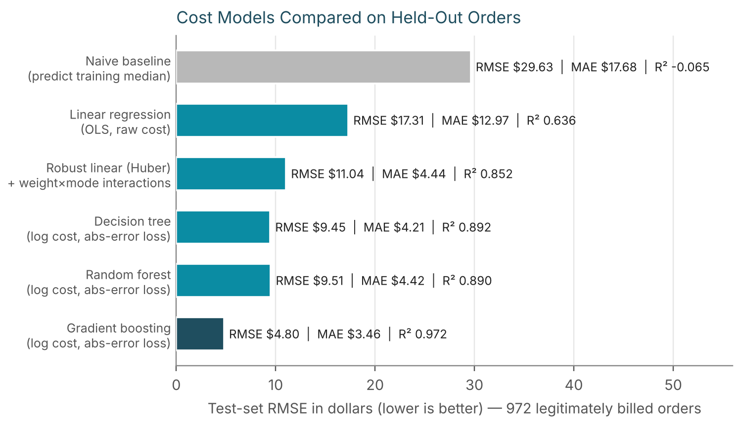
Figure 2. Held-out RMSE for each candidate; gradient boosting (dark bar) is the model selected in Section 4.3.
Gradient boosting reaches an MAE of $3.46 (95% CI $3.24 to $3.67), an RMSE of $4.80 ($4.39 to $5.24) and an R² of 0.972 (0.966 to 0.977). Its median percentage error is 9.6% (9.0% to 10.7%), and 51% of quotes land within 10% of the correct price and 76% within 20%. Against the naive baseline, MAE falls from $17.68 to $3.46.
Three comparisons are worth drawing out. First, plain linear regression is the weakest real model (R² 0.636, MAE $12.97), because it is fitted by squared error on labels that include the wrong bills and has one price per kilogram for all modes. Second, the robust linear model is close to the ensembles on MAE ($4.44 against $3.46) but far behind on RMSE ($11.04 against $4.80); it is accurate for ordinary parcels and wrong by large amounts on heavy ones. Third, the single decision tree and the random forest are nearly identical on RMSE ($9.45 and $9.51). Averaging many trees did not repair their large misses on heavy parcels, which boosting, fitting each tree to the previous trees' errors, handles far better (training-fold MAE at the weight cap: $11.44 against $20.76 and $21.42, Table 7).

5.3 Where the model is right and where it is wrong
Table 9. Champion error by weight band (raw order weight) and by shipping mode
Weight band | Orders | Mean cost | MAE | MdAPE
< 5 kg | 421 | $15.91 | $3.11 | 16.5%
5–10 kg | 191 | $27.27 | $3.24 | 9.7%
10–20 kg | 232 | $46.84 | $3.44 | 6.4%
> 20 kg | 128 | $70.02 | $5.00 | 5.7%

Shipping mode | Orders | Mean cost | MAE | Bias (actual − predicted) | MdAPE
Standard Class | 555 | $24.55 | $2.67 | −$0.10 | 9.2%
Second Class | 201 | $30.30 | $3.41 | −$0.62 | 11.3%
First Class | 138 | $44.95 | $4.14 | +$0.88 | 9.1%
Same Day | 78 | $74.63 | $8.02 | +$2.73 | 10.8%

The dollar error rises with parcel weight, but the percentage error falls: light parcels have the largest MdAPE (16.5% below 5 kg) because a fixed few dollars of unexplained variation is a large share of a $16 bill, and the smallest for the heaviest (5.7% above 20 kg). By mode, Same Day is hardest to price (MAE $8.02), and the model under-prices it on average by $2.73 per order. This is the mode where the cost spread between orders is widest and where an unobserved driver has the most leverage (Section 5.5).
A data limitation found through the error analysis: the weight cap
Week 2 capped order weight at 31.55 kg. In the held-out window, 39 correctly billed orders (4.0%) sit exactly at the cap, and the model's MAE on them is $7.86, against $3.28 on all other orders, about 2.4 times as large. Across all 5,000 orders, 160 are at the cap and 55 of those weighed more than 1.5 times the cap in the raw data. The cap was right for removing mis-keyed weights but it also merges real 40 kg and 60 kg parcels into one value. For cost modelling the uncapped weight, with mis-keyed weights handled separately, would be the better input.

5.4 What the model relies on
Permutation importance shuffles one feature at a time on the held-out orders and records how much RMSE rises. A feature the model leans on will hurt it when scrambled; one it ignores will not.
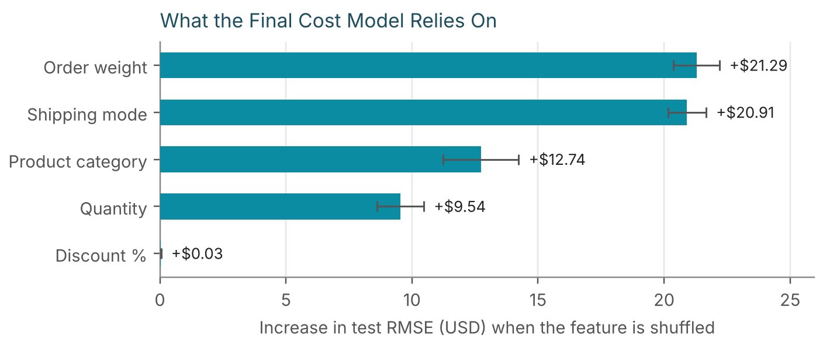
Figure 3. Increase in held-out RMSE when each feature is shuffled (mean of 20 repeats; bars show one standard deviation).
Order weight (+$21.29) and shipping mode (+$20.91) dominate, followed by product category (+$12.74) and quantity (+$9.54). The discount has no effect (+$0.03), as it should not: a carrier does not price freight by the customer's discount. Category and quantity partly act as stand-ins for weight, because heavier categories and larger quantities mean heavier parcels, so their importance is shared among correlated inputs and should not be read as separate causes.

5.5 What the model cannot see: delivery distance
The order file has no destination, zone or distance, but real carrier tariffs depend on them. In the simulator that generated the data, distance is a genuine cost driver, which makes it possible to measure what the missing field costs: the champion was refitted with the simulator's distance added and everything else unchanged.
Table 10. Value of one missing feature (held-out period, same method and hyperparameters)
Measure | Champion (no distance) | With distance (upper bound) | Change
MAE | $3.46 | $2.58 | −26%
RMSE | $4.80 | $3.71 | −23%
R² | 0.972 | 0.983 | +0.011
Median % error | 9.6% | 7.4% | −2.2 pts
Quotes within 10% | 51.1% | 60.5% | +9.4 pts
Audit flag line (billed ÷ expected) | 1.85× | 1.59× | tighter
Audit: flagged / true / false alarms | 31 / 28 / 3 | 29 / 28 / 1 | 2 fewer false alarms

Adding distance cuts MAE by 26% and tightens the audit flag line from 1.85× to 1.59× the expected price. The simulator also adds independent random noise to every price (standard deviation $2.50), which sets a floor of about $2.00 on MAE that no feature can remove; with distance the model is at $2.58, close to that floor. This is an upper bound: real tariffs use zones rather than exact kilometres, and real distance data would be noisier. The practical conclusion stands: capturing a destination zone for every order is the single most valuable data improvement for cost prediction.

6. Two Further Prediction Tasks
The brief names delivery time and shipment volume as example targets, so both were modelled with the same discipline: a time-based split, cross-validated tuning, a baseline to beat, and a confidence interval on the headline metric. Neither produced a usable model, and the evidence for that conclusion is shown rather than hidden.

6.1 Late-delivery classification and delay regression
Labels come from the 4,672 orders with a genuinely recorded delivery date. The 271 orders whose date Week 2 imputed are excluded: the imputation placed them on the promised date, so they are all "on time" by construction and would inflate the on-time rate. The split is again chronological (3,737 training, 935 test). 44.1% of training orders and 42.6% of test orders were late. Features are order-time attributes only: weight, quantity, discount, quoted shipping cost, order weekday and month, promised days, mode, category, distribution centre, region and segment.
Logistic regression and a random forest were compared with a majority-class baseline. The forest was tuned by grid search (12 settings × 5 time-series folds, scored by ROC-AUC, the probability that a randomly chosen late order is ranked above a randomly chosen on-time one, where 0.5 is a coin flip).
Table 11. Late-delivery classifiers on the held-out period
Model | Accuracy | Precision | Recall | F1 | ROC-AUC | CV AUC (mean ± sd)
Majority-class baseline | 0.574 | 0.000 | 0.000 | 0.000 | 0.500 | —
Logistic Regression | 0.571 | 0.385 | 0.013 | 0.024 | 0.504 | 0.484 +/- 0.039
Random Forest (tuned) | 0.574 | 0.000 | 0.000 | 0.000 | 0.501 | 0.494 +/- 0.030

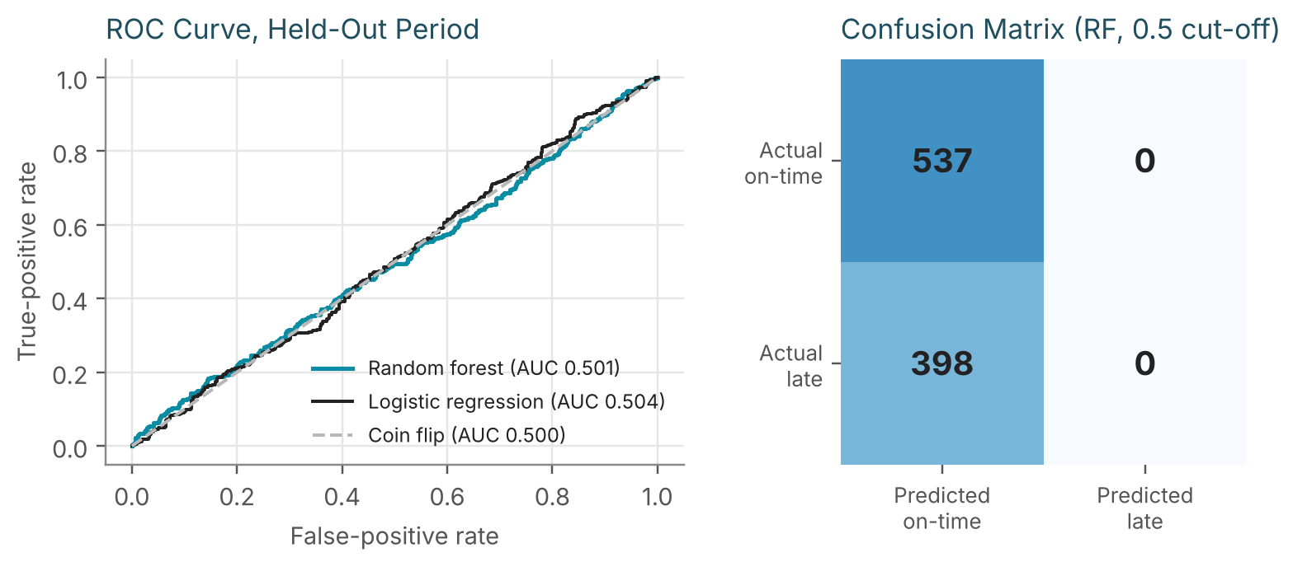
Figure 4. Left: ROC curves for both models lie on the coin-flip diagonal. Right: the tuned forest predicts "on time" for every order.
Every model is at chance. The forest's test AUC is 0.501 with a 95% bootstrap interval of 0.462 to 0.540, and the logistic regression's is 0.504 (0.466 to 0.543); both intervals contain 0.5. Cross-validated AUC is below 0.5 for both, which is what noise looks like. The forest's accuracy of 57.4% is exactly the majority-class baseline, because it predicts on-time for all 935 test orders (confusion matrix: 537 true negatives, 398 missed late orders, no positive predictions). Accuracy alone would have hidden this, which is why precision, recall and AUC are reported.
Regressing the delay in days gives the same answer. Predicting the training mean has a test RMSE of 1.790 days, and gradient boosting scores 1.804 days with an R² of -0.016, slightly worse than no model. The delay has a standard deviation of 1.79 days in the test period and none of the available fields explains any of it. The permutation importances for the classifier are all within noise of zero (the largest, promised days, is 0.007 AUC with a standard deviation of 0.004).
Interpretation and decision
This is a finding about the data, not about modelling skill. In the simulated order file, delay is generated independently of the order's attributes, and Week 3's chi-square tests (Section 8) found no significant difference in lateness by mode, centre, category or region. Real late deliveries are driven by carrier, lane, handling scans, weather and capacity, none of which this file contains.
Decision: do not deploy a late-delivery predictor from these fields. The data investment that would make one possible is carrier scan events and lane identifiers, listed in Section 9.

6.2 Weekly order volume
Order volume is the other example target in the brief. The 90 complete weeks (first and last partial weeks dropped) average 54.7 orders with a standard deviation of 8.1. If orders arrived at random around a constant rate, week-to-week counts would vary with a standard deviation of about the square root of the mean, 7.4 orders, and no forecast could do better than that. In the 72 training weeks the variance-to-mean ratio is 0.92, close to the 1.0 expected for purely random arrivals. Three forecasts were compared on the last 18 weeks.
Table 12. Weekly-volume forecasts on the last 18 weeks (RMSE in orders per week)
Method | RMSE | Note
Training-period mean | 11.2 | Best of the three
Mean of the previous 4 weeks | 13.3 | Reacts to recent noise
Last week's count | 15.3 | Reacts most, worst result
Theoretical floor for random arrivals | 7.4 | Square root of the training mean

The more a method reacts to recent weeks, the worse it does (11.2 for the mean, 13.3 for a 4-week average, 15.3 for last week), which is the pattern expected when each week's deviation is noise to be averaged away, not a trend to be followed. The test weeks were also more volatile than the training weeks (standard deviation 11.5 against 7.4 expected for random arrivals); with only 18 weeks that is not read as a change in the process. The recommendation is to plan capacity on the long-run mean of about 55 orders per week with a buffer sized to the observed spread, and not to build a volume model until the order stream shows structure (promotions, seasons, trends) that a forecast could use.

7. Optimization Strategies
Prediction is only worth the effort if it changes a decision. The cost model supports two levers directly (freight audit and mode reassignment), the measured delay distribution supports a third (promise dates), the demand history supports a fourth (safety stock), and a fifth (route planning) is illustrated on a hypothetical instance because the order file contains no delivery coordinates. For every lever the evidence is stated together with its limits, and Section 7.6 sets them side by side.
Table 13. From prediction to decision
Lever | What the model or analysis provides | Decision it informs
7.1 Freight-bill audit | Expected price for every order and a label-free tolerance band | Which carrier invoices to dispute
7.2 Mode reassignment | Re-priced cost of the same order in the next cheaper mode | Which orders to move to a cheaper tier
7.3 Promise-date calibration | Out-of-sample distribution of delays by mode | How many days to add to the promised date
7.4 Safety stock | Daily demand mean and spread by category | How much buffer stock to hold, and for which classes
7.5 Route planning | Order weights and capacity; savings algorithm | How to group stops into vans and sequence them

7.1 Freight-bill audit
Resource allocation in an accounts-payable team is a triage problem: there are far more invoices than hours, so the model should hand reviewers a short list that is mostly real. The detector compares each bill with the model's expected price on the log scale and flags the order when the billed price exceeds the expected price by more than a tolerance. The tolerance is learned without labels. Out-of-fold predictions on the training period (five expanding-window fits, 3,330 predictions) have a median log residual of 0.0044 and a robust standard deviation of 0.153, which corresponds to a typical error of about 17%. The flag line is the median plus four robust standard deviations, which is a billed price more than 1.85 times the expected price. The multiplier k = 4 was fixed before the test period was scored.
Python — label-free audit detector (12_final_analysis.py)
oof = [] # out-of-fold residuals, training period only
for tr_i, va_i in TimeSeriesSplit(5).split(train):
m = make_champion().fit(train.iloc[tr_i][FEATS], train.iloc[tr_i]["shipping_cost"])
va = train.iloc[va_i]
oof.append(np.log(va["shipping_cost"]) - np.log(m.predict(va[FEATS])))
oof = pd.concat(oof)
med = np.median(oof)
sigma = 1.4826 * np.median(np.abs(oof - med)) # robust sigma from the MAD
K = 4 # fixed in advance, not tuned on test labels
thr = med + K * sigma

test["log_ratio"] = np.log(test["shipping_cost"]) - np.log(test["expected"])
flag = test["log_ratio"] > thr # billed > exp(thr) x expected
print(f"flag line: billed > {np.exp(thr):.2f}x expected | "
f"flagged {flag.sum()} of {len(test)}")
Output
flag line: billed > 1.85x expected | flagged 31 of 1000
Worked example: two orders from the held-out window
Not flagged. Order ORD-100400 (Standard Class, Electronics, 2 units, 4.22 kg): expected $14.95, billed $17.52. Ratio 1.17, well under the 1.85 flag line. The $2.57 gap is ordinary price variation.
Flagged. Order ORD-101086 (Standard Class, Electronics, 3 units, 6.15 kg): expected $19.02, billed $114.03. Ratio 6.00. The audited correct price was $15.10, so the carrier overstated this one invoice by $98.93.

Table 14 scores three approaches on the 1,000 held-out orders, of which 28 were mis-keyed. The Week 2 rule flags anything above the IQR fence of $86.43. The first-attempt model was trained on capped costs with a fixed $19.82 rule. The final detector is the one above.
Table 14. Audit methods compared on the held-out period
Method | Flagged | Real errors caught | False alarms | Missed | Precision | Recall
A. IQR fence (Week 2) | 70 | 26 | 44 | 2 | 0.371 | 0.929
B. Capped-target GB, $19.82 rule | 66 | 28 | 38 | 0 | 0.424 | 1.000
C. Robust log-scale model (k=4) | 31 | 28 | 3 | 0 | 0.903 | 1.000

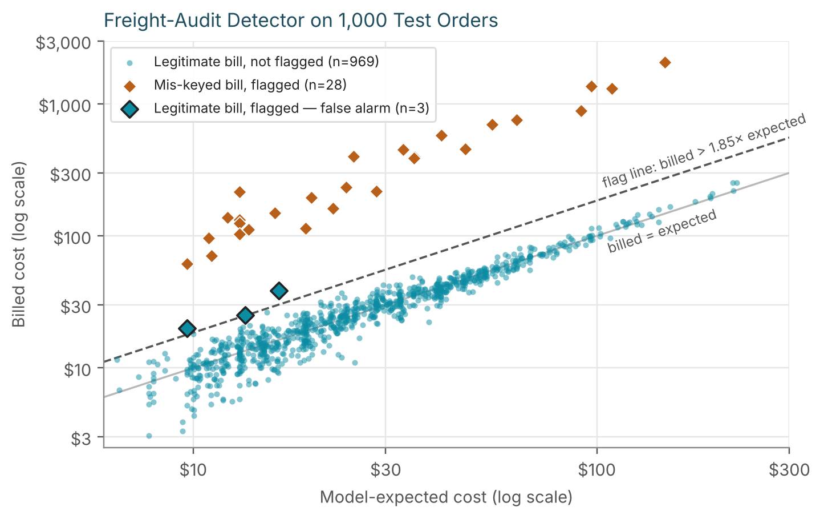
Figure 5. Billed against model-expected cost for the 1,000 held-out orders (log scales). Orange diamonds are mis-keyed bills; the dashed line is the flag line.
The final detector catches all 28 mis-keyed bills with 3 false alarms, a precision of 90.3%. The Week 2 rule needs 70 reviews to find 26 errors (precision 37.1%) and misses 2. The money is concentrated: the 28 mis-keyed bills carry $11,000 of over-billing against $32,789 of correct cost, so 25.1% of everything billed in the window was wrong. The detector surfaces essentially all of it for the price of reviewing 31 invoices instead of 1,000.
The 2.6% error rate and 6 to 14 times multipliers are assumptions made in Week 2, and real over-billing rates are usually far lower, so the dollar figure shows the scale of what the method can surface, while precision and recall are what should be expected to carry over. Two further results qualify the headline.
- The three false alarms share a pattern. All are parcels under 1 kg (billed $20.00, $25.02, $38.39 against expected $9.65, $13.44, $16.31). On a small bill, ordinary price noise is a large percentage and trips a ratio rule. Their excess over the expected price was at most $22.08, while the smallest true error exceeded its expected price by $51.55. Adding a minimum-excess rule of $25 on top of the ratio rule would have left exactly 28 flags, all real. That observation was made on the test labels, so it is a diagnostic and not a tuned result; the floor should be set by what the business considers worth a dispute and then monitored.
- Sensitivity to the multiplier. Moving k from 3 to 6 changes false alarms from 6 to 0 with recall unchanged at 100% (Table 15). The best-looking row, k = 6, was not adopted because it was identified by looking at test labels. k = 4 stays the declared default.
Table 15. Sensitivity of the detector to the tolerance multiplier k
k | Flag line (billed ÷ expected) | Flagged | Real errors caught | False alarms | Precision
3 | 1.59× | 34 | 28 | 6 | 0.824
4 | 1.85× | 31 | 28 | 3 | 0.903
5 | 2.16× | 29 | 28 | 1 | 0.966
6 | 2.51× | 28 | 28 | 0 | 1.000
8 | 3.41× | 28 | 28 | 0 | 1.000

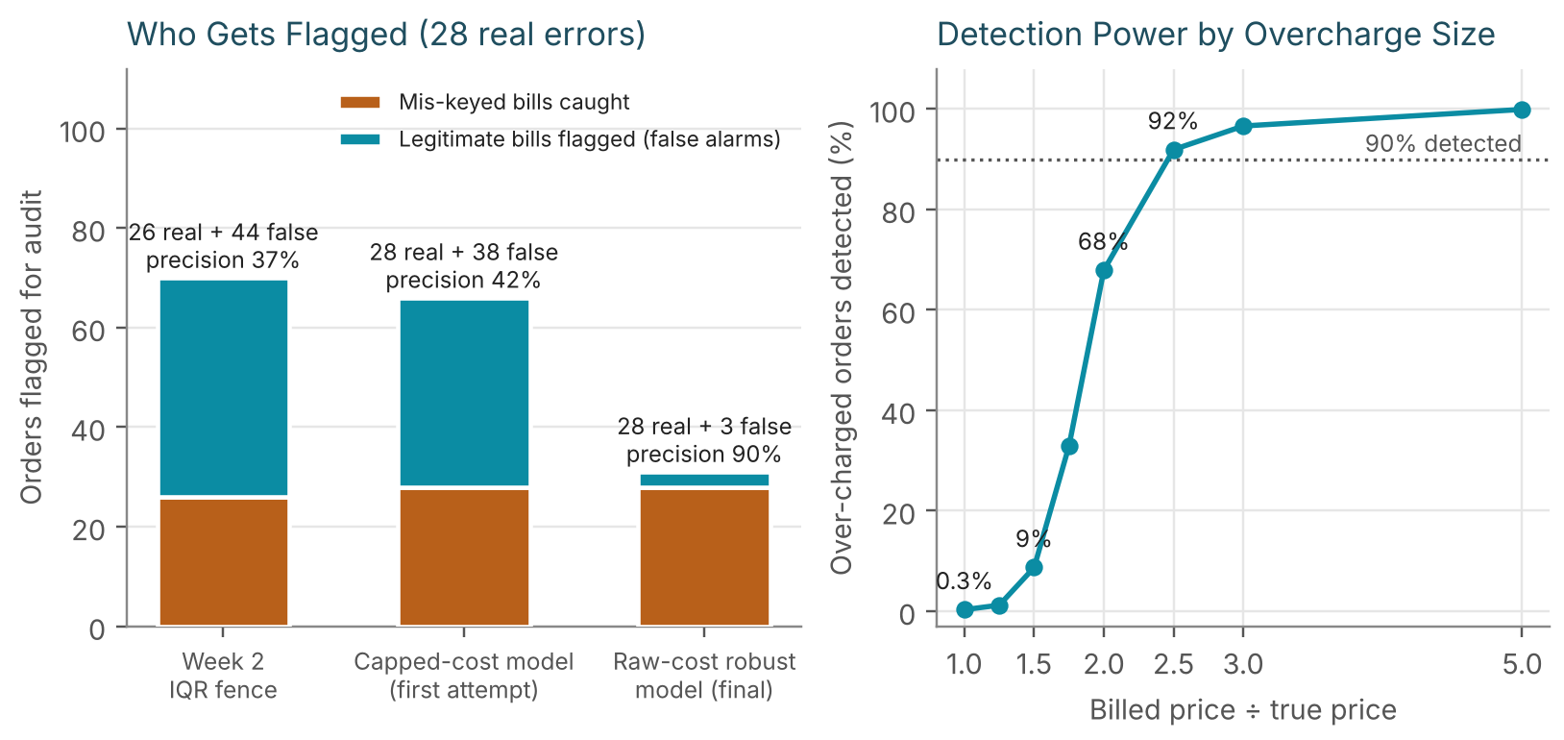
Figure 6. Left: who each method flags. Right: share of correctly billed orders that would be flagged if they were over-charged by a given factor.
What the detector cannot find
The 100% recall reflects how large the injected errors are (7.6 to 13.7 times the correct price in the held-out window). The right-hand panel of Figure 6 shows the detector's real limits. A bill 1.5 times too high is flagged only 8.7% of the time, 2 times too high 68%, 2.5 times 92%, and 3 times or more 97% or better. Correct bills are flagged only 0.3% of the time. The method therefore finds gross keying errors and duplicate or wrong-service charges. A carrier that adds a steady 10% to 30% surcharge would go unnoticed, and that needs a different control, namely periodic reconciliation of invoices against the contracted rate card.

7.2 Shipping-mode reassignment
Cost minimization starts from a question the model can answer: what would this same order have cost one tier down? Each order in the held-out window was re-priced with only the shipping mode changed, holding weight, quantity, category and discount fixed. The saving is the current expected cost minus the one-tier-down expected cost (Same Day to First Class, First Class to Second Class, Second Class to Standard).
Python — mode-reassignment counterfactual (12_final_analysis.py)
TIERS = ["Standard Class", "Second Class", "First Class", "Same Day"] # cheapest to dearest
by_mode = {m: champ.predict(test[FEATS].assign(shipping_mode=m)) for m in TIERS}
pos = test["shipping_mode"].map({m: i for i, m in enumerate(TIERS)}).values
cur = np.array([by_mode[TIERS[p]][i] for i, p in enumerate(pos)]) # as shipped
one = np.array([by_mode[TIERS[max(p-1, 0)]][i] for i, p in enumerate(pos)]) # one tier down
test["save1"] = cur - one
elig = test[test.shipping_mode != "Standard Class"] # 429 of 1,000
for share in [0.10, 0.25, 0.50, 1.00]:
print(f"{share:.0%} of eligible orders moved: "
f"save ${share * elig.save1.sum():,.0f} per 1,000 orders")
Output
10% of eligible orders moved: save $557 per 1,000 orders
25% of eligible orders moved: save $1,393 per 1,000 orders
50% of eligible orders moved: save $2,786 per 1,000 orders
100% of eligible orders moved: save $5,573 per 1,000 orders
Table 16. Modelled saving from moving an order one tier down, by current mode (1,000 held-out orders)
Current mode | Orders | Average cost now | Average cost one tier down | Average saving | Saving if all move
Same Day | 81 | $72.91 | $47.61 | $25.31 | $2,050
First Class | 141 | $44.09 | $30.85 | $13.24 | $1,867
Second Class | 207 | $31.11 | $23.11 | $8.00 | $1,656
Standard Class | 571 | $24.64 | n/a | n/a | n/a

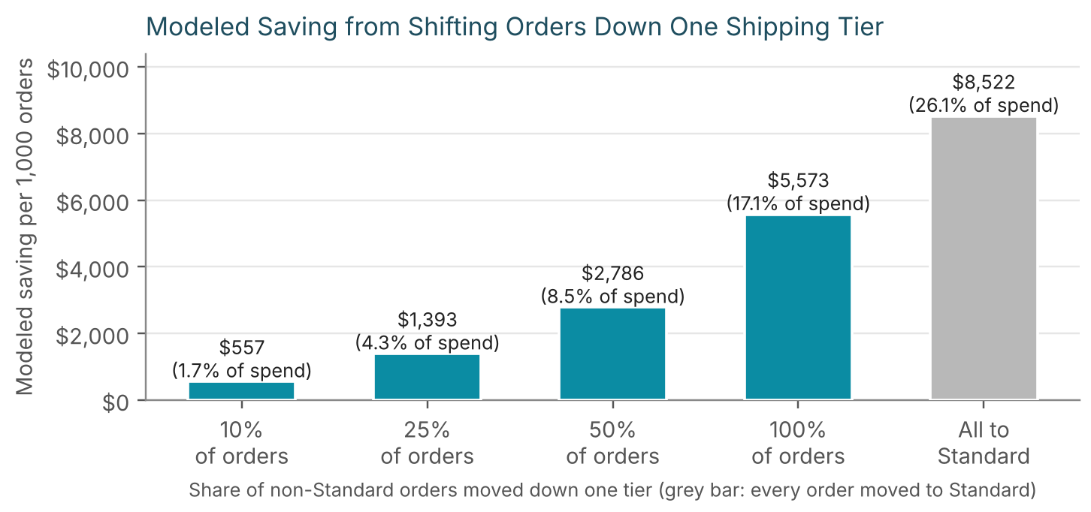
Figure 7. Modelled saving per 1,000 orders as a larger share of non-Standard orders moves down one tier; the grey bar is the ceiling if every order shipped Standard.
Moving every non-Standard order down one tier would save $5,573 per 1,000 orders, 17.1% of modelled spend; a cautious 10% to 25% would save $557 to $1,393 (1.7% to 4.3%). The 25% case equals 1.8% of the product margin earned on the same orders. Same Day orders are the richest target because each move saves $25.31 on average, against $13.24 for First Class and $8.00 for Second Class.
Three cautions apply. First, this is a model counterfactual, not an experiment: it assumes the same parcel can be shipped in the slower mode at the model's expected price. Second, the saving is not free, because a downgrade lengthens the delivery promise. Same Day orders carry 0 to 1 promised days and Standard orders 5 to 6. Third, the main reason downgrading looks attractive in this data is that the faster modes do not deliver more reliably. On-time rates for genuine deliveries are 57.0% (Standard), 56.3% (Second), 54.2% (First) and 53.9% (Same Day), and the difference is not statistically significant (chi-square p = 0.447; Section 8). If the real carriers' faster services do buy reliability, that argument weakens. The right next step is a controlled pilot on orders where the customer did not pay for speed or where the promise has slack, measuring on-time rate and complaints alongside cost.

7.3 Promise-date calibration
Delivery cannot be predicted from the available fields (Section 6.1), but its distribution can be measured, and the distribution is what a promise date needs. Delay is defined as actual minus promised delivery date in days. For genuine deliveries, the training-period 90th and 95th percentiles of delay give the number of days to add so that a chosen share of orders arrives by the padded date. The rule was then checked on the later, held-out 20% of deliveries.
Python — empirical-quantile padding (12_final_analysis.py)
gen = df[df.is_delivered == True] # genuine deliveries only (4,672)
gs = int(len(gen) * 0.8); gtr, gte = gen.iloc[:gs], gen.iloc[gs:]
for q in [0.90, 0.95]:
pad = int(np.ceil(gtr["delivery_delay_days"].quantile(q))) # days to add
cover = (gte["delivery_delay_days"] <= pad).mean() # share on time, out of sample
print(f"q{int(q*100)}: add {pad} days -> {100*cover:.1f}% "
f"on time in the held-out period")
Output
q90: add 3 days -> 92.6% on time in the held-out period
q95: add 4 days -> 95.9% on time in the held-out period
Table 17. Padding by shipping mode: days to add and out-of-sample on-time share
Shipping mode | Test orders | On time today | Add (q90) | On time at q90 | Add (q95) | On time at q95
Standard Class | 539 | 60.7% | +3 d | 94.1% | +4 d | 96.8%
Second Class | 195 | 55.4% | +3 d | 90.8% | +4 d | 94.9%
First Class | 131 | 51.1% | +3 d | 93.1% | +4 d | 96.9%
Same Day | 70 | 50.0% | +3 d | 85.7% | +4 d | 90.0%
All modes (pooled) | 935 | 57.4% | +3 d | 92.6% | +4 d | 95.9%

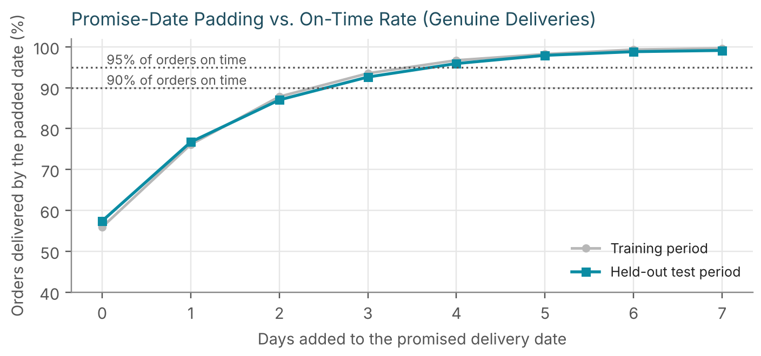
Figure 8. On-time share against days added to the promised date. Training and held-out curves agree closely, so the rule transfers.
Today only 57.4% of held-out orders arrive by the promised date. Adding 1 day lifts that to 76.7%, 2 days to 87.0%, 3 days to 92.6% and 4 days to 95.9%; the training and test curves differ by at most 1.5 points at any padding, so the estimate is stable. The average promise window is 4.25 days today, so a 3-day pad is a 71% longer window. Same Day has the lowest coverage (85.7% at +3 days, 90.0% at +4) on only 70 test orders; with a sample that small its coverage is uncertain by several points, which is a reason to start with the pooled rule and refine by mode once more deliveries accumulate.
This lever changes the promise, not the parcel. It removes the broken promises that damage trust and drive service contacts, but it also lengthens the stated delivery time, which can cost sales. The honest framing is a trade-off curve (Figure 8) for the commercial team to choose a point on, and an A/B test on a subset of orders to measure the conversion effect before changing the default. A real improvement in delivery performance needs carrier-level data that this file does not have.

7.4 Safety stock and ABC tiering
Resource allocation for inventory asks how much buffer to hold, and whether more valuable categories deserve more of it. Demand is the number of units ordered per calendar day in each category across the network (including zero-demand days), over all 640 days. With a replenishment lead time of L = 7 days (an assumption, as the file has no supplier data), the safety stock for a service level with normal quantile z is SS = z · σ_d · √L and the reorder point is ROP = μ_d · L + SS. Uniform 95% service (z = 1.645) is compared with tiered service: 98% for class A (Electronics, Home Goods), 95% for class B (Sporting Goods, Apparel) and 90% for class C (Office Supplies).
The economics of tiering are tested rather than assumed. Extra carrying cost is the added units times unit price times a 20% annual carrying rate. Margin protected comes from the standard normal loss function G(z) = φ(z) − z(1 − Φ(z)): units short per replenishment cycle equal σ_d√L · G(z), there are 365/L cycles per year, and each unit short loses the unit price times the gross margin (14.4%, measured from the data).
Python — safety stock and tiering economics (12_final_analysis.py, abridged)
L, carry = 7, 0.20
Z_TIER = {"Electronics": .98, "Home Goods": .98, "Sporting Goods": .95,
"Apparel": .95, "Office Supplies": .90}
margin = df.profit_per_order.sum() / df.order_value.sum() # gross margin, 14.4%
spent = df.assign(r=df.unit_price * df.quantity).groupby("product_category")
price = spent["r"].sum() / spent["quantity"].sum() # revenue-weighted unit price
daily = (df.groupby(["order_date", "product_category"])["quantity"].sum()
.unstack(fill_value=0))
daily = daily.reindex(pd.date_range(df.order_date.min(), df.order_date.max()), fill_value=0)
G = lambda z: norm.pdf(z) - z * (1 - norm.cdf(z)) # standard normal loss function
for c_ in daily.columns:
mu, sd = daily[c_].mean(), daily[c_].std(); sig_L = sd * np.sqrt(L)
ss_u, ss_t = norm.ppf(0.95) * sig_L, norm.ppf(Z_TIER[c_]) * sig_L # uniform vs tiered
extra_carry = (ss_t - ss_u) * price[c_] * carry
dG = G(norm.ppf(0.95)) - G(norm.ppf(Z_TIER[c_]))
margin_saved = sig_L * dG * 365 / L * price[c_] * margin
print(f"{c_:16s} SS {ss_u:5.1f} -> {ss_t:5.1f} | "
f"net ${margin_saved - extra_carry:6.0f}/yr")
Table 18. Safety stock by category, uniform 95% against tiered service level
Category | Class | Demand / day (mean, sd) | Safety stock, uniform | Safety stock, tiered | Reorder point, tiered | Extra carrying $/yr | Margin protected $/yr | Net $/yr
Electronics | A | 6.83, 6.08 | 26.5 | 33.0 | 80.8 | $442 | $551 | $110
Home Goods | A | 6.50, 5.62 | 24.4 | 30.5 | 76.0 | $187 | $233 | $46
Sporting Goods | B | 5.60, 5.16 | 22.4 | 22.4 | 61.6 | $0 | $0 | $0
Apparel | B | 9.04, 6.72 | 29.2 | 29.2 | 92.5 | $0 | $0 | $0
Office Supplies | C | 3.49, 4.25 | 18.5 | 14.4 | 38.8 | −$64 | −$176 | −$112

Worked example: Electronics
Demand averages 6.83 units per day with a standard deviation of 6.08, so over the 7-day lead time σ = 6.08 × √7 = 16.09 units. At 95% service, SS = 1.645 × 16.09 = 26.5 units ($8,890 of stock at $336 per unit); at 98%, SS = 2.054 × 16.09 = 33.0 units. The extra 6.5 units cost $442 a year to carry and avoid about 11 units of stock-outs a year, worth $551 of margin, a net $110. Reorder point at the tiered level: 6.83 × 7 + 33.0 = 80.8 units.

Tiering raises the value of safety stock from $18,206 to $21,030 (+15.5%) and returns a net $44 a year: Electronics +$110, Home Goods +$46, and Office Supplies −$112 because lowering its service level to 90% costs more margin than it saves in carrying. That is effectively break-even and well inside the error of the inputs, so the recommendation is not to build a tiering scheme at this volume. Demand is intermittent (zero-demand days average 22.9%), which makes the normal approximation crude; a lead-time reduction or demand-variability reduction would shrink the buffer more than any reshuffling of service levels.

7.5 Route planning
Route planning is the lever the brief names directly, but the order file has no delivery coordinates, so no routing model can be fitted to MRL's actual routes. The section instead shows, on a transparent hypothetical instance, how large the gap is between simple and planned dispatch and how it is measured, using the real parcel weights. The instance is one morning wave of 40 stops leaving DC-Central-02 in a 50 km × 50 km area. Stop locations are random and seeded (assumptions, not data); each stop's load is drawn from the 1,655 real order weights of that centre; vans carry at most 150 kg; distance is straight-line; and the cost rate is $1.20 per km (an assumption). The same experiment was repeated on 200 random days so the result is a distribution, not one favourable day.
Five policies were compared on identical stops. Arrival order (fill vans in the order orders arrived) is kept as a worst case. The dispatcher sweep, which orders stops by compass angle around the depot and fills vans in that order, is the fair baseline, since it is what an experienced dispatcher does with a map and no software. Nearest neighbour sends each van to the closest unvisited stop. Clarke–Wright savings starts with one van per stop and merges routes in order of the distance saved, s(i, j) = d(depot, i) + d(depot, j) − d(i, j), as long as capacity allows. A 2-opt pass then removes crossing legs inside each route.
Python — Clarke-Wright savings (15_route_demo.py)
def savings(load_kg, D):
n = len(load_kg)
routes = {i: [i] for i in range(1, n)} # start: one van per stop
where = {i: i for i in range(1, n)}; load_of = {i: load_kg[i] for i in range(1, n)}
pairs = sorted(((D[0, i] + D[0, j] - D[i, j], i, j)
for i, j in itertools.combinations(range(1, n), 2)), reverse=True)
for s, i, j in pairs: # biggest saving first
if s <= 0: break
ri, rj = where[i], where[j]
if ri == rj or load_of[ri] + load_of[rj] > CAP: continue # capacity check
a, b = routes[ri], routes[rj]
if a[-1] == i and b[0] == j: new = a + b
elif a[0] == i and b[-1] == j: new = b + a
elif a[0] == i and b[0] == j: new = a[::-1] + b
elif a[-1] == i and b[-1] == j: new = a + b[::-1]
else: continue # i or j is interior to its route
routes[ri] = new; load_of[ri] += load_of[rj]
for k in b: where[k] = ri
del routes[rj], load_of[rj]
return list(routes.values())
Table 19. Route policies over 200 simulated mornings of 40 stops (distance saving measured against the dispatcher sweep)
Policy | Mean km | Mean vans | Mean saving | 5th–95th pct | Cost at $1.20/km
Arrival order (worst case) | 1090 | 3.2 | −145% | -198% to -102% | $1,308
Dispatcher sweep (baseline) | 448 | 3.1 | — | — | $538
Nearest neighbour | 420 | 3.1 | 5.7% | -13% to 24% | $503
Clarke–Wright savings | 317 | 3.1 | 28.8% | 17% to 39% | $380
Savings + 2-opt | 314 | 3.1 | 29.4% | 18% to 40% | $377

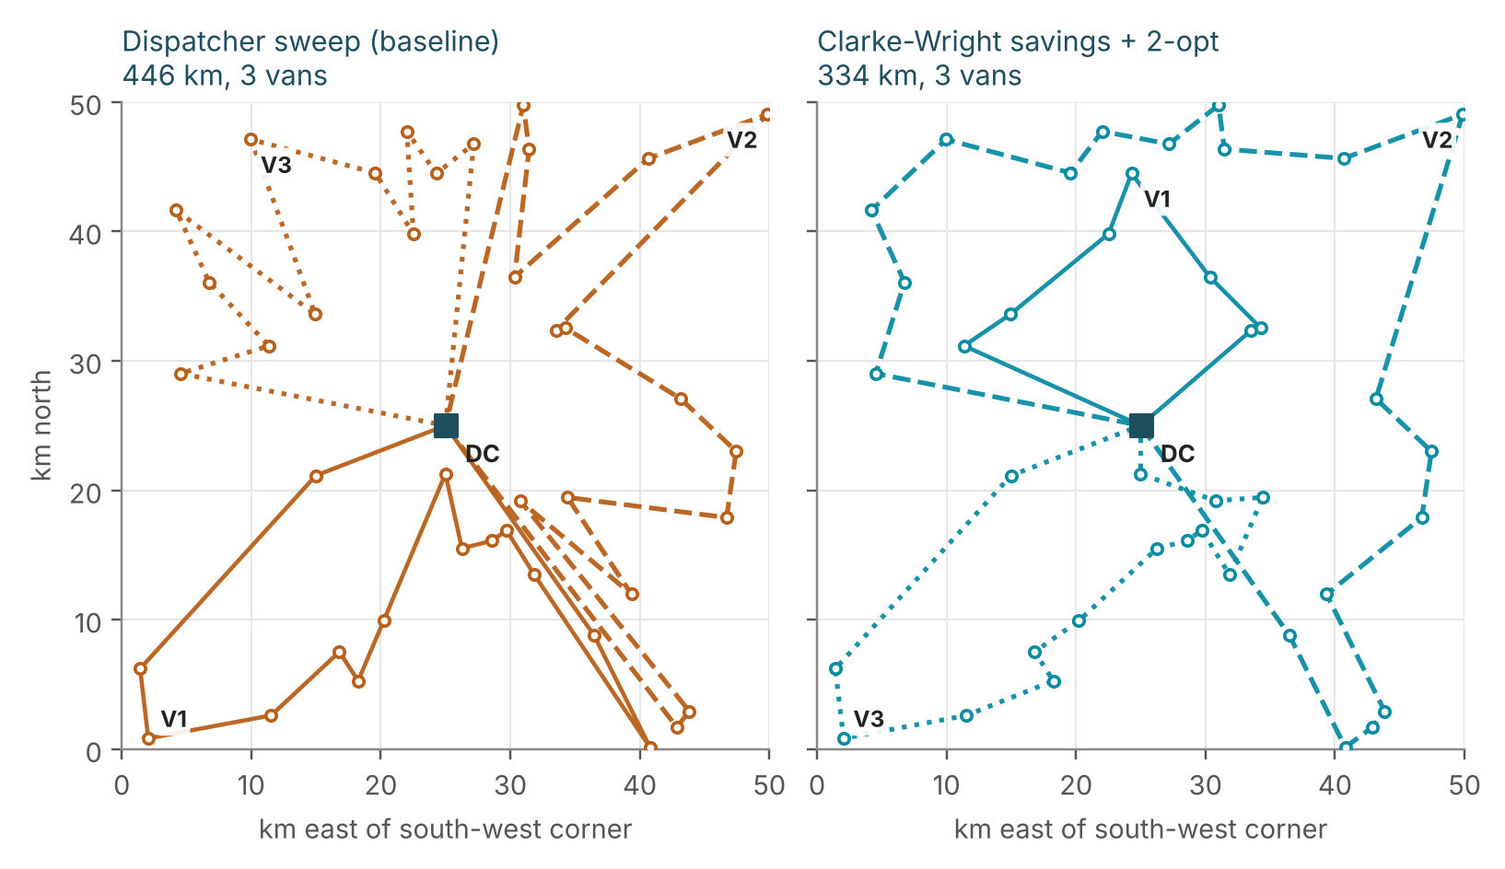
Figure 9. The same 40 stops on one simulated morning (seed 0): dispatcher sweep against Clarke–Wright savings with 2-opt. Colour marks the policy; line style and label mark the van.
On the worked morning the sweep needs 446.5 km and the planned routes 334.0 km, a reduction of 25.2% (112.5 km, about $135 at $1.20 per km), with the same 3 vans carrying the same 361 kg. Over 200 mornings the saving averages 29.4% and never falls below 6.6%. Nearest neighbour is only 5.7% better on average and is worse than the sweep on some days (5th percentile -13%), so a greedy rule alone is not a safe substitute for the savings algorithm. The 2-opt pass adds a further 0.6 points. The vans needed barely change (about 3 in all policies, because 384 kg of load against 150 kg capacity forces at least 3); the gain comes from shorter, non-crossing legs.
Two limits matter. The stops are synthetic, so the percentages show what the method can do on 40 scattered points and not what MRL would achieve. And a 40-stop wave belongs to the 15,000-orders-per-week scale assumed in Week 1; the order file here implies about 2.6 orders per centre per day, where route optimization has almost nothing to optimize. The recommendation is therefore conditional: capture delivery coordinates, and adopt a savings-based planner (open-source solvers such as OR-Tools implement it) once daily waves reach a size where van count and distance matter.

7.6 Impact summary
Table 20. The five levers side by side
Lever | Measured effect | Evidence | Main caveat
Freight audit | 28 of 28 mis-keyed bills found; 31 reviews instead of 1,000; $11,000 surfaced | Held-out, scored against ground truth | Only errors above about 2× are visible; error rate is simulated
Mode reassignment | $557–$1,393 per 1,000 orders at 10–25% adoption (1.7–4.3% of spend) | Model counterfactual | Needs a pilot; slower promise; not an experiment
Promise calibration | On-time promises 57.4% → 92.6% (+3 days) or 95.9% (+4 days) | Held-out, stable across periods | Changes the promise, not the delivery; conversion effect unknown
Safety-stock tiering | +15.5% stock value for +$44/yr | Analytic cost-benefit on 640 days | Break-even: not recommended
Route planning | −29.4% distance vs sweep (18–40% range) | 200 simulated mornings | Hypothetical stops; needs coordinates and larger waves

The effects are measured on different bases (spend, invoices, promises, stock, distance), overlap in places, and rest on assumptions of different strength, so they are not added into a single savings figure. The audit and the promise calibration are the best supported; the mode and routing results are directional estimates that justify a pilot but not a budget line.

8. Corrections to Earlier Weeks
Building a model forces every upstream number to be used for something, and four of them did not survive that. They are corrected here, with the evidence, so that the three earlier reports and this one agree. None of the corrections reverses a recommendation, but two of them change a headline figure.
Table 21. What changed and why
Earlier statement | Corrected figure | Reason
On-time delivery 58.6% on 4,943 orders (Weeks 2 and 3); 36.4 points below the 95% target | 56.2% on 4,672 orders with a genuine delivery date; 38.8 points below target | Week 2 imputed 271 missing delivery dates as the promised date plus the median delay (0 days), so every imputed order counts as on time by construction.
Same Day costs 123% more per kg than Standard (Week 3: $5.98 against $2.68) | 206% more on correct prices ($7.71 against $2.52); 223% on raw bills | Week 2 capped cost at $86.43, which clips genuine heavy express parcels. The cap understated the express premium by about 80 points.
Week 2 IQR rule flags outlier bills (349 orders) | Only 123 of the 349 (35.2%) were mis-keyed; 226 were correct bills. 31% of all Same Day orders were flagged although correct | A single global fence ignores that heavier, faster parcels legitimately cost more. The model-based detector compares each bill with its own expected price.
Week 3 segment rankings (for example, Electronics has the lowest on-time rate) | No segment difference in on-time rate is statistically significant (p = 0.447 to 0.899) | The spread of 55–57% across segments is within sampling error: a segment of about 1,168 orders has a 95% interval of ±2.8 points.
Week 1 scenario of 15,000 orders per week | This sample holds about 55 orders per week | Dollar results in this report are per 1,000 orders and are not scaled up; Week 1 projections need rescaling before reuse.

8.1 Is lateness really the same everywhere?
Week 3 reported that on-time performance sat in a narrow band across shipping mode, centre, category and region and called it a systemic gap. A chi-square test of independence makes that statement testable. On the 4,672 genuine deliveries, lateness is statistically independent of all four dimensions.
Table 22. Chi-square independence tests of lateness against each segment dimension
Dimension | χ² | df | p-value | Lowest on-time rate | Highest on-time rate
shipping_mode | 2.66 | 3 | 0.447 | Same Day 53.9% | Standard Class 57.0%
dc_id | 0.21 | 2 | 0.899 | DC-West-03 55.9% | DC-Central-02 56.7%
product_category | 1.50 | 4 | 0.827 | Electronics 55.1% | Sporting Goods 57.4%
customer_region | 1.00 | 3 | 0.802 | South 55.1% | Central 57.0%

Every p-value is far above 0.05. The correct reading is that the delivery shortfall is network-wide, which supports the Week 3 conclusion, and that differences between segments are not distinguishable from chance, which withdraws the Week 3 ranking claims. It also explains why no segment-level feature could predict lateness in Section 6.1.
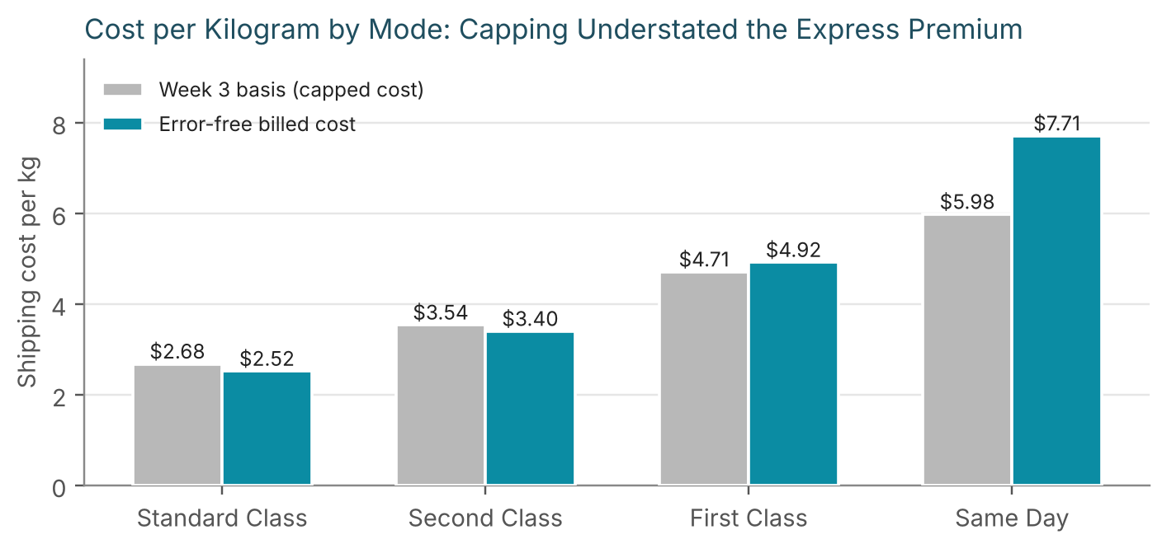
Figure 10. Cost per kilogram by mode on the Week 3 (capped) basis against error-free correct prices. The express premium is understated by capping.
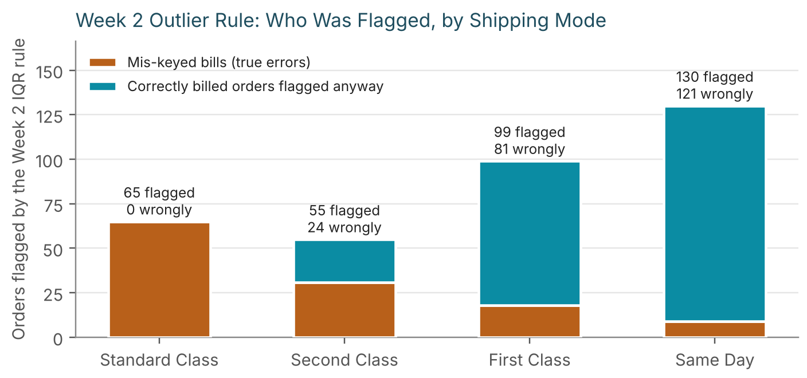
Figure 11. Orders flagged by the Week 2 IQR rule, by shipping mode. Orange: mis-keyed bills. Teal: correct bills flagged anyway.

9. Recommendations
The recommendations are ordered by how well the evidence supports them. Each has a measurable success criterion so that a pilot can be judged against it, and the data investments come first because they unlock several levers at once.
Table 23. Actions, evidence and success measures
# | Action | Evidence in this report | Success measure | When
1 | Run the audit detector on every incoming carrier invoice at k = 4, with a minimum-excess floor agreed with finance (start at $25) and route flags to accounts payable. | 28 of 28 errors caught; 3 false alarms; Week 2 rule needed 70 reviews for 26 errors | Precision of reviewed flags ≥ 85%; dollars disputed and recovered per month | 0–30 days
2 | Add a quarterly reconciliation of invoices against the contracted rate card. | The detector is blind below about 2× (9% detected at 1.5×) | Share of invoices within contract rate | 30–90 days
3 | Record destination zone or distance, and uncapped parcel weight, on every order. | Distance would cut MAE by 26% ($3.46 to $2.58); capped-weight orders have 2.4× the error | Quote MAE ≤ $2.60 on a 4-week holdout | 30–90 days
4 | Pilot a mode downgrade for 10–25% of non-Standard orders where the customer did not pay for speed or the promise has slack. | $557–$1,393 saved per 1,000 orders; on-time rates equal across modes (p = 0.447) | Cost per order down; on-time rate and complaints unchanged | 60–120 days
5 | A/B test a default promise date padded by 3 days. | On-time promises 57.4% → 92.6% on held-out orders | On-time promises ≥ 90%; conversion change within an agreed tolerance | 30–90 days
6 | Keep a uniform 95% service level for safety stock; do not build ABC tiering at this volume. | Net +$44 a year for +15.5% stock | Stock-out rate at or below 5% of cycles | Now
7 | Capture carrier scan events and lane identifiers before attempting any delay model. | Delay AUC 0.50 (CI 0.46–0.54) from order attributes | Go/no-go: AUC ≥ 0.65 on a held-out period | 90–180 days
8 | Capture delivery coordinates, then adopt savings-based route planning once waves reach about 20 stops. | −29% distance vs sweep on 40 hypothetical stops | Km per stop against the sweep baseline | 90–180 days
9 | Operate the cost model: retrain monthly, track median % error and the share of orders flagged, and re-estimate the robust sigma. | Median % error 9.6%; flag rate 3.1% on held-out orders | Median % error within 10% ± 2 points; flag rate stable | Ongoing

10. Limitations and Threats to Validity
- Simulated data. The order file is generated, so patterns such as delay independent of order attributes and a fixed cost formula are properties of the generator. Methods and their relative performance should transfer; absolute numbers (error rate, dollar savings, the exact R²) should not be quoted as expectations for a real network.
- Ground truth used for scoring and selection. The identity of the 130 mis-keyed bills is known only because the data are simulated. It scored every model and picked between model families on training folds. No model was fitted and no threshold set using it. A real deployment needs an audited invoice sample of at least a few hundred bills to do the same.
- A small held-out set. The held-out window has 1,000 orders and only 28 mis-keyed bills. Catching all 28 gives a recall whose 95% lower confidence bound is about 88% (exact two-sided binomial), not 100%, and the three false alarms give a precision interval that is wider still.
- Development history. The failure of the first cost model on heavy parcels was discovered when it was scored on the held-out window, so that window is not perfectly untouched. After the redesign, model families were chosen on training folds only, the audit multiplier k = 4 was fixed in advance, and the distance experiment (Table 10) and the $25 floor remark in Section 7.1 are labelled as diagnostics that used test labels.
- One time window. Results come from one 129-day test window. Seasonal effects, rate-card changes and carrier behaviour over a longer span are not tested; a rolling back-test would be the next validation step.
- Counterfactual and illustrative levers. Mode reassignment is a model counterfactual; promise padding does not measure customer response; safety stock assumes a 7-day lead time and normal demand although 22.9% of days have no demand; routing uses invented stop locations, straight-line distance and a single capacity constraint, without road networks or delivery time windows.
- Scale. The sample is about 55 orders per week, against 15,000 assumed in Week 1, so savings are quoted per 1,000 orders and not projected to a network total.

11. Reflection and Conclusion

11.1 How data quality shaped the modelling
Earlier feedback asked for a fuller account of how data quality affects results. This week gives a measured answer: each Week 2 data-quality decision has a quantified effect on what could be modelled, collected in Table 24.
Table 24. Data-quality decisions and their measured consequences
Data-quality issue or decision | Measured consequence
2.55% of training bills mis-keyed at 6–14× | Squared-error linear regression reaches R² 0.636; robust boosting on the log scale reaches 0.972. The Week 2 outlier rule had 35% precision.
Capping cost at $86.43 (Week 2) | A model trained on the capped target had an MAE of $18.00 on parcels over 20 kg, against $6.40 once trained on the raw bill. The express premium is understated by about 80 points (123% against 206%).
Capping weight at 31.55 kg (Week 2) | Orders at the cap are mispriced by 2.4× the typical error ($7.86 against $3.28).
Imputing 271 delivery dates (Week 2) | Overstates on-time delivery by 2.4 points (58.6% against 56.2%), and a delay model trained on them would learn the imputation rule instead of delivery behaviour.
No distance or zone in the order file | Adding distance would cut the cost model's MAE by 26% and reduce audit false alarms.
Scaling and normalization | Needed only by the linear models. Applied inside each pipeline and fitted on training rows only, so test-period statistics cannot leak. Tree models are unaffected by feature scale; the target is log-transformed instead.

11.2 What worked, what did not, and what I would do next
Three practices made the difference between a model that looked good and one that held up. The first was a time-based split and a rule for choosing the model that was written before it was run. The second was scoring against known-correct prices, which exposed the first model's failure on heavy parcels, a failure that a cross-validated average over contaminated labels could not see. The third was reporting where the data gave nothing: lateness and volume could not be predicted, and tiered safety stock did not pay for itself, which saves effort that would otherwise go into building the wrong things.
With more time, the next steps in order would be a rolling back-test over several time windows, a cost model with zone-level inputs once they exist, a pilot of the audit detector on live invoices, and a controlled test of promise padding and mode reassignment.

11.3 Conclusion
A gradient-boosted model on the log scale predicts the shipping cost of an order to within about $3.46 on average (R² 0.972) from five order-time attributes, and it is robust to the wrong bills in its own training data. Used as an expected price, it turns freight-bill review from a search through 1,000 invoices into a review of 31, with all 28 gross errors among them. It also prices counterfactuals that point to a 1.7–4.3% spend reduction from modest mode changes, and it sits alongside a promise-date rule that makes on-time promises 93% reliable. Equally important, the analysis showed that delivery delay and weekly volume cannot be predicted from the data on hand, that risk-tiered safety stock does not pay, and that several Week 2–3 figures needed correcting. The recommended next investment is data (distance, uncapped weight, carrier scans, delivery coordinates), because it unlocks better cost prediction, a delay model and route planning together.

References
Breiman, L. (2001). Random forests. Machine Learning, 45(1), 5–32.
Clarke, G., & Wright, J. W. (1964). Scheduling of vehicles from a central depot to a number of delivery points. Operations Research, 12(4), 568–581.
Constante, F., Silva, F., & Pereira, A. (2019). DataCo Smart Supply Chain for Big Data Analysis. Mendeley Data.
Croes, G. A. (1958). A method for solving traveling-salesman problems. Operations Research, 6(6), 791–812.
Friedman, J. H. (2001). Greedy function approximation: A gradient boosting machine. The Annals of Statistics, 29(5), 1189–1232.
Huber, P. J. (1964). Robust estimation of a location parameter. The Annals of Mathematical Statistics, 35(1), 73–101.
Hyndman, R. J., & Athanasopoulos, G. (2021). Forecasting: Principles and Practice (3rd ed.). OTexts.
Pedregosa, F., et al. (2011). Scikit-learn: Machine learning in Python. Journal of Machine Learning Research, 12, 2825–2830.
Rousseeuw, P. J., & Croux, C. (1993). Alternatives to the median absolute deviation. Journal of the American Statistical Association, 88(424), 1273–1283.
Silver, E. A., Pyke, D. F., & Thomas, D. J. (2017). Inventory and Production Management in Supply Chains (4th ed.). CRC Press.

Appendix A — Reproducibility and Code Map
Every script uses a fixed random seed of 42 and reads the cleaned Week 2 file. Running them in the order below regenerates every number, table and figure in this report. The report itself is assembled from the saved outputs by a script, so no figure in the text was typed by hand.
Table 25. Scripts in run order
Script | Purpose | Main outputs
01_generate_data.py, 02_clean_pipeline.py (Week 2) | Simulate and clean the order data | cleaned_logistics_sample.csv (5,000 × 35)
08_ground_truth.py | Recover which bills were mis-keyed and the hidden distance; identity-check against the cleaned file | ground_truth_shipping_errors.csv
11_selection_on_training_folds.py | Score families on training folds against audited prices (Table 7) | selection_cv_vs_audited_truth.csv
10_final_cost_models.py | Tune and test all candidates; bootstrap intervals; importance; error analysis (Tables 6, 8, 9) | final_model_comparison.csv, final_test_frame.csv
09_audit_validation.py | First-attempt audit methods for comparison (Table 14, rows 1–2) | audit_method_comparison.csv
05_late_classifier.py | Late-delivery classifiers and delay regression (Section 6.1) | classifier_results.csv, classifier_extra.json
12_final_analysis.py | Audit detector, mode counterfactual, promise calibration, safety stock, corrections (Sections 7.1–7.4, 8) | audit_final_*.csv, opt_*.csv, corr_*.csv
13_charts_final.py, 14_export_tables.py | Figures and the table file used by the report | fig*.png, report_tables.json
15_route_demo.py, 16_route_figure.py | Route-planning simulation and Figure 9 (Section 7.5) | route_*.csv, figK_routes.png
17_extras.py, 18_distance_value.py | Bootstrap intervals, volume forecast, worked examples; value of distance (Table 10) | extra_numbers.json, distance_value.json
build_report.js | Assembles this document from the files above | this report

Environment: Python 3.13; scikit-learn 1.9.1; pandas 3.0.5; NumPy 2.5.3; SciPy 1.18.1; matplotlib for figures; docx-js for this document. Reproduction checks printed by the scripts: the champion scores MAE $3.46, RMSE $4.80 and R² 0.972 on the 972 correctly billed test orders in both 10_final_cost_models.py and 12_final_analysis.py; the audit flags 31 orders (28 real) at k = 4; the late-delivery forest has a test AUC of 0.501.

