FACE PREP CAPSTONE PROJECT REPORT

Travel Tours Package Management System

Submitted By:
Name: TR KAMALESHWARAN(FACE PREP)
Reg No: 43110386
College: SATHYABAMA UNIVERSITY
Date: 19-12-2025

TABLE OF CONTENTS
- Executive Summary
- Introduction
- Project Overview
- System Requirements
- System Architecture
- Technology Stack
- System Design
- Implementation Details
- Database Design
- Testing
- Challenges and Solutions
- Future Enhancements
- Conclusion
- Http Request Methods
- References

1. EXECUTIVE SUMMARY
The Travel Tours Package Management System is a comprehensive web based application designed to streamline the management of tour packages, bookings, customer enquiries, and user interactions for travel agencies. The system provides a robust platform for both customers and administrators to manage travel-related operations efficiently.
Key Features:
- User authentication and authorization with JWT-based security
- Tour package browsing and management
- Online booking system
- Customer enquiry management
- Newsletter subscription
- Payment processing
- Admin dashboard for system management
- Responsive web interface
Technologies Used:
- Backend: Spring Boot 2.7.18, Java 17
- Database: MySQL 8.0
- Security: Spring Security, JWT (JSON Web Tokens)
- Frontend: HTML5, CSS3, JavaScript, Bootstrap 5
- Build Tool: Apache Maven

2. INTRODUCTION

2.1 Background
The travel and tourism industry has experienced significant growth in recent years, with an increasing demand for online platforms that facilitate easy booking and management of tour packages. Traditional methods of managing tours and bookings are time-consuming and prone to errors. This project addresses these challenges by providing a modern, web-based solution.

2.2 Problem Statement
Travel agencies face several challenges: - Manual booking processes are inefficient - Difficulty in managing customer enquiries - Lack of centralized system for tour package management - Inadequate customer engagement tools - Security concerns with user data

2.3 Objectives
The primary objectives of this project are:
- Primary Objectives:
  - Develop a secure web-based system for tour package management
  - Implement user authentication and role-based access control
  - Create an intuitive booking system for customers
  - Provide an admin dashboard for system management
  - Ensure data security and user privacy
- Secondary Objectives:
  - Implement responsive design for mobile compatibility
  - Create RESTful API for future integrations
  - Provide real-time booking status updates
  - Enable customer enquiry management
  - Implement newsletter subscription functionality

2.4 Scope
In Scope: - User registration and authentication - Tour package browsing and search - Booking management - Admin dashboard - Customer enquiry system Newsletter subscription - Payment processing
Out of Scope: - Mobile application development - Email notification system
- Social media integration - Advanced analytics and reporting - Multi-language support

3. PROJECT OVERVIEW

3.1 Project Description
The Travel Tours Package Management System is a full-stack web application that enables travel agencies to manage their tour packages, handle customer bookings, and interact with customers effectively. The system consists of:
- Customer Portal: Allows users to browse packages, make bookings, submit enquiries, and subscribe to newsletters
- Admin Portal: Enables administrators to manage packages, bookings, enquiries, and system users

3.2 System Users
The system supports three types of users:
- Guest Users:
  - Browse tour packages
  - View package details
  - Submit enquiries
  - Subscribe to newsletter
  - Register for an account
- Authenticated Users:
  - All guest user features
  - Make bookings
  - View booking history
  - Manage profile
- Administrators:
  - All user features
  - Manage tour packages
  - Manage bookings
  - View and respond to enquiries
  - Manage users
  - System configuration

3.3 Key Functionalities
- User Management:
  - User registration
  - User authentication (login/logout)
  - Role-based access control
  - Password encryption
- Tour Package Management:
  - Create, read, update tour packages
  - Category-based organization
  - Image management
  - Availability tracking
- Booking Management:
  - Create bookings
  - View booking history
  - Update booking status • Booking number generation
- Enquiry Management:
  - Submit customer enquiries
  - View and manage enquiries • Mark enquiries as read/unread
- Newsletter Management:
  - Subscribe to newsletter
  - Manage subscribers
  - Email collection 6. Payment Processing:
  - Payment creation
  - Payment status tracking
  - Payment history

4. SYSTEM REQUIREMENTS
4.1 Functional Requirements

FR1: User Authentication
- FR1.1: System shall allow users to register with email, password, first name, last name, and phone
- FR1.2: System shall authenticate users using email and password
- FR1.3: System shall generate JWT tokens for authenticated users
- FR1.4: System shall validate JWT tokens for protected endpoints

FR2: Tour Package Management
- FR2.1: System shall display all available tour packages
- FR2.2: System shall allow filtering packages by category
- FR2.3: System shall display detailed information for each package
- FR2.4: System shall allow admins to create, update, and delete packages

FR3: Booking Management
- FR3.1: System shall allow authenticated users to create bookings
- FR3.2: System shall generate unique booking numbers
- FR3.3: System shall calculate total amount based on number of travellers
- FR3.4: System shall allow users to view their booking history
- FR3.5: System shall allow admins to update booking status

FR4: Enquiry Management
- FR4.1: System shall allow users to submit enquiries
- FR4.2: System shall associate enquiries with tour packages
- FR4.3: System shall allow admins to view all enquiries
- FR4.4: System shall track enquiry read status

FR5: Newsletter Management
- FR5.1: System shall allow users to subscribe to newsletter
- FR5.2: System shall prevent duplicate email subscriptions
- FR5.3: System shall maintain subscriber list
4.2 Non-Functional Requirements

NFR1: Performance
- System shall respond to API requests within 2 seconds
- System shall support at least 100 concurrent users
- Database queries shall be optimized

NFR2: Security
- All passwords shall be encrypted using BCrypt
- JWT tokens shall expire after 24 hours
- API endpoints shall be protected based on user roles
- CORS shall be configured for security

NFR3: Usability
- User interface shall be responsive and mobile-friendly
- System shall provide clear error messages
- Navigation shall be intuitive

NFR4: Reliability
- System shall handle errors gracefully
- Database transactions shall ensure data integrity
- System shall validate all user inputs

NFR5: Scalability
- System architecture shall support future enhancements
- Database design shall support data growth
- Code structure shall be maintainable
4.3 Technical Requirements

• Java Development Kit (JDK): Version 17 or higher
- Spring Boot: Version 2.7.18
- MySQL: Version 8.0 or higher
- Maven: Version 3.6 or higher
- Web Browser: Chrome, Firefox, Edge (latest versions)
- Server: Apache Tomcat (embedded in Spring Boot)

5. SYSTEM ARCHITECTURE

5.1 Architecture Overview
The system follows a three-tier architecture:
- Presentation Layer: HTML, CSS, JavaScript (Frontend)
- Business Logic Layer: Spring Boot Controllers and Services (Backend)
- Data Access Layer: JPA Repositories and MySQL Database

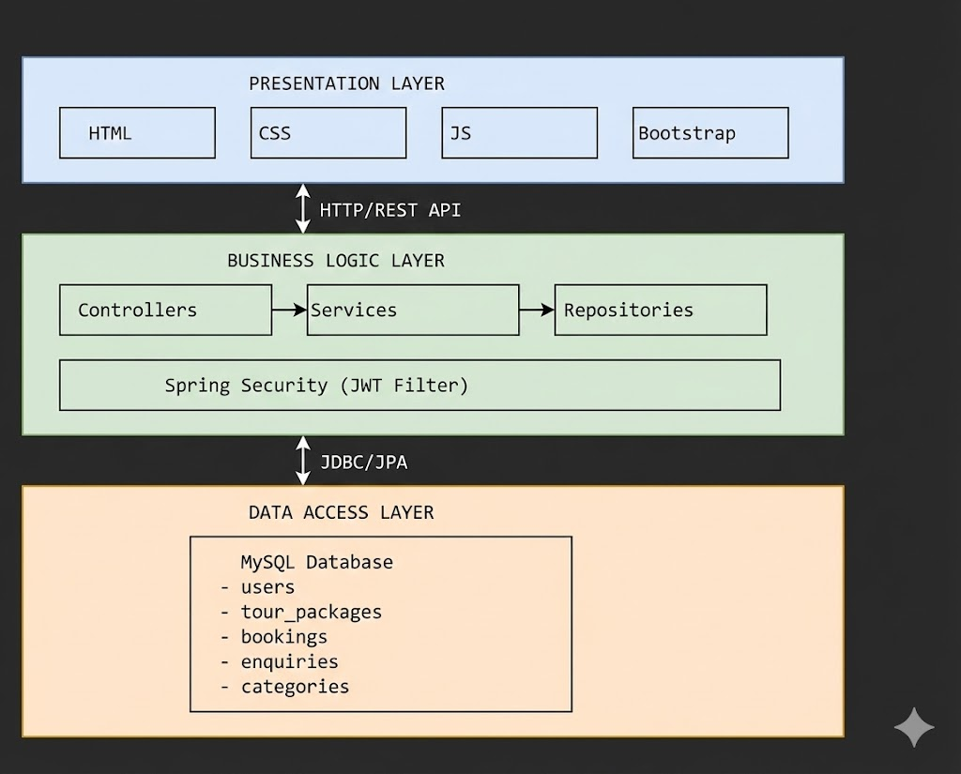
5.2 Architecture Diagram

5.3 Design Patterns Used
- MVC (Model-View-Controller):
  - Model: Entity classes
  - View: HTML pages
  - Controller: Spring Boot Controllers
- Repository Pattern:
  - Data access abstraction through JPA repositories 3. DTO Pattern:
  - Data Transfer Objects for API communication
- Service Layer Pattern:
  - Business logic separation in service classes
- Singleton Pattern:
  - Spring bean management

6. TECHNOLOGY STACK

6.1 Backend Technologies
Technology | Version | Purpose
Java | 17 | Programming language
Spring Boot | 2.7.18 | Application framework
Spring Security | 2.7.18 | Security framework
Spring Data JPA | 2.7.18 | Data persistence
MySQL Connector | Latest | Database driver
JWT (jwt) | 0.12.3 | Token generation
Maven | 3.6+ | Build tool

6.2 Frontend Technologies

Technology | Version | Purpose
HTML5 | Latest | Markup language
CSS3 | Latest | Styling
JavaScript (ES6+) | Latest | Client-side logic
Bootstrap | 5.x | UI framework
Font Awesome | Latest | Icons

6.3 Development Tools
• IDE: Spring Tools Suite (STS) / IntelliJ IDEA

• Version Control: Git
- API Testing: Postman / Browser DevTools • Database Management: MySQL Workbench
6.4 Why These Technologies?
- Spring Boot: Rapid development, auto-configuration, embedded server
- MySQL: Reliable, widely used, ACID compliance
- JWT: Stateless authentication, scalable
- Bootstrap: Responsive design, modern UI components
- Maven: Dependency management, build automation

7. SYSTEM DESIGN

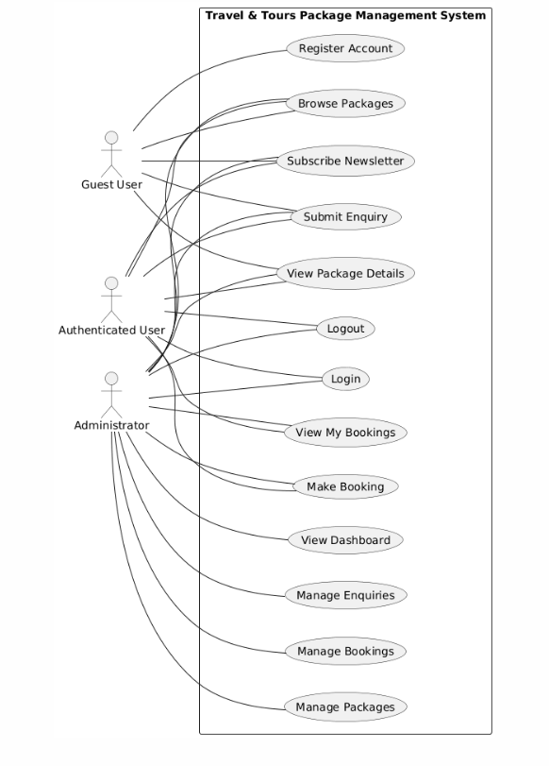
7.1 Use Case Diagram

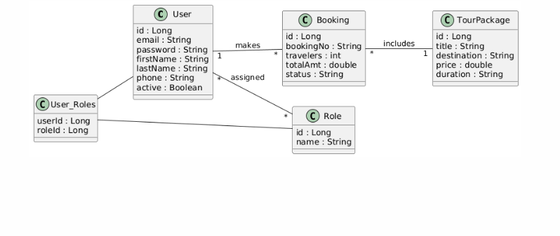
7.2 Class Diagram (Key Entities)

7.3 Sequence Diagram (Booking Flow)
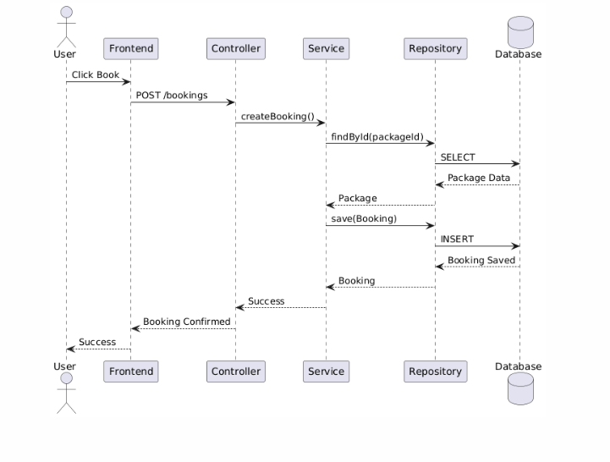

8. IMPLEMENTATION DETAILS
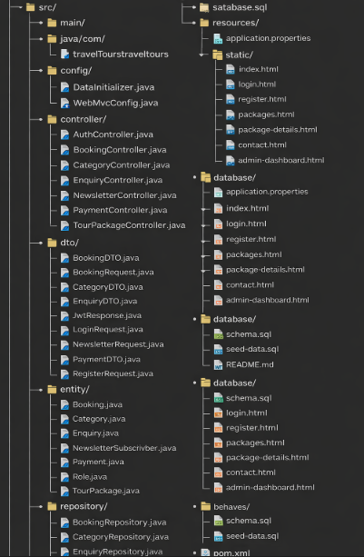
8.1 Project Structure

8.2 Key Components
8.2.1 Entity Classes User Entity: - Represents system users - Fields: id, email, password, firstName, lastName, phone, active - Many-to-Many relationship with Role
TourPackage Entity: - Represents tour packages - Fields: id, title, destination, description, price, duration, categoryId - One-to-Many relationship with Booking
Booking Entity: - Represents user bookings - Fields: id, bookingNumber, userId, tourPackageId, numberOfTravelers, totalAmount, status - Many-to-One with User and TourPackage
Category Entity: - Represents tour categories - Fields: id, name, description, imageUrl - One-to-Many with TourPackage
Enquiry Entity: - Represents customer enquiries - Fields: id, name, email, phone, message, tourPackageId, isRead
NewsletterSubscriber Entity: - Represents newsletter subscribers - Fields: id, email, active, subscribedAt
Payment Entity: - Represents payment transactions - Fields: id, bookingId, amount, paymentStatus, paymentDate
8.2.2 Service Layer Services implement business logic: - AuthService: Handles authentication and registration - TourPackageService: Manages tour packages - BookingService: Handles booking operations - EnquiryService: Manages customer enquiries - NewsletterService: Handles newsletter subscriptions - PaymentService: Manages payment processing - CategoryService: Manages tour categories
8.2.3 Controller Layer REST controllers handle HTTP requests: - AuthController: /api/auth/* - TourPackageController: /api/packages/* BookingController: /api/bookings/* - EnquiryController: /api/enquiries/* - NewsletterController: /api/newsletter/* - PaymentController:
/api/payments/* - CategoryController: /api/categories/*

9. DATABASE DESIGN

9.1 Database Schema
The system uses MySQL database with the following tables:
- roles - User roles (ADMIN, USER)
- users - User accounts
- user_roles - User-Role mapping (junction table)
- categories - Tour categories
- tour_packages - Tour packages

6. tour_package_images - Package images
- bookings - User bookings
- enquiries - Customer enquiries
- newsletter_subscribers - Newsletter subscribers
- payments - Payment transactions

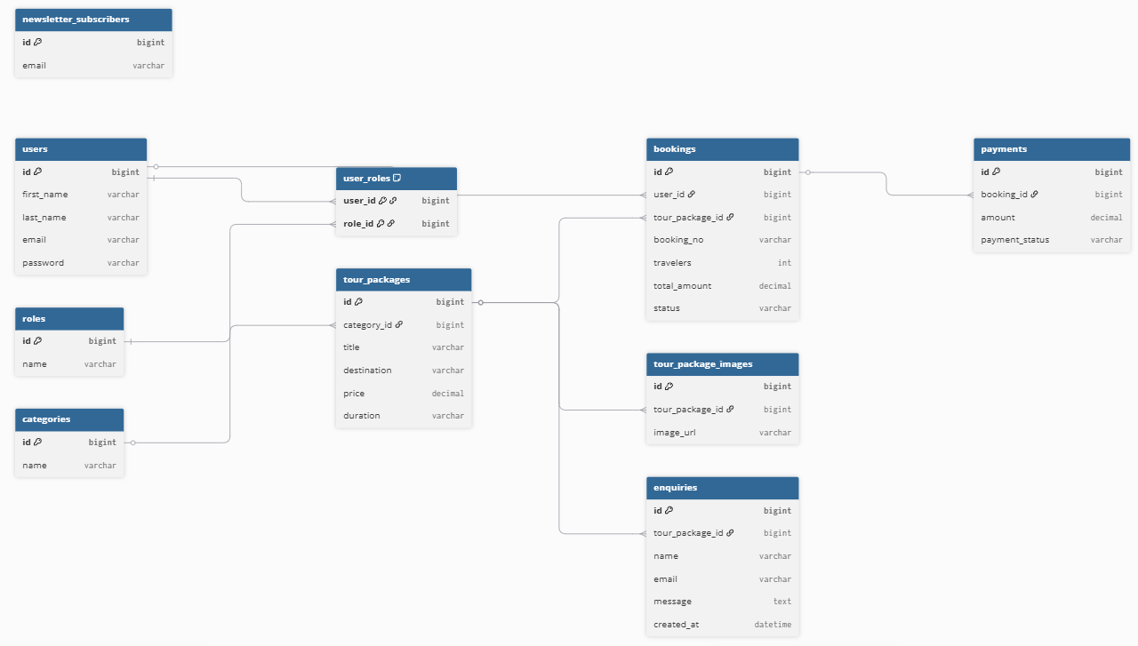
9.2 Entity Relationship Diagram

9.3 Key Database Tables users Table
CREATE TABLE users ( id BIGINT AUTO_INCREMENT PRIMARY KEY, email VARCHAR(100) NOT NULL UNIQUE, password VARCHAR(255) NOT NULL, first_name VARCHAR(100) NOT NULL, last_name VARCHAR(100) NOT NULL, phone VARCHAR(20), active BOOLEAN NOT NULL DEFAULT TRUE, created_at DATETIME NOT NULL,
updated_at DATETIME
);

tour_packages Table
CREATE TABLE tour_packages ( id BIGINT AUTO_INCREMENT PRIMARY KEY, title VARCHAR(200) NOT NULL, destination VARCHAR(100), description TEXT, itinerary TEXT, duration INT NOT NULL, price DECIMAL(10,2) NOT NULL, discount_price DECIMAL(10,2), main_image_url VARCHAR(500), category_id BIGINT NOT NULL, active BOOLEAN NOT NULL DEFAULT TRUE, available_seats INT NOT NULL, start_date DATE, end_date DATE, tour_type VARCHAR(50),
FOREIGN KEY (category_id) REFERENCES categories(id)
);

bookings Table
CREATE TABLE bookings ( id BIGINT AUTO_INCREMENT PRIMARY KEY, booking_number VARCHAR(50) NOT NULL UNIQUE, user_id BIGINT NOT NULL, tour_package_id BIGINT NOT NULL, number_of_travelers INT NOT NULL, total_amount DECIMAL(10,2) NOT NULL, status VARCHAR(50), special_requests VARCHAR(500), booking_date DATETIME NOT NULL, updated_at DATETIME,
FOREIGN KEY (user_id) REFERENCES users(id),
FOREIGN KEY (tour_package_id) REFERENCES tour_packages(id)
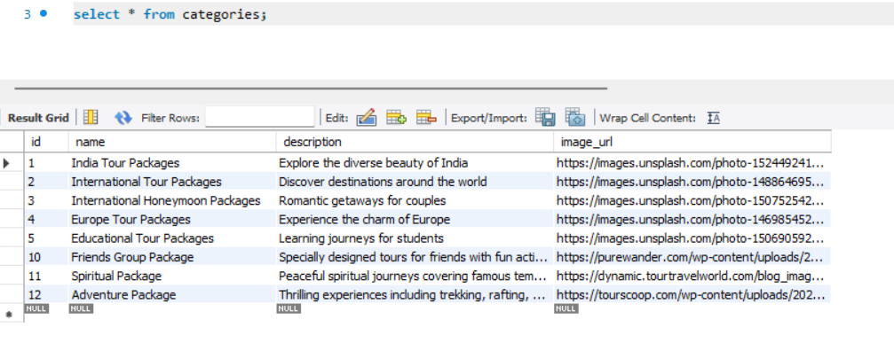
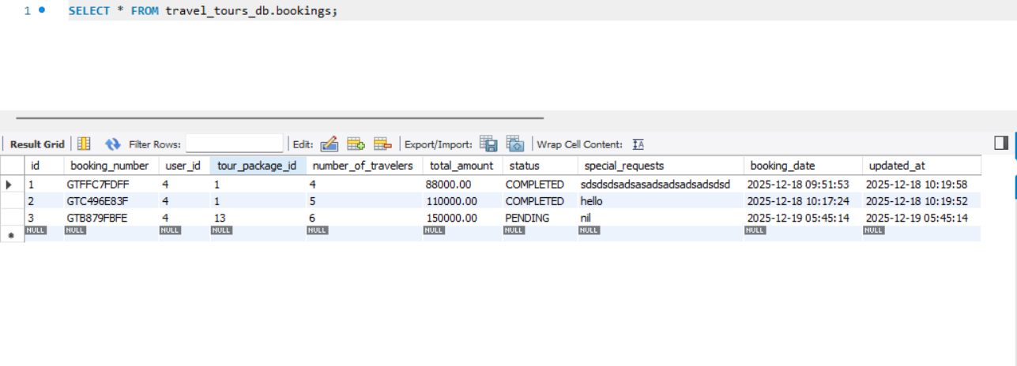
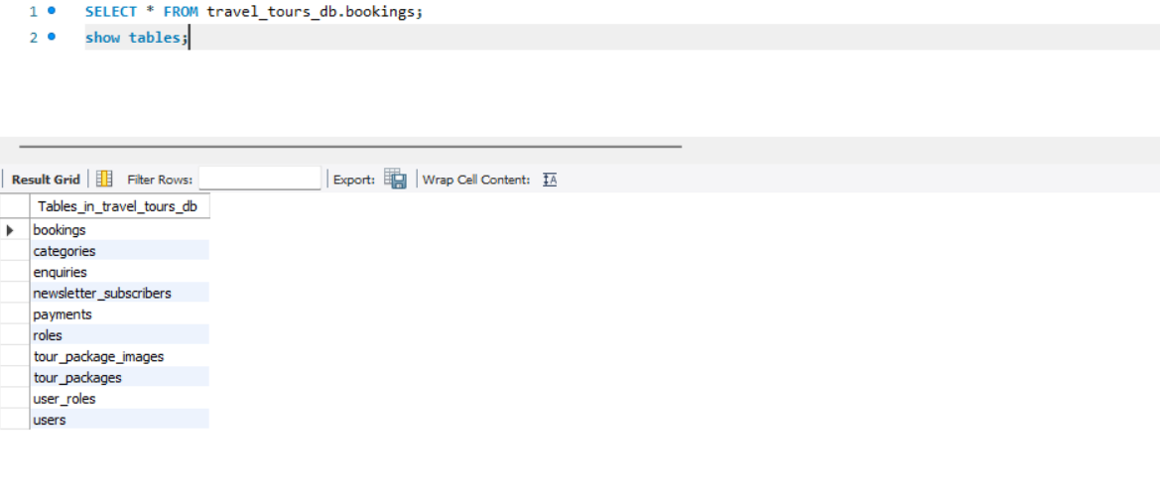
);
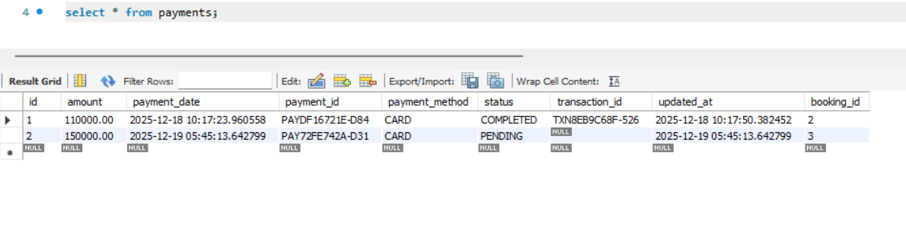
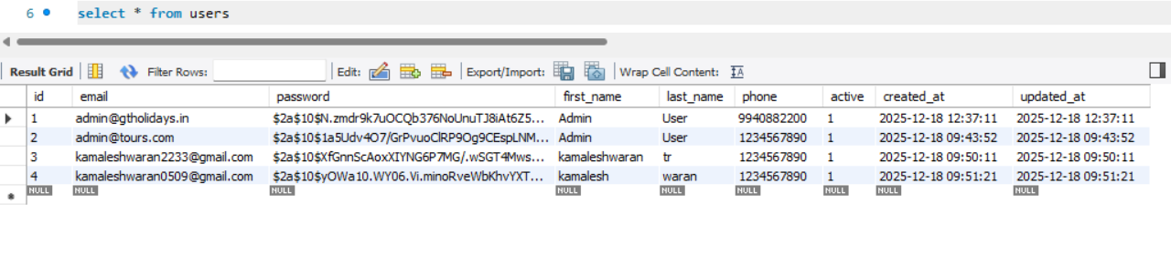
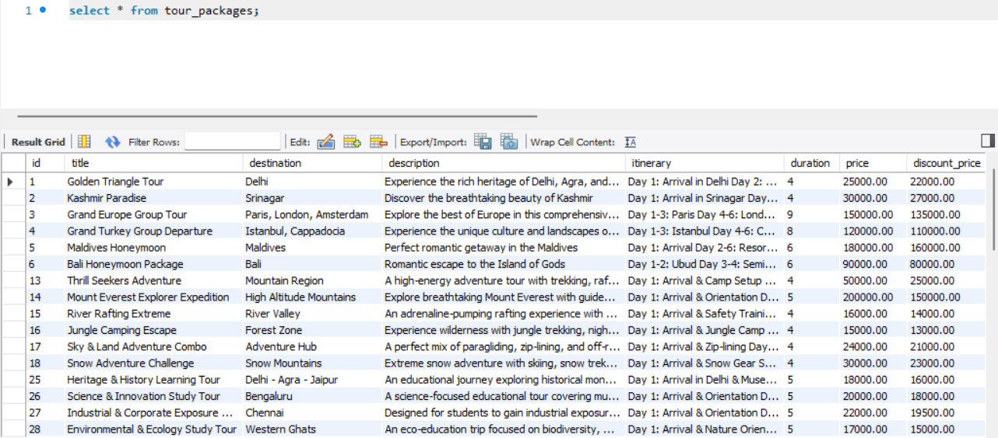

9.4 Database Relationships
- User Role: Many-to-Many (via user_roles junction table)
- User Booking: One-to-Many • TourPackage Booking: One-to-Many • Category TourPackage: One-to-Many

• TourPackage Enquiry: One-to-Many • Booking Payment: One-to-Many

10. TESTING
10.1 Testing Strategy

Unit Testing
- Service layer methods
- Utility functions

Integration Testing
- API endpoint testing
- Database operations
- Authentication flow

System Testing
- End-to-end user flows
- Cross-browser testing
- Performance testing
13.2 Test Cases

Authentication Tests
- User registration with valid data
- User registration with duplicate email
- User login with valid credentials
- User login with invalid credentials
- JWT token validation

Booking Tests
- Create booking as authenticated user
- Create booking as guest (should fail)
- View own bookings
- Admin view all bookings

Package Tests
- View all packages (public)
- View package details
- Filter packages by category
- Admin create/update/delete packages

11. CHALLENGES AND SOLUTIONS

11.1 Challenges Faced
Challenge 1: JWT Token Implementation Problem: Implementing secure JWT authentication with proper token validation.
Solution: - Used jjwt library for token generation and validation - Implemented
JWT filter to intercept requests - Added token expiration handling - Stored tokens securely in localStorage
Challenge 2: CORS Configuration Problem: Frontend API calls were blocked by CORS policy.
Solution: - Configured CORS in Spring Security - Added allowed origins, methods, and headers - Enabled credentials support
Challenge 3: Password Encryption Problem: Storing passwords securely.
Solution: - Implemented BCrypt password encoder - All passwords are hashed before storage - Password comparison uses BCrypt matcher
Challenge 4: Role-Based Access Control Problem: Implementing different access levels for users and admins.
Solution: - Created Role entity with ADMIN and USER roles - Implemented UserPrincipal for Spring Security - Configured method-level security - Added role checks in controllers
Challenge 5: Frontend-Backend Integration Problem: Connecting frontend JavaScript with backend REST API.
Solution: - Created centralized API helper functions - Implemented token storage and retrieval - Added error handling for API calls - Created consistent response handling

12. FUTURE ENHANCEMENTS

12.1 Planned Features
1. Email Notifications:
- Booking confirmation emails
- Enquiry response emails
- Newsletter emails 2. Payment Gateway Integration:
- Online payment processing
- Payment gateway integration (Stripe, PayPal)
- Payment history
3. Advanced Search:
- Search by destination, price range, duration
- Filter by multiple criteria
- Sort options 4. User Dashboard:
- User profile management
- Booking history with filters
- Favorite packages
- Reviews and Ratings:
  - User reviews for packages
  - Rating system • Review moderation
- Admin Features:
  - Analytics dashboard
  - Report generation
  - User management
  - Package analytics 7. Mobile Application:
  - Native mobile app (iOS/Android)
  - Push notifications
  - Mobile-optimized UI 8. Social Media Integration:
  - Share packages on social media
  - Social login (Google, Facebook)
  - Social media feed 9. Multi-language Support:
  - Internationalization (i18n)
  - Multiple language support
  - Currency conversion
7. Advanced Features:
- Real-time chat support
- Video tours
- Virtual reality previews
- Weather integration

13. CONCLUSION

13.1 Project Summary
The Travel Tours Package Management System successfully addresses the needs of modern travel agencies by providing:
- Secure Authentication: JWT-based authentication with role-based access control
- Efficient Management: Centralized system for managing tours, bookings, and enquiries
- User-Friendly Interface: Responsive web application accessible on all devices
- Scalable Architecture: Well-structured codebase ready for future enhancements
- Robust Security: Password encryption, token-based authentication, and input validation

13.2 Objectives Achieved
Primary Objectives: - Developed secure web-based system for tour package management - Implemented user authentication and role-based access control - Created intuitive booking system for customers - Provided admin dashboard for system management - Ensured data security and user privacy
Secondary Objectives: - Implemented responsive design for mobile compatibility - Created RESTful API for future integrations - Provided real-time booking status updates - Enabled customer enquiry management - Implemented newsletter subscription functionality

13.3 Technical Achievements
- Successfully implemented Spring Boot application with clean architecture
- Integrated JWT authentication for secure API access
- Created responsive frontend using Bootstrap 5
- Designed normalized database schema with proper relationships
- Implemented RESTful API following best practices

13.4 Impact
The system provides: - For Customers: Easy access to tour packages, simple booking process, enquiry submission - For Administrators: Efficient management of packages, bookings, and customer interactions - For Business: Centralized system reducing manual work, improved customer service, better data management

14 HTTP REQUEST METHODS
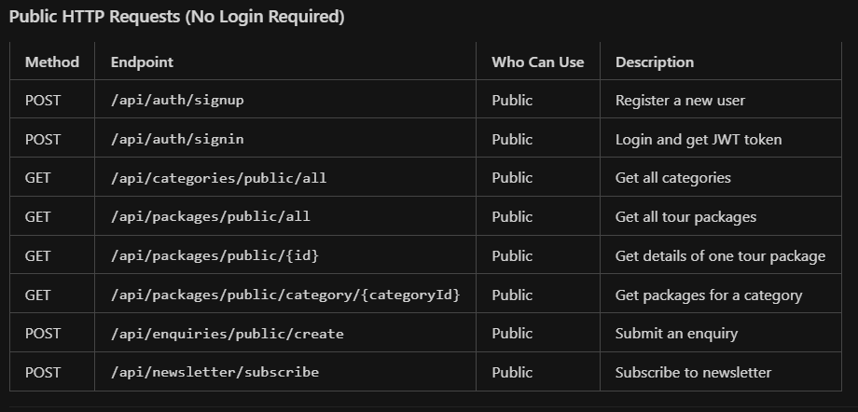
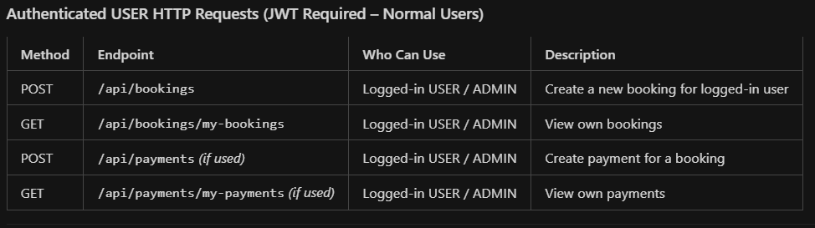
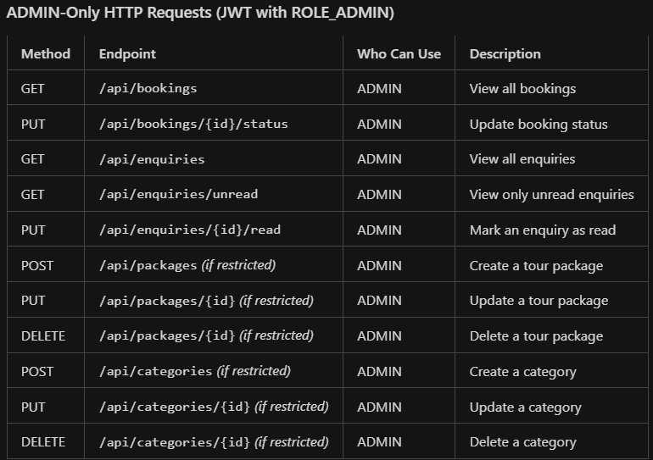

15. REFERENCES

15.1 Technologies and Frameworks
- Spring Boot Documentation. (2024). Spring Boot Reference Documentation. https://spring.io/projects/spring-boot
- Spring Security Documentation. (2024). Spring Security Reference. https://spring.io/projects/spring-security
- MySQL Documentation. (2024). MySQL 8.0 Reference Manual. https://dev.mysql.com/doc/
- Bootstrap Documentation. (2024). Bootstrap 5 Documentation. https://getbootstrap.com/docs/5.0/
- JWT.io. (2024). JSON Web Token Introduction. https://jwt.io/introduction

14.2 Books and Articles
- Walls, C. (2018). Spring in Action, Fifth Edition. Manning Publications.
- Deinum, M., Rubio, D., Long, J., & Gutierrez, F. (2014). Spring MVC Cookbook. Packt Publishing.
- Spilca, L. (2020). Spring Security in Action. Manning Publications.

15.3 Online Resources
- Baeldung. (2024). Spring Boot Tutorials. https://www.baeldung.com/springboot
- JavaTpoint. (2024). Spring Boot Tutorial. https://www.javatpoint.com/springboot-tutorial
- W3Schools. (2024). JavaScript Tutorial. https://www.w3schools.com/js/

15.4 Tools and Software Used
- Spring Tools Suite (STS) - IDE
- MySQL Workbench - Database Management
- Postman - API Testing
- Git - Version Control
- Maven - Build Tool

Website Functioning Demo Video: https://drive.google.com/drive/folders/1VS3dCVlZAVZPNJi3rY5V8-ilgrCIFjw_

END OF REPORT

