

STUDENT CASE STUDY EXECUTION REPORT

Department | FED
Subject | DSA-2
Academic Year | I-III Semester (2025-26)
Faculty Name | BALAIAH GUDIPUDI
Student Name | KAMTAM PRIYANKA
Roll Number | 2520090001
Branch | CSIT
Course Outcome | COURSE OUTCOME – 1

Case Study Topic: WhatsApp Delivered-Receipts Ordering using AVL Tree

Work Done Summary
In this case study, we analyzed how a backend system stores message-delivered receipts using timestamp keys. Since timestamps arrive in strictly increasing order, inserting them into a plain BST creates a highly unbalanced structure. We compared the performance of a plain BST with an AVL Tree and evaluated the impact on SLA requirements.
The AVL Tree maintains balance through rotations, ensuring logarithmic height and efficient retrieval of the oldest pending receipt.

Implementation Details
- Simulated insertion of monotonically increasing timestamps.
- Compared Plain BST and AVL Tree heights.
- Calculated worst-case search path length.
- Estimated pointer-hop latency.
- Evaluated SLA compliance.
Output:
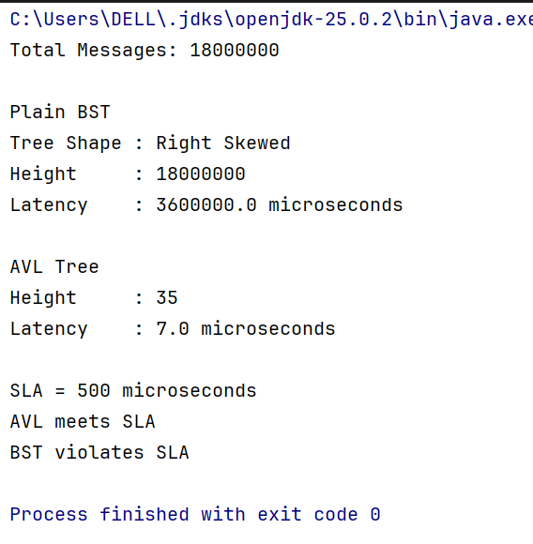

Result
- Plain BST becomes a right-skewed linked list.
- Height ≈ 18,000,000.
- Worst-case search = 18,000,000 pointer hops.
- AVL height ≈ 35.
- AVL latency ≈ 7 μs.
- AVL comfortably satisfies the 500 μs SLA.

Time Complexity
Operation | BST | AVL
Insert | O(n) | O(log n)
Search | O(n) | O(log n)
Find Oldest Receipt | O(n) | O(log n)

Conclusion
The plain BST is unsuitable because monotonically increasing timestamps create a skewed structure. AVL Trees maintain balance and provide logarithmic performance, making them the preferred choice for WhatsApp-scale receipt indexing.
GitHub Link: https://github.com/KAMTAM-PRIYANKA23/DSA-2-Case-Studies-Codes-

Student Signature | Faculty Signature

