

STUDENT CASE STUDY EXECUTION REPORT

Department | FED
Subject | DSA-2
Academic Year | I-III Semester (2025-26)
Faculty Name | BALAIAH GUDIPUDI
Student Name | KAMTAM PRIYANKA
Roll Number | 2520090001
Branch | CSIT
Course Outcome | COURSE OUTCOME – 2

Case Study Topic: YouTube Video Catalog using B+ Tree

Work Done Summary
In this case study, we estimated the size and height of a B+ Tree storing 500 million video metadata records. We computed leaf fanout, internal-node fanout, and overall tree height using SSD page constraints. We also estimated the I/O cost of point lookups.

Implementation Details
- Calculated leaf page capacity.
- Calculated internal page fanout.
- Estimated B+ Tree height.
- Computed point lookup I/O cost.
- Analyzed caching benefits.
Output:
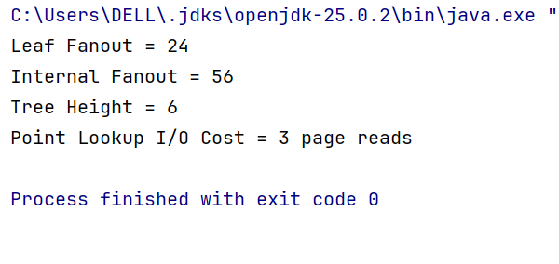

Time Complexity
Operation | Complexity
Search | O(logf N)
Insert | O(logf N)
Delete | O(logf N)
Range Query | O(logf N + k)

Conclusion

The B+ Tree achieves excellent scalability with a height of only 6 levels for 500 million records. With upper levels cached, a lookup requires only 3 SSD page reads, making it highly efficient for YouTube-scale metadata storage.
GitHub Link: https://github.com/KAMTAM-PRIYANKA23/DSA-2-Case-Studies-Codes-

Student Signature | Faculty Signature

