

STUDENT CASE STUDY EXECUTION REPORT

Department | FED
Subject | DSA-2
Academic Year | I-III Semester (2025-26)
Faculty Name | BALAIAH GUDIPUDI
Student Name | KAMTAM PRIYANKA
Roll Number | 2520090001
Branch | CSIT
Course Outcome | COURSE OUTCOME - 3

Case Study Topic: Slack Channel-Membership Graph using Union-Find

Work Done Summary
In this case study, we analyzed a Slack workspace represented as a graph. We used Union-Find with Path Compression and Union-by-Rank to determine connected components and identify the largest component efficiently.

Implementation Details
- Processed 240,000 edges.
- Applied Union-Find operations.
- Used Path Compression.
- Used Union-by-Rank.
- Maintained component sizes during union.

Answer to Questions

(i) Time Complexity
Union-Find with Path Compression +
Union-by-Rank
O(E α(V))
E = 240,000
V = 12,000
α(V) ≈ 4
Overall ≈ O(240,000)

(ii) Number of find() Operations
Each edge requires:
find(u)
find(v)
Total finds
= 2 × 240,000
= 480,000
Approximate pointer hops:
480,000 × α(V)
≈ 480,000 × 4
≈ 1,920,000 hops

(iii) Largest Component Size
After every union operation:
size[parent] =
size[parent] + size[child]
Maintain a global maximum variable. Whenever a union occurs, update the component size and compare it against the current maximum. After all unions complete, this maximum value represents the largest connected component size.
Output:
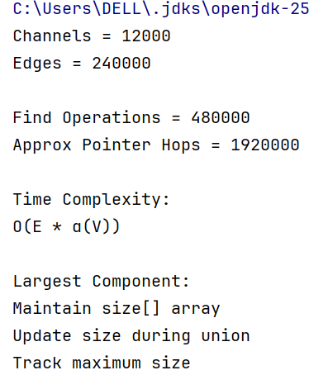

Time Complexity
Operation | Complexity
Find | O(α(V))
Union | O(α(V))
Entire Graph Processing | O(E α(V))

Conclusion
Union-Find with Path Compression and Union-by-Rank efficiently processes all 240,000 channel-sharing edges. The algorithm runs nearly in linear time and can determine both the number of connected components and the largest component size with minimal overhead.
GitHub Link: https://github.com/KAMTAM-PRIYANKA23/DSA-2-Case-Studies-Codes-

Student Signature | Faculty Signature

