Project Report
SkyWings Airlines Reservation System
Frontend Web Application – Airline Reservation and Booking Management System
Submitted by
Kamtam Priyanka
Roll No: 2520090001

Abstract
The global travel and aviation sector relies heavily on robust digital infrastructure. To address the complexities of modern travel planning, this project focuses on the design and development of the SkyWings Airlines Reservation System. This responsive web application is developed to simulate a real-world airline booking platform, providing users with an intuitive and seamless travel planning experience.
The application is structured into comprehensive modules that allow users to search for flights, view intricate flight details, and interactively select seats. It features a multi-step workflow that concludes with a mock payment process and the generation of an electronic ticket. Built entirely as a modern frontend application, it utilizes React.js, Vite, and Tailwind CSS to demonstrate cutting-edge Component-Based Architecture. By leveraging Browser Local Storage for all CRUD operations, the project successfully showcases complex state management, data persistence, and dynamic client-side routing without the need for a traditional backend server.

Index
1. Introduction
2. System Requirements
3. Technology Stack
4. System Architecture
5. Design
6. Implementation
7. Features
8. Testing
9. Deployment
10. Challenges & Limitations
11. Future Enhancements
12. Conclusion
13. References
14. Appendices (Screenshots)

Chapter 1: Introduction

1.1 Background of the Project
The aviation industry relies on fast, reliable, and user-friendly reservation systems. Historically, these systems were bulky, server-heavy applications that required constant page reloads. With the advent of Single Page Applications (SPAs) and modern JavaScript frameworks, the standard for user experience has shifted toward instantaneous, dynamic interfaces. The SkyWings Airlines Reservation System was conceptualized to simulate these modern, luxury flight booking environments using responsive matching and interactive configurations.

1.2 Problem Statement
Traditional academic projects often rely heavily on complex backend setups to demonstrate basic CRUD (Create, Read, Update, Delete) operations, which can overshadow the importance of frontend user experience (UX) and interface (UI) design. There is a need for an application that rigorously tests state management, multi-step workflows, and component reusability strictly on the client side.

1.3 Scope of the Project
The scope of this project is confined to a comprehensive frontend web application simulating an airline platform. It handles complete user journeys—from registration and authentication to interactive flight searches, seat configuration, and ticket generation. All data storage is restricted to Browser Local Storage, excluding external backend databases.

1.4 Objectives
- To simulate a real airline reservation platform with a complete booking workflow.
- To demonstrate modern frontend development practices using React and Component-Based Development.
- To practice and implement React routing (React Router DOM) and complex state management.
- To showcase full CRUD operations entirely without a backend server.
- To build a highly responsive, mobile-friendly, and user-centric interface.

1.5 Importance of the Application
This application serves as a robust demonstration of frontend engineering capabilities. By managing complex states—such as interactive seat maps and multi-step payment simulations—it proves that modern web browsers can handle significant application logic. It provides a blueprint for building SPAs that require persistent data without immediate server validation.

1.6 Target Users / Audience
- Standard Users (Passengers): Individuals looking to simulate booking luxury flights, searching routes, and managing electronic boarding passes.
- Administrators: Restricted personnel requiring access to a dedicated Admin Portal to configure available flight schedules, manage occupied seat maps, and inspect active traveler databases.

Chapter 2: System Requirements

2.1 Hardware Requirements
- Processor: Dual-core processor (Intel i3 / AMD Ryzen 3 or higher recommended for development).
- RAM: Minimum 4 GB (8 GB recommended for running local development servers).
- Storage: 500 MB of free disk space for project files and node modules.
- Client Device: Any modern device (Desktop, Tablet, Mobile) with a standard screen resolution to support the responsive layout.

2.2 Software Requirements
- Operating System: Windows 10/11, macOS, or Linux.
- Environment: Node.js (v16.x or higher) and npm/yarn for package management.
- Web Browser: Google Chrome, Mozilla Firefox, Microsoft Edge, or Safari (must support HTML5, CSS3, and Local Storage).

2.3 Development Tools and Frameworks
- IDE: Visual Studio Code (recommended).
- Build Tool: Vite (for fast, optimized frontend building).
- Icons: Lucide React for consistent UI iconography.

Chapter 3: Technology Stack

3.1 Front-End
- React.js (Functional Components & Hooks): Serves as the core library for building the user interface through reusable components like Navbar, Dashboard, and SeatSelection. It utilizes Hooks such as useState() and useEffect() for state and lifecycle management.
- JavaScript / TypeScript: Provides the core programming logic.
- HTML5 & CSS3: For semantic structure and foundational styling.
- Tailwind CSS: A utility-first CSS framework utilized for responsive design, gradient hero sections, hover effects, and a modern card-based layout.
- React Router DOM: Used for client-side routing, enabling dynamic routes like /flight-details/:flightId and /payment/:flightId without page reloads.

3.2 Back-End & Database (Simulated)
Browser Local Storage: Since this project demonstrates CRUD operations without a traditional backend, Local Storage is utilized as the primary database. It persistently stores Registered Users, Flight Data, Booking History, Seat Information, and Login Sessions.

3.3 Version Control
Git & GitHub: Used for source code management, branch tracking, and version control throughout the development lifecycle.

Chapter 4: System Architecture

4.1 High-Level Architecture Diagram
The project follows a Component-Based Architecture. The application is divided into independent, reusable React components (e.g., SearchFlights, FlightDetails, BookingSummary) that interact with a centralized routing layer and a local storage data layer.

4.2 Description of Each Layer
- Presentation Layer (UI): Built with Tailwind CSS and React components. It handles user inputs, form validations, and displays interactive elements like flight cards and the seat selection fuselage map.
- Routing Layer: Managed by BrowserRouter, handling navigation across dynamic paths using useNavigate(), useParams(), and useSearchParams().
- Data/State Layer: Replaces a traditional backend. Uses standard JavaScript objects serialized into JSON to perform Create, Read, Update, and Delete operations directly against the browser's Local Storage API.

4.3 Deployment Architecture
As a Vite-based React Single Page Application (SPA), deployment involves compiling the code into static HTML, CSS, and minified JS files. These static assets can be deployed to any modern static hosting service (such as Vercel, Netlify, or GitHub Pages) ensuring rapid content delivery globally.

Chapter 5: Design

5.1 Local Storage Schema
Instead of a traditional ER Diagram, the system relies on a structured JSON schema stored in Local Storage.
Table | Key Fields
Users (skywings_users) | userId, fullName, email, password
Flights (skywings_flights) | flightId, airlineName, departure, destination, date, price, duration, amenities
Bookings (skywings_bookings) | bookingId (PNR), userId, flightId, passengerDetails, seatNumber, totalPrice, status (Confirmed/Cancelled)
Seats (skywings_seats) | flightId mapped to an array of seat objects detailing seatId and status (Available, Blocked, Booked)

Chapter 6: Implementation

6.1 Module-wise Implementation
- Version 1 – Module 1: User Authentication & Navigation. Implemented user registration and login forms with required field and email validation. Session data is saved to Local Storage to secure the Dashboard.
- Version 2 – Module 2: Flight Management. Developed CRUD capabilities for flight operations, rendering dynamic Flight Cards.
- Version 3 – Module 3: Flight Search & Flight Details. Implemented search algorithms with price and airline filtering, utilizing URL Query Parameters for responsive UI updates.
- Version 4 – Module 4: Booking & Payment. Built the multi-step workflow including seat selection, mock payment gateway validation, and E-Ticket generation.

6.2 Front-End Logic (UI Rendering, State Management)
The UI is driven by React Functional Components. State transitions—such as selecting a seat or updating a passenger's age—are managed securely through useState. Lists of flights and bookings are dynamically rendered using React lists and keys.

6.3 Local Storage API Integration
Custom JavaScript utility functions were implemented to act as an API layer, abstracting the localStorage.getItem() and localStorage.setItem() calls. This allowed the React components to perform asynchronous-style data fetching and updating cleanly.

6.4 Authentication & Authorization
The application features dual authentication pathways. Passengers register and log in to view their saved flight bookings. A separate, restricted Admin Portal requires specific credentials (e.g., admin / admin123) to access the terminal dashboard for flight and inventory management.

Chapter 7: Features

7.1 List of Main Features
- User Authentication (Signup/Login)
- Interactive Flights Lookup Engine
- Flight Filtering and Sorting
- Interactive Cabin Configurator (Seat Selection)
- Mock Payment Simulation
- Electronic Ticket Generation
- Administrator Dashboard Hub

7.2 How Each Feature Works
- Interactive Flights Lookup: Users select departure, destination, date, and cabin class. The system queries Local Storage to find matching routes and displays them as interactive cards detailing duration, price, and instant booking options.
- Seat Selection: Users are presented with an interactive fuselage map. They can tap any seat to instantly assign it. Row 1 is reserved for Business class, and Row 3 acts as emergency exits with dynamic workspace legroom.
- Electronic Ticket: Upon passing mock payment validation, the system generates an official PNR and renders an electronic ticket featuring security verification and boarding details, which is formatted ready for printing.
- Administrator Hub: Admins log in to view real-time control loops showing mapped routes, booked PNRs, and revenue logs. They can use the Interactive Cabin Configurator to force pre-book limits or manually block seats.

Chapter 8: Testing

8.1 Validation and Logic Testing
Extensive manual testing was performed to validate the multi-step workflow:
- Form Validations: Checked inputs to enforce non-empty patterns manually for emails, passwords, and passenger ages.
- Payment Validation: Ensured the mock payment form rejects invalid card formats before proceeding to E-Ticket generation.

8.2 Integration Testing
The complete workflow was tested end-to-end:
User Signup
↓
Dashboard
↓
Search Flights
↓
Apply Filters
↓
View Details
↓
Seat Selection
↓
Booking Summary
↓
Mock Payment
↓
Generate E-Ticket
↓
View Booking History

8.3 Tools Used for Testing
- React Developer Tools: Used to inspect component hierarchies and state changes.
- Chrome DevTools: Used for examining Local Storage persistence, responsive design testing (Mobile/Tablet views), and debugging console errors.

Chapter 9: Deployment

9.1 Steps to Deploy
- Build Generation: Run the command npm run build via Vite to bundle the React application into optimized static assets.
- Environment Configuration: Ensure any mock environment variables (if used) are securely set.
- Hosting: Upload the generated dist folder to a static hosting provider (e.g., Vercel).
- Routing Configuration: Configure the host to rewrite all requests to index.html to support React Router DOM's client-side routing.

Chapter 10: Challenges & Limitations

10.1 Limitations
- Data Volatility: Because the system relies entirely on Browser Local Storage, clearing browser cache or switching devices will result in the loss of user data, bookings, and admin configurations.
- Mock Payment: The platform uses a Mock Payment Gateway; no real physical cards are billed, and it cannot process actual financial transactions.
- Offline Client-Side Sandbox: The application operates as a 100% offline client-side sandbox, meaning data is not shared between different users on different machines.

Chapter 11: Future Enhancements

11.1 Planned Features
- Backend Integration: Transitioning the Local Storage architecture to a robust backend using Node.js and MongoDB to allow cross-device synchronization and persistent, secure data storage.
- Real Payment Gateway: Integrating Stripe or Razorpay APIs to replace the mock payment simulator with real transactional capabilities.
- Live Flight APIs: Connecting to external services (like Amadeus or Skyscanner) to fetch real-world, live flight schedules and dynamic pricing rather than relying on mock databases.

Chapter 12: Conclusion

12.1 Summary of the Project
The SkyWings Airlines Reservation System successfully simulates a real airline reservation platform while demonstrating highly effective modern frontend development practices. By leveraging React.js, Vite, and Tailwind CSS, the project delivered a highly responsive, single-page application.

12.2 What Was Achieved
The project successfully implemented a complete booking workflow—from flight search and interactive seat selection to payment simulation and electronic ticket generation. It achieved full CRUD operations using Browser Local Storage, proving the efficacy of complex client-side state management and dynamic routing without backend dependencies.

Chapter 13: References
- React Documentation: https://react.dev/
- Tailwind CSS Documentation: https://tailwindcss.com/
- React Router DOM: https://reactrouter.com/
- Vite Build Tool: https://vitejs.dev/

Chapter 14: Appendices

Screenshots of the Application
The following screenshots illustrate the major screens and features of the SkyWings Airlines Reservation System.
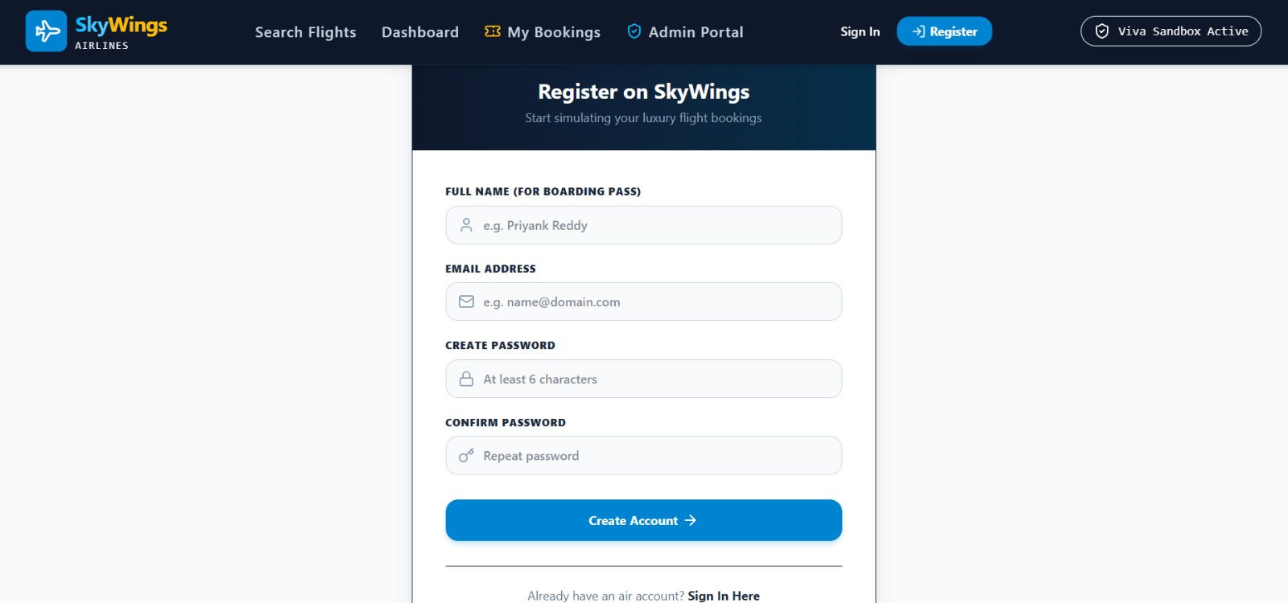
Registration Page
User registration form capturing full name, email, and password.
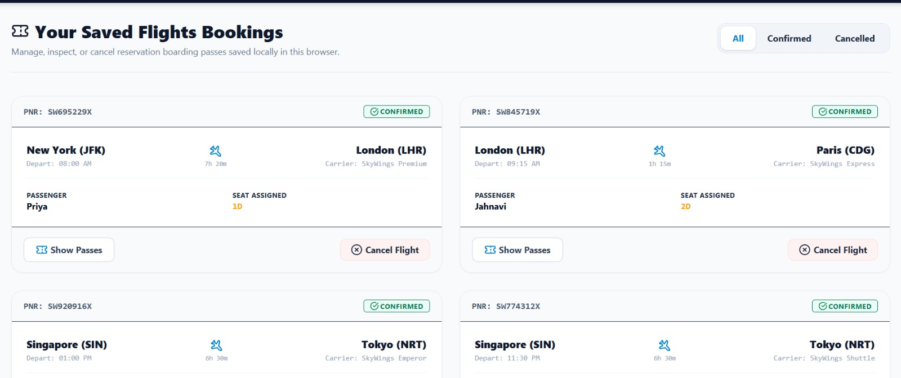
My Bookings
Display of saved bookings showing PNR, route, passenger, and seat details.
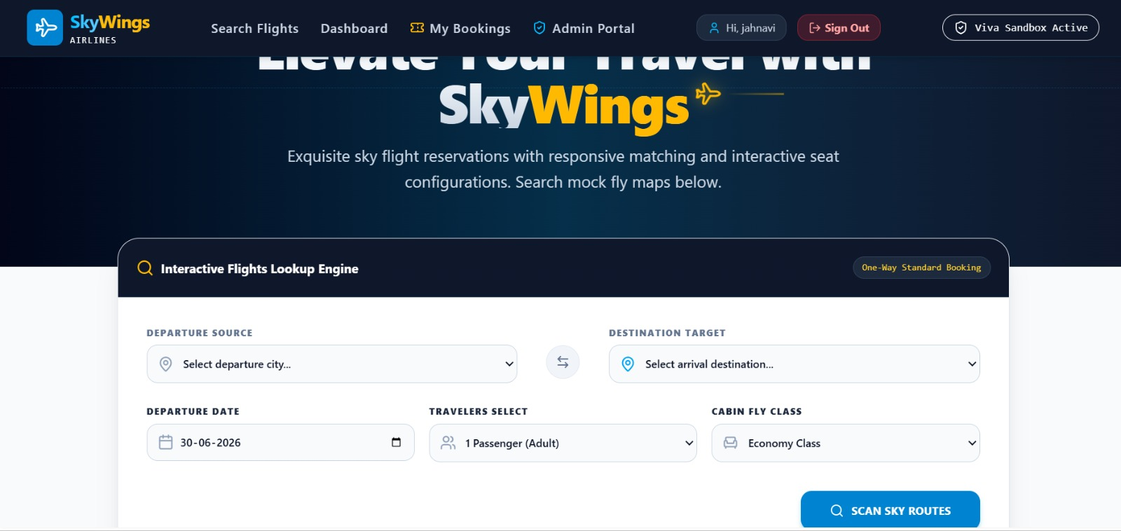
Dashboard Flight Search
Interactive lookup engine for departure, destination, and cabin class.
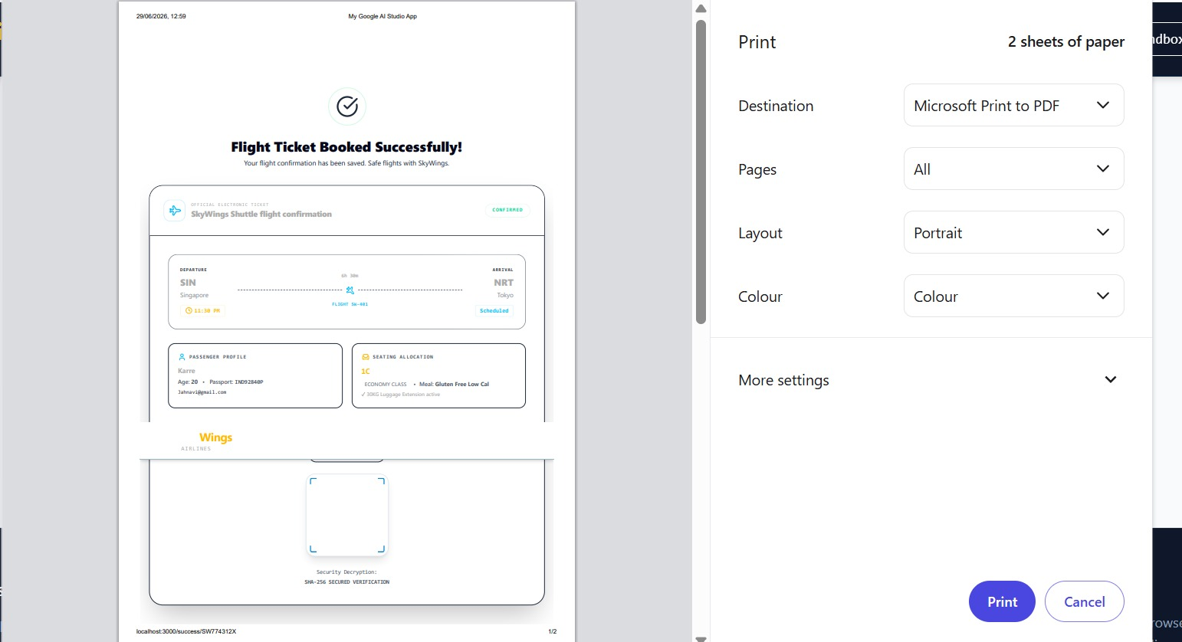
Electronic Ticket Generation
Confirmation screen with printable flight ticket.
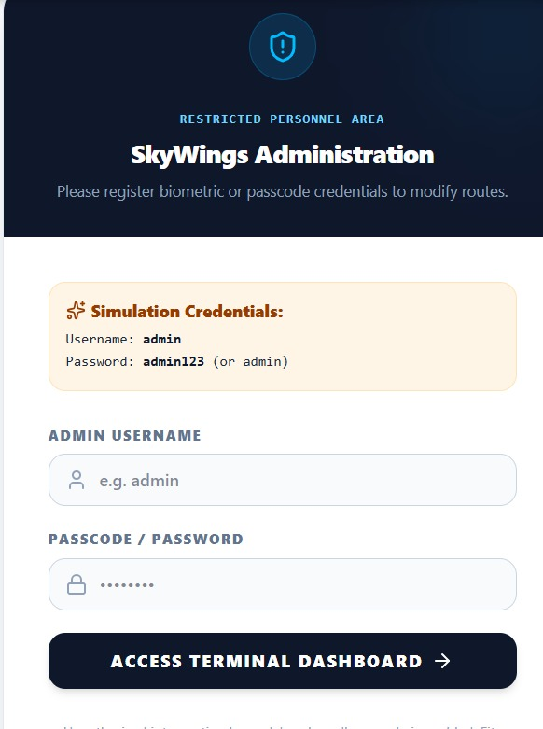
Admin Portal Login
Restricted access login screen.
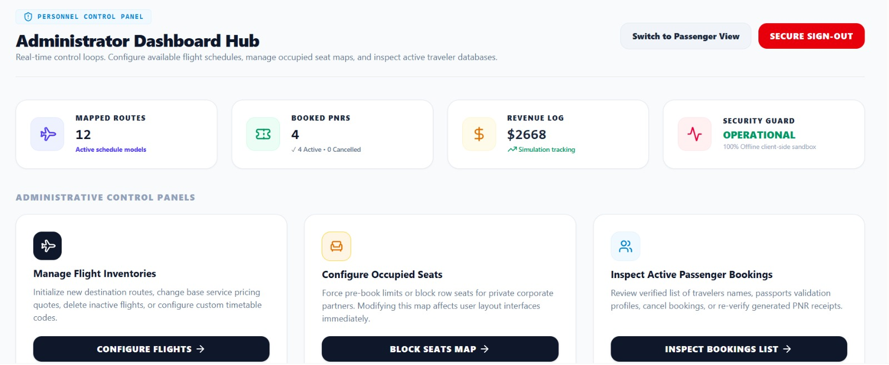
Administrator Dashboard Hub
Overview of mapped routes, booked PNRs, and revenue.
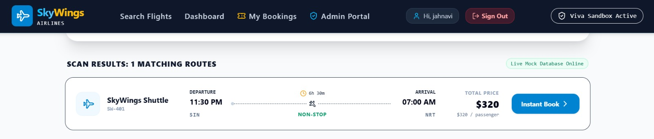
Flight Search Results
Matching routes with instant booking options.
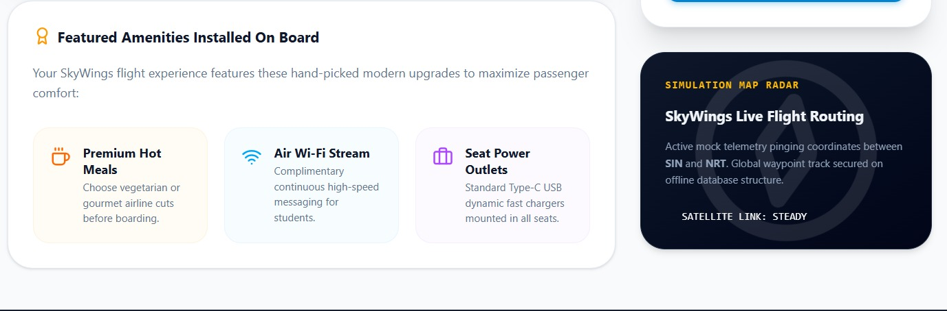
Flight Details & Amenities
Display of onboard amenities like hot meals and Wi-Fi.
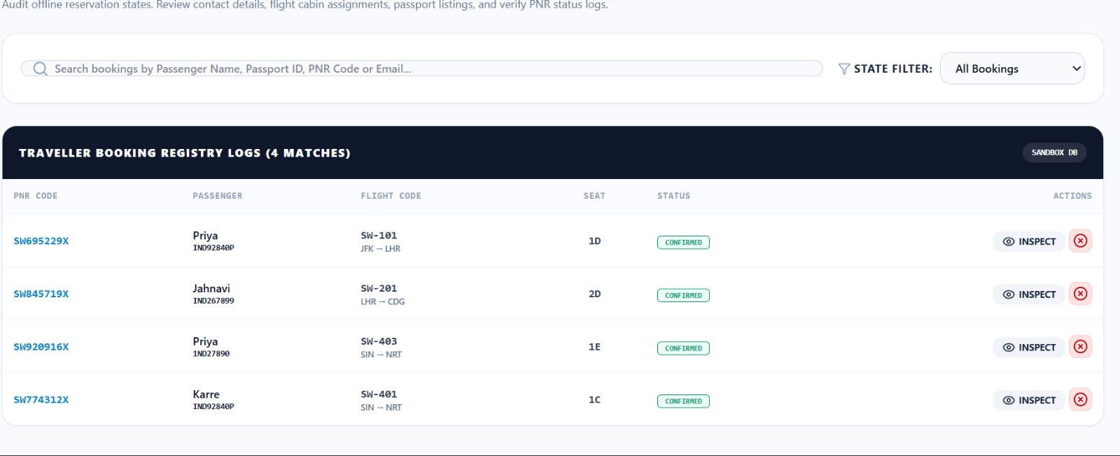
Admin Booking Registry
Log of all traveler bookings.
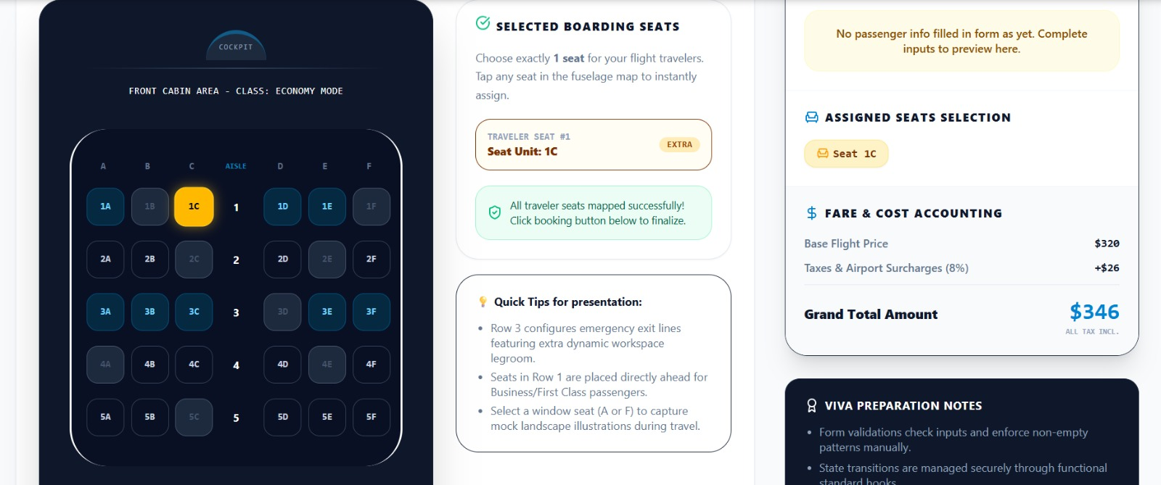
Seat Selection
Interactive fuselage map for cabin seat assignment.
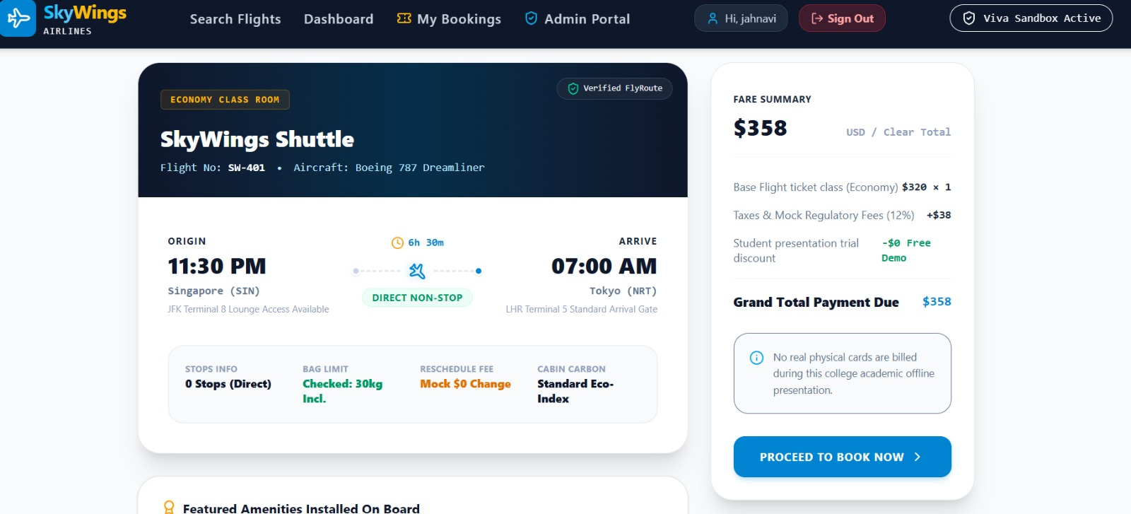
Flight Details & Fare Summary
Breakdown of taxes and total payment.
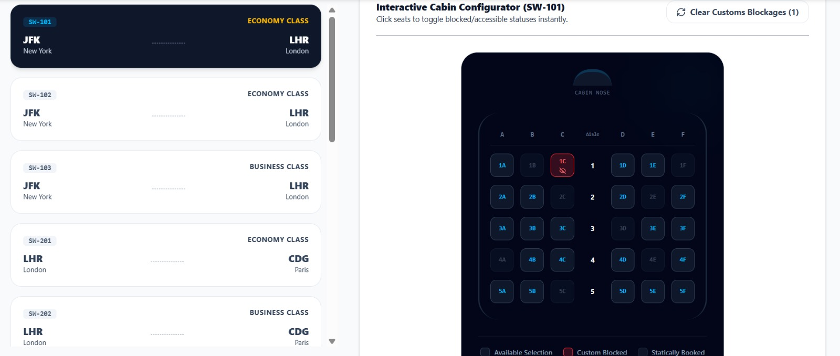
Interactive Cabin Configurator
Admin tool for toggling blocked and available seats.

