KANE-O'S HASHME
OPERATING MANUAL
+ TECHNICAL SPECIFICATION
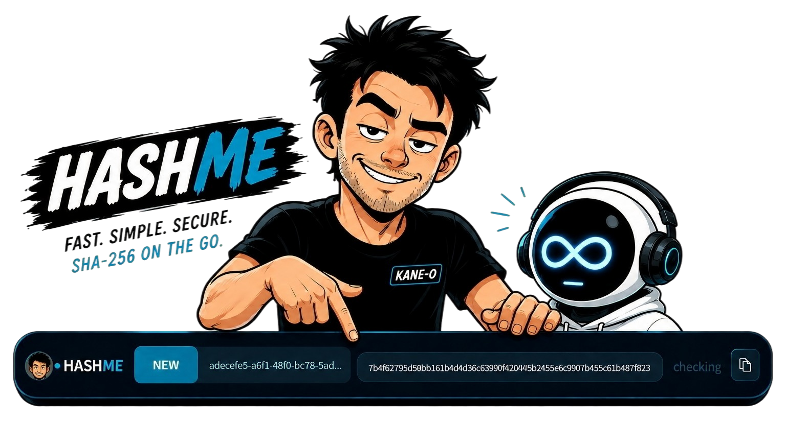
FAST. SIMPLE. SECURE. SHA-256 ON THE GO.
VERSION 1.2 | WINDOWS 11+ x64
PRIVATE OPEN-SOURCE CANDIDATE
KANE-O LABS | SOVEREIGN / KANE-O | 19 SEPTEMBER 2026

1. Quick Start
PURPOSE HASHME calculates a file's SHA-256 fingerprint locally, identifies whether the content is new or already known, and places complete evidence-ready output one click away.

READY - the complete strip is a file drop target.

Standard workflow
- Open HASHME from the Windows Start menu or launch the portable HASHME.exe.
- Drag one file or several files from Windows Explorer onto any part of the strip.
- Wait while HASHME reads each file and calculates its complete 64-character SHA-256.
- Read the status badge, then press Copy to place every filename and SHA-256 on the clipboard.
- Press CLEAR when finished. The visible result is reset; the private verification catalogue remains intact.
NEW - the content has not previously been recorded by this HASHME installation.
EXISTING - the recalculated fingerprint matches a known record or recognised sidecar.
PRECISION NOTE HASHME does not write a hash into the source file. It reads the file, calculates the fingerprint, and records the relationship in its own local catalogue. The source file is never rewritten.

2. Status and Evidence Guide
The badge colour is a fast signal; the text is the authoritative state. Hover over shortened status or result text to view the complete tooltip.
STATUS | SIGNAL | EXACT MEANING
READY | IDLE | Waiting for one or more files.
NEW | BLUE | No matching HASHME record or recognised SHA-256 sidecar was found. The calculated fingerprint is recorded locally.
EXISTING | ORANGE | The recalculated hash matches the prior path record, known identical content, or a recognised sidecar/manifest record.
CHANGED | RED | This path was recorded before, but its current bytes produce a different hash. The stored baseline is preserved.
MISMATCH | RED | The current hash does not match the expected value in a recognised sidecar or SHA256SUMS manifest.
MATCH | GREEN | Pair Match received two files whose complete SHA-256 values are identical.
DIFFERENT | RED | Pair Match received two files with different SHA-256 values.
ERROR | RED | The file could not be read or hashed. The displayed detail explains why.

Changed records are fail-closed
HASHME never silently replaces a changed baseline. If the change is authorised, right-click and choose Replace stored record with current hash. HASHME rehashes the file before replacing the catalogue record; if the bytes changed again, replacement is refused.

Recognised verification records
- Sidecars: filename.ext.sha256 or filename.sha256; a bare 64-character hash is accepted in a sidecar.
- Manifests: SHA256SUMS, SHA256SUMS.txt, or SHA256SUMS.sha256 in the file's directory.
- Supported lines include conventional 'hash filename' and BSD 'SHA256 (filename) = hash' formats.
CLEAR IS NOT DELETE CLEAR, Escape, or Delete removes the visible result and disarms Pair Match. It does not erase settings or the verification catalogue.

3. Pair Match and Multi-File Work
Pair Match is for direct evidence comparison: arm it first, then drop exactly two files together. The mode automatically disarms after that drop.
PAIR ARMED - the next drop must contain exactly two files.
MATCH - both recalculated SHA-256 fingerprints are identical.

Run a pair comparison
- Right-click HASHME and select Pair Match - next drop.
- Drag exactly two files onto any part of the strip.
- Read MATCH or DIFFERENT, then press Copy for the complete paired evidence line.
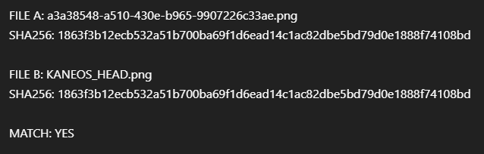
Clipboard proof preserves both filenames, both SHA-256 values, and MATCH: YES or NO.

Multiple ordinary files
Outside Pair Match, drop any number of files together. HASHME processes them in deterministic drop order. The visible field remains a single truncated line; Copy returns every complete filename and SHA-256 on one continuous clipboard line separated by four spaces.
COPY FORMAT filename.ext SHA256: <64 hex characters> next-file.ext SHA256: <64 hex characters>

4. Controls and Settings
Right-click anywhere on the strip to open HASHME's control menu. Settings persist locally between launches.
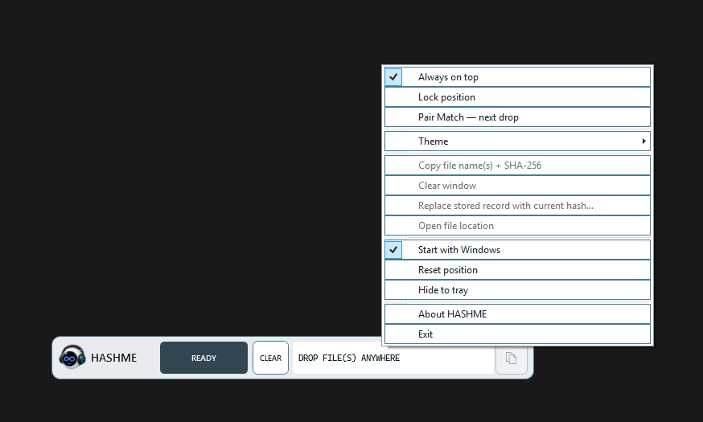
The complete right-click menu, including position, verification, startup, tray and lifecycle controls.
WINDOW | Always on top; Lock position; Reset position. When unlocked, drag the strip from any non-button area.
EVIDENCE | Pair Match; Copy; Clear; Replace changed record; Open file location.
APPEARANCE | HashMe Dark, Graphite, Light, and High Contrast themes.
LIFECYCLE | Start with Windows; Hide to tray; About; Exit. Double-click the tray icon to restore HASHME.

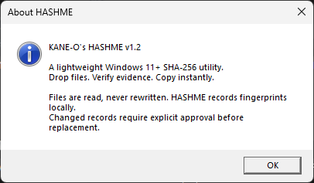
About confirms the product identity and v1.2 release.

5. Installation and Technical Specification
Use the MSI for a normal per-user installation or direct update from v1.0/v1.1. The portable ZIP may be extracted and HASHME.exe launched directly.
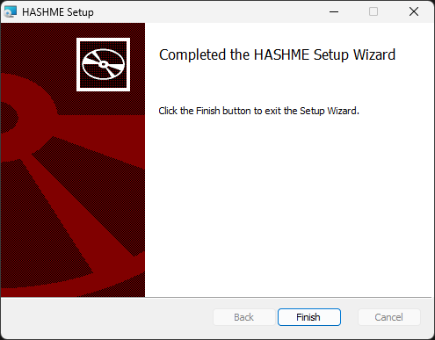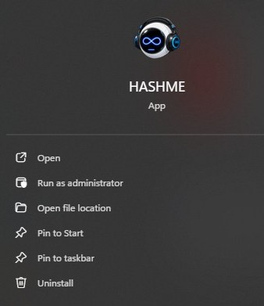
Windows 11 device evidence: explicit installer completion and installed application entry.
PRODUCT | HASHME - KANE-O's lightweight SHA-256 utility
RELEASE | v1.2.0; private open-source candidate; 19 September 2026
OWNER / PUBLISHER | KANE-O LABS
PLATFORM | Windows 11 or later, x64; Per-Monitor V2 high-DPI aware
APPLICATION | WPF, net10.0-windows; self-contained single-file PE32+ GUI
BUILD TOOLCHAIN | Official .NET SDK 10.0.401; 0 warnings/errors; 15/15 core tests passed
INTERFACE | 600 x 54 device-independent pixels; whole-window drag/drop; notification-area support
HASHING | SHA-256; 64 lowercase hexadecimal characters; streaming, local and read-only
INSTALL SCOPE | Per-user, no elevation; %LOCALAPPDATA%\KANE-O\HASHME; Start-menu shortcut
LOCAL DATA | settings.json and hash-records.json under %LOCALAPPDATA%\KANE-O\HASHME
STARTUP | Optional HKCU Run entry: KANE-O.HASHME
NETWORK / SOURCE FILES | No network access requested or used; dropped source files are never rewritten
SUPPORT / SECURITY | hashme256@proton.me

Release integrity
HASHME.exe: cb4e8165f0f5dd232ea8eae2bbd0b10f679a5b2aa9348a985e565bef6f451147
v1.2 MSI: c882a8e46ec0281a4b3f7d5b94a47ae8111990d4309e79dd5171dbc36ad85247
HashMe mascot: e115eee7ef8df70ac89337664dbe4a8efa4451527a1888565264b1773a4e3319
FINAL RECORD Private open-source candidate rebuild: PASS (15/15). Windows device acceptance and explicit publication authorisation remain required. The installer is unsigned.

