Smart Campus Parking and Traffic Management System

CSA0925 – Programming in Java
AWT/Swing + JDBC (MySQL)

PART 1 – PSEUDOCODE

1. Database Connection Module
BEGIN DBConnection
CONSTANT URL <- "jdbc:mysql://localhost:3306/campus_parking"
CONSTANT USER <- "root"
VARIABLE conn <- NULL
FUNCTION getConnection()
IF conn is NULL OR conn is closed THEN
LOAD com.mysql.cj.jdbc.Driver
conn <- DriverManager.getConnection(URL, USER, PASSWORD)
END IF
RETURN conn
END FUNCTION
FUNCTION testConnection()
TRY
CALL getConnection()
IF conn is valid THEN RETURN null // success
CATCH SQLException
RETURN error message
END TRY
END FUNCTION
FUNCTION close()
IF conn is not NULL THEN
conn.close()
conn <- NULL
END IF
END FUNCTION
END DBConnection

2. User Management Module
BEGIN UserDAO
FUNCTION addUser(user)
sql <- "INSERT INTO users(full_name,email,phone,
user_type,id_number,address) VALUES(?,?,?,?,?,?)"
ps <- PreparedStatement(sql)
SET ps.param(1) <- user.fullName
SET ps.param(2) <- user.email
SET ps.param(3) <- user.phone
SET ps.param(4) <- user.userType
SET ps.param(5) <- user.idNumber
SET ps.param(6) <- user.address
EXECUTE ps
RETURN rowsAffected > 0
END FUNCTION
FUNCTION getAllUsers()
sql <- "SELECT * FROM users ORDER BY full_name"
stmt <- Statement() // plain Statement for simple SELECT
rs <- stmt.executeQuery(sql)
list <- empty list
WHILE rs.next()
user <- mapRowToUser(rs)
list.add(user)
END WHILE
RETURN list
END FUNCTION
FUNCTION searchUsers(keyword)
sql <- "SELECT * FROM users WHERE full_name LIKE ?
OR email LIKE ? OR id_number LIKE ?"
ps <- PreparedStatement(sql)
SET all params <- "%" + keyword + "%"
RETURN executeAndMap(ps)
END FUNCTION
FUNCTION updateUser(user)
sql <- "UPDATE users SET full_name=?,email=?,phone=?,
user_type=?,id_number=?,address=? WHERE user_id=?"
ps <- PreparedStatement(sql)
SET parameters from user object
EXECUTE ps
RETURN rowsAffected > 0
END FUNCTION
FUNCTION deleteUser(userId)
sql <- "DELETE FROM users WHERE user_id=?"
ps <- PreparedStatement(sql)
SET ps.param(1) <- userId
EXECUTE ps
RETURN rowsAffected > 0
END FUNCTION
END UserDAO

3. Vehicle Management Module
BEGIN VehicleDAO
FUNCTION addVehicle(vehicle)
sql <- "INSERT INTO vehicles(user_id,license_plate,
vehicle_type,make,model,color) VALUES(?,?,?,?,?,?)"
ps <- PreparedStatement(sql)
SET parameters from vehicle object
EXECUTE ps
RETURN rowsAffected > 0
END FUNCTION
FUNCTION getVehicleByPlate(plate)
sql <- "SELECT v.*, u.full_name AS owner_name
FROM vehicles v JOIN users u ON v.user_id=u.user_id
WHERE v.license_plate=?"
ps <- PreparedStatement(sql)
SET ps.param(1) <- plate
rs <- ps.executeQuery()
IF rs.next() THEN RETURN mapRowToVehicle(rs)
ELSE RETURN null
END FUNCTION
FUNCTION getVehiclesByUser(userId)
sql <- "SELECT * FROM vehicles WHERE user_id=?"
ps <- PreparedStatement(sql)
SET ps.param(1) <- userId
RETURN executeAndMap(ps)
END FUNCTION
END VehicleDAO

4. Parking Zone and Slot Module
BEGIN ParkingZoneDAO
FUNCTION getAllZones()
sql <- "SELECT z.*,
(SELECT COUNT(*) FROM parking_slots s
WHERE s.zone_id=z.zone_id
AND s.status='Available') AS available_slots
FROM parking_zones z ORDER BY z.zone_name"
stmt <- Statement()
RETURN executeAndMapZones(stmt, sql)
END FUNCTION
FUNCTION addZone(zone)
VALIDATE zoneName is not empty
VALIDATE hourlyRate is valid number
sql <- "INSERT INTO parking_zones VALUES(?,?,?,?,?,?)"
ps <- PreparedStatement(sql)
SET parameters from zone object
EXECUTE ps
END FUNCTION
END ParkingZoneDAO
BEGIN ParkingSlotDAO
FUNCTION getAvailableSlots(zoneId)
sql <- "SELECT s.*, z.zone_name FROM parking_slots s
JOIN parking_zones z ON s.zone_id=z.zone_id
WHERE s.zone_id=? AND s.status='Available'
ORDER BY s.slot_number"
ps <- PreparedStatement(sql)
SET ps.param(1) <- zoneId
RETURN executeAndMapSlots(ps)
END FUNCTION
FUNCTION updateSlotStatus(slotId, status)
sql <- "UPDATE parking_slots SET status=? WHERE slot_id=?"
ps <- PreparedStatement(sql)
SET ps.param(1) <- status
SET ps.param(2) <- slotId
EXECUTE ps
END FUNCTION
FUNCTION getSlotsByStatus(status)
sql <- "SELECT * FROM parking_slots WHERE status=?"
ps <- PreparedStatement(sql)
SET ps.param(1) <- status
RETURN executeAndMapSlots(ps)
END FUNCTION
END ParkingSlotDAO

5. Reservation Module
BEGIN ReservationDAO
FUNCTION addReservation(reservation)
// Step 1: Conflict check
checkSql <- "SELECT COUNT(*) FROM reservations
WHERE slot_id=? AND status='Active'
AND NOT (reserved_until<=? OR reserved_from>=?)"
ps <- PreparedStatement(checkSql)
SET ps.param(1) <- reservation.slotId
SET ps.param(2) <- reservation.reservedFrom
SET ps.param(3) <- reservation.reservedUntil
IF count > 0 THEN
THROW SQLException("Conflicting reservation exists")
END IF
// Step 2: Insert
sql <- "INSERT INTO reservations
(user_id,vehicle_id,slot_id,
reserved_from,reserved_until,status)
VALUES(?,?,?,?,?,'Active')"
ps <- PreparedStatement(sql, RETURN_GENERATED_KEYS)
SET parameters from reservation object
EXECUTE ps
// Step 3: Update slot
CALL slotDAO.updateSlotStatus(slotId, 'Reserved')
RETURN generatedKey
END FUNCTION
FUNCTION cancelReservation(reservationId)
reservation <- getReservationById(reservationId)
sql <- "UPDATE reservations SET status='Cancelled'
WHERE reservation_id=?"
ps <- PreparedStatement(sql)
EXECUTE ps
CALL slotDAO.updateSlotStatus(reservation.slotId, 'Available')
END FUNCTION
END ReservationDAO

6. Vehicle Entry / Exit – Stored Procedures & CallableStatement
STORED PROCEDURE sp_vehicle_entry(vehicleId, slotId, userId) -> sessionId
GET slotStatus FROM parking_slots WHERE slot_id = slotId
IF slotStatus != 'Available' THEN
RAISE ERROR "Slot is not available"
ELSE
INSERT INTO parking_sessions(vehicle_id, slot_id, user_id,
entry_time, status)
VALUES(vehicleId, slotId, userId, NOW(), 'Active')
sessionId <- LAST_INSERT_ID()
UPDATE parking_slots SET status='Occupied' WHERE slot_id=slotId
END IF
END PROCEDURE
STORED PROCEDURE sp_vehicle_exit(sessionId) -> fee
GET entryTime, slotId, hourlyRate
FROM parking_sessions JOIN parking_slots JOIN parking_zones
WHERE session_id = sessionId
hours <- MAX( CEIL( minutes_diff(NOW, entryTime) / 60 ), 1 )
fee <- hours x hourlyRate
UPDATE parking_sessions SET exit_time=NOW(), duration_hrs=hours,
fee_amount=fee, status='Completed'
UPDATE parking_slots SET status='Available' WHERE slot_id=slotId
RETURN fee
END PROCEDURE
BEGIN SessionDAO
FUNCTION recordEntry(vehicleId, slotId, userId)
cs <- CallableStatement("{CALL sp_vehicle_entry(?,?,?,?)}")
SET cs.IN(1) <- vehicleId
SET cs.IN(2) <- slotId
SET cs.IN(3) <- userId
REGISTER cs.OUT(4) <- INTEGER // sessionId
cs.execute()
RETURN cs.getInt(4)
END FUNCTION
FUNCTION recordExit(sessionId)
cs <- CallableStatement("{CALL sp_vehicle_exit(?,?)}")
SET cs.IN(1) <- sessionId
REGISTER cs.OUT(2) <- DECIMAL // fee
cs.execute()
RETURN cs.getBigDecimal(2)
END FUNCTION
END SessionDAO

7. Parking Pass Module
BEGIN PassDAO
FUNCTION addPass(pass)
sql <- "INSERT INTO parking_passes
(user_id,vehicle_id,zone_id,pass_type,
start_date,end_date,pass_fee,status)
VALUES(?,?,?,?,?,?,?,'Active')"
ps <- PreparedStatement(sql, RETURN_GENERATED_KEYS)
SET parameters from pass object
EXECUTE ps
RETURN generatedKey
END FUNCTION
FUNCTION expireOldPasses()
sql <- "UPDATE parking_passes SET status='Expired'
WHERE end_date < CURDATE() AND status='Active'"
stmt <- Statement() // plain Statement for batch update
stmt.executeUpdate(sql)
END FUNCTION
FUNCTION autoCalculateEndDate(startDate, passType)
IF passType = 'Monthly' THEN RETURN startDate + 1 month
IF passType = 'Semester' THEN RETURN startDate + 6 months
IF passType = 'Annual' THEN RETURN startDate + 1 year
END FUNCTION
END PassDAO

8. Payment Module
BEGIN PaymentDAO
FUNCTION addPayment(payment)
sql <- "INSERT INTO payments
(user_id,session_id,pass_id,amount,payment_mode,status)
VALUES(?,?,?,?,?,?)"
ps <- PreparedStatement(sql, RETURN_GENERATED_KEYS)
SET ps.param(1) <- payment.userId
SET ps.param(2) <- payment.sessionId (or NULL)
SET ps.param(3) <- payment.passId (or NULL)
SET ps.param(4) <- payment.amount
SET ps.param(5) <- payment.paymentMode
SET ps.param(6) <- payment.status
EXECUTE ps
RETURN generatedKey
END FUNCTION
FUNCTION getAllPayments()
sql <- "SELECT p.*, u.full_name FROM payments p
JOIN users u ON p.user_id=u.user_id
ORDER BY p.payment_date DESC"
stmt <- Statement()
RETURN executeAndMapPayments(stmt, sql)
END FUNCTION
END PaymentDAO

9. Violation Module
BEGIN ViolationDAO
FUNCTION addViolation(violation)
VALIDATE vehicle is registered
VALIDATE fineAmount > 0
sql <- "INSERT INTO violations
(vehicle_id,slot_id,violation_type,
description,fine_amount,status)
VALUES(?,?,?,?,?,'Pending')"
ps <- PreparedStatement(sql)
SET parameters from violation object
EXECUTE ps
RETURN rowsAffected > 0
END FUNCTION
FUNCTION updateViolationStatus(violationId, status)
sql <- "UPDATE violations SET status=?
WHERE violation_id=?"
ps <- PreparedStatement(sql)
SET ps.param(1) <- status // 'Paid' or 'Waived'
SET ps.param(2) <- violationId
EXECUTE ps
END FUNCTION
FUNCTION searchViolations(keyword)
sql <- "SELECT vl.*, v.license_plate, s.slot_number
FROM violations vl
JOIN vehicles v ON vl.vehicle_id=v.vehicle_id
LEFT JOIN parking_slots s ON vl.slot_id=s.slot_id
WHERE v.license_plate LIKE ?
OR vl.violation_type LIKE ?"
ps <- PreparedStatement(sql)
SET params <- "%" + keyword + "%"
RETURN executeAndMapViolations(ps)
END FUNCTION
END ViolationDAO

10. Reports Module
BEGIN ReportsPanel
FUNCTION zoneOccupancyReport()
sql <- "SELECT zone_name, zone_type, total_slots,
COUNT(CASE WHEN status='Available' THEN 1 END) AS available,
COUNT(CASE WHEN status='Occupied' THEN 1 END) AS occupied
FROM parking_zones JOIN parking_slots GROUP BY zone_id"
EXECUTE via Statement
FILL table with results
SHOW occupancy% = (occupied / total) x 100 in summary
END FUNCTION
FUNCTION revenueReport()
sql <- "SELECT zone_name,
SUM(session fee) AS session_revenue,
SUM(pass fee) AS pass_revenue
FROM zones JOIN sessions JOIN passes GROUP BY zone_id"
EXECUTE via Statement
SHOW total revenue in summary
END FUNCTION
FUNCTION dailyRevenueReport()
sql <- "SELECT DATE(payment_date), COUNT(*), SUM(amount)
FROM payments WHERE status='Paid'
GROUP BY DATE(payment_date)
ORDER BY date DESC LIMIT 30"
EXECUTE via Statement
FILL table with last 30 days data
END FUNCTION
FUNCTION utilizationReport()
sql <- "SELECT zone_name, total_slots,
ROUND(occupied_count * 100.0 / total_slots) AS pct
FROM parking_zones JOIN parking_slots
GROUP BY zone_id ORDER BY pct DESC"
EXECUTE via Statement
DISPLAY utilization per zone
END FUNCTION
END ReportsPanel

11. Main Application Flow
BEGIN Application
FUNCTION main()
SET UIManager <- SystemLookAndFeel
CREATE MainFrame
SHOW MainFrame
END FUNCTION
BEGIN MainFrame
ON STARTUP
CREATE 7 panels:
UserVehiclePanel, ZoneSlotPanel, ReservationPanel,
EntryExitPanel, PassPaymentPanel, ViolationPanel, ReportsPanel
BUILD JMenuBar: File | Manage | Reports | Database | Help
ADD header (dark blue), JTabbedPane, status bar
TEST DBConnection
IF success -> status <- "Connected to campus_parking"
IF failure -> SHOW warning dialog
ON MENU "Refresh All" -> CALL refresh() on all 7 panels
ON MENU "Test Connection" -> CALL DBConnection.testConnection()
ON MENU "Exit"
SHOW "Exit application?" confirm dialog
IF YES -> DBConnection.close() -> System.exit(0)
END MainFrame
END Application

PART 2 – IMPLEMENTATION AND OUTPUT

Technology Stack
Component | Technology Used
Language | Java 21
GUI Framework | Java Swing – JFrame, JTabbedPane, JTable, JComboBox, JMenuBar, GridBagLayout, JSplitPane
Database | MySQL 8.0
Connectivity | JDBC – Statement, PreparedStatement, CallableStatement
Driver | mysql-connector-j-8.3.0.jar
Build | javac (JDK 21) – 51 .class files generated

Project Structure
parking/
├── database.sql <- MySQL schema + stored procedures + sample data
├── lib/
│ └── mysql-connector-j.jar <- JDBC driver
├── src/parking/
│ ├── db/
│ │ └── DBConnection.java <- Singleton JDBC connection manager
│ ├── model/ <- 9 entity classes (POJO)
│ │ ├── User.java
│ │ ├── Vehicle.java
│ │ ├── ParkingZone.java
│ │ ├── ParkingSlot.java
│ │ ├── Reservation.java
│ │ ├── ParkingSession.java
│ │ ├── ParkingPass.java
│ │ ├── Payment.java
│ │ └── Violation.java
│ ├── dao/ <- 9 DAO classes (JDBC operations)
│ │ ├── UserDAO.java
│ │ ├── VehicleDAO.java
│ │ ├── ParkingZoneDAO.java
│ │ ├── ParkingSlotDAO.java
│ │ ├── ReservationDAO.java
│ │ ├── SessionDAO.java <- uses CallableStatement
│ │ ├── PassDAO.java
│ │ ├── PaymentDAO.java
│ │ └── ViolationDAO.java
│ └── ui/ <- 7 Swing GUI classes
│ ├── MainFrame.java <- root window + menu bar
│ ├── UserVehiclePanel.java
│ ├── ZoneSlotPanel.java
│ ├── ReservationPanel.java
│ ├── EntryExitPanel.java
│ ├── PassPaymentPanel.java
│ ├── ViolationPanel.java
│ └── ReportsPanel.java
└── out/ <- compiled .class files (51 total)

Database Schema – 9 Tables
users (user_id PK, full_name, email UNIQUE, phone,
user_type, id_number UNIQUE, address)
vehicles (vehicle_id PK, user_id FK->users,
license_plate UNIQUE, vehicle_type, make, model, color)
parking_zones (zone_id PK, zone_name UNIQUE, zone_type,
location, total_slots, hourly_rate, description)
parking_slots (slot_id PK, zone_id FK->zones,
slot_number, slot_type, status)
reservations (reservation_id PK, user_id FK, vehicle_id FK,
slot_id FK, reserved_from, reserved_until, status)
parking_sessions (session_id PK, vehicle_id FK, slot_id FK,
user_id FK, entry_time, exit_time,
duration_hrs, fee_amount, status)
parking_passes (pass_id PK, user_id FK, vehicle_id FK,
zone_id FK, pass_type, start_date,
end_date, pass_fee, status)
payments (payment_id PK, user_id FK, session_id FK,
pass_id FK, amount, payment_mode, payment_date, status)
violations (violation_id PK, vehicle_id FK, slot_id FK,
violation_type, description, fine_amount,
violation_date, status)

JDBC Statement Types Used
Statement Type | Used In | Purpose
Statement | getAllUsers(), getAllZones(), Reports panels | Simple SELECT queries with no parameters
PreparedStatement | All INSERT, UPDATE, DELETE, filtered SELECT | Parameterized queries – prevents SQL injection
CallableStatement | SessionDAO.recordEntry(), SessionDAO.recordExit() | Invokes MySQL stored procedures with IN/OUT params

Input Validation Implemented
Scenario | Handling Method
Duplicate email / ID / license plate | MySQL UNIQUE constraint + SQLException caught and shown in dialog
Unavailable or reserved slot | Slot status checked before entry; stored procedure raises error if not Available
Invalid date format for reservations | SimpleDateFormat parse wrapped in try/catch; user shown correct format
Conflicting reservations | Overlap query using PreparedStatement checks before insert
Vehicle already parked | Active session lookup before recording new entry
Invalid numeric input (fee, rate) | BigDecimal parse wrapped in try/catch with error dialog
Database connection failure | Startup test with user-friendly warning dialog and fix instructions
SQL exceptions | All DAO methods declare/throw SQLException; UI catches and shows error

Key Features by Module
Module | Features Implemented
Users & Vehicles | Register, update, delete, search by keyword, filter by type
Zones & Slots | CRUD zones, add/edit slots, colour-coded grid (green/red/yellow/grey), status filter
Reservations | Conflict detection, datetime validation, active/cancel/expire status management
Entry / Exit | CallableStatement entry/exit, auto fee calc, active sessions table, history table
Passes & Payments | Monthly/Semester/Annual pass issuance, auto end-date, payment history tab
Violations | Record violation, search, mark Paid/Waived, colour-coded status table
Reports (8 types) | Zone occupancy, vehicle history, revenue, active sessions, utilisation %, violation summary, pass status, daily revenue

Output Screenshots
1. Main Application Window – header, 7 tabs, menu bar, status bar showing "Connected to campus_parking database"
2. Users & Vehicles Panel – user registration form, search bar, data table
3. Zones & Slots Panel – colour-coded slot grid (green=Available, red=Occupied, yellow=Reserved)
4. Reservations Panel – booking form with zone/slot dropdown and conflict detection
5. Entry / Exit Panel – active sessions table, fee calculation result dialog
6. Passes & Payments Panel – pass issuance form and payment history table
7. Violations Panel – violation recording form and colour-coded status table
8. Reports Panel – zone-wise occupancy report with summary statistics

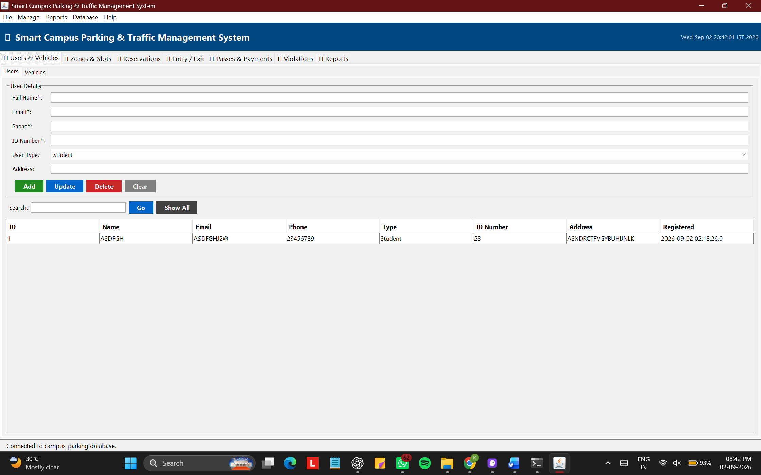
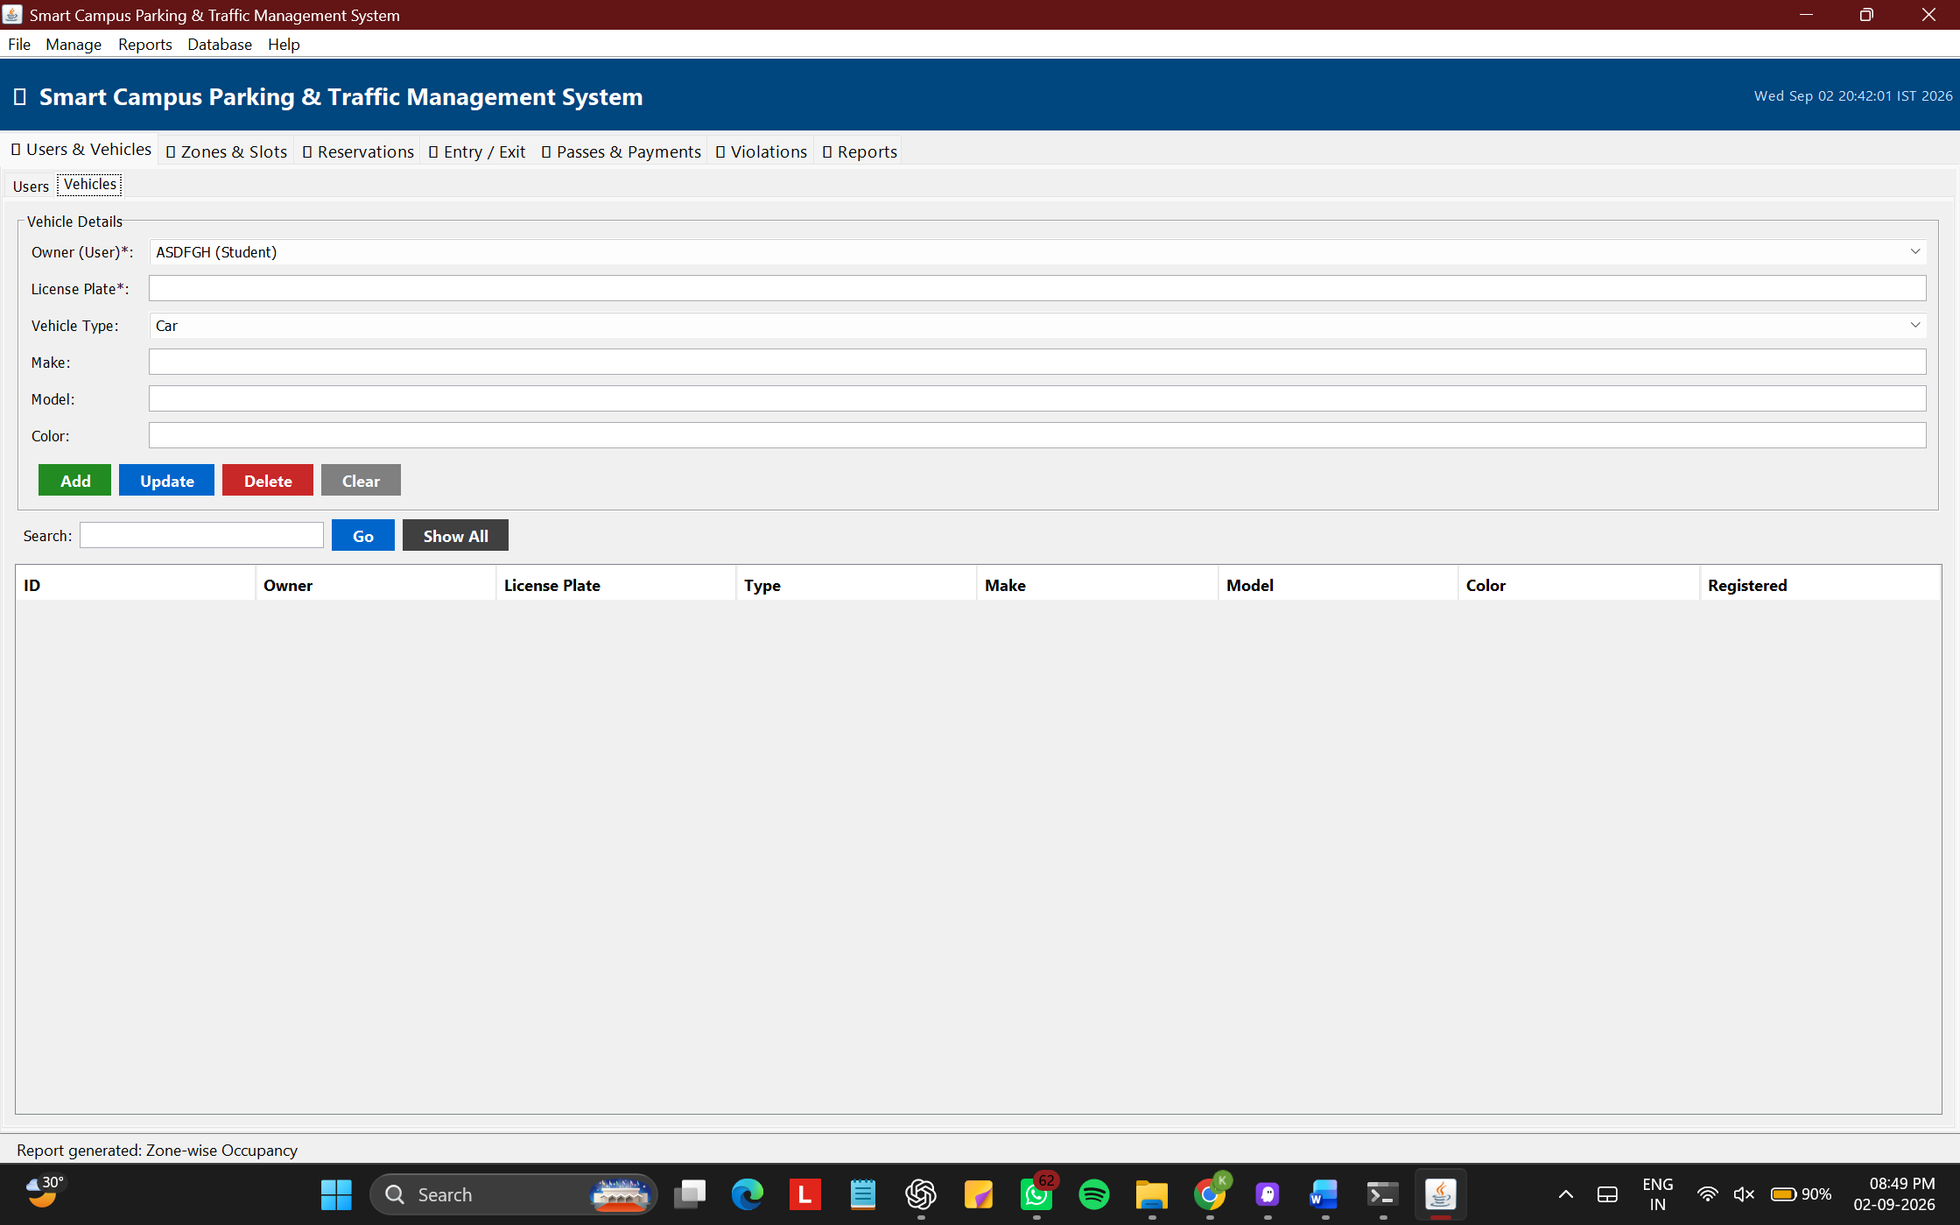

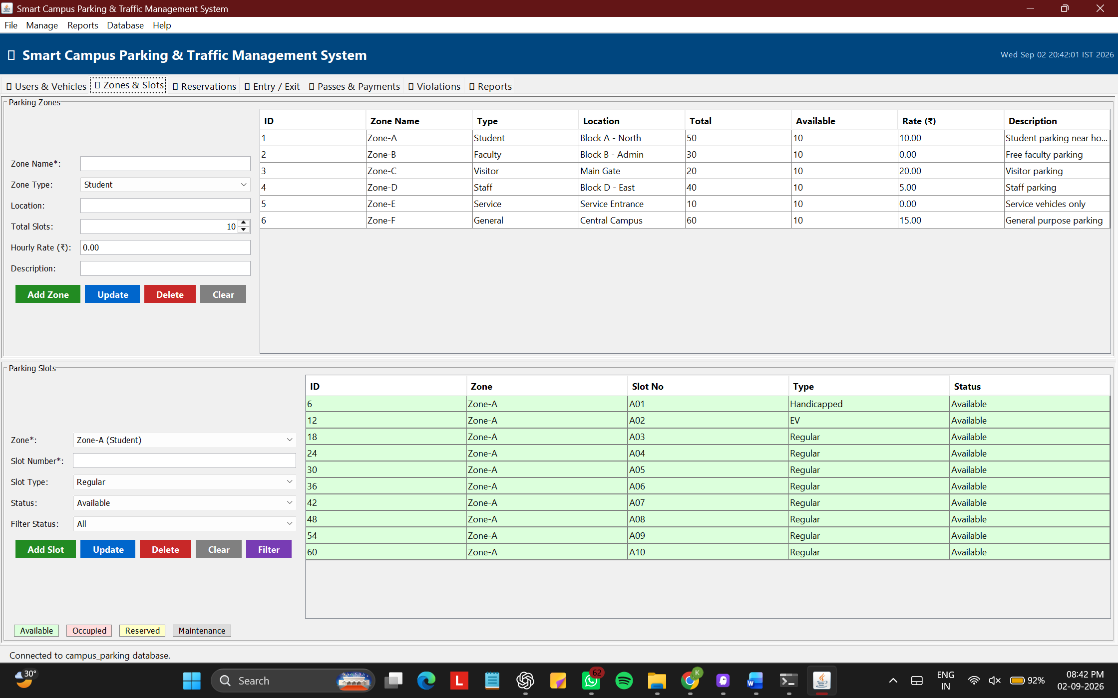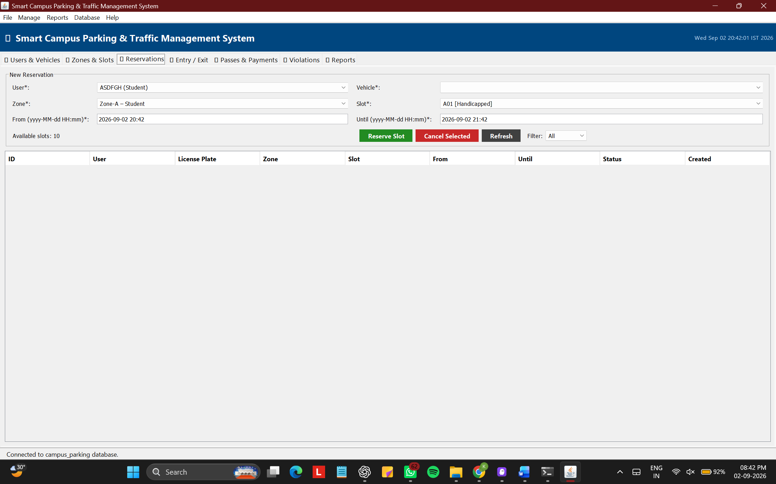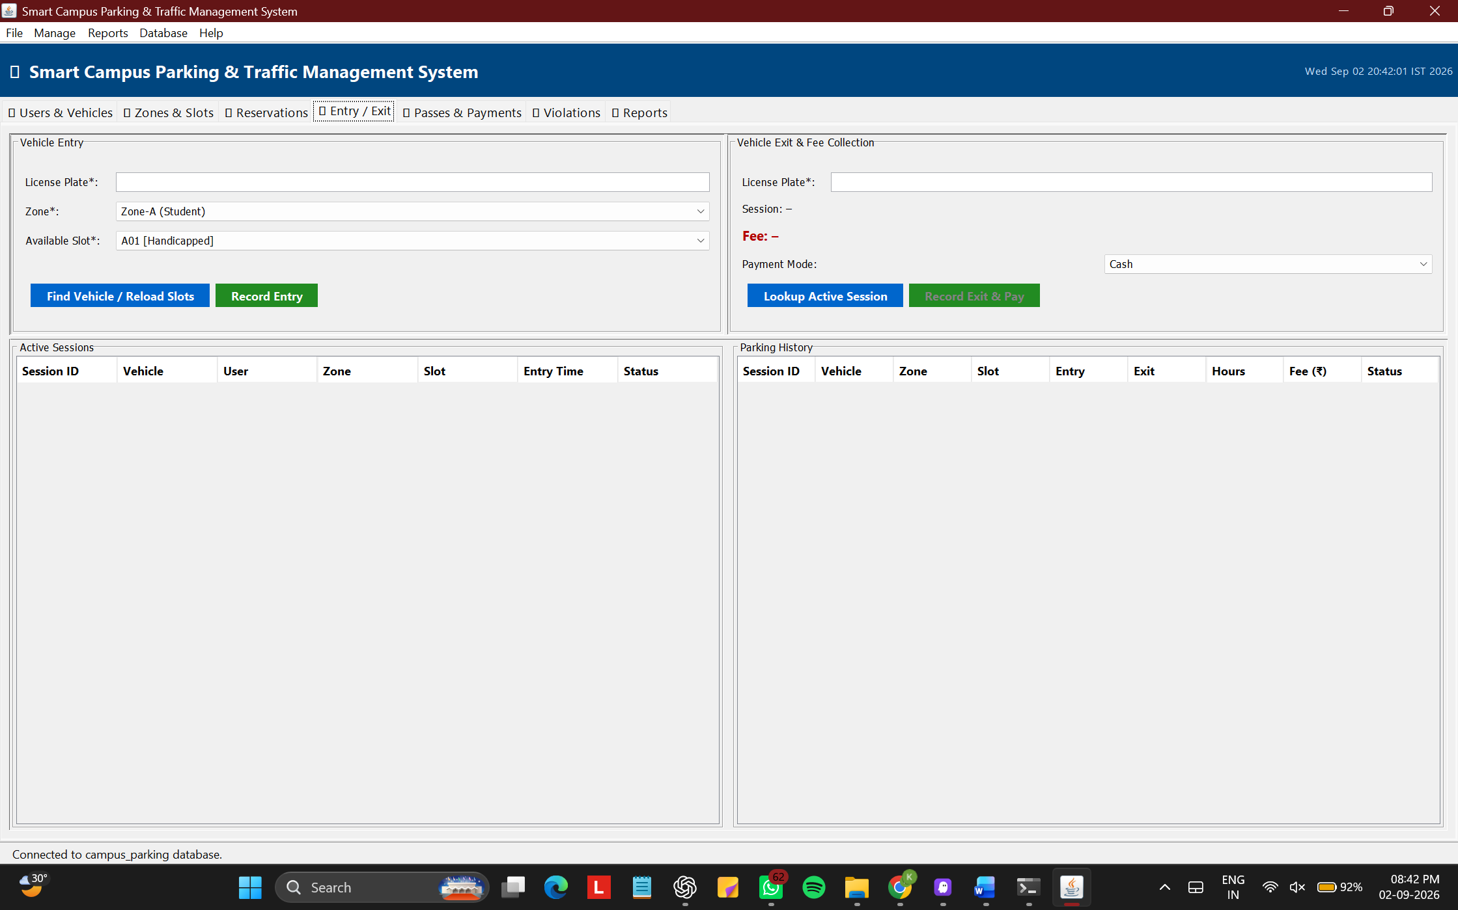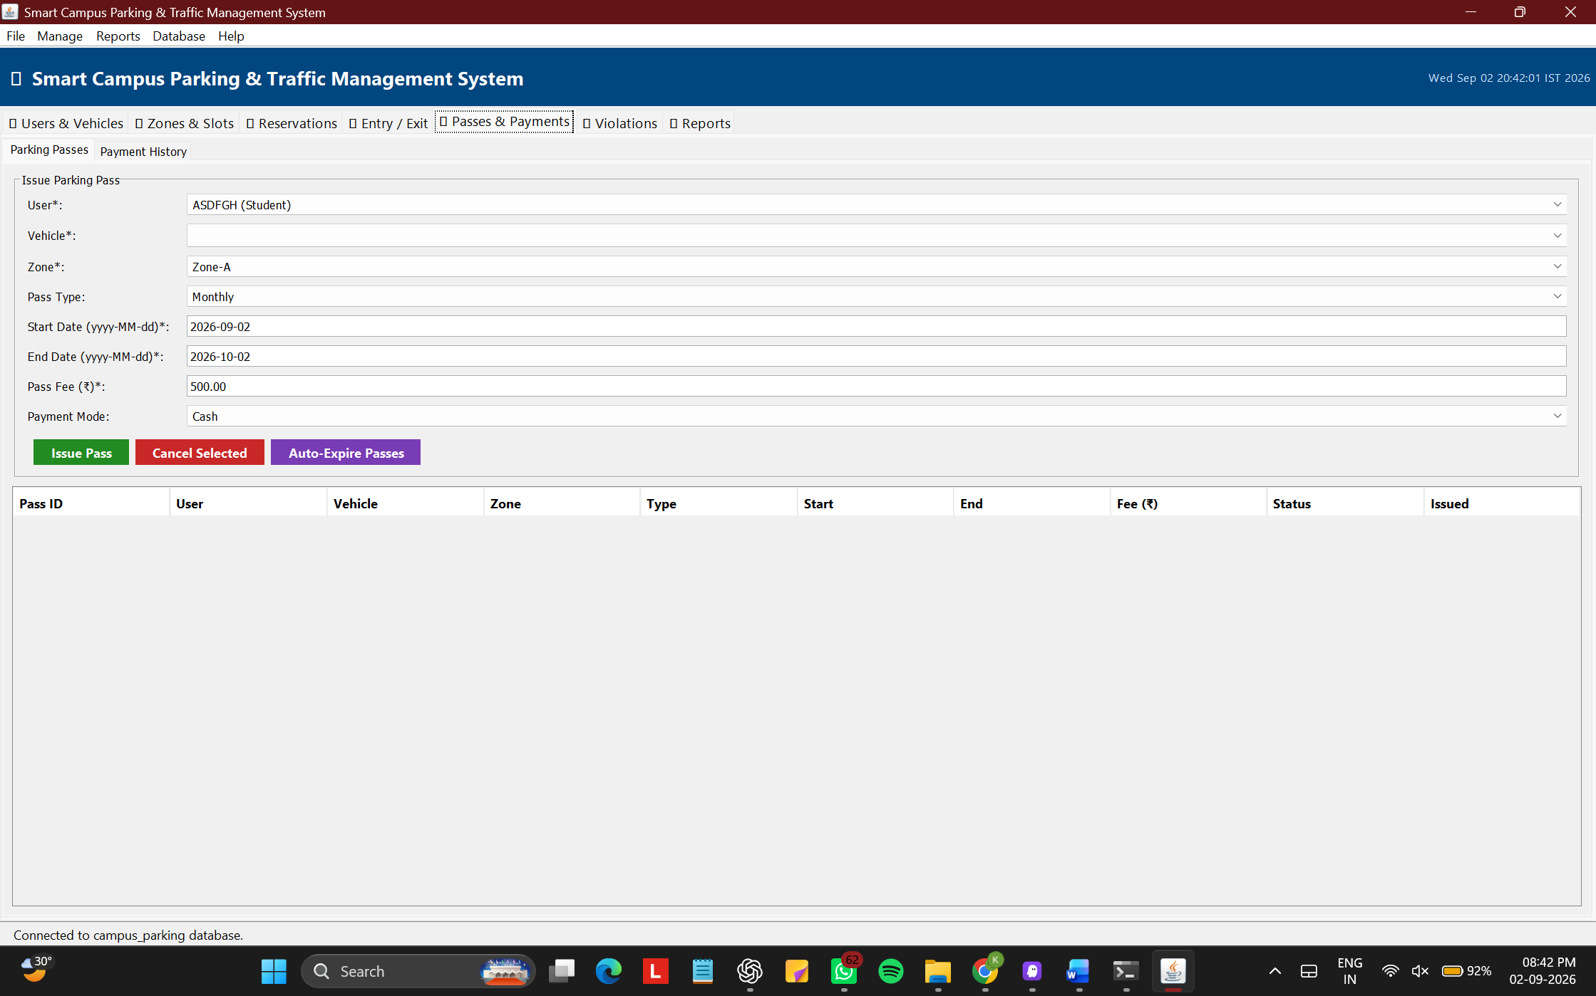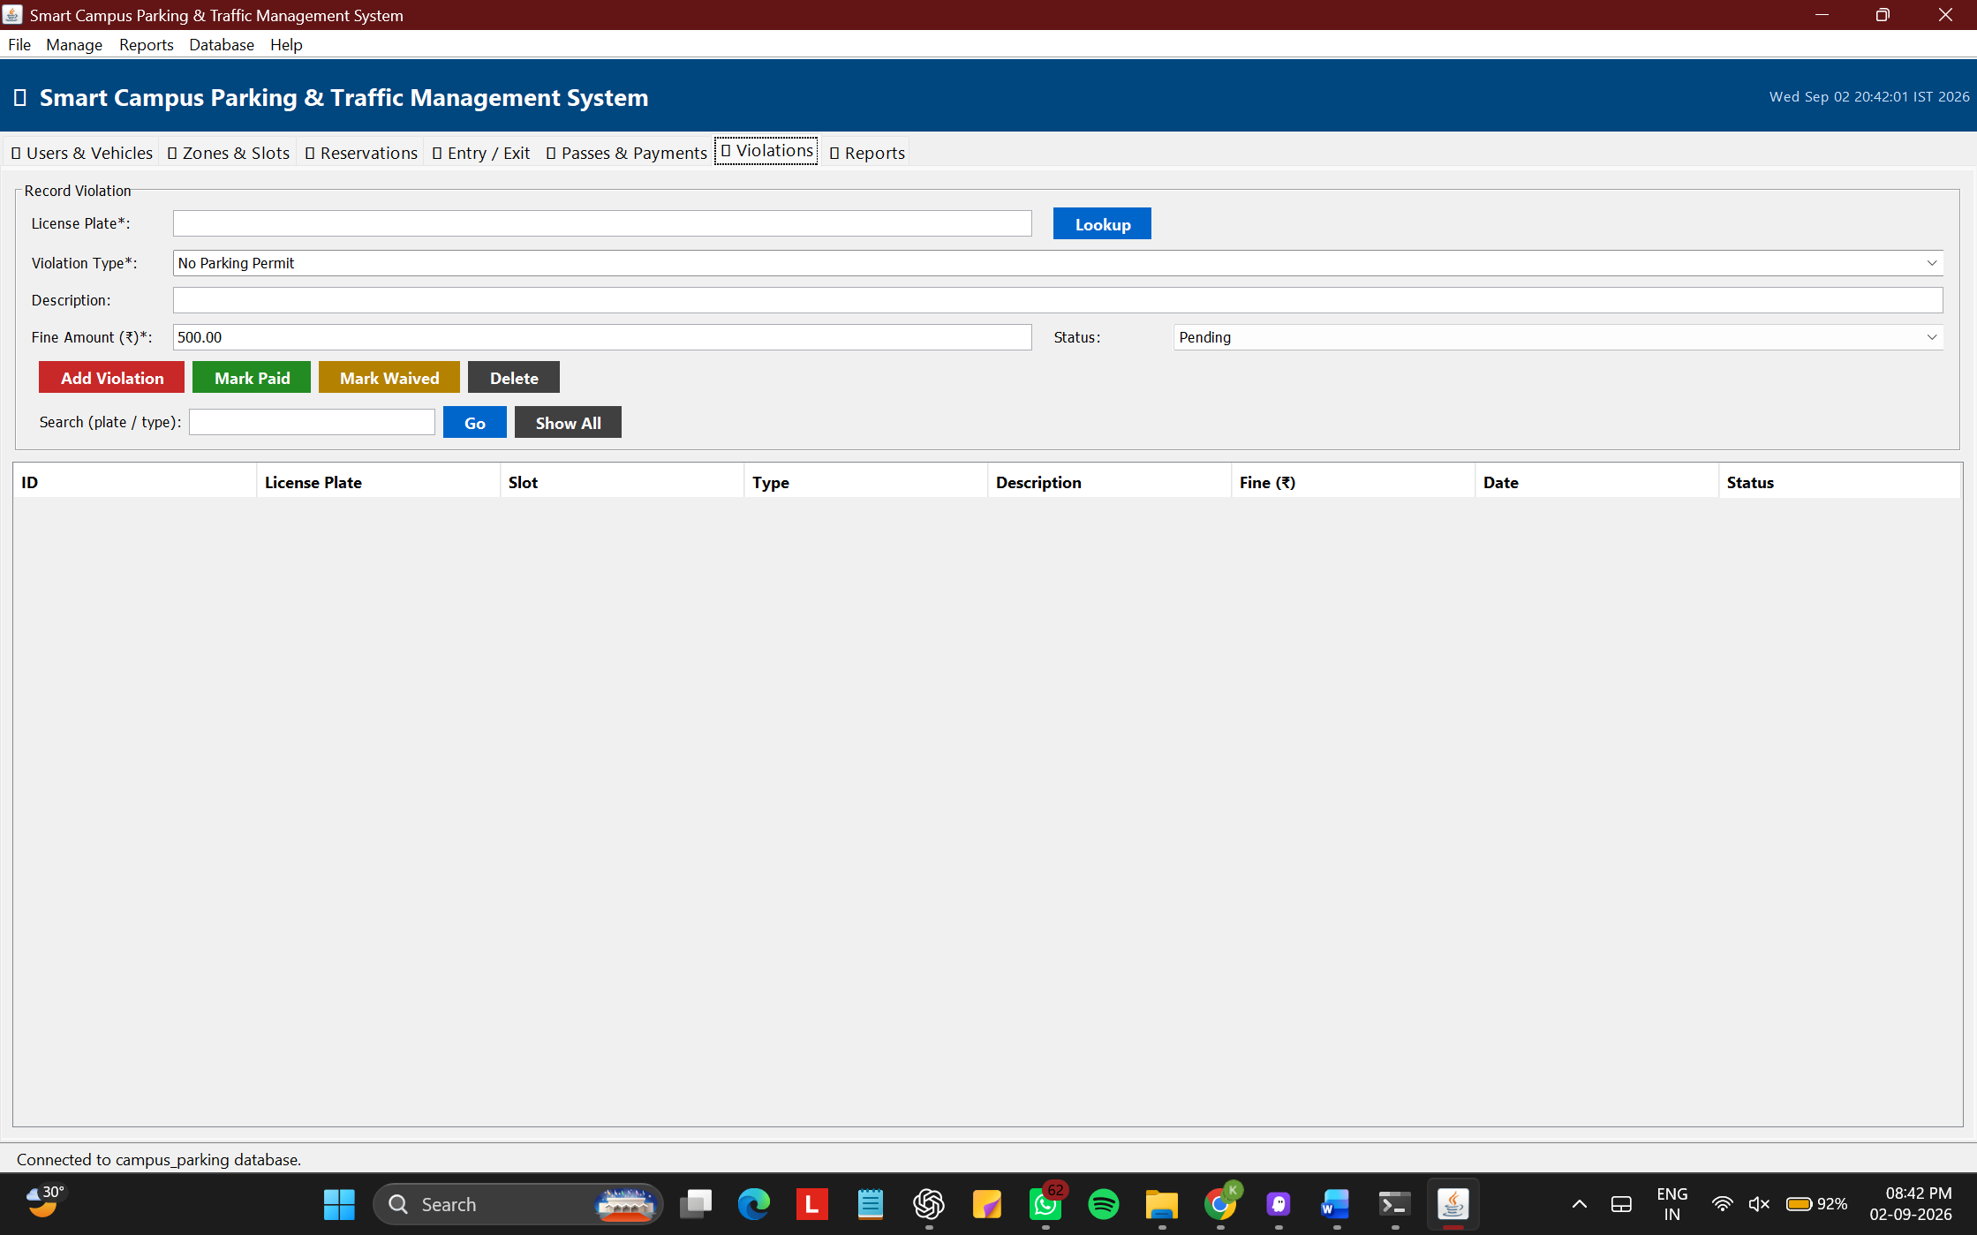

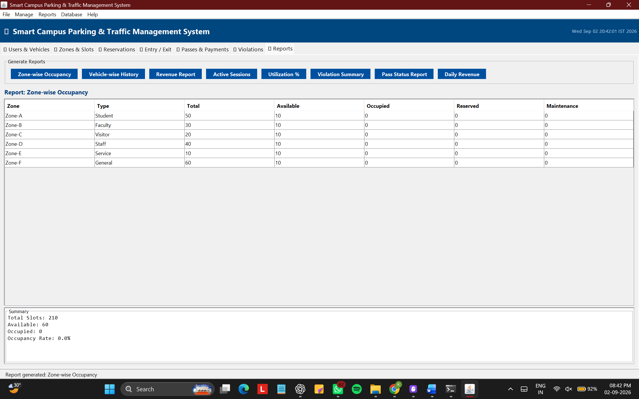

PART 3 – INDIVIDUAL CONTRIBUTION WRITE-UPS
Note: As per submission guidelines, register numbers and names are not included in this document. Each write-up below corresponds to one team member.

Team Member 1 – Database Design, Backend Connectivity and DAO Layer
This assignment involved building a complete Smart Campus Parking and Traffic Management System using Java Swing and JDBC with a MySQL backend. My contribution focused on the database design, JDBC connectivity, and the backend DAO layer of the project.
I designed the relational database schema with nine tables — users, vehicles, parking zones, parking slots, reservations, parking sessions, parking passes, payments, and violations — with all primary key and foreign key relationships carefully defined to maintain referential integrity. I wrote two stored procedures: sp_vehicle_entry, which atomically inserts a session record and marks the slot as Occupied, and sp_vehicle_exit, which calculates the parking fee based on duration and hourly rate and marks the slot as Available on exit.
I implemented the DBConnection singleton class managing the JDBC connection lifecycle, and developed six DAO classes — UserDAO, VehicleDAO, ParkingZoneDAO, ParkingSlotDAO, SessionDAO, and PaymentDAO. In these classes I used three JDBC statement types as required: plain Statement for simple SELECT all queries, PreparedStatement for all parameterized INSERT, UPDATE, DELETE and filtered SELECT operations to prevent SQL injection, and CallableStatement in SessionDAO to invoke the stored procedures with IN and OUT parameters for vehicle entry and exit.
I tested all SQL queries in MySQL Workbench before Java integration, debugged JDBC driver configuration issues, and verified that slot status transitions (Available → Occupied → Available) were atomic. This assignment gave me deep practical knowledge of relational database normalization, JDBC statement types, stored procedure design, and secure database programming.

Team Member 2 – GUI Design, Main Frame, User/Vehicle and Entry/Exit Panels
My contribution focused on designing and implementing the graphical user interface, specifically the MainFrame, UserVehiclePanel, and EntryExitPanel.
I built the MainFrame as the root application window using BorderLayout, with a dark blue header banner, a JTabbedPane containing seven functional tabs, a complete JMenuBar with five menus (File, Manage, Reports, Database, Help) including keyboard mnemonics and accelerators, and a status bar at the bottom. I also implemented the startup database connectivity test that shows a user-friendly warning dialog with fix instructions if MySQL is unavailable.
I developed the UserVehiclePanel with two sub-tabs using GridBagLayout for precise form alignment. The Users sub-tab provides full CRUD — add, update, delete, and search by keyword — with input validation for required fields and email format. The Vehicles sub-tab links vehicles to registered owners via a dynamic JComboBox and validates the license plate uniqueness at the database level. Both tabs use JTable with row selection to pre-populate the edit form.
I built the EntryExitPanel, which is operationally the most critical module. The entry side looks up a vehicle by license plate, loads available slots for the selected zone, checks whether the vehicle is already parked, and invokes the stored procedure via CallableStatement. The exit side looks up the active session by plate, calls the exit stored procedure which calculates the fee, and records the payment automatically. I also implemented the active sessions and parking history tables that update in real time. This work gave me strong practical experience in event-driven Swing programming, layout management, and end-to-end workflow design.

Team Member 3 – Reservations, Passes, Violations, Zone/Slot Panel, Reports and Documentation
My role covered the reservation system, zone and slot management, parking passes, violations, the reporting module, and the project documentation.
I built the ZoneSlotPanel using a JSplitPane with GridBagLayout forms. The slot table uses a custom prepareRenderer to colour-code rows — green for Available, red for Occupied, yellow for Reserved, and grey for Maintenance — giving operators an immediate visual overview. I developed ParkingZoneDAO and ParkingSlotDAO including the getAvailableSlots and getSlotsByStatus methods used across multiple panels.
I developed the ReservationPanel with datetime validation, dynamic slot loading based on the selected zone, and conflict detection. The ReservationDAO uses a PreparedStatement overlap query to prevent double-booking on the same slot within the same time window, and immediately updates the slot status to Reserved on success. I built the PassPaymentPanel with auto end-date calculation using Java LocalDate — Monthly adds one month, Semester six months, Annual one year — and a payment history sub-tab. Each pass issuance triggers an automatic payment record linked via foreign key.
For violations, I implemented the ViolationPanel with record creation, status updates (Paid/Waived), deletion, and keyword search, with colour-coded table rows by status. I developed the ReportsPanel with eight report types — zone occupancy, vehicle history, revenue, active sessions, utilisation percentage, violation summary, pass status, and daily revenue — using complex SQL with GROUP BY, CASE expressions, subqueries, and aggregates.
Finally, I handled all project documentation: the pseudocode for all eleven modules, the README setup guide, the GitHub repository structure, and this submission document. I also performed integration testing, identifying and fixing the JComboBox type mismatch compilation error and the Windows button rendering issue. This project significantly strengthened my skills in analytical SQL, Swing custom rendering, and full-stack Java application development.

SDG RELEVANCE

SDG 9 – Industry, Innovation and Infrastructure
The system digitises and automates manual parking management on a university campus, replacing paper-based methods with a structured, database-driven Java application. This directly contributes to building resilient and innovative campus infrastructure.

SDG 11 – Sustainable Cities and Communities
By providing real-time slot availability, reservation management, and utilisation reports, the system reduces vehicle congestion within the campus. Drivers no longer circle looking for parking, reducing fuel consumption and improving the campus environment.

SDG 13 – Climate Action
The system includes dedicated EV (Electric Vehicle) slot types within the parking infrastructure. By tracking and prioritising EV slots, the system encourages adoption of electric vehicles on campus, contributing to reduced carbon emissions.

