IN PUT side:
Input file I have 2 column, first column is the FSN and second column is the Link,
Example = FSN, Link

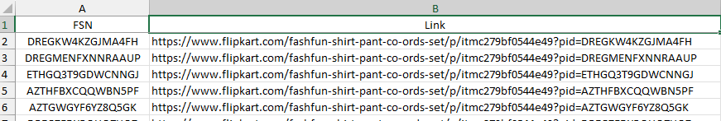

Out PUT side:
Output side, I want to fill 3 columns against in FSN:
Need to take Input on below location
Input file location: D:\KAPIL\BIA\Data scraping\V\Input.xlsx

Need to save out put on below location
Location : Output file location : D:\KAPIL\BIA\Data scraping\V
1 FSN
2 Average RATING
3 RATING
4 REVIEWS

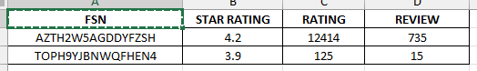

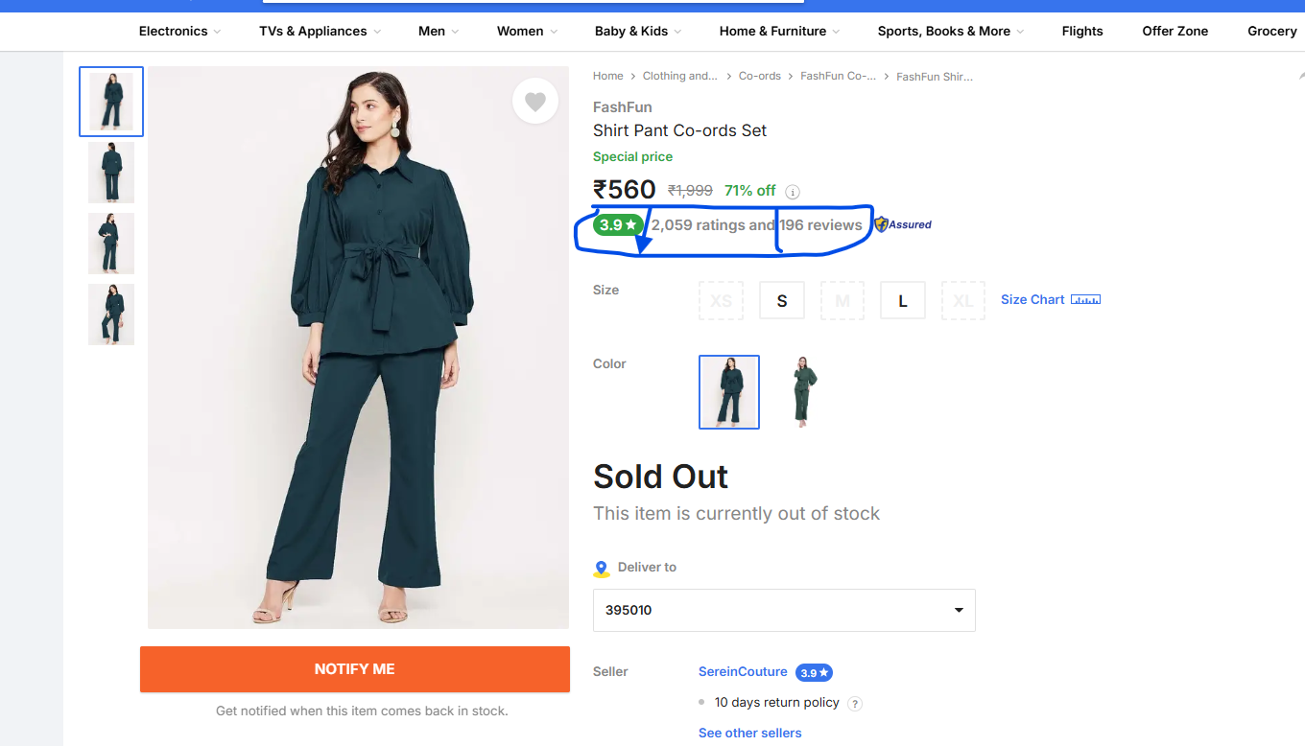

I have also Use screen shot and excel sheet for your references .
Please use the below python library for data scrapping.
Use below library
Scrapy, Web driver, soup, selenium, google web driver, playwright, puppeteer, pandas, requests, zenrows

