# İnstall gstreamer

sudo apt-get update

sudo apt-get upgrade

sudo apt-get install gstreamer1.0-tools

sudo apt-get install gstreamer1.0-plugins-good

sudo apt-get install gstreamer1.0-plugins-bad

sudo apt-get install gstreamer1.0-plugins-ugly

sudo apt-get install libglib2.0-dev

sudo apt-get install libgstreamer1.0-dev

sudo apt-get install libgstreamer-plugins-base1.0-dev

# install numpy

pip/pip3 install numpy

# Clone OpenCV repo

git clone <https://github.com/opencv/opencv.git>  
cd opencv/  
git checkout 4.1.0

# Building

mkdir build  
cd build

cmake -D CMAKE_BUILD_TYPE=RELEASE \

-D INSTALL_PYTHON_EXAMPLES=ON \

-D INSTALL_C_EXAMPLES=OFF \

-D PYTHON_EXECUTABLE=$(which python3) \

-D BUILD_opencv_python2=OFF \

-D CMAKE_INSTALL_PREFIX=$(python3 -c "import sys; print(sys.prefix)") \

-D PYTHON3_EXECUTABLE=$(which python3) \

-D PYTHON3_INCLUDE_DIR=$(python3 -c "from distutils.sysconfig import get_python_inc; print(get_python_inc())") \

-D PYTHON3_PACKAGES_PATH=$(python3 -c "from distutils.sysconfig import get_python_lib; print(get_python_lib())") \

-D WITH_GSTREAMER=ON \

-D BUILD_EXAMPLES=ON ..

# 6. Check your log

✔ check if it has Python 3: section and all interpreter and path are right.  
(If they aren’t there, check the numpy package)

✔ check the GStreamer section.  
(If they aren’t say YES, go check GStreamer lib package)

if something went wrong just remove build folder and try again.

metin içeren bir resim

Açıklama otomatik olarak oluşturuldu

metin içeren bir resim

Açıklama otomatik olarak oluşturuldu

# 7. Building

sudo make -j$(nproc)

# Install package

sudo make install  
sudo ldconfig

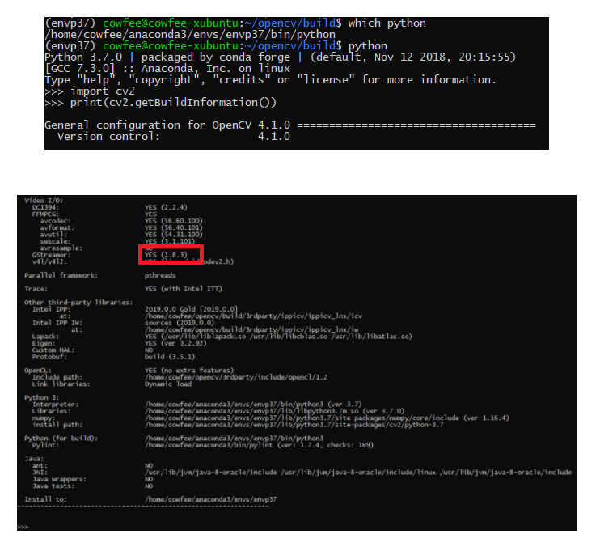

# Using

This is my Gstreamer pipeline SEND script line:

gst-launch-1.0 -v v4l2src ! video/x-raw,width=320,height=240 ! videoconvert ! jpegenc ! rtpjpegpay ! udpsink host=192.168.1.101 port=5200

This is my Gstreamer pipeline RECEIVER script line:

gst-launch-1.0 -v udpsrc port=5200 ! application/x-rtp, encoding-name=JPEG,payload=26 ! rtpjpegdepay ! jpegdec ! videoconvert ! autovideosink

# opencv capture using

"udpsrc port=5000 ! application/x-rtp,media=video,payload=26,clock-rate=90000,encoding-name=JPEG,framerate=30/1 ! rtpjpegdepay ! jpegdec ! videoconvert ! appsink",cv2.CAP_GSTREAMER

# Link

<https://github.com/PhysicsX/Gstreamer-on-embedded-devices>

<https://galaktyk.medium.com/how-to-build-opencv-with-gstreamer-b11668fa09c>

<https://answers.opencv.org/question/202017/how-to-use-gstreamer-pipeline-in-opencv/>