**Set up Commands for Apache, Mysql, php**

**For Apache2 Installation**

**For installing Apache on Ubuntu environment this command is used**

**:~ $ sudo apt install apache2**

confirming that the **Apache2** service is up and enabled by following commands:

**:~ $ sudo systemctl status apache2**

**:~ $ sudo systemctl is_enabled apache2**

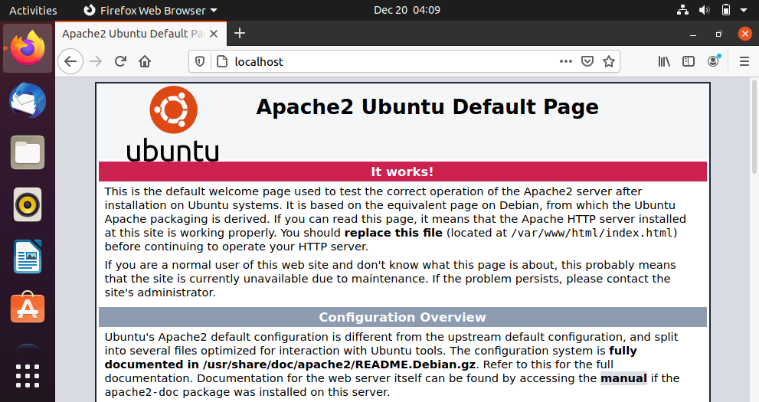

**For Php Installation**

**To install Php following command is used**

**:~ $ sudo apt install php libapache2-mod-php php-mysql**

To install PHP extensions we run following command

**:~ $ apt-cache search php |grep php-**

**THEN RESTART APACHE2**

Create an **info.php** page under the web document root **/var/www/html/** directory

**:~ $ vi /var/www/html/info.php**

Write the following code and open the file on the browser with following address.***http://YOUR_SERVER_IP/info.php***

*<?php*

*Phpinfo();*

*?>*

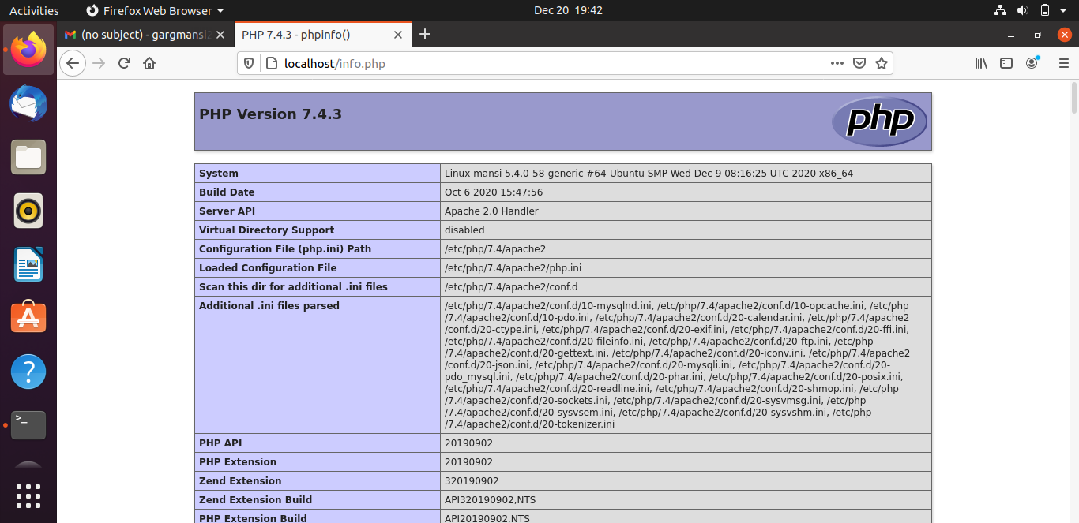

**For Mysql Installation**

**To install Mysql update the package index on server**

**:~ $ sudo apt update**

**Then install the mysql-server package:**

**:~$ sudo apt install mysql-server**

**Run the security script with sudo:**

**:~$ sudo mysql_secure_installation**

**For installing Mysql on Ubuntu environment this command is used**

**:~$ sudo mysql**