DNS:
# dnf install bind bind-utils -y
# nmtui
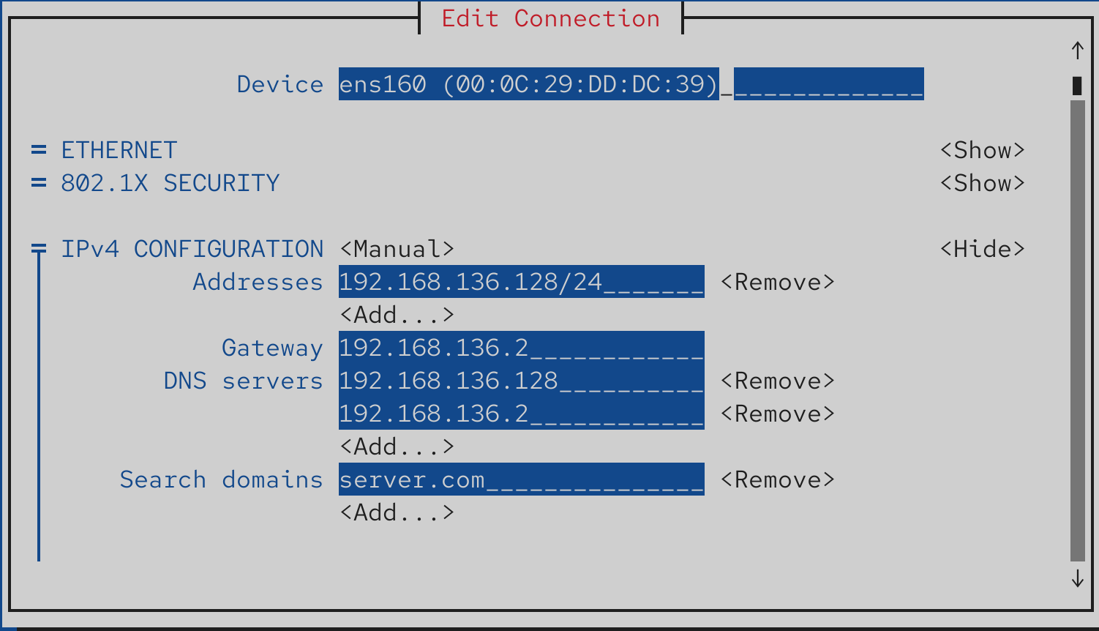
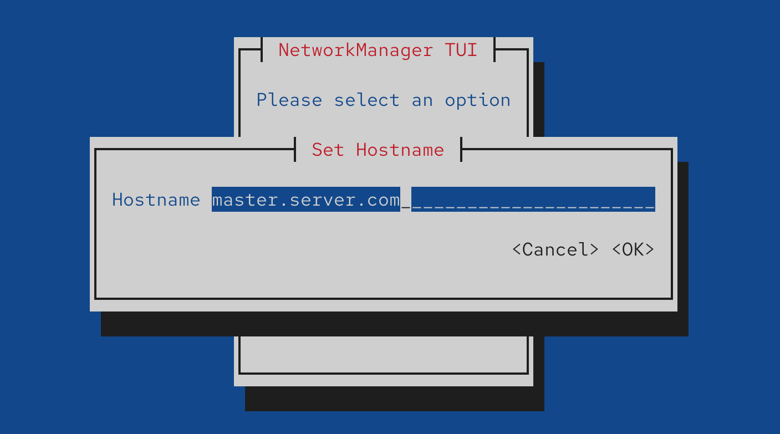
Activate Deactivate
# vim /etc/named.conf
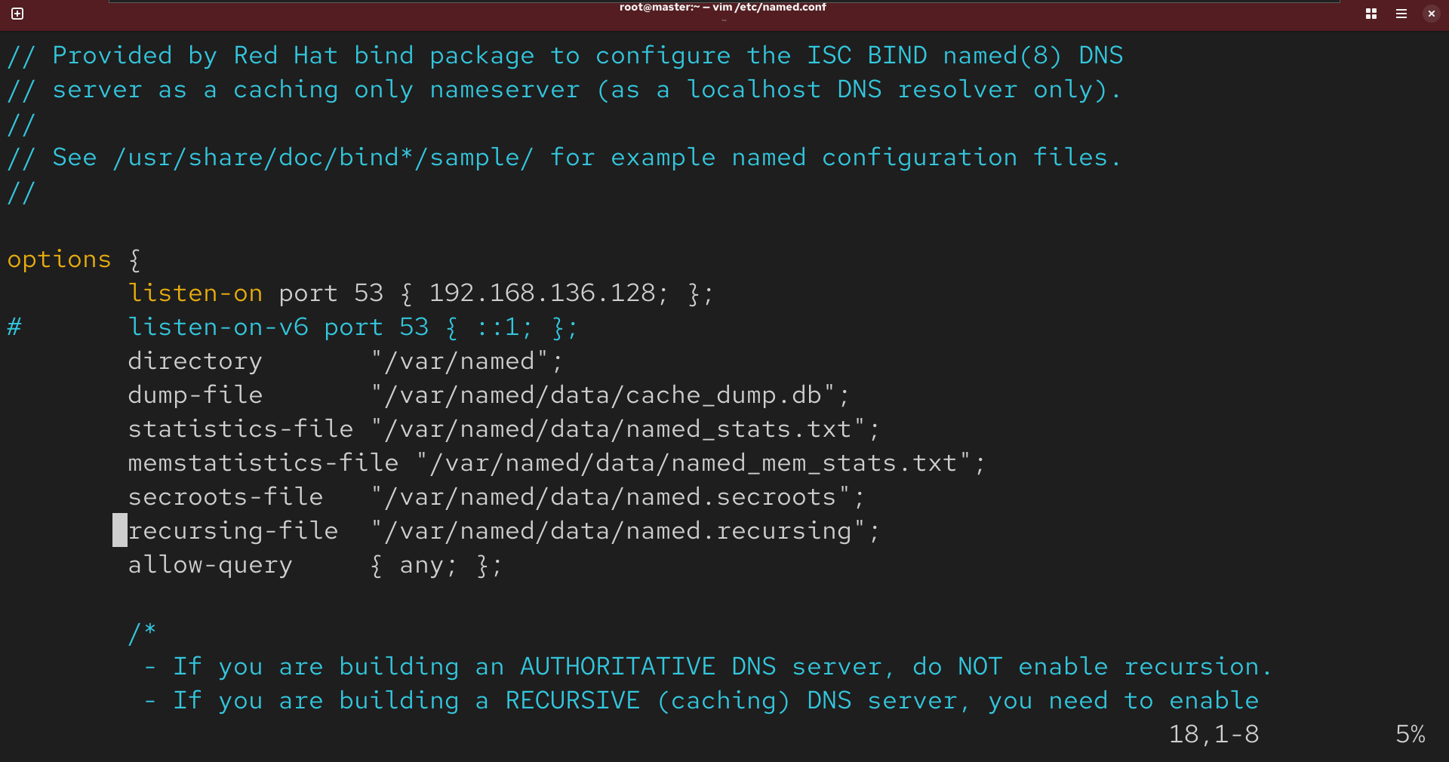
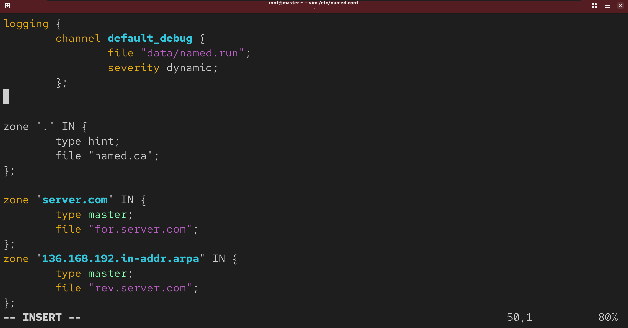
# cd /var/named
# ls
You will see other forward reverse zone files here
# cp named.localhost for.server.com
# vim for.server.com
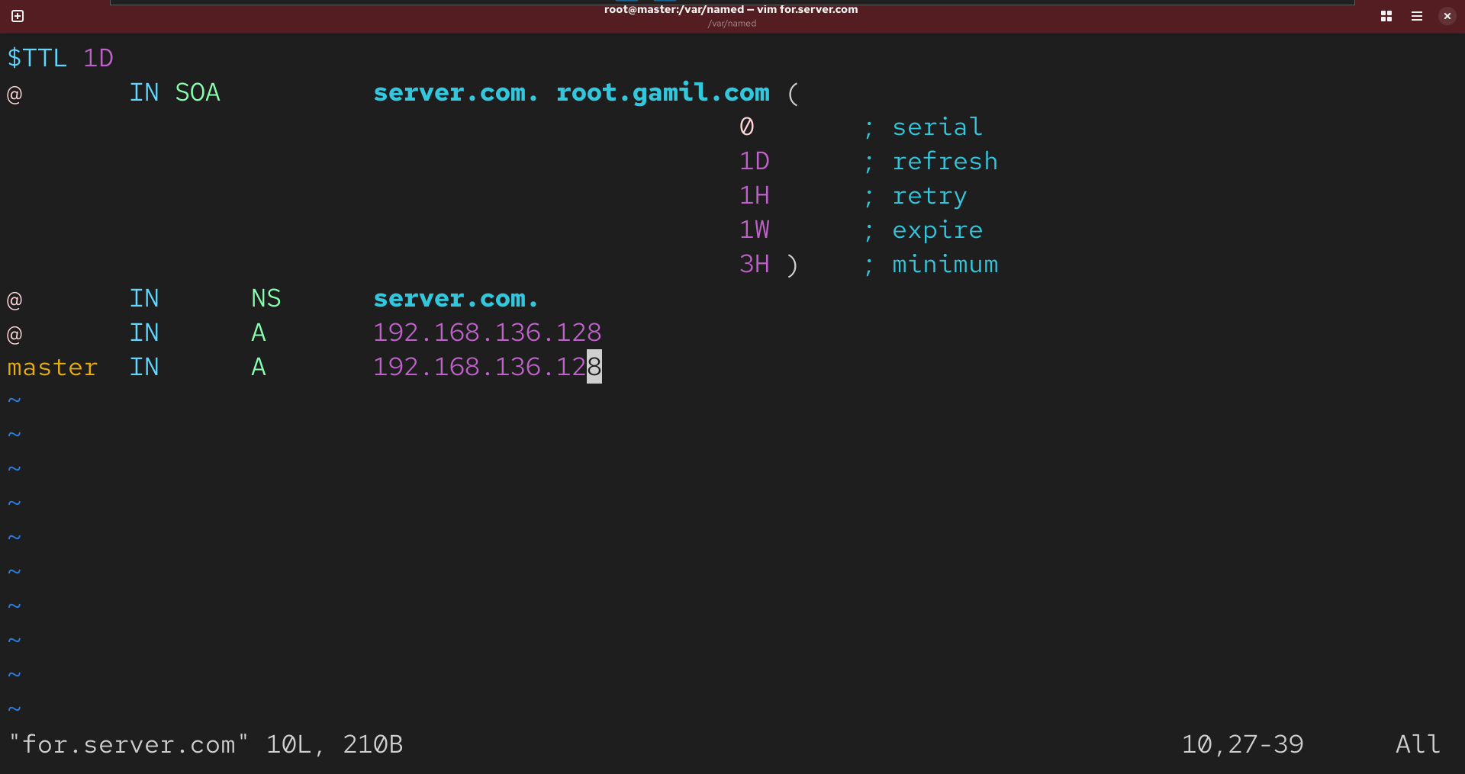
# cp for.server.com rev.server.com
# vim rev.server.com
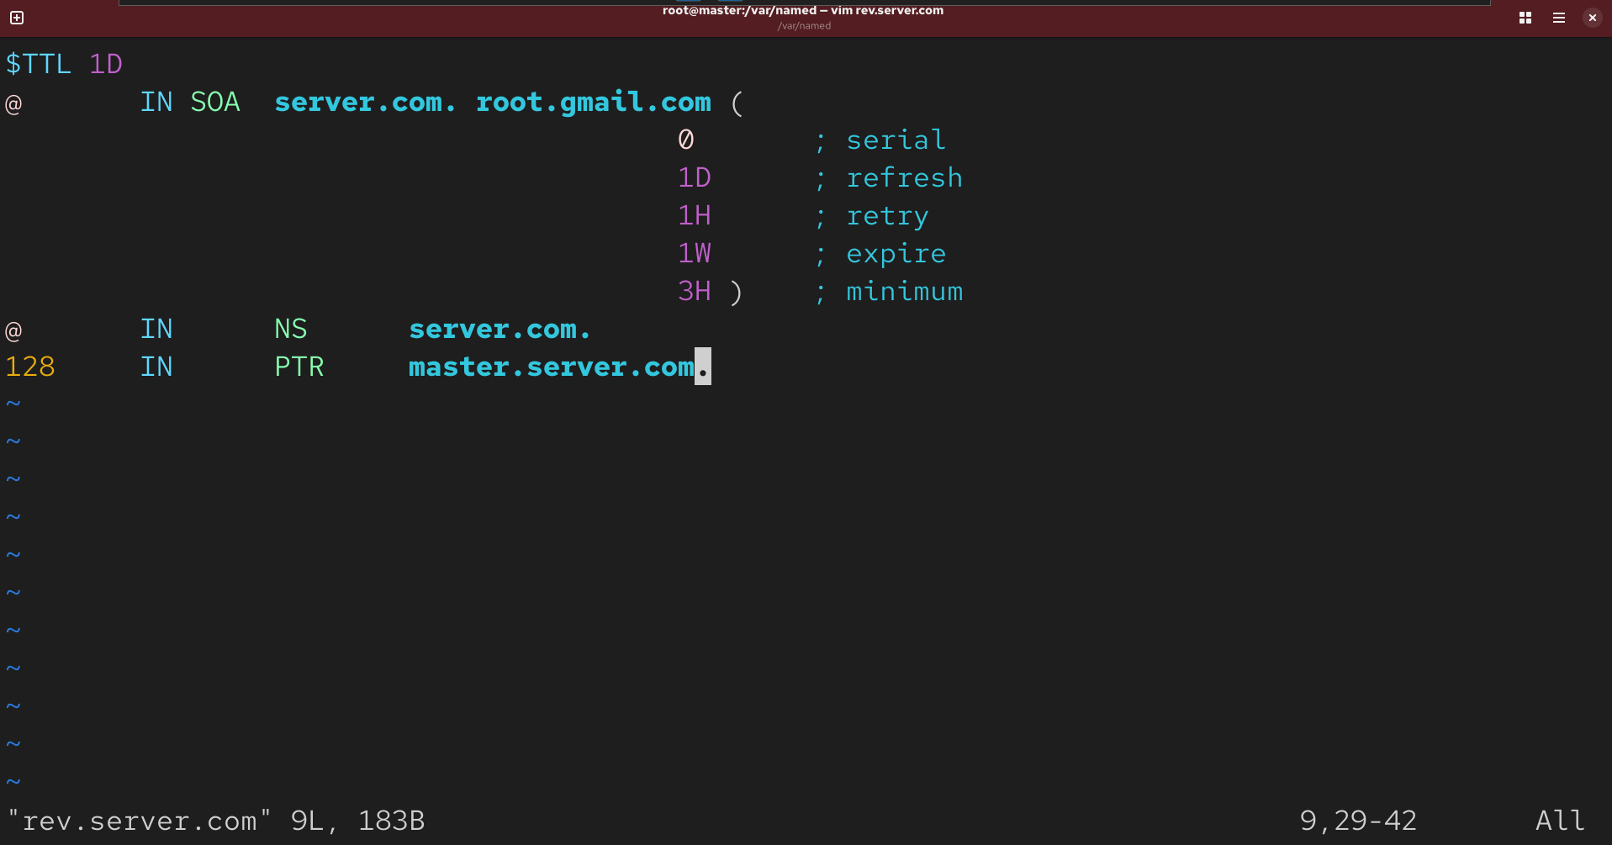
# Systemctl restart named
# systemctl enable named
# host -t a server.com
# host -t a master
# host -t a 192.168.136.128
# firewall-cmd --zone=public --add-service=dns --permanent
# firewall-cmd --reload
Apache:
# dnf install httpd -y
# firewall-cmd --zone=public --add-service=http --permanent
# firewall-cmd --reload
# systemctl restart httpd
# systemctl enable httpd
# vim /etc/named.conf
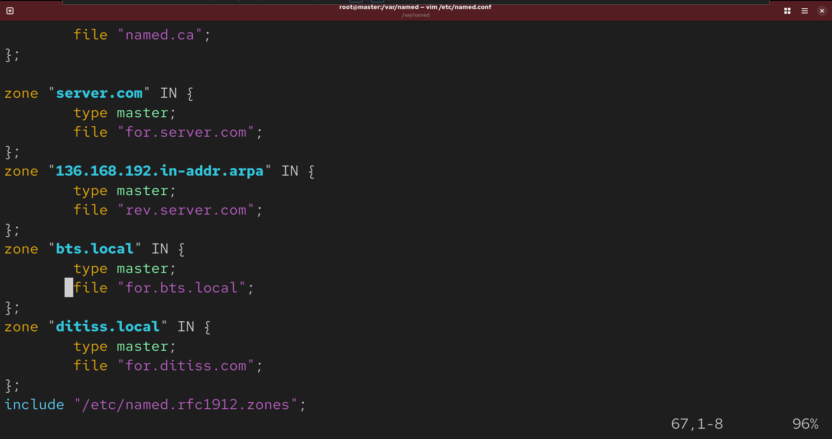
# cp for.server.com for.bts.local
# vim /var/named/for.bts.local
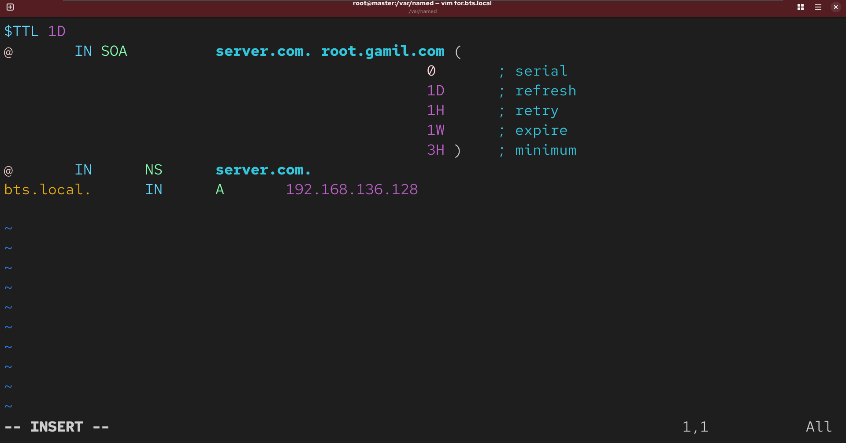
# cp for.server.com for.ditiss.com
# vim /var/named/for.ditiss.com
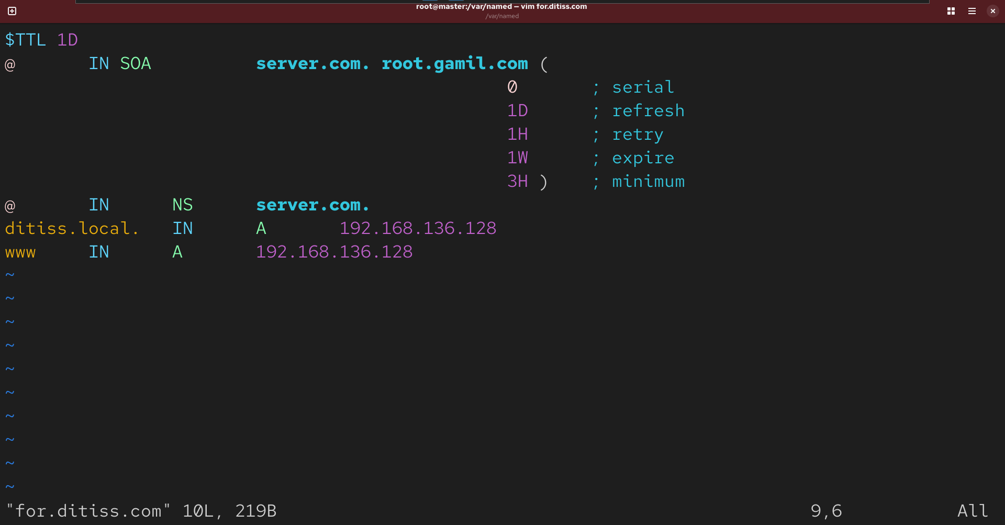
# systemctl restart named
# mkdir -p /var/www/server.com
# mkdir -p /var/www/bts.local
# mkdir -p /var/www/ditiss.com
# Cd /var/www/server.com
# cat>index.html
<h1>this is server</h1>
# Cd /var/www/bts.local
# cat>index.html
<h1>this is bts</h1>
# Cd /var/www/ditiss.com
# cat>index.html
<h1>this is ditiss</h1>
# chown -R apache:apache /var/www/
# chmod -R 755 /var/www
# vim /etc/httpd/conf.d/vhosts.conf
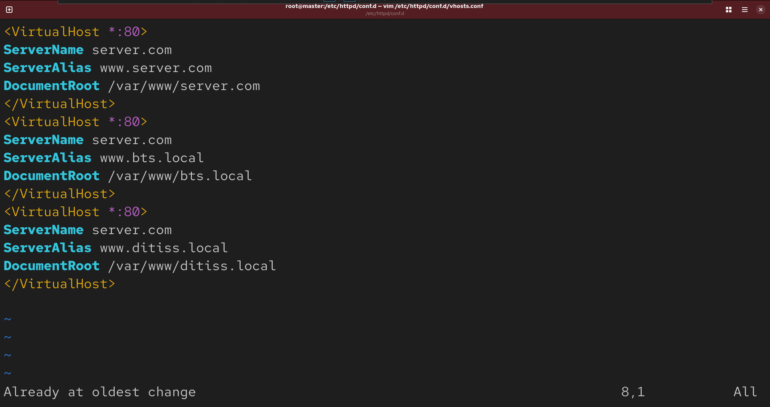
# systemctl restart httpd
Verity it on browser http://master.server.com http://bts.local http://ditiss.com

