远程科研报告

王子谦

2019.1.5

**Background**

Chatbot is an assistant that communicates with us through text messages, a virtual companion that integrates into websites, applications or instant messengers and helps many companies to get closer to customers. No one can deny that chatbot is important component of Artificial Intelligence. Chat robot have a long history of researches, for example,IBM have developed and refined their Waston Chatbot to deal with questions of different areas, from education to health. Recently, with deep learning becoming more popular,Natural Language Processing also created many state-of-art chatbot application. But we have to come to terms with the fact that all of those technology about Chatbot are still in nascent phase. If we want to make more progress in this area, we should start from scratch, firstly analyse basic problems which Chatbot should deal with.

The firstly question is about intention recognition because the chatbot should accurately respond to what user want to know. In this course, Professor Zhang taught some techniques such as Regular Expression to distinct some simple text pattern. We also exposed ourselves with some useful advanced machine learning knowledge such as KNN or SVM to distinct intention of the question.

And the second problem is about entity recognition. Based on knowing meaning of the question, chatbot need to search concrete information by identifying tags/entities such as people or locations in sentences. As a student who major in Software Engineering, knowing database is a must for me. And professor also mentioned some SQL languages which can query structured data. However, the textual sentence is unstructured data and we should transform it. So Professor Zhang taught us a useful Python library- Spacy in this course to solve this problem.

The third key problem is about understanding the context. In order to fulfill several rounds of multiple queries,The chatbot need to keep track of previous information to answer the question.In this course, We mainly analyzed how to respond questions about denial intention, and Professor Zhang also taught us finite state machine to help chatbot switch among different kind of questions.

In the end, to augment the chatbot, we also dipped into some other areas such as speech recognition and translation technology. With translation technology, we hope our chatbot can adapt to different languages from Chinese to English. With speech recognition, we hope bots can become more user friendly, and use of that technology also popular trend of robotics application because some Chinese AI compaines like iFlytek also tackle on problems about it.

**Process and resolution**

**RASA** is a very useful tool, and we can use it to construct more robust chatbot more quickly compared with pure NLP technology, such as seq2seq or attention model. So in the end, we used **RASA NLU** to fulfill basic intention recognition and entity extraction, and we used **RASA CORE** to fulfill dialogue management. And finally we deploy the whole framework to social media software like **Wechat** to realize more real and convenient human-machine interaction.

We Choose movie information query as main QA domain of our chatbot. Unlike some software like Doubai or IMDb, the user just need to input whole sentences to get information they want.

1. **design and recognition of intentions and entity about movie information query**

We define 10 kind frequent intention as follow

- greet - thank

- ask_now_playing_movies(ask bot what movie is on in the cinema)

- ask_movie_information(ask bot type and overview of the movie )

- ask_movie_rating(ask bot the rating of the movie)

- ask_movie_stars(ask bot cast of the movie)

- ask_star_movies(ask famous movie of the star)

- dislike_movie(express dislike to the movie)

- like_movie(express great interest to the movie)

- ask_related_recommendation(ask related or similar other movies with the movie)

And we design concrete question data in nlu.json, the pattern is showed as followed

{ "text":"I want to ask information about Interstellar",

"intent":"ask_movie_information",

"entities":[ { "start":32, "end": 44, "value":"Interstellar", "entity":"movie"}]},

And we also define pipelines for RASA NLU, it’s configuration of libraries, for example, we can use ner_synonyms to better recognize synonyms in difference sentences of same intention.

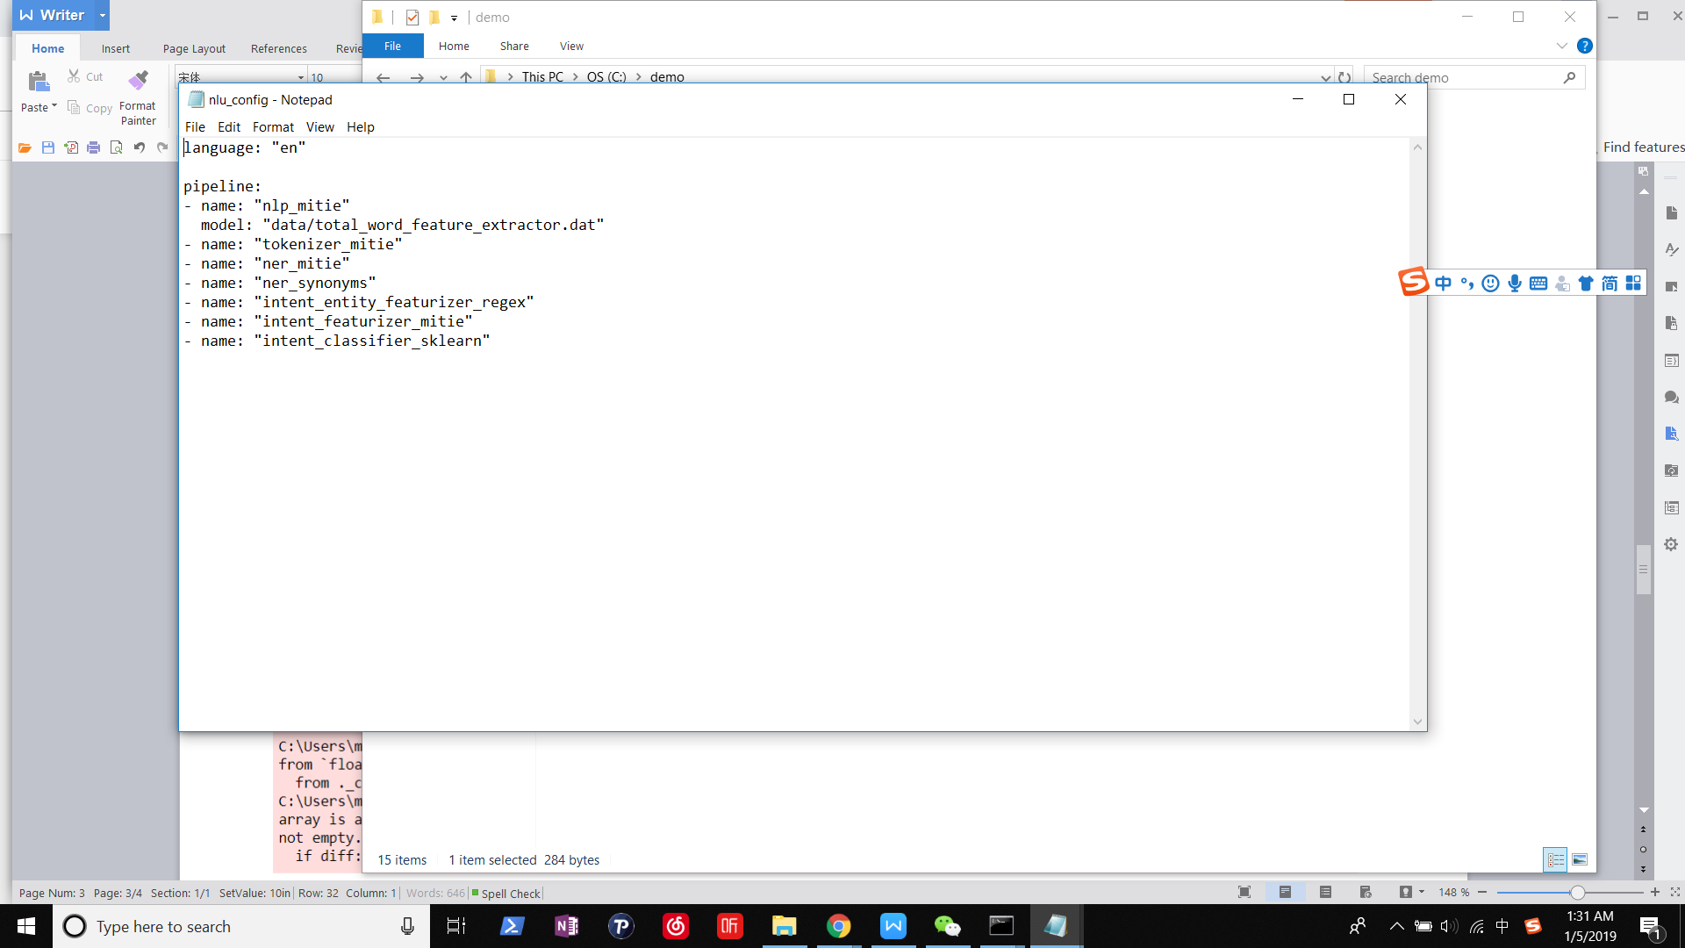

Now, we can use train RASA NLU with those JSON data using libraries in pipelines, and get temporary results of intention recognition and entity extraction.

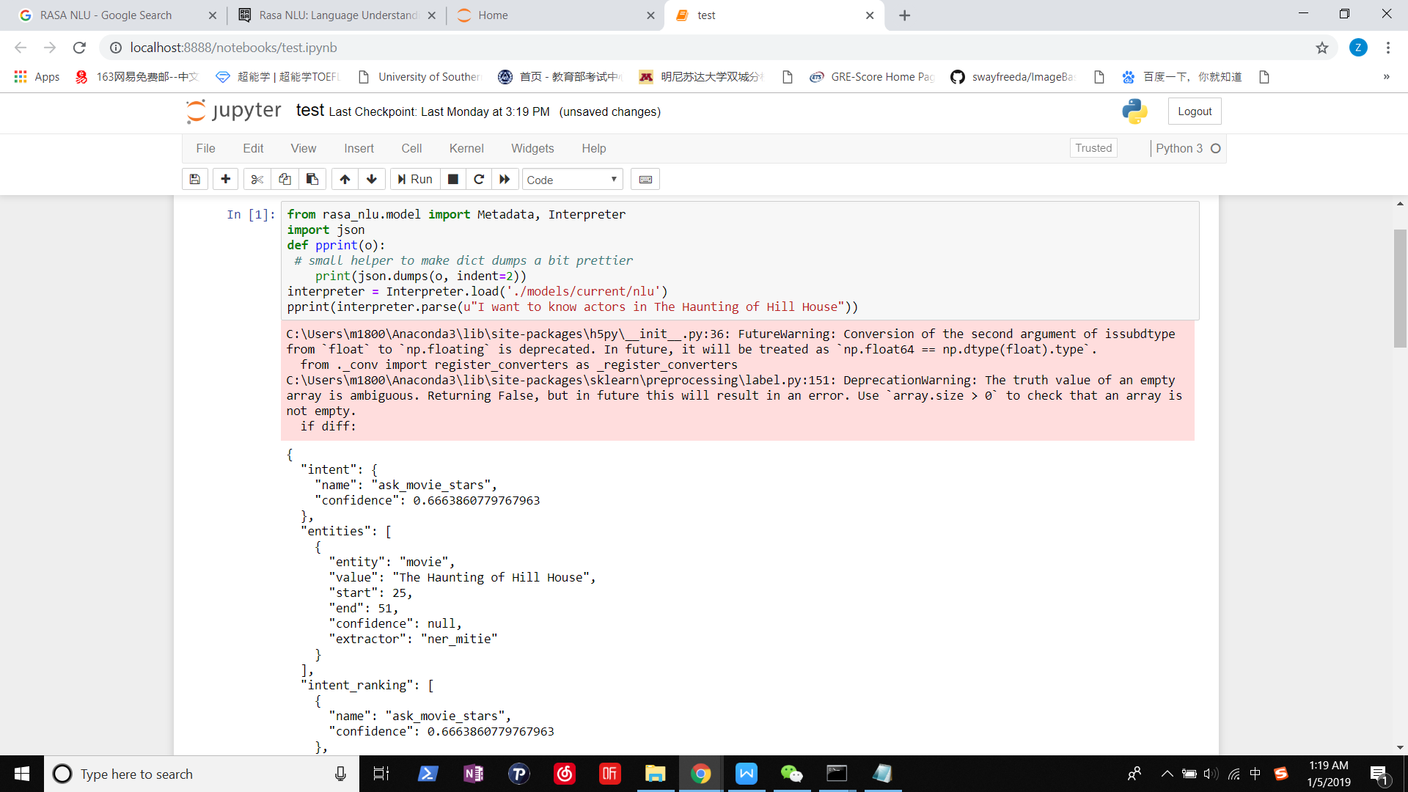

**2.design of answers with querying API**

Based on known questions with their entity and intention, we need to design corresponding problems. In this project, I use TMDbs to query information.



We can search information about films about stars in this API, we can use python to request JSON data in this API and clean data to return desired results.

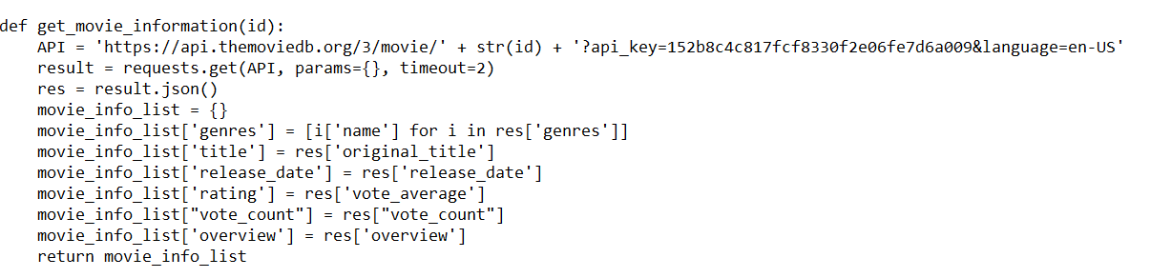

In file domain.yml, we list all intents,entities actions which will be used latter, we have to noted there that **Action** is concrete answers to different kinds of specific question. We define all Actions in action.py. Those functions in this files encapsulate returned API data, and finally return whole textual sentences. For example, the *ActionMovieRating* as follow defines answer to ask_movie_rating, and those action also can keep track of entities in context, for example, if I ask “I want to know the rating of this movie”, the Action will fetch value in “movie” slot which is identified and stored in previous Q&A process.

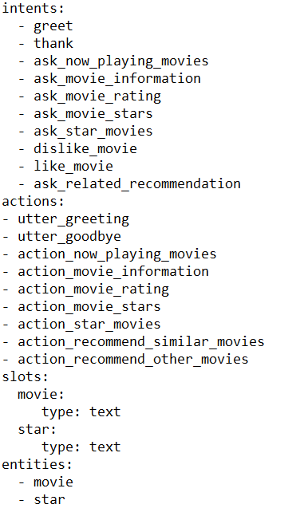

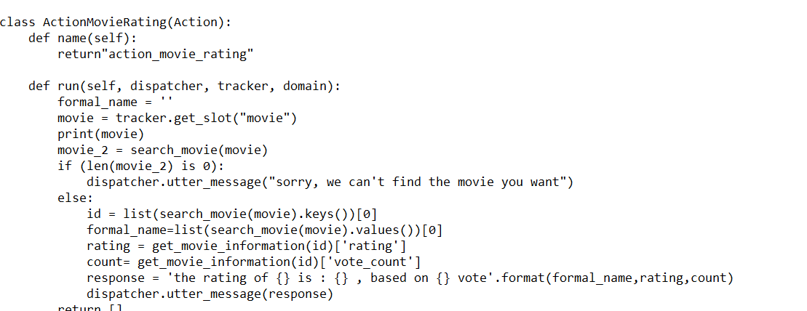

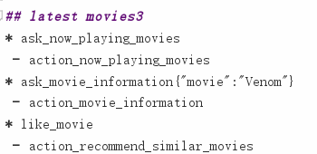

Now, we need define **stories** to simulate finite state machine, the RASA NLU need to know what real conversations are and train itself with data. In the file stories.md, we write many possible conversations which contain different intents of question and corresponding answers. For example, The case of *lastest movies3*, the user may ask what movie is on now, then the bot lists all hot movies in the cinema, and then the user may ask one specific movie among them, and the robot will answer concrete details. In the end, the user may show great interest about this movie, the bot can thus actively show similar movies for the user. Compared with traditional FSM, this technology can deal with more complex case, and large-scale data.

**3.Integrating of whole framework and testing**

In the run.py, we combine all the work above. We train RASA NLU to get NLU Interpreter, and We use RASA NLU’s agent to train stories with using NLU interpreter. We also define scientific training policies in the file policies.yml.

In the end, we test it and get good outcome. For example, the chatbot can accurately offer answers about movie’s information and rating.

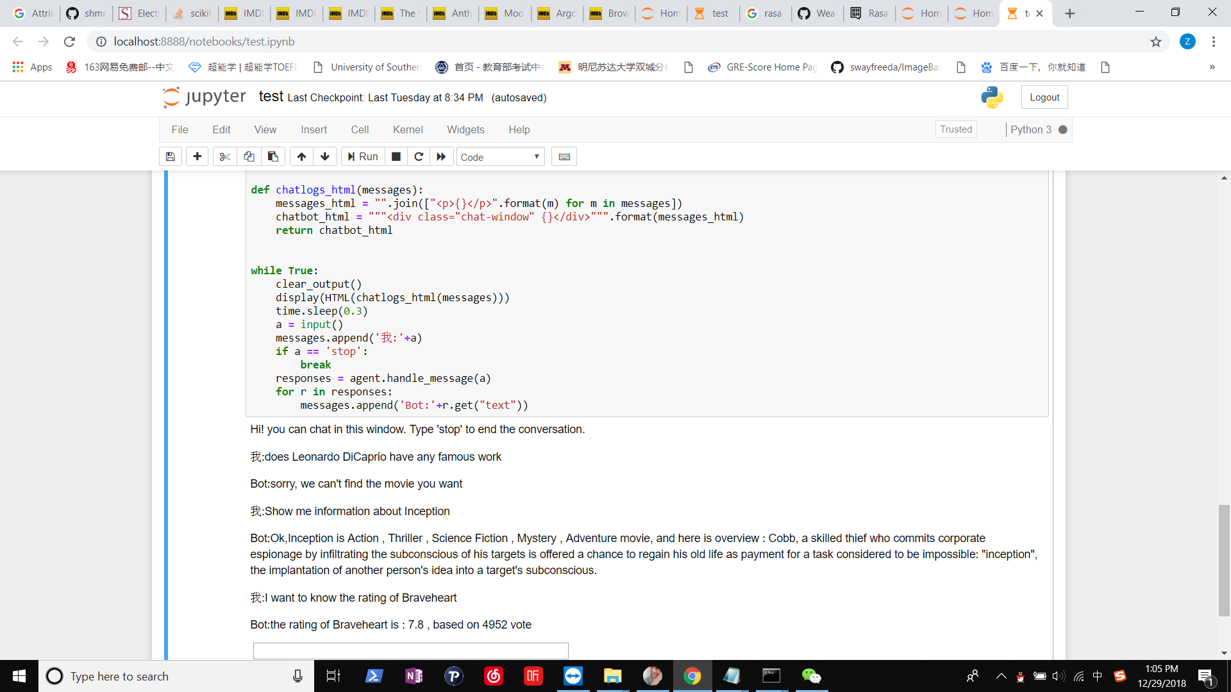

**Feeling and harvest**

This project really gave me an insight to Chatbot technology. Professor Zhang introduced us all aspects of chatbot even some other cutting-edge knowledge about Machine Learning and Natural Language Processing. And we also explored real application of such technology, those practical experience let me fulfill more engineering combat in wider scopes of AI and how to spot problems and solve it more promptly.

In retrospect, I only focused on Computer Vision, those new experience really refreshed me, and consolidated my basic knowledge. In the end, I need to say really hope do more researches about Robotics in my master degree, and such experience can teach me how to let the real robots and machine understand human’s instruction, for example Amazon Alex can smartly echo speakers in real home environment, those fantastic products are my future goal of researches about Chatbot.

However, I have to admit that I confronted many problems in this project. For example, my bot initially can’t answer many kinds of question. Latter I found it’s the problems of training data. So I need to write more and more data and refine those data about stories and NLU. Thus, this project also edify me to accurately choose comprehensive and massive enough training data in the area of deep learning and other fields. On the other hand, I also need to find more problems in more real use of our chatbot application to enhance experience effect.