Experiment 06:
Configuring VLANs and VLAN Trunking.
A traditional Layer 2 switch works primarily using MAC addresses.
Suppose we have:
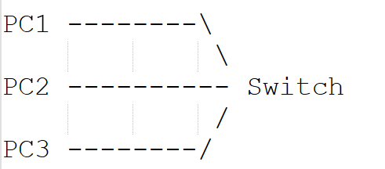
Suppose PC1 wants to communicate with PC2.
PC1 sends an Ethernet frame containing something like:
Source MAC = MAC of PC1
Destination MAC = MAC of PC2
The switch looks at the destination MAC address to decide which port to send the frame out of.
The switch maintains something called a: MAC Address Table.

For Example:
MAC Address | Port
PC1 MAC | Fa0/1
PC2 MAC | Fa0/2
PC3 MAC | Fa0/3

So if a frame comes for PC2, the switch knows: "PC2 is connected to Fa0/2."
So the frame gets sent out through Fa0/2. That, in a nutshell, is how a Layer 2 switch operates.

So What Exactly Is a Layer 2 Switch?
A Layer 2 switch is a network device that primarily operates at the Data Link Layer (Layer 2) of the OSI model.
It uses MAC addresses to forward Ethernet frames.
For example:
PC1
|
| Ethernet
|
Switch
|
PC2
The switch isn't concerned with IP addresses when deciding where traffic goes.
Its main job is: Receive an Ethernet frame → examine the MAC address → forward the frame through the appropriate port.
The Cisco 2960 switch, which we frequently use inside Packet Tracer, is essentially a Layer 2 device.

And What About a Layer 3 Switch?
A Layer 3 switch combines the abilities of a Layer 2 switch with Layer 3 routing.
So it can understand:
- MAC addresses
- IP addresses
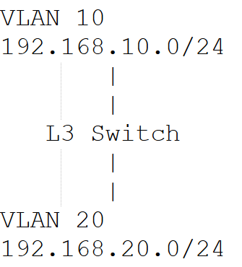
When a device on VLAN 10 needs to talk to a device on VLAN 20, an ordinary Layer 2 switch has no way of routing that traffic between the two networks.
A Layer 3 switch can. It can perform Inter-VLAN Routing.
Feature | Layer 2 Switch | Layer 3 Switch
Main OSI Layer | Layer 2 | Layer 2 + Layer 3
Uses MAC address | Yes | Yes
Uses IP address for routing | No | Yes
Switching | Yes | Yes
Routing | No | Yes
Inter-VLAN Routing | Not by itself | Yes
Example | Cisco 2960 | Cisco 3560

So, What Exactly Is a VLAN?
VLAN stands for: Virtual Local Area Network
The important word here is Virtual. Normally, suppose we have one physical switch:
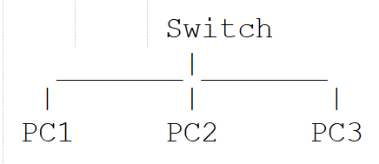
Without any VLAN configuration, all of these computers share a single Layer 2 broadcast domain.
Now imagine that the organization wants:
HR Department
Sales Department
to be logically separated.

We could physically use two switches:
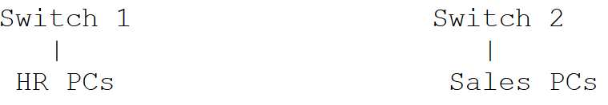

Instead, we can use one physical switch and logically divide it.
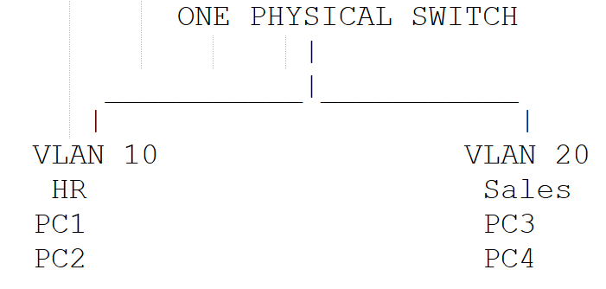
Now we have created two logical networks inside the same physical switch.
That's really the core idea behind a VLAN.

Why Do VLANs Keep Devices Separated?
This point matters a lot. Normally, a switch forwards Ethernet frames inside a single broadcast domain.
When we create VLANs, the switch logically separates its ports.
For example:
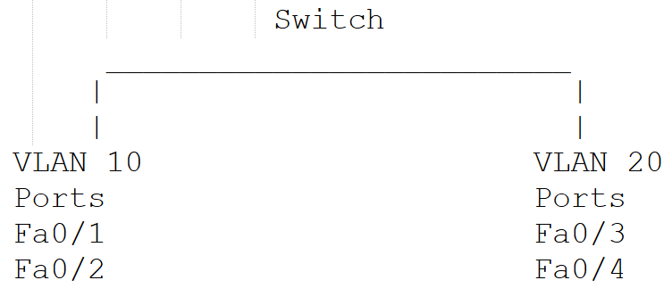
As far as the switch is concerned, VLAN 10 and VLAN 20 are two independent Layer 2 networks.
Therefore, a broadcast from VLAN 10 does not normally cross into VLAN 20.

What Does a VLAN Actually Accomplish?
Suppose:
VLAN 10 → HR
VLAN 20 → Sales

Then:
PC1 ── VLAN 10
PC2 ── VLAN 10

PC3 ── VLAN 20
PC4 ── VLAN 20
PC1 and PC2 belong to the same VLAN.
PC3 and PC4 belong to another VLAN.
Therefore:
PC1 → PC2
PC3 → PC4

PC1 → PC3
as long as no Layer 3 routing has been set up. This is the same idea we looked at a moment ago.

Challenges With a Traditional LAN.

Problem in a Normal LAN | How VLAN Solves It | Why It Is Needed
1. All devices are part of the same broadcast domain | VLAN divides one physical LAN into multiple logical networks. | Reduces unnecessary broadcast traffic.
2. Difficult to separate departments | Different departments can be placed in different VLANs. | For example, Accounts → VLAN 10, HR → VLAN 20, IT → VLAN 30.
3. Security is reduced | Devices belonging to different VLANs are logically separated. | Users in one VLAN cannot directly communicate with another VLAN without routing.
4. Broadcast traffic reaches many unnecessary devices | Broadcasts are normally limited to the same VLAN. | Improves network performance.
5. Physical location determines network grouping | VLAN allows logical grouping regardless of physical location. | Two PCs in different rooms can belong to the same VLAN.
6. Moving a user may require changing physical connections | The switch port can simply be assigned to the required VLAN. | Network management becomes easier.
7. A large LAN becomes difficult to manage | A large LAN can be divided into smaller VLANs. | Makes the network easier to organize and manage.
8. Departments may need separate networks | Each department can have its own VLAN. | Provides logical separation between departments.
9. Broadcast storms can affect a large LAN | VLANs create separate broadcast domains. | A broadcast problem in one VLAN is less likely to affect other VLANs.
10. One physical switch may need to support multiple networks | VLANs allow multiple logical networks on the same physical switch. | Saves hardware and reduces infrastructure cost.

Where's the Real Benefit Here?
Imagine a college network with:
Students
Faculty
Administration
Accounts

Instead of putting everybody into one huge network, we can create:
VLAN 10 → Students
VLAN 20 → Faculty
VLAN 30 → Administration
VLAN 40 → Accounts
This gives us logical separation.

Even though they may physically use the same switch infrastructure, they are logically separated.

Understanding Access Ports on a Switch
An access port is a switch port that normally belongs to one VLAN.
For example:
PC1
|
|
Fa0/1
|
Switch
Suppose we configure: Fa0/1 → VLAN 10
PC1 is therefore connected to VLAN 10.
Another PC:
PC2
|
|
Fa0/2
|
Switch
Suppose: Fa0/2 → VLAN 20
Then PC2 belongs to VLAN 20.
Access ports are typically used to connect devices such as:
- PCs
- Printers
- Servers
- IP phones in appropriate configurations
- End-user devices

Understanding Trunk Ports
Imagine we have two switches.
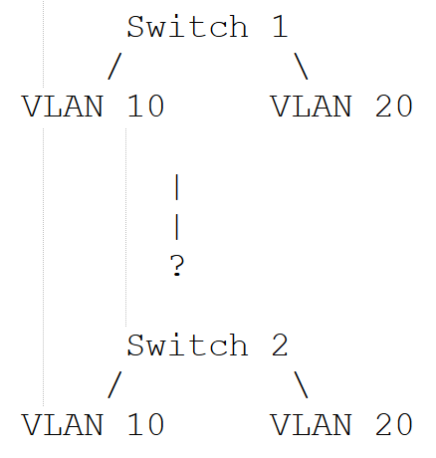

Suppose both switches have:
VLAN 10 → HR
VLAN 20 → Sales
We need to connect the two switches.
The question is: How can one physical cable carry traffic belonging to both VLAN 10 and VLAN 20?
We could use two cables:
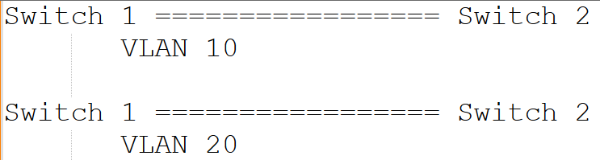
That works, but it's wasteful. A better approach is to use a: Trunk Port.
A trunk port is a switch port that can carry traffic belonging to multiple VLANs over a single physical link.
For example:
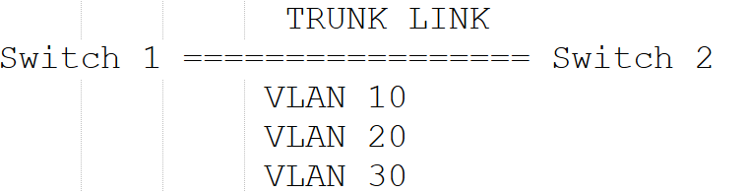
A single cable ends up carrying traffic for several VLANs at once — which is precisely what VLAN trunking is designed to do.
Access Port | Trunk Port
Normally carries one VLAN | Carries multiple VLANs
Usually connects end devices | Usually connects network devices
PC → Switch | Switch → Switch
Traffic is normally untagged toward an end device | VLAN information is carried across the trunk
Example: Fa0/1 assigned to VLAN 10 | Example: Gi0/1 carrying VLAN 10,20,30

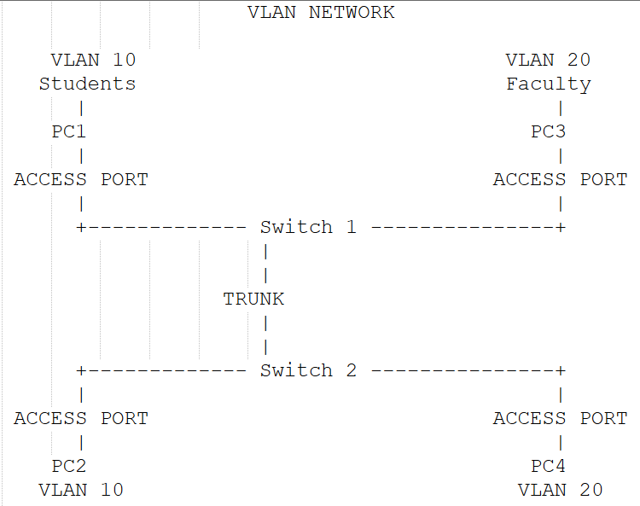

So How Does the Receiving Switch Identify the VLAN?
This is the key problem that VLAN trunking solves. Suppose Switch 1 sends a frame across the trunk.
The frame needs some way to communicate: "I belong to VLAN 10."
Without that information, Switch 2 has no way to tell if the frame came from VLAN 10, VLAN 20, VLAN 30, or any other VLAN.
This is where VLAN tagging comes in.

Understanding VLAN Tagging
With Ethernet trunking, VLAN information can be added to the Ethernet frame.
The most important standard used for this is: IEEE 802.1Q or simple called as 802.1Q.

A VLAN tag contains information that allows the receiving switch to identify the VLAN.
Conceptually:
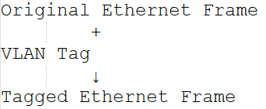
For example:
Frame
|
+---- VLAN ID = 10
The receiving switch sees VLAN ID 10 and knows: "This frame belongs to VLAN 10."

Understanding VLAN Trunking
VLAN trunking refers to sending traffic from several VLANs across just one physical link between two network devices.

VLAN Trunking ≠ VTP
There are three different concepts that sound similar:
- VLAN Trunking: Carries multiple VLANs over one link.
- 802.1Q: The standard used to tag VLAN traffic on an Ethernet trunk.
- VTP (VLAN Trunking Protocol): But VTP does not mean "the protocol that carries multiple VLANs over a trunk."
VTP is used to distribute/manage VLAN configuration information among Cisco switches in a VTP domain.
Types of Trunking Protocols:
Protocol | Type | Status/Use
IEEE 802.1Q | Open IEEE standard | Common/current Ethernet VLAN trunking method
ISL (Inter-Switch-Link) | Cisco proprietary | Legacy/obsolete in modern networks

For this experiment, we'll go with IEEE 802.1Q trunking.

Steps:
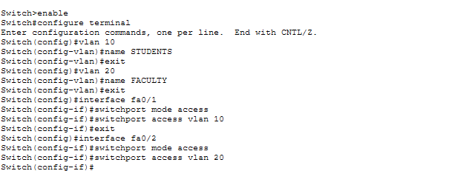

Step 1: Take two switches 2960 Cisco and take 4 PC’s.
Step 2: Use Copper-Straight Through cables to connect them.
PC1 → SW1 Fa0/1
PC2 → SW1 Fa0/2

PC3 → SW2 Fa0/1
PC4 → SW2 Fa0/2
Then connect two switches:
SW1 Gi0/1 → SW2 Gi0/1

The topology should look like this:
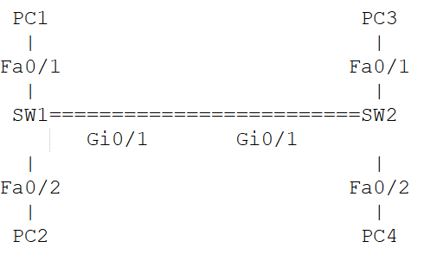
The link between SW1 and SW2 is going to become the trunk link.

Step 3:
Assign IP Addresses:
PC1:
IP Address: 192.168.10.11
Subnet Mask: 255.255.255.0

PC3:
IP Address: 192.168.10.12
Subnet Mask: 255.255.255.0
PC1 and PC3 are going to belong to: VLAN 10

So their IP addresses are also from: 192.168.10.0

PC2:
IP Address: 192.168.20.11
Subnet Mask: 255.255.255.0

PC4:
IP Address: 192.168.20.12
Subnet Mask: 255.255.255.0
VLAN 20.

Step 4: Configuring VLAN on SW1 (Switch 1).
SW1 -> GO TO CLI.
Switch>
Enter Privileged Mode:
Type: Enable
Switch#
Enter Configuration Mode:
Type: Configure Terminal or Conf t
Switch(config)#

Step 5: Create VLAN 10 on SW1
Type: VLAN 10
Switch(config-vlan)#
Give it a name: name STUDENTS
Now VLAN 10 has been created.
VLAN 10 -> STUDENTS.

Step 6: Create VLAN 20 on SW1
Type: Exit
Then: VLAN 20
And
Name FACULTY

Now SW1 has:
VLAN 10 -> STUDENTS
VLAN 20 -> FACULTY

Step 7: Assigning PORTS to VLAN.
Creating a VLAN does not automatically put PCs into that VLAN.
We still have to tell the switch: “Fa0/1 belongs to VLAN 10”
And “Fa0/1 belongs to VLAN 20”

Step 8: Configure Fa0/1 as an Access Port.
Type: Exit
Now enter the interface: interface fa0/1
You should see: Switch(config-if)#
Now tell the switch that this is an access port:
Type: Switchport mode access
Then assign it to VLAN 10: switchport access vlan 10
So the complete configuration will be:
interface fa0/1
switchport mode access
switchport access vlan 10
By this we tell SW1 that fa0/1 -> Access Port -> VLAN 10.
Therefore, PC1- > Fa0/1 -> VLAN 10.

Step 9: Configure Fa0/2 for VLAN 20:
Type: Exit
interface fa0/2
then
switchport mode access
then
switchport access vlan 10.

Step 10: Repeat the same process for SW2.

Step 11: Now we have to configure the TRUNK.
This is the most important part of the experiment.
We have: SW1 Gi0/1 ================= Gi0/1 SW2
Currently, this is just a normal switch-to-switch connection.
We need to tell both switches:
"This link is going to carry multiple VLANs."
Therefore, we configure it as a trunk.

Step 12:
On SW1:
enable
configure terminal
then
interface gigabitEthernet 0/1
then
switchport mode trunk
Now Gig0/1 is now the trunk port.

Step 13: Repeat the same process for SW2.

Step 14:
Suppose PC1 sends a frame to PC3.
PC1 belongs to: VLAN 10
The frame reaches:
PC1
↓
SW1 Fa0/1
↓
VLAN 10
SW1 needs to send that frame to SW2.
The frame travels through:
SW1
↓
Gi0/1
↓
TRUNK
↓
Gi0/1
↓
SW2
Because it is crossing a trunk, VLAN information is carried using the trunking mechanism, typically IEEE 802.1Q.
SW2 receives the frame and knows: "This frame belongs to VLAN 10."
It then forwards it to:
VLAN 10
↓
Fa0/1
↓
PC3
Therefore, PC1 → PC3 works.

Step 15: Testing the configurations.
Ping PC1 to PC3, it should work as they belong to same VLAN 10.
Ping PC2 to PC4, they should work as they belong to same VLAN 20.

But what happens, when we ping PC1 to PC4? It should fail in this topology.
Because: VLAN 10 ≠ VLAN 20
and we haven't configured a router or Layer 3 switch.

Step 16: Verify VLANs
Show vlan brief

Step 17: Verify the Trunk
show interfaces trunk

Step 18: Verify MAC Address Learning
show mac address-table

Complete Configuration for SW1:
enable
configure terminal

vlan 10
name STUDENTS
exit

vlan 20
name FACULTY
exit

interface fa0/1
switchport mode access
switchport access vlan 10
exit

interface fa0/2
switchport mode access
switchport access vlan 20
exit

interface gigabitEthernet 0/1
switchport mode trunk
exit

Complete Configuration for SW2:
enable
configure terminal

vlan 10
name STUDENTS
exit

vlan 20
name FACULTY
exit

interface fa0/1
switchport mode access
switchport access vlan 10
exit

interface fa0/2
switchport mode access
switchport access vlan 20
exit

interface gigabitEthernet 0/1
switchport mode trunk
exit

