# **Name:** Karin Sinkevitch

**Date:** September 7, 2020

**Course:** IT FDN 110A

**Assignment:** 09

**GitHub URL:** <https://github.com/KARSINK22/IntroToProg-Python-Mod09>

# **Working with Modules**

# Introduction

This document steps through the Assignment09.py script which demonstrates the “main” module, connecting multiple modules to each other, and class inheritance.

# Create Python Script “Assigment09.py”

“Assigment09.py” is very similar to Assignment08 which loads data from file into a list of product objects when first run then shows the user a menu of options. The options are to show the user the current data, add data to the list of product objects, remove data from the list, or save the data to a file, or exit the program. The main difference is that the classes are broken into 3 modules: DataClasses, ProcessingClasses, and IOClasses (see Figure 1). The Main module imports these classes and runs a while loop for user selection. A TestHarness.py was created to test out each class’ functionality prior to using it in the Main script.

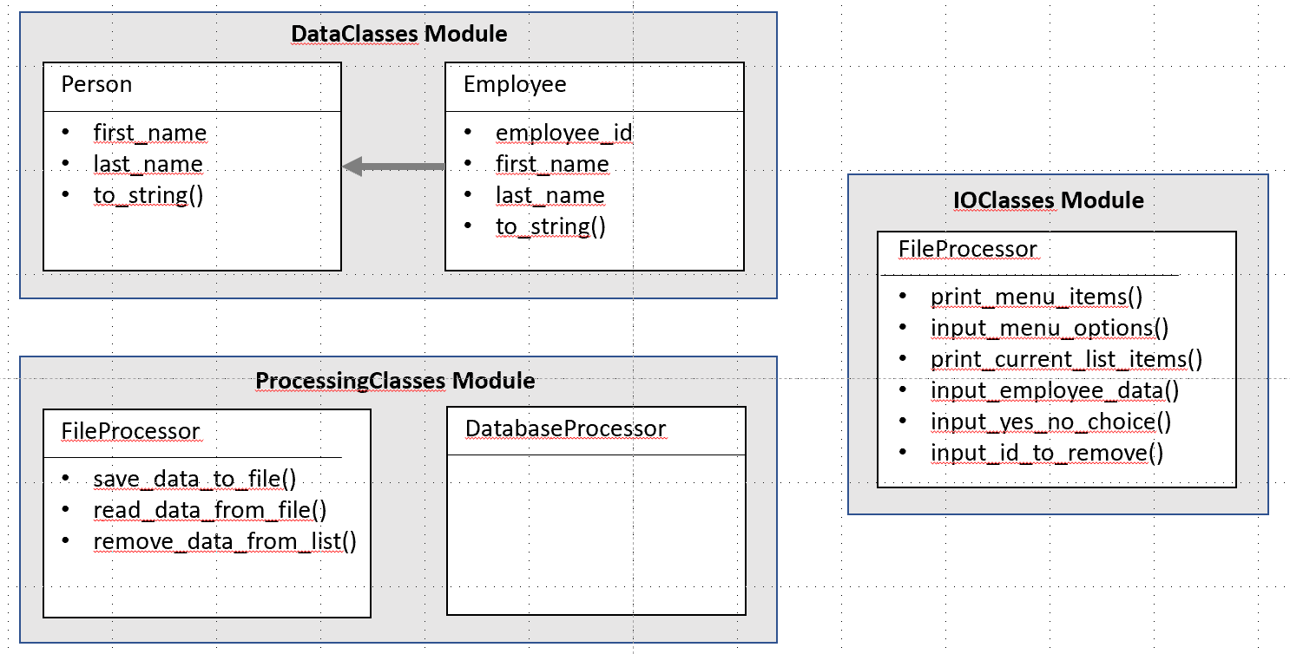

Figure Script Modules

Figure 2 through Figure 6 show the code being executed in PyCharm.

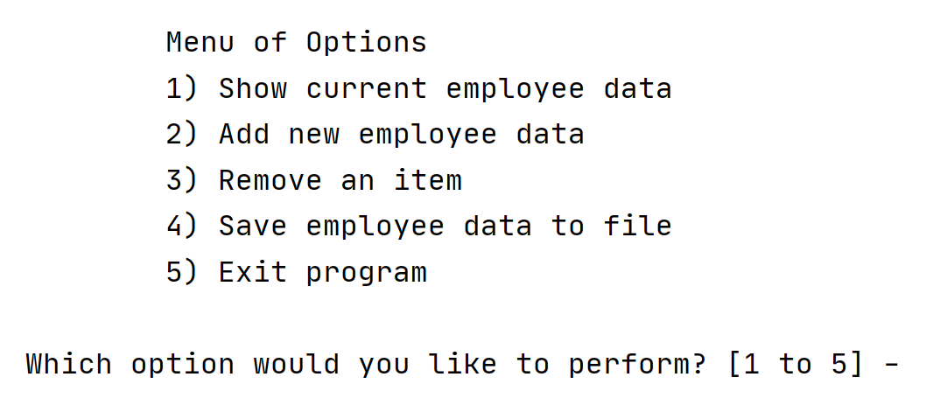

Figure PyCharm: Menu of Options

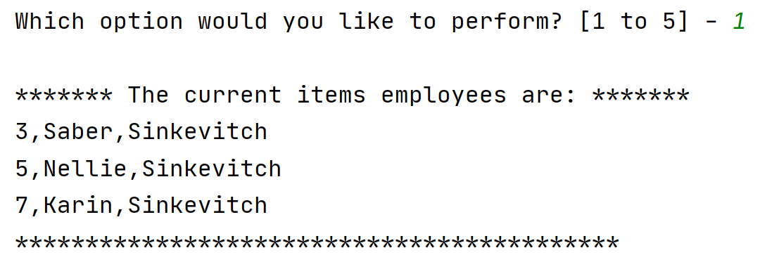

Figure PyCharm: Option 1 Selected

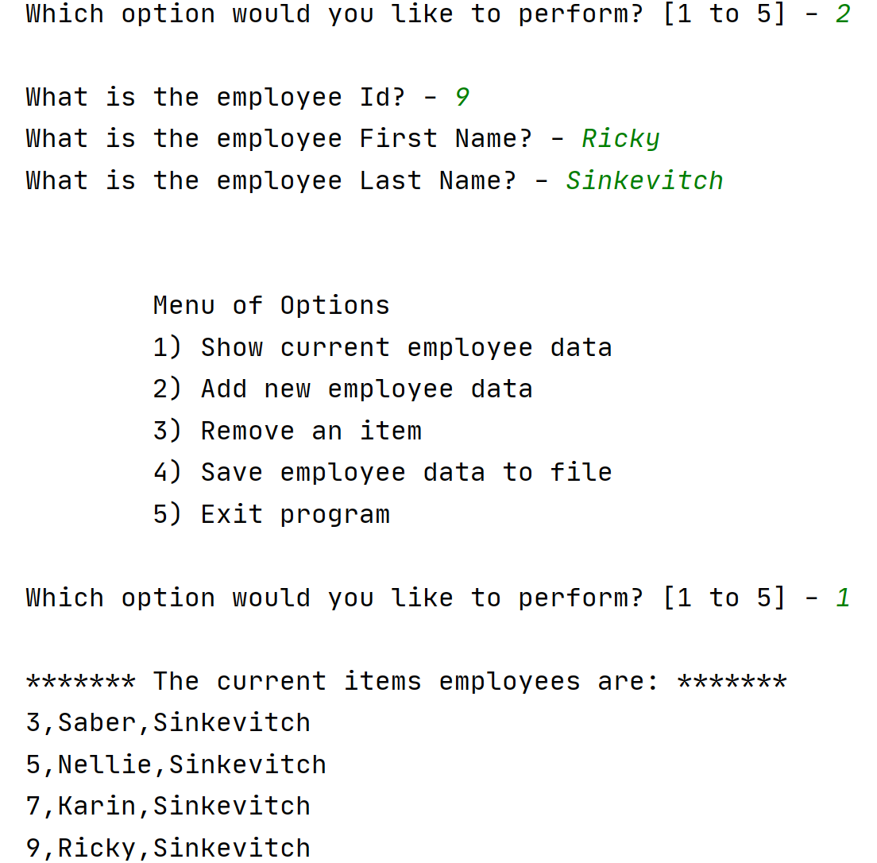

Figure PyCharm: Option 2 Selected

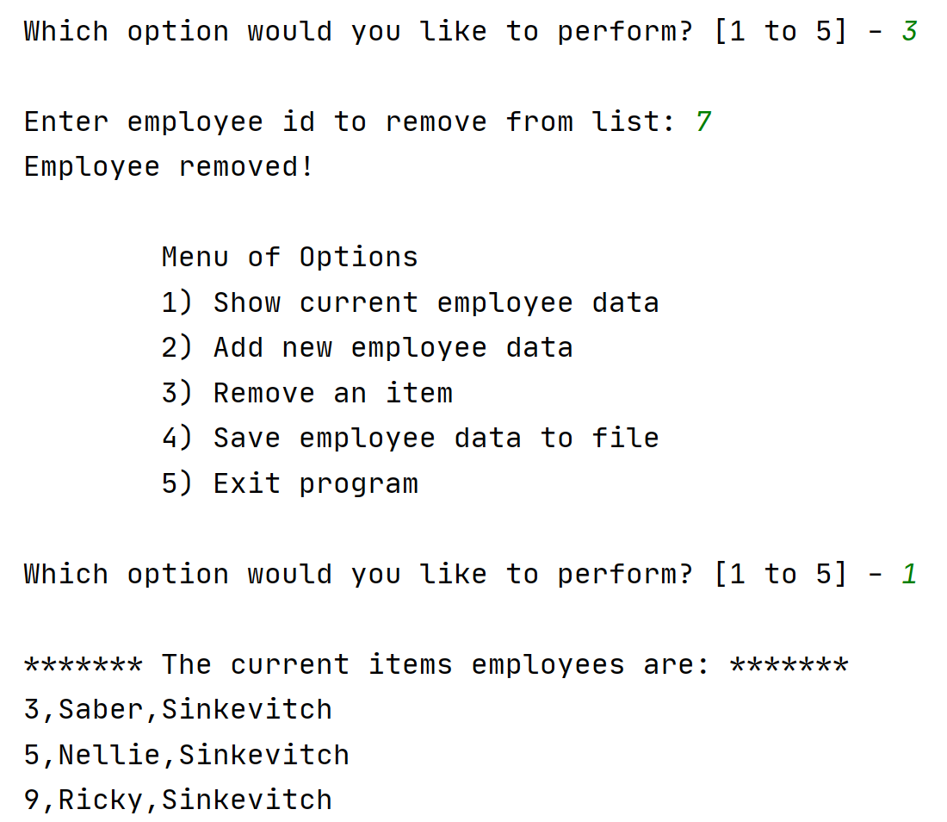

Figure PyCharm: Option 3 Selected

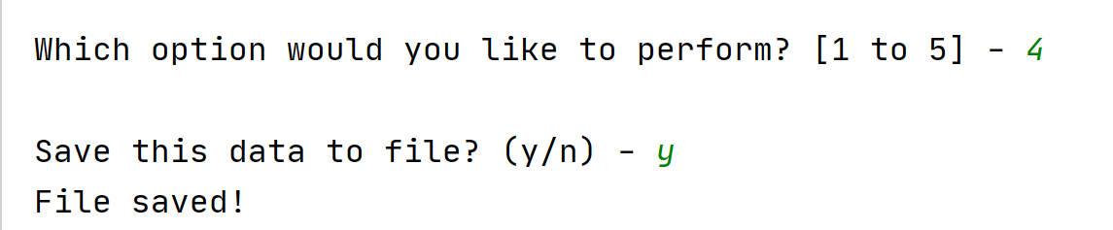

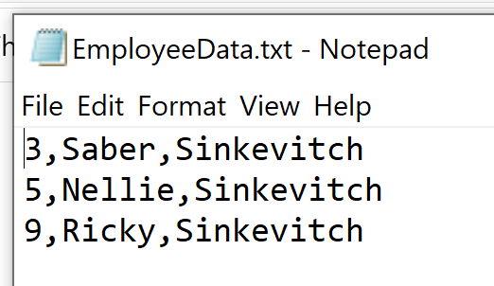

Figure PyCharm: Option 4 Selected and EmployeeData.txt File

Try-except error handling is used when opening, writing, and saving to a file. It is also used to ensure the user inputs are correct and to make sure that Main.py is the module being executed and not the class modules. Figure 7 shows the script being run in the console.

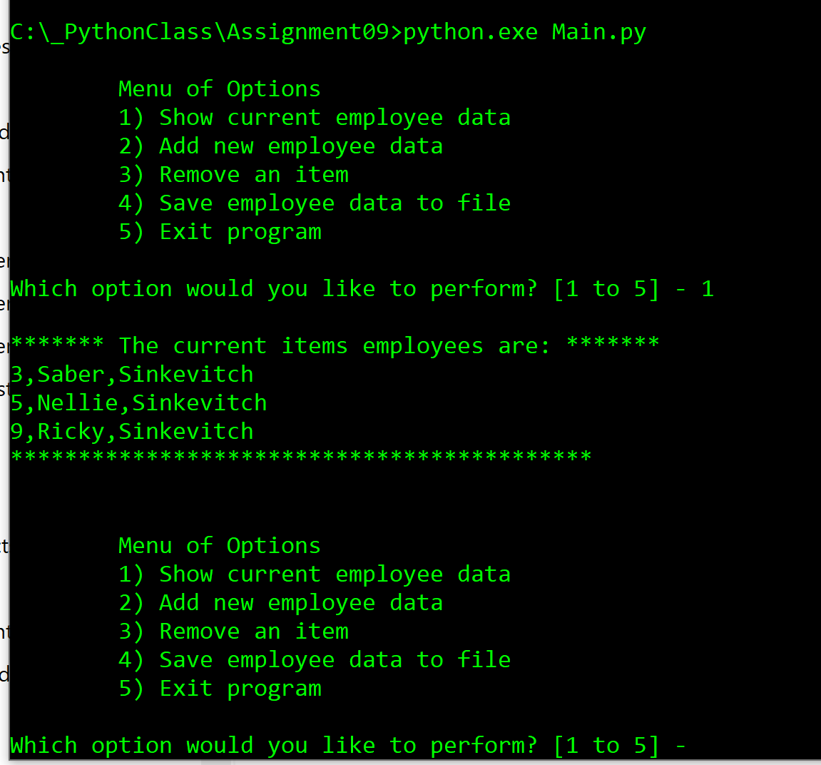

Figure 7 Script Running in Console

# Summary

Using modules to separate out classes from code helps keep the code readable and easier to use on multiple projects. Inheriting a class is a nice way to save time re-writing the same code. Using a test harness script to test out classes and their methods is a very helpful tool that should be used often when coding.