Retail Sales Data Analysis using Python, SQL and Power BI

Executive Summary

This project analyzes Superstore retail sales data using Python, SQL, and Power BI to identify sales trends, profit performance, customer behavior, and category-level patterns. Python was used for data cleaning, preprocessing, and exploratory data analysis, while SQL was used to retrieve business insights from the dataset. Power BI was used to organize the findings into a dashboard-style view for better understanding and presentation. The available charts show that Office Supplies leads in sales and order volume, sales values are highly skewed with several large outliers, and discounts have a negative relationship with profit. Sales and profit also show a positive connection, which helps highlight strong-performing segments. Overall, this project demonstrates practical skills in data cleaning, business analysis, visualization, and reporting, while providing clear recommendations to improve pricing, category focus, and decision-making.
Dashboard Screenshot

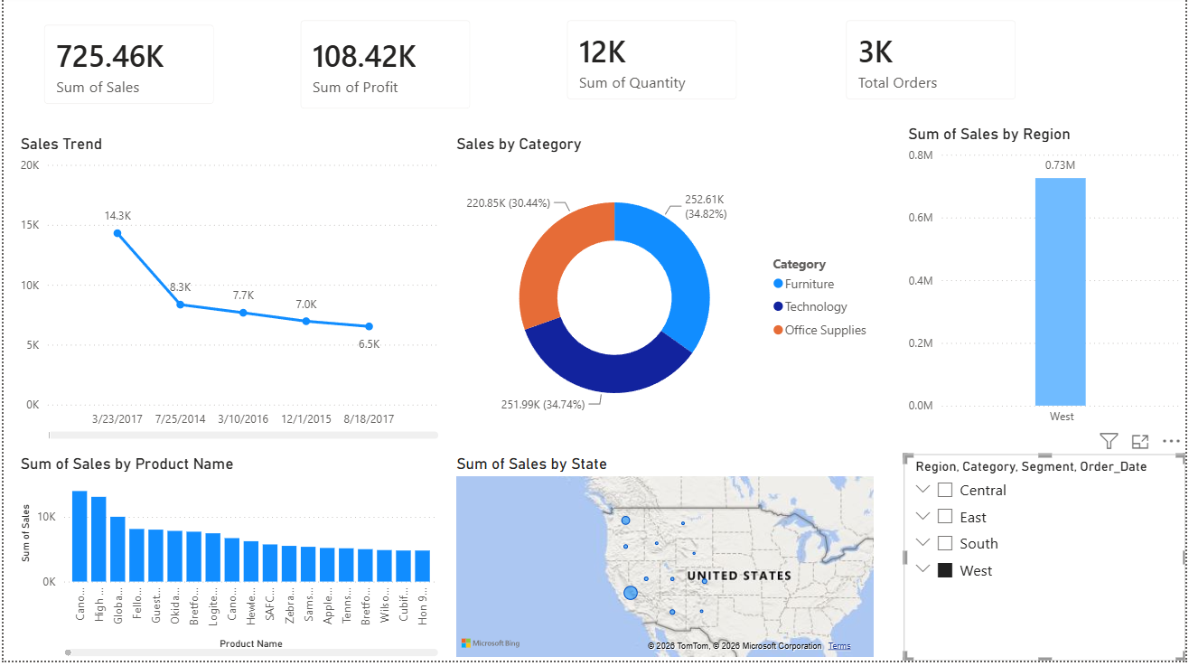
Figure 1. Power BI dashboard screenshot

Top 5 Insights

1. Office Supplies generated the highest total sales among all categories.  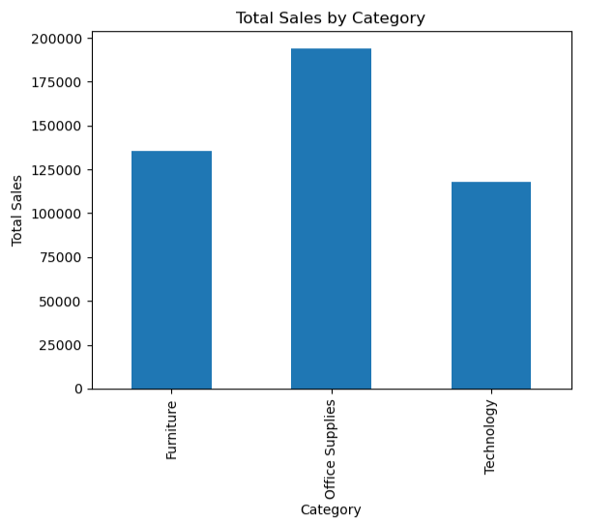  Figure 2. Category sales comparison | 2. Office Supplies also recorded the highest number of orders, showing strong customer demand.  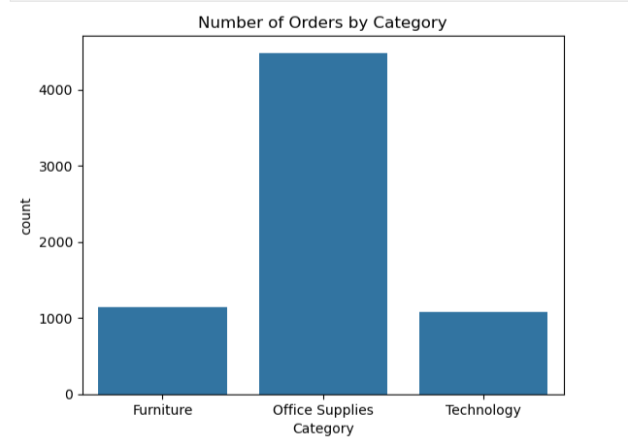  Figure 3. Order count by category
3. Sales values are right-skewed, with many small orders and a few very large outliers.  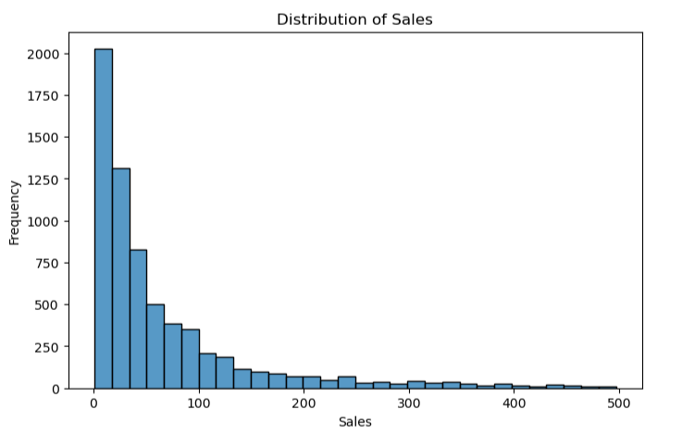  Figure 4. Distribution of sales | 4. The boxplot confirms the presence of extreme sales outliers in the dataset.  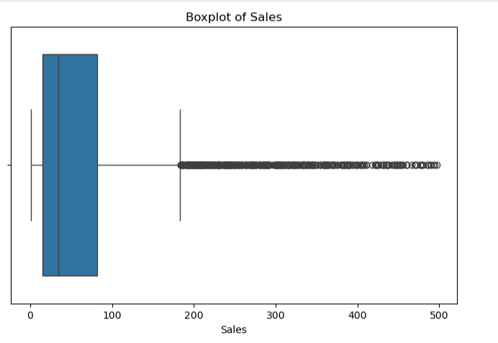  Figure 5. Sales outlier pattern
5. Discount is negatively related to profit, while sales and profit move together positively.  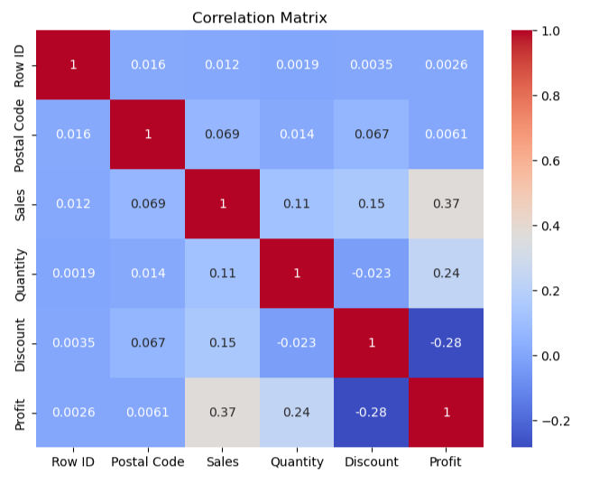  Figure 6. Correlation matrix | Sales over time shows repeated spikes, indicating periods of stronger transaction activity.  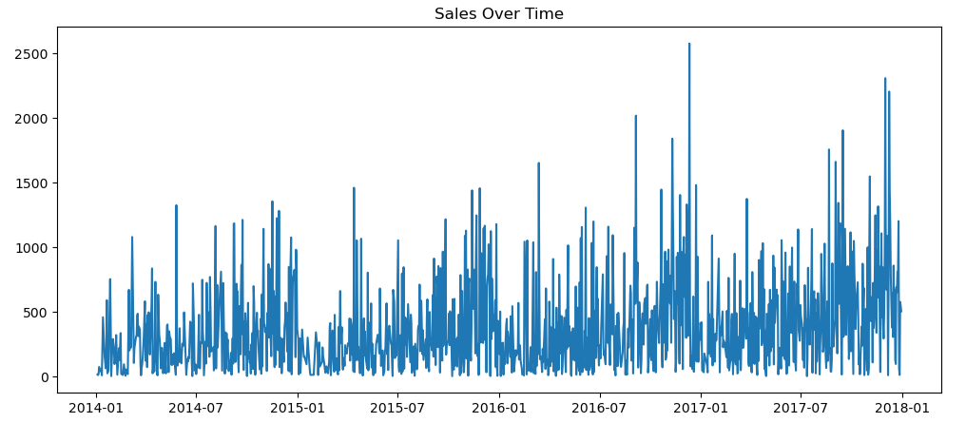  Figure 7. Sales trend over time
Business Recommendations
- Reduce excessive discounts on low-profit products to improve overall profitability.
- Focus more on strong-performing categories and maintain stock planning for high-demand items.
- Track unusual sales spikes and customer buying behavior regularly to support better business decisions.

