Experiment 1: Create a simple cloud software application for educational institutions to manage fee collection and payment tracking using any Cloud Service Provider to demonstrate SaaS.

AIM:
To create a cloud-based Fee Collection and Payment Tracking System for educational institutions and deploy it as Software as a Service (SaaS).

PROCEDURE
- Login to Zoho Creator.
- Click Create Application and choose From Scratch.
- Enter application name as Fee Management App.
- Create a form named Fee Collection Form.
- Add fields such as:
  - Student Name
  - Register Number
  - Department
  - Semester
  - Fee Amount
  - Payment Status
  - Payment Date
  - Email
- Click Done to save the form.
- Create a List Report named Fee Report.
- Configure report fields to display important details.
- Click Access this application to run the app.
- Enter sample fee payment details and submit.
- View stored data in the report section.
- Copy and share the application link to demonstrate SaaS.

OUTPUT:
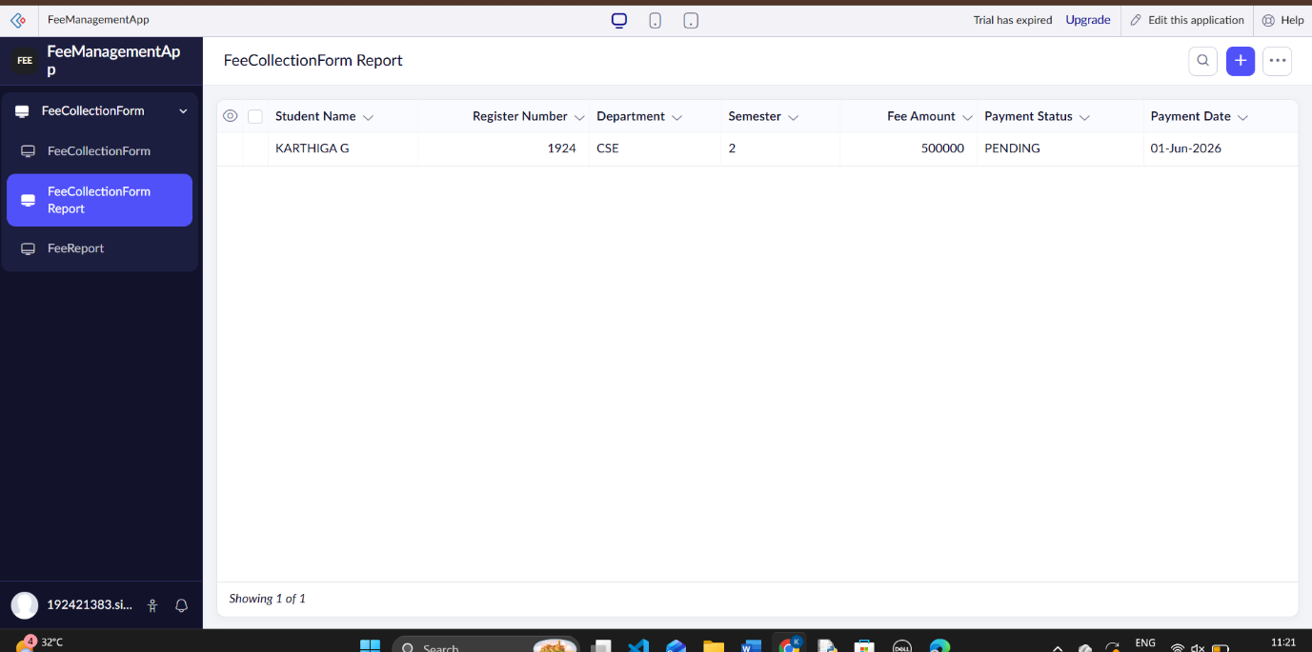

RESULT:
A cloud-based Fee Collection and Payment Tracking System was successfully developed and deployed as SaaS using Zoho Creator.

Experiment 2: Create a simple cloud software application for racking inventory, stock updates, and sales management using any Cloud Service Provider to demonstrate SaaS.

AIM:
To create a cloud-based Inventory, Stock Update, and Sales Management System and deploy it as Software as a Service (SaaS).

PROCEDURE:
- Login to Zoho Creator.
- Click Create Application and select From Scratch.
- Enter application name as Inventory Management App.
- Create a form named Inventory Form.
- Add fields such as:
  - Product Name
  - Product ID
  - Category
  - Stock Quantity
  - Price
  - Sales Status
  - Supplier Name
  - Update Date
- Click Done to save the form.
- Create a List Report named Inventory Report.
- Configure report fields to display inventory details.
- Click Access this application to run the app.
- Enter sample product details and submit.
- View inventory and stock data in the report.
- Share the application link to demonstrate SaaS.

OUTPUT:

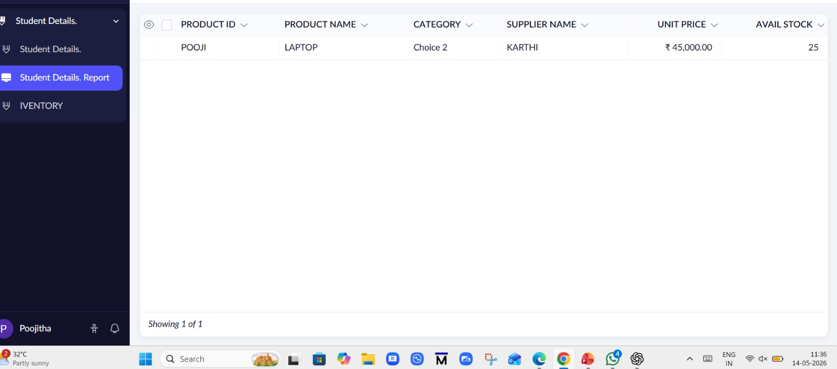

RESULT
An Inventory, Stock Update, and Sales Management System was successfully developed and deployed as SaaS using Zoho Creator.

