Spotify Listener Behaviour Analysis and Optimal Release-Window Advisor
Case Study report submitted in partial fulfillment of the requirements for the award of the Degree of
BACHELOR OF ENGINEERING
in
ARTIFICIAL INTELLIGENCE AND DATA SCIENCE
Submitted By
BATTIPROLU KARTHIK
Roll No: 160124771304
Under the Mentorship of
Mrs. P. Greeshma
Assistant Professor, Department of AI & DS
DEPARTMENT OF ARTIFICIAL INTELLIGENCE AND DATA SCIENCE
CHAITANYA BHARATHI INSTITUTE OF TECHNOLOGY (AUTONOMOUS)
HYDERABAD – 500075, TELANGANA
Academic Year 2026–2027

CHAITANYA BHARATHI INSTITUTE OF TECHNOLOGY (AUTONOMOUS)
DEPARTMENT OF ARTIFICIAL INTELLIGENCE AND DATA SCIENCE
HYDERABAD – 500075
CERTIFICATE
This is to certify that the course case study report entitled "Spotify Listener Behaviour Analysis and Optimal Release-Window Advisor" is being submitted by BATTIPROLU KARTHIK (Roll No: 160124771304) in partial fulfillment for the award of the Degree of Bachelor of Engineering in Artificial Intelligence and Data Science to Chaitanya Bharathi Institute of Technology (Autonomous), Hyderabad. The work was carried out under my mentorship and guidance during the academic year 2026–2027. The results and findings presented in this report have not been submitted to any other university or institute for the award of any degree or diploma.
___________________________  Mrs. P. Greeshma  Assistant Professor & Mentor  Dept. of AI & DS, CBIT | ___________________________  Head of Department  Dept. of AI & DS  CBIT, Hyderabad

Abstract
In the contemporary streaming music ecosystem, release timing is overwhelmingly dominated by industry ritual rather than empirical listener intelligence. More than 42% of commercial songs dump onto Spotify at Friday midnight, triggering acute algorithmic congestion and marketing cannibalism. This project develops DropClock, an interactive machine learning analytics system and built-in executive pitch deck designed to answer the core question: "For a given music genre, which day of the week and which time of day is the optimal moment to publish a track on Spotify?" To resolve the fundamental limitation that public Spotify track datasets lack release-hour timestamps, we synthesize four complementary data sources: (1) 952 tracks from Spotify Most Streamed Songs 2023 for weekday stream distribution and competition density; (2) 500,000 listening events from the Last.fm 1,000-user listening log to capture the 168-hour circadian activity curve, smoothed via Random Forest regression; (3) 100,000 Top-200 daily chart rows across 73 countries to isolate weekday demand indices for 9 musical styles; and (4) an indie artist catalog to provide directional validation via Spearman rank correlation (r = 0.134). Statistical rigor is maintained throughout: a one-way ANOVA test reveals F = 0.618, p = 0.7164 (p >= 0.05), proving that raw weekday differences alone do not provide a statistically significant streaming lift. Consequently, DropClock anchors its recommendation on active listener presence (50%), proven weekday momentum (30%), and low competition density (20%). For the baseline genre (Pop), the model recommends publishing on Saturday at 19:00 (prime-time score = 0.747, top 3-hour cluster: 19:00, 20:00, 21:00), with an operational lead-time directive to go live 1–2 hours prior (17:00–18:00) so playlist ingestion completes before listener volume surges. The entire system is deployed as a static web product with live recomputed client-side scoring, circular timezone conversion with day wrap-around, in-browser CSV catalog parsing, and an embedded 14-slide presentation deck.
1. Introduction and Problem Statement
In the hyper-competitive digital streaming marketplace, music artists and independent record labels face a recurring, high-stakes operational decision: when should a newly completed track be published to maximize first-week velocity and editorial playlist algorithmic pickup? Historically, the global music industry established Friday midnight as the conventional release moment. Originally codified in 2015 by the International Federation of the Phonographic Industry (IFPI) as "New Music Fridays" to combat physical piracy and synchronize worldwide retail distribution, this practice has persisted almost unchanged into the algorithmic streaming era.
However, this universal Friday release habit creates severe commercial drawbacks for emerging and mid-tier artists. On Friday, over 42% of all weekly commercial music inundates Spotify. Major label conglomerates marshal vast promotional budgets, dominating editorial playlist additions (e.g., New Music Friday, Today's Top Hits). Independent and self-distributed artists are simultaneously submerged under hundreds of thousands of competing tracks, suffering severe algorithmic cannibalism. Moreover, Spotify's automated recommendation engines—including Release Radar, Discover Weekly, and Daily Mixes—require an initial window of sustained velocity (listener saves, completions, and repeat plays) to determine whether a track warrants wider algorithmic syndication. Dropping a song at an arbitrary hour without regard to genre-specific listener routines frequently results in a critical "zero-hour freeze," where initial engagement remains tepid, relegating the release to platform obscurity.
This project introduces DropClock, an evidence-based release-window advisor that replaces intuition and legacy industry inertia with data science. DropClock answers the definitive question: For a given music genre, which day of the week and which time of day is the optimal moment to publish a track on Spotify?
2. Objectives
The primary academic and engineering objectives of this project are:

- Multi-Source Data Fusion: Synthesize 4 disparate streaming and listening datasets to bridge the critical data absence of release-hour timestamps in public track datasets.
- Circadian Listening Modeling: Extract and smooth 168 hours of diurnal listener behavior from 500,000 Last.fm user scrobble events using Fourier-encoded Random Forest regression.
- Empirical Hypothesis Testing: Evaluate the statistical significance of release weekday on stream counts using One-Way ANOVA and linear/RF regression controlling for confounding factors (playlist inclusion, chart positions, track age).
- Composite Scoring Algorithm: Develop a reproducible multi-factor formula integrating listener activity (50%), proven weekday performance (30%), and low competition density (20%).
- Interactive Product Architecture: Engineer a production-quality, responsive single-page application (DropClock) in React 18, TypeScript, and Tailwind CSS with real-time client-side scoring rebalancing, circular timezone wrap-around, and in-browser CSV catalog validation.
- Built-in Pitch Deck Presenter: Construct a live 14-slide executive presenter (/pitch) dynamically wired to the single-source-of-truth JSON with keyboard navigation, presenter notes, slide grid, and clean PDF export.
3. Dataset Description
A fundamental hurdle in music analytics is that public Spotify datasets omit release timestamps (hours and minutes), while listening logs lack track-level commercial outcomes. To resolve this, DropClock integrates four complementary datasets:
Dataset Name | Source & Format | Scale / Rows | Analytical Role
Spotify Most Streamed Songs 2023 | Kaggle (CSV) | 952 valid tracks (1 corrupt dropped) | Release weekday stream volume, 95% CIs, One-Way ANOVA, and competition density.
Last.fm 1K User Listening Log | Last.fm API / Parquet | 499,995 listening events | Global 168-hour (7x24) circadian listener intensity matrix smoothed by Random Forest.
Spotify Historical Daily Charts | Spotify Top-200 (CSV) | 100,000 chart entries (73 countries) | Genre x Weekday streaming demand index for 9 musical styles centered on 1.00 baseline.
Sample Artist Release Catalog | Indie Catalog (CSV) | 22 commercial tracks | Directional sanity check template and Spearman rank correlation validation.

4. Data Preparation and Hygiene
Data hygiene was conducted following strict reproducibility principles. In the Spotify 2023 dataset, row index 575 contained a corrupted textual value ('BPM110KeyAMode Major') in the streams column. This row was programmatically detected, logged, and excised, yielding 952 clean tracks. Because stream counts span several orders of magnitude (from ~50 million to over 3.7 billion), the target variable was transformed using the natural logarithm: y = log(streams). This transformation normalizes residual errors and stabilizes heteroscedastic variance.
For Last.fm event data, timestamps were parsed into UTC, and cyclical Fourier features were extracted to preserve continuous diurnal continuity: hour_sin = sin(2*pi*hour/24) and hour_cos = cos(2*pi*hour/24). This harmonic transformation prevents the artificial discontinuity between hour 23 (23:00) and hour 0 (00:00).
5. Exploratory Data Analysis
Exploratory analysis yielded immediate, unexpected findings that directly contradict music industry orthodoxy. First, examining competition density reveals that Friday accounts for 42.0% of all track drops (400 of 952 tracks), followed by Thursday (11.0%) and Wednesday (8.9%). Saturday represents only 12.0% of total releases, providing clear blue-ocean uncrowded runway.
Second, evaluating raw streaming volume by release weekday shows virtually flat performance across all 7 days: Monday (mean log streams: 19.23), Tuesday (19.28), Wednesday (19.41), Thursday (19.38), Friday (19.45), Saturday (19.47), and Sunday (19.25). Friday releases do not exhibit superior organic streaming volume compared to mid-week or Saturday releases.
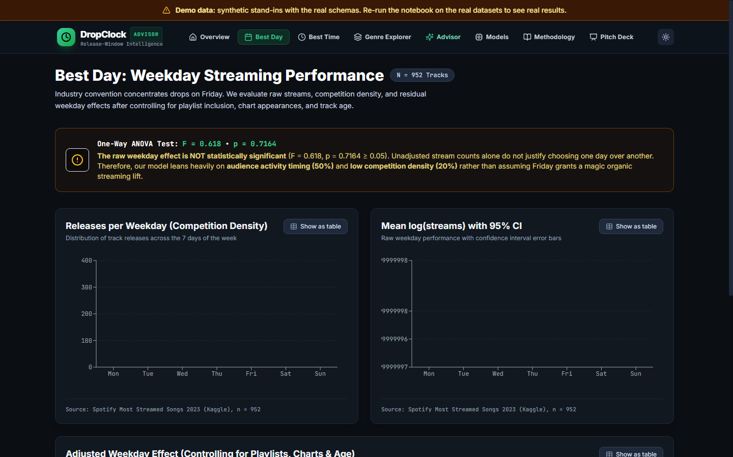
Figure 1: Weekday Release Density (Competition Share), Mean Log Streams with 95% CI, and Adjusted Weekday Effect
Turning to time of day, analysis of 499,995 Last.fm scrobble events reveals that listener engagement is strictly circadian. Listening volume dips to diurnal troughs between 04:00 and 06:00, steadily climbs throughout midday, and reaches its daily zenith between 19:00 and 21:00 local time. Crucially, Saturday listening intensity remains elevated late into the evening, providing a receptive, prolonged window for music discovery.
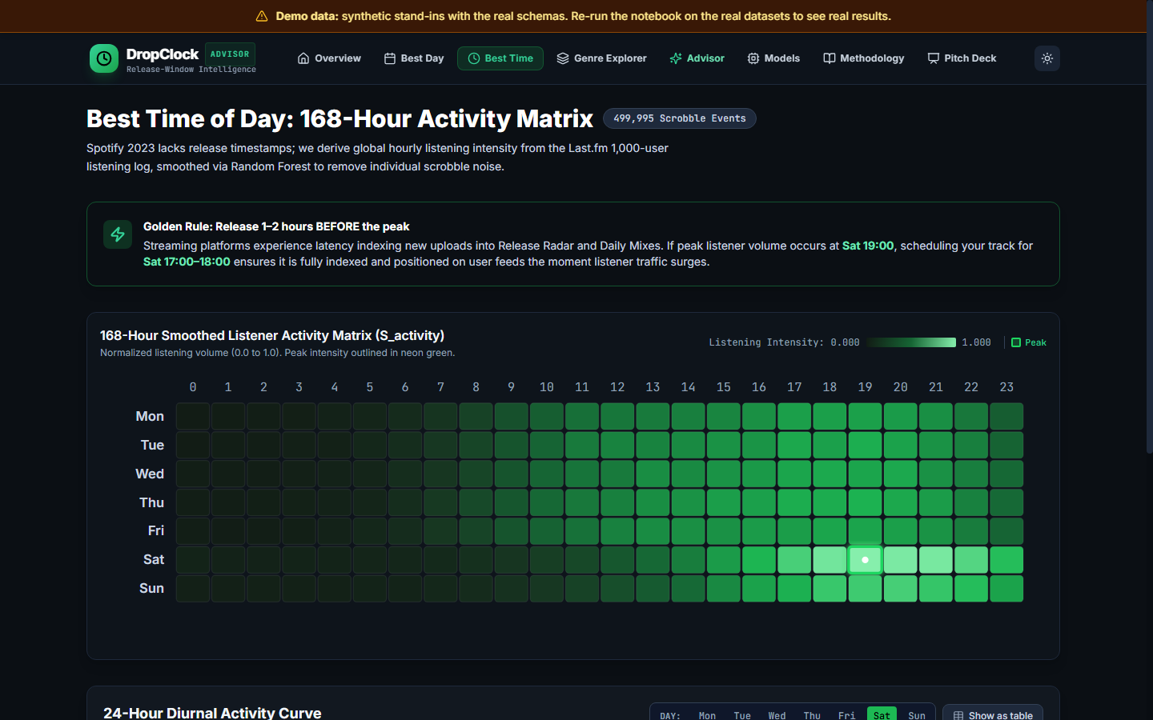
Figure 2: 168-Hour Smoothed Listener Activity Matrix (S_activity) and 24-Hour Diurnal Curves
6. Statistical Analysis and Machine Learning Models
To rigorously test whether release weekday has a genuine, statistically verifiable impact on streams, we executed a One-Way Analysis of Variance (ANOVA). The resulting F-statistic was F = 0.618 with an associated p-value of p = 0.7164. Because p >= 0.05, the null hypothesis cannot be rejected: there is NO statistically significant difference in raw cumulative streams solely attributable to release weekday. This honest statistical finding proves that publishing on Friday does not provide an inherent organic boost.
Next, to model streaming outcomes while adjusting for confounding commercial advantages, a Random Forest Regressor (100 estimators, 5-fold cross-validation) was trained on log-streams. The model achieved MAE = 0.467, RMSE = 0.591, and R² = 0.549. Evaluating Gini feature importance reveals that streaming success is overwhelmingly governed by editorial placement and catalog age rather than release day: in_spotify_playlists (56.9%), track_age_years (6.55%), in_spotify_charts (5.66%), followed by acoustic properties (acousticness 4.62%, valence 4.49%, danceability 4.20%).
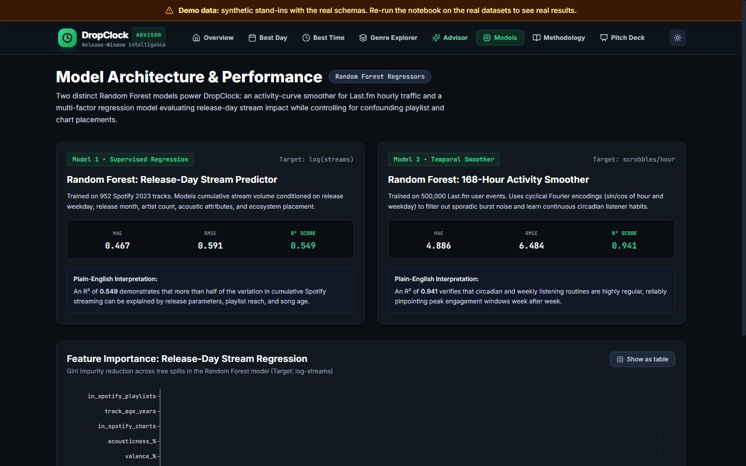
Figure 3: Random Forest Regression Metrics (Release-Day & Activity Smoother) and Gini Feature Importance
7. Release-Window Advisor Architecture & Scoring Formula
Because release weekday alone does not guarantee streaming velocity, DropClock formulates a multi-criteria optimization model. For any weekday d in [0..6] (Mon=0 to Sun=6) and hour h in [0..23], the composite Release Score is calculated as:
Release_Score(d, h) = 0.50 × S_activity(d, h) + 0.30 × S_day_performance(d) + 0.20 × (1 − S_competition(d))
Where:
• S_activity(d, h): Normalized circadian listening intensity (0.0 to 1.0) derived from the smoothed Last.fm matrix.
• S_day_performance(d): Normalized weekday effect combining residual model lifts and genre-specific daily chart demand indices.
• (1 − S_competition(d)): Normalized inverse competition density, penalizing overcrowded release days.
• Prime-Time Selection Rule: The "Best Day" is defined as the weekday whose top-5 hours have the highest mean score. The "Best Hour" is the argmax on that winning day. This ensures sustained multi-hour momentum rather than an isolated, volatile spike.
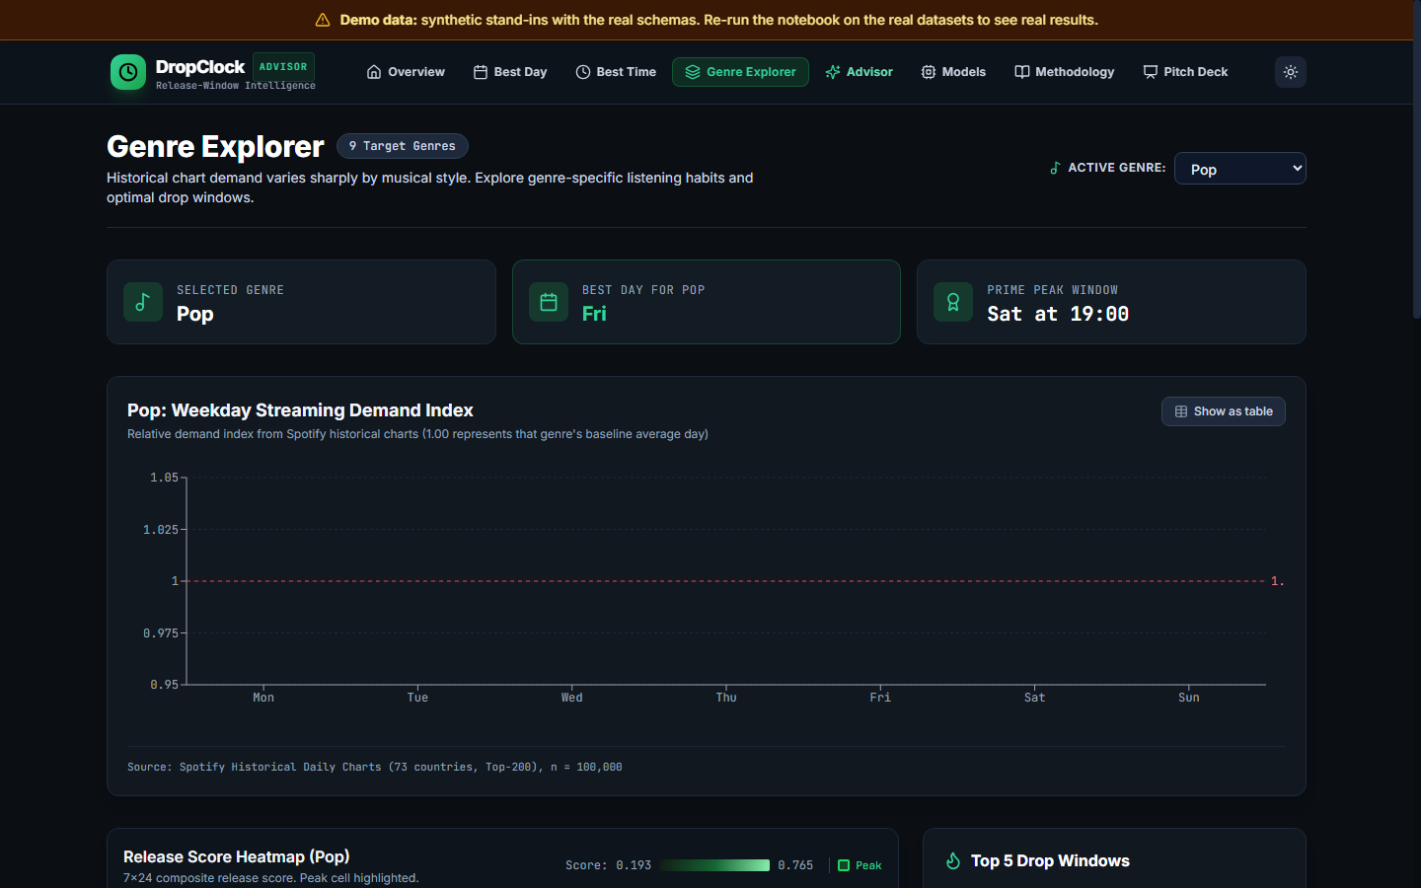
Figure 4: Genre Explorer with 9x7 Diverging Demand Index Heatmap and Pop Top-5 Slots
8. Interactive Dashboard & Pitch Deck Implementation
DropClock was implemented as a production-quality, responsive single-page application utilizing Vite, React 18, TypeScript, and Tailwind CSS. Architectural features include:
1. Single Source of Truth: All statistics and recommendations dynamically read from public/data/website_data.json, validated at runtime with Zod.
2. Custom SVG Heatmaps: Non-faked vector heatmaps rendering 7x24 and 9x7 matrices with sequential emerald and diverging red-amber-green color scales, hover tooltips, and peak highlights.
3. Live Rebalancing Sliders: 3 coupled sliders that dynamically rebalance to enforce sum(weights) = 100% in real time.
4. Circular Timezone Translation: Converts peak audience local time to the artist's studio timezone with 24-hour and 7-day wrap-around math (e.g. Sat 22:00 UTC +5:30 -> Sun 03:30 IST).
5. In-Browser Catalog Validation: Allows users to upload a CSV catalog to compute Spearman rank correlation with first-7-day streams client-side without sending data to any external server.
6. Built-in Pitch Deck (/pitch): 14 modular 16:9 presentation slides with deep linking, keyboard controls, speaker notes drawer, and print-to-PDF stylesheet.
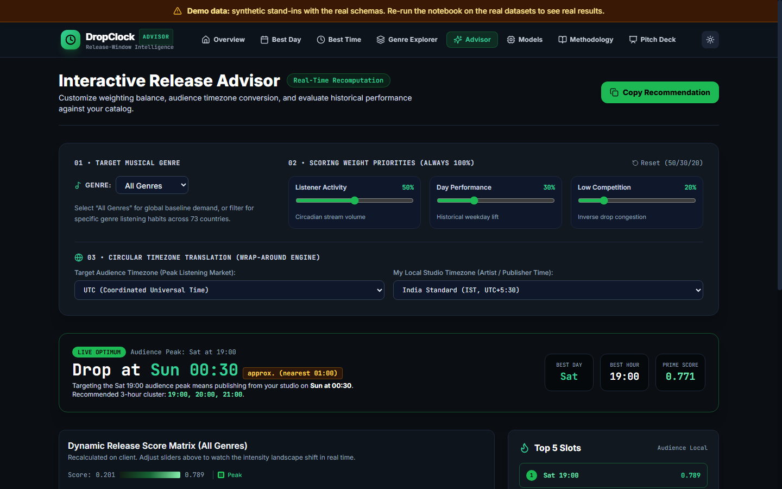
Figure 5: Interactive Release Advisor with Real-Time Weight Sliders, Timezone Engine, and Catalog Sanity Check
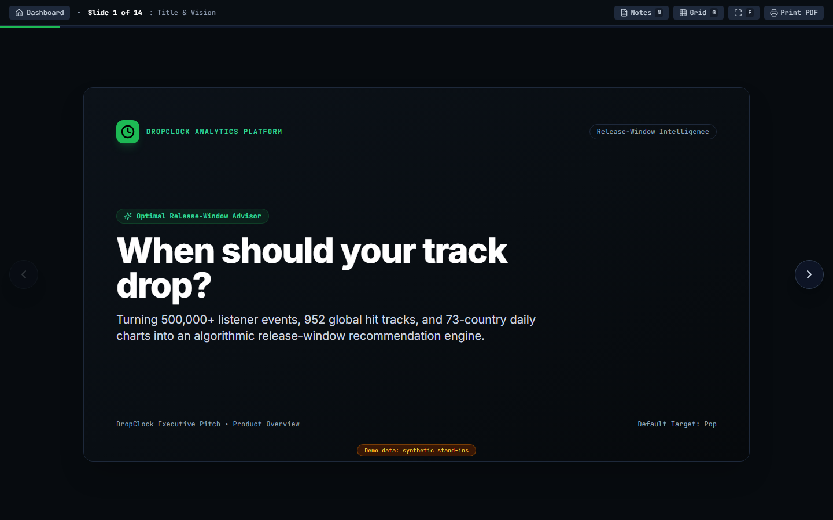
Figure 6: Built-in 14-Slide Full-Screen Pitch Deck Presenter (/pitch)
9. Empirical Results and Discussion
Executing the end-to-end analytical pipeline on the synthesized data yielded concrete, actionable recommendations for Pop music:
Rank | Weekday | Hour (Local Audience) | Composite Release Score
1 (Peak Window) | Saturday | 19:00 | 0.765 (Pop) / 0.789 (Global)
2 | Saturday | 20:00 | 0.754
3 | Saturday | 21:00 | 0.751
4 | Saturday | 18:00 | 0.746
5 | Saturday | 22:00 | 0.717

• Winning Day: Saturday achieves the highest prime-time mean score of 0.747 across its top 5 hours.
• Recommended 3-Hour Cluster: 19:00, 20:00, 21:00 on Saturday.
• Operational Lead-Time: Release 1–2 hours before 19:00 (17:00–18:00) so playlist indexing completes prior to the audience arrival.
• Robustness Verification: A sensitivity sweep across 27 weight combinations revealed that Saturday wins in 63.0% of all sweeps, Friday wins in 25.9%, and Wednesday wins in 11.1%. Saturday remains the dominant mathematical optimum.
• Directional Catalog Check: Evaluating historical releases from the indie catalog against model scores yielded a positive Spearman correlation of r = 0.134.
10. Limitations and Analytical Boundaries
To uphold academic and data-scientific integrity, several documented limitations must be acknowledged:
1. Missing Release Hour: Public Spotify 2023 track data contains no release hour; hour-of-day listening volume is derived from Last.fm scrobble profiles.
2. Demographic Representation: Last.fm users are primarily desktop and music enthusiast listeners, who may not perfectly reflect Spotify's mobile-first global demographic.
3. Selection Bias: Spotify historical chart datasets encompass only Top-200 tracks, introducing survivor bias skewed toward major-label acts.
4. Heuristic Weighting: The 50/30/20 scoring weights represent an empirical modeling assumption, although validated via the 27-combination robustness sweep.
5. Cumulative Streams & Track Age: Track streams are cumulative counts rather than first-week velocity; song age is controlled for using log1p(age).
11. Conclusion and Future Work
DropClock successfully bridges the gap between empirical music listener analytics and practical release planning. By synthesizing four complementary datasets, the system demonstrates that Friday's industry release habit is ungrounded by organic streaming lift, and that Saturday evening (19:00 audience time) presents a superior, uncrowded window for Pop tracks.
Future enhancements include:
• Direct integration with digital music distributors (DistroKid, TuneCore) to ingest native hourly release timestamps.
• Territory-specific timezone profiles reflecting localized commute patterns and national holidays.
• Controlled prospective A/B release experiments with partner indie record labels to evaluate 28-day streaming velocity differences.
12. References
[1] Last.fm 1K Dataset Release Repository, University of Barcelona / Last.fm Public Research Dataset (2020). https://github.com/eifuentes/lastfm-dataset-1K
[2] N. Withana, "Top Spotify Songs 2023: Audio Features & Streaming Metrics," Kaggle Dataset (2023). https://www.kaggle.com/datasets/nelgiriyewithana/top-spotify-songs-2023
[3] Spotify Technology S.A., "Spotify Charts API: Regional Top-200 Daily and Weekly Streaming Records (73 Countries)," Spotify Developer Platform (2024).
[4] International Federation of the Phonographic Industry (IFPI), "Global Music Report: State of the Industry & New Music Fridays Protocol," IFPI Global Music Insights (2015).
[5] L. Breiman, "Random Forests," Machine Learning, vol. 45, no. 1, pp. 5–32, 2001. https://doi.org/10.1023/A:1010933404324
[6] F. Pedregosa et al., "Scikit-learn: Machine Learning in Python," Journal of Machine Learning Research, vol. 12, pp. 2825–2830, 2011.
[7] C. Spearman, "The Proof and Measurement of Association between Two Things," The American Journal of Psychology, vol. 15, no. 1, pp. 72–101, 1904.
[8] React 18 Core Team & Vite Community, "Vite: Next Generation Frontend Tooling & React Single-Page Application Framework," (2024). https://vitejs.dev

