AgroDetect — Comprehensive Project Documentation

Project Description:
AgroDetect is an advanced AI-based agricultural image analysis platform designed to assist farmers, agronomists, researchers, and home gardeners in identifying plant diseases and detecting various fruits and vegetables using image recognition technology.
The system utilizes modern deep learning models capable of analyzing plant images and identifying disease patterns within seconds. Users can simply upload an image or capture a photo of a plant leaf, fruit, or vegetable using their device’s camera. The system then processes the image and predicts the most likely disease or crop type based on trained machine learning models.
One of the key advantages of AgroDetect is that it does not stop at providing only classification results. Instead, it integrates the prediction output with an extensive knowledge base that contains detailed agricultural information. After detecting a disease, the system provides a comprehensive report that includes the disease name, description, symptoms, causes, recommended treatments, and preventive measures.
The platform is designed to be highly user-friendly and accessible from multiple devices such as smartphones, tablets, and computers. This ensures that farmers in remote areas can easily access the technology without requiring expensive hardware or complex installations.
Additionally, AgroDetect is built using a modular architecture that allows the integration of multiple machine learning models. For instance, the system can dynamically switch between plant disease classification models and fruit/vegetable detection models depending on the uploaded image. This intelligent routing mechanism improves prediction accuracy and ensures that the appropriate model is used for each analysis task.
Overall, AgroDetect functions as a complete digital agricultural assistant that helps users quickly diagnose plant diseases and make informed decisions regarding crop treatment and management.

Scenarios
Scenario 1: Farmer Detecting Plant Disease
A farmer notices unusual spots and discoloration on the leaves of tomato plants in the field. Unsure whether the symptoms indicate early blight, bacterial spot, or nutrient deficiency, the farmer uploads a photo of the leaf to AgroDetect.
AgroDetect processes the image using its trained disease classification model and identifies the condition as Tomato Early Blight with a high confidence score.
The platform then provides:
- Disease name and classification
- Symptoms associated with the disease
- Causes of infection
- Recommended chemical treatments
- Organic treatment alternatives
- Preventive farming practices
This allows the farmer to quickly apply appropriate treatment and prevent the disease from spreading across the crop.

Scenario 2: Home Gardener Diagnosing Plant Health
A home gardener growing vegetables in a backyard garden notices that the leaves of an apple tree have developed dark circular patches. The gardener uploads an image to AgroDetect for analysis.
The AI system detects the disease as Apple Scab and generates a detailed report describing the condition and possible remedies.
The platform suggests organic treatment methods such as:
- Pruning infected leaves
- Improving air circulation
- Applying sulfur-based sprays
This enables the gardener to protect the plant while maintaining organic gardening practices.

Scenario 3: Agricultural Researcher Monitoring Crop Health
An agricultural researcher conducting experiments on crop health wants to analyze multiple plant images to identify disease patterns. By using AgroDetect, the researcher uploads images of plant samples collected from different farms.
The system analyzes the images and classifies diseases across various plant species. The researcher can observe disease distribution patterns and study environmental factors influencing crop health.
This helps researchers develop better disease prevention strategies and improve agricultural research outcomes.
Architecture Overview:

AgroDetect follows a modular AI-driven architecture consisting of a frontend user interface, backend processing layer, and machine learning inference engine.
The platform is built using a lightweight yet powerful architecture that allows seamless communication between the user interface and AI models. The architecture ensures efficient image processing, accurate predictions, and smooth user experience.
The system workflow begins when a user uploads an image through the web interface. The image is then preprocessed and passed to the machine learning model for analysis. Once the model generates a prediction, the system retrieves additional disease information from the knowledge base and displays the results in a structured format.
This modular design ensures scalability and allows additional models and features to be integrated into the system in future versions.
Core Components
Streamlit Frontend
The frontend of AgroDetect is developed using Streamlit, a Python-based web framework designed for building interactive data applications. The interface provides a clean and simple environment where users can upload plant images, view analysis results, and explore treatment recommendations.
Streamlit also enables the integration of dynamic visual elements such as charts, confidence scores, and disease severity indicators.

Image Processing Module
The image processing module is responsible for handling uploaded images. It performs preprocessing steps such as resizing images, converting formats, and normalizing pixel values before sending them to the machine learning model.
This ensures that all images meet the input requirements of the classification models.

AI Disease Detection Model
The core functionality of AgroDetect is powered by deep learning models trained on plant disease datasets. These models analyze visual features of plant leaves, fruits, or vegetables and classify them into specific disease categories.
The system utilizes optimized convolutional neural network architectures that provide high accuracy while maintaining efficient performance.

Knowledge Base Module
The knowledge base module maps the AI prediction results to detailed agricultural information. It contains structured data about plant diseases, including symptoms, causes, treatment options, and preventive measures.
This module transforms raw machine learning outputs into user-friendly diagnostic reports.

Pre-Requisites
Accounts & API Keys
In order to run AgroDetect effectively, certain accounts and configurations may be required.
Hugging Face Account
https://huggingface.co
This account allows access to pre-trained machine learning models used for plant disease classification.

Tools & Frameworks
Python 3.9+
Streamlit – Used for developing the web application interface
PyTorch – Deep learning framework used for running neural network models
Transformers (HuggingFace) – Used for loading and managing pretrained AI models
Pillow – Image processing library for handling uploaded images
Plotly – Used for generating interactive visualizations
Visual Studio Code – Development environment used for coding and testing the application

Project Workflow:
Phase 1: Environment Setup
Activity 1.1: Install Python Environment & Dependencies
The development environment is prepared by installing Python and necessary libraries required for machine learning and web development.
Activity 1.2: Configure Project Environment
A virtual environment is created to isolate project dependencies and ensure smooth execution.
Activity 1.3: Install Required Libraries
All required libraries such as Streamlit, PyTorch, and Transformers are installed using package managers.

Phase 2: Backend Development
Activity 2.1: Project Structure Setup
The initial project directory structure is created, organizing files into modules such as frontend, model processing, and configuration files.
Activity 2.2: Model Integration
Pretrained machine learning models are integrated into the system for plant disease classification.
Activity 2.3: Image Processing Pipeline
The image preprocessing pipeline is developed to standardize uploaded images before model inference.
Activity 2.4: Disease Detection Feature
The AI model is connected to the application interface to analyze images and generate disease predictions.
Activity 2.5: Knowledge Base Mapping
Prediction results are linked to a structured agricultural knowledge base to provide detailed disease information.

Phase 3: Frontend Development
Activity 3.1: User Interface Design
A user-friendly dashboard is developed using Streamlit to allow easy interaction with the system.
Activity 3.2: Image Upload Interface
Users are provided with options to upload images or capture photos directly from the application.
Activity 3.3: Result Visualization
Prediction results, confidence scores, and disease information are displayed in a clear and organized format.

Phase 4: Deployment
Activity 4.1: Local Deployment Setup
The application is configured to run locally using the Streamlit development server.
Activity 4.2: Application Testing
The system is tested to ensure smooth operation and accurate disease detection.

Phase 5: Testing
Activity 5.1: Functional Testing of Features
All system features including image upload, disease detection, and information display are tested to ensure correct functionality.
Activity 5.2: Model Accuracy Testing
The AI model predictions are validated using test datasets to ensure reliable performance

Technical Architecture:

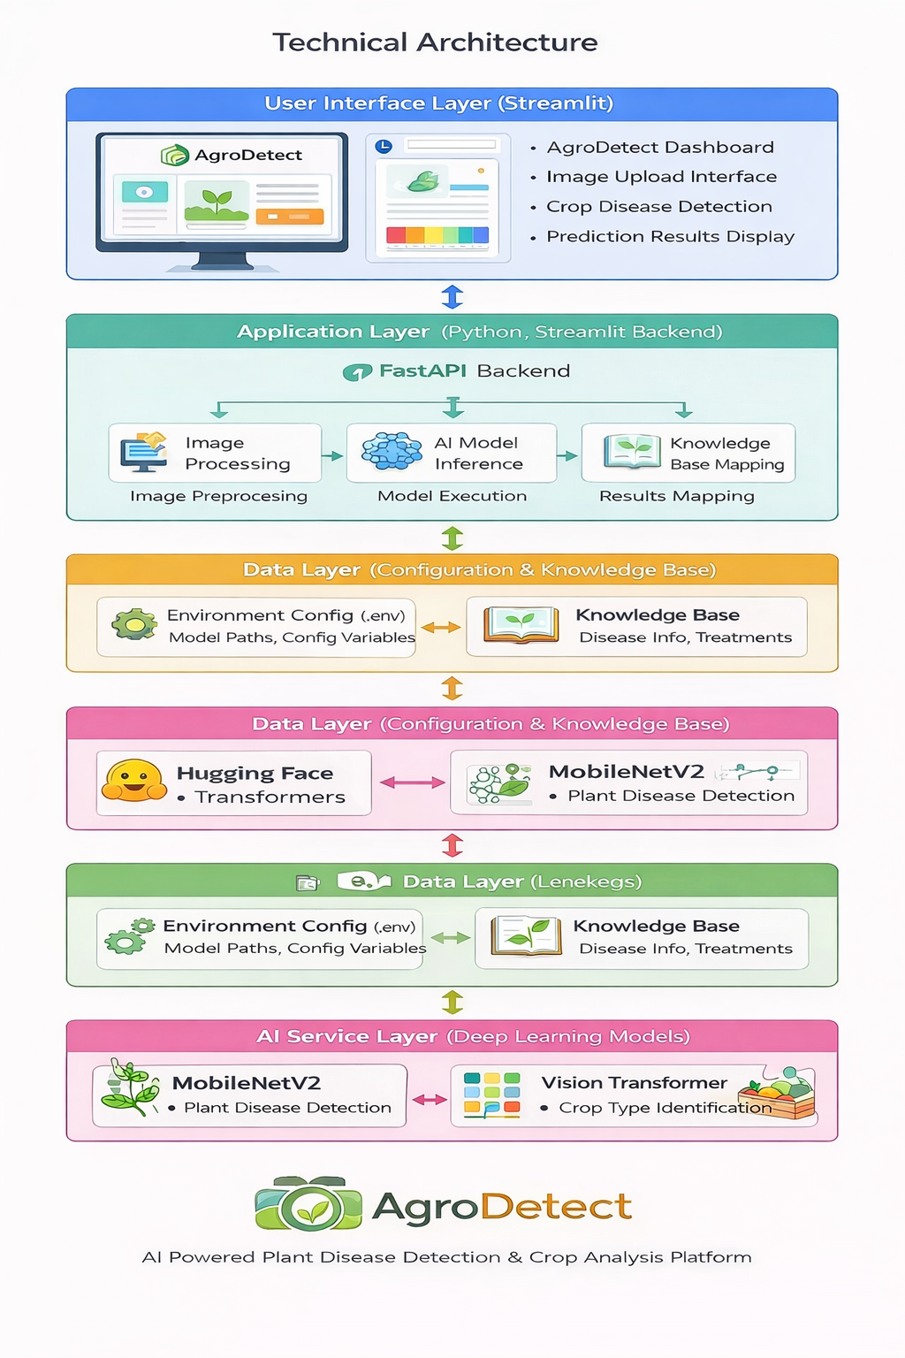
MILESTONE 1: Environment Setup & AI Model Configuration
This milestone establishes the foundational AI development environment required for the AgroDetect system. It involves installing the required programming environment, configuring essential libraries, and preparing the deep learning model used for plant disease detection.
The main objective of this phase is to ensure that the system can process crop images, load the trained AI model, and perform accurate plant disease classification.
By the end of this milestone, the development environment will be fully configured and ready for implementing the backend services and machine learning model integration.

Activity 1.1: Install Python Environment & Dependencies
The AgroDetect platform is developed using Python because of its extensive ecosystem for machine learning, computer vision, and web applications. This activity focuses on installing Python, creating an isolated environment for project dependencies, and installing all required libraries.
Step 1: Install Python
Download and install Python 3.10 or higher from the official Python website.
Download link:
https://www.python.org/downloads/
Ensure that “Add Python to PATH” is checked during installation.

Step 2: Create Virtual Environment
A virtual environment isolates project dependencies and prevents conflicts between different Python projects.
Run the following command to create a virtual environment:
python -m venv venv

Step 3: Activate Virtual Environment
For Windows:
venv\Scripts\activate
Once activated, the terminal prompt will show:
(venv)
This indicates that the project environment is active.

Step 4: Install Required Dependencies
Install the required Python libraries for the AgroDetect system.
pip install streamlit
pip install tensorflow
pip install keras
pip install numpy
pip install pillow
pip install opencv-python
pip install scikit-learn
pip install matplotlib
pip install python-dotenv
These libraries provide support for:
• Deep learning model execution
• Image processing and preprocessing
• Data manipulation and analysis
• Visualization of results
• Environment variable management

Verification
Verify that Python and all libraries are installed correctly.
Check Python version:
python --version
Check installed packages:
pip list
The installed packages should include:
• tensorflow
• keras
• numpy
• streamlit
• opencv-python
• pillow
Successful installation confirms that the environment is ready for AI model execution.

Activity 1.2: Configure AI Model for Plant Disease Detection
AgroDetect uses a Convolutional Neural Network (CNN) based deep learning model to analyze plant leaf images and detect diseases.
The model used in this project is based on MobileNetV2, a lightweight and efficient deep learning architecture designed for image classification tasks.
Steps
- Download or place the trained model file in the project directory.
Example:
plant_disease_model.h5
- Load the model using TensorFlow/Keras.
Example code:
from tensorflow.keras.models import load_model
model = load_model("plant_disease_model.h5")
- The model processes input images and predicts the disease category.
Example prediction workflow:
• Input: Leaf image uploaded by user
• Preprocessing: Image resizing and normalization
• Model Inference: CNN analyzes leaf patterns
• Output: Predicted disease label

Model Capabilities
The trained model can identify multiple plant diseases such as:
• Leaf Spot
• Early Blight
• Late Blight
• Powdery Mildew
• Healthy Plant Condition
The CNN model extracts visual features such as:
• Leaf texture
• Color variations
• Disease spots
• Shape abnormalities
Models
ozair23/mobilenet_v2_1.0_224-finetuned-plantdisease
linkanjarad/mobilenet_v2_1.0_224-plant-disease-identification
Diginsa/Plant-Disease-Detection-Project
jazzmacedo/fruits-and-vegetables-detector

This enables accurate classification of plant health conditions.

Activity 1.3: Install Image Processing & Data Handling Libraries
Since AgroDetect works with plant images, image preprocessing is a crucial step before feeding data into the AI model.
This activity installs libraries required for image loading, resizing, and transformation.
Install Required Libraries
pip install pillow
pip install opencv-python
pip install numpy
Purpose of Each Library
Pillow (PIL)
Used for opening and manipulating images uploaded by users.
OpenCV
Provides advanced image processing capabilities such as filtering, resizing, and color transformations.
NumPy
Used for numerical operations and converting images into arrays that can be processed by the AI model.

Image Preprocessing Example
import cv2
import numpy as np
image = cv2.imread("leaf.jpg")
image = cv2.resize(image, (224,224))
image = image / 255.0
image = np.reshape(image, (1,224,224,3))
This preprocessing step ensures that the image is formatted correctly for the CNN model.

Outcome of Milestone
After completing this milestone:
• Python development environment will be fully configured
• All required libraries will be installed
• The plant disease detection model will be integrated
• Image preprocessing pipeline will be ready
This prepares the system for the next phase, which involves backend development and building the AgroDetect user interface for disease prediction.

Test 1: Home Page
Open application in browser.

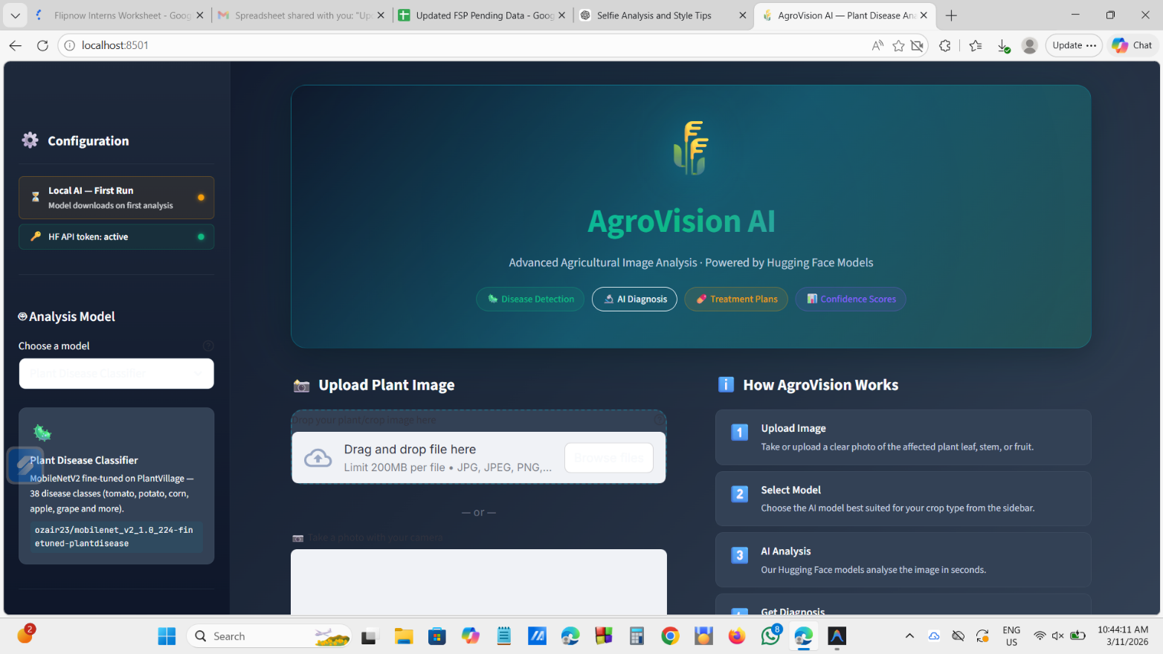

Test 2: image upload

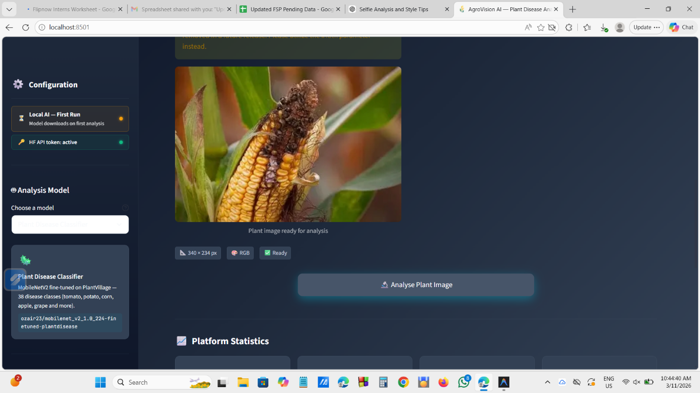

Test 3 diagnosis

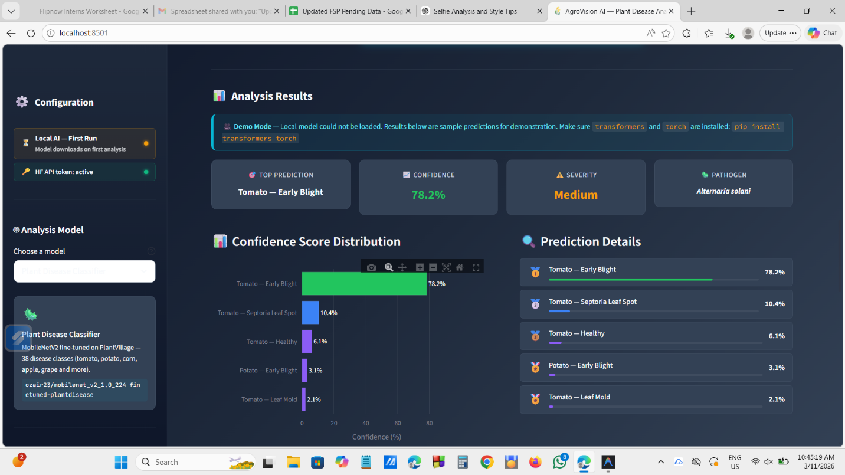

Test 3 :additional features

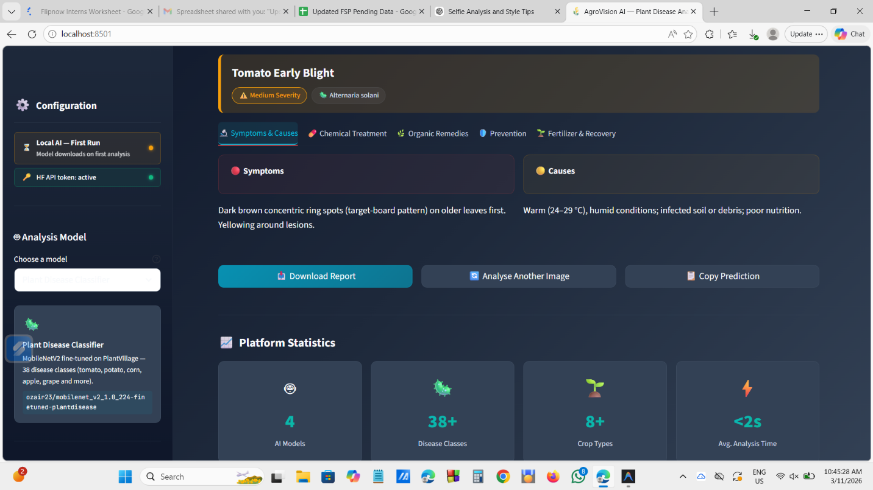

Test 4:available models
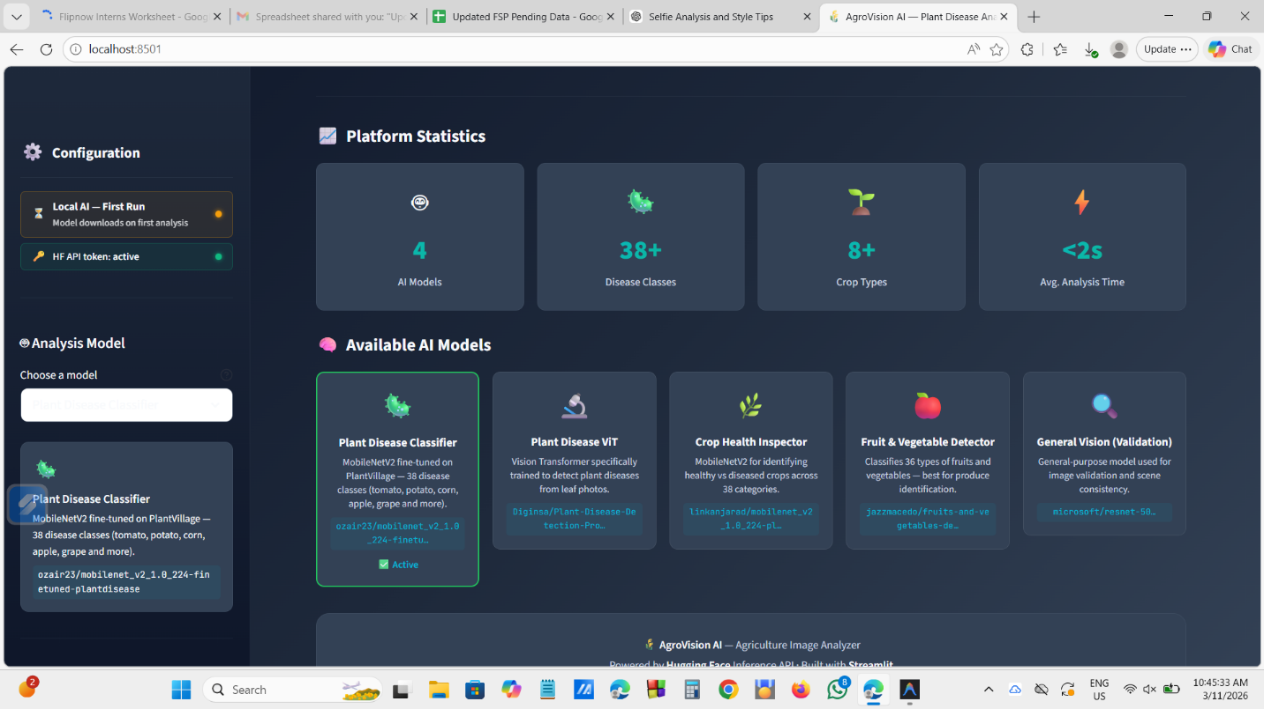

Conclusion
AgroDetect is an AI-powered plant disease detection system designed to assist farmers, researchers, and agricultural professionals in identifying crop diseases quickly and accurately. The platform leverages modern deep learning and computer vision techniques to analyze plant leaf images and detect diseases at an early stage, enabling timely intervention and improved crop management.
The system integrates image processing, convolutional neural networks, and a user-friendly web interface to create an efficient and accessible solution for agricultural disease diagnosis. By allowing users to upload images of plant leaves and receive instant predictions, AgroDetect simplifies the process of disease identification and reduces dependency on manual inspection or expert consultation.
The architecture of AgroDetect combines multiple components including the Streamlit-based user interface, Python backend, image preprocessing modules, and deep learning models such as MobileNetV2. These components work together to process input images, extract relevant features, and classify plant diseases with high accuracy.
One of the major advantages of AgroDetect is its ability to provide rapid, automated analysis, which can significantly help in preventing crop losses caused by undetected plant diseases. Early detection allows farmers to apply the correct treatments, reduce pesticide misuse, and improve overall agricultural productivity.
Additionally, the system demonstrates how Artificial Intelligence can be effectively applied in agriculture to solve real-world problems. By combining AI models with accessible web technologies, AgroDetect showcases a scalable approach that can be further expanded with additional datasets, disease categories, and smart farming integrations.
In conclusion, AgroDetect represents a practical and innovative application of AI in precision agriculture, offering a reliable tool for plant disease detection. With further improvements and larger datasets, the platform has the potential to evolve into a comprehensive agricultural support system that contributes to sustainable farming and improved food security.

