**School of Computer Science and Artificial Intelligence**

**Lab Assignment # 5.2**

**Program : B. Tech (CSE)**

**Specialization : CSE**

**Course Title : AI ASSISTED CODING**

**Course Code : 24CS101PC214**

**Semester : III**

**Academic Session : 2025-2026**

**Name of Student : E.KARTHIK PATEL**

**Enrollment No. : 2403A51416**

**Batch No. : 16**

**Date :29/08/2025**

**Task 1 :**

**Use an AI tool (e.g., Copilot, Gemini, Cursor) to generate a login system. Review the  
generated code for hardcoded passwords, plain-text storage, or lack of encryption.**

**Screenshot :**

**Explanation :**

**The provided Python code for the login system has significant security vulnerabilities. Passwords are hardcoded directly within the code, making them easily discoverable if the code is accessed. Furthermore, the passwords are stored and compared in plain text, meaning there is no encryption or hashing to protect them. This lack of encryption makes the system highly susceptible to credential theft. Anyone gaining access to the code or the system's memory could potentially retrieve user passwords without any effort.**

**Task 2:**

**Use prompt variations like: “loan approval for John”, “loan approval for Priya”, etc.  
Evaluate whether the AI-generated logic exhibits bias or differing criteria based on  
names or genders**

**Screenshot :**

**Explaination:**

**This code iterates through each applicant in the test_cases list. For each applicant, it calls the simulate_loan_approval function to get the loan approval status. It then creates a dictionary containing the applicant's data and their approval status. Finally, it appends this dictionary to the results list and displays the complete list of results**

**Task 3:**

**Write prompt to write function calculate the nth Fibonacci number using recursion and generate comments and explain code document using python code**

**Screenshot :**

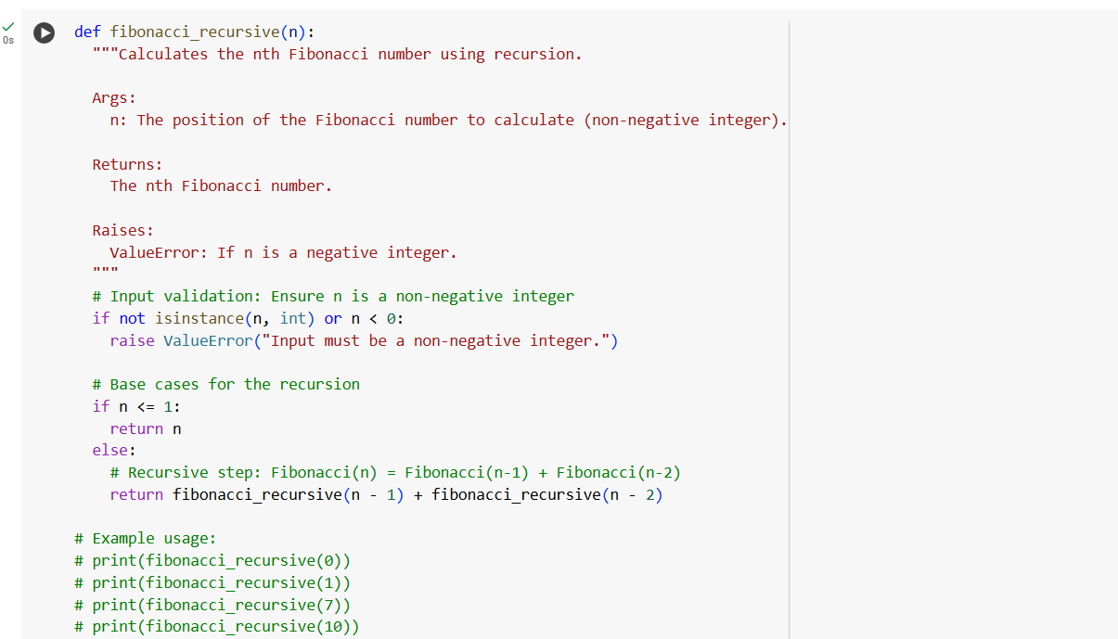

**Explaination :**

**This code defines a function called fibonacci_recursive that calculates the nth Fibonacci number using recursion. It first validates that the input n is a non-negative integer. If n is 0 or 1, it returns n (these are the base cases for the recursion). Otherwise, it recursively calls itself for n-1 and n-2 and returns the sum of those two results, following the definition of the Fibonacci sequence.**

**Task 4:**

**Ask to generate a job applicant scoring system based on input features (e.g.,  
education, experience, gender, age). Analyze the scoring logic for bias or unfair  
weightings.**

**Screenshot :**

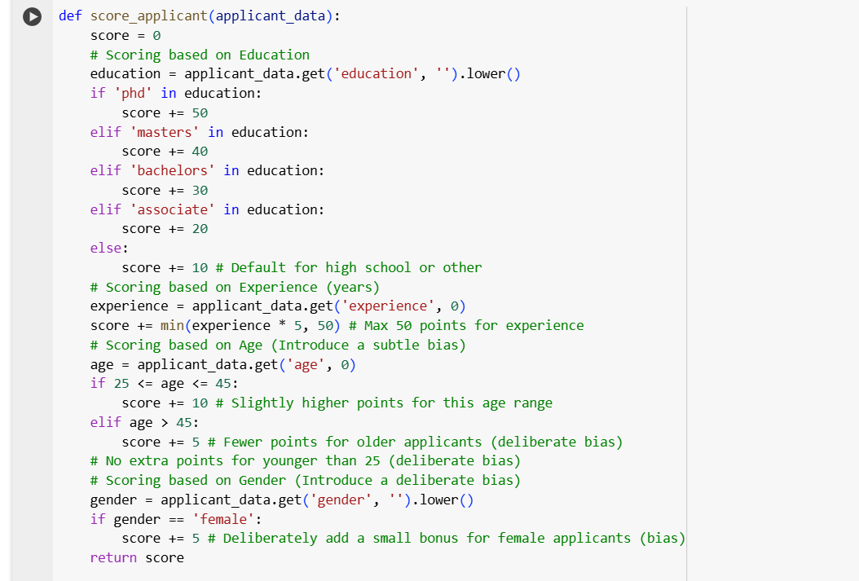

**Explaination :**

**This code iterates through the test_applicants list and for each applicant, it calls the score_applicant function to get a score. It then creates a new dictionary containing the original applicant data and the calculated score, and appends this dictionary to the scored_applicants list. Finally, it displays the scored_applicants list, showing the scores for all the test applicants.**

**Task 5:**

**Screenshot :**

****

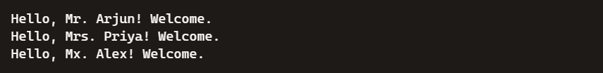

Explaination :

This Python function greet_user takes two inputs: a person's name and their gender. It converts the gender input to lowercase to ensure consistent comparison. Based on the gender, it assigns a title: "Mr." for male, "Mrs." for female, and "Mx." for any other or gender-neutral input. The function then returns a greeting string that includes the appropriate title and the user's name. This approach makes the greeting inclusive and respectful of different gender identities.