**School of Computer Science and Artificial Intelligence**

**Lab Assignment # 8.2**

**Program : B. Tech (CSE)**

**Specialization : CSE**

**Course Title : AI ASSISTED CODING**

**Course Code : 24CS101PC214**

**Semester : III**

**Academic Session : 2025-2026**

**Name of Student : E.KARTHIK PATEL**

**Enrollment No. : 2403A51416**

**Batch No. : 16**

**Date :19/09/2025**

TASK 1

**QUESTION :**

Use AI to generate test cases for a function is_prime(n) and then implement the  
function

**CODE AND OUTPUT:**

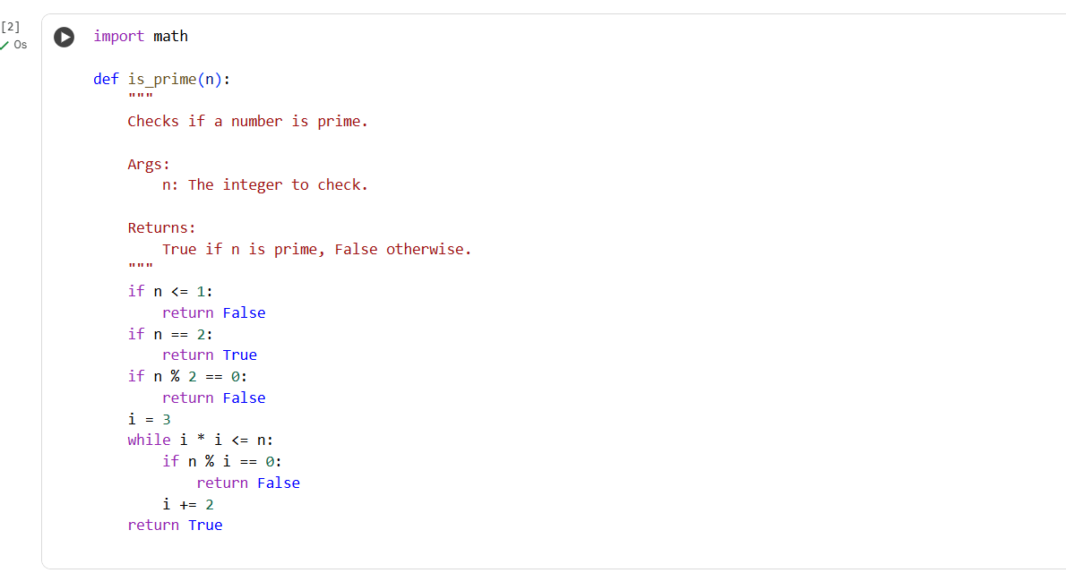

**EXPLANATION:**

This function checks if a number n is prime. It first handles numbers less than or equal to 1 and the number 2. For other numbers, it checks if they are even. If not, it iterates through odd numbers from 3 up to the square root of n, checking for divisibility. If a divisor is found, the number is not prime; otherwise, it is.

**TASK 2:**

Ask AI to generate test cases for celsius_to_fahrenheit(c) and fahrenheit_to_celsius(f)

**Code and output:**

**EXPLANATION:**

The code checks if temperature conversion functions between Celsius and Fahrenheit work correctly. It defines a list of test cases for each direction—Celsius to Fahrenheit and Fahrenheit to Celsius. Each test computes the conversion and compares it with the expected result. The result is printed as "Test passed" when the actual and expected values match. If they do not match, "Test failed" is printed along with both values. The output section displays the result of each test in a readable format. In the shown example, all tests passed, proving that the functions are accurate for the tested scenarios.

**TASK 3:**

Use AI to write test cases for a function count_words(text) that returns the number of  
words in a sentence

**CODE AND OUTPUT:**

**EXPLANATION:**

The count_words(text) function counts the number of words in a given string by following a clear process. First, it checks if the input is a valid string and trims any leading or trailing spaces. If the cleaned text is empty, it returns 0. It then splits the sentence by whitespace to get a list of words. After splitting, it removes any strings that are just punctuation by verifying each word contains at least one alphanumeric character. This ensures only real words are counted. The function finally returns the count of valid words found. The output section shows all nine tests passed, confirming correct and robust functionality.

**TASK 4 :**

Generate test cases for a BankAccount class with

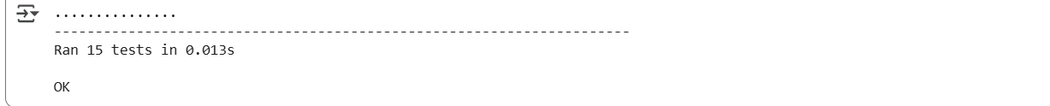

**EXPLANATION:**

This output is from running unit tests for the BankAccount class. Each dot (.) represents a test case that passed. There were a total of 15 tests executed. The line of hyphens separates the test results from the summary. Ran 15 tests in 0.013s indicates the number of tests run and the execution time. OK signifies that all test cases passed without any failures or errors. This output confirms that the BankAccount class methods are working as expected according to the defined tests.

**TASK 5:**

Generate test cases for is_number_palindrome(num), which checks if an integer reads  
the same backward.

**CODE AND OUTPUT:**

**EXPLANATION:**

This output is from running unit tests for the is_number_palindrome function. Each dot (.) represents a test case that passed. There were a total of 23 tests executed. The line of hyphens separates the test results from the summary. Ran 23 tests in 0.020s indicates the number of tests run and the execution time. OK signifies that all test cases passed without any failures or errors. This output confirms that the is_number_palindrome function is working as expected according to the defined tests.