Electronic Device Recommendation System

*A*

*DBMS Project Report*

*Submitted in partial fulfilment of the Requirements for the award of the Degree of*

**BACHELOR OF ENGINEERING** IN **INFORMATIONTECHNOLOGY**

By

**Peetela Karthik - 1602-22-737-317**

**Chanakya M - 1602-22-737-137**



**Department of Information Technology Vasavi College of Engineering(Autonomous)**

**ACCREDITEDBY NAAC WITH 'A++'GRADE**

**(Affiliated to Osmania University and Approved by AICTE) Ibrahimbagh,Hyderabad-31**

**2024**

**Vasavi College of Engineering (Autonomous)**

**ACCREDITED BY NAAC WITH'A++'GRADE**

**(Affiliated to Osmania University and Approved by AICTE)Hyderabad-500031 DepartmentofInformationTechnology**

**DECLARATIONBYTHECANDIDATE**

We **Karthik, Chanakya** bearing hall ticket numbers **1602-22-737-317,1602-22-737-137** here by declare that the project report entitled **“Electronic Device Recommendation System”** is submitted in partial fulfilment of the requirement for the award of the degree of **Bachelor of Engineering in Information Technology.**

This is a record of bonafide work carried out by us and the results embodied in this project report have not been submitted to any other university or institute for the award of any other degree or diploma.

**Peetela Karthik**

**1602-22-737-317**

**Chanakya M**

**1602-22-737-137**

(FacultyIn-Charge) (Head,DeptofIT)

ACKNOWLEDGMENT

We extend our sincere thanks to Dr. S. V. Ramana, Principal, Vasavi College of Engineering for his encouragement.

We express our sincere gratitude to Dr. K. Ram Mohan Rao, Professor & Head, Department of Information Technology, Vasavi College of Engineering, for introducing the Mini-Project module in our curriculum, and also for his suggestions, motivation, and co-operation for the successful completion of our Mini Project.

We also want to thank and convey our gratitude towards our DBMS Faculty, SreeLakshmi for guiding us in understanding the process of project development & giving us timely suggestions at every phase.

ABSTRACT

In today's fast-paced consumer electronics market, selecting the right device has become increasingly complex due to numerous options. Electronic device recommendation systems have emerged to help consumers make informed decisions by leveraging machine learning and data analytics. These systems utilize user preferences, product specifications, reviews, and expert opinions to generate personalized recommendations.

Key components of these systems include data collection, feature extraction, similarity computation, and recommendation generation.

These recommendation systems are widely used in e-commerce, online retail, and consumer electronics stores, enhancing user experience, increasing customer satisfaction, and driving sales. By offering tailored recommendations, they simplify the decision-making process, helping users find products that best match their preferences.

**Introduction:**

In the rapidly evolving landscape of consumer electronics, selecting the most suitable device has become a daunting task for consumers, overwhelmed by the sheer variety and complexity of available options. The explosion of technological advancements and the burgeoning consumer electronics market have further compounded this challenge. To navigate this vast array of choices, electronic device recommendation systems have emerged as essential tools, leveraging sophisticated machine learning and data analytics techniques to aid consumers in making well-informed decisions.

This project report delves into the significance, methodologies, and applications of electronic device recommendation systems. These systems harness diverse data sources, including user preferences, product specifications, reviews, and expert opinions, to generate personalized recommendations tailored to individual needs and preferences. By integrating advanced algorithms such as collaborative filtering, content-based filtering, and hybrid approaches, these systems analyze user data and accurately predict preferences. Additionally, the incorporation of natural language processing techniques allows for the extraction of valuable insights from textual reviews, further refining the quality of recommendations.

The report explores the key components of recommendation systems, including data collection, feature extraction, similarity computation, and recommendation generation. It also highlights how advancements in deep learning have enhanced the ability to discern intricate patterns in large-scale datasets, resulting in more precise and personalized recommendations.

Electronic device recommendation systems are not only pivotal in e-commerce and online retail but also in physical consumer electronics stores, significantly enhancing the shopping experience by providing users with recommendations that align with their specific preferences. Ultimately, these systems facilitate informed purchasing decisions, increase customer satisfaction, and drive sales.

This project report aims to provide a comprehensive overview of electronic device recommendation systems, emphasizing their role in simplifying the decision-making process for consumers inundated with choices in the electronics market. Through the integration of cutting-edge machine learning and data analytics techniques, these systems offer invaluable assistance in navigating the complex landscape of consumer electronics.

ER Diagram :-

Implementation:-

<!DOCTYPE html>

<html>

<head>

<!-- Basic -->

<meta charset="utf-8" />

<meta http-equiv="X-UA-Compatible" content="IE=edge" />

<!-- Mobile Metas -->

<meta name="viewport" content="width=device-width, initial-scale=1, shrink-to-fit=no" />

<!-- Site Metas -->

<meta name="keywords" content="" />

<meta name="description" content="" />

<meta name="author" content="" />

<title>DBMS</title>

<!-- bootstrap core css -->

<link rel="stylesheet" type="text/css" href="css/bootstrap.css" />

<link href="https://fonts.googleapis.com/css?family=Poppins:400,700&display=swap" rel="stylesheet">

<!-- Custom styles for this template -->

<link href="css/style.css" rel="stylesheet" />

<!-- responsive style -->

<link href="css/responsive.css" rel="stylesheet" />

</head>

<body>

<div class="hero_area">

<!-- header section strats -->

<header class="header_section">

<div class="container-fluid">

<nav class="navbar navbar-expand-lg custom_nav-container">

<a class="navbar-brand" href="index.html">

<img src="images/logo.png" alt="" />

<span>

ElectroRec

</span>

</a>

<button class="navbar-toggler" type="button" data-toggle="collapse" data-target="#navbarSupportedContent" aria-controls="navbarSupportedContent" aria-expanded="false" aria-label="Toggle navigation">

<span class="navbar-toggler-icon"></span>

</button>

<div class="collapse navbar-collapse" id="navbarSupportedContent">

<ul class="navbar-nav ">

<li class="nav-item active">

<a class="nav-link" href="index.html">Home <span class="sr-only">(current)</span></a>

</li>

<li class="nav-item">

<a class="nav-link" href="index.html"> About</a>

</li>

<li class="nav-item">

<a class="nav-link" href="index.html"> Category </a>

</li>

</ul>

<div class="user_option">

<a href="login.HTML">

<span>

Login

</span>

</a>

<form class="form-inline my-2 my-lg-0 ml-0 ml-lg-4 mb-3 mb-lg-0">

<button class="btn my-2 my-sm-0 nav_search-btn" type="submit"></button>

</form>

</div>

</div>

<div>

<div class="custom_menu-btn ">

<button>

<span class=" s-1">

</span>

<span class="s-2">

</span>

<span class="s-3">

</span>

</button>

</div>

</div>

</nav>

</div>

</header>

<!-- end header section -->

<!-- slider section -->

<section class="slider_section ">

<div class="carousel_btn-container">

<a class="carousel-control-prev" href="#carouselExampleIndicators" role="button" data-slide="prev">

<span class="sr-only">Previous</span>

</a>

<a class="carousel-control-next" href="#carouselExampleIndicators" role="button" data-slide="next">

<span class="sr-only">Next</span>

</a>

</div>

<div id="carouselExampleIndicators" class="carousel slide" data-ride="carousel">

<ol class="carousel-indicators">

<li data-target="#carouselExampleIndicators" data-slide-to="0" class="active">01</li>

<li data-target="#carouselExampleIndicators" data-slide-to="1">02</li>

<li data-target="#carouselExampleIndicators" data-slide-to="2">03</li>

</ol>

<div class="carousel-inner">

<div class="carousel-item active">

<div class="container-fluid">

<div class="row">

<div class="col-md-5 offset-md-1">

<div class="detail-box">

<h1>

Electronic<br>

Device <br>

Recommandation <br>

System

</h1>

<p>

"Empowering Choices: Our Electronic Device Recommendation System harnesses cutting-edge algorithms to provide personalized suggestions, enhancing your tech experience."

</p>

</div>

</div>

<div class="offset-md-1 col-md-4 img-container">

<div class="img-box">

<img src="images/slider-img.png" alt="">

</div>

</div>

</div>

</div>

</div>

<!-- about section -->

<section class="about_section layout_padding">

<div class="container">

<div class="row">

<div class="col-md-10 col-lg-9 mx-auto">

<div class="img-box">

<img src="images/about-img.jpg" alt="">

</div>

</div>

</div>

<div class="detail-box">

<h2>

About ElectroRec

</h2>

<p>

Welcome to Electronic Device Recommandation System, where we simplify the world of technology. Our innovative recommendation system analyzes your preferences to suggest the perfect electronic devices for you, whether it's a smartphone, laptop, tablet, or smartwatch. With our user-friendly platform, we empower you to make informed decisions and enhance your tech experience. Join us as we revolutionize the way you discover and choose electronic devices.

</p>

<a href="">

Read More

</a>

</div>

</div>

</section>

<!-- end about section -->

<!-- category section -->

<section class="category_section layout_padding">

<div class="container">

<div class="heading_container">

<h2>

Category

</h2>

</div>

<div class="category_container">

<div class="box">

<div class="img-box">

<img src="images/phone.png" alt="">

</div>

<div class="detail-box">

<h5>

Mobile

</h5>

</div>

</div>

<div class="box">

<div class="img-box">

<img src="images/headphone.png" alt="">

</div>

<div class="detail-box">

<h5>

Head Phone

</h5>

</div>

</div>

<div class="box">

<div class="img-box">

<img src="images/lap.png" alt="">

</div>

<div class="detail-box">

<h5>

Laptop

</h5>

</div>

</div>

<div class="box">

<div class="img-box">

<img src="images/tws.png" alt="">

</div>

<div class="detail-box">

<h5>

TWS

</h5>

</div>

</div>

<div class="box">

<div class="img-box">

<img src="images/watch.png" alt="">

</div>

<div class="detail-box">

<h5>

Watch

</h5>

</div>

</div>

<div class="box">

<div class="img-box">

<img src="images/tab.png" alt="">

</div>

<div class="detail-box">

<h5>

Tablet

</h5>

</div>

</div>

</div>

</div>

</section>

<!-- end category section -->

<!-- freelance section -->

<section class="freelance_section ">

<div id="accordion">

<div class="container-fluid">

<div class="row">

<div class="col-md-5 offset-md-1">

<div class="detail-box">

<div class="heading_container">

<h2>

choose Your product

</h2>

</div>

<div class="tab_container">

<div class="t-link-box" data-toggle="collapse" data-target="#collapseOne" aria-expanded="true" aria-controls="collapseOne">

<div class="img-box">

<img src="images/phone.png" alt="">

</div>

<div class="detail-box">

<h5>

</h5>

<h3>

Mobiles

</h3>

</div>

</div>

<div class="t-link-box collapsed" data-toggle="collapse" data-target="#collapseTwo" aria-expanded="false" aria-controls="collapseTwo">

<div class="img-box">

<img src="images/lap.png" alt="">

</div>

<div class="detail-box">

<h5>

</h5>

<h3>

Laptops

</h3>

</div>

</div>

<div class="t-link-box collapsed" data-toggle="collapse" data-target="#collapseThree" aria-expanded="false" aria-controls="collapseThree">

<div class="img-box">

<img src="images/watch.png" alt="">

</div>

<div class="detail-box">

<h5>

</h5>

<h3>

smartwatchs

</h3>

</div>

</div>

<div class="t-link-box collapsed" data-toggle="collapse" data-target="#collapseFour" aria-expanded="false" aria-controls="collapseFour">

<div class="img-box">

<img src="images/headphone.png" alt="">

</div>

<div class="detail-box">

<h5>

</h5>

<h3>

headphone

</h3>

</div>

</div>

</div>

</div>

</div>

<div class="col-md-6">

<div class="collapse show" id="collapseOne" aria-labelledby="headingOne" data-parent="#accordion">

<div class="img-box">

<a href="file:///C:/Users/naama/OneDrive/Desktop/Final_DBMS/mobile-store/index.html#" target="_blank">

<img src="images/phone-copilot_-removebg-preview.png" alt=""></a>

</div>

</div>

<div class="collapse" id="collapseTwo" aria-labelledby="headingTwo" data-parent="#accordion">

<div class="img-box">

<a href="file:///C:/Users/naama/OneDrive/Desktop/Final_DBMS/Laptop-store/index.html#" target="_blank">

<img src="images/Laptop-copilot-removebg-preview.png" alt=""></a>

</div>

</div>

<div class="collapse" id="collapseThree" aria-labelledby="headingThree" data-parent="#accordion">

<div class="img-box">

<a href="file:///C:/Users/naama/OneDrive/Desktop/Final_DBMS/Smartwatch-store/index.html#" target="_blank">

<img src="images/smartwatch-copilot_-removebg-preview.png" alt=""></a>

</div>

</div>

<div class="collapse" id="collapseFour" aria-labelledby="headingfour" data-parent="#accordion">

<div class="img-box">

<a href="file:///C:/Users/naama/OneDrive/Desktop/Final_DBMS/Headphone-store/index.html#" target="_blank">

<img src="images/Headphones-copilot-removebg.png" alt=""></a>

</div>

</div>

</div>

</div>

</div>

</div>

</section>

<!-- end freelance section -->

<!-- client section -->

<section class="client_section layout_padding">

<div class="container">

<div class="row">

<div class="col-lg-9 col-md-10 mx-auto">

<div class="heading_container">

<h2>

Reviews

</h2>

</div>

<div id="carouselExampleControls" class="carousel slide" data-ride="carousel">

<div class="carousel-inner">

<div class="carousel-item active">

<div class="detail-box">

<h4>

user1

</h4>

<p>

Rating: [5/5]</br>

Impressed by Laptop recommended by ElectroRec. Sleek design, powerful performance, and seamless user experience. Highly recommend it to all tech enthusiasts!

</p>

<img src="images/quote.png" alt="">

</div>

</div>

<div class="carousel-item">

<div class="detail-box">

<h4>

user2

</h4>

<p>

Rating: [4.7/5]</br>

Impressed by Laptop recommended by ElectroRec. Sleek design, powerful performance, and seamless user experience. Highly recommend it to all tech enthusiasts!

</p>

<img src="images/quote.png" alt="">

</div>

</div>

<div class="carousel-item">

<div class="detail-box">

<h4>

user3

</h4>

<p>

Rating: [4.5/5]</br>

Impressed by Laptop recommended by ElectroRec. Sleek design, powerful performance, and seamless user experience. Highly recommend it to all tech enthusiasts!

</p>

<img src="images/quote.png" alt="">

</div>

</div>

</div>

<a class="carousel-control-prev" href="#carouselExampleControls" role="button" data-slide="prev">

<span class="sr-only">Previous</span>

</a>

<a class="carousel-control-next" href="#carouselExampleControls" role="button" data-slide="next">

<span class="sr-only">Next</span>

</a>

</div>

</div>

</div>

</div>

</section>

<!-- end client section -->

<!-- info section -->

<section class="info_section ">

<div class="info_container layout_padding-top">

<div class="container">

<div class="info_top">

<div class="info_logo">

<img src="images/logo.png" alt="" />

<span>

ElectroRec

</span>

</div>

<div class="social_box">

<a href="#">

<img src="images/fb.png" alt="">

</a>

<a href="#">

<img src="images/twitter.png" alt="">

</a>

<a href="#">

<img src="images/linkedin.png" alt="">

</a>

<a href="#">

<img src="images/instagram.png" alt="">

</a>

<a href="#">

<img src="images/youtube.png" alt="">

</a>

</div>

</div>

<!-- footer section -->

<footer class="container-fluid footer_section ">

<div class="container">

<p>

&copy; <span id="displayDate"></span> All Rights Reserved By

<a href="https://html.design/">Karthik

</a>

</p>

</div>

</footer>

<!-- end footer section -->

<script src="js/jquery-3.4.1.min.js"></script>

<script src="js/bootstrap.js"></script>

<script src="js/custom.js"></script>

</body>

</body>

</html>

Server.js

const express = require('express');

const mongoose = require('mongoose');

const cors = require('cors');

const app = express();

app.use(cors());

mongoose.connect('mongodb://localhost:27017/smartwatch_store', {

useNewUrlParser: true,

useUnifiedTopology: true

});

const phoneSchema = new mongoose.Schema({

name: String,

price: Number,

category: String,

image: String,

specs: String

});

const Phone = mongoose.model('Phone', phoneSchema);

app.get('/phones', async (req, res) => {

const phones = await Phone.find();

res.json(phones);

});

app.listen(5000, () => {

console.log('Server is running on port 5000');});

Database

Output

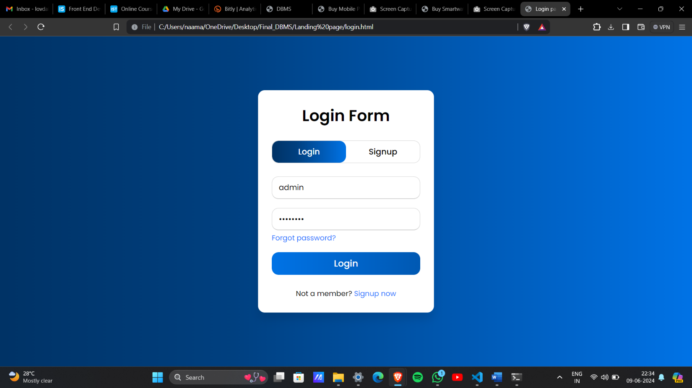

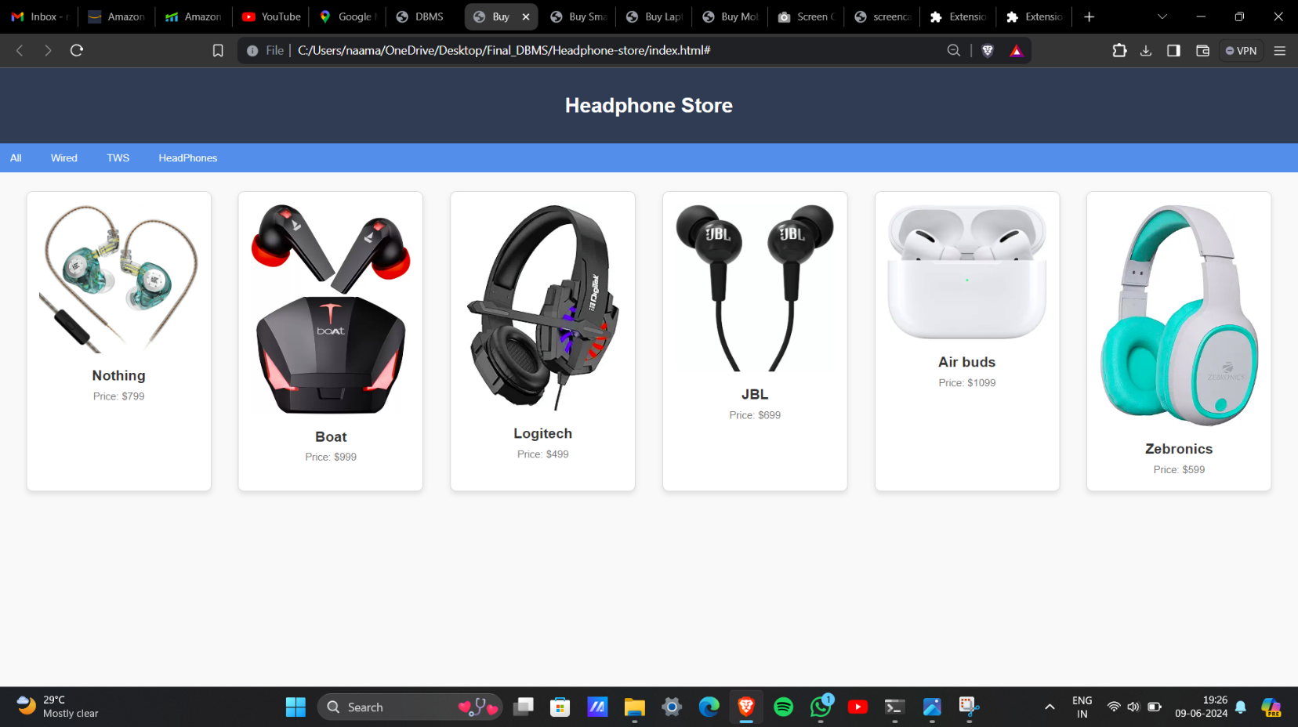

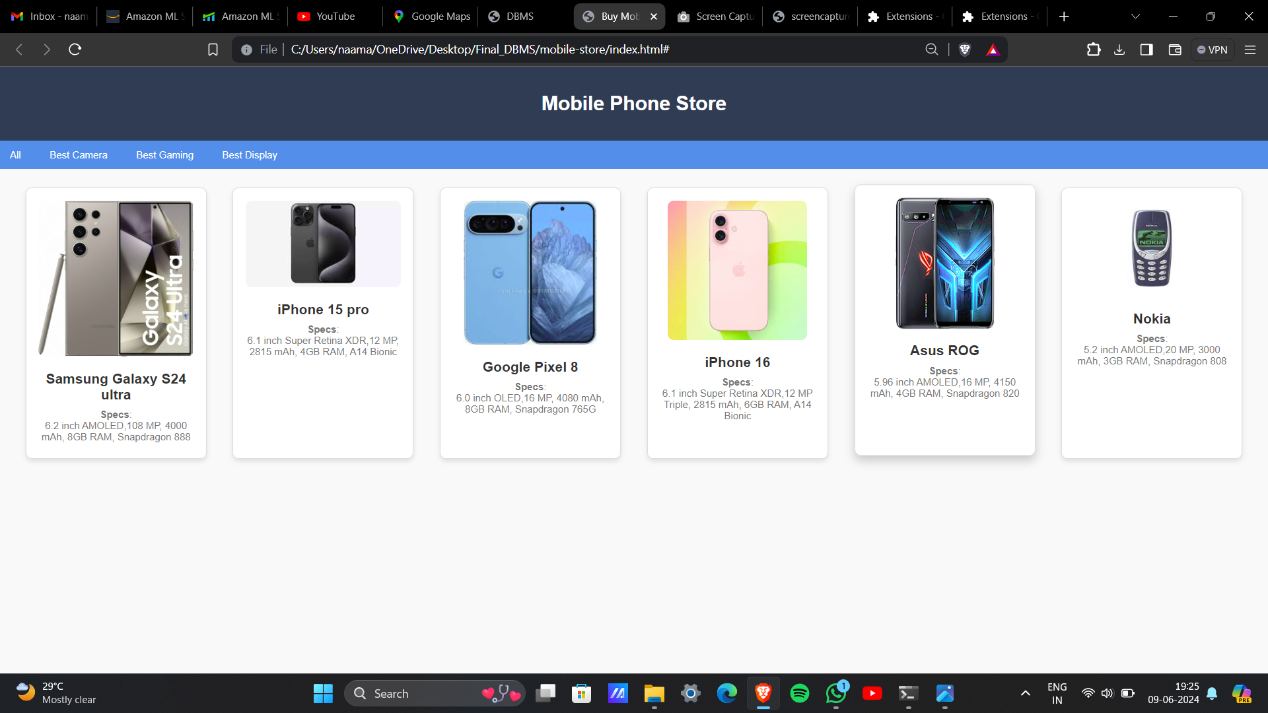

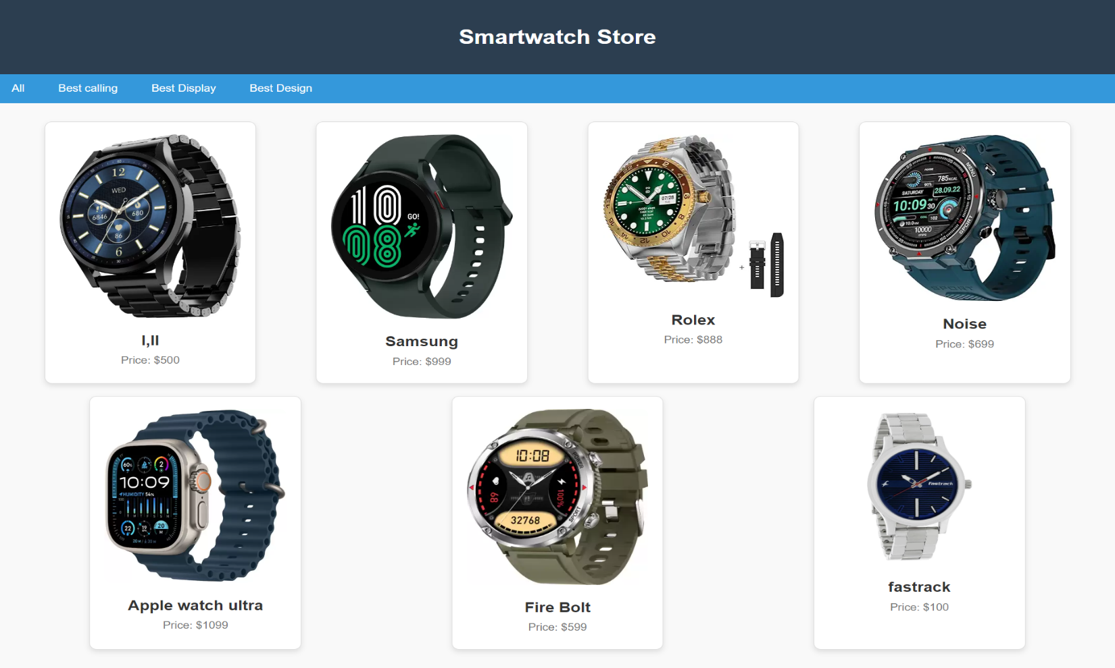

THANK YOU