AI ASSISTED CODING
LAB ASSIGNMENT – 20.3
Name: KARTHIK REDDY
Roll no: 2403A510F8
Batch 06 CSE 2nd year
Task 1 – Input Validation Check Prompt:
"Generate a simple Python program that asks for a username and password and allows login if they match predefined credentials."
Code Generated:
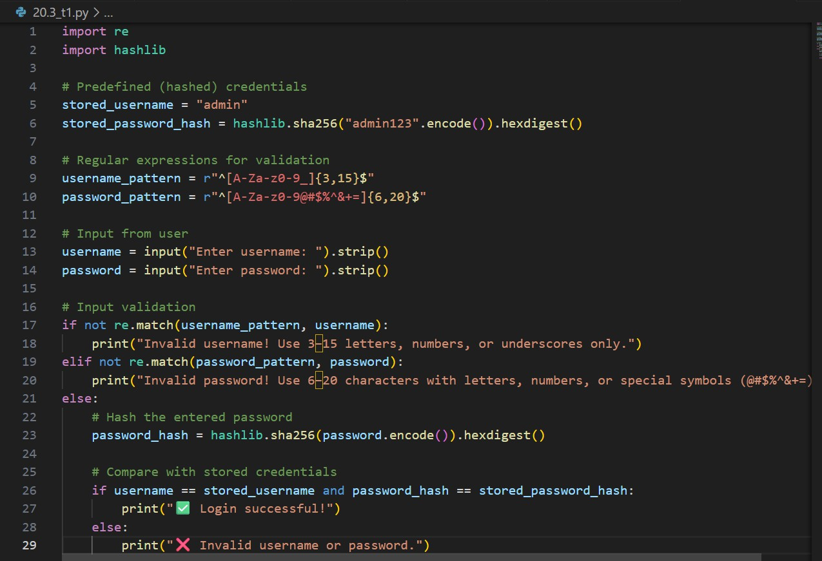
Output:

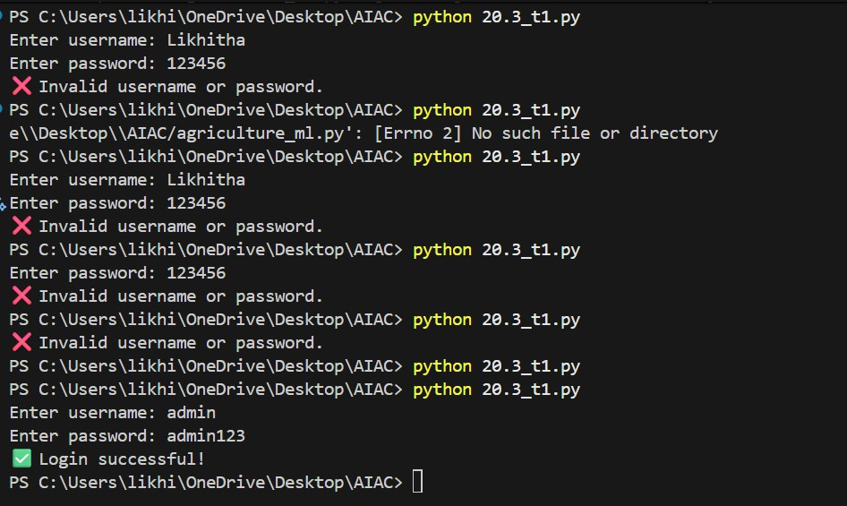
Observation:
- The initial AI-generated login script did not include any input validation or sanitization, making it insecure.
- The improved version adds regex-based input validation, password hashing, and safe comparison, ensuring that only properly formatted and secure inputs are accepted.
Task 2 – SQL Injection Prevention Prompt:
“Generate a Python script using SQLite to fetch user details from a database based on a username entered by the user.”
Code Generated:

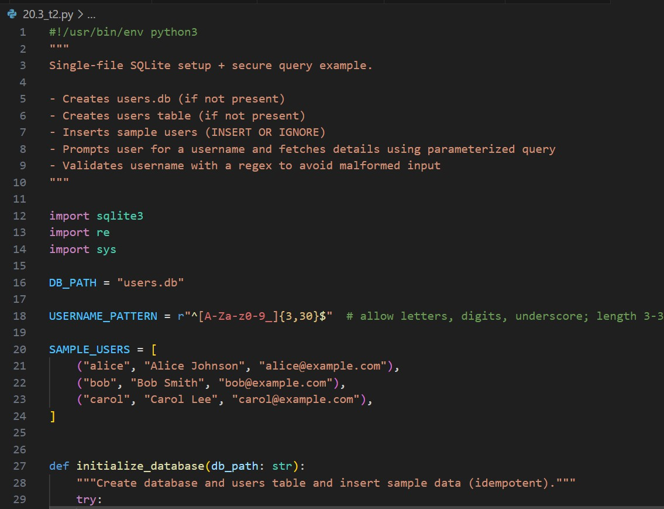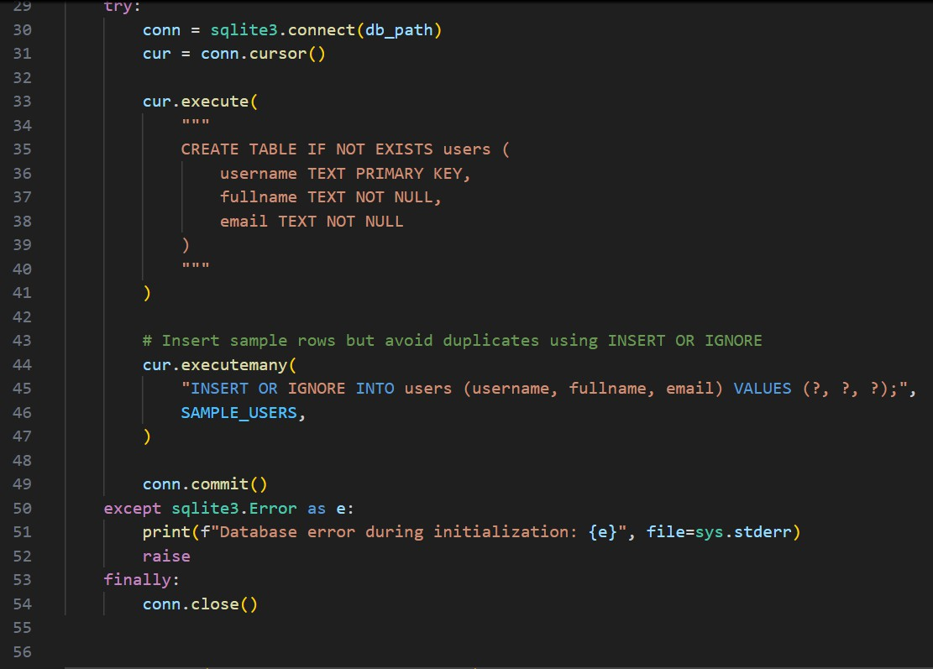

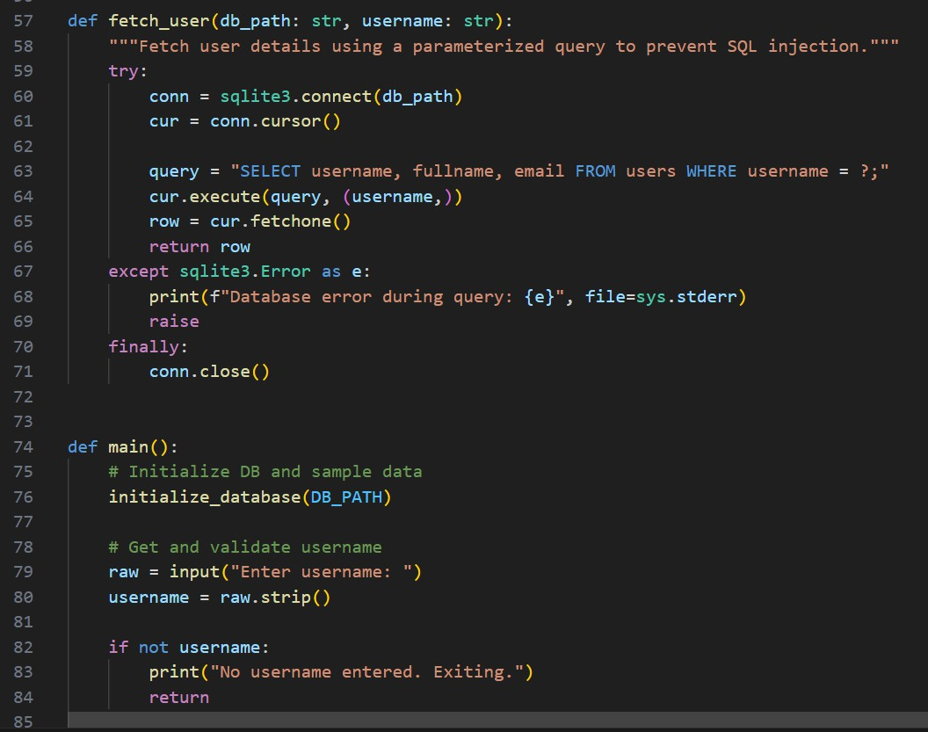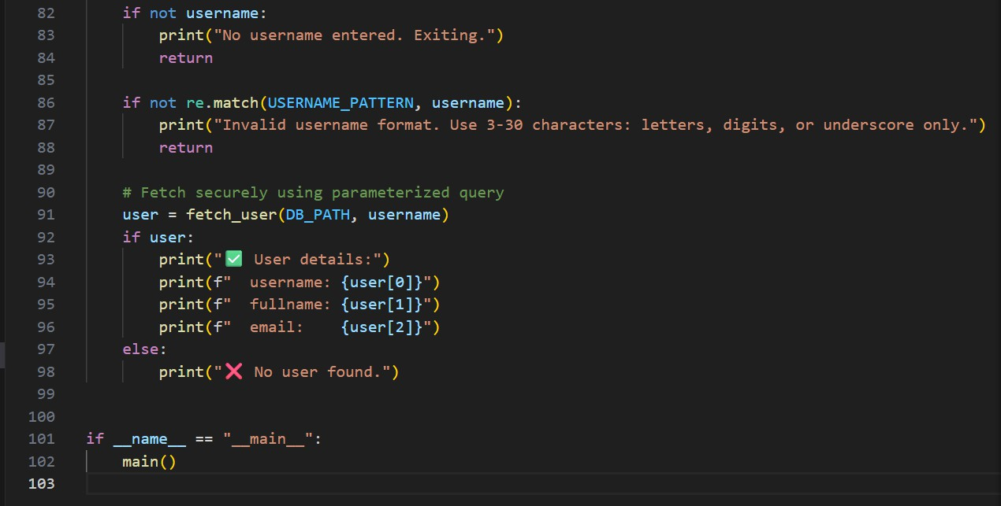
Output:

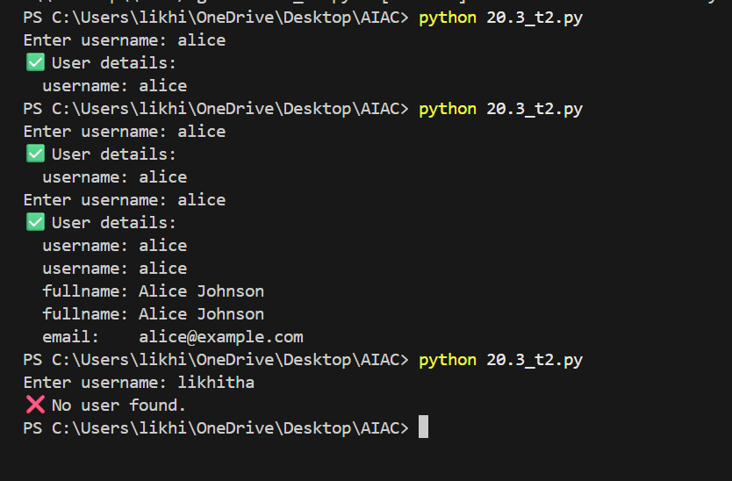
Observation:
- The original AI-generated SQL script was vulnerable to SQL injection because it used string concatenation to build queries directly from user input.In the improved version, parameterized queries (? placeholders) are used, which prevent malicious SQL code from being executed.
- Additionally, the script includes input validation using regex to ensure usernames follow a safe pattern, and it creates the database and sample table automatically if they don’t exist.
- This makes the program secure, self-contained, and reliable, protecting both the database and user data from injection or accidental corruption.

Task 3 – Cross-Site Scripting (XSS) Check Prompt:
"Generate a simple HTML feedback form (name, email, message) that uses JavaScript to show the submitted feedback below the form."
Code Generated:

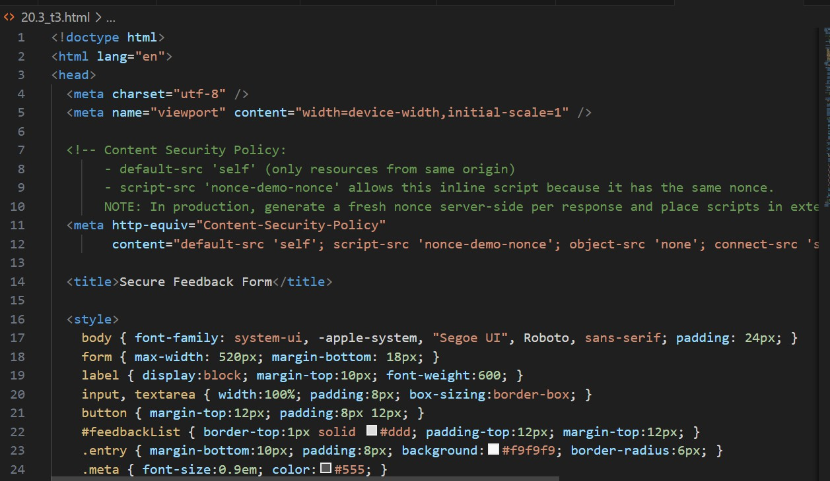

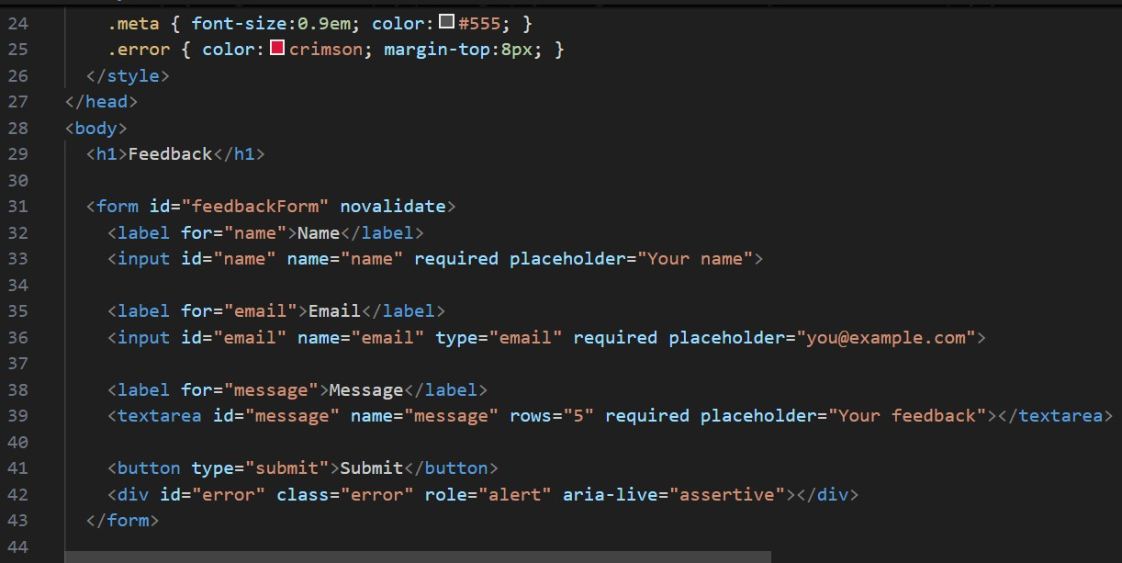

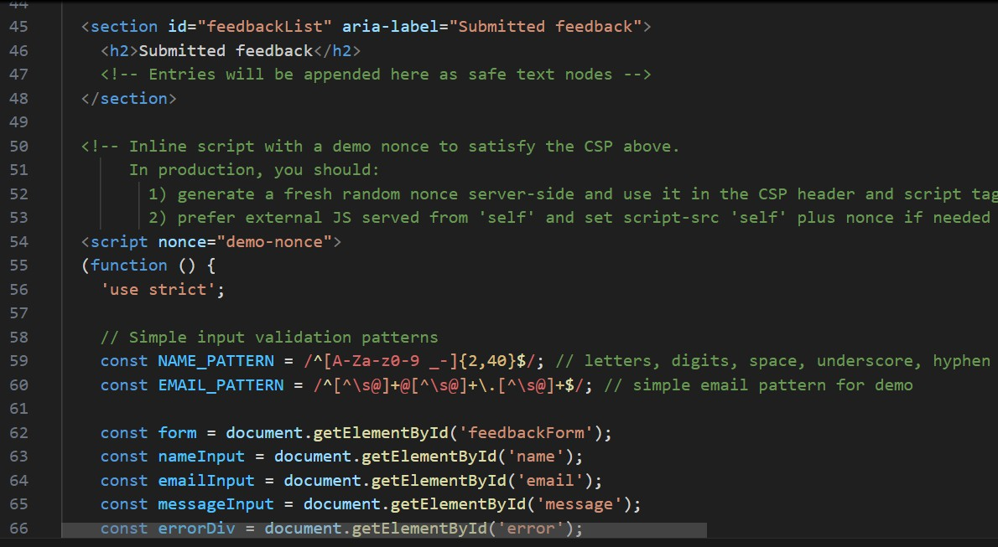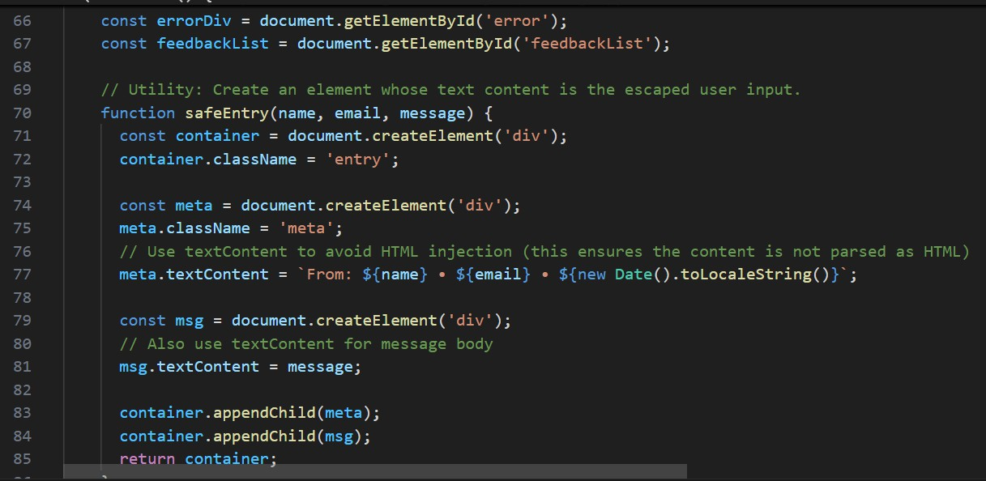

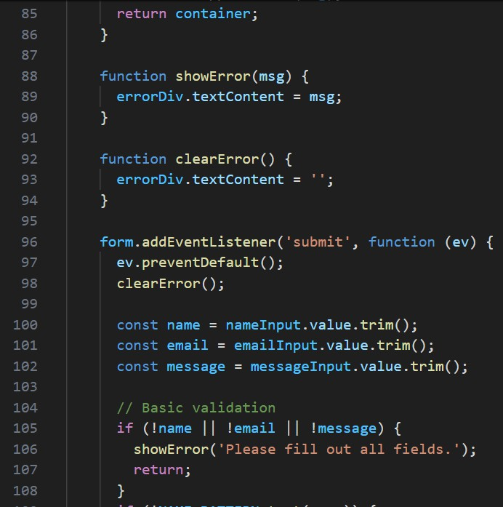

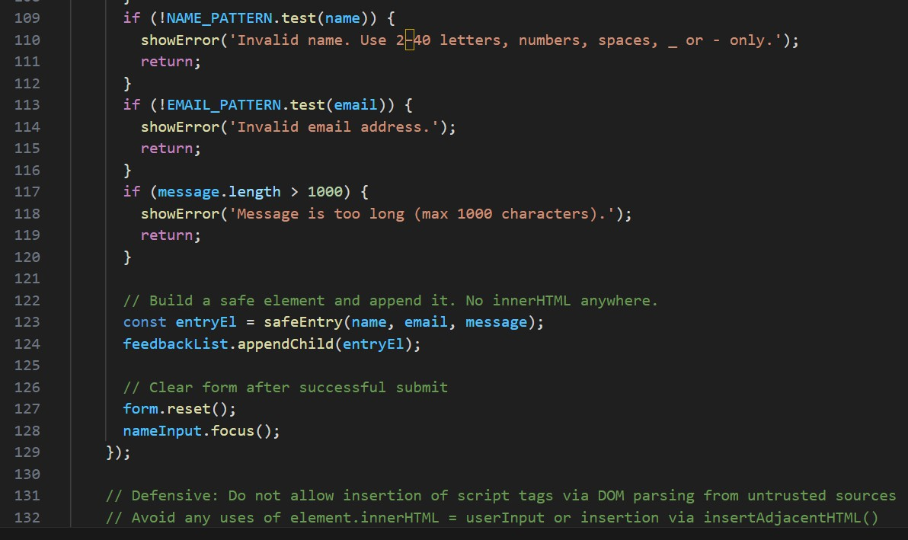
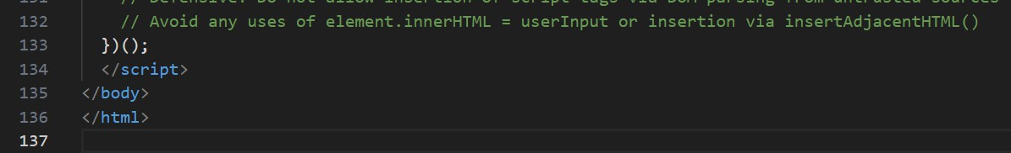
Output:
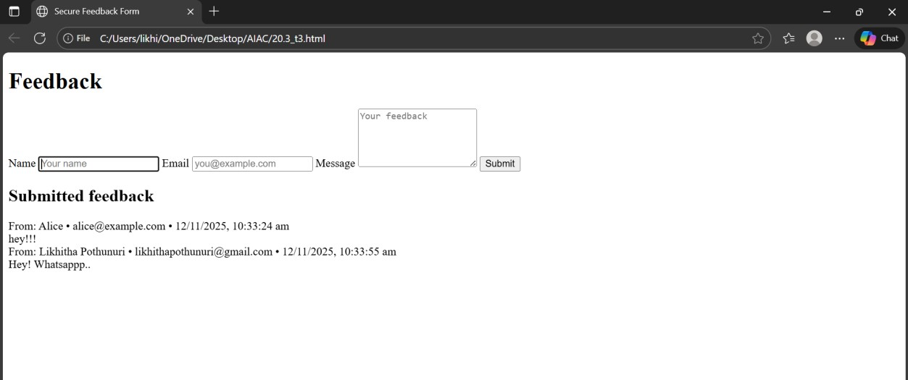
Observation:
- The original AI-generated feedback form was
vulnerable to XSS because it directly displayed user input using innerHTML.

- The secure version fixes this by using textContent to safely display input, validating user data, and adding a Content Security Policy (CSP).
- This ensures that any malicious scripts entered by a user will not be executed, keeping the webpage safe.
Task 4 – Real-Time Application: Security Audit of AI-Generated
Prompt:
“Generate a simple Python Flask file upload program that saves uploaded files to a folder.”
Code Generated:

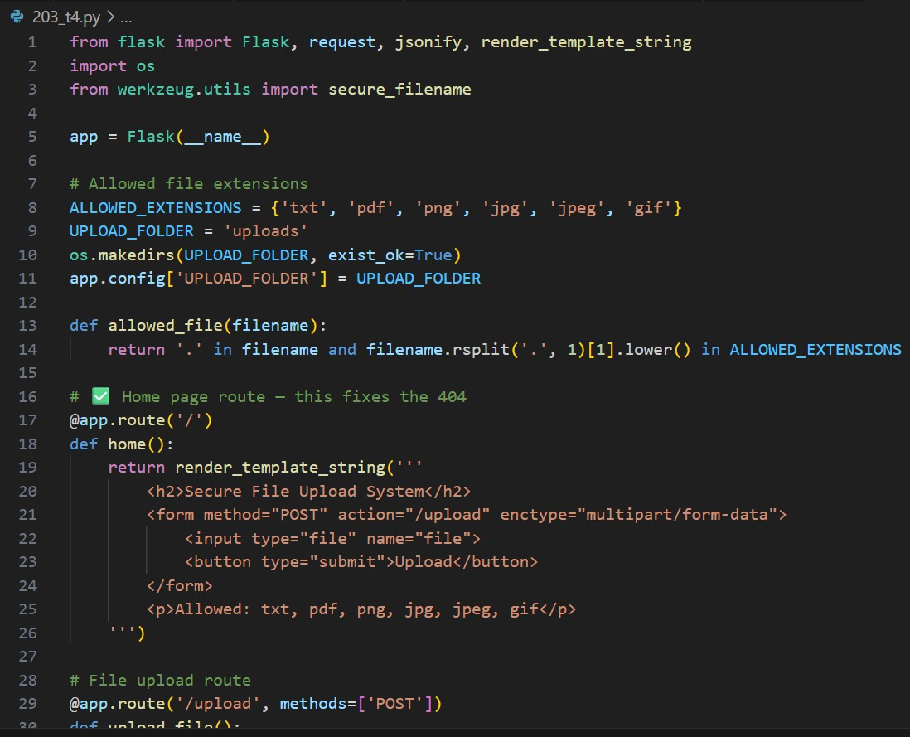
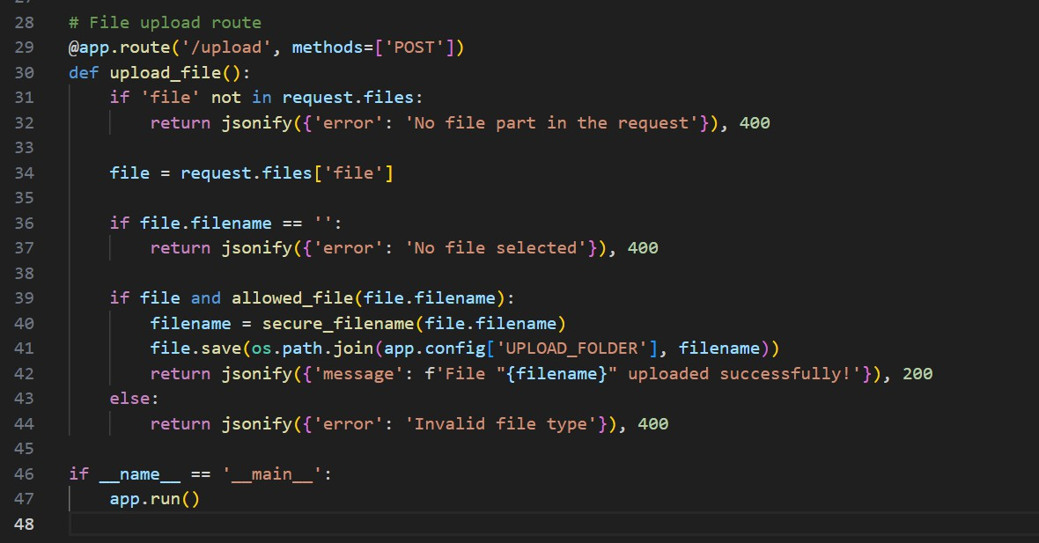

Output:

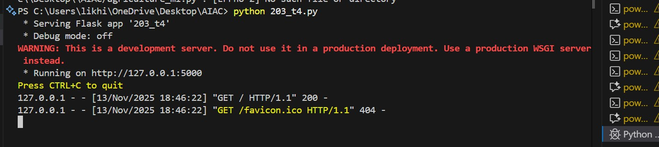
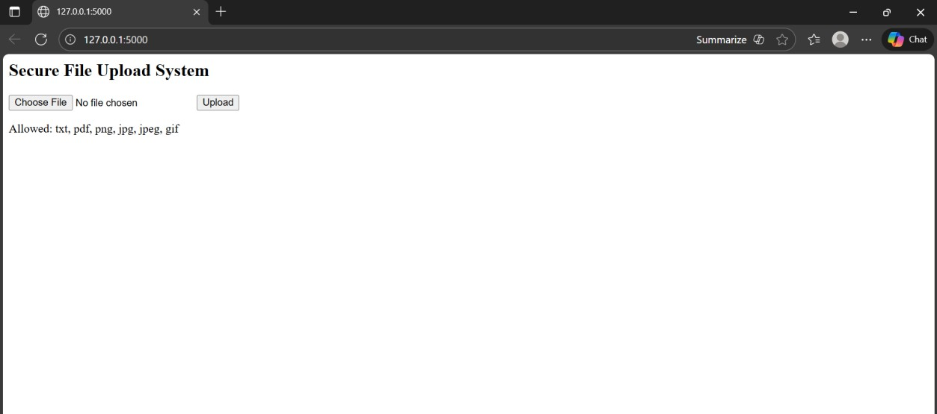
Observation:
- The insecure version directly saved user-uploaded files without any validation, making it vulnerable to path traversal and malicious file uploads.
- The secure version fixes these issues by using
secure_filename(), validating file types and sizes, and disabling debug mode, ensuring that uploaded files are stored safely and securely.

